*Original Research Article*

Population Assessment of Economically Valuable Timber Species Distributed in Chhattisgarh Forest Divisions, India.

ABSTRACT

|  |
| --- |
| **Aims:** The present study deals to document the distribution of economically important threatened tree species in the different forest divisions of Chhattisgarh state. This research intends to provide researchers with the necessary information to locate these species for initiation of conservation programs within the region.  **Study design:** The systematic random sampling method was used for tree sampling.  **Place and Duration of Study:** Forest divisions selected for documentation of tree species spread across over Raigarh, Jashpur, Dharamjaigarh, Korba, Bilaspur, Gourela-Pendra-Marwahi, Kawardha, Mahasamund, Gariyaband, Kanker, Dhamtari, Kondagaon, West Bhanupratapur, Jagdalpur, Sukma and Dantewara divisions.The survey was conducted for two years from 2021 to 2023.  **Methodology:** To identify regions with greater species richness, sample plots were laidoutin the forest division. A total of 12.8 hectares were covered by 320 sample plots (20 m × 20 m) spaced 100 m apart. Tree height and girth at breast height were measured with the a Range Finder and Measuring Tape. Coordinates of each plot were recorded with a Garmin GPS. Relative density was calculated (Number of individuals of a species / Total number of individuals of all species) x 100. Distribution maps of targeted species was prepared using ArcGis 10.8 sofware.  **Results:** Survey of 16 Forest Divisions in Chhattisgarh revealed 24 threatened tree species. *Buchanania lanzan* and *Shorea robusta* were the most widespread found in all divisions. Gariyaband division exhibited the highest number of threatened species (16), where as Kondagaon and West Bhanupratappur had the least (7).  **Conclusion:**This study identifies the distribution of threatened tree species across Chhattisgarh's Forest Divisions. The information has assumed significance in the wake of conservation, planning and the development of species distribution models. The resulting data, including distribution maps of targeted species, will enable conservationists to locate areas for preservation efforts. |

***Keywords:*** *Chhattisgarh forest division, Conservation, Distribution mapping, Economic importance, Population assessment and Threatened tree species*

1. INTRODUCTION

Trees are among the most valuable gifts of nature and are essential part of every terrestrial ecosystem­ [1]. Trees provide numerous direct and indirect benefits including carbon sequestration to making cities more liveable [2]. The trees provide timber as a raw material for various industries to manufacture wood-based products i.e. Paper & Pulp, Plywood, Particle Boards, Furniture, Cosmetics, Beverages and Construction etc. Trees are the source of Medicine, Gums, Oleoresins, Resins, Fibres, Tannins, Cutch and Katha, Dyes, Fruits, Essential oils and more articles of economical important.

Each tree species exhibits unique characteristics, some are deciduous in nature and others are evergreen, some have wonderful leaves or fruits, whereas others have beautiful blossoms, some have scents, while others are unattractive yet economical important [1]. Because of these unique characteristics some are directly consumable and others are used for other purposes. For instance, *Gardenia gummifera* fruits can directly be consumed by humans and animals whereas the *Cleistanthus collinus* has toxic properties, is used for deliberate self-harm [3]. Over exploitation of forest leads to loss of biodiversity, fragmentation of habitat, Deforestation and Climate Change, Soil Degradation Soil Erosion besides having Economic Consequences, Loss of Traditional Knowledge, Social and Cultural Impact etc. The decline of wild populations further lead to species extinctions, consequently reductions to overall biodiversity [4].

Globally 22,035 tree species are under threatened category, approximately one third of the global tree species are at risk of becoming extinction [5]. The extinction of tree species directly affects the survival of the life forms on the earth. Hence, conservation of these economically important tree species are need of the hour before they permanently vanish from their habitat. So far the study focused on the documentation of the economical important threatened tree species and its distribution in different forest divisions of the Chhattisgarh state. This study help researchers to find the location of threatened tree species existing in Chhattisgarh for launching its conservation / breeding program.

2. methodology

**Study Area:**

The study site was selected in different forest divisions of Chhattisgarh. Chhattisgarh's geographical location ranges from 17°46' to 24°5' north latitude and 80°15' to 84°20' east longitude, with an average rainfall of 1207 mm (Figure 1). The overall geographical area of the state is approximately 1,35,192 square kilometers. Chhattisgarh is one of the most biodiverse states in the country, with around 55,717 square kilometers of forest cover, accounting for 41.21% of its entire geographical area. The state of Chhattisgarh accounts for 7.8% of India's total forest cover (7,13,789 square kilometers) [6-7].

The Forest Divisions selected for documentation of tree species are Raigarh, Jashpur, Dharamjaigarh, Korba, Bilaspur, Gourela-Pendra-Marwahi (GPM), Kawardha, Mahasamund, Gariyaband, Kanker, Dhamtari, Kondagaon, West Bhanuprattapur, Jagdalpur, Sukma and Dantewara.The study was carried out from 2021 to 2023. The systematic random sampling method was used for tree sampling. The sample plots were selected higher species diversity based on the respected forest division maps. A total of 20 sample plots of 20m X 20m were laid out for tree enumeration at every selected forest area with an interval of 100mtrs. Total 320 sample plots of 12.8 ha area covered for the survey. Range Finder and Measuring Tapes were used for measuring the height and girth at breast height of a trees. Co-ordinates of each sample plot were collected with help of Garmin GPS. The relative density of tree species was calculated by number of individuals of a species divided by total number of individuals of all species multiplied by 100. The economic values of the individual tree species collected from various available literatures. The mapping of species was done by using ArcGis 10.8 software.

**Figure 1- Map of Study 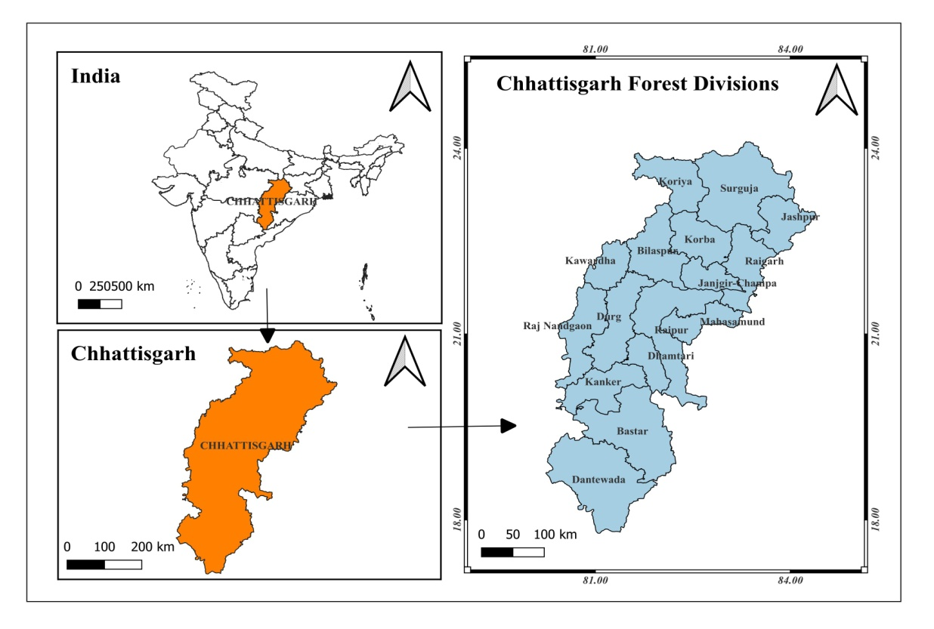Site**

3. results and discussion

Economically important 24 tree species representing 20 families were recorded from the sixteen Forest Divisions of Chhattisgarh which comes under threatened category of IUCN Red data book list. Out of these 24 threatened species, two are "Critically Endangered" one is "Endangered" eleven are "Vulnerable" and ten are "Near Threatened. (Table.1). These species have economic importance to society directly or indirectly and forest dwellers are exploiting them for their livelihood. Over exploitation of species lead to threat to their existence. C*leistanthus collinus* is effective green medicine to treat various infectious diseases both human being and animals [8], apart from this, wood has high caloric value of 4595 Kcal/kg compared to the other wood species. This resultant into over exploitation for fuel wood by the forest dwellers [9]. Some species exhibit seed dormancy due to unfavourable conditions, for instance *Dillenia pentagyna* (Karmal) showing low seed germination capacity. *D. Pentagyna* shows reasonable germination percentage when fruits are consumed by the elephants and excrete out [10]. Due to the disintegration of elephant’s habitat, the germination of Karmal seed has been declined over the decades. Decline in population of *B. serrata* is due to unsustainable tapping for gum/resin collection. Brutal and injurious tapping methods often lead to the death of tree. New tapping methods using "**ethephon**" (2-chloroethylphosphonic acid), a plant growth regulator, have boosted gum/ resin exudation in various species, including *Anogiessus latifolia*, *Acacia senegal*, *Commiphora wightii*, *Sterculia urens* *and Mangifera indica*. These procedures also ensure the long-term productivity, regeneration and survival of tapped trees. Ethephon is safe, affordable and nontoxic [11].

**Table 1. List of tree species with its Economic Importance Existing in Chhattisgarh Forest Divisions**

|  |  |  |  |  |  |
| --- | --- | --- | --- | --- | --- |
| **S.No.** | **Scientific Name of Species** | **Family** | **Local name** | **Status in IUCN List** | **Economic Importance** |
|  | *Aegle marmelos*  (L.) Correa | Rutaceae | Bael | Near Threatened [12] | Fruits are edible and has cultural importance. |
|  | *Acacia catechu*  (L.f.)Willd. | Fabaceae | Khair | Near Threatened [13] | The heart wood used to extraction of cutch and Katha.  Ethnobotany: A 20 ml decoction of bark is used twice a day to treat stomach discomfort [14]. |
|  | *Boswellia serrata*  Roxb. Ex Colebr. | Burseraceae | Salai | Near threatened [13] | It is an economically important plant because of its high-quality oleo gum resin and essential oil. Essential oils are utilized as flavorings in food and in the perfume industry [15]. |
|  | *Buchanania lanzan*  Spreng. | Anacardiacae | Chironji | Vulnerable [13] | Seed kernels used as dry fruits in Indian deserts.  Ethnobotany Uses: - Powder of leaves is used during loose motion. |
|  | *Careya arborea* Roxb. | Lecythidaceae | Kumbhi,  Ghohar | Vulnerable [13] | Fruits of Kumbhi helps in promoting Digestion, As astringent [16]. |
|  | *Chloroxylonsswietenia*  Roxb. DC. | Rutaceae | Bhirra | Vulnerable [12] | Main stem used by butchers for chopping meat. |
|  | *Cleistanthus collinus* (Roxb.) Benth. Ex Hook.f. | Phyllanthaceae | Garari | Vulnerable [12] | Wood has high caloric value and suitable for fuel wood. |
|  | *Cordia macleodii* (Griff.) Hook.f. & Thomson | Boraginaceae | Dahipalash | Endangered [13] | In cases of high fever, a fresh paste made from the leaves is applied to the forehead as wound treatment. Stem bark is useful for jaundice [17]. |
|  | *Dalbergia latifolia* Roxb. | Fabaceae | Shisham | Vulnerable [12] | Timber used in furniture industry |
|  | *Dillenia pentagyna* Roxb. | Dilleniaceae | Karmal | Critically Endangered [13] | Traditional medicine uses the leaves, bark, and fruit of these plants, which have beneficial therapeutic properties [18]. |
|  | *Garuga pinnata* Roxb. | Burseraceae | Kankad | Vulnerable [13] | Fruits are edible & used for pickle making by tribals in India.  The barkused for treating wounds and inflammation in folklore medicine [19]. |
|  | *Grewia tiliifolia* Vahl | Tiliaceae | Dhaman | Near Threatened [13] | Traditional medicine uses the bark and roots to treat fractures, diarrhea, and skin disorders. The wood is used to make tool handles. The fruits are edible. |
|  | *Hymenodictyon excelsum* (Roxb.) Wall. | Rubiaceae | Bhonrsal | Near Threatened [13] | The wood used in pencil industry [20]. |
|  | *Ougeinia oojeinensis* (Roxb.) Hochreut | fabaceae | Tiwas | Near Threatened [13] | Different plant parts, including leaves, stems, roots, and barks, were utilized as medicines in homeopathic, Siddha, Ayurvedic and Unani therapeutics[21]. |
|  | *Pterocarpus marsupium* Roxb. | Papilionaceae | Bijasal | Vulnerable [13] | The timber has economic importance |
|  | *Schleichera oleosa* (Lour.) Oken | Sapindaceae | Lac Tree | Near Threatened [13] | The tree is host for lac insect and produce lac resin. |
|  | *Schrebera swietenioides* Roxb. | Oleaceae | Mokha | Near Threatened [13] | The root, bark and leaves have anthelmintic, digestive, constipating, acrid and bitter properties. Flatulence, skin conditions, leprosy, diarrhea, anemia and rectal illnesses can all benefit from them [22]. |
|  | *Semecarpus anacardium* L.f. | Anacardiaceae | Bhilawan | Near Threatened [13] | The fruits are edible |
|  | *Soymida febrifuga* (Roxb.) A. Juss | Meliaceae | Rohan | Vulnerable [13] | The bark extract is widely used to treat dysmenorrhea, menorrhagia and leucorrhea[23]. |
|  | *Spondias mangifera* Willd. (L.f.) Kurz | Anacardiaceae | Amra | Near threatened [13] | The trunk bark used traditionally as refrigerant, tonic, antiseptic, astringent and for the treatment of dysentery, diarrhoea and prevent vomiting [24]. |
|  | *Sterculia urens* Roxb. | Sterculiaceae | Kullu, | Vulnerable [13] | Gum karaya extracted from tree stem |
|  | *Stereospermum chelonoides* Roxb. (D.C) | Bignoniaceae | Padri Tree | Vulnerable [13] | It has been used for Diarrhoea, Skin diseases & Fever [25]. |
|  | *Terminalia chebula* Retz. | Combretaceae | Harra | Near Threatened [13] | Fruits are used in making triphalachurnam in avurveda |
|  | *Wrightia tinctoria* (Dennst.) Mabb. | Apocynaceae | Dudi | Vulnerable [13] | The tree has good analgesic, anti-inflammatory, anti-hermitic, antiulcer, anti-dysenteric, anti-diabetic, anticancer, antipyretic activities and also effective in the treatment of psoriasis [26]. |

**3.1. Distribution of species and their relative density:**

A total 16 Forest Divisions were surveyed to document the threatened species in Chhattisgarh. Among the 24 threatened species *B.lanzan and S.Oleosa* were recorded in all 16 forest divisions, *T.chebula, S.anacardium, P.marsupium* & *C.arborea* species were recorded in 14 forest divisions, *C.Collinus* was recorded in 12 forest divisions, *A. marmelos, B. serrata* & *O. oojeinensis* were documented in 11 forest divisions, *S. febrifuga* spread over the 8 forest divisions, *C. swietenia, G. pinnata* & *S. chelonoides* were enumerated in 7 forest divisions, *D. pentagyna* recorded in 5 forest divisions, *A. catechu, D. latifolia, G. Tiliifolia* & *S. urens* documented in 4 forest divisions, *S. swietenioides, H. Orixense* & *W. tinctoria* were recorded in 2 forest divisions and *S. Mangifera* & *C. Macleodii* were recorded in 1 forest division depicted in (Figure 3,A-Y). Tree species, revealing varied distribution patterns from wide spread species, such as *Buchanania lanzan* and *Schleichera oleosa*, to those restricted to only one or two divisions, a pattern potentially influenced by habitat specificity and localized pressures [27].

Most threatened tree species were documented in Gariyaband Forest division i.e. 19 individuals from surveyed areas. 17 species in Dantewara, 16 species in Jashpur, 15 species in Jagdalpur, 14 species in Sukma, Korba & Bilaspur, 12 species in Kawardha, 11 species in Mahasamund, 10 species in Damtari, 9 species in Raigarh, GPM & Kanker, 8 species in Dharamjaigarh and 7 species in Kondagaon & West Bhanuprattapur forest divisions..The significant variation in threatened species richness among divisions, with localities such as Gariyaband and Dantewara having a high number, highlights the ecological importance of these regions as critical conservation sites. These distribution and density patterns provide important baseline data for developing targeted conservation and management strategies for vulnerable tree flora in the state's [28, 29].

The heat map (Figure 2) displays the relative density of the 24 endangered tree species in the 16 Chhattisgarh Forest Divisions. The heat map analysis reveals significant differences in relative densities among these species. Remarkably, the relative density of *Acacia catechu* was significantly higher in the Mahasamund (26.53%) division. Additionally, higher relative densities were noted for *Pterocarpus marsupium* in the Bilaspur (24.29%) and *Soymida febrifuga* in the Mahasamund (25.45%) divisions. Several species and divisions displayed moderate or at-par relative densities, usually between 5% and 12%, suggesting that population representation varied throughout the landscape. Conversely, several species recorded the lowest relative densities (2.7%), particularly species with restricted distributions such as *Cordia macleodii* & *Spondias mangifera*, which showed low densities across the divisions where they were present, i.e., Jagdalpur: 3.01% & Bilaspur: 3.1%.

The variation noted between relative densities in species and divisions exhibits the geographical variation among Chhattisgarh's threatened tree populations. Increased relative density of species such as *Acacia catechu* in particular divisions could suggest favorable habitat conditions or localized threats being less severe, leading to healthier populations [30, 31]. Low relative abundances, especially in species with small populations, indicate potential issues such as habitat specialization, poor regeneration, or increased susceptibility to anthropogenic stresses, indicating their vulnerability [32]. These are important in determining key habitats and implementing targeted conservation efforts to increase the populations of threatened tree species [31].

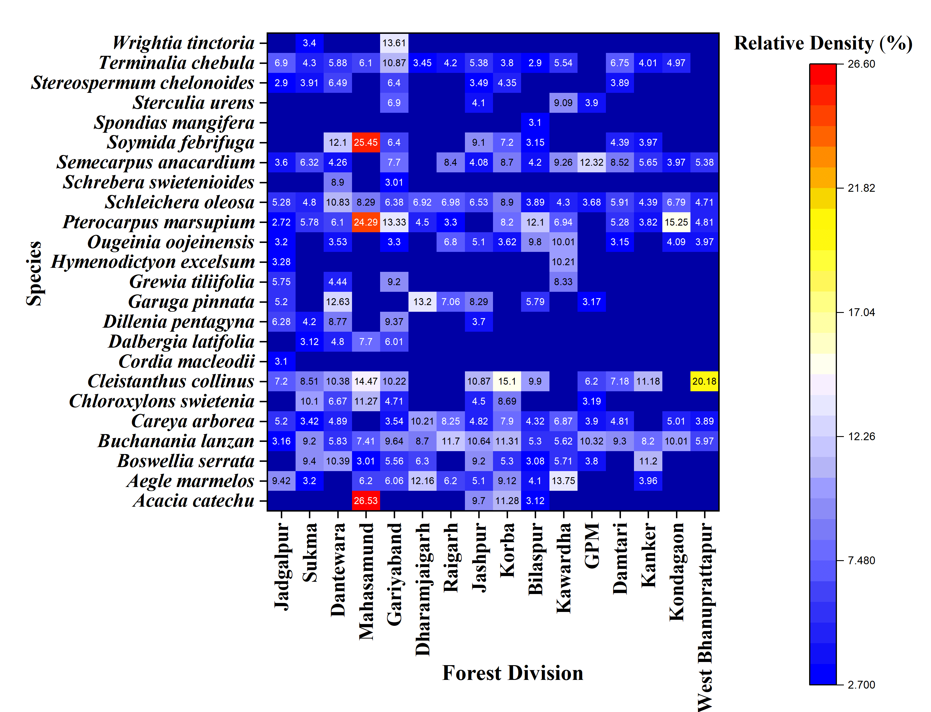

**Figure 2. Relative Density of Threatened Tree Species In Different Forest Divisions Chhattisgarh State.**

|  |  |  |
| --- | --- | --- |
| A | B | C |
| D | E | F |
| G | H | I |

|  |  |  |
| --- | --- | --- |
| J | K | L |
| M | N | O |
| P | Q | R |

|  |  |  |
| --- | --- | --- |
| S | U | V |
| W | X | Y |

Figure 3. (A-Y) - Distribution Maps of 24 Threatened Tree Species In Chhattisgarh Forest Divisions.

Conclusion:

The study covered 16 forest divisions of Chhattisgarh with different forest types to enumerate the actual distribution of these tree species, which are commercially important but categorised under the threatened category. This study not only provide base-line information for conservationists to prepare their conservation plans scientifically but also with the help of distribution map, it is easy to locate its populations. The resultant data helps to establish preservation plot of threatened species in its natural habitat.

References:

1. Seth, M. K.(2003). Trees and their economic importance. *The Botanical Review*, 69(4), 321-376.https://www.jstor.org/stable/4354466.
2. Cannon, C.H., Dhyani, A., Jin, C. & Rivers, M. (2023). The Global Tree Assessment provides a multifaceted view on the future of tree diversity conservation. *Plants, People, Planet*, **5**(4), 61-465.https://doi.org/10.1002/ppp3.10392.
3. Chrispal, A. (2012).*Cleistanthuscollinus* poisoning. *Journal of Emergencies, Trauma and Shock*, **5**(2), 160-166.https://doi.org/10.4103/0974-2700.96486.
4. Chapin Iii, F. S., Zavaleta, E. S., Eviner, V. T., Naylor, R. L., Vitousek, P. M., Reynolds, H. L., Hooper, D. U., Lavorel, S., Sala, O. E., Hobbie, S. E. & Mack, M. C. (2000).Consequences of changing biodiversity. *Nature,***405**(6783), 234-242.https://doi.org/10.1038/35012241.
5. Botanic Gardens Conservation International, State of the world's trees. Botanic Gardens Conservation International, 2021.https://www.bgci.org/wp/wp-content/uploads/2021/08/FINAL-GTAReportMedRes-1.pdf.
6. Directorate Agriculture, Chhattisgarh Raipur (Agriculture Development and Farmer Welfare and Bio-Technology Department).[http://agriportal.cg.nic.in/agridept/ AgriEn/Default.aspx](http://agriportal.cg.nic.in/agridept/%20AgriEn/Default.aspx).
7. Indian State of Forest Report. Published by. Forest Survey of India, 2021 (Ministry of Environment Forest and Climate Change) Kaulagarh road, P.O. IPE Dehradun – 248195, Uttarakhand.https://fsi.nic.in/forest-report-2021-details.
8. 8) Elangomathavan, R. (2013). Bio-prospecting of *Cleistanthuscollinus* and its antibacterial activity. *Asian Journal of Pharmaceutical and Clinical Research*, **6**(4), 206-209. https://[www.researchgate.net/](http://www.researchgate.net/)profile/SumanThamburaj/publication/ 258255218_Bioprospecting_of_Cleistanthus_collinus_and_its_antibacterial_activity/links/00b7d522eeffa0385c000000/Bio-prospecting-of-Cleistanthus-collinus-and-its-antibacterial-activity.pdf.
9. Chichaghare, A.R., Deshmukh, H.K., Kumar, N.M. & Jamatiya, A. (2019). Garari (*Cleistanthuscollinus*): Multipurpose hedge crop for organic farming through agroforestry intervention.*Journal of Pharmacognosy and Phytochemistry*, **8**(2), 2124-2127..https://www.phytojournal.com/archives/2019/vol8issue2/PartAI/8-1-661-486.pdf.
10. Vinod, T. R. (1994). Food and feeding habits of Asian elephants (*Elephas maximus* Linn.) Doctoral dissertation, Department of Wildlife Science, College of Forestry, Vellanikkara.http://14.139.185.57:8080/jspui/bitstream/123456789/5160/1/170635.pdf.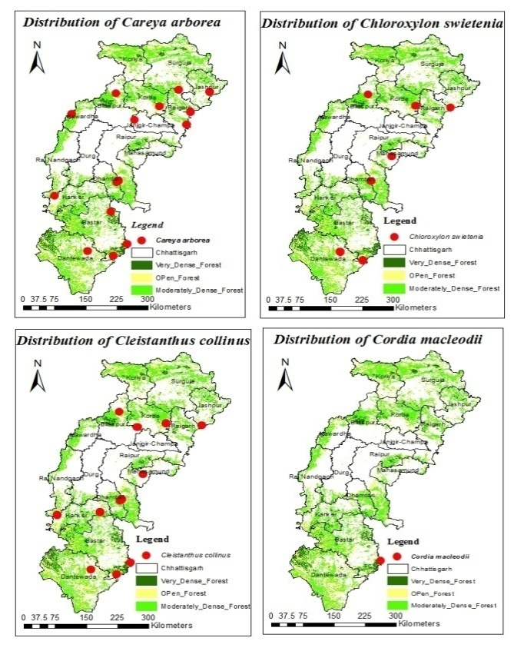
11. Nair, M. B. (2000). Sustainable utilization of gum and resin by improved tapping technique in some species. *Harvesting of Non-Wood*, 293**.**
12. IUCN (2024). The IUCN Red List of Threatened Species. Version 2024-1.https://www.iucnredlist.org.
13. Khanna, K. K., Dubey, P. C., Tiwari, A. P., & Sikarwar, R. L. S. (2021). Studies on threat status of tree species of Madhya Pradesh, India.https://www.researchgate.net/publication/349026807_Studies_on_Threat_Status_of_Tree_species_of_Madhya_Pradesh_India.
14. Dahare, D.K. and Jain, A. (2010). Ethnobotanical Studies on Plant Resources of Tahsil Multai, District Betul, Madhya Pradesh, India. *Ethnobotanical Leaflets*, **14**, 694- 705.Directorate Agriculture, Chhattisgarh Raipur (Agriculture Development and Farmer Welfare andBio-Technology Department).https://opensiuc.lib.siu.edu/cgi/viewcontent.cgi?article=1680&context=ebl.
15. Mothana, R.A., Hasson, S.S., Schultze, W., Mowitz, A. & Lindequist, U. (2011). Phytochemical composition and in vitro antimicrobial and antioxidant activities of essential oils of three endemic SoqotraenBoswellia species. *Food chemistry*, **126**(3), 1149-1154.https://doi.org/10.1016/j.foodchem.2010.11.150.
16. Rimi, S., Mishra, H.S., Kumar, A.A., Rinky, J., Kumar, S. A. & Pooja, S. (2023). Therapeutic Potential of *Careaarborea*Roxb. *World Journal of Pharmaceutical Research,***12**(17), 721-734.https://doi.org/10.20959/wjpr202317-29693.
17. Quattrocchi, U. (2012). CRC world dictionary of medicinal and poisonous plants: common names, scientific names, eponyms, synonyms and etymology (5 VolumeSet).https://pdfs.semanticscholar.org/d15a/ff4da91cd16d00fc3d6be05c087fe4f00b1f.pdf/1000.
18. Gandhi, D. & Mehta, P. (2013). Dilleniaindica Linn. And*Dilleniapentagyna*Roxb.: Pharmacognostic, Phytochemical and therapeutic aspects. *Journal of applied pharmaceutical Science*, **3**(11),134-142.https://doi.org/10.7324/JAPS.2013.31124.
19. Bhagwat, J.A. & Bhagwat, A.M. (2013). Stem bark of *Garuga pinnata*roxb.: a renewable resource for wound healing drug. *International Journal of Pharmacology & Biological Sciences*,**7**(2).https://[www.proquest.com/](http://www.proquest.com/)docview/1462044696? sourcetyp=Scholarly%20Journals#
20. Tint, U.S. Study on Some Burmese Timbers Suitable for Pencil Making.https://www.forestdepartment.gov.mm/sites/default/files/Research%20Books%20file/11%281987%29.pdf
21. Tiwari, A., Patel, A., Shrivastava, S., Karole, S., Vishwakarma, U. & Mishra, P. (2020). Comprehensive review on phytochemistry, ethnobotanical, bioactivities and medicinal mysteries of *Ougeiniaoojeinensis* (Roxb.) Hochr. *Pharmaceutical and Biosciences Journal,***8**(2), 29-34.https://goi.org/10.20510/ukjpb/8/i2/1586230488.
22. Bagali, R.S., Jalalpure, S.S., & Patil, S. S. (2020). Evaluation of *Schreberaswietenioides* Roxb. fruit Ethanolic extract for Antioxidant and Hepatoprotective activity against CCl4 induced liver injury in rats. *Research Journal of Pharmacy and Technology,***13**(11), 5115-5120.https:// doi.org/ 10.5958/ 0974360X.2020.00895.1.
23. KrushnaPalei, A., Nishteswar, K. & Shukla, V. J. (2013). Phytochemical screening of *Soymidafebrifuga*Roxb. (Meliaceae) root bark. *International Journal of Pharmacy & Life Sciences*,**4**(2), 2371.https://[www.ijplsjournal.com/](http://www.ijplsjournal.com/)issues%20PDF%20files/feb-2013/4.pdf.
24. 24) Kritikar, K.R., & Basu, B. D. (1975). Indian Medicinal Plants, M/S Bishen Singh, Mahendra Pal Singh. Dehradun, India,**1**, 672-675.https:/books.google.co.in/books/about/Indian_Medicinal_Plants.html?id=kODNoAEACAAJ&redir_esc=y
25. Maurya, R. & Dongarwar, N. (2012). Studies on the medicinal uses of wild trees of Nagpur district. *International Journal of Life science and Pharma Research,***2**(1), 21-24.<https://www.ijlpr.com/index.php/journal/article/view/44>.
26. Chandrashekar, R., Adake, P., Rao, S. N., & Santanusaha, S.(2013).Wrightiatinctoria: An overview. *Journal of Drug Delivery and Therapeutics,* **3**(2).DOI 10.22270/jddt.v3i2.444.
27. Christensen, M., & Heilmann-Clausen, J. (2009). Forest biodiversity gradients and the human impact in Annapurna Conservation Area, Nepal. *Biodiversity and Conservation*, *18*(8), 2205–2221. <https://doi.org/10.1007/s10531-009-9583-9>.
28. Zhang, Y.-B., & Ma, K.-P. (2008). Geographic distribution patterns and status assessment of threatened plants in China. *Biodiversity and Conservation*, *17*(7), 1783–1798. <https://doi.org/10.1007/s10531-008-9384-6>.
29. Mahatara, D., Sharma, D., Acharya, A., Ulak, S., Paudel, P., & Dhakal, B. (2021). Maxent modelling for habitat suitability of vulnerable tree <i>Dalbergia latifolia</i> in Nepal. *Silva Fennica*, *55*(4). <https://doi.org/10.14214/sf.10441>.
30. Cheyne, S., Hamard, M., Sastramidjaja, W., Ripoll Capilla, B., Rowland, D., Zrust, M., Höing, A., Gilhooly, L., Houlihan, P., Loken, B., Rayadin, Y., Spehar, S., Kursani, K., Phillips, A., & Thompson, C. (2016). Population mapping of gibbons in Kalimantan, Indonesia: correlates of gibbon density and vegetation across the species’ range. *Endangered Species Research*, *30*, 133–143. <https://doi.org/10.3354/esr00734>.
31. Vergeer, P., Ouborg, N. J., Copal, A., & Rengelink, R. (2003). The interacting effects of genetic variation, habitat quality and population size on performance of*Succisa pratensis*. *Journal of Ecology*, *91*(1), 18–26. <https://doi.org/10.1046/j.1365-2745.2003.00736.x>
32. Murphy, D. D., Freas, K. E., & Weiss, S. B. (1990). An Environment‐meta population Approach to Population Viability Analysis for a Threatened Invertebrate. *Conservation Biology*, *4*(1), 41–51. <https://doi.org/10.1111/j.1523-1739.1990.tb00266.x>.