Original Research Article
Effect of Aqueous Extract of Carica papaya and Gongronema latifolium Leaves on Some Serum Enzymes and Lipid Profiles of Carbon Tetrachloride (CCl₄)-Induced Wistar Rats

ABSTRACT
Aim: To investigate the aqueous leaf extract of Carica papaya (pawpaw) and Gongronema latifolium (utazi) in the treatment of Wistar rats induced with carbon tetrachloride (CCl₄)-liver damage so as to ascertain the effect of both extracts on selected biochemical parameters.
Study design: Twenty-five (25) wistar rats with mean weight of 125g were used for the study and they were grouped into 5, each having 5 rats each. Group 1 served as the normal control which was given the standard feed and water ad libitum; group 2 served as the test control which were induced with CCl₄ but untreated with the extracts; while groups 3 to 5 were induced with CCl₄, and also treated daily with the aqueous leaf extracts with the concentrations of 5%, 10%, and 15% for 1 week.
Place and Duration of Study: The animal house of the Department of Biochemistry, University of Port Harcourt; and Department of Chemical Pathology, University of Port Harcourt Teaching Hospital (UPTH), between March and August 2019.
Methodology: After 7 days of treatment with both extracts in Groups 3-5, the 25 animals were sacrificed upon which their blood and a liver sample per group were taken for biochemical analysis. Biochemical tests such as Glucose, Alanine and Aspartate aminotransferases (ALT and AST), Alkaline phosphatase (ALP), Triacylglycerol (TAG), Cholesterol (CHOL), High density lipoprotein cholesterol (HDL-C), and Low density lipoprotein cholesterol (LDL-C) were assayed using Randox and Agappe kits, and autoanalysers.
Results: A significant decrease in liver enzyme activities due to a significant increase (P<0.05) in the levels of Aspartate and Alanine aminotransferase (AST and ALT) was shown.
Conclusion: The management of liver damage by the aqueous leaf extract of both plants was effective with increased concentration as the ameliorative effect was visible.

Key words: Carica papaya, Gongronema latifolium, Biochemical analysis, Liver damage, Liver enzymes.

- INTRODUCTION
The liver is the main organ responsible for drug metabolism and appears to be a sensitive target site for substances modulating biotransformation. During the course of aerobic metabolic reactions, considerable amounts of reactive oxygen species (ROS) such as superoxide anion (O²⁻) and hydrogen peroxide (H₂O₂) are generated which undergo a variety of chain reactions and produce free radicals such as OH⁻. These hydrogen species attack polyunsaturated fatty acids and thereby initiate the process of lipid peroxidation resulting in degradation and inactivation of various important biomolecules (Gupta et al., 2004).
Herbs have recently attracted attention as health beneficial foods and as source materials for drug development. Herbal medicines derived from plants extracts are being increasingly utilized to treat a wide variety of clinical diseases including liver disease, ischemia, reperfusion injury, atherosclerosis, acute hypertension, haemorrhagic shock, diabetes mellitus, and cancer with relatively little knowledge regarding their modes of action according to Guyton and Hall (1996).
The papaya, raw papaya pulp contains 88% water, 11% carbohydrates, and negligible fat and protein. In a 100g amount, papaya fruit provides 43 kilocalories and is a significant source of vitamin C (75% of the Daily Value, DV) and a moderate source of folate (10% DV), but otherwise has low content of nutrients. The origin of Carica papaya is in the tropics of the Americas, perhaps from Southern Mexico and neighbouring Central America (Heywood et al., 2007). Gongronema latifolium leaves belong to the family of plants known as Asclepiadoideae (Balogun et al., 2016).
1.1 Aim and Objectives of the Study
Aim: The aim of this research is to determine the hepatoprotective nature of Carica papaya (pawpaw) leaf and Gongronema latifolium (utazi) leaf, and to evaluate the effect of aqueous extract of the leaves on selected parameters of Wistar rats.
Objectives: The objectives of this research are:
- To determine the effect of aqueous extract of pawpaw leaf on the serum enzymes and lipid profile of the induced Wistar rats.
- To determine the effect of aqueous extract of utazi leaf on the serum enzymes and lipid profile of the induced Wistar rats.

1.2 Significance of the Study
The study evaluates the use of the two leaves on the serum enzymes and lipid profile of Wistar rats, intends to make available adequate scientific information about diseases on the lipid dysfunction in Wistar rats, and can serve as a reference to other researchers.
1.3 Phytochemicals
Papaya skin, pulp, and seeds contain a variety of phytochemicals including carotenoids and polyphenols (Rossetto et al., 2008), as well as benzyl isothiocyanates and benzyl glucosinates, with skin and pulp levels that increase during ripening (Seigler et al., 2002). Papaya seeds also contain the cyanogenic substance, Prunasin (Titanji et al., 2008).
1.4 Study Area
The study area includes Choba community in Obio/Akpor Local Government Area of Rivers State, Nigeria. This area is located in the Niger Delta region bordering the Atlantic Ocean and lies approximately in latitudes 6°54'N and longitudes 4°53'E.
2. MATERIALS AND METHODS
2.1 Experimental Animals
A total of twenty-five (25) Wistar rats (3 - 4 months old) of both sexes (male and female) weighing between 120-130g were purchased from the animal house of the Department of Biochemistry, University of Port Harcourt, Rivers State, Nigeria. They were housed in stainless steel cages (5 rats per cage) and kept in a well-ventilated room where they acclimatized to their new environment within a week.
During and after the period of acclimatization, the rats were fed with standard diet (Livestock Feeds Nig. Ltd. Ikeja, Nigeria) and water ad libitum. The standard guidelines for the use of experimental animals (including applying humane actions during sacrifice) were adhered to.
2.2 Carbon tetrachloride
Carbon tetrachloride, also known by many other names [the most notable being tetrachloromethane, also recognized by the International Union of Pure and Applied Chemistry (IUPAC)] is an organic compound with the chemical formula, CCl₄. It is a colourless liquid with a “sweet” smell that can be detected at low levels. It has practically no flammability at lower temperatures. It was formerly widely used in fire extinguishers, as a precursor to refrigerants and as a cleaning agent, but has since been phased out because of toxicity and safety concerns. Exposure to high concentrations of CCl₄ (including vapour) can affect the central nervous system, degenerate the liver and kidneys. Prolonged exposure can be fatal (Doherty, 2000).
2.3 Preparation of Carbon tetrachloride (CCl₄)
The CCl₄ administered to the Wistar rats was prepared using the pilot study lasted for 14 days. It was done in order to determine the proper dose administered to each rat; and this is the amount each rat tolerated till the end of the study. For the preparation of CCl₄, 20ml of olive oil was measured into a clean bottle, and then another 20ml of CCl₄ was measured and put into the same bottle with olive oil. The solution was then shaken for 5 minutes to ensure a proper mixture. The mixture was then administered to the rats at specific amounts (100mg/kg, 250mg/kg, and 500mg/kg body weight) for one week.
2.4 Plant Material
2.4.1 Sources of Plants Leaves
Pawpaw leaves (Carica papaya) were collected from a tree behind the University of Port Harcourt animal house building at Choba campus, while the Utazi leaves (Gongronema latifolium) were purchased from Alakahia market opposite the University of Port Harcourt Teaching Hospital road. They were, then, identified at the herbarium of the University of Port Harcourt for reference purposes.
The leaves were dried properly at room temperature to ensure that the nutrients and chemicals in them were not lost through heating in an open flame.

2.4.2 Preparation and Collection of Plants Leaves extract
The dried leaves of Carica papaya and Gongronema latifolium were ground properly to powder form and were weighed 5 g each and dissolved in 100 ml of distilled water each. After vigorous shaking of the sample mixture for 5 minutes, it (the solution) was allowed to stand for 24 hours at 37°C. The mixture was then filtered thrice, each time through a piece of white cotton cloth and into a collecting beaker until a fine filtrate or clear solution of the juice which was needed was obtained or extracted. The clear solution became the stock. The filtrate was then stored at room temperature and dilutions (solutions of 5%, 10%, and 15% prepared from the stock) were made as recommended and administered to the rats daily for a period of one week.
2.5 Study Design
A total of 25 Wistar rats were used in this study and they were grouped into 5 as shown below.
TABLE 1 Study design
GROUP | GROUP NAME | NUMBER OF RATS
1 | Normal control group | 5
2 | CCl₄ (test) control group | 5
3 | CCl₄ + 5% leaves extract | 5
4 | CCl₄ + 10% leaves extract | 5
5 | CCl₄ + 15% leaves extract | 5

2.6 Collection and preparation of blood and liver samples
After seven (7) days of treatment, the animals were placed under anaesthesia using chloroform and sacrificed, blood samples were collected by cardiac puncture into (a) lithium heparin bottles (b) fluoride oxalate bottles and (c) plain bottles. The animals were then quickly dissected and the liver collected into plain plastic specimen container with 10% formalin. The dissected liver was then suspended in ice-cold solution and homogenized. The blood samples were then taken to the Chemical Pathology laboratory at the University of Port Harcourt Teaching Hospital.
2.7 Analysis
2.7.1 Analysis of Biochemical Parameters
Biochemical tests such as Glucose, Alanine aminotransferase (ALT), Aspartate aminotransferase (AST), Alkaline phosphatase (ALP), Triglyceride (TG) or Triacylglycerol (TAG), Total cholesterol (Total CHOL) or Cholesterol (CHOL), High density lipoprotein cholesterol (HDL-C) cholesterol, and Low density lipoprotein cholesterol (LDL-C) were assayed using Randox and Agappe kits as described by Kaplan and Pesce (2001). Glucose is usually determined after an enzymatic oxidation in the presence of glucose oxidase. The hydrogen oxide formed reacts, under catalysis of peroxidase, with phenol and 4-aminophenazone to form a red-violet quinoneimine dye as indicator according to Kaplan and Pesce (2001). The triglycerides are determined using the colorimetric method which is after enzymatic hydrolysis with lipases. The indicator is a quinoneimine formed from hydrogen peroxide, 4-aminophenazone, and 4-chlorophenol under the catalytic influence of peroxidase according to Kaplan and Pesce (2001). Enzymatic colorimetric determination of total cholesterol according to the following reactions: Cholesterol esterase catalyzes the hydrolysis of cholesterol ester, breaking it down into free cholesterol and a fatty acid. Cholesterol oxidase catalyzes the oxidation of cholesterol to yield 4-cholesten-3-one and hydrogen peroxide (H₂O₂). Peroxidase catalyzes the reaction of phenol and 4-aminophenazone in the presence of hydrogen peroxide (H₂O₂) to produce a red quinoneimine chromogen with water as a byproduct of the reaction according to Kaplan and Pesce (2001).
LDL, very low density lipoproteins (VLDL), and chylomicron fractions are precipitated quantitatively by the addition of phosphotungstic acid (PTA) in the presence of magnesium ions. After centrifugation, the cholesterol concentration in the HDL fraction, which remains in the supernatant, is determined as described by Kaplan and Pesce (2001). Calculation for LDL in mmol/L was done using the following method;
LDL-C = Total CHOL – HDL-C – (Triglycerides/2.2)
2.7.2 Enzymes Assays
The determination of alanine aminotransferase (ALT) in the serum samples, performed at 37⁰C, was determined by the colorimetric method (Ibekwe et al., 2007). ALT catalyzes the reaction between L-alanine and α-ketoglutarate (2-oxoglutarate) to form pyrurate and L-glutamate. For aspartate aminotransferase (AST), L-aspartate replaced L-alanine (Ibekwe et al., 2007). AST catalyzes the reaction between L-aspartate and α-ketoglutarate (2-oxoglutarate) to form oxaloacetate and L-glutamate. The alkaline phosphatase (ALP) acts upon the alkaline monophosphate (AMP)-buffered sodium thymolphthalein-monophosphate. The addition of an alkaline reagent stops enzyme activity and simultaneously develops a blue chromogen, which is measured photometrically according to Kaplan and Pesce (2001). The level of ALP in the blood is checked through the ALP test, which is often part of routine blood tests. The levels of this enzyme in the blood depend on factors such as age, sex, or blood type as described by Dhruv and Savio (2017). Abnormal levels of ALP in the blood could indicate issues relating to the liver, gall bladder, or bones (ALP: The Test, 2016).
2.8 Histopathology
The sections of the preserved liver slices obtained with the use of a tissue slicer were fixed on microscopic slides and stained before observing under the microscope following the method described by Baker and Silverton (2005).
2.9 Statistical analysis
All data were statistically analyzed with analysis of variance (ANOVA) at 95% confidence level and expressed as mean ± standard error of mean (SEM).
3. RESULTS AND DISCUSSION
3.1 RESULTS
The results below, represented in figures, show details of the effect of Glucose, AST, ALT, ALP, Cholesterol, Triacylglycerol, and High density lipoprotein values in the control and test animals.
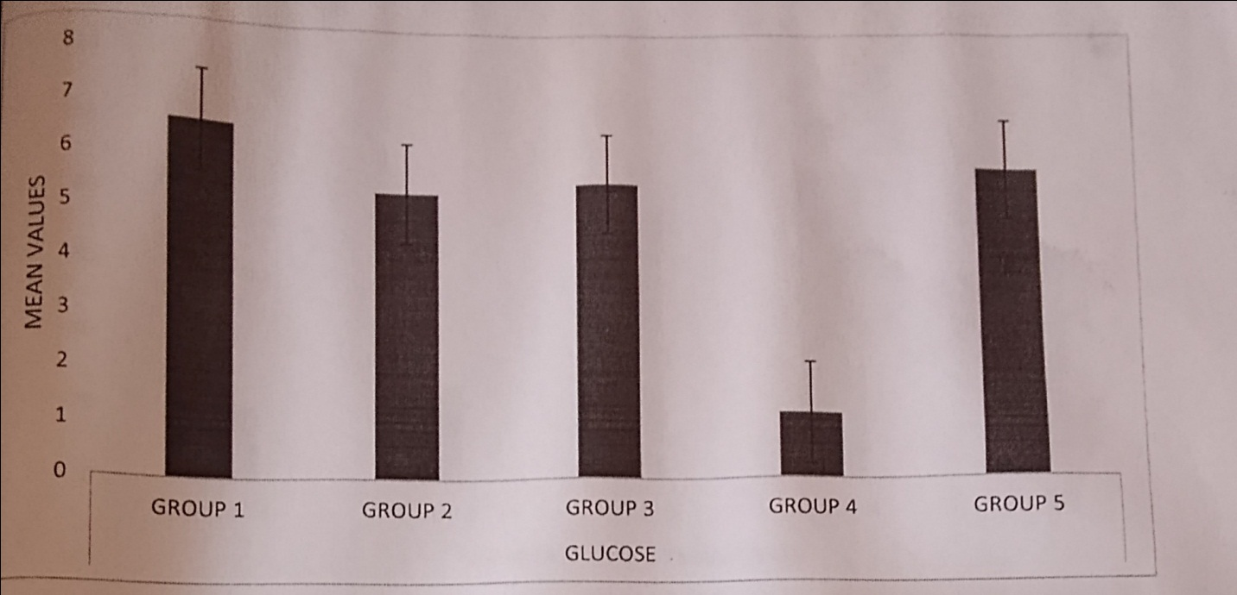
Figure 1 Glucose (GLU)
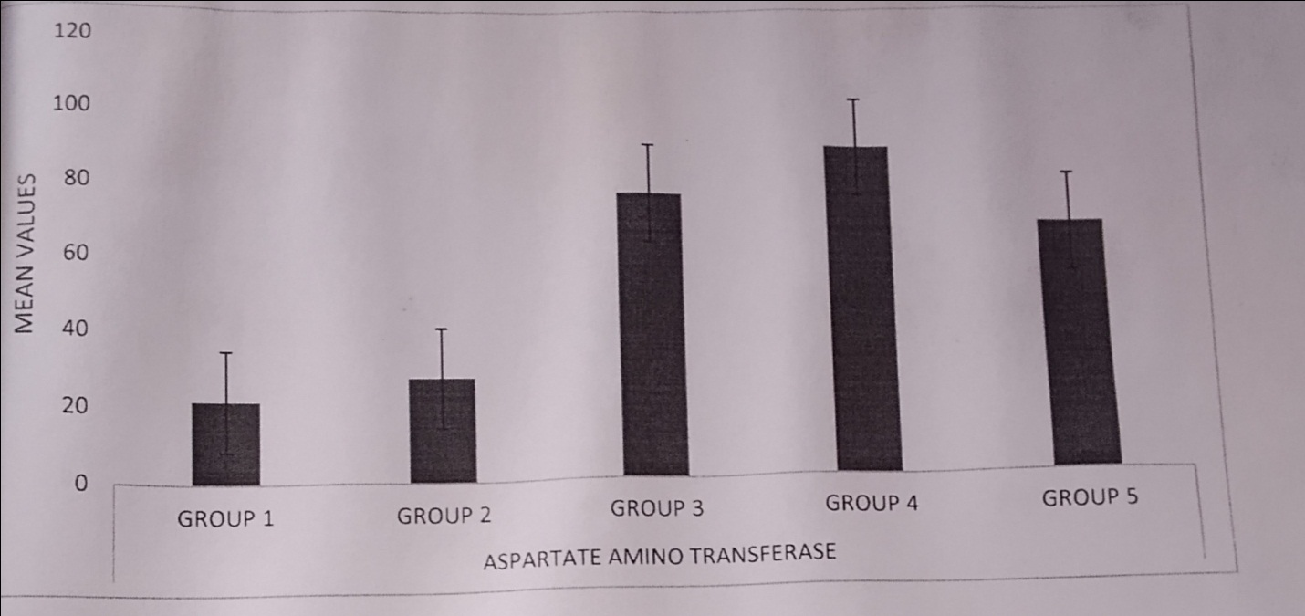
Figure 2 Aspartate Amino Transferase (AST)
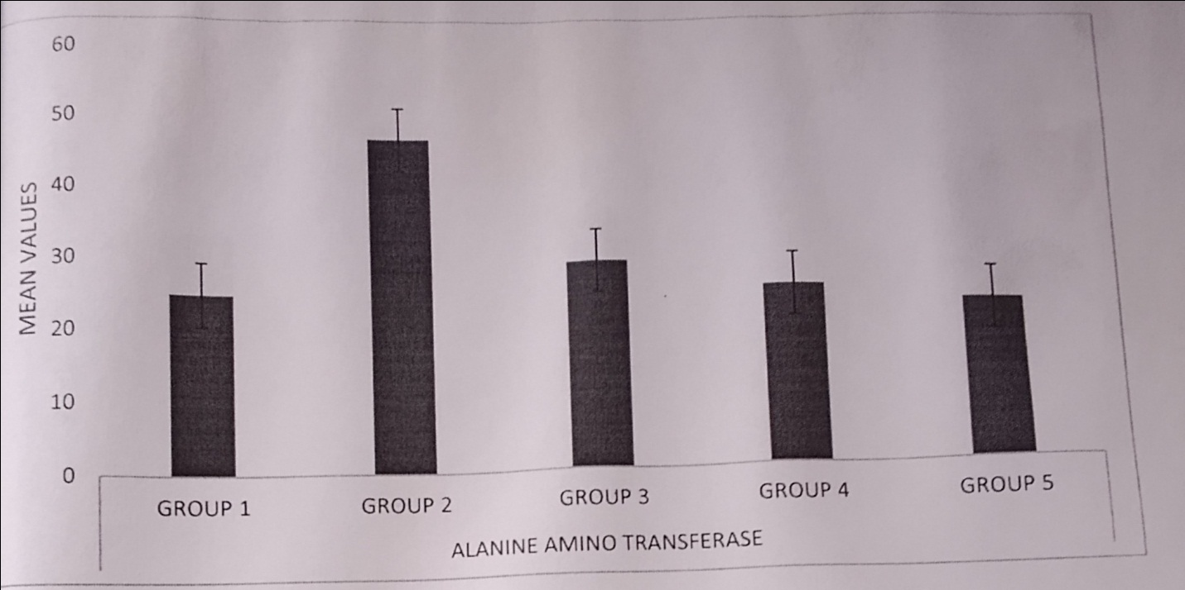
Figure 3 Alanine Aminotransferase (ALT)

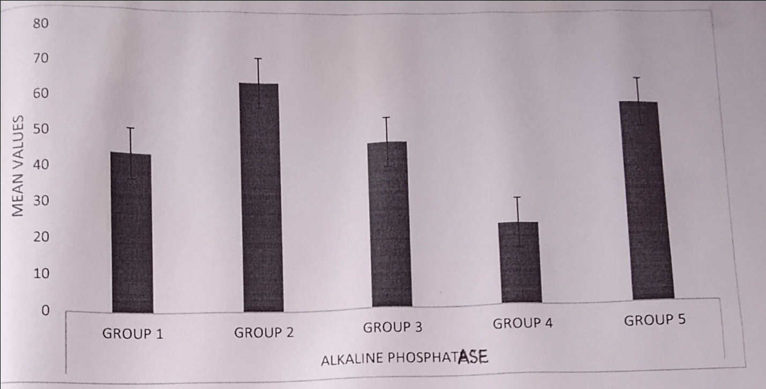
Figure.4 Alkaline Phosphatase (ALP)
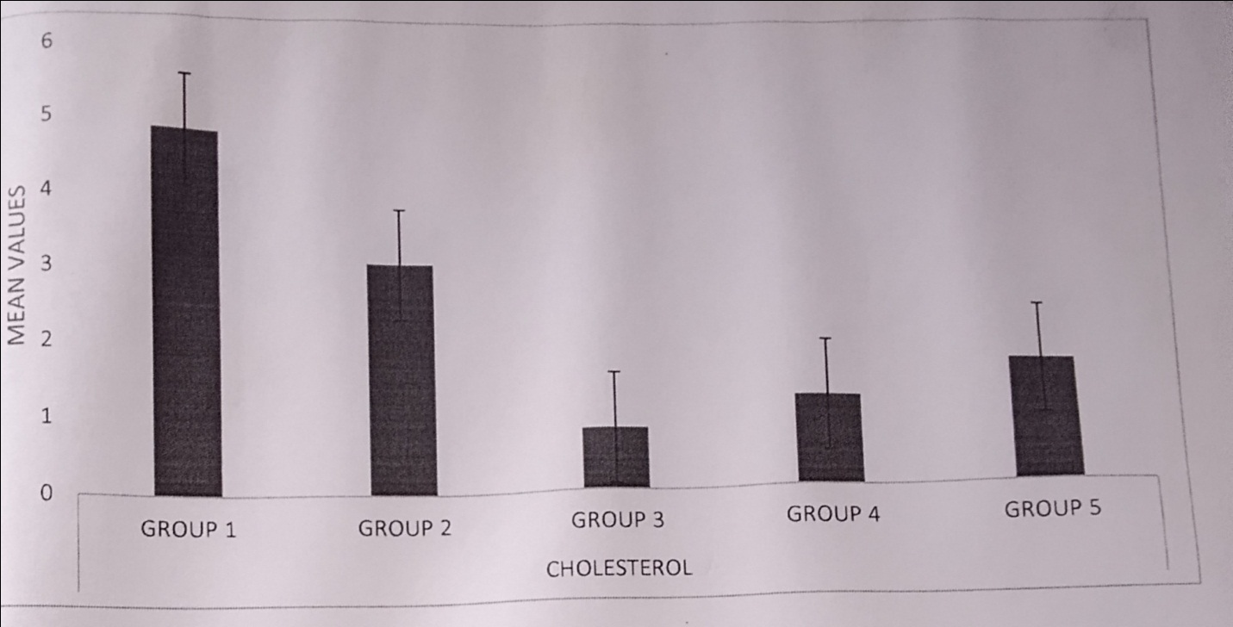
Figure 5 Cholesterol (CHOL)

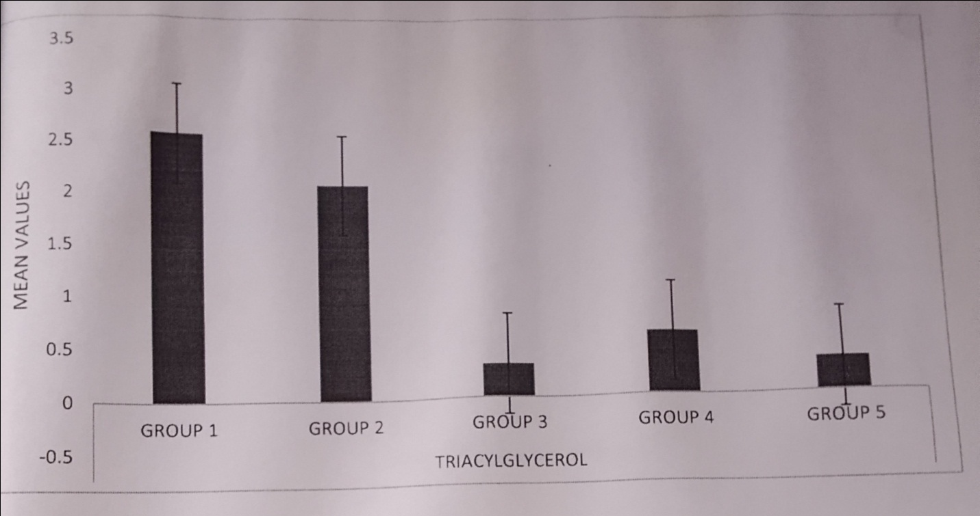
Figure 6 Triacylglycerol (TAG)
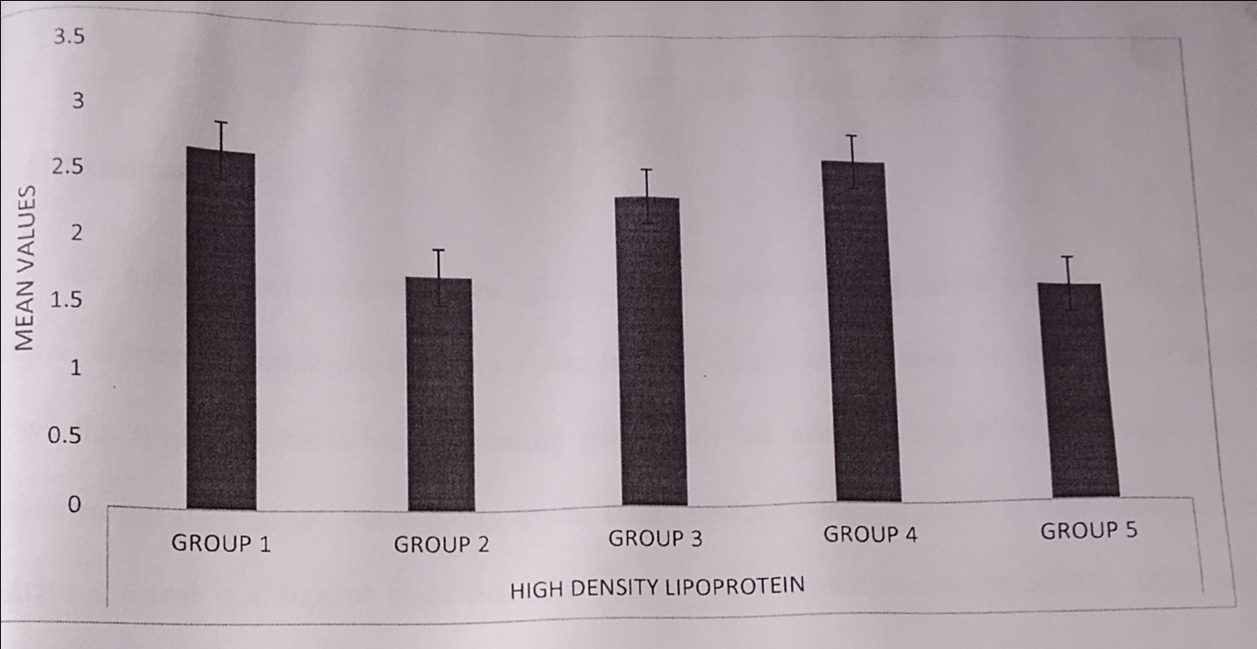
Figure.7 High Density Lipoprotein (HDL)
3.1.1 Histopathology Results
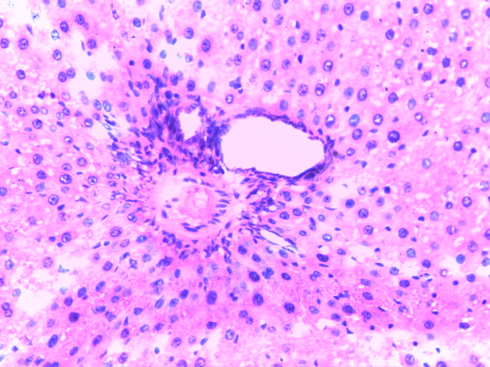

Sections of the liver showing a normal liver architecture
Plate 1 (H & E ×20)
Liver architecture of normal control Wistar rat in group 1 for day 8 (a day after sacrifice).
Histology: Sections of the liver show normal portal tract (blue) and normal hepatocytes (black). Normal liver.

Sections of the liver showing micro and macro lipid vesicles in approximately 90% of hepatocytes
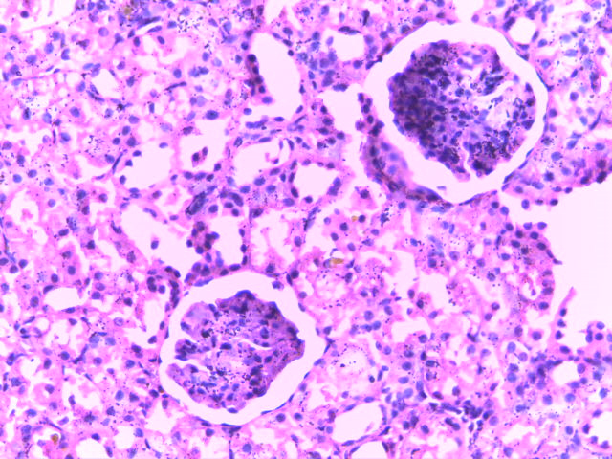
Plate 2 (H & E ×20)
Liver architecture of test control Wistar rat in group 2 for day 8
Histology: Sections of the liver show severe lymphocytic infiltration of the portal tract (blue) and severe hepatic damage (black).
Diagnosis: Severe steatosis

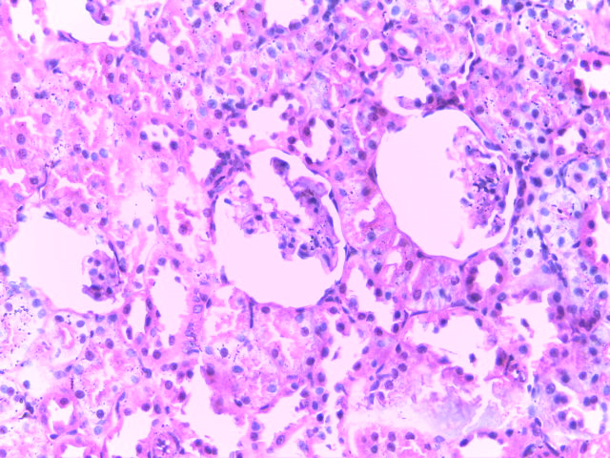
Sections of the liver showing micro and macro lipid vesicles in approximately 50% of hepatocytes
Plate 3 (H & E ×20)
Liver architecture of Wistar rat in group 3 (administered 5% leaves extract) for day 8
Histology: Sections of the liver show moderate lymphocytic infiltration (blue) and moderate hepatic damage (black).
Diagnosis: moderate hepatic damage

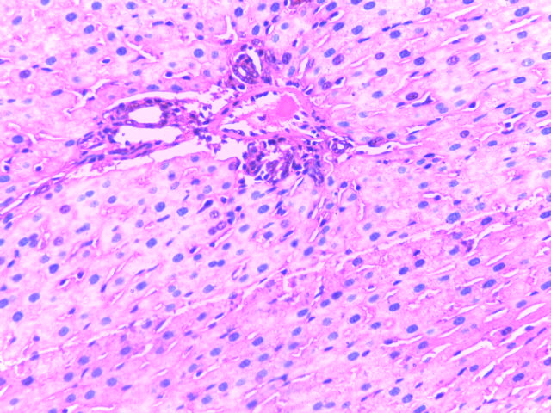
Section of the liver showing mild hepatic damage
Section of the liver showing lipid vesicles in approximately 30% of hepatocytes
Plate 4 (H & E ×20)
Liver architecture of Wistar rat in group 4 (administered 10% leaves extract) for day 8
Histology: Sections of the liver show mild lymphocytic infiltration of the portal tract (blue) and mild hepatic damage (black).
Diagnosis: mild steatosis

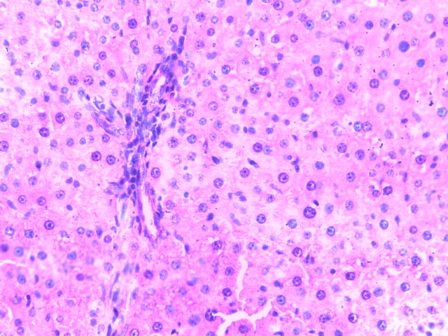
Section of the liver showing normal liver architecture
Section of the liver showing micro and macro lipid vesicles in approximately 10% of hepatocytes
Plate.5 (H & E ×20)
Liver architecture of Wistar rat in group 5 (administered 15% leaves extract) for day 8
Histology: Sections of the liver show mild lymphocytic infiltration of the portal tract (blue) and normal hepatocytes (black)
Diagnosis: mild to apparently normal steatosis

3.2 DISCUSSION
Plants have always been a good source of drugs. Numerous studies have shown that a wide variety of plant extracts are effective in the cardiovascular system according to Deeni and Sadiq (2002).
From the glucose concentration chart, the normal control shows the high concentration of glucose present in the sample while the test control shows high concentration of glucose but slightly lower than that of the normal control as corroborated by McGill (2005). It was also shown that for LDL, the test control levels decreased compared to the levels of the treated groups as corroborated by Stocker and Keaney (2004).
The charts which show the treatments of all parameters carried out. In glucose, there was no significant difference in any treatment. In ALT, normal control is slightly significantly different (P<0.05) to the test control, and treatment three is significantly different from all other treatments while in AST, there was no significant difference between treatment one, treatment two, and treatment three. In comparing the parameters in this group; treatment one, treatment two, and treatment three are significantly different (P<0.05) from the test control and normal control. In cholesterol, TAG, and HDL, there was no significant difference (P<0.05) in any treatment as corroborated by Mosca et al. (2004).
Result from group 4 which was treated with 10% extract concentration was slightly less effective compared to that of group 5 while group 3 treated with 5% extract concentration had a lower effect on the rats.
4. CONCLUSION
The best result was obtained with group 5 which was treated with 15% extract concentration. The combined leaves extract of Carica papaya and Gongronema latifolium has been shown to reverse the toxic effects of CCl₄ on the liver of Wistar rats due to their antioxidant and hepatoprotective effect. Both plants leaves could be used as a potential therapy management due to its ability in ameliorating CCl₄-induced liver damage.
REFERENCES
ALP: The Test - Alkaline Phosphatase (2016). Lab Tests Online, American Association for Clinical Chemistry (AACC), pp. 8-23.
Baker, F. J. & Silverton, R. E. (2005). Introduction to Medical Laboratory Techniques, 7th edition, Butterworts, London. pp. 310-330.
Balogun, M. E., Besong, E. E., Obimma, J. N., Mbamalu, O. S., & Djobissie, S. F. A. (2016). Gongronema latifolium: A Phytochemical, Nutritional and Pharmacological Review. Journal of Physiology and Pharmacology Advances, 6(1), 811-824.
Deeni, Y. Y. & Sadiq., N. M. (2002). Anti-microbial properties phytochemical constituents of the leaves of African Mistletoe (Loranthacea), An ethanomedicinal plant in Hausaland, Northern Nigeria. Journal of Ethnopharmacology, 839(3), 235-240.
Dhruv, L. & Savio, J. (2017). Alkaline Phosphatase. StatPearls, Florida, United States of
America. pp. 9-20.
Doherty, R. E. (2000). A history of the production and use of carbon tetrachloride, tetrachloroethylene, and 1,1,1-trichloroethane in the United States: part 1â€″ historical background; carbon tetrachloride and tetrachloroethylene. Environmental Forensics, 1(2), 934-945.
Gupta, M., Mazumder, U. K., Kumar, S. T., & Gomathi, P. (2004). Antioxidant and hepatoprotective effects of Bauhinia racemosa against paracetamol and carbon tetrachloride induced liver damage in rats. Iran Journal of Pharmacology and Therapeutics, 3, 12-20.
Guyton & Hall (1996). Textbook of Medical Physiology, 9th edition, Saunders, 498-604.
Heywood, V. H., Brummitt, R. K., Culham, A., & Seberg, O. (2007). Flowering plant families of the world. Firefly Books, Buffalo. p. 424.
Ibekwe, S. E.; Uwakwe, A. A. and Monanu, M. O. (2007). In vivo effects of sodium benzoate on plasma aspartate aminotransferase and alkaline phosphatase of Wistar albino rats. Scientific Research and Essay, 2(1), 010-012.
Kaplan, L. A. & Pesce, A. J. (2001). Clinical chemistry. 4th edition. St. Louis, M. O.: Mosby. p. 175.
McGill, J. B. (2005). The Link Between Diabetes & Obesity. American Association of Clinical Endocrinologists. Endocrine, 6(3), 13.
Mosca, L., Appel, L. J., & Benjamin, E. J. (2004). American Heart Association. Evidence-based
guidelines for cardiovascular disease prevention in women. Circulation, 109, 672-693.
Rossetto, M. R. M., Oliveira do Nascimento, J. R., Purgatto, E., Fabi, J. P., Lajolo, F. M., &
Cordenunsi, B. R. (2008). Benzylglucosinolate, Benzylisothiocyanate, and Myrosinase Activity in Papaya fruit during development and ripening. Journal of Agricultural and Food Chemistry, 56(20), 9592-9599.
Seigler, D. S., Pauli, G. F., Nahrstedt, A., & Leen, R. (2002). Cyanogenicallosides and
glucosides from Passifloraedulis and Carica papaya. Phytochemistry, 60(8), 873-882.
Stocker, R. & Keaney, J. F. J. (2004). Role of oxidative modifications in atherosclerosis.
Physiology Review, 84(4), 1381-1478.

APPENDICES
Appendix A Glucose (GLU) and liver enzyme markers (AST, ALT, ALP) levels for all the groups
GROUPS | GLU | AST | ALT | ALP
NORMAL CONTROL | 6.38±0.62ª | 25.00±2.00ª | 25.00±0.00ª | 44.50±3.07ª
TEST CONTROL | 5.43±0.65ª | 28.00±1.00ª | 16.85±11.83^{a,b} | 65.00±9.19^{a,b}
TREATMENT ONE | 3.43±1.48^{a,b} | 86.00±4.51^{b} | 26.33±4.16^{a,b} | 28.67±6.89^{a,b}
TREATMENT TWO | 2.10±0.06^{b} | 86.00±4.16^{b} | 29.00±3.00^{a,b} | 33.67±5.24^{a,b}
TREATMENT THREE | 2.43±0.47^{b} | 85.00±4.51^{b} | 69.67±34.36^{a,b} | 19.33±2.33^{a,b}

Appendix B Lipid profile (CHOL, TAG, HDL, and LDL) levels for all the groups
GROUPS | CHOL | TAG | HDL | LDL
NORMAL CONTROL | 4.88±0.80ª | 2.60±0.30ª | 2.70±0.68ª | 1.03±0.30ª
TEST CONTROL | 3.10±0.20^{a,b} | 2.20±0.32ª | 1.80±0.20ª | 113.25±9.84^{a,b}
TREATMENT ONE | 1.60±0.70^{b} | 1.93±1.14ª | 1.87±0.88ª | 156.67±33.20^{a,b}
TREATMENT TWO | 1.23±0.07^{b} | 0.53±0.09^{b} | 2.97±0.85ª | 222.67±52.11^{a,b}
TREATMENT THREE | 1.23±0.45^{b} | 0.80±0.15^{b} | 2.73±0.58ª | 161.67±24.46^{b}

