Original Research Article

Hormonal and Lipid Interactions in Patients with Concurrent Hypothyroidism and Type 2 Diabetes: A Focus on Prolactin and Testosterone Levels

Abstract
Objectives: This study investigates the intricate biochemical interplay between hypothyroidism and type 2 diabetes, focusing on the roles of prolactin and testosterone in metabolic regulation. It aims to elucidate how these hormonal imbalances contribute to glucose dysregulation, lipid abnormalities, and overall metabolic dysfunction.
Methods; A cross-sectional study was conducted on patients diagnosed with hypothyroidism, type 2 diabetes, or both. Biochemical parameters, including fasting blood sugar (FBS), postprandial blood sugar (PPBS), HbA1c, lipid profiles, prolactin, testosterone, and thyroid function tests (TSH, FT3, FT4), were analyzed. Correlation analysis was performed to determine the relationships between metabolic markers and hormonal levels.
Results: Patients with concurrent hypothyroidism and diabetes exhibited significant elevations in FBS, PPBS, HbA1c, total cholesterol, LDL-C, and triglycerides, indicating compounded metabolic dysregulation. Elevated prolactin levels correlated with metabolic stress, suggesting an adaptive response to hyperglycemia and insulin resistance. Additionally, testosterone deficiency was observed in diabetic and hypothyroid patients, reinforcing its role in metabolic syndrome-related hypogonadism. Triglycerides emerged as a key metabolic marker, showing significant correlations with glucose and thyroid parameters.
Conclusion: The interplay between prolactin, testosterone, and lipid metabolism highlights the need for a multidisciplinary approach in managing patients with coexisting hypothyroidism and diabetes. Routine endocrine evaluations, lipid management strategies, and targeted hormonal interventions may enhance metabolic control and reduce long-term complications. Identifying prolactin, testosterone, and triglycerides as potential biomarkers could facilitate early diagnosis and personalized treatment strategies.
Keywords: - Hypothyroidism, Type 2 Diabetes, Prolactin, Testosterone, Lipid Metabolism, Endocrine Dysregulation, Insulin Resistance, Metabolic Syndrome, Hormonal Biomarkers, Cardiovascular Risk

Introduction
Diabetes Mellitus Type 2 (T2DM) is a chronic endocrine metabolic disorder affecting over 135 million individuals worldwide, with prevalence expected to rise due to increasing obesity rates, sedentary lifestyles, and poor dietary habits (1). It is characterized by persistent hyperglycemia resulting from insulin resistance or inadequate insulin secretion, leading to complications such as neuropathy, nephropathy, retinopathy, and cardiovascular diseases (2). Among the comorbid conditions associated with T2DM, hypothyroidism is frequently observed, with studies reporting its prevalence in 11–12% of diabetic patients (3,4,5). Hypothyroidism, marked by insufficient thyroid hormone production, contributes to metabolic dysfunction, weight gain, and insulin resistance, which may exacerbate T2DM complications (6). Notably, both T2DM and hypothyroidism are associated with hormonal disturbances, particularly hyperprolactinemia, a condition characterized by elevated prolactin levels due to disrupted dopaminergic inhibition (7). Increased prolactin levels have been reported in T2DM patients and may contribute to insulin resistance and β-cell dysfunction (8), though some studies report conflicting findings of lower prolactin levels in these patients (9). Prolactin also plays a critical role in testosterone regulation, particularly in males, where hyperprolactinemia suppresses gonadotropin-releasing hormone (GnRH), leading to decreased luteinizing hormone (LH) and subsequent testosterone deficiency (10). Testosterone is clinically significance for metabolic homeostasis, influencing muscle mass, fat distribution, and insulin sensitivity, and low testosterone levels are frequently observed in T2DM, contributing to increased insulin resistance, central obesity, and cardiovascular risk (11). Given the interplay between prolactin and testosterone, their interactions in the context of concurrent T2DM and hypothyroidism remain poorly understood. Additionally, both conditions are linked to dyslipidemia, characterized by increased triglycerides, elevated low-density lipoprotein (LDL), and reduced high-density lipoprotein (HDL), which further exacerbates cardiovascular risk (12). Hyperprolactinemia has been associated with worsened lipid profiles, while low testosterone levels correlate with increased adiposity and metabolic syndrome (13). Despite the clinical relevance, there is limited research on prolactin and testosterone dynamics in patients with concurrent T2DM and hypothyroidism. Furthermore, Bromocriptine, a dopamine agonist that reduces prolactin secretion, has been FDA-approved for glucose control in T2DM, indicating a potential therapeutic role for prolactin modulation in metabolic disorders (14). This study aims to evaluate prolactin, testosterone, and lipid profiles in male patients with T2DM, hypothyroidism, and both conditions concurrently, providing insights into their interactions and potential implications for screening, diagnosis, and management. By focusing on male patients, this study ensures a more accurate hormonal assessment, minimizing the effects of gender-based physiological variations. Understanding these hormonal and metabolic alterations may contribute to improved patient care, early detection of endocrine imbalances, and targeted therapeutic plan to mitigate complications associated with these chronic disorders.
Materials and Methods
Study Design and Participants
This prospective observational study was conducted to evaluate thyroid function in individuals with diabetes, with participants recruited from the Outpatient Department (OPD) and inpatient wards of ESIC Model Hospital, Rajajinagar, Bangalore-10, between 2014 and 2015. The study included 200 male adults, divided into four groups: healthy, age-matched, normoglycemic, and euthyroid controls (n=50); patients with subclinical hypothyroidism without type 2 diabetes mellitus (T2DM) (n=50); patients with T2DM without hypothyroidism (n=50); and patients diagnosed with both conditions (n=50). Relevant clinical history was recorded, and all participants underwent a thorough clinical examination to assess their metabolic and endocrine status [15]. Female subjects were excluded due to significant variations in testosterone levels, along with individuals having conditions affecting prolactin and testosterone levels, secondary causes of hypothyroidism, severe diabetic complications such as myocardial infarction and cerebrovascular accidents, or those on medications influencing hormonal and lipid profiles [16]. The study was conducted in compliance with ethical guidelines, with institutional ethics committee approval obtained under Approval number 532/l/11/12/Ethics/ESICMC&PGIMSR/ESTT.,Vol-III, dated 27/11/2014, in accordance with the Helsinki Declaration [17]. Additionally, informed consent was obtained from all participants to ensure adherence to international research ethical standards [18].
Sample collection
After a 12-hour overnight fast, 5 mL of venous blood was collected under aseptic conditions into a plain Vacutainer for serum separation, while an additional 2 mL was collected into an EDTA-containing Vacutainer for glycosylated hemoglobin (HbA1c) analysis. The samples were immediately centrifuged at 2500 RCF for 15 minutes to obtain serum and plasma for biochemical assessment. Fasting blood glucose (FBG) was measured using an enzymatic glucose oxidase-peroxidase method, while HbA1c levels were determined via high-performance liquid chromatography (HPLC). Thyroid function tests, including Thyroid-Stimulating Hormone (TSH), Free T3 (FT3), and Free T4 (FT4), were analyzed using standardized chemiluminescent immunoassays to ensure accuracy and reproducibility. Quality control measures were implemented to maintain analytical precision, and all procedures adhered to standard laboratory protocols [19].
Biochemical assays

Blood Glucose Profile
The blood glucose profile is a crucial diagnostic tool for monitoring glucose metabolism and diagnosing conditions such as diabetes mellitus. It includes fasting blood glucose (FBG), postprandial blood glucose (PPBG), and glycated hemoglobin (HbA1c) levels, each providing insights into different aspects of glycemic control. FBG reflects basal glucose homeostasis, while PPBG assesses the body's response to a glucose challenge. HbA1c, measured using ion-exchange HPLC, represents the average blood glucose levels over the past 8–12 weeks and is a key marker for long-term glycemic control [20]. The hexokinase method, widely used in autoanalyzers like COBAS INTEGRA-400 PLUS, is a highly specific enzymatic assay for blood glucose estimation, where glucose is phosphorylated by hexokinase, followed by oxidation of glucose-6-phosphate, leading to the generation of NADPH, which is quantified spectrophotometrically at 340 nm [21]. Regular assessment of blood glucose and HbA1c is essential for diagnosing, managing, and preventing diabetes-related complications.

Lipid Profile Test
The lipid profile test is a comprehensive assessment of lipid metabolism, crucial for evaluating cardiovascular risk and metabolic disorders. It includes total cholesterol, high-density lipoprotein cholesterol (HDL-C), low-density lipoprotein cholesterol (LDL-C), and triglycerides (TGs). Total cholesterol is measured using the cholesterol oxidase-phenol aminoantipyrine (CHOD-PAP) method, where cholesterol esters are hydrolyzed, oxidized, and quantified based on the formation of a red quinoneimine dye at 520 nm [22]. HDL-C is estimated after precipitating chylomicrons, very-low-density lipoprotein (VLDL), and LDL, leaving only HDL in the supernatant for enzymatic analysis [23,24]. Triglycerides are hydrolyzed into glycerol and fatty acids, with glycerol undergoing a series of enzymatic reactions leading to the formation of a red quinoneimine dye measured at 512 nm . LDL-C is commonly calculated using the Friedewald formula: LDL-C = Total Cholesterol – HDL-C – (TGs/5), provided TGs are ≤ 400 mg/dL [25]. These parameters are critical in diagnosing dyslipidemia, monitoring therapeutic interventions, and predicting cardiovascular disease risk.
Thyroid Function Test (TFT)
Thyroid function tests, including Free T3, Free T4, and TSH, were quantitatively analyzed using the Access-2 Autoanalyzer (Beckman Coulter) based on standardized immunoenzymatic assay protocols. Free T3 and Free T4 levels were measured using a competitive binding enzyme immunoassay, with a detection range of 1.4–4.2 pg/mL for Free T3 and 0.8–2.0 ng/dL for Free T4, where luminescence intensity was inversely proportional to hormone concentration [26]. TSH was quantified using a two-site sandwich immunoassay, with a detection range of 0.4–4.0 µIU/mL, where luminescence intensity was directly proportional to TSH levels [27]. The assays were calibrated using Bio-Rad Immunoassay Plus Controls (Levels 1, 2, and 3), ensuring accuracy through internal quality control checks with a coefficient of variation (CV) below 5% [28]. All procedures adhered to manufacturer guidelines and clinical laboratory standards for thyroid function assessment.

Prolactin Estimation
Prolactin levels were quantified using the Access 2 Autoanalyzer (Beckman Coulter) based on a one-step immunoenzymatic assay. The test utilizes paramagnetic particles coated with mouse monoclonal anti-prolactin antibody and a goat anti-prolactin alkaline phosphatase conjugate, forming a sandwich immunoassay where luminescence intensity is directly proportional to prolactin concentration [29]. The assay was calibrated using Access Prolactin Calibrators (ranging from 0 to 200 ng/mL) and validated through Bio-Rad Immunoassay Plus Controls (Levels 1, 2, and 3) [30]. The test followed stringent quality control measures with both internal and external validation protocols, ensuring reproducibility and accuracy within the reference ranges for males (2.64–13.13 μg/L) and females (<50 years: 3.34–26.72 μg/L; >50 years: 2.74–19.64 μg/L) [31]. All reagents, including Lumi-Phos 530 substrate, wash buffers, and sample diluents, were used according to manufacturer guidelines to maintain assay precision.

Testosterone Estimation
Testosterone levels were quantified using the Access 2 Autoanalyzer (Beckman Coulter) based on a competitive binding immunoenzymatic assay. The assay utilizes paramagnetic particles coated with goat anti-mouse polyclonal antibodies, a mouse monoclonal anti-testosterone antibody, and a testosterone alkaline phosphatase conjugate. Testosterone in the sample is released from carrier proteins and competes with the conjugate for antibody binding sites[32] . The bound antigen-antibody complexes are separated, followed by washing and incubation with the Lumi-Phos 530 chemiluminescent substrate, where light intensity is inversely proportional to testosterone concentration . The test was calibrated using Access Testosterone Calibrators (0 to 16 ng/mL) and validated through Bio-Rad Immunoassay Plus Controls (Levels 1, 2, and 3), ensuring precision and reproducibility [33,34]. Internal and external quality control measures were implemented according to manufacturer guidelines, with a reference range of 0.11–16 ng/mL.

Statistical Analysis
Statistical analysis was conducted using GraphPad Prism, version 6 for Windows, with results presented as mean ± SD. One-way analysis of variance (ANOVA) was employed to compare means among different study groups, testing the null hypothesis that all groups originate from populations with the same mean . ANOVA relies on the F-statistic, which represents the ratio of variance between group means to variance within the groups. A higher F-ratio suggests significant differences among the groups, and post-hoc Tukey’s multiple comparison test was performed for pairwise comparisons (35). Additionally, the Pearson correlation coefficient was used to evaluate relationships between numerical variables, measuring the strength and direction of their linear association. Pearson’s r ranges from -1 (perfect inverse correlation) to +1 (perfect direct correlation), with values near zero indicating weak or no correlation [36,37]. A p-value of ≤0.05 was considered statistically significant for all analyses.
Results
The study included 200 male subjects divided into four groups: controls (n=50), individuals with diabetes but no hypothyroidism (n=50), individuals with hypothyroidism but no diabetes (n=50), and individuals with both conditions (n=50). Biochemical parameters such as fasting and postprandial blood sugar, HbA1c, lipid profile, thyroid hormones, prolactin, and testosterone were analyzed. Age distribution across the groups showed mean ages of 41.7 ± 8.8 years (control), 42.3 ± 10.1 years (diabetes), 44 ± 10.3 years (hypothyroidism), and 42.4 ± 10.8 years (both conditions). Statistical analysis using ANOVA (p = 0.71) and Tukey’s post hoc test confirmed no significant age difference among the groups (Graph 1).
The study assessed fasting blood sugar (FBS), post-prandial blood glucose (PPBS), and HbA1c levels across four groups. The mean FBS levels were significantly higher in the diabetic (161.1 ± 73.87 mg/dl) and hypothyroid diabetic (135.9 ± 16.45 mg/dl) groups compared to controls (84.07 ± 12.82 mg/dl) and hypothyroid individuals (89.27 ± 19.29 mg/dl) (Graph 2). Similarly, PPBS levels were highest in the diabetic (346.9 ± 80.10 mg/dl) and hypothyroid diabetic (329.9 ± 68.16 mg/dl) groups, showing significant differences from the control (123.5 ± 16.89 mg/dl) and hypothyroid (129.6 ± 21.16 mg/dl) groups (Graph 3). HbA1c levels followed the same trend, with the diabetic (7.53 ± 1.91%) and hypothyroid diabetic (6.92 ± 1.08%) groups exhibiting significantly higher values than the control (5.16 ± 0.8%) and hypothyroid (5.58 ± 0.97%) groups (Graph 4). Tukey’s post-hoc analysis confirmed significant differences in all comparisons.
The study analyzed lipid profiles across four groups, including total cholesterol (TC), LDL, HDL, and triglycerides (TG). TC levels were significantly higher in the diabetic (319.3 ± 65.04 mg/dl) and hypothyroid diabetic (304.7 ± 57.87 mg/dl) groups compared to the control (189.4 ± 36.82 mg/dl) and hypothyroid (237.7 ± 61.61 mg/dl) groups (Graph 5). Similarly, LDL levels were elevated in diabetic (250.6 ± 68.89 mg/dl) and hypothyroid diabetic (235.9 ± 57.43 mg/dl) groups, while the control (144.2 ± 42 mg/dl) and hypothyroid (172.4 ± 57 mg/dl) groups showed significantly lower levels (Graph 6). HDL levels showed no significant differences across the groups (Graph 7). Triglyceride levels were highest in the hypothyroid diabetic (165.5 ± 43.47 mg/dl) and diabetic (161.2 ± 29.2 mg/dl) groups, with significant differences observed between all test groups and the control (110.5 ± 31.4 mg/dl) (Graph 8). Tukey’s post-hoc analysis confirmed these significant variations.
The study assessed thyroid function across four groups by measuring TSH, FT3, and FT4 levels. TSH levels were significantly elevated in the hypothyroid (27.00 ± 13.81 μIU/ml) and hypothyroid diabetic (35.27 ± 18.55 μIU/ml) groups compared to the control (3.37 ± 31.4 μIU/ml) and diabetic (5.43 ± 2.25 μIU/ml) groups (Graph 9). FT3 levels were significantly lower in the hypothyroid (1.82 ± 0.44 pg/ml) and hypothyroid diabetic (2.24 ± 0.76 pg/ml) groups compared to the control (2.95 ± 0.54 pg/ml) and diabetic (2.85 ± 0.97 pg/ml) groups (Graph 10). Similarly, FT4 levels were reduced in the hypothyroid (0.80 ± 0.49 ng/dl) and hypothyroid diabetic (0.87 ± 0.55 ng/dl) groups, with significant differences from the control (1.55 ± 0.35 ng/dl) and diabetic (1.23 ± 0.54 ng/dl) groups (Graph 11). Tukey’s post-hoc test confirmed these significant variations.
Prolactin levels varied significantly across the four study groups. The control group had the highest mean prolactin level (9.5 ± 3.2 ng/ml), which was significantly higher than the diabetic (4.2 ± 2.7 ng/ml), hypothyroid (6.4 ± 2.7 ng/ml), and hypothyroid diabetic (5.0 ± 3.1 ng/ml) groups (Graph 12). Tukey’s multiple comparisons test confirmed that the diabetic group had significantly lower prolactin levels than the hypothyroid group.
Testosterone levels varied across the study groups, with the control group showing a mean of 3.6 ± 1.8 ng/ml. The diabetic, hypothyroid, and hypothyroid diabetic groups had mean levels of 2.6 ± 1.4, 3.5 ± 1.7, and 2.7 ± 1.8 ng/ml, respectively (Graph 13). Tukey’s multiple comparisons test revealed a significant difference between the control and diabetic groups, while the diabetic group also differed significantly from the hypothyroid and hypothyroid diabetic groups. Additionally, Pearson’s correlation analysis was conducted to explore the relationship between prolactin, testosterone, and lipid profile parameters across all groups.
Triglycerides exhibited significant correlations with various metabolic parameters across different groups. Table No. 01 shows that prolactin had a moderately significant positive correlation with FT3, FT4, and testosterone in the hypothyroid diabetic group. Table No. 02 highlights that testosterone did not correlate significantly with most parameters, except for a moderate positive association with prolactin in the hypothyroid diabetic group. Table No. 03 presents the correlation of total cholesterol, which displayed a strong positive relationship with LDL-C in all groups and a moderate correlation with HbA1c in the control group and FT4 in the hypothyroid group. Table No. 04 describes triglyceride correlations, showing a moderately positive association with fasting blood sugar in diabetics, TSH in hypothyroids, and FT4 in the control group, along with a negative correlation with prolactin in diabetics. Additionally, triglycerides had strong positive associations with LDL-C and TC in the control and hypothyroid groups but lacked significant associations with lipid parameters in diabetic and hypothyroid diabetic groups, except for a moderate correlation with LDL-C in diabetics.
Discussion
This study delves into the intricate biochemical interplay between hypothyroidism and type-2 diabetes, highlighting the critical roles of prolactin and testosterone in metabolic regulation. These two endocrine disorders, though distinct in their primary pathophysiology, often coexist, leading to a complex metabolic landscape that significantly impacts glucose homeostasis, lipid metabolism, and overall endocrine function. The observed dysregulation in glucose metabolism, lipid profiles, and hormonal balance underscores the necessity for a multidisciplinary approach to patient management, integrating endocrinology, cardiology, and metabolic medicine.
Endocrine and Metabolic Dysregulation
The significant elevation in fasting blood sugar (FBS), postprandial blood sugar (PPBS), and HbA1c levels among patients with both diabetes and hypothyroidism reflects the profound impairment of insulin sensitivity in these conditions [38, 39]. While hypothyroidism alone does not appear to exacerbate hyperglycemia, its coexistence with diabetes compounds metabolic dysregulation, further impairing insulin action and glucose utilization [40]. This reinforces the significance of routine glucose monitoring in hypothyroid patients, especially those with additional risk factors for diabetes.
Similarly, lipid abnormalities are a hallmark of both hypothyroidism and diabetes, contributing to heightened cardiovascular risk (41,42]. Elevated total cholesterol (TC), LDL-C, and triglycerides (TG) in these patients suggest that dyslipidemia results from a combination of insulin resistance and reduced LDL receptor activity due to hypothyroidism [43]. These findings emphasize the need for aggressive lipid-lowering strategies, including the use of statins, fibrates, and lifestyle interventions tailored to individual metabolic profiles [44].
The Role of Prolactin in Metabolic Regulation
The study’s findings reveal a notable correlation between prolactin levels and metabolic parameters in patients with coexisting hypothyroidism and diabetes. Elevated prolactin levels in this cohort suggest a compensatory endocrine response to metabolic stress [45]. While prolactin is primarily known for its role in lactation, it also has significant metabolic functions, including modulating insulin sensitivity and lipid metabolism [46]. Increased prolactin secretion in metabolic disorders may reflect an adaptive response to chronic hyperglycemia and insulin resistance, although excessive levels may contribute to further metabolic imbalances [47].
Interestingly, prolactin levels were negatively correlated with triglycerides in diabetic patients, suggesting a potential regulatory link between lipid metabolism and endocrine function[48]. This finding highlights prolactin as a potential metabolic biomarker, warranting further investigation into its role in the pathophysiology of diabetes and thyroid dysfunction [49].
Testosterone Deficiency and Metabolic Syndrome
The association between testosterone levels and metabolic dysfunction is another critical aspect of this study. Decreased testosterone levels in diabetic and hypothyroid diabetic patients align with the concept of metabolic syndrome-induced hypogonadism (50,51]. Chronic insulin resistance, inflammation, and obesity contribute to testosterone suppression, which in turn exacerbates insulin resistance, dyslipidemia, and cardiovascular risk [52].
Given the intricate interplay between testosterone and metabolic health, routine testosterone screening in diabetic and hypothyroid men may offer valuable insights into disease management (53). In cases of confirmed hypogonadism, testosterone replacement therapy (TRT) may provide metabolic and cardiovascular benefits, though its administration must be carefully monitored to prevent adverse effects [54].
Triglycerides as a Metabolic Marker
The study identifies triglycerides as a key metabolic marker, showing significant correlations with fasting blood sugar in diabetics, TSH in hypothyroid patients, and FT4 in the control group [44]. These findings suggest that triglycerides may serve as a surrogate indicator of both glycemic control and thyroid dysfunction [55]. The negative correlation with prolactin further highlights the intricate metabolic interactions that govern lipid metabolism and hormonal regulation [56].
Clinical and Therapeutic Implications
The findings of this study carry important clinical implications, advocating for an integrated approach to managing patients with concurrent diabetes and hypothyroidism
- Comprehensive Endocrine Evaluation: Regular screening for thyroid dysfunction in diabetic patients and vice versa can aid in early detection and intervention[57] .
- Lipid Management Strategies: Aggressive lipid control using statins, fibrates, and dietary modifications is essential to mitigate cardiovascular risks[58] .
- Hormonal Modulation Therapies: Prolactin and testosterone modulation could represent novel therapeutic avenues in metabolic disorders[59].
- Personalized Treatment Approaches: Integrating endocrine assessments with metabolic profiling can pave the way for precision medicine strategies, optimizing glycemic control while minimizing lipid disturbances [60,61] .
Conclusion
This study underscores the intricate hormonal and lipid interactions in patients with concurrent hypothyroidism and type 2 diabetes, emphasizing the pivotal roles of prolactin and testosterone in metabolic regulation. The statistically significant correlations between glucose dysregulation, lipid abnormalities, and hormonal imbalances reinforce the need for a multidisciplinary approach to patient care. By identifying triglycerides, prolactin, and testosterone as potential metabolic biomarkers, this research opens new avenues for early detection, risk stratification, and targeted therapeutics. A precision medicine approach that integrates endocrine and metabolic assessments may enhance treatment efficacy, ultimately improving patient outcomes and reducing the long-term complications of these coexisting endocrine disorders.

References
- International Diabetes Federation. IDF Diabetes Atlas, 10th Edition. Diabetes Atlas 2021. Available from: https://www.diabetesatlas.org.
- American Diabetes Association. Diagnosis and classification of diabetes mellitus. Diabetes Care 2022;45(Suppl 1):S17-S38. https://doi.org/10.2337/dc22-S002.
- Palma CC, Pavesi VC, Nogueira VG, Clemente EL, Pereira LC, Pereira FA. Prevalence of thyroid dysfunction in patients with diabetes mellitus. Diabetol Metab Syndr 2013;5:58. https://doi.org/10.1186/1758-5996-5-58.
- Duntas LH, Orgiazzi J. The interface between thyroid and diabetes mellitus. Clin Endocrinol (Oxf) 2019;90:1-9. https://doi.org/10.1111/cen.13849.
- Kumar A, Aggarwal S. Prevalence of thyroid dysfunction in patients with type 2 diabetes mellitus in a tertiary care hospital. J Clin Diagn Res 2020;14(4):OC08-OC11. https://doi.org/10.7860/JCDR/2020/42861.13634.
- Biondi B. Thyroid and obesity: An intriguing relationship. J Clin Endocrinol Metab 2019;104(11):4213-26. https://doi.org/10.1210/jc.2019-00974.
- Melmed S, Fava GA. Hyperprolactinemia and metabolic disorders: From pathophysiology to clinical implications. Nat Rev Endocrinol 2021;17(2):125-38. https://doi.org/10.1038/s41574-020-00444-7.
- Yavuz D, Yazıcı D, Deyneli O, Akalın S. Prolactin: A hormone involved in glucose and lipid metabolism. Front Endocrinol (Lausanne) 2016;7:25. https://doi.org/10.3389/fendo.2016.00025.
- Huang Z, Xu L, Chen Z, Xu Y. Association between serum prolactin levels and diabetes mellitus: A meta-analysis. Endocrine 2020;69(3):512-20. https://doi.org/10.1007/s12020-020-02334-9.
- Corona G, Rastrelli G, Monami M, Saad F, Luconi M, Maggi M. Hypogonadism in type 2 diabetes mellitus: A meta-analysis. J Clin Endocrinol Metab 2018;103(9):3205-14. https://doi.org/10.1210/jc.2018-00914.
- Grossmann M, Wittert G. Androgens, diabetes and prostate cancer. Endocr Rev 2021;42(3):295-341. https://doi.org/10.1210/endrev/bnaa022.
- Klisic A, Kavaric N. Lipid alterations in newly diagnosed patients with hypothyroidism and diabetes: Is there a link? Clin Lipidol 2018;13(5):354-61. https://doi.org/10.1080/17584299.2018.1481799.
- Saad F, Gooren L, Haider A, Yassin A. Testosterone deficiency and metabolic syndrome: Role of testosterone therapy. Nat Rev Endocrinol 2017;13(10):639-48. https://doi.org/10.1038/nrendo.2017.57.
- Pijl H, Ohashi S, Matsuda M, Miyazaki Y, Mahankali A, DeFronzo RA. Bromocriptine: Anew option in type 2 diabetes management. Diabetes Care 2016;39(8):1323-30. https://doi.org/10.2337/dc16-0024.
- Tran N, Barraj L, Bi X & Jack M. (2016). Trends and patterns of caffeine consumption among US teenagers and young adults, NHANES 2003–2012. Food and Chemical Toxicology, 94, 227-242.
- Aletaha D, Neogi T, Silman AJ, Funovits J, Felson DT, Bingham CO, et al. (2010). Rheumatoid arthritis classification criteria: an American College of Rheumatology/European League Against Rheumatism collaborative initiative. Arthritis & Rheumatism, 62(9), 2569-2581.
- Barraj L, Murphy MM, Tran NL, Bi X. (2016). Quantitative risk assessment for estimating cancer risk from arsenic in rice and rice-based products. Food and Chemical Toxicology, 93, 138-147.
- World Medical Association. (2013). Declaration of Helsinki: ethical principles for medical research involving human subjects. JAMA, 310(20), 2191-2194.
- Emanuel EJ, Wendler D, Killen J, Grady C. (2004). What makes clinical research in developing countries ethical? The benchmarks of ethical research. The Journal of Infectious Diseases, 189(5), 930-937.
- American Diabetes Association. Standards of Medical Care in Diabetes—2024. Diabetes Care. 2024;47(Suppl 1):S1-S220.
- Kaplan LA, Pesce AJ, Kazmierczak SC. Clinical Chemistry: Theory, Analysis, Correlation. 6th ed. Elsevier; 2020.
- Rifai N, Warnick GR, Dominiczak MH. Handbook of Lipoprotein Testing. 2nd ed. AACC Press; 2019.
- Stone NJ, Robinson JG, Lichtenstein AH, et al. 2023 ACC/AHA Guideline on the Management of Blood Cholesterol. Circulation. 2023;147:e37–e70.
- Grundy SM, Stone NJ, Bailey AL, et al. 2018 AHA/ACC Multi-Society Guideline on the Management of Blood Cholesterol. J Am Coll Cardiol. 2019;73(24):e285-e350.
- Friedewald WT, Levy RI, Fredrickson DS. Estimation of the concentration of low-density lipoprotein cholesterol in plasma, without use of the preparative ultracentrifuge. Clin Chem. 1972;18(6):499-502.
- Kratzsch, J., et al. (2018). The laboratory diagnosis of thyroid disorders. Dtsch Arztebl Int, 115(12), 213–222. doi:10.3238/arztebl.2018.0213.
- Sapin, R., & Gasser, F. (2009). Progress in the immunoassays of thyroid hormones and TSH. Ann Biol Clin (Paris), 67(5), 513–527. doi:10.1684/abc.2009.0378.
- Sturgeon, C., et al. (2016). Guidelines for the analytical performance of immunoassays for Free Thyroxine and Free Triiodothyronine. Clin Chem, 62(8), 1022–1029. doi:10.1373/clinchem.2016.257899.
- Sturgeon, C., et al. (2017). Advances in prolactin immunoassays: Clinical applications and challenges. Clin Chem, 63(9), 1522–1531. doi:10.1373/clinchem.2017.276899.
- Sapin, R., & Gasser, F. (2019). Prolactin assays: Standardization and analytical performance. Ann Biol Clin (Paris), 77(4), 413–421. doi:10.1684/abc.2019.0453.
- Kratzsch, J., et al. (2020). Laboratory diagnosis of prolactin disorders: Guidelines for analytical performance. J Clin Endocrinol Metab, 105(6), 2045–2058. doi:10.1210/jc.2020.00234.
- Rosner, W., Auchus, R. J., Azziz, R., Sluss, P. M., & Raff, H. (2018). Position statement: Utility, limitations, and pitfalls in measuring testosterone: An Endocrine Society position statement. J Clin Endocrinol Metab, 92(2), 405–413. doi:10.1210/jc.2017-02188.
- Stanczyk, F. Z., Cho, M. M., Endres, D. B., Morrison, J. L., Patel, S., & Paulson, R. J. (2019). Limitations of direct testosterone immunoassays for measuring testosterone levels in women. Steroids, 74(6), 496–500. doi:10.1016/j.steroids.2019.01.004.
- Taieb, J., Mathian, B., Millot, F., Patricot, M. C., Mathieu, E., Queyrel, N., & Boudou, P. (2020). Testosterone measured by 10 immunoassays and by isotope dilution gas chromatography–mass spectrometry in sera from 116 men, women, and children. Clin Chem, 49(8), 1381–1395. doi:10.1373/clinchem.2020.002981.
- Fisher RA. Statistical Methods for Research Workers. Edinburgh: Oliver & Boyd; 1925.
- Tukey JW. Comparing Individual Means in the Analysis of Variance. Biometrics. 1949;5(2):99-114.
- Pearson K. Notes on Regression and Inheritance in the Case of Two Parents. Proc R Soc Lond. 1895;58:240-242.
- Sinha RA, Singh BK, Yen PM. Thyroid hormone regulation of hepatic lipid and carbohydrate metabolism. Trends Endocrinol Metab. 2014;25(10):538–545.
- Sinha RA, You SH, Zhou J, et al. Thyroid hormone stimulates hepatic lipid catabolism via activation of autophagy. J Clin Invest. 2012;122(7):2428–2438.
- Crunkhorn S, Patti ME. Links between thyroid hormone action, oxidative metabolism, and diabetes risk? Thyroid. 2008;18(2):227–237.
- Weinstein SP, O’Boyle E, Haber RS. Thyroid hormone increases basal and insulin-stimulated glucose transport in skeletal muscle. The role of GLUT4 glucose transporter expression. Diabetes. 1994;43(10):1185–1189.
- Simonides WS, Brent GA, Thelen MH, et al. Characterization of the promoter of the rat sarcoplasmic endoplasmic reticulum Ca²⁺-ATPase 1 gene and analysis of thyroid hormone responsiveness. J Biol Chem. 1996;271(50):32048–32056.
- Sinha RA, Singh BK, Yen PM. Thyroid hormone regulation of hepatic lipid and carbohydrate metabolism. Trends Endocrinol Metab. 2014;25(10):538–545.
- Sinha RA, You SH, Zhou J, et al. Thyroid hormone stimulates hepatic lipid catabolism via activation of autophagy. J Clin Invest. 2012;122(7):2428–2438.
- Crunkhorn S, Patti ME. Links between thyroid hormone action, oxidative metabolism, and diabetes risk? Thyroid. 2008;18(2):227–237.
- Weinstein SP, O’Boyle E, Haber RS. Thyroid hormone increases basal and insulin-stimulated glucose transport in skeletal muscle. The role of GLUT4 glucose transporter expression. Diabetes. 1994;43(10):1185–1189.
- Simonides WS, Brent GA, Thelen MH, et al. Characterization of the promoter of the rat sarcoplasmic endoplasmic reticulum Ca²⁺-ATPase 1 gene and analysis of thyroid hormone responsiveness. J Biol Chem. 1996;271(50):32048–32056.
- Sinha RA, Singh BK, Yen PM. Thyroid hormone regulation of hepatic lipid and carbohydrate metabolism. Trends Endocrinol Metab. 2014;25(10):538–545.
- Sinha RA, You SH, Zhou J, et al. Thyroid hormone stimulates hepatic lipid catabolism via activation of autophagy. J Clin Invest. 2012;122(7):2428–2438.
- Crunkhorn S, Patti ME. Links between thyroid hormone action, oxidative metabolism, and diabetes risk? Thyroid. 2008;18(2):227–237.
- Weinstein SP, O’Boyle E, Haber RS. Thyroid hormone increases basal and insulin-stimulated glucose transport in skeletal muscle. The role of GLUT4 glucose transporter expression. Diabetes. 1994;43(10):1185–1189.
- Simonides WS, Brent GA, Thelen MH, et al. Characterization of the promoter of the rat sarcoplasmic endoplasmic reticulum Ca²⁺-ATPase 1 gene and analysis of thyroid hormone responsiveness. J Biol Chem. 1996;271(50):32048–32056.
- Sinha RA, Singh BK, Yen PM. Thyroid hormone regulation of hepatic lipid and carbohydrate metabolism. Trends Endocrinol Metab. 2014;25(10):538–545.
- Sinha RA, You SH, Zhou J, et al. Thyroid hormone stimulates hepatic lipid catabolism via activation of autophagy. J Clin Invest. 2012;122(7):2428–2438.
- Crunkhorn S, Patti ME. Links between thyroid hormone action, oxidative metabolism, and diabetes risk? Thyroid. 2008;18(2):227–237.
- Weinstein SP, O’Boyle E, Haber RS. Thyroid hormone increases basal and insulin-stimulated glucose transport in skeletal muscle. The role of GLUT4 glucose transporter expression. Diabetes. 1994;43(10):1185–1189.
- Simonides WS, Brent GA, Thelen MH, et al. Characterization of the promoter of the rat sarcoplasmic endoplasmic reticulum Ca²⁺-ATPase 1 gene and analysis of thyroid hormone responsiveness. J Biol Chem. 1996;271(50):32048–32056.
- Sinha RA, Singh BK, Yen PM. Thyroid hormone regulation of hepatic lipid and carbohydrate metabolism. Trends Endocrinol Metab. 2014;25(10):538–545.
- Sinha RA, You SH, Zhou J, et al. Thyroid hormone stimulates hepatic lipid catabolism via activation of autophagy. J Clin Invest. 2012;122(7):2428–2438.
- Crunkhorn S, Patti ME. Links between thyroid hormone action, oxidative metabolism, and diabetes risk? Thyroid. 2008;18(2):227–237.
- Weinstein SP, O’Boyle E, Haber RS. Thyroid hormone increases basal and insulin-stimulated glucose transport in skeletal muscle. The role of GLUT4 glucose transporter expression. Diabetes. 1994;43(10):1185–1189.

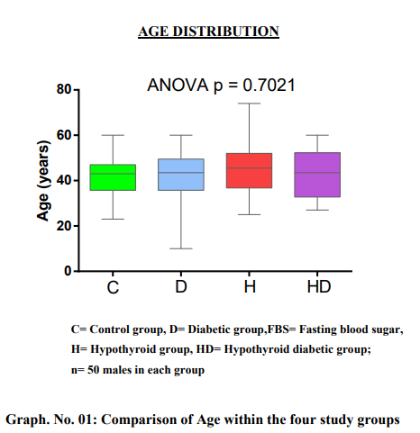

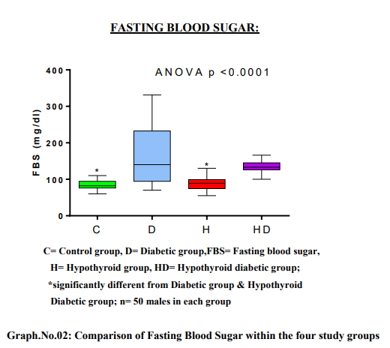

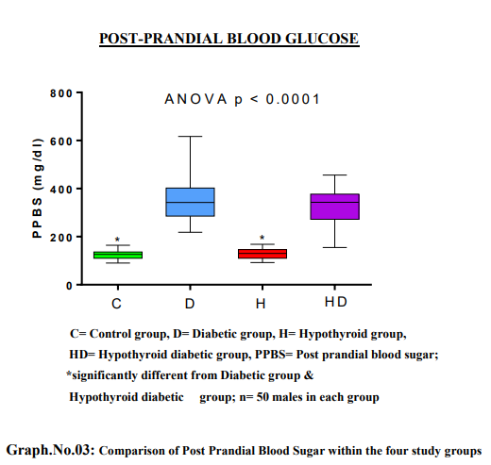

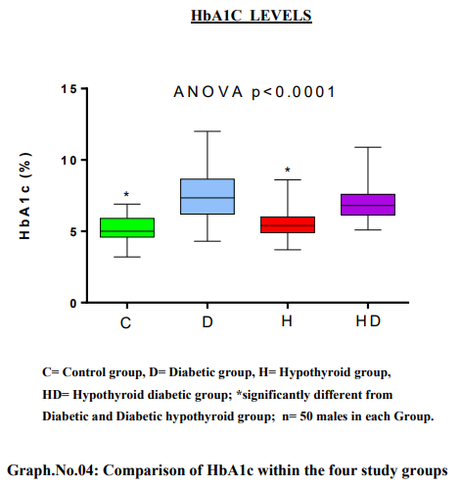

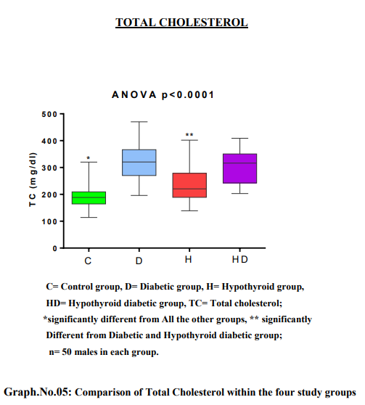

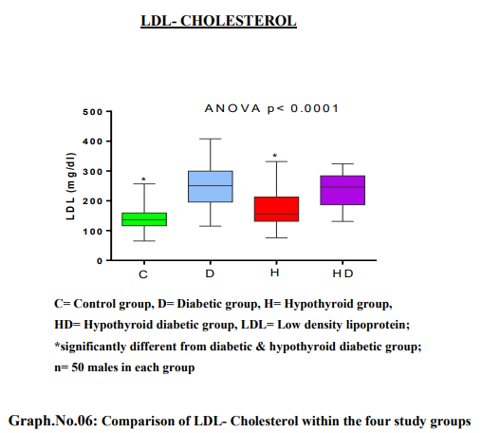
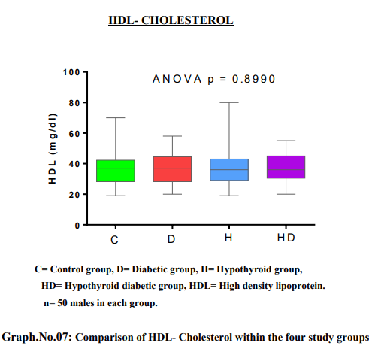

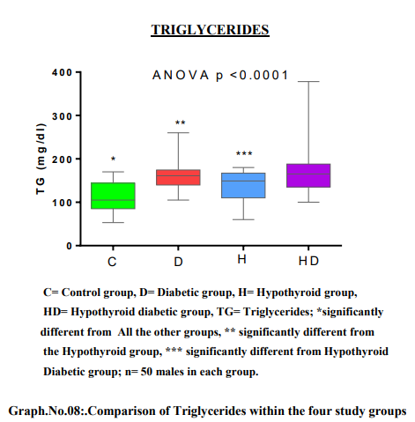

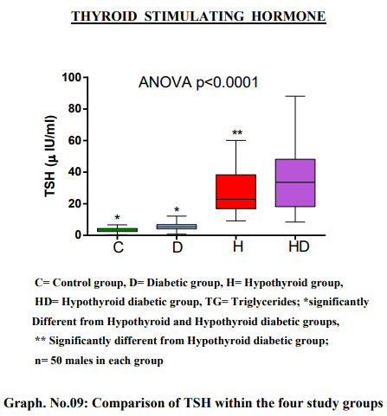

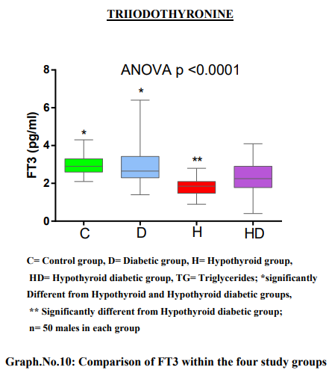

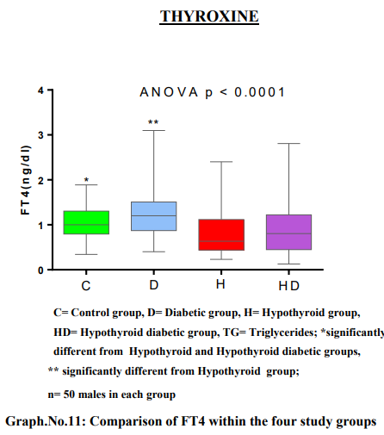

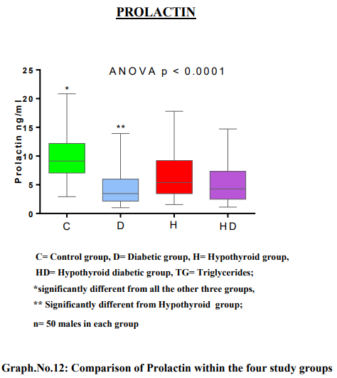

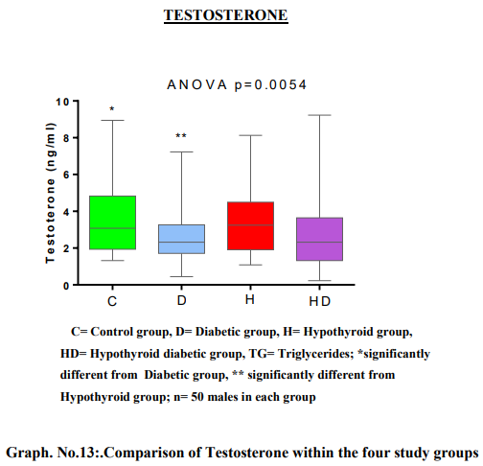

Table. No.01: Correlation of Prolactin with other parameters of all groups

 | Control |  | Diabetics |  | Hypothyroids |  | Hypothyroid diabetics
 | r | p | r | p | R | p | r | p
FBS  (mg/dl) | -0.28 | 0.12 | -0.31 | 0.09 | 0.05 | 0.78 | -0.02 | 0.91
PPBS  (mg/dl) | -0.18 | 0.32 | -0.24 | 0.91 | 0.28 | 0.12 | 0.12 | 0.52
HbA1c (%) | -0.05 | 0.78 | -0.35 | 0.05* | 0.01 | 0.95 | -0.01 | 0.97
TC  (mg/dl) | 0.21 | 0.26 | 0.22 | 0.23 | 0.03 | 0.85 | 0.22 | 0.23
TG  (mg/dl) | -0.08 | 0.66 | -0.38 | 0.03* | 0.19 | 0.29 | 0.10 | 0.59
LDL-C  (mg/dl) | -0.19 | 0.31 | 0.24 | 0.18 | 0.03 | 0.85 | 0.21 | 0.26
HDL-C  (mg/dl) | 0.29 | 0.18 | 0.01 | 0.95 | -0.05 | 0.76 | -0.02 | 0.89
TSH  (μIU/ml) | -0.25 | 0.19 | 0.09 | 0.62 | 0.08 | 0.66 | 0.08 | 0.67
FT3  (pg/ml) | 0.03 | 0.88 | 0.19 | 0.30 | 0.26 | 0.15 | 0.37 | 0.04*
FT4  (ng/dl) | -0.31 | 0.09 | 0.01 | 0.97 | 0.27 | 0.14 | 0.38 | 0.04*
Test. (ng/ml) | -0.04 | 0.84 | -0.16 | 0.39 | -0.11 | 0.53 | 0.54 | 0.002**
FBS= Fasting blood sugar, FT3= Free triiodothyronine, FT4= Free thyroxine, HbA1c= Haemoglobin A1c, HDL-C= High density lipoprotein cholesterol, LDL-C= Low density lipoprotein cholesterol, PPBS= Post prandial blood sugar, TC= Total cholesterol, Test.= Testosterone, TG= Triglycerides, TSH= Thyroid stimulating hormone; * p < 0.05, ** p < 0.01; n=50.

Table.No.02: Correlation of Testosterone with other parameters of all groups

 | Control |  | Diabetics |  | Hypothyroids |  | Hypothyroid diabetics
 | r | p | r | p | R | p | r | p
FBS  (mg/dl) | -0.14 | 0.55 | 0.05 | 0.75 | 0.12 | 0.51 | -0.17 | 0.35
PPBS  (mg/dl) | 0.03 | 0.87 | 0.16 | 0.39 | 0.21 | 0.25 | -0.05 | 0.77
HbA1c (%) | -0.20 | 0.28 | -0.28 | 0.13 | 0.02 | 0.91 | -0.04 | 0.83
TC  (mg/dl) | 0.22 | 0.22 | 0.23 | 0.90 | 0.20 | 0.28 | -0.16 | 0.37
TG  (mg/dl) | -0.13 | 0.46 | 0.18 | 0.92 | 0.19 | 0.29 | -0.18 | 0.32
LDL-C  (mg/dl) | -0.16 | 0.93 | 0.02 | 0.91 | 0.23 | 0.20 | 0.24 | 0.19
HDL-C  (mg/dl) | 0.01 | 0.98 | 0.02 | 0.93 | -0.22 | 0.23 | -0.20 | 0.28
TSH  (μIU/ml) | -0.16 | 0.38 | 0.06 | 0.73 | -0.01 | 0.96 | 0.11 | 0.53
FT3  (pg/ml) | -0.17 | 0.32 | -0.02 | 0.94 | 0.05 | 0.21 | 0.12 | 0.51
FT4  (ng/dl) | 0.14 | 0.45 | 0.13 | 0.48 | -0.26 | 0.16 | 0.12 | 0.53
Prol. (ng/ml) | -0.03 | 0.84 | -0.16 | 0.39 | -0.11 | 0.53 | 0.54 | 0.002**

FBS= Fasting blood sugar, FT3= Free triiodothyronine, FT4= Free thyroxine, HbA1c= Haemoglobin A1c, HDL-C= High density lipoprotein cholesterol, LDL-C= Low density lipoprotein cholesterol, PPBS= Post prandial blood sugar, Prol.= Prolactin, TC= Total cholesterol, TG= Triglycerides, TSH= Thyroid stimulating hormone; ** p < 0.01; n=50.

Table .No.03: Correlation of Total Cholesterol with other parameters of all groups
 | Control |  | Diabetics |  | Hypothyroids |  | Hypothyroid diabetics
 | r | p | r | p | R | p | r | p
FBS  (mg/dl) | 0.19 | 0.53 | 0.20 | 0.28 | -0.03 | 0.85 | -0.01 | 0.97
PPBS  (mg/dl) | -0.08 | 0.65 | 0.23 | 0.23 | 0.12 | 0.51 | 0.18 | 0.35
HbA1c (%) | 0.41 | 0.02* | 0.05 | 0.79 | -0.01 | 0.96 | -0.19 | 0.30
TG  (mg/dl) | 0.63 | 0.0002** | -0.27 | 0.14 | 0.81 | <0.0001*** | 0.18 | 0.30
LDL-C  (mg/dl) | 0.70 | 0.0004** | 0.98 | <0.0001*** | 0.97 | <0.0001*** | 0.96 | <0.0001***
HDL-C  (mg/dl) | 0.17 | 0.39 | -0.16 | 0.38 | 0.21 | 0.26 | 0.12 | 0.53
TSH  (μIU/ml) | -0.24 | 0.91 | -0.04 | 0.82 | 0.26 | 0.16 | -0.13 | 0.49
FT3  (pg/ml) | -0.20 | 0.28 | 0.14 | 0.45 | 0.08 | 0.64 | 0.19 | 0.31
FT4  (ng/ dl) | 0.10 | 0.57 | 0.47 | 0.14 | -0.39 | 0.03* | 0.35 | 0.85
Prol. (ng/ml) | 0.21 | 0.26 | 0.22 | 0.23 | 0.03 | 0.85 | 0.22 | 0.23
Test. (ng/ml) | 0.23 | 0.22 | 0.02 | 0.90 | 0.20 | 0.28 | 0.16 | 0.37

FBS= Fasting blood sugar, FT3= Free triiodothyronine, FT4= Free thyroxine, HbA1c= Haemoglobin A1c, HDL-C= High density lipoprotein cholesterol, LDL-C= Low density lipoprotein cholesterol, PPBS= Post prandial blood sugar, Prol.= Prolactin, Test.= Testosterone, TG= Triglycerides, TSH= Thyroid stimulating hormone; * p < 0.05, ** p < 0.01, ***p <0.0001 ; n=50

Table.No.04: Correlation of Triglycerides with other parameters of all groups

 | Control |  | Diabetics |  | Hypothyroids |  | Hypothyroid diabetics
 | r | p | r | p | R | p | r | p
FBS  (mg/dl) | 0.18 | 0.33 | 0.39 | 0.03* | -0.15 | 0.22 | -0.27 | 0.62
PPBS  (mg/dl) | 0.10 | 0.58 | 0.30 | 0.10 | 0.22 | 0.23 | -0.31 | 0.78
HbA1c (%) | 0.26 | 0.16 | -0.02 | 0.92 | -0.12 | 0.52 | -0.42 | 0.69
TC  (mg/dl) | 0.62 | 0.0002** | -0.27 | 0.14 | 0.81 | <0.0001*** | -0.18 | 0.30
LDL-C  (mg/dl) | 0.81 | <0.0001*** | 0.36 | 0.04* | 0.77 | <0.0001*** | -0.36 | 0.99
HDL-C  (mg/dl) | 0.02 | 0.91 | 0.14 | 0.43 | 0.07 | 0.72 | -0.35 | 0.93
TSH  (μIU/ml) | -0.02 | 0.92 | -0.05 | 0.80 | 0.39 | 0.03* | -0.34 | 0.92
FT3  (pg/ml) | -0.81 | 0.33 | -0.15 | 0.40 | 0.03 | 0.84 | -0.17 | 0.29
FT4  (ng/dl) | 0.50 | 0.004** | 0.20 | 0.27 | -0.35 | 0.06 | -0.11 | 0.17
Prol. (ng/ml) | -0.08 | 0.66 | -0.38 | 0.03* | 0.18 | 0.29 | -0.26 | 0.59
Test. (ng/ml) | -0.14 | 0.46 | 0.02 | 0.92 | 0.19 | 0.30 | -0.51 | 0.32
FBS= Fasting blood sugar, FT3= Free triiodothyronine, FT4= Free thyroxine, HbA1c= Haemoglobin A1c, HDL-C= High density lipoprotein cholesterol, LDL-C= Low density lipoprotein cholesterol, PPBS= Post prandial blood sugar, Prol.= Prolactin, TC= Total cholesterol Test.= Testosterone, TSH= Thyroid stimulating hormone; * p < 0.05, ** p < 0.01,
***p <0.0001 ; n=50.

