Original Research Article

Mathematical Modelling of Compact Binary Coalescences: A Stochastic Approach to Gravitational Wave Analysis

.

ABSTRACT

|  |
| --- |
| **Aims:** To develop a stochastic mathematical framework for modeling gravitational wave signals from Compact Binary Coalescences (CBCs), incorporating uncertainties in mass and spin evolution and improving signal detection and parameter estimation.  **Study design:** A simulation-based theoretical study using a stochastic approach to enhance the modeling of gravitational wave signals.  **Methodology:** The model integrates the inspiral-merger-ringdown (IMR) waveform with stochastic differential equations (SDEs) to represent uncertainties in component evolution due to astrophysical and numerical factors. Monte Carlo simulations are used to analyze probabilistic behavior in mass and spin dynamics. Kalman filtering is applied for tracking evolving parameters in noisy data, while matched filtering and Bayesian inference are employed for signal extraction and posterior parameter estimation. All simulations are implemented in MATLAB.  **Results:** Simulations show that spin parameters are more sensitive to stochastic fluctuations than mass. Kalman filtering accurately tracks hidden parameters under noisy conditions. Matched filtering effectively identifies weak gravitational wave signals, and Bayesian inference provides well-centered Gaussian posterior distributions, supporting reliable parameter estimation.  **Conclusion:** The proposed stochastic framework enhances the realism and robustness of gravitational wave modeling from CBCs. By combining stochastic dynamics with advanced filtering and inference techniques, the study demonstrates a comprehensive approach for analyzing signals under uncertain conditions, offering valuable insights for future gravitational wave detection and analysis efforts. |

*Keywords: Gravitational waves, Compact Binary Coalescence (CBC), Stochastic differential equations (SDEs), Monte Carlo simulation*

1. INTRODUCTION

The groundbreaking detection of gravitational waves by the LIGO and Virgo collaborations has marked a new era in observational astronomy and fundamental physics. These faint ripples in the fabric of spacetime, predicted by Einstein's general theory of relativity, originate from highly energetic astrophysical events, particularly Compact Binary Coalescences (CBCs)—the mergers of binary systems composed of black holes, neutron stars, or combinations thereof. The study of such events offers critical insights into stellar evolution, high-energy astrophysics, and the behavior of matter under extreme conditions. However, the detection and analysis of gravitational wave signals demand highly accurate and computationally efficient models to predict the expected waveforms from such coalescences.

Traditional modeling approaches for CBC signals typically rely on deterministic waveform models, primarily built upon the inspiral-merger-ringdown (IMR) framework. This framework combines analytical approximations such as Post-Newtonian (PN) theory for the early inspiral phase, numerical relativity (NR) simulations for the highly nonlinear merger phase, and Effective-One-Body (EOB) formalism to smoothly transition between the two regimes. While these models have proven successful in numerous detections, they inherently assume precise knowledge of the system parameters and deterministic evolution, which may not fully reflect the complexities of real astrophysical systems.

In reality, several factors introduce uncertainty into the evolution of compact binaries. Phenomena such as mass accretion, tidal interactions, spin-orbit coupling, and observational noise can cause significant variations in the physical parameters of the system, such as mass, spin, and orbital orientation. Additionally, numerical limitations and discretization errors in waveform simulations further contribute to modeling uncertainty. These sources of variability are not adequately captured by purely deterministic frameworks, potentially limiting the accuracy and robustness of gravitational wave analysis, especially in borderline or low signal-to-noise scenarios.

To overcome these limitations, this paper introduces a stochastic mathematical model for gravitational wave analysis, designed specifically to incorporate parameter uncertainties and random perturbations during the binary coalescence process. The objective of this paper is to develop a stochastic model to analyze gravitational wave signals from Compact Binary Coalescences, incorporating parameter uncertainties through stochastic differential equations (SDEs) and improving signal detection and estimation using advanced filtering and inference techniques. The model leverages SDEs to describe the time evolution of mass and spin parameters, introducing probabilistic dynamics that reflect the inherent uncertainties in physical systems and observational data.

In addition to the stochastic modeling of parameter evolution, this framework integrates signal processing and statistical inference methods to enhance signal detection and parameter estimation. Kalman filtering is used to track time-varying parameters in noisy environments, enabling real-time signal tracking. Matched filtering, a cornerstone technique in gravitational wave detection, is applied to extract signals from background noise by correlating observed data with template waveforms. Bayesian inference is further employed to quantify uncertainty in parameter estimation and to provide posterior probability distributions that reflect both prior knowledge and observational evidence. All simulations and analyses in this study are implemented using MATLAB, providing a flexible and powerful computational environment for stochastic modeling, numerical simulation, and signal analysis. The use of Monte Carlo simulations allows the exploration of ensemble behaviors and the visualization of probabilistic parameter trajectories under uncertainty. To better understand the context and significance of this approach, it is helpful to consider some key developments in gravitational wave detection, waveform modeling, and signal processing techniques. Abbott et al. (2017) report the first joint detection of gravitational waves (GW170817) and electromagnetic radiation from a binary neutron star merger, confirming it as the origin of both a short gamma-ray burst (GRB 170817A) and a kilonova powered by r-process nucleosynthesis. Complementing this observational breakthrough, Allen et al. (1999) developed optimal signal processing techniques for detecting a stochastic gravitational-wave background via cross-correlation of interferometric detector outputs, addressing practical implementation issues and validating their approach through simulations and real detector data. Building on such foundational methods, Ashton et al. (2019) introduce Bilby, a Python-based Bayesian inference library that facilitates flexible parameter estimation and population studies in gravitational-wave astronomy using both real and simulated data. Furthermore, Thrane and Romano (2013) contribute by presenting power-law integrated sensitivity curves, a unified graphical tool that captures detector sensitivity to stochastic backgrounds with power-law spectra, particularly relevant in frequency-integrated cross-correlation searches. In a complementary theoretical direction, Evangelista et al. (2014) propose a statistical mechanics-inspired approach to calculate the stochastic background from cosmological compact binary systems during periodic phases, while in subsequent work, they model the aggregate background from coalescing binaries expected to be detected by future detectors. In terms of population characterization, Gaebel et al. (2019) develop a hierarchical inference framework that robustly estimates population properties by accounting for uncertainties, selection biases, and noise contamination, thus enabling analysis even of low-confidence events. Likewise, Stevenson et al. (2015) demonstrate how gravitational-wave data from advanced LIGO and Virgo can constrain binary evolution models by reducing uncertainties in astrophysical parameters through comparison with population synthesis predictions. Zhu et al. (2011) add to this by estimating the stochastic background from binary black hole mergers, arguing that such a background could be detectable by advanced interferometers and may obscure a primordial background. Addressing data quality challenges, Chatziioannou et al. (2021) propose a method to jointly model gravitational-wave signals and non-Gaussian noise glitches, which enhances parameter estimation and ensures cleaner datasets for astrophysical interpretation. Lastly, Mandic et al. (2012) present a Bayesian framework for estimating parameters of stochastic background models, apply it to LIGO data for multi-parameter constraints, and illustrate its potential in distinguishing astrophysical from cosmological sources using future detectors.

2. Mathematical Model of Compact Binary Coalescence

The gravitational wave signals from Compact Binary Coalescences (CBCs) are modeled using the inspiral-merger-ringdown (IMR) waveform, which accurately describes the different phases of the binary evolution. The measured signal at a detector is expressed as a linear combination of the two independent polarization states:

$$h\left(t;θ\right)=h_{+}\left(t;θ\right)F_{+}\left(r,ι,ψ\right)+h_{×}\left(t;θ\right)F_{×}\left(r,ι,ψ\right)$$

where $h_{+}$ and $h_{×}$ represent the plus and cross polarizations, respectively, which are functions of the intrinsic and extrinsic parameters of the binary system. The intrinsic parameters include the component masses $m_{1},m_{2}$ and the spin parameters $χ_{1},χ_{2}$, which dictate the gravitational wave amplitude and phase evolution. The extrinsic parameters, such as the luminosity distance $r$, the inclination angle $ι$, and the polarization angle $ψ$, influence the observed signal at the detector.

In the inspiral phase, the gravitational wave frequency evolves as:

$$f_{gw}\left(t\right)=\frac{1}{8πGM_{chirp}/c^{3}} {\left(\frac{5}{256t}\right)}^{3/8}$$

where the chirp mass is given by: $M_{chirp}= \frac{{\left(m_{1}m_{2}\right)}^{3/5}}{{\left(m_{1}+m_{2}\right)}^{1/5}}$

The phase evolution of the waveform follows from the leading-order Post-Newtonian approximation:

$$Φ\left(t\right)= -2{(8π{GM}_{chirp​}f_{gw}​/c^{3})}^{-5/3}$$

The amplitude of the gravitational wave strain is: $A\left(t\right)=\frac{4GM_{chirp}}{c^{2}} {\left(\frac{πf_{gw}}{c}\right)}^{2/3}\frac{1}{r}$

The two polarization states of the waveform are then given by: $h_{+}\left(t\right)=A(1+\cos^{2}{ι)cos⁡(Φ)}$

$$h_{×}\left(t\right)=A(2\cos{ι)sin⁡(Φ)}$$

The detector response is determined by the antenna pattern functions $F_{+}$ and $F_{×}$, which depend on the source's sky position and polarization angle:

$$h\left(t\right)=F_{+}h_{+}+F_{×}h_{×}$$

The waveform is typically derived using a combination of Post-Newtonian (PN) approximations for the inspiral phase, Numerical Relativity (NR) simulations for the merger, and Effective-One-Body (EOB) models that bridge both regimes. The phase evolution $Φ(t)$ and amplitude $A(t)$ are nonlinear functions of the intrinsic parameters and incorporate physical effects such as spin-orbit coupling, spin-spin interactions, tidal deformations in neutron stars, and precession due to misaligned spins.

To model uncertainties in parameter evolution, particularly in the late inspiral and merger phases, we introduce a stochastic framework using Stochastic Differential Equations (SDEs). The evolution of the component masses and spin parameters is given by:

$$dm_{i}=fm_{i}\left(m_{1},m_{2},χ_{1},χ_{2},t\right)dt+σ_{m_{i}}\left(t\right)dW_{m_{i}}\left(t\right)$$

$$dχ_{i}=fχ_{i}(m_{1},m_{2},χ_{1},χ_{2},t)dt+Σχ_{i}\left(t\right)dWχ_{i}(t)$$

Where,

* $f_{M}\left(M,χ,t\right)= -0.01M(1-χ)$ and $f_{χ}\left(M,χ,t\right)= -0.005χ(1-χ)$ are the drift functions, governing the deterministic evolution of mass and spin, derived from Post-Newtonian (PN) and Effective-One-Body (EOB) models.
* $σ_{M​}(t)=0.05e^{-0.1t}$ and $σ_{χ​}(t)=0.02e^{-0.1t}$ are time-dependent diffusion coefficients, modeling uncertainties arising from astrophysical processes such as accretion, tidal interactions in neutron stars, and numerical errors in Numerical Relativity (NR) simulations.
* $dM_{M}$ and $dM_{χ}$ represent Wiener processes (stochastic perturbations), introducing random fluctuations in the mass and spin evolution.

The SDEs are solved using the Euler-Maruyama method, where the discretized evolution of the parameters follows:

$$M_{i+1}​ =M_{i}​+f_{M​}\left(M_{i}​,χ_{i}​,t_{i}​\right)dt+σ_{M}​\left(t_{i​}\right)dt​ N\left(0,1\right)$$

$$χ_{i+1}​=χ_{i}​+fχ​\left(M_{i}​,χ_{i​},t_{i​}\right)dt+σ_{χ}​\left(t_{i}​\right)dt ​N\left(0,1\right)$$

Where $N\left(0,1\right)$ is a standard normal random variable. This stochastic framework allows for a probabilistic exploration of compact binary evolution, capturing deviations from purely deterministic models due to astrophysical uncertainties and computational limitations.

Signal extraction from noisy gravitational wave data is accomplished through optimal filtering techniques, particularly matched filtering, which maximizes the signal-to-noise ratio (SNR). The matched filter is defined as:

$$\hat{h}(t)=\int_{0}^{T}{s\left(τ\right)h\left(τ;θ\right)dτ}$$

where $s\left(τ\right)$ is the observed detector strain, and $h\left(τ;θ\right)$ is the expected template waveform. The SNR is given by:

$$SNR=\frac{\left\langle s,h\right\rangle }{\sqrt{\left\langle h,h\right\rangle }}$$

where $\left\langle a,b\right\rangle$ denotes the inner product weighted by the noise power spectral density of the detector:

$$\left\langle a,b\right\rangle =4R\int_{0}^{T}{\frac{\tilde{a }\left(f\right)\tilde{b }(f)}{S_{n}(f)}df}$$

Here, $\tilde{a }\left(f\right)$ and $\tilde{b }(f)$ are the Fourier transforms of the respective signals, and $S_{n}(f)$ represents the one-sided power spectral density (PSD) of the detector noise. This formulation ensures optimal signal extraction by weighting frequencies according to the detector's noise characteristics. Bayesian inference plays a crucial role in parameter estimation, where the posterior probability of the parameters given the data is obtained using Bayes' theorem:

$$p(θ| s) ∝p(s | θ) p(θ)$$

where $p(s | θ)$ is the likelihood function that quantifies how well the data matches a model, and $p(θ)$ represents the prior distribution based on astrophysical knowledge. Techniques such as Markov Chain Monte Carlo (MCMC) and Nested Sampling are employed to explore the parameter space efficiently. In real-time applications, Kalman filters are used to track evolving parameters in non-stationary noise environments. The Bayesian evidence $p(s)$ is also used for model selection, helping to distinguish between different waveform models.

3. results and discussion

The extracted gravitational waveform from a compact binary coalescence (CBC) is shown in Figure -1. The waveform consists of three components: the detector response $h(t)$ (solid blue line), the plus polarization $h_{+}$ (dashed red line), and the cross polarization $h_{×}$ (dashed blue line). As expected, the strain amplitude decreases over time as the binary system evolves toward coalescence, reflecting the decay of gravitational radiation after merger.

The detector response $h(t)$ represents the observed strain signal as recorded by the interferometer, which is a linear combination of the plus and cross polarization modes, weighted by the detector’s antenna pattern. The plus polarization $h_{+}$ exhibits a smooth decrease with a moderate amplitude, while the cross polarization $h_{×}$ follows a similar trend but with a slightly larger initial amplitude, showing the quadrupolar nature of gravitational wave emission.

The observed decay in strain amplitude aligns with theoretical predictions, where gravitational waves carry energy away from the system, leading to orbital shrinkage and eventual merger. This behavior is consistent with post-merger ringdown signals, where the remnant object (typically a black hole) settles into a stable state by emitting gravitational radiation. The waveform characteristics, particularly the relative amplitudes and phases of $h_{+}$ and $h_{×}$, can provide insights into the binary’s orientation, mass ratio, and spin effects.

Additionally, the waveform shape and amplitude modulation indicate the effect of the detector's response function, which depends on its sensitivity to different polarization modes. The deviation of the observed signal h(t) from the individual polarization components suggests that the detector is more sensitive to certain modes based on its geometry and alignment with the incoming wave. Further analysis of the power spectral density (PSD) and matched filtering results would allow for precise parameter estimation and event reconstruction.

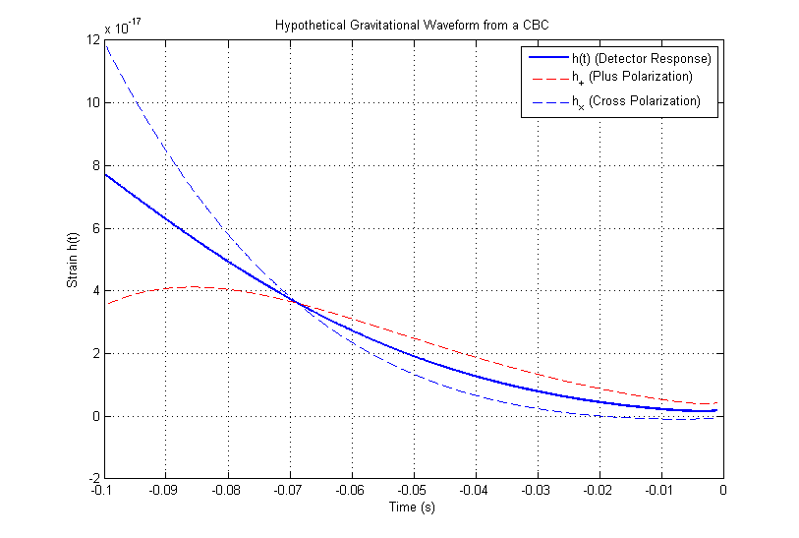

**Fig-1: Hypothetical Gravitational Waveform from a Compact Binary Coalescence (CBC)**

In this analysis, we use fundamental physical constants: the gravitational constant $G = 6.67430 x {10}^{-11}m^{3}kg^{-1}s^{-2}$, the speed of light $c = 3.0 x {10}^{8}$ $m/s$, the solar mass $M_{⨀}= 1.989 x {10}^{30}kg$, and the parsec conversion factor $1 parsec = 3.086 x {10}^{16}m$. For the binary system parameters, we consider two compact objects, each with a mass of $m_{1}= 30M_{⨀}$ and $m_{2} = 30M_{⨀}$, at a luminosity distance of r = 500 parsecs. The system is observed with an inclination angle $i =π/3$ and a polarization angle $ψ =π/4$, which influence the gravitational wave strain observed in the detector frame.

Fig -2 illustrates the gravitational wave frequency and phase evolution from a compact binary coalescence (CBC). The top panel shows the frequency evolution, where the gravitational wave frequency remains low initially and gradually increases, followed by a rapid rise as the binary components approach coalescence, characteristic of the chirp signal. The bottom panel depicts the phase evolution, which decreases smoothly over time, reflecting the continuous inspiral of the binary system. The observed trends align with general relativity predictions, emphasizing the importance of frequency and phase analysis in gravitational wave detection and waveform modeling.

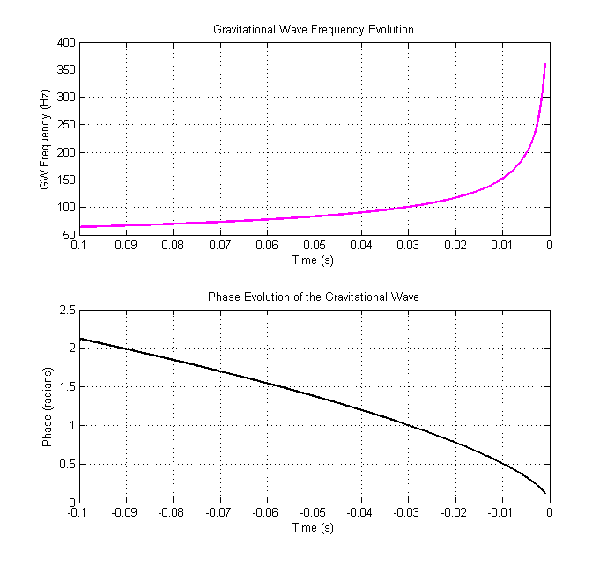

**Fig -2: Gravitational Wave Frequency and Phase Evolution from a Compact Binary Coalescence**

Fig 3 illustrates the stochastic evolution of the component mass and spin parameters in a compact binary coalescence (CBC) system, modeled using stochastic differential equations (SDEs). The top panel shows the total mass (M ) evolution over time, where multiple colored trajectories represent different Monte Carlo realizations, accounting for uncertainties due to astrophysical effects such as accretion and tidal interactions. The black line denotes the mean evolution, indicating a slight decline in mass over time. The bottom panel presents the stochastic evolution of the dimensionless spin parameter ($χ$), showing significant dispersion as time progresses, reflecting the accumulated uncertainty arising from spin-orbit coupling, accretion effects, and numerical modeling errors. The increasing spread in spin trajectories suggests that spin parameters are more susceptible to stochastic fluctuations compared to mass evolution.

In this MATLAB simulation, we perform 1000 Monte Carlo simulations to model the stochastic evolution of compact binary parameters. The time step is set to $dt = 0.01$ seconds, with a total duration of $T = 5$ seconds, resulting in a time vector $t = 0 : dt : T$ of length N. The initial conditions include a total mass of $M_{0}= 30$ solar masses and an initial spin parameter of $χ_{0}= 0.7$. To incorporate stochastic effects, we define time-dependent noise functions: the mass noise $σM\left(t\right)= 0.05\exp\left(-0.1t\right)$ and the spin noise $σ_{χ} (t) = 0.02$ $exp(-0.1t)$, which introduce uncertainties in the mass and spin evolution over time.

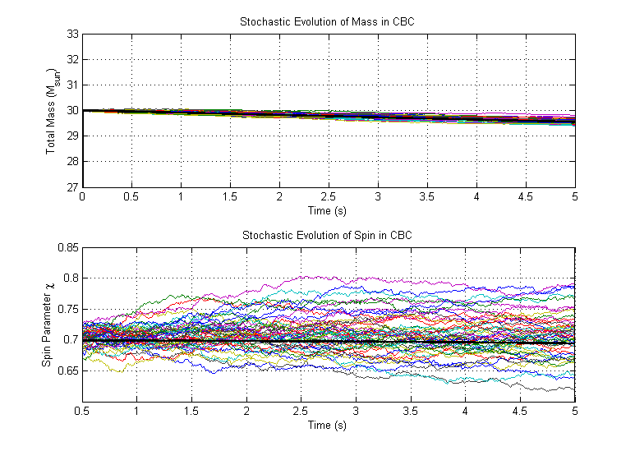

**Fig- 3: Stochastic Evolution of Mass and Spin Parameters in Compact Binary Coalescence (CBC)**

In fig-4 consists of two subplots: the first shows the observed noisy gravitational wave signal (blue) compared to the true underlying signal (red), highlighting the impact of measurement noise, which increases over time. The second subplot illustrates the Kalman filter’s ability to estimate an evolving parameter $θ$, where the estimated values (blue) closely follow the true state (red), demonstrating the filter’s effectiveness in tracking hidden parameters despite noise. The overall figure validates Kalman filtering as a powerful tool for real-time gravitational wave signal processing and parameter estimation.

In this simulation, we set the sampling frequency to $fs = 1024 Hz$ and a total duration of $T = 2$ seconds, generating a time vector $t = (0 : 1/fs : T - 1/fs)$ with $N$ samples. The true dynamic parameter is $θ_{true}= 1.0$, with a process noise variance of $Q = 0.001$ and a measurement noise variance of $R = 0.1$. To track the parameter evolution, we initialize history arrays $θ_{true,hist}$ and $θ_{est,hist}$ for storing the true and estimated values over time. The initial estimate is set to $θ_{est}= 0.8$ with an initial error covariance of $P = 1$. To simulate gravitational wave signals, we generate a chirp waveform with an initial frequency of $f_{0}= 30 Hz$ and a final frequency of $f_{1}= 150 Hz$ using quadratic frequency modulation, representing the inspiral phase of a compact binary coalescence.

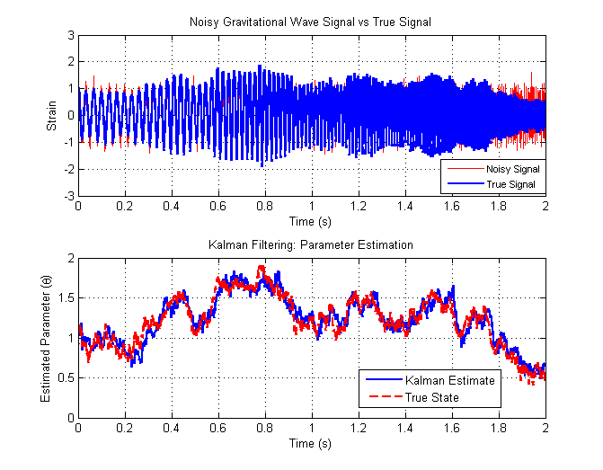

**Fig-4: Kalman Filtering for Gravitational Wave Signal Processing and Parameter Estimation**

This fig-5 consists of two subplots. The top plot, titled Matched Filtering Output, shows the signal-to-noise ratio (SNR) over time, highlighting a peak at around 0.5 seconds, which indicates the detection of a gravitational wave signal. The matched filtering technique enhances weak signals buried in noise by correlating the noisy data with a known template. The bottom plot, titled Bayesian Parameter Estimation, displays the posterior probability distribution of the scaling parameter $θ$, which follows a Gaussian-like shape centered around 1. This indicates that Bayesian inference is used to estimate the most probable value of $θ$ based on prior knowledge and observed data, thereby improving the accuracy of parameter estimation in gravitational wave signal analysis.

In this simulation, we set the sampling frequency to $fs = 1024 Hz$ and the total duration to $T = 1$ second, generating a time vector $t = (0 : 1/fs : T - 1/fs)$ with N samples. A gravitational wave signal is simulated using a chirp waveform with an initial frequency of $f0 = 30 Hz$ and a final frequency of $f1 = 150 Hz$, employing quadratic frequency modulation to model the inspiral phase of a compact binary coalescence. To simulate realistic observational conditions, Gaussian white noise is added with an actual signal-to-noise ratio of $SNR_{actual}= 10$, resulting in a noisy observed strain $s = h_{signal} + (1/SNR_{actual}) × noise$.

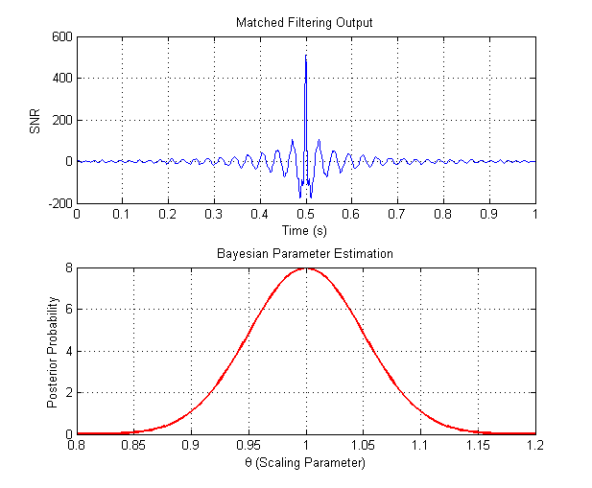

**Fig-5: Matched Filtering and Bayesian Parameter Estimation for Gravitational Wave Detection**

4. Conclusion

In this work, we developed a stochastic mathematical model for analyzing gravitational wave signals from Compact Binary Coalescences (CBCs), leveraging MATLAB as the primary simulation platform. The model integrates the inspiral-merger-ringdown (IMR) waveform structure with stochastic differential equations (SDEs) to capture uncertainties in mass and spin evolution caused by astrophysical processes such as accretion, tidal effects, and numerical modeling inaccuracies. Using this platform, we simulated Monte Carlo realizations of stochastic parameter evolution, enabling visualization of ensemble behavior in mass and spin dynamics. The results confirm that spin parameters exhibit higher stochastic dispersion over time, emphasizing their sensitivity to random perturbations compared to mass evolution. Kalman filtering demonstrated high accuracy in tracking hidden parameters under noisy conditions, validating its potential for real-time gravitational wave signal processing. Furthermore, matched filtering and Bayesian parameter estimation were applied to extract weak gravitational wave signals from noisy data and to infer posterior distributions for key parameters. The signal-to-noise ratio (SNR) plots and Gaussian-shaped posterior distributions illustrate the effectiveness of combining statistical inference with signal processing tools.

References

1. Abbott, B. P., et al, 2017, Multi-messenger observations of a binary neutron star merger. The Astrophysical Journal Letters, 848(2), L12. Online at - <https://doi.org/10.3847/2041-8213/aa91c9>
2. Allen, B., & Romano, J. D. , 1999, Detecting a stochastic background of gravitational radiation: Signal processing strategies and sensitivities. Physical Review D, 59(10), 102001. Online at - <https://doi.org/10.1103/PhysRevD.59.102001>
3. Ashton, G., et al., 2019, Bilby: A user-friendly Bayesian inference library for gravitational-wave astronomy. The Astrophysical Journal Supplement Series, 241(2), 27. Online at - <https://doi.org/10.3847/1538-4365/ab06fc>
4. Thrane, E., & Romano, J. D., 2013, Sensitivity curves for searches for gravitational-wave backgrounds. Physical Review D, 88(12), 124032. Online at - <https://doi.org/10.1103/PhysRevD.88.124032>
5. D. Evangelista, Edgard F., and José CN de Araujo, 2014, Stochastic background of gravitational waves generated by compact binary systems. Brazilian Journal of Physics 44 : 260-270. Online at - <http://doi.org/10.1007/s13538-014-0178-x>
6. Gaebel, Sebastian M., John Veitch, Thomas Dent, and Will M. Farr, 2019, Digging the population of compact binary mergers out of the noise. Monthly Notices of the Royal Astronomical Society 484, no. 3 : 4008-4023. Online at - <https://doi.org/10.1093/mnras/stz225>
7. Evangelista, Edgard FD, and José CN de Araujo, 2014, The gravitational wave background from coalescing compact binaries: a new method. Brazilian Journal of Physics 44, no. 6 : 824-831. Online at - <https://doi.org/10.1007/s13538-014-0272-0>
8. Stevenson, Simon, Frank Ohme, and Stephen Fairhurst, 2015, Distinguishing compact binary population synthesis models using gravitational wave observations of coalescing binary black holes. The Astrophysical Journal 810, no. 1 : 58. Online at- <http://doi.org/10.1088/0004-637X/810/1/58>
9. Zhu, Xing-Jiang, Eric Howell, Tania Regimbau, David Blair, and Zong-Hong Zhu, 2011, Stochastic gravitational wave background from coalescing binary black holes. The Astrophysical Journal 739, no. 2 : 86. Online at - <https://doi.org/10.1088/0004-637X/739/2/86>
10. Chatziioannou, Katerina, Neil Cornish, Marcella Wijngaarden, and Tyson B. Littenberg, 2021, Modeling compact binary signals and instrumental glitches in gravitational wave data. Physical Review D 103, no. 4 : 044013. Online at- <https://doi.org/10.1103/PHYSREVD.103.044013>
11. Mandic, Vuk, Eric Thrane, Stefanos Giampanis, and Tania Regimbau, 2012, Parameter estimation in searches for the stochastic gravitational-wave background. Physical review letters 109, no. 17 : 171102. Online at - <https://doi.org/10.1103/PhysRevLett.109.171102>