***Original Research Article***

**Assessing Sensory Acceptability of Ginger-Turmeric based Functional Beverage by Fuzzy Logic Approach**

**Abstract**

Increasing health consciousness among consumers, particularly in relation to the prevention and management of chronic diseases, has catalyzed innovations in the development of functional beverages. Ginger (*Zingiber officinale* Roscoe), known as *Adrak* in Ayurveda, is believed to have extensive medicinal properties and comprises over 400 bioactive compounds, including significant phenolic acids like 6-gingerol. Similarly, turmeric (*Curcuma longa* Linnaeus), referred to as *Haridra*, has a rich historical background in Southeast Asia and is recognized for its bioactive constituents, chiefly curcumin. Both are abundant in essential minerals and have been shown to confer notable health benefits, including anti-inflammatory and antioxidant effects, as evidenced by more than 3,000 scholarly publications elucidating their therapeutic potential. This study undertakes the development of a functional beverage that incorporates the juices of ginger and turmeric, thereby aligning historical significance with contemporary wellness trends. Sensory evaluation is crucial in the formulation of functional beverages; however, traditional sensory evaluation is hampered by inherent subjectivity, as it relies heavily on the individual preferences of the evaluators. To mitigate this subjectivity, a fuzzy logic analysis is employed. Fuzzy logic serves to mathematically refine the linguistic preferences assigned to each sensory parameter, such as, colour, aroma, mouthfeel, and taste, resulting in comparable quantitative scores. These final scores are crucial for refining the formulation of the mixture components, thereby improving the overall quality and consumer acceptance of the functional beverage.

**Keywords**

Ginger, Functional Beverage, Fuzzy logic, Sensory evaluation, Turmeric,

## Introduction

Rising health consciousness among consumers has led to increased interest in functional foods, particularly functional beverages, which are at the forefront of food industry innovations (Corbo et al., 2014; Rocha-Parra et al., 2016). These products are specifically formulated to promote health and provide bioactive benefits through the incorporation of various ingredients, including essential vitamins, minerals, amino acids, and other bioactive compounds (Gomez et al., 2023). These ingredients are meticulously sourced from diverse origins, encompassing plant materials, animals, and microorganisms. This strategic selection of components is aimed at maximizing the functional efficacy of the products while contributing to overall health and well-being. The functional beverages market is anticipated to attain a valuation of $208.13 billion by the year 2024, signifying a Compound Annual Growth Rate (CAGR) of 7.5% from 2022 to 2027 (Gupta et al., 2023). This expansion within the functional food sector is predominantly propelled by the rising incidence of lifestyle-related diseases, coupled with a growing public emphasis on preventive health strategies (Sharma et al., 2024). Such trends underscore the increasing consumer demand for products that not only provide nutritional benefits but also contribute to the maintenance of health and the mitigation of disease risk. In recent years, there has been a marked increase in the popularity of functional foods, which have been recognized for their potential to reduce the risk of various diseases (Sik et al., 2022). The incorporation of functional foods into dietary practices may offer a proactive approach to disease prevention and health promotion.

Among various functional foods, ginger, referred to as *adrak* in ancient Indian texts, has been recognized for its medicinal properties. It was valued in Ayurveda and known as "the great cure." Chemical analyses indicate that ginger comprises over 400 compounds, including important minerals, with variability depending on the type and storage conditions (Zhukovets & Musa Özcan, 2020). The primary constituents identified among the 18 phenolic acids detected in ginger are 6-gingerol, 8-gingerol, 10-gingerol, 1-dehydro-6-gingerdione, and diacetoxy-8-gingerdiol. According to a study conducted by Asamenew et al., (2019) , the total phenolic content was quantified at 434.7 mg/100 g dry weight (DW) for ginger samples originating from Korea, while a higher content of 698.1 mg/100 g DW was observed in samples from Ethiopia. Similarly, turmeric, known as *Haridra* in Vedic texts, has been used for centuries because of its medicinal, flavoring, and coloring properties (Nair, 2019) . With a rich history of use in Southeast Asia for culinary and religious ceremonies, turmeric is often dubbed "Indian saffron" (Govindarajan, 1980). Turmeric is a treasure trove of bioactive compounds, with over 100 identified components (Iweala et al., 2023). The primary constituent of the root is volatile oil, which contains turmerone, while its vibrant color is attributed to curcuminoids, a group of natural antioxidants. These curcuminoids include curcumin, demethoxycurcumin, methoxycurcumin, and dihydrocurcumin. In its standardized form, turmeric typically contains 5-6.6% curcumin and less than 3.5% volatile oils. The volatile oil fraction is composed of various compounds, such as d-α-phellandrene, d-sabinene, cinol, borneol, and zingiberene, as well as a diverse range of sesquiterpenes, including germacrone, termerone, and bisacurone. Notably, turmeric is also a rich source of the essential ω-3 fatty acid, α-linolenic acid (Prasad and Aggarwal, 2011). Both Ginger and turmeric are also a good source of mineral such as sodium, potassium, calcium, phophorous, iron, manganese and magnesium (Jose et al., 2022; Shukla et al., 2019).

Extensive research has demonstrated that turmeric, particularly its primary active ingredient, curcumin, offers a diverse range of health benefits. This vibrant yellow spice is known for its ability to combat serious health issues such as cancer (Ávila-Gálvez et al., 2021; Weng & Goel, 2022), diabetes (Yaikwawong et al., 2024), osteoarthritis (Singhal et al., 2021), fatty liver (Mirhafez et al., 2021) and heart disease (Abolfazli et al., 2024; Mad Azli et al., 2024). Furthermore, curcumin is celebrated for its potent antioxidant properties that protect cells from damage caused by free radicals (Tanvir et al., 2017). It also provides neuroprotective benefits (Banji et al., 2021), that are essential for maintaining cognitive function, along with liver-protective effects that aid in detoxification processes within the body (Dehzad et al., 2023). Moreover, turmeric exhibits antimicrobial activity (Odo et al., 2023), helping the body fend off harmful pathogens, and its kidney-protective and anti-inflammatory qualities (Zhao et al., 2021) contribute to overall organ health and the reduction of chronic inflammation. In addition to turmeric, ginger extract has also been recognized for its beneficial effects across various patient groups. Danwilai et al., (2017) has highlighted its positive impacts on cancer patients, while Mozaffari-Khosravi et al., (2016) have revealed significant advantages for individuals with osteoarthritis. Ginger has also proven effective against cardiovascular disorders (Talaei et al., 2018) and has shown promising results in managing diabetes (Arablou et al., 2014)..

Recent scientific interest in ginger and turmeric is evident, with over 3,000 publications exploring their health benefits over the past 25 years (Prasad & Aggarwal, 2011). Both ginger and turmeric are recognized as functional foods that not only have historical health significance but also align with contemporary trends emphasizing wellness and disease prevention. Plant-based (PB) diets have gained popularity, with varying levels of awareness across European countries (Jaeger et al., 2023; Waehrens et al., 2023). To harness the therapeutic potential of ginger and turmeric, this study developed a functional beverage by utilizing their juice.

In product development, sensory evaluation plays a crucial role, and among various methods, the fuzzy logic-based approach is particularly useful because of its ability to handle complex decision-making by panellist (Das, 2005). This approach can analyze ambiguous sensory scores and provide meaningful insights into consumer acceptance, ranking, and preferences. It also offers mathematical tools to describe the uncertainty of consumers’ preferences for food products. Unlike statistical techniques that rely on mean values, fuzzy logic can accommodate linguistic and non-deterministic expressions (Franklin et al., 2019). This methodology has been effectively employed to assess the sensory characteristics of a range of products, including soy milk beverages (Kumar et al., 2021), safflower seed milk analogs (Tadakod et al., 2023), mixed fruit beverage (Dhar et al., 2021), ready-to-eat snack food (Deshmukh et al., 2018) and probiotic whey beverage (Faisal et al., 2017).

In this study, fuzzy logic was used to elucidate the complex interrelationships between independent variables, specifically the proportions of ingredients, and dependent variables, which encompass acceptance, rejection, ranking, and indicators of beverage strength and weakness. The linguistic sensory scores derived from the panellists were subjected to fuzzy analysis to gain insight into the sensory preferences associated with various functional beverage formulations. This methodological approach provides a nuanced understanding of consumer perceptions within the context of beverage evaluation.

## Material and Method

### Materials

Fresh rhizomes of ginger and turmeric, harvested at an age of 7 to 9 months, were used as the essential raw materials in the development of a functional beverage. The rhizomes were subject to a comprehensive cleaning process, which included thorough washing, followed by sun drying for one hour. The dried rhizomes were stored under refrigerated conditions to maintain their quality for subsequent use. In addition, rock sugar (*Mishri)* and distilled water were utilized to enhance the overall sensory characteristics of the final product.

### Extraction of Ginger and Turmeric Juice

Juice was obtained from the fresh rhizomes of ginger and turmeric using the method described previously (Ademosun et al. 2021, Ogori et al. 2021, Raje-Nimbalkar et al. 2023). The cleaned rhizomes were cut into 1 cm pieces and subsequently ground using a mixer grinder. The juice was extracted from the resulting paste by pressing and filtering through a muslin cloth.

### Design of experiment

A D-optimal mixture design was employed using the statistical software package Design Expert (version 13, Statease Inc., Minneapolis, MN) to formulate the compositions and conduct statistical analyses (Franklin et al., 2019; Surya et al. 2021). The concentration ranges for ginger and turmeric juice were established between 5% and 15%, while distilled water was varied from 60% to 80%. *Mishri* was maintained at a constant level of 10%. Based on the levels of the ingredients, the D-optimal mixture design yielded a total of 16 suggested formulations.

### Preparation of functional beverage

To prepare the functional beverage, *Mishri* was initially dissolved in a specified volume of distilled water by heating the solution to a temperature of 80°C for 10 minutes for each of the 16 samples. Upon completion, the mixture of distilled water and *Mishri* was filtered and transferred into amber glass bottles. The bottles were subsequently cooled to 25°C, after which the calculated quantities of ginger juice and turmeric juice were incorporated into the mixture according to the formulation.

### Sensory evaluation of developed functional beverage

Eleven semi-trained panellists were selected to participate based on their interests in the study. Prior to the evaluation process, the panellists underwent training on the procedural aspects, the scorecard (refer to Table 1), and the scoring methodology. The panellists' assessments regarding four quality attributes—colour, aroma, taste, and mouthfeel—were gathered using a five-point sensory scale: 1 = Not Satisfactory, 2 = Fair, 3 = Medium, 4 = Good, and 5 = Excellent. Additionally, the significance of each quality attribute relevant to the product was evaluated using a five-point scale, with the following designations: not at all important, somewhat important, important, highly important, and extremely important.

The key steps involved in conducting a sensory evaluation using fuzzy logic techniques are (Das, 2005; Deshmukh et al., 2018; Franklin et al., 2019; Kumar et al., 2021):

- Collection of sensory evaluation data

- Triplets for the sensory scale

- Calculation of triplets to derive sensory scores

- Assessment of triplets for the sensory scores of quality attributes

- Determination of triplets for the relative weightage of quality attributes

- Computation of triplets for the overall sensory score

- Establishment of values for the membership function of the standard fuzzy scale

- Calculation of overall membership function values for sensory scores based on the standard fuzzy scale

- Evaluation of similarity values and ranking of functional beverage samples

# Table 1: Sensory Evaluation Score Card for Fuzzy Model

|  |  |  |  |  |  |
| --- | --- | --- | --- | --- | --- |
|  | **Sensory scale factors** | | | | |
| **Not satisfactory** | **Fair** | **Medium** | **Good** | **Excellent** |
| **Colour** | | | | | |
| Sample No. -- |  |  |  |  |  |
| Sample No. -- |  |  |  |  |  |
| Sample No. -- |  |  |  |  |  |
| Sample No. -- |  |  |  |  |  |
| **Aroma** | | | | | |
| Sample No. -- |  |  |  |  |  |
| Sample No. -- |  |  |  |  |  |
| Sample No. -- |  |  |  |  |  |
| Sample No. -- |  |  |  |  |  |
| **Taste** | | | | | |
| Sample No. -- |  |  |  |  |  |
| Sample No. -- |  |  |  |  |  |
| Sample No. -- |  |  |  |  |  |
| Sample No. -- |  |  |  |  |  |
| **Mouthfeel** | | | | | |
| Sample No. -- |  |  |  |  |  |
| Sample No. -- |  |  |  |  |  |
| Sample No. -- |  |  |  |  |  |
| Sample No. -- |  |  |  |  |  |
|  |  |  |  |  |  |
| **Sensory quality attributes** | **Not at all important** | **Somewhat important** | **Important** | **Highly important** | **Extremely important** |
| Colour |  |  |  |  |  |
| Aroma |  |  |  |  |  |
| Taste |  |  |  |  |  |
| Mouthfeel |  |  |  |  |  |

#### Collection of Sensory evaluation data

Sensory evaluation data were collected for all 16 formulations from a panel of 11 participants, and are presented in the format outlined in Table 1.

#### Triplets for sensory scale

The triangular membership function distribution pattern of the five-point sensory scales is represented by a set of three numerical values, referred to as a triplet. Each sensory scale is depicted as a triangle (Fig. 1). The first number in the triplet indicates the abscissa coordinate at which the membership function attains a value of one. The second and third numbers denote the respective distances to the left and right of the first number, respectively, where the membership function reaches a value of zero. Similarly, triplets are established for all five-point sensory scales, as shown in Table 2.

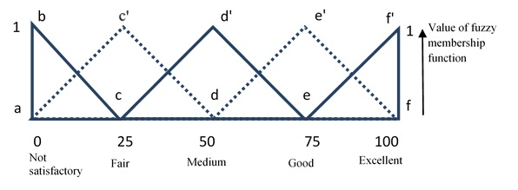

Fig. 1: Values of triplets associated with triangular membership distribution function for five-point sensory scales

Table 2: Triplets associated with sensory scales

|  |  |  |  |  |  |  |  |  |  |  |  |  |  |  |
| --- | --- | --- | --- | --- | --- | --- | --- | --- | --- | --- | --- | --- | --- | --- |
| Not Satisfactory/Not at all important | | | Fair/Somewhat important | | | Medium/  Important | | | Good/Highly important | | | Excellent/Extremely important | | |
| 0 | 0 | 25 | 25 | 25 | 25 | 50 | 25 | 25 | 75 | 25 | 25 | 100 | 25 | 0 |

#### Calculation of triplets to derive sensory scores

For each quality attribute of the individually formulated functional beverage samples, triplet data were obtained by summing the preferences provided by the panellists for each specific sensory scale, incorporating the corresponding triplets linked to the sensory scale and the total number of panellists. The triplets for each quality attribute of the individual samples were calculated using the following equation (Eqn. 1):

|  |  |
| --- | --- |
| $${\text{S}}_{\text{i}}\text{D = }\frac{{\text{J}}_{\text{1}}\left(\text{0 0 25}\right)\text{+}{\text{J}}_{\text{2}}\left(\text{25 25 25}\right)\text{+}{\text{J}}_{\text{3}}\left(\text{50 25 25}\right)\text{+}{\text{J}}_{\text{4}}\left(\text{75 25 25}\right)\text{+}{\text{J}}_{\text{5}}\left(\text{100 25 0}\right)}{ {\text{J}}_{\text{1}}\text{+ }{\text{J}}_{\text{2}}\text{+ }{\text{J}}_{\text{3}}\text{+ }{\text{J}}_{\text{4}}\text{+ }{\text{J}}_{\text{5}}}$$ | .… (1) |

Where,

Si is Sample i=1,2,3…16

D = C for color, A for aroma, T for taste and M for mouthfeel

J1 is sum of panellist preferred for sensory scale 1

J2 is sum of panellist preferred for sensory scale 2

J3 is sum of panellist preferred for sensory scale 3

J4 is sum of panellist preferred for sensory scale 4

J5 is sum of panellist preferred for sensory scale 5

This equation generates four triplets for each sample. For instance, the triplets corresponding to the sensory score of Sample 1 were designated as S1C, S1A, S1T and S1M. Similarly, triplets were determined for all other samples.

#### Assessment of triplets for the sensory scores of quality attributes

For each quality attribute of the formulated functional beverage, a triplet was derived in a manner consistent with the aggregation of panellist preferences, with triplets corresponding to the sensory scales and the number of panellists. This process is represented by the following equation (Eqn. 2):

|  |  |  |
| --- | --- | --- |
|  | $$\text{QD =}\frac{{\text{J}}_{\text{1}}\left(\text{0 0 25}\right)\text{+}{\text{J}}_{\text{2}}\left(\text{25 25 25}\right)\text{+}{\text{J}}_{\text{3}}\left(\text{50 25 25}\right)\text{+}{\text{J}}_{\text{4}}\left(\text{75 25 25}\right)\text{+}{\text{J}}_{\text{5}}\left(\text{100 25 0}\right)}{ {\text{J}}_{\text{1}}\text{+ }{\text{J}}_{\text{2}}\text{+ }{\text{J}}_{\text{3}}\text{+ }{\text{J}}_{\text{4}}\text{+ }{\text{J}}_{\text{5}}}$$ | .… (2) |

Where,

QD denotes the quality attribute D

D = C for color, A for aroma, T for taste and M for mouthfeel

J1 is sum of panellist preferred for sensory scale 1

J2 is sum of panellist preferred for sensory scale 2

J3 is sum of panellist preferred for sensory scale 3

J4 is sum of panellist preferred for sensory scale 4

J5 is sum of panellist preferred for sensory scale 5

The aforementioned equation yields triplet values for the sensory assessment of color, aroma, taste, and mouthfeel, designated as QC, QA, QT, and QM, respectively.

#### Determination of triplets for the relative weightage of quality attributes

To determine the triplets corresponding to the overall sensory score of all formulated beverage samples, it was essential to ascertain the relative weights of quality attributes (QDrel) using the following equation (Eqn. 3):

|  |  |  |
| --- | --- | --- |
|  | $${QD}_{rel}\text{ =}\frac{\text{QD}}{ Q_{sum}}$$ | .… (3) |

Where,

Qsum is sum of first digit of triplets of *QC, QA, QT* and *QM.*

The triplet values representing the relative weights of color, aroma, taste, and mouthfeel were derived from the aforementioned equation and are denoted as QCrel, QArel, QTrel and QMrel, respectively.

#### Computation of triplets for the overall sensory score

The overall sensory score for each individual sample was determined using the following equation (Eqn. 4):

|  |  |  |
| --- | --- | --- |
|  | $${SO}_{i}\text{=SiC ∙ Q}{\text{C}}_{\text{rel}}\text{+}\text{SiA}\text{ ∙ Q}{\text{A}}_{\text{rel}}\text{+}\text{SiT}\text{ ∙ Q}{\text{T}}_{\text{rel}}\text{+}\text{SiM}\text{ ∙ Q}{\text{M}}_{\text{rel}}$$ | .… (4) |

Using the triplet multiplication rule, overall sensory score was determined for all the 16 samples in form of triplets SO1, SO2, SO3, ….and SO16.

#### Defining values of membership function of standard fuzzy scale

The study employed a standardized fuzzy scale, as illustrated in Figure 2, which comprises a 6-point sensory scale characterized by the following designations: F1 (Not Satisfactory/Not at all necessary), F2 (Fair/Somewhat necessary), F3 (Satisfactory/Necessary), F4 (Good/Important), F5 (Very Good/Highly Important), and F6 (Excellent/Extremely Important). Each of these sensory scales adhered to a triangular distribution pattern withg a maximum membership value of 1. The membership function values associated with each scale are delineated by a set of 10 numerical values, which correspond to the peak fuzzy membership function values within designated ranges (0-10, 10-20, ..., 90-100). For instance, as shown in Figure 2, the membership function values for F1 (Not Satisfactory/Not at all necessary) are represented by Equation 5.

|  |  |  |
| --- | --- | --- |
|  | $$\text{F1 = (1, 0.5, 0, 0, 0, 0, 0, 0, 0, 0)}$$ | .… (5) |

Values of the membership functions for F2, F3, F4, F5, and F6 can similarly be obtained, as shown in Equation 6.

|  |  |  |
| --- | --- | --- |
|  | F2 = (0.5, 1, 1, 0.5, 0, 0, 0, 0, 0, 0)  F3 = (0, 0, 0.5, 1, 1, 0.5, 0, 0, 0, 0)  F4 = (0, 0, 0, 0, 0.5, 1, 1, 0.5, 0, 0)  F5 = (0, 0, 0, 0, 0, 0, 0.5, 1, 1, 0.5)  F6 = (0, 0, 0, 0, 0, 0, 0, 0, 0.5, 1) | .… (6) |

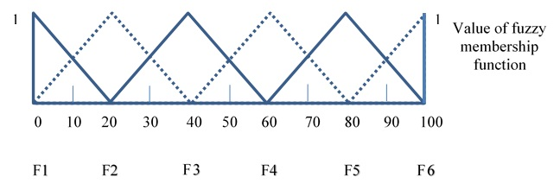

Fig. 2: Standard fuzzy scale

#### Establishment of values for the membership function of the standard fuzzy scale

The graphical representation of the membership function associated with a triplet (a, b, c) is shown in Figure 3. This representation indicates that when the abscissa value is equal to 'a', the membership function attains a value of one. Conversely, for values below (a - b) or above (a + c), the membership function value is zero. For any given value of x on the abscissa, the membership function Bx can be expressed as shown in Equation 7.

|  |  |  |
| --- | --- | --- |
|  | $$B_{x}=\frac{x-\left(a-b\right)}{b},for \left(a-b\right)<x<a$$ $$B_{x}=\frac{(a+c)-x}{c},for a<x<(a+c)$$ $$B_{x}=0, for all other values of x$$ | .… (7) |

For each of the samples and its triplet (Eqn. 1), value of membership function Bxat *x* = 0, 10, 20, 30, 40, 50, 60, 70, 80, 90 and 100 were obtained from equation (7). Membership value of the samples on standard fuzzy scale was given by a set of 10 numbers:

"(Maximum value of Bx at 0 < x < 10), (Maximum value of Bx at 10 < x < 20), (Maximum value of Bx at 20 < x < 30), (Maximum value of Bx at 30 < x < 40), (Maximum value of Bx at 40 < x < 50), (Maximum value of Bx at 50 < x < 60), (Maximum value of Bx at 60 < x < 70), (Maximum value of Bx at 70 < x < 80), (Maximum value of Bx at 80 < x < 90), (Maximum value of Bx at 90 < x < 100)".

Accordingly, the values of overall membership function of sensory scores for all the samples on standard fuzzy scale was obtained in a set of 10 numbers and denoted as B1, B2, B3,…and B16.

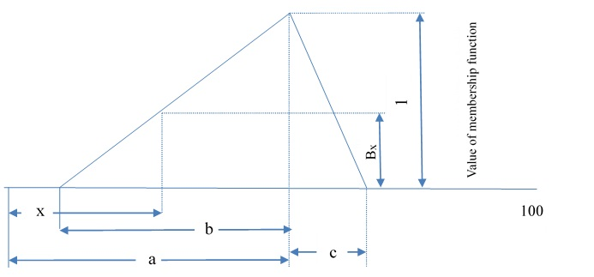

Fig. 3: Graphical representation of triplet (a b c) and its membership function

#### Evaluation of similarity values and ranking of functional beverage samples

For each sample, the membership functions (B1, B2, B3, …, B16) were evaluated in relation to the membership functions of the standard fuzzy scale (F1, F2, F3, F4, F5, and F6). Each term, ranging from B1 to B16 and F1 to F6, corresponds to a row matrix containing ten elements. The similarity value Sm(F, B) for a given sample B is determined using the following equation (Eqn. 8):

|  |  |  |
| --- | --- | --- |
|  | $$\text{Sm}\text{(F,B)=}\frac{\text{FoB}}{\text{maximum of (}\text{FoF}\text{ and BoB)}}$$ | .… (8) |

where,

FoB denotes the product of matrix F with the transpose of matrix B

FoF denotes the product of matrix F with the transpose of F and

BoB denotes the product of matrix B with its transpose

The similarity values for all samples were computed and employed for subsequent analysis. A MATLAB program (version R2023b) was developed to conduct the mathematical calculations of the various parameters as detailed in Das (2005.

## Result

A sensory evaluation was conducted according to a previously described method, involving 11 semi-trained panellists. The panellists received training on the product's characteristics, sensory evaluation procedure, scorecard, and scoring method. Each panellist was provided with a 50 ml sample of the beverage in a bottle, and the evaluation took place over three sessions. Without disclosing the formulation, the anticipated sensory attributes of the functional beverage were discussed, and the choices were recorded on a fuzzy scorecard (Table 1). For each quality characteristic, panellists indicate the corresponding fuzzy scale factor. Sensory quality attributes, including colour, aroma, taste, and mouthfeel, were assessed using a five-point linguistic scale: "Not Satisfactory" (NS), "Fair" (FR), "Medium" (MM), "Good" (GD), and "Excellent" (EX). Additionally, the importance of the quality attributes of the sample was evaluated on another five-point linguistic scale: “Not at All Important” (NI), “Somewhat Important” (SI), “Important” (IT), “Highly Important” (HI), and “Extremely Important” (EI) (Fig. 4 to 8).

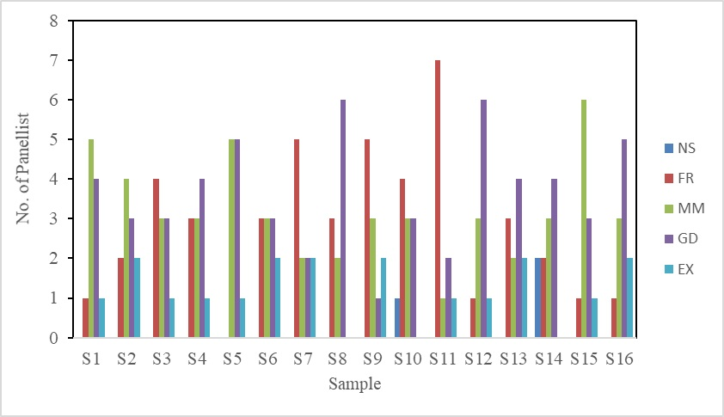

Fig. 4: Panellist preference for colour

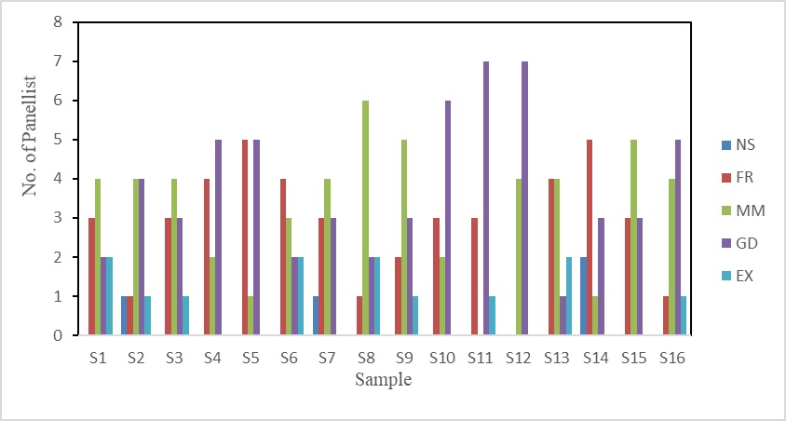

Fig. 5: Panellist preference for aroma

Fig. 6: Panellist preference for taste

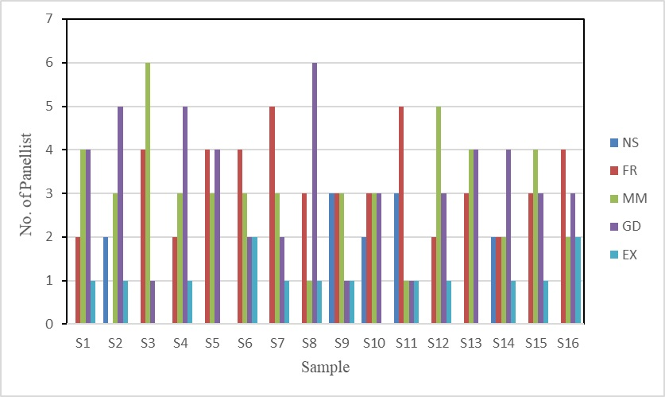

Fig. 7: Panellist preference for mouthfeel

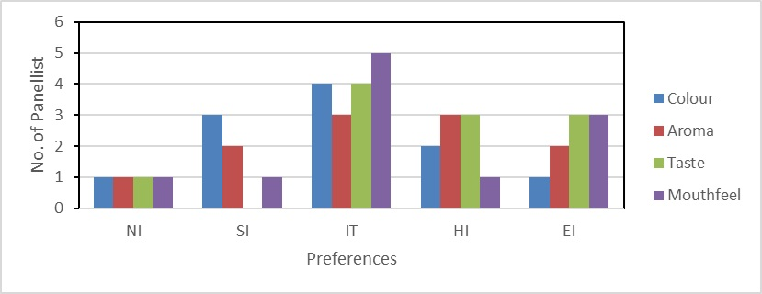

Fig. 8: Panellist preference for quality attributes

A sensory evaluation was performed following the aforementioned methodologies, utilizing fuzzy modeling to analyze the set of perceptions. The process involved the development of a MATLAB program specifically designed to evaluate sensory scores through fuzzy analysis. This program delineates fuzzy scale factors, sensory attributes, and the number of panellists and samples involved in the study. It initializes a matrix to record the similarity values and iteratively processes each sample, sensory attribute, and panellist to compute these values. Detailed information, including sensory score triplets, sensory scores for quality attributes, relative weightings of quality attributes, overall sensory scores, and the comprehensive membership functions of sensory scores mapped to a standard fuzzy scale (categorized as “Not Satisfactory,” “Fair,” “Satisfactory,” “Good,” “Very Good,” and “Excellent”), are presented in Tables 3 to 7. The results indicated that the panellists were capable of distinguishing between the different blends based on these assessments. Notably, significant differences were observed in the attributes of colour, aroma, taste, and mouthfeel. To address the variability among panellists, mitigate individual biases, and enhance the accuracy of the findings, the weighted average score of the similarity values was computed for subsequent analysis, as detailed in Table 8.

Table 3: Sum of the number of panellist with different preferences and triplets associated with the sensory scores for the colour of functional beverages.

|  |  |  |  |  |  |  |  |  |  |
| --- | --- | --- | --- | --- | --- | --- | --- | --- | --- |
| **Sensory quality attributes of beverage** | **NS** | **FR** | **MM** | **GD** | **EX** | **Triplets of the sensory score** | | | |
| S1 | 0 | 1 | 5 | 4 | 1 | S1C | 61.36 | 25.00 | 22.73 |
| S2 | 0 | 2 | 4 | 3 | 2 | S2C | 61.36 | 25.00 | 20.45 |
| S3 | 0 | 4 | 3 | 3 | 1 | S3C | 52.27 | 25.00 | 22.73 |
| S4 | 0 | 3 | 3 | 4 | 1 | S4C | 56.82 | 25.00 | 22.73 |
| S5 | 0 | 0 | 5 | 5 | 1 | S5C | 65.91 | 25.00 | 22.73 |
| S6 | 0 | 3 | 3 | 3 | 2 | S6C | 59.09 | 25.00 | 20.45 |
| S7 | 0 | 5 | 2 | 2 | 2 | S7C | 52.27 | 25.00 | 20.45 |
| S8 | 0 | 3 | 2 | 6 | 0 | S8C | 56.82 | 25.00 | 25.00 |
| S9 | 0 | 5 | 3 | 1 | 2 | S9C | 50.00 | 25.00 | 20.45 |
| S10 | 1 | 4 | 3 | 3 | 0 | S10C | 43.18 | 22.73 | 25.00 |
| S11 | 0 | 7 | 1 | 2 | 1 | S11C | 43.18 | 25.00 | 22.73 |
| S12 | 0 | 1 | 3 | 6 | 1 | S12C | 65.91 | 25.00 | 22.73 |
| S13 | 0 | 3 | 2 | 4 | 2 | S13C | 61.36 | 25.00 | 20.45 |
| S14 | 2 | 2 | 3 | 4 | 0 | S14C | 45.45 | 20.45 | 25.00 |
| S15 | 0 | 1 | 6 | 3 | 1 | S15C | 59.09 | 25.00 | 22.73 |
| S16 | 0 | 1 | 3 | 5 | 2 | S16C | 68.18 | 25.00 | 20.45 |
| NS- Not satisfactory, FR-Fair, MM-Medium, GD-Good, Ex-Excellent | | | | | | | | | |

Table 4: Sum of the number of panellist with different preferences and triplets associated with the sensory scores for the aroma of functional beverages.

|  |  |  |  |  |  |  |  |  |  |
| --- | --- | --- | --- | --- | --- | --- | --- | --- | --- |
| **Sensory quality attributes of beverage** | **NS** | **FR** | **MM** | **GD** | **EX** | **Triplets of the sensory score** | | | |
| S1 | 0 | 3 | 4 | 2 | 2 | S1S | 56.82 | 25.00 | 20.45 |
| S2 | 1 | 1 | 4 | 4 | 1 | S2S | 56.82 | 22.73 | 22.73 |
| S3 | 0 | 3 | 4 | 3 | 1 | S3S | 54.55 | 25.00 | 22.73 |
| S4 | 0 | 4 | 2 | 5 | 0 | S4S | 52.27 | 25.00 | 25.00 |
| S5 | 0 | 5 | 1 | 5 | 0 | S5S | 50.00 | 25.00 | 25.00 |
| S6 | 0 | 4 | 3 | 2 | 2 | S6S | 54.55 | 25.00 | 20.45 |
| S7 | 1 | 3 | 4 | 3 | 0 | S7S | 45.45 | 22.73 | 25.00 |
| S8 | 0 | 1 | 6 | 2 | 2 | S8S | 61.36 | 25.00 | 20.45 |
| S9 | 0 | 2 | 5 | 3 | 1 | S9S | 56.82 | 25.00 | 22.73 |
| S10 | 0 | 3 | 2 | 6 | 0 | S10S | 56.82 | 25.00 | 25.00 |
| S11 | 0 | 3 | 0 | 7 | 1 | S11S | 63.64 | 25.00 | 22.73 |
| S12 | 0 | 0 | 4 | 7 | 0 | S12S | 65.91 | 25.00 | 25.00 |
| S13 | 0 | 4 | 4 | 1 | 2 | S13S | 52.27 | 25.00 | 20.45 |
| S14 | 2 | 5 | 1 | 3 | 0 | S14S | 36.36 | 20.45 | 25.00 |
| S15 | 0 | 3 | 5 | 3 | 0 | S15S | 50.00 | 25.00 | 25.00 |
| S16 | 0 | 1 | 4 | 5 | 1 | S16S | 63.64 | 25.00 | 22.73 |
| NS- Not satisfactory, FR-Fair, MM-Medium, GD-Good, Ex-Excellent | | | | | | | | | |

Table 5: Sum of the number of panellist with different preferences and triplets associated with the sensory scores for the Taste of functional beverages.

|  |  |  |  |  |  |  |  |  |  |
| --- | --- | --- | --- | --- | --- | --- | --- | --- | --- |
| **Sensory quality attributes of beverage** | **NS** | **FR** | **MM** | **GD** | **EX** | **Triplets of the sensory score** | | | |
| S1 | 0 | 4 | 3 | 3 | 1 | S1T | 52.27 | 25.00 | 22.73 |
| S2 | 1 | 1 | 2 | 6 | 1 | S2T | 61.36 | 22.73 | 22.73 |
| S3 | 0 | 3 | 4 | 4 | 0 | S3T | 52.27 | 25.00 | 25.00 |
| S4 | 0 | 4 | 4 | 3 | 0 | S4T | 47.73 | 25.00 | 25.00 |
| S5 | 0 | 3 | 3 | 5 | 0 | S5T | 54.55 | 25.00 | 25.00 |
| S6 | 0 | 4 | 4 | 2 | 1 | S6T | 50.00 | 25.00 | 22.73 |
| S7 | 0 | 3 | 5 | 2 | 1 | S7T | 52.27 | 25.00 | 22.73 |
| S8 | 0 | 2 | 1 | 6 | 2 | S8T | 68.18 | 25.00 | 20.45 |
| S9 | 3 | 1 | 2 | 3 | 2 | S9T | 50.00 | 18.18 | 20.45 |
| S10 | 1 | 4 | 3 | 3 | 0 | S10T | 43.18 | 22.73 | 25.00 |
| S11 | 2 | 2 | 3 | 3 | 1 | S11T | 47.73 | 20.45 | 22.73 |
| S12 | 0 | 2 | 2 | 7 | 0 | S12T | 61.36 | 25.00 | 25.00 |
| S13 | 1 | 4 | 3 | 2 | 1 | S13T | 45.45 | 22.73 | 22.73 |
| S14 | 0 | 2 | 3 | 5 | 1 | S14T | 61.36 | 25.00 | 22.73 |
| S15 | 1 | 4 | 4 | 2 | 0 | S15T | 40.91 | 22.73 | 25.00 |
| S16 | 1 | 1 | 3 | 5 | 1 | S16T | 59.09 | 22.73 | 22.73 |
| NS- Not satisfactory, FR-Fair, MM-Medium, GD-Good, Ex-Excellent | | | | | | | | | |

Table 6: Sum of the number of panellist with different preferences and triplets associated with the sensory scores for the mouthfeel of functional beverages.

|  |  |  |  |  |  |  |  |  |  |
| --- | --- | --- | --- | --- | --- | --- | --- | --- | --- |
| **Sensory quality attributes of beverage** | **NS** | **FR** | **MM** | **GD** | **EX** | **Triplets of the sensory score** | | | |
| S1 | 0 | 2 | 4 | 4 | 1 | S1M | 59.09 | 25.00 | 22.73 |
| S2 | 2 | 0 | 3 | 5 | 1 | S2M | 56.82 | 20.45 | 22.73 |
| S3 | 0 | 4 | 6 | 1 | 0 | S3M | 43.18 | 25.00 | 25.00 |
| S4 | 0 | 2 | 3 | 5 | 1 | S4M | 61.36 | 25.00 | 22.73 |
| S5 | 0 | 4 | 3 | 4 | 0 | S5M | 50.00 | 25.00 | 25.00 |
| S6 | 0 | 4 | 3 | 2 | 2 | S6M | 54.55 | 25.00 | 20.45 |
| S7 | 0 | 5 | 3 | 2 | 1 | S7M | 47.73 | 25.00 | 22.73 |
| S8 | 0 | 3 | 1 | 6 | 1 | S8M | 61.36 | 25.00 | 22.73 |
| S9 | 3 | 3 | 3 | 1 | 1 | S9M | 36.36 | 18.18 | 22.73 |
| S10 | 2 | 3 | 3 | 3 | 0 | S10M | 40.91 | 20.45 | 25.00 |
| S11 | 3 | 5 | 1 | 1 | 1 | S11M | 31.82 | 18.18 | 22.73 |
| S12 | 0 | 2 | 5 | 3 | 1 | S12M | 56.82 | 25.00 | 22.73 |
| S13 | 0 | 3 | 4 | 4 | 0 | S13M | 52.27 | 25.00 | 25.00 |
| S14 | 2 | 2 | 2 | 4 | 1 | S14M | 50.00 | 20.45 | 22.73 |
| S15 | 0 | 3 | 4 | 3 | 1 | S15M | 54.55 | 25.00 | 22.73 |
| S16 | 0 | 4 | 2 | 3 | 2 | S16M | 56.82 | 25.00 | 20.45 |
| NS- Not satisfactory, FR-Fair, MM-Medium, GD-Good, Ex-Excellent | | | | | | | | | |

**Table 7: Sum of the number of panellist with different preferences, triplets associated with scores and the relative weightage for quality attributes of the beverages samples in general.**

|  |  |  |  |  |  |  |  |  |  |  |  |  |  |
| --- | --- | --- | --- | --- | --- | --- | --- | --- | --- | --- | --- | --- | --- |
| **Quality attributes** | **NI** | **SI** | **IT** | **HI** | **EI** | **Triplets for sensory scores** | | | | **Triplets for relative**  **Weightage** | | | |
| Colour | 1 | 3 | 4 | 2 | 1 | QC | 47.73 | 22.73 | 22.73 | QCrel | 0.21 | 0.10 | 0.10 |
| Aroma | 1 | 2 | 3 | 3 | 2 | QA | 56.82 | 22.73 | 20.45 | QArel | 0.25 | 0.10 | 0.09 |
| Taste | 1 | 0 | 4 | 3 | 3 | QT | 65.91 | 22.73 | 18.18 | QTrel | 0.29 | 0.10 | 0.08 |
| Mouthfeel | 1 | 1 | 5 | 1 | 3 | QM | 59.09 | 22.73 | 18.18 | QMrel | 0.26 | 0.10 | 0.08 |
| NI-Not at all important, SI-Somewhat important, IT-Important, HI-Highly Important, EI-Extremely Important | | | | | | | | | | | | | |

Table 8: Similarity value and weighted average of formulated functional beverage

|  |  |  |  |  |  |  |  |
| --- | --- | --- | --- | --- | --- | --- | --- |
| **S.No.** | **NS** | **FR** | **ST** | **GD** | **VG** | **ET** | **WA** |
| 1 | 0.032 | 0.248 | 0.556 | 0.680 | 0.433 | 0.112 | 0.705 |
| 2 | 0.019 | 0.203 | 0.519 | 0.689 | 0.471 | 0.133 | 0.718 |
| 3 | 0.067 | 0.330 | 0.642 | 0.642 | 0.312 | 0.049 | 0.644 |
| 4 | 0.046 | 0.283 | 0.593 | 0.668 | 0.392 | 0.093 | 0.689 |
| 5 | 0.045 | 0.277 | 0.584 | 0.666 | 0.402 | 0.101 | 0.694 |
| 6 | 0.048 | 0.291 | 0.609 | 0.678 | 0.374 | 0.074 | 0.680 |
| 7 | 0.070 | 0.347 | 0.664 | 0.639 | 0.282 | 0.031 | 0.628 |
| 8 | 0.018 | 0.188 | 0.478 | 0.673 | 0.515 | 0.162 | 0.733 |
| 9 | 0.057 | 0.352 | 0.701 | 0.649 | 0.262 | 0.024 | 0.628 |
| 10 | 0.082 | 0.396 | 0.706 | 0.613 | 0.247 | 0.023 | 0.620 |
| 11 | 0.073 | 0.385 | 0.715 | 0.628 | 0.241 | 0.020 | 0.621 |
| 12 | 0.018 | 0.188 | 0.472 | 0.662 | 0.516 | 0.169 | 0.731 |
| 13 | 0.055 | 0.310 | 0.631 | 0.664 | 0.342 | 0.060 | 0.663 |
| 14 | 0.052 | 0.332 | 0.678 | 0.652 | 0.286 | 0.031 | 0.634 |
| 15 | 0.064 | 0.327 | 0.642 | 0.643 | 0.315 | 0.051 | 0.645 |
| 16 | 0.019 | 0.193 | 0.487 | 0.675 | 0.502 | 0.154 | 0.728 |
| NS-Not satisfactory, FR-Fair, ST-Satisfactory, GD-Good, VG-Very good, ET Excellent, WAS- Weighted average score | | | | | | | |

The weighted average of sensory acceptability values demonstrated variability ranging from 0.620 to 0.733 (Table 8). The influence of ingredient levels on sensory acceptability was found to be complex. The lowest weighted average sensory acceptability score was recorded for sample number 10, which contained a lower concentration of ginger juice in combination with a higher concentration of turmeric juice. Conversely, the highest score was attributed to sample 8, consisting of a ginger to turmeric juice ratio of 10.61:9.46.

## Discussion

**4.1 Key findings**

Table 9 shows the findings of the ANOVA employed to assess the significance of ingredient levels on the sensory acceptability of the functional beverage. The data were aptly characterized by a special cubic model, exhibiting a high R² value of 0.968. The 'Model' row reflects the substantial significance of the overall model, which is underscored by an F-value of 45.37 and a p-value of less than 0.0001. This indicated a strong model fit for the data, affirming that the included factors exerted a significant influence on the response variable. In contrast, the linear and quadratic mixture effects (as represented by the GJ×TJ, GJ×DW, and TJ×DW rows) revealed that none of these individual factors significantly affected the response variable, as evidenced by their respective p-values exceeding 0.05. Nonetheless, the interaction effect denoted as GJ×TJ×DW, which pertains to the combination of ginger juice, turmeric juice, and distilled water, exhibited high significance with an F-value of 117.38 and a p-value less than 0.0001. This finding underscore that the interplay between these three components substantially affects the sensory acceptability of the beverage. The resulting regression equation for sensory acceptability (Eqn. 9), after excluding non-significant terms, corroborates these findings.

|  |  |  |
| --- | --- | --- |
|  | Sensory Acceptability = 3.35 GJ×TJ×DW | ….(9) |

Where,

GJ = Coded value of Ginger Juice

TJ = Coded value of TurmericJuice

DW = Coded value of Distilled Water

The contour plot and 3D surface graph indicate that the highest sensory acceptability was achieved at a ratio of GJ:TJ:DW of 10.61:9.46:69.93, while the lowest sensory acceptability occurred with a minimal GJ percentage of 5%. It was observed that sensory acceptability increases with higher levels of GJ, reaching its peak within the specified range, which is likely attributable to its desirable pungency. Okwunodulu et al. (2023) also noted an enhanced mouthfeel with increased ginger content, whereas a rise in turmeric percentage resulted in a decreased mouthfeel in the ginger-garlic-turmeric-pineapple juice blend. Conversely, higher levels of TJ produced a significant decline in sensory acceptability, likely due to increased bitterness from turmerones (Sun et al., 2023). These findings further support the appealing qualities of ginger as highlighted in the Characa Samhita (Sharma, 1981). These results suggest that a greater proportion of GJ relative to TJ may effectively mask the bitterness associated with TJ. Similar findings have been reported by Ogori et al. (2021) and Yusufali et al. (2024) for a pineapple juice mixture with 10% turmeric and 10% ginger.

Table 9: ANOVA for variation of ingredient level on sensory acceptability

|  |  |  |  |  |  |
| --- | --- | --- | --- | --- | --- |
| **Source** | **Sum of squares** | **df** | **Mean square** | **F-value** | **p-value** |
| Model | 0.0258 | 6 | 0.0043 | 45.37 | <0.0001*** |
| Linear Mixture | 0.0003 | 2 | 0.0002 | 1.77 | 0.2244NS |
| GJ×TJ | 0.0000 | 1 | 0.0000 | 0.1195 | 0.7375NS |
| GJ×DW | 0.0001 | 1 | 0.0001 | 1.00 | 0.3434NS |
| TJ×DW | 0.0001 | 1 | 0.0001 | 0.7442 | 0.4107NS |
| GJ×TJ×DW | 0.0111 | 1 | 0.0111 | 117.38 | <0.0001*** |
| Residual | 0.0009 | 9 | 0.0001 |  |  |
| Lack of Fit | 0.0004 | 4 | 0.0001 | 1.11 | 0.4459NS |
| Pure Error | 0.0005 | 5 | 0.0001 |  |  |
| Cor Total | 0.0267 | 15 |  |  |  |
| R² | 0.97 |  |  |  |  |
| Adjusted R² | 0.95 |  |  |  |  |
| Predicted R² | 0.88 |  |  |  |  |
| APR | 16.87 |  |  |  |  |
| C.V. % | 1.45 |  |  |  |  |
| *** p < 0.001, NS – Non-significant, | | | | | |

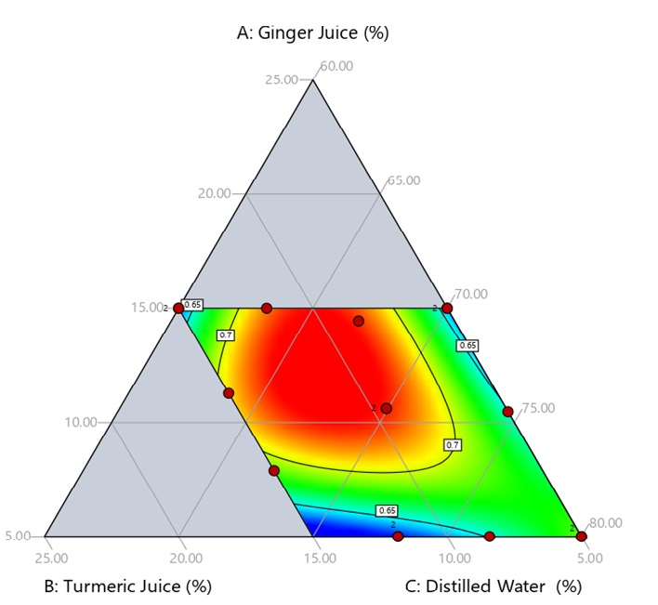

**Fig. 9: Effect of ingredient proportion on sensory acceptability of functional beverage (Contour plot)**

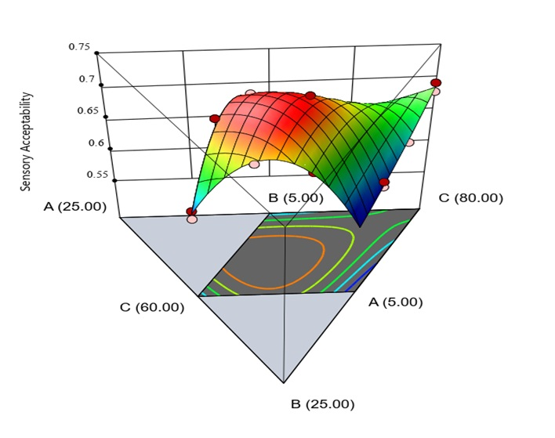

Fig. 10: Effect of ingredient proportion on sensory acceptability of functional beverage (3-D surface graph)

A-Ginger juice (GJ), B-Turmeric juice (TJ), C-Distilled water (DW)

**4.2 Limitations and suggestions for future research**

The sensory evaluation in this study provided valuable insights into the functional beverage's quality attributes, but several limitations must be acknowledged. The sample size of 11 semi-trained panellists may not represent the broader population, limiting the findings' generalizability. The evaluation occurred over three sessions, which could introduce variability due to panellist fatigue or changes in sensory acuity. Additionally, external factors like environmental conditions during tasting were not considered. Future research should increase the sample size and include a more diverse participant group to enhance generalizability. Exploring a wider range of ingredient combinations and assessing long-term consumer acceptance in real-world settings would also be beneficial. Conducting blind taste tests may help reduce bias. Finally, employing advanced statistical methods, such as machine learning, could provide deeper insights into the relationships between ingredient ratios and sensory attributes.

## Conclusion

This study aimed to analyze the sensory properties of a functional beverage developed with ginger and turmeric as the primary ingredients, utilizing fuzzy logic analysis. The therapeutic potential of these two ingredients is well documented in ancient literature and supported by modern scientific research. This study represents the first effort to combine the juices of ginger and turmeric to create a healthier drink. Sensory evaluation indicated that the developed functional beverage was organoleptically acceptable. Sixteen samples were evaluated based on variations in ingredient levels generated by the D-optimal mixture design. The sensory preferences expressed by the panelists regarding color, aroma, mouthfeel, and taste were subjected to fuzzification and defuzzification to derive a comparable numerical score. Regression analysis of the data revealed a non-linear relationship between the levels of ginger juice, turmeric juice, and water. ANOVA results show that while the individual ingredients (ginger juice, turmeric juice, and distilled water) do not significantly affect the sensory acceptability of the functional beverage, the combined interaction of all three ingredients was highly significant. Optimal sensory acceptability was achieved with a specific ratio of ginger juice, turmeric juice, and distilled water, highlighting ginger's role in enhancing flavor and mitigating the bitterness of turmeric. These findings align with historical references to ginger's appetizing qualities and suggest that careful balancing of ingredients is crucial for creating palatable functional beverages.

## Ethical statement

Ethical consent was obtained from all the panellists of sensory evaluation. Ethical approval is not required for sensory evaluations as per Indian national regulations (FSSAI, 2011).

**References**

Abolfazli, S., Mortazavi, P., Kheirandish, A., Butler, A. E., Jamialahmadi, T., & Sahebkar, A. (2024). Regulatory effects of curcumin on nitric oxide signaling in the cardiovascular system. Nitric Oxide,143,16-28. https://doi.org/10.1016/j.niox.2023.12.003.

Ademosun, M. T., Omoba, O. S., & Olagunju, A. I. (2021). Antioxidant properties, glycemic indices, and carbohydrate hydrolyzing enzymes activities of formulated ginger-based fruit drinks. Journal of Food Biochemistry, 45(3), Article e13324. https://doi.org/10.1111/jfbc.13324.

Arablou, T., Aryaeian, N., Valizadeh, M., Sharifi, F., Hosseini, A., & Djalali, M. (2014). The effect of ginger consumption on glycemic status, lipid profile and some inflammatory markers in patients with type 2 diabetes mellitus. International Journal of Food Sciences and Nutrition, 65(4), 515–520. https://doi.org/10.3109/09637486.2014.880671.

Asamenew, G., Kim, H. W., Lee, M. K., Lee, S. H., Kim, Y. J., Cha, Y. S., Yoo, S. M., & Kim, J. B. (2019). Characterization of phenolic compounds from normal ginger (Zingiber officinale Rosc.) and black ginger (Kaempferia parviflora Wall.) using UPLC–DAD–QToF–MS. European Food Research and Technology, 245(3), 653–665. https://doi.org/10.1007/s00217-018-3188-z.

Ávila-Gálvez, M. Á., González-Sarrías, A., Martínez-Díaz, F., Abellán, B., Martínez-Torrano, A. J., Fernández-López, A. J., Giménez-Bastida, J. A., & Espín, J. C. (2021). Disposition of dietary polyphenols in breast cancer patients’ tumors, and their associated anticancer activity: the particular case of curcumin. Molecular Nutrition and Food Research, 65(12), Article e2100163. https://doi.org/10.1002/mnfr.202100163.

Banji, D., Banji, O. J. F., & Srinivas, K. (2021). Neuroprotective effect of turmeric extract in combination with its essential oil and enhanced brain bioavailability in an animal model. BioMed Research International, 2021, Article 6645720. https://doi.org/10.1155/2021/6645720.

Corbo, M. R., Bevilacqua, A., Petruzzi, L., Casanova, F. P., & Sinigaglia, M. (2014). Functional beverages: the emerging side of functional foods: commercial trends, research, and health implications. Comprehensive Reviews in Food Science and Food Safety, 13(6), 1192–1206. https://doi.org/10.1111/1541-4337.12109.

Danwilai, K., Konmun, J., Sripanidkulchai, B. O., & Subongkot, S. (2017). Antioxidant activity of ginger extract as a daily supplement in cancer patients receiving adjuvant chemotherapy: A pilot study. Cancer Management and Research, 9, 11–18. https://doi.org/10.2147/CMAR.S124016.

Das, H. . (2005). Food processing operations analysis. Asian Books Private Limited (Chapter 26).

Dehzad, M. J., Ghalandari, H., Amini, M. R., & Askarpour, M. (2023). Effects of curcumin/turmeric supplementation on liver function in adults: A GRADE-assessed systematic review and dose–response meta-analysis of randomized controlled trials. Complementary Therapies in Medicine, 74, Article 102952. https://doi.org/10.1016/j.ctim.2023.102952.

Deshmukh, S. D., Pardeshi, I. L., Solanke, S. B., & Shinde, K. J. (2018). Sensory evaluation of ready to eat snack food using fuzzy logic. International Journal of Current Microbiology and Applied Sciences, 7(10), 551–562. https://doi.org/10.20546/ijcmas.2018.710.061.

Dhar, R., Bhalerao, P. P., & Chakraborty, S. (2021). Formulation of a mixed fruit beverage using fuzzy logic optimization of sensory data and designing its batch thermal pasteurization process. Journal of Food Science, 86(2), 463–474. https://doi.org/10.1111/1750-3841.15583.

Faisal, S., Chakraborty, S., Devi, Hazarika, & Puranik, V. (2017). Sensory evaluation of probiotic whey beverages formulated from orange powder and flavor using fuzzy logic Introduction. International Food Research Journal, 24(2), 703-710.

Franklin, M. E. E., Pushpadass, H. A., Kamaraj, M., Muthurayappa, M., & Battula, S. N. (2019). Application of D-optimal mixture design and fuzzy logic approach in the preparation of chhana podo (baked milk cake). Journal of Food Process Engineering, 42(5), Article e13121. https://doi.org/10.1111/jfpe.13121.

Gomez, S., Anjali, C., Kuruvila, B., Maneesha, P. K., & Joseph, M. (2023). Phytochemical constitution and antioxidant activity of functional herbal drink from Indian gooseberry (Emblica officinalis Gaertn.) fruits containing spices and condiments. Food Production, Processing and Nutrition, 5(1), 4–13. https://doi.org/10.1186/s43014-022-00127-8.

Govindarajan, V. S. (1980). Turmeric—chemistry, technology, and quality. C R C Critical Reviews in Food Science and Nutrition, 12(3), 199–301. https://doi.org/10.1080/10408398009527278.

Gupta, A., Sanwal, N., Bareen, M. A., Barua, S., Sharma, N., Joshua Olatunji, O., Prakash Nirmal, N., & Sahu, J. K. (2023). Trends in functional beverages: Functional ingredients, processing technologies, stability, health benefits, and consumer perspective. Food Research International, 170, Article 113046. https://doi.org/10.1016/j.foodres.2023.113046.

Iweala, E. J., Uche, M. E., Dike, E. D., Etumnu, L. R., Dokunmu, T. M., Oluwapelumi, A. E., Okoro, B. C., Dania, O. E., Adebayo, A. H., & Ugbogu, E. A. (2023). Curcuma longa (Turmeric): Ethnomedicinal uses, phytochemistry, pharmacological activities and toxicity profiles—A review. Pharmacological Research - Modern Chinese Medicine, 6, Article 100222. https://doi.org/10.1016/j.prmcm.2023.100222.

Jaeger, S. R., Giacalone, D., Jin, D., Ryan, G. S., & Cardello, A. V. (2023). Information about health and environmental benefits has minimal impact on consumer responses to commercial plant-based yoghurts. Food Quality and Preference, 106, Article 104820. https://doi.org/10.1016/j.foodqual.2023.104820.

Jose, D. A., Bhabhina, N. M., Leela, N. K., Vishudha, M., Aarthi, S., & Prasath, D. (2022). Comprehensive assessment of phytometabolites and health benefits of Geographical Indication turmeric in India. Journal of Spices and Aromatic Crops, 31(1), 45–55. https://doi.org/10.25081/josac.2022.v31.i1.7668.

Kumar, Rahul., Ghosh, P., Srinivasa Rao, P., Rana, S. S., Vashishth, R., & Vivek, K. (2021). Sensory evaluation of microwave assisted ultrasound treated soymilk beverage using fuzzy logic. Journal of the Saudi Society of Agricultural Sciences, 20(4), 257–264. https://doi.org/10.1016/j.jssas.2021.02.005.

Mad Azli, A. A., Salamt, N., Aminuddin, A., Roos, N. A. C., Mokhtar, M. H., Kumar, J., Hamid, A. A., & Ugusman, A. (2024). The role of curcumin in modulating vascular function and structure during menopause: a systematic review. Biomedicines, 12(10), Article 2281. https://doi.org/10.3390/biomedicines12102281.

Mirhafez, S. R., Azimi-Nezhad, M., Dehabeh, M., Hariri, M., Naderan, R. D., Movahedi, A., Abdalla, M., Sathyapalan, T., & Sahebkar, A. (2021). The effect of curcumin phytosome on the treatment of patients with non-alcoholic fatty liver disease: a double-blind, randomized, placebo-controlled trial. In Advances in Experimental Medicine and Biology, 1308, 25-35. https://doi.org/10.1007/978-3-030-64872-5_3.

Mozaffari-Khosravi, H., Naderi, Z., Dehghan, A., Nadjarzadeh, A., & Fallah Huseini, H. (2016). Effect of ginger supplementation on proinflammatory cytokines in older patients with osteoarthritis: outcomes of a randomized controlled clinical trial. Journal of Nutrition in Gerontology and Geriatrics, 35(3), 209–218. https://doi.org/10.1080/21551197.2016.1206762.

Nair, K. P. (2019). Turmeric (Curcuma longa L.) And ginger (Zingiber officinale Rosc.)-world’s invaluable medicinal spices the agronomy and economy of turmeric and ginger. Springer. https://doi.org/10.1007/978-3-030-29189-1.

Odo, E. O., Ikwuegbu, J. A., Obeagu, E. I., Chibueze, S. A., & Ochiaka, R. E. (2023). Analysis of the antibacterial effects of turmeric on particular bacteria. Medicine, 102(48), Article e36492. https://doi.org/10.1097/MD.0000000000036492.

Ogori, A. F., Amove, J., Aduloju, P., Sardo, G., Okpala, C. O. R., Bono, G., & Korzeniowska, M. (2021). Functional and quality characteristics of ginger, pineapple, and turmeric juice mix as influenced by blend variations. Foods, 10(3), Article 525. https://doi.org/10.3390/foods10030525.

Okwunodulu, I. N., Obioma, V. N., Okwunodulu, F. U., Ndife, J., & Wabali, V. (2023). Functional combo juice drink from ginger, garlic turmeric and pine apple juice blends: Bioactive compounds, anti-oxidant activity, physicochemical elucidation and their sensorial expectations. Food Chemistry Advances, 3, Article 100391. https://doi.org/10.1016/j.focha.2023.100391.

Prasad, S., & Aggarwal, B. B. (2011). Turmeric, the golden spice from traditional medicine to modern medicine. In Iris F.F.; Sissi W.G.(Eds.), Herbal medicine - biomolecular and clinical aspects (pp. 263–288). Taylor and Francis.

Raje-Nimbalkar, F. A., Raskar, A. B., Kadav, V. B., & Joshi, S. V. (2023). Preparation of low fat lassi by incorporation of ginger juice. International Journal of Bio-Resource and Stress Management, 14(7), 1082–1088. https://doi.org/10.23910/1.2023.3476.

Rocha-Parra, D., García-Burgos, D., Munsch, S., Chirife, J., & Zamora, M. C. (2016). Application of hedonic dynamics using multiple-sip temporal-liking and facial expression for evaluation of a new beverage. Food Quality and Preference, 52, 153-159. https://doi.org/10.1016/j.foodqual.2016.04.013.

Sharma, M., Vidhya C. S., Ojha, K., Yashwanth B. S., Singh, B., Gupta, S., & Pandey, S. K. (2024). The role of functional foods and nutraceuticals in disease prevention and health promotion. European Journal of Nutrition & Food Safety, 16(2), 61–83. https://doi.org/10.9734/ejnfs/2024/v16i21388.

Sharma, P. V. (1981). Charaka Samhita - Text with English Tanslation. Chaukhambha Orientalia.

Shukla, Abhishek., Goud, V. V., & Das, C. (2019). Antioxidant potential and nutritional compositions of selected ginger varieties found in Northeast India. Industrial Crops and Products, 128, 167–176. https://doi.org/10.1016/j.indcrop.2018.10.086.

Sik, B., Székelyhidi, R., Lakatos, E., Kapcsándi, V., & Ajtony, Z. (2022). Analytical procedures for determination of phenolics active herbal ingredients in fortified functional foods: an overview. European Food Research and Technology, 248, 329–344. https://doi.org/10.1007/s00217-021-03908-6.

Singhal, S., Hasan, N., Nirmal, K., Chawla, R., Chawla, S., Kalra, B. S., & Dhal, A. (2021). Bioavailable turmeric extract for knee osteoarthritis: a randomized, non-inferiority trial versus paracetamol. Trials, 22(1), Article 105. https://doi.org/10.1186/s13063-021-05053-7.

Sun, X., Follett, P. A., Wall, M. M., Duff, K. S., Wu, X., Shu, C., Plotto, A., Liang, P., & Stockton, D. G. (2023). Physical, chemical, and sensory properties of a turmeric-fortified pineapple juice beverage. Foods, 12(12), Article 2323. https://doi.org/10.3390/foods12122323.

Tadakod, M., Deshmni, S., Harshitha, T., Kavitha, C., & Desai, S. R. (2023). Sensory Studies of Safflower Seed Milkshake Analogue using Fuzzy Logic. Mysore J. Agric. Sci., 57(1), 139–151. https://www.researchgate.net/publication/369385043.

Talaei, B., Mozaffari-Khosravi, H., & Bahreini, S. (2018). The effect of ginger powder supplementation on blood pressure of patients with type 2 diabetes: a double-blind randomized clinical controlled trial. Journal of Nutrition and Food Security, 3(2), 70–78.

Tanvir, E. M., Hossen, M. S., Hossain, M. F., Afroz, R., Gan, S. H., Khalil, M. I., & Karim, N. (2017). Antioxidant properties of popular turmeric (Curcuma longa) varieties from Bangladesh. Journal of Food Quality, 2017, Article 8471785. https://doi.org/10.1155/2017/8471785.

Waehrens, S. S., Faber, I., Gunn, L., Buldo, P., Bom Frøst, M., & Perez-Cueto, F. J. A. (2023). Consumers’ sensory-based cognitions of currently available and ideal plant-based food alternatives: A survey in Western, Central and Northern Europe. Food Quality and Preference, 108, Article 104875. https://doi.org/10.1016/j.foodqual.2023.104875.

Weng, W., & Goel, A. (2022). Curcumin and colorectal cancer: An update and current perspective on this natural medicine. Seminars in Cancer Biology, 80, 73-86. https://doi.org/10.1016/j.semcancer.2020.02.011.

Yaikwawong, M., Jansarikit, L., Jirawatnotai, S., & Chuengsamarn, S. (2024). Curcumin extract improves beta cell functions in obese patients with type 2 diabetes: a randomized controlled trial. Nutrition Journal, 23(1), Article 119. https://doi.org/10.1186/s12937-024-01022-3.

Yusufali, Z., Follett, P., Wall, M., & Sun, X. (2024). Physiochemical and sensory properties of a turmeric, ginger, and pineapple functional beverage with effects of pulp content. Foods, 13(5), Article 718. https://doi.org/10.3390/foods13050718.

Zhao, Y. H., Shen, C. F., Wang, G. J., Kang, Y., Song, Y. H., & Liu, J. W. (2021). Curcumin alleviates acute kidney injury in a dry-heat environment by reducing oxidative stress and inflammation in a rat model. Journal of Biochemical and Molecular Toxicology, 35(1),Article 22630. https://doi.org/10.1002/jbt.22630.

Zhukovets, T., & Musa Özcan, M. (2020). A review: composition, use and bioactive properties of ginger (Zingiber officinale L.) rhizoms. Journal of Agroalimentary Processes and Technologies, 26(3), 200–216.