Original Research Article

COMPOSITION, STRUCTURE, AND PROPERTIES OF VERMICULITE FROM THE TEBINBULOK DEPOSIT IN KARAKALPAKSTAN

Abstract
In this research, the chemical composition and physicochemical properties of vermiculite from the Tebinbulak deposit, located in the Karauzyak district of the Republic of Karakalpakstan, were comprehensively investigated. The analyses conducted using X-ray diffraction (XRD), scanning electron microscopy (SEM), and energy-dispersive spectroscopy (EDS) revealed that the studied vermiculite belongs to the class of layered magnesium–aluminum and magnesium–iron aluminosilicates. The crystal structure of the mineral contains interlayer water molecules, which contribute to its distinctive physicochemical behavior. Owing to its broad range of applications—including in construction, the food and chemical industries, oil and gas extraction, nuclear energy, environmental protection, metallurgy, mechanical engineering, railway car manufacturing, shipbuilding, mining, and agriculture—the industrial relevance and economic value of vermiculite are steadily increasing.
Keywords: Vermiculite, Tebinbulak deposit, Karakalpakstan, X-ray diffraction, SEM, EDS, magnesium fertilizer, physicochemical properties.

Introduction
The mineral vermiculite is classified as a layered magnesium–aluminum and magnesium–iron aluminosilicate. Its crystal lattice contains interlayer water molecules, which play a critical role in its thermal behavior. Upon exposure to elevated temperatures ranging from 600 to 1200 °C, vermiculite undergoes significant thermal expansion, increasing in volume by approximately 8 to 12 times due to the swelling of its layered structure. The resulting calcined (expanded) vermiculite is a lightweight, highly porous material characterized by a silvery or golden appearance. Following thermal treatment, expanded vermiculite becomes odorless, non-toxic, and exhibits excellent thermal and acoustic insulation properties. These characteristics make it suitable for use as a non-combustible loose-fill insulating material in external walls, attics, and floor systems. One of the notable advantages of expanded vermiculite is its high flowability, enabling it to effectively fill cavities with complex or irregular geometries [1].
Vermiculite is considered a unique natural mineral with significant innovative potential across various industrial applications. Structurally, it belongs to the hydromica group—secondary alteration products derived from the decomposition and hydrolysis of biotite and phlogopite micas. The general chemical formula of vermiculite is: (Mg, Fe²⁺, Fe³⁺)[(Si, Al)₄O₁₀][OH]₂·4H₂O. In its natural state, vermiculite typically appears in golden-yellow to brown hues (Figure 1), reflecting its mineralogical composition and geological formation conditions.

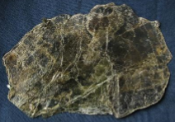 | 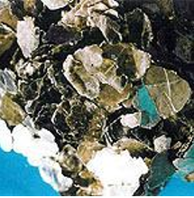
Figure 1. Natural Vermiculite
The main components in the composition of this mineral are: SiO₂ (33–45%), Al₂O₃ (6–18%), FeO (1–3%), Fe₂O₃ (5–17%), MgO (14–30%), H₂O (5–18%), and it may also contain CaO, K₂O, NiO, TiO₂, MnO, Na₂O, and other additives. The chemical composition of calcined vermiculite remains unchanged in terms of elemental constituents; however, thermal treatment leads to an increase in the concentration of these components due to the loss of interlayer water and volatile compounds. Owing to its broad applicability across numerous sectors—including construction, the food and chemical industries, oil and gas extraction, nuclear energy, environmental protection, metallurgy, mechanical engineering, railway car manufacturing, shipbuilding, mining, and agriculture—the industrial significance and economic value of thermally processed vermiculite are considerable [2].
According to data presented in technical and scientific literature, vermiculite is a widely occurring mineral found in significant quantities across the globe. Notable large-scale deposits are located in countries such as China, Madagascar, Colombia, Brazil, and others. The chemical compositions of vermiculite samples from these deposits have been determined using standardized analytical techniques, and the results are summarized in Table 1.
Table 1
Chemical composition of vermiculite minerals from various deposits [3–5]
Names of Deposits in Countries | SiO₂ | TiO | Al₂O₃ | Cr₂O₃ | Fe₂O₃ | FeO | MnO | MgO | NiO | CaO | Na₂O | K₂O
Madagascar | 44,5 | 0,69 | 14,7 | - | 2,6 | - | 0,07 | 33,7 | - | - | - | -
Колумбиya | 45,4 | 0,73 | 13,0 | - | 6.9 | 1.2 | 0.11 | 24.1 | - | 2.8 | 0.2 | 0.6
Brazil | 39.9 | 1.12 | 9.27 | 0.06 | - | 6.6 | 0.04 | 25.4 | 0.02 | 0.2 | 0.04 | 3.5
China | 43.2 | 1.01 | 11.8 | 0.16 | - | 4.2 | 0.01 | 24.2 | 0.04 | 0.4 | 0.7 | 7.4
Egypt | 39.1 | 1.21 | 12.2 | 0.25 | 1.54 | 8.36 | - | 22.0 | - | 0.5 | - | 10.3

Globally, an estimated 500,000 to 600,000 tons of vermiculite are processed annually into finished products. Of this total volume, approximately 80% is extracted in the United States and South Africa, while the remaining 20% is produced by countries such as Brazil, Argentina, China, India, Egypt, Kenya, Russia, and others [6, 7]. In industrially developed nations, vermiculite is utilized to manufacture a wide array of value-added products intended for use in metallurgy, chemical processing, energy generation, aviation, mechanical engineering, and shipbuilding industries. For instance, in the production of steel and cast iron alloys—processes inherently associated with extremely high temperatures—a reliable refractory material is essential to maintain operational efficiency and protect industrial equipment. In such contexts, vermiculite is widely employed due to its excellent thermal resistance (withstanding temperatures exceeding 1300 °C) and its inherently low thermal conductivity, making it an effective and sustainable solution for high-temperature insulation applications.
In the chemical industry, vermiculite is valued for its high adsorption capacity, which is particularly useful in mitigating the effects of technological failures during the production of chemical reagents, alkalis, and acids.
In the energy sector, vermiculite is primarily employed in nuclear power applications due to its ability to reflect gamma radiation and absorb harmful emissions from radioactive isotopes such as strontium, cesium, cobalt, and other heavy metals. Additionally, vermiculite is used to produce fire-resistant insulation for high-voltage electrical cables and distribution panels, as well as to establish fire barriers at energy facilities.
Vermiculite's applications have also expanded into various branches of mechanical engineering. In the automotive industry, it is a key component in the manufacture of brake pads and other friction elements. In aviation, the refractory properties of vermiculite are utilized to ensure rapid heat dissipation and controlled deceleration during braking operations—particularly on runways where layered applications are required.
In shipbuilding, vermiculite is incorporated into coatings applied to underwater sections of ship hulls to prevent biofouling by mollusks. It is also employed in the production of fire-resistant components and thermal insulation materials for both marine and land-based transport vehicles [8, 9].
Furthermore, vermiculite is widely utilized in agricultural practices across many developed countries, including the United States, United Kingdom, Canada, Germany, Belgium, Italy, South Africa, and others [10]. In the Russian Federation, approximately 20% of vegetable crops are cultivated using seedling techniques. While this method incurs higher initial costs, it offers substantial agronomic advantages such as seed conservation, earlier harvest periods, and improved crop productivity [11].
In Uzbekistan, vermiculite finds extensive application in horticulture, vegetable farming, and floriculture as a soil conditioner and a source of magnesium fertilizer. It promotes faster seed germination and supports effective seedling development. Its composition includes essential macro- and micronutrients beneficial for plant growth.
Recent scientific investigations have confirmed the presence of significant vermiculite reserves in the Republic of Karakalpakstan (Uzbekistan), specifically at the Tebinbulak deposit located in the Karauzyak district, near the city of Nukus. The total estimated reserves of vermiculite at this site amount to approximately 1,332,620 tons. The discovery and planned exploitation of this first known vermiculite deposit in Uzbekistan represent a promising opportunity for advancing national industrial development and expanding the mineral’s application across multiple sectors of the economy [12].
Materials and Methods
The primary material utilized in this research was vermiculite sourced from the Tebinbulak deposit, which is widely used as a magnesium-based fertilizer for the cultivation of agricultural seedlings. This vermiculite, naturally enriched with stabilizing magnesium and silicate minerals, was selected for its high thermal stability, chemical inertness, and broad availability within Uzbekistan.
Prior to experimental use, the vermiculite underwent a moisture removal process. It was initially dried in a laboratory drying oven at 105 °C for a duration of three hours. Subsequently, the dried material was finely ground in a porcelain mortar until particle sizes reached approximately 0.25 microns. The ground vermiculite was then passed through a sieve to ensure uniform particle size distribution suitable for further analysis.
To determine the chemical composition and physicochemical properties of vermiculite, sample batches weighing 100 grams each were prepared. The samples were homogenized under controlled conditions using a laboratory-scale rotary mixer operated at a speed of 50 revolutions per minute (rpm) for a duration of 10 minutes. Mixing was conducted in an antistatic polyethylene container to prevent electrostatic interference. The procedure was carried out under both dry conditions and at ambient room temperature to ensure uniformity and minimize external variability in sample behavior.
To investigate potential physical interactions within the vermiculite mineral composition, the following characterization techniques were employed:
- X-ray Diffraction (XRD) using Cu-Kα radiation, applied to identify and analyze modifications in the crystalline phases;
- Scanning Electron Microscopy (SEM, model EVO MA 10) to examine the surface morphology and assess the dispersion of particles;
- Energy Dispersive X-ray Spectroscopy (EDS) for the determination of elemental composition, homogeneity, and the detection of trace-level interactions among constituent elements.

Results and Discussion
Evaluation of the experimental analyses of the vermiculite mineral revealed significant variations depending on the concentration and nature of impurities present.
Figure 2 illustrates the X-ray diffraction (XRD) pattern of the optimized vermiculite sample, highlighting the crystallographic phases detected. Several sharp and well-defined diffraction peaks indicate a high degree of crystallinity within the sample. The most intense peak corresponds to silicon and magnesium oxides, confirming their predominant presence as major constituents of the mineral composition.
In addition to these primary peaks, several secondary diffraction peaks were identified, corresponding to other mineral phases present within the vermiculite matrix, as detailed below:
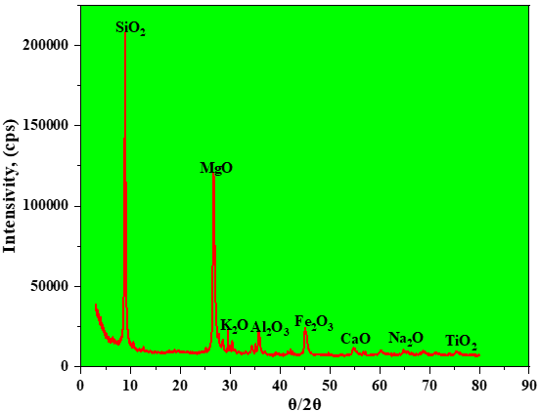
Figure 2. XRD Analysis of the Vermiculite Sample from the “Tebinbulak” Deposit

SiO₂ (quartz): This represents the silicate phase within vermiculite. It remains structurally stable during processing and acts as an inert additive, enhancing the raw material’s resistance to elevated temperatures.
MgO: Peaks corresponding to magnesium oxide indicate its presence in the mineral composition. Magnesium oxide serves as an essential nutrient for plants and contributes to the mechanical strength of materials.
Fe₃O₄ (magnetite): Originating from trace iron-bearing minerals in natural vermiculite, magnetite contributes to the overall structural stability and thermal resistance of the mineral.
Al₂O₃ (aluminum oxide): This compound signifies the strong crystallinity of vermiculite and is likely derived from aluminum silicates present within the mineral matrix.
K₂O (potassium oxide): Potassium, detected in minor quantities, is an important macronutrient for agricultural crops and is present in the vermiculite composition.
For morphological and elemental composition analyses, vermiculite samples were manually pressed into tablets measuring 7 mm in diameter and 3 mm in thickness. The surface morphology of the powdered samples was examined using a Scanning Electron Microscope (SEM) EVO MA 10 (Zeiss, Germany).
Sample preparation involved mounting the tablets onto a round holder composed of a metal alloy, which was then coated with a carbon film featuring a double-sided adhesive layer. Measurements were conducted at an accelerating voltage (EHT – Extra High Tension) of 15.00 kV, with a working distance (WD) set to 8.5 mm. Imaging was performed in Secondary Electron Detection (SED) mode using Smart SEM software, capturing images at various magnifications.
Elemental composition analysis was carried out by Energy Dispersive X-ray Spectroscopy (EDS) using the same SEM EVO MA 10 system (Zeiss, Germany). The localized elemental analysis was performed using an Oxford Instruments Aztec Energy Advanced X-act Silicon Drift Detector (SDD).
The elemental composition data included electron microscopy images marking the analyzed localized areas, tabulated quantitative results, and corresponding spectral graphs. The results are presented in Table 2 and Figure 3.
Table 2
Chemical Composition of Tebinbulak Vermiculite, %
Elements |  | Equivalent mass |  | Mass.norm., % |  |  | Abs. pogr., %  1 sigma
Oxygen |  | 8 |  | 52,24 |  |  | 2,46
Silicon |  | 14 |  | 18,60 |  |  | 1,39
Magnesium |  | 12 |  | 11,95 |  |  | 1,06
Aluminum |  | 13 |  | 3,04 |  |  | 0,64
Iron |  | 26 |  | 5,62 |  |  | 0,55
Calcium |  | 20 |  | 3,36 |  |  | 0,26
Potassium |  | 19 |  | 2,72 |  |  | 0,21
Sodium |  | 11 |  | 1,68 |  |  | 0,21
Titanium |  | 22 |  | 0,79 |  |  | 0,11
 |  |  |  | 100
Oxide elements
SiO₂ | Al₂O₃ | Fe₂O₃ | MgO |  | SaO | K₂O |  | Na₂O | TiO₂
39,86-42,0 | 3,04-5,74 | 7,36-8,03 | 15,6-20 |  | 4,70 | 3,28 |  | 2,26 | 1,32

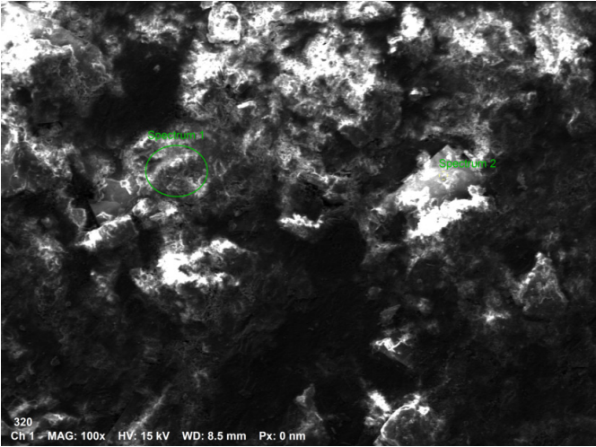

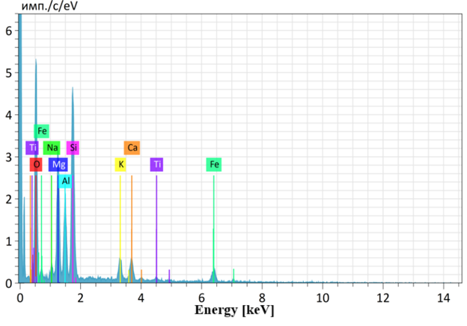
Fig. 3. X-ray diffraction patterns of vermiculite from the Tebinbulak deposit
From these results, it was demonstrated that the vermiculite from the Tebinbulak deposit in Karakalpakstan contains a complex mineral composition primarily consisting of silicon dioxide (SiO₂), magnesium oxide (MgO), iron oxide (Fe₃O₄), aluminum oxide (Al₂O₃), and potassium oxide (K₂O). These components collectively contribute to the mineral’s high thermal stability, structural integrity, and suitability for various industrial and agricultural applications. 3.28% K₂O; 2.26% Na₂O; 4.70% CaO; 15.6–19.92% MgO; 3.04–5.74% Al₂O₃; 7.36–8.03% Fe₂O₃; and 1.32% TiO₂.
Conclusion
X-ray diffraction (XRD) analysis confirmed that the vermiculite mineral retained its original crystal structure without undergoing any physical or chemical alterations. Instead, vermiculite functions as an inert physical barrier within the composite matrix. Scanning Electron Microscopy (SEM) and surface topography examinations revealed a uniform distribution of vermiculite particles, which significantly contributes to the structural cohesion and mechanical stability of the composite material. Furthermore, Energy Dispersive X-ray Spectroscopy (EDS) analysis corroborated the presence of characteristic elemental components intrinsic to vermiculite, thereby validating its hybrid mineral nature.
Building upon the physicochemical properties elucidated in this study, future research aims to employ vermiculite as a functional modifier additive for ammonium nitrate fertilizer—one of the primary nitrogen fertilizers used in agriculture. The anticipated benefits include enhanced granule strength, reduced agglomeration and stickiness, and decreased sensitivity to detonation. These improvements are expected to facilitate safer handling, improve fertilizer efficiency, and ultimately promote healthier plant growth and increased crop.

References
  - A.R. Aripov, D.B. Kholikulov, R.K. Guseynov, F.E. Akhtamov, G.F. Mamaraimov. Enrichment of Vermiculite Ores from the Karauzyak Deposit, Republic of Karakalpakstan // Universum: Technical Sciences: Electronic Scientific Journal. — 2021. — 3(84). — pp. 78-81.
  - E.R. Akhtamov, E.V. Koshkarov, A.Yu. Dedyukhin, V.N. Ageykin. Application of Vermiculite in Bituminous Compositions and Mastics for Road Construction // Bulletin of South Ural State University. Series "Construction and Architecture". — 2021. — Vol. 21, No. 1. — pp. 43-47.
  - N.P. Gerus. Production of Perlite and Vermiculite Worldwide. Moscow: VNIIESM, 2017. — 48 pages.
  - A.P. Afanasyev, A.V. Atamanov. Experience of Systematization of Vermiculite Deposits and Some Tasks for Further Research // Proceedings of "Research and Application of Vermiculite". Leningrad: Nauka, 1997. — pp. 21-24.
  - S.L. Akhnazarova, V.V. Kafarov. Methods of Experiment Optimization in Chemical Technology. Moscow: Higher School, 2005. — 327 pages.
  - M. Mizuno, A. Fukaya, G. Jimbo. Funtai Kogaku Kaishi of the Society of Powder Technology. Japan, 1989. — Vol. 26, No. 9. — pp. 632-637.
  - Vermiculite: Production and Employment. Vitcas Limited, Great Britain. Electronic resource: http://shop.vitcas.com/vermiculite-fire-board-fire-profinsulation-72-p.asp (12.04.2010).
  - USA Vermiculite Association. Electronic resource: http://www.vermiculite.org
  - Vermiculite Cleaning Processes. Torfteh, Canada. Electronic resource: http://www.torfteh.com/pdf/Application.Description-vermiculite_exfoliation.pdf (31.08.2011).
  - D.P. Bolotnikov. Application of Vermiculite Abroad // Kovdorsky Vermiculite. Moscow-Leningrad: Nauka, 1966. — pp. 107-148.
  - B.G. Axyarov, R.R. Ismagilov, R.R. Rakhimov. Use of Vermiculite in Growing Vegetable Seedlings // Agronomy and Forestry, 2015. — pp. 67-70.
  - A.S. Makbuzov, Yu.M. Tikhonov, I.V. Kolomiets. Production of Vermiculite from the Karatas-Altintas Deposit (Western Kazakhstan) in Lightweight Concrete // Proceedings of the 65th Scientific Conference. St. Petersburg: SPbGASU, 2008. — pp. 136-140.

