***Original Research Article***

**Effect of Aqueous Extract of *Moringa oleifera* Leaves and *Vernonia amygdalina* Leaves on Carbon Tetrachloride (CCl4)-Induced Liver Injury in Wistar Rats**

**ABSTRACT**

**Aims:**The effect of *Moringa oleifera* and *Vernonia amygdalina* aqueous leaf extracts on carbon tetrachloride (CCl4)-induced liver injury on Wistar rats were investigated.

**Study Design:** Twenty-five (25) wistar rats weighing 100g-250g of about four months old were used in this study, and were grouped into five groups with each group comprising five wistar rats each. Group 1 served as the positive control which was given the standard feed and water *ad libitum*. The remaining 20 wistar rats in groups 2-5 were administered CCl4 peritoneally (20ml) mixed with olive oil (20ml) in a ratio 1:1 at a dose of 1500mg/kg. Group 2 served as the negative control which was CCl4 induced without treatment while groups 3 to 5 were treated with the aqueous leaves extract with different concentrations daily based on the body weight for a period of two weeks.

**Place and Duration of Study:** The animal house of the Department of Biochemistry, University of Port Harcourt; and Department of Chemical Pathology, University of Port Harcourt Teaching Hospital (UPTH), between January and June 2021. This study was conducted within six months.

**Methodology:** At the end of the treatment, animals from each group were sacrificed with blood and liver samples collected for biochemical and histological investigation respectively. Blood samples were analyzed using Randox kits, and autoanalysers. **Results:** Serum enzyme assay results reveal that the aqueous extract of the leaves of both plants recorded a significant reduction (*P*≥0.05) in the elevated activities of the hepatic enzyme. However, these enzymes remained significantly elevated (*P*<0.05) in CCl4-induced wistar rats which did not receive the extract.

**Conclusion:** In conclusion, the aqueous extract of both leaves has hepatoprotective and hepatocurative potentials in hepatocellular disorders.

**Key words:** *Moringa oleifera*, *Vernonia amygdalina*, Hepatic enzyme, Hepatocurative potentials, Liver injury.

1. **INTRODUCTION**

Herbal medicine is an important and significant part of alternative medicine. It is a part and parcel of alternative treatment method, and it includes the use of different parts of a plant having medicinal properties. These parts may include the leaves, stems, roots, seeds, flowers, and fruits. The medicinal properties of the plant are from chemical compounds that are naturally found in the plant. They are basically the vegetable that we consume on a daily basis. If we can consume them with intent understanding to prevent diseases, then food would indeed have become our medicine and medicine, food (Feher and Schmidt*,* 2003).

Over 50% of all modern clinical drugs are of natural product origin and natural products play an important role in drug development programmes. Many natural and artificial agents possessing anti-oxidative properties have been proposed to prevent and treat hepatopathies induced by oxidative stress (Lieber, 1997).

*Moringa oleifera* is a fast growing, drought resistant tree of the family of Moringaceae, native to the Indian subcontinent. Common names include; moringa, drumstick tree, horseradish tree, and benolive tree. It is widely cultivated for its young seed pods and leaves, used as vegetables and traditional herbal medicine. It is also used for water purification (Sredatha and Si Padma, 2009).

*Moringa oleifera* is promising as a food in the tropics because the tree is in full leaf at the end of the dry season when most foods are typically scarce. A large number of reports on the nutritional and medicinal qualities of *Moringa oleifera* now exist in both the scientific and popular literature, its leaves have been reported to contain more vitamin A than carrots, more calcium than milk, more iron than spinach, more vitamin C than oranges and more potassium than bananas, and that the protein quality of moringa leaves rivals that of milk and eggs. The nutritional properties of *Moringa oleifera* are now so well known that there seems to be little doubt of the substantial wealth benefit to be realized by consumption of *Moringa oleifera* leaf powder in situation where starvation is imminent (Sredatha and Si Padma, 2009).

The bark, sap, root, leaves, seeds, and flowers are used in traditional medicine. Research has examined how it might affect blood lipid profiles and insulin secretion. Extract from leaves contain various polyphenols which are under basic research to determine their potential effect in humans (Sredatha and Si Padma, 2009).

*Vernonia amygdalina* is a valuable medicinal plant that is widespread in East and West Africa (Burkill, 1985). It is known as bitter leaf and may be used as active anti-cancer (Izeubgie, 2003), anti-bacterial, anti-malarial agent etc. This plant contains complex active components that are pharmacologically useful, the roots and the leaves are used in ethnomedicine to treat fever, hiccups, kidney problems, liver problems, and stomach discomfort. The stem and root of the bark are used as chewing sticks in West African countries. *In vitro* studies have shown that bitter leaf was effective in causing a concentration-dependent-decrease in the CCl4-induced cytotoxic effects and to restore the levels of AST, ALT, and ALP of rat hepatocytes (Anosike *et al*., 2009).

*Vernonia amygdalina* is a widely used local plant in Nigeria for therapeutic and nutritional purposes. It grows in a range of ecological zones in Africa and produces large mass of forage and is drought tolerant. A number of investigations have shown that saponins, flavonoids, and a host of other secondary plant metabolites including arginine and glutamic acid possess hypoglycaemic effect in various animal models (Saxena and Kishore, 2004) and have been found to be hepatoprotective in diabetic animal experiments.

**1.1 Aim and Objectives of the Study**

**Aim:** The aim of this study is to determine the effect of aqueous extract of *Moringa oleifera* leaves and *Vernonia amygdalina* leaves on CCl4-induced liver injury in Wistar rats.

**Objectives:** The objectives of this research are to:

1. Investigate the influence of aqueous extract of *Moringa oleifera* and *Vernonia amygdalina* leaves on CCl4-induced liver damage.
2. Evaluate the combined effect of both plants.
3. Search for drugs for the treatment of liver diseases and also add to the ones in current use.

**1.2 Significance of the Study**

This study is significant in that it will provide more information on how *Moringa oleifera* and *Vernonia amygdalina* would affect liver injury, hopefully leading to the provision of a wider range of solution to liver injury problem.It would show if the effect of both leaves extract can be used as preventive treatment to avoid liver problem. The study would also be able to provide more information about *Moringa oleifera* and *Vernonia amygdalina* and become a baseline for future studies.

Due to the search for more suitable and reliable drugs for treatment of liver disease and due to the cost of orthodox drugs for the treatment of liver disease, it is important to search for alternative drugs of high efficacy and safety for the treatment of liver disease.

**1.3 Scope of Study**

The study is on the effect of aqueous extract of *Moringa oleifera* and *Vernonia amygdalina* leaves on some serum enzyme of CCl4-induced liver damage of Wistar rats.

The study was analyzed at the University of Port Harcourt and also at the Chemical Pathology Laboratory of University of Port Harcourt Teaching Hospital (UPTH).

**1.4 Reason for Combination of Plants**

Combination of the plants is for a better efficiency which are of benefits in the study and its results. Combination may increase the medicinal potential of a chemical substance of interest present in individual plants.

**1.5 Study Area**

The study area includes Choba community in Obio/Akpor Local Government Area of Rivers State, Nigeria. This area is located in the Niger Delta region bordering the Atlantic Ocean and lies approximately in latitudes 6°54'N and longitudes 4°53'E.

**2. MATERIALS AND METHODS**

**2.1 Experimental Animals**

Twenty-five (25) Wistar rats of about four months old, weighing between 100-250g were obtained from the animal house of the Department of Biochemistry, University of Port Harcourt, Rivers State. The animals were housed in the ventilated experiment house under the constant conditions throughout the period of the experiment. They were maintained on standard animal pellet and water *ad libitum*. The animals were acclimatized for one week prior to the commencement of the experiment.

**2.2 Carbon tetrachloride**

Carbon tetrachloride is a manufactured chemical and does not occur naturally in the environment. It is produced by chlorination of a variety of low molecular weight hydrocarbons such as carbon disulfide, methane, ethane, propane, or ethylene dichloride, and also by thermal chlorination of methyl chloride (Senfert *et al*., 1994).

Carbon tetrachloride also known as tetrachloromethane is an organic compound with the chemical formula, CCl4. It is a colourless liquid with a “sweet” smell that is detected at low levels. Exposure to high concentration of CCl4 including vapour can affect the central nervous system and degenerate the liver and kidney (Senfert *et al*., 1994), prolonged exposure can be fatal and lead to coma or death, exposure can also result in cancer. Symptoms of hepatic damage may appear after a delay of one or more days following acute exposure (Senfert *et al*., 1994). CCl4 is one of the most potent hepatotoxins (toxic to the liver), so much so that it is widely used in scientific research to evaluate hepatoprotective agent. Several sensitive and specific tests are available to measure CCl4 in exposed persons. The most convenient way is to measure CCl4 in exhaled air. CCl4 can also be measured in the blood, fat, or other tissues (Hasan *et al*., 2012).

**2.3 Preparation of Stock (CCl4)**

20ml of CCl4 was diluted in 20ml of olive oil in ratio 2:2 and was employed for initiating liver damage.

**2.4 Plant Collection and Preparation of Aqueous Extract**

Fresh leaves of *Moringa oleifera* and *Vernonia amygdalina* were collected and identified from a botanic garden in Port Harcourt, Rivers State, Nigeria. The leaves were dried in closed air, avoiding direct contact with moisture and sun for a duration of three (3) weeks after which the leaves were ground to fine powder using mortar and pestle. 10g of the powder was soaked in 40ml of distilled water. After vigorous shaking for 10 minutes, the mixture was allowed to stand for 24 hours. The mixture was then filtered thrice, each time through a piece of white clean cotton cloth. A final filtration using Whatman No. 541 filter paper followed.

**2.5 Preparation of the Animals**

A total of 25 Wistar rats (100-250g) of about four months old were bred in the animal house of the Department of Biochemistry, University of Port Harcourt, Choba, Rivers State, and were used in the study. The rats were randomly selected and kept in five (5) different groups of five (5) rats per group and in separate cages. The animals were fed commercially with formulated rat feed and water *ad libitum*. Their cages were cleaned daily and their food and water was changed daily. The animals were allowed to acclimatize for one week.

**2.6 Study Design**

The animals were divided into 5 experimental groups with each group consisting of 5 rats per cage.

The Group I (Positive Control) was fed with commercially formulated pellet and water ad libitum.

The Group 1I (Negative Control) was induced with CCl4 and kept without administering any extract but was fed with commercially formulated pellet and water *ad libitum*.

The Groups III, IV, and V were fed with commercially formulated feed, water *ad libitum*, and 5%, 10%, and 15% respectively of the extract according to individual body weight of each rat. The rats were anaesthetized in chloroform and sacrificed twenty-four hours after the last day (day 14) of treatment. The blood and liver samples of the rats were collected and stored in 10% formalin histological tissue bottle. The plasma and serum activities of all liver enzymes were assayed.

**2.7 Method of Blood and Organ Collection**

The animals were anaesthetized using cotton wool soaked in chloroform in a desiccator. The anaesthetized animals were placed on a dissecting slab, the blood samples were collected from the jugular vein into lithium heparin bottles. The liver was collected and stored in tissue bottles with formaldehyde for biochemistry test. The blood and tissue samples were then taken to the Chemical Pathology laboratory at the University of Port Harcourt Teaching Hospital (UPTH) for analysis.

**2.8 Analysis**

2.8.1 Assessment of Biochemical Parameters

Biochemical analysis of the serum enzymes for Aspartate aminotransferase (AST), Alanine aminotransferase (ALT), Alkaline phosphatase (ALP), Glucose (GLU), Urea (U), Creatinine (CREAT), Cholesterol (CHO), Total protein (TP), and Triglyceride (TG) were assayed in the laboratory using Randox and Agappe kits as described by Kaplan and Pesce (2001).

**2.9 Histopathology**

The sections of the preserved liver slices obtained with the use of a tissue slicer were fixed on microscopic slides and stained before observing under the microscope following the method described by Baker and Silverton (2005).

**2.10 Statistical analysis**

Results of the biochemical estimations were reported as Mean ± SD (Standard deviation). Statistical analysis was performed using ANOVA and *P* value of less than (<) 0.05 was considered statistically significant.

**3. RESULTS AND DISCUSSION**

**3.1 RESULTS**

The following interpretations from the results were deduced;

3.1.1 Effect of treatment on Glucose level

In the result shown in table 1 below, the glucose concentration of the positive control (4.14±0.70) is lower than that of the negative control (6.56±0.61) indicating a slight increase in glucose level of the negative control. As for the group induced with CCl4 and treated with the plant extracts (5%, 10%, 15% concentration respectively), there was a decrease (5.44±0.57, 4.34±0.38, 4.34±0.52), there was a decrease in the glucose level when compared to the negative control indicating the effect of the treatment with the extract.

3.1.2 Effect of treatment on Urea level

In the urea result shown in table 1 below, the urea positive control (2.54±0.30) is lower than that of the negative control (2.84±0.27) indicating a slight difference in urea level. The group treated with CCl4 and the plant extracts had a decrease compared to the negative control.

3.1.3 Effect of treatment on Liver enzyme markers

The activities of the three more prominent liver enzyme markers, ALP, ALT, and AST after treatment with plant extracts are shown in table 1 below. There was an increase in the level of ALP, AST, and ALT activities in the CCl4 treated rats when compared with the negative control. The serum concentrations of the three liver enzyme markers reduced significantly (*P*<0.05) for all the treatment groups when compared with the negative control group. The reduction of the ALT, AST, and ALP activities by the plants extract was dependent on the concentration given. The combined extract treatment was more effective in reversing the enzyme activities.

3.1.4 Effect of treatment on Total Protein level

The effect of treatment on total protein was shown in table 1 below as there was a decrease in the negative control group (50.60±2.41) which was significantly different from the positive control group (60.20±1.48). Group 4 administered plants extract treatment showed no significant difference (p<0.05) compared to the positive control.

3.1.5 Effect of treatment on Triglyceride level

Effect of treatment on triglyceride was shown in table 1 below, as there was an increase in the group administered CCl4 alone which is the negative control (3.36±0.62) when compared to the positive control (1.60±0.44). The groups that were treated with plants extract showed an improvement compared to the negative control (2.44±0.43, 1.94±0.38, 1.64±0.46 respectively).

**TABLE 1: Effect of aqueous extract of *Moringa oleifera* leaves and *Vernonia amygdalina* leaves on selected biochemical parameters**

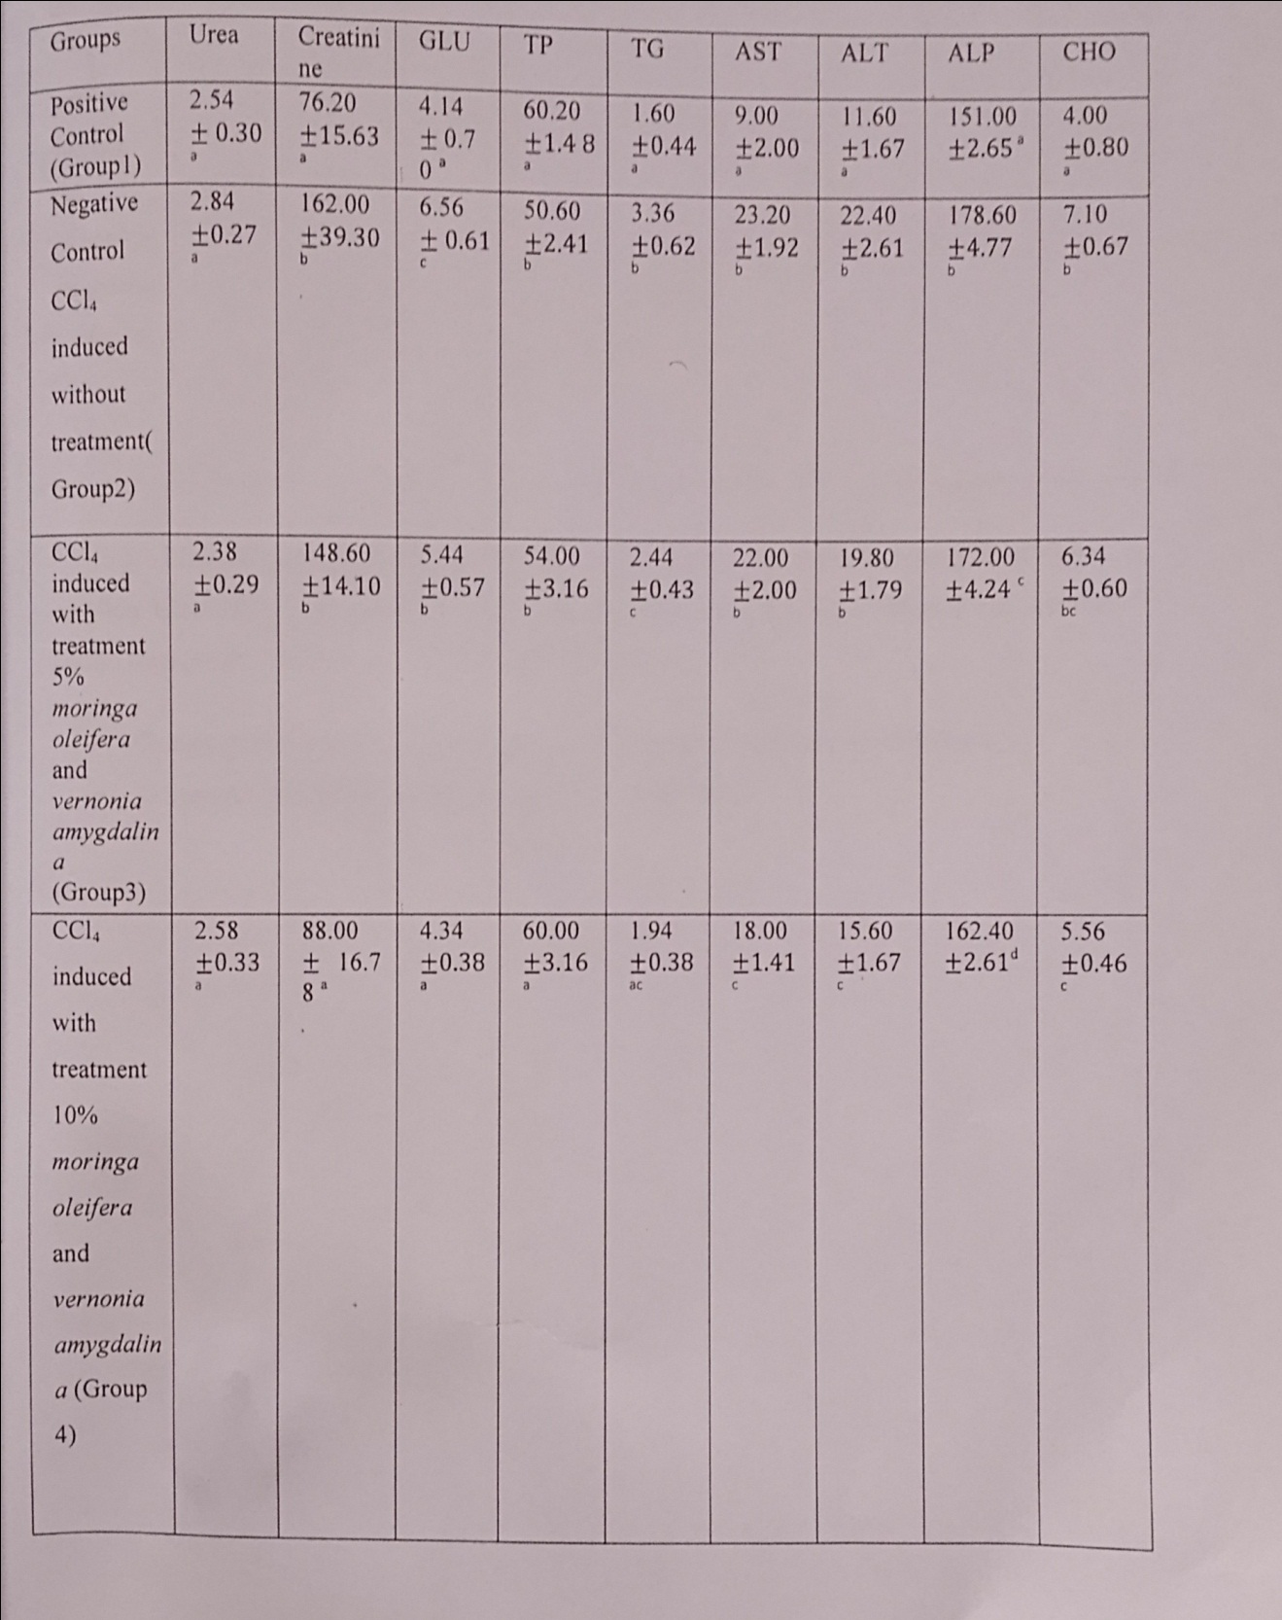

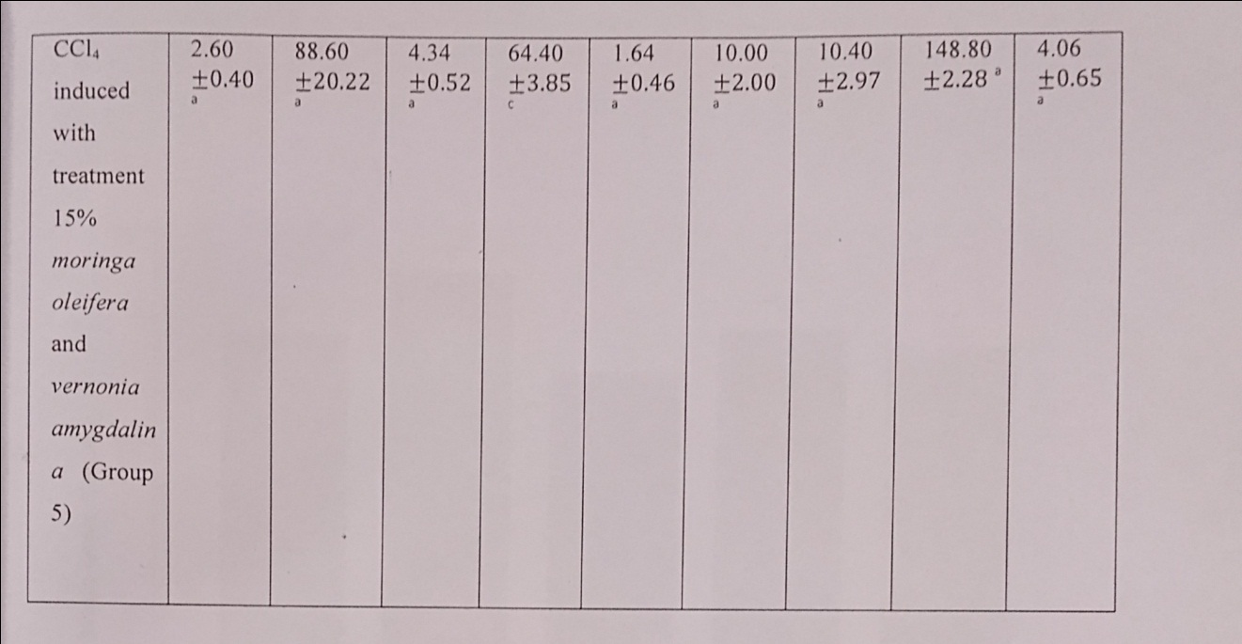

Groups with the same subset for each parameter have no significant difference.

Groups with different subsets are significantly different.

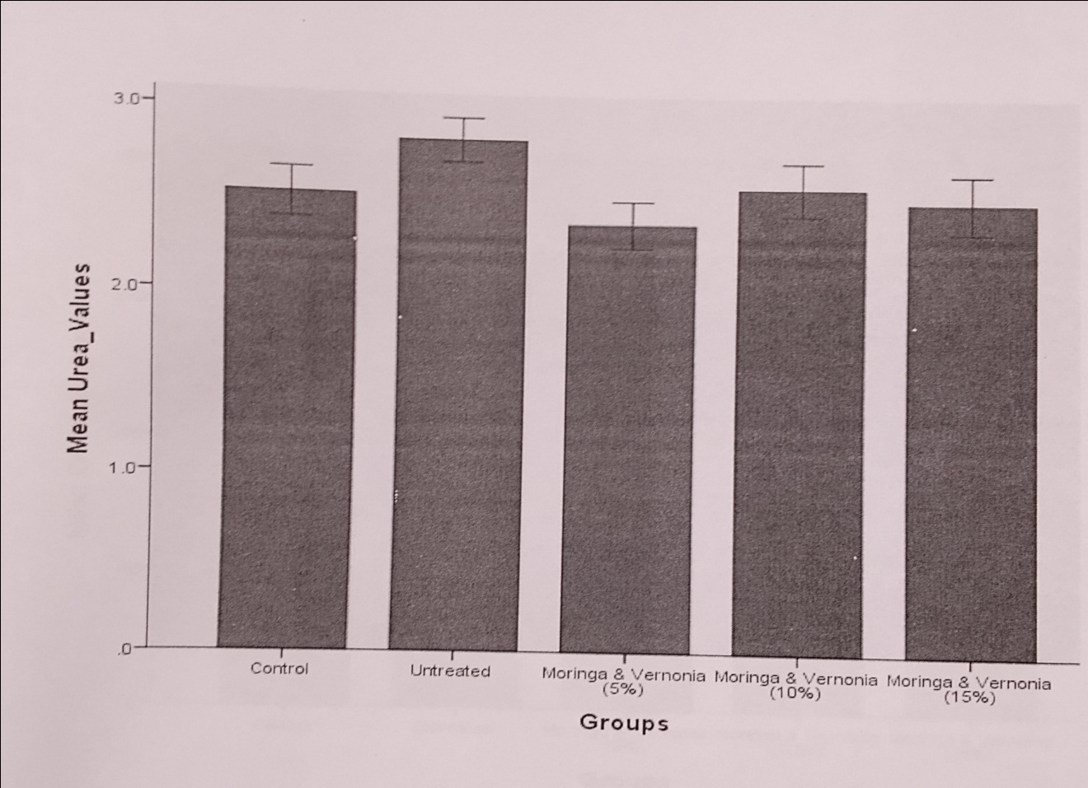

**FIGURE 1** Urea level in all rat groups. Bars are mean ± SD

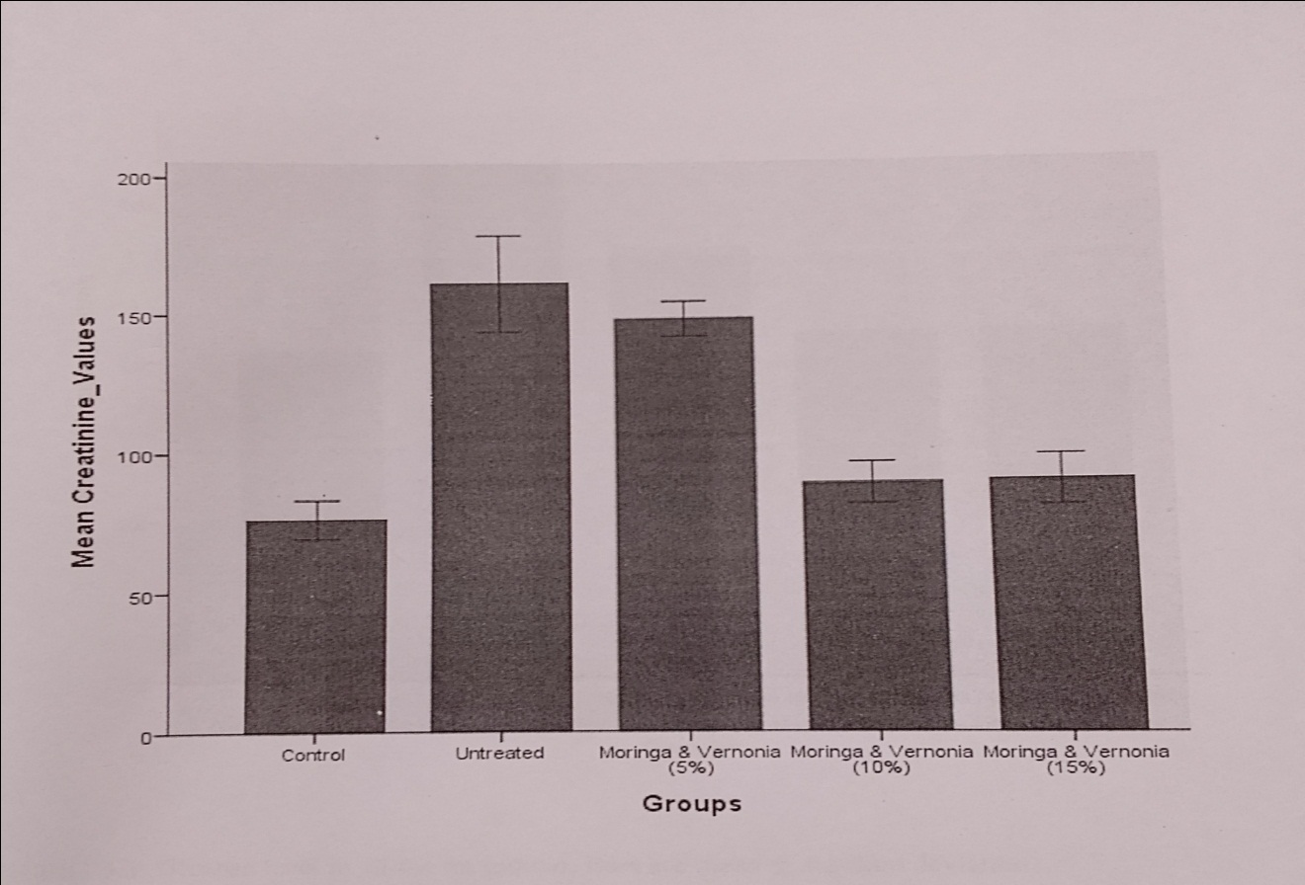

**FIGURE 2** Creatinine level in all rat groups. Bars are mean ± SD

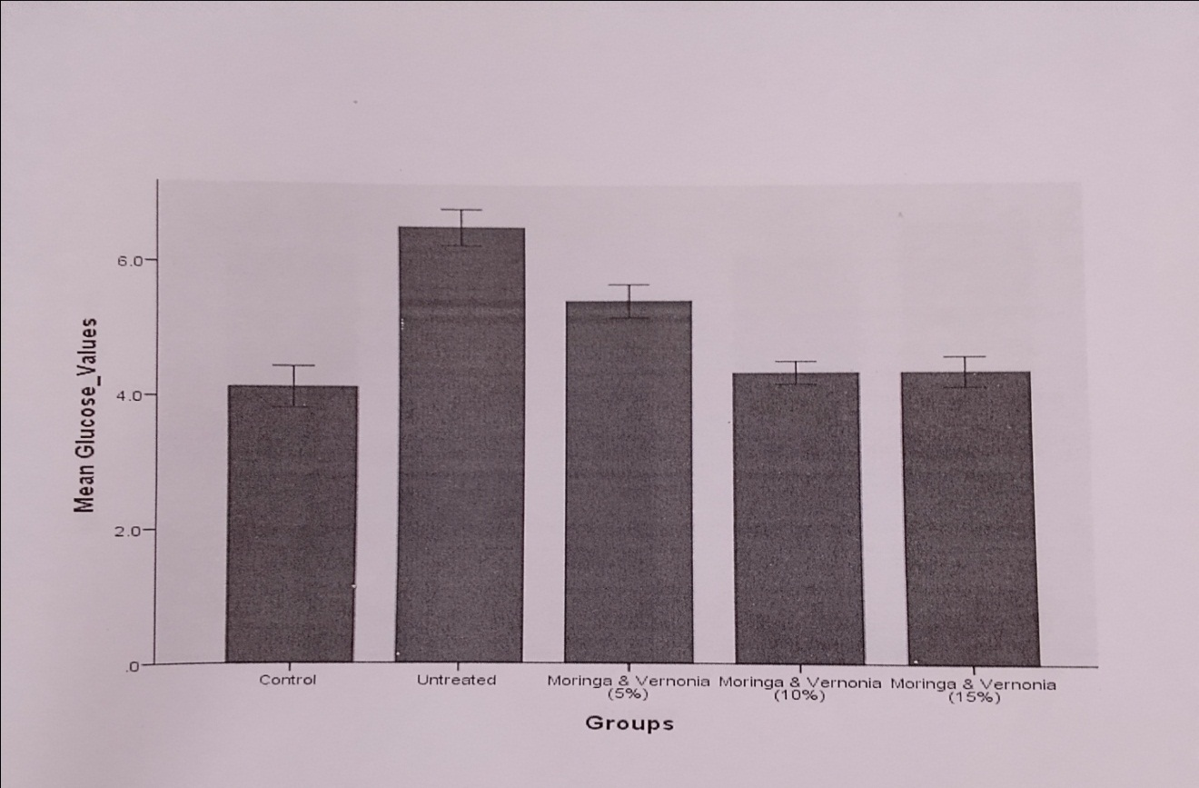

**FIGURE 3** Glucose level in all rat groups. Bars are mean ± SD

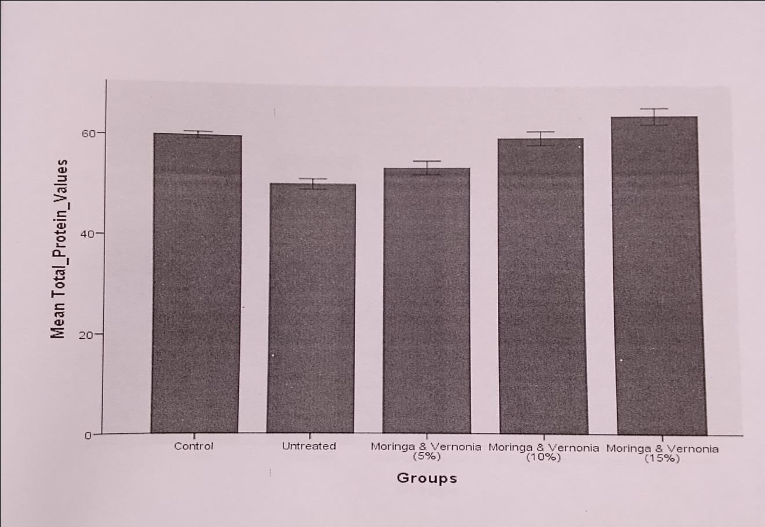

**FIGURE 4** Total protein level in all the rat groups. Bars are mean ± SD

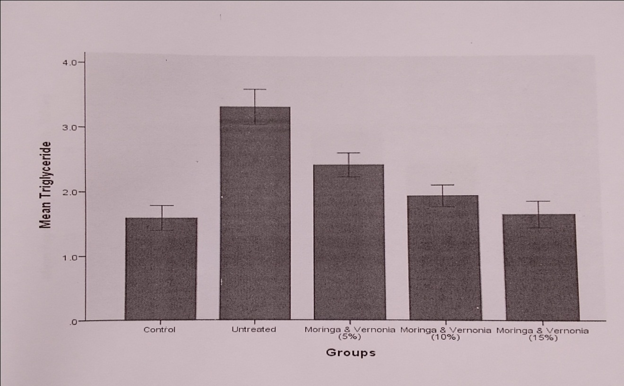

**FIGURE 5** Triglyceride level in all rat groups. Bars are mean ± SD (*P*<0.05)

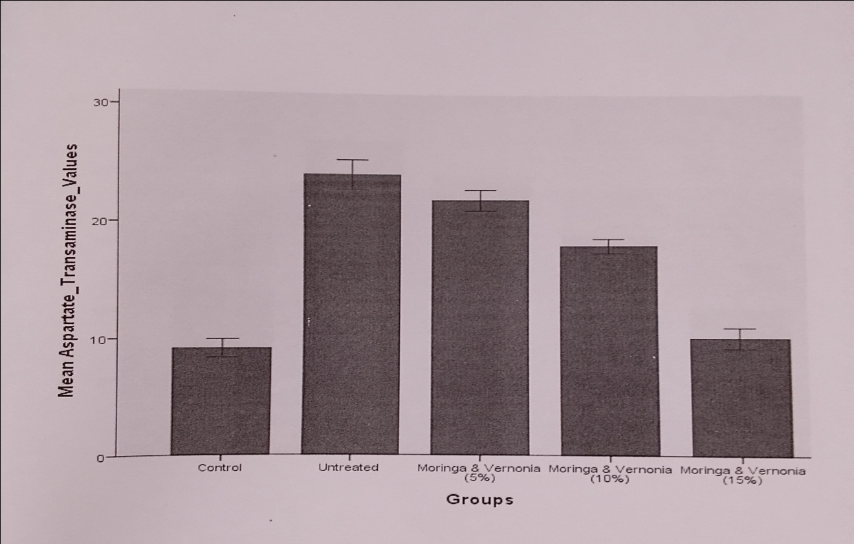

**FIGURE 6** AST level in all the rat groups. Bars are mean ± SD (*P*<0.05)

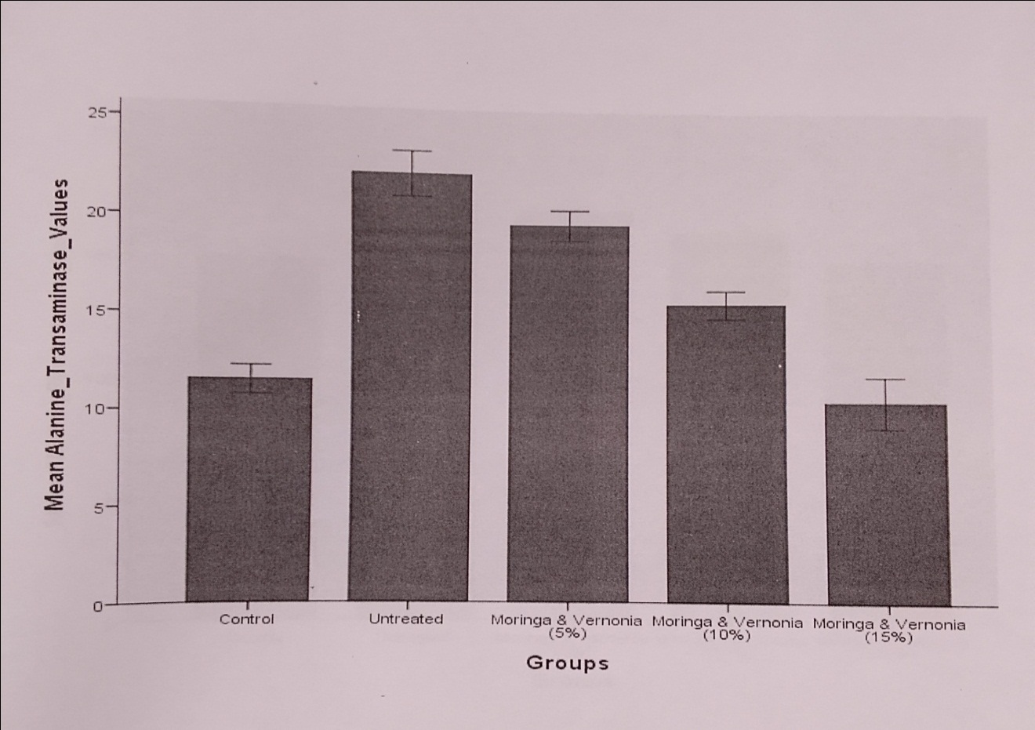

**FIGURE 7** ALT level in all the rat groups. Bars are mean ± SD (*P*<0.05)

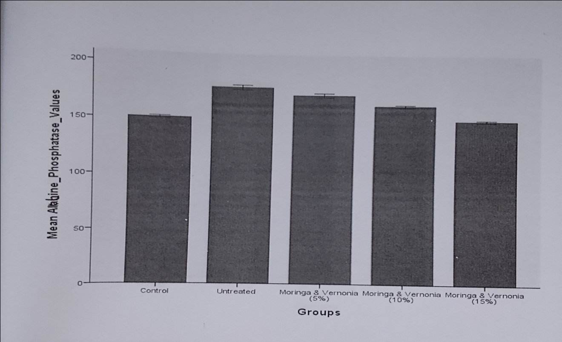

**FIGURE 8** ALP level in all the rat groups. Bars are mean ± SD (*P*<0.05)

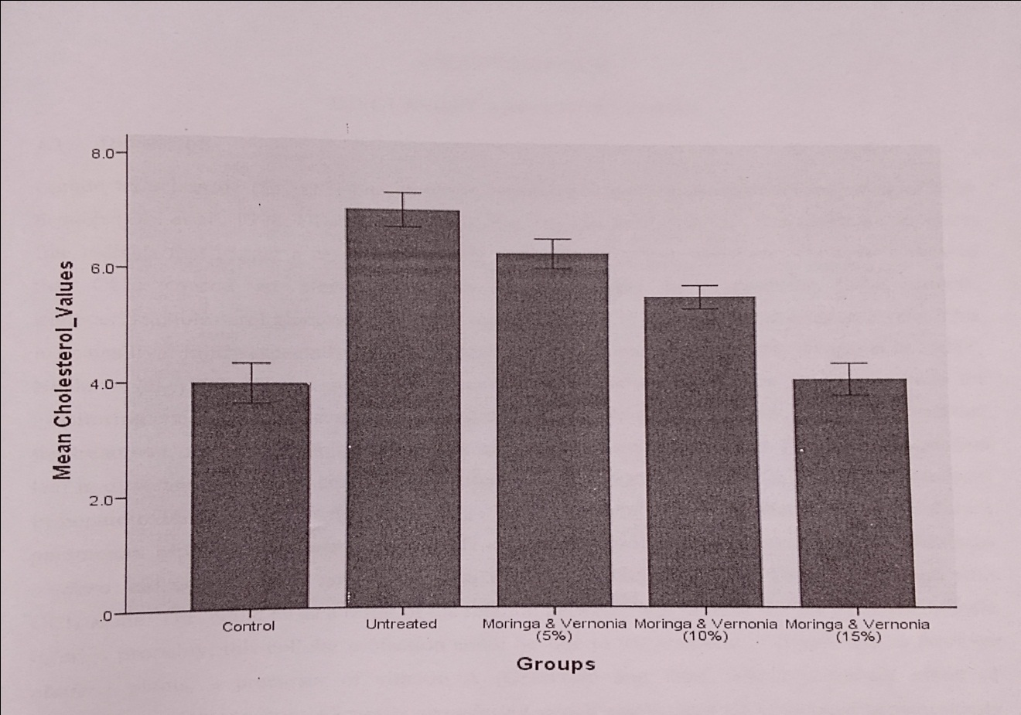

**FIGURE 9** Cholesterol level in all rat groups. Bars are mean±SD (*P*<0.05)

**3.2 DISCUSSION**

Carbon tetrachloride (CCl4) is one common hepatotoxin used in the experimental study of liver damage (Obi *et al.,* 1998). CCl4 treatment generates free radicals that trigger a cascade of events resulting in hepatic damages. The results showed that CCl4 caused an elevation in the serum content of creatinine, total protein, triglyceride, cholesterol, glucose, ALT, AST, ALP, and also a slight increase in urea levels. This indicates liver injury especially the rise in ALT activity. Hence, serum or plasma enzymes levels have been used as indices for monitoring chemically induced tissue damages. From the result of this study, it was observed that the treatment of rats with aqueous extracts of *Moringa oleifera* and *Vernonia amygdalina* leaves in different percentage concentration after CCl4 administration caused a significant reduction in hepatotoxicity for rats treated with CCl4. This is evident in marked decrease in the different parameters especially in serum ALT, AST, and ALP activities of those treated with both leaves extract (*P*<0.05) relative to the group treated with CCl4 alone. This could be as a result of the relation between high level of the enzymes and hepatic injuries. This cellular protection could be due to the presence of beta(β)-carotene in *Moringa oleifera* plants, a precursor of vitamin A combined effect of sesquiterpene lactone from *Vernonia amygalina* which ameliorates CCl4-induced hepatotoxicity in rats (Babalola *et al*., 2001).

Akah and Okafor (1992) reported that the leaf of *Vernonia amygdalina* contains saponins, sesquiterpene lactone, steroid glycosides, alkaloids, tannins, and flavonoids. Flavonoids are reported to exhibit antioxidant activity and are effective scavengers of superoxide anions. The aqueous leaf extract of *Vernonia amygdalina* may have exhibited hepatoprotective activity due to its antioxidant property attributable to its flavonoid content. It has been commonly reported that *Moringa oleifera* plant is rich in compounds containing the simple sugar, rhamnose, and a fairly unique group of compounds called glucosinolates and isothiocyanate, niazimicin, pterygosperm, benzyl isothiocyanate and 4-(a-rhamnopyranosyloxy) benzyl glucosinolate and a number of vitamins and minerals as well as other more commonly recognized phytochemicals such as carotenoids (β-carotene or pro-vitamin A) (Lowell, 1989). This could possibly be the reason for its hepatoprotective activity.

**4. CONCLUSION**

In conclusion, the result indicated that the combined treatment with both leaves extracts after establishment of CCl4-induced liver damage significantly reduced and even reversed the damage in the Wistar rats, hence, the leaf extracts of the combined plants might be more effective hepatoprotectors in the diets of subjects with hepatopathies since the model of CCl4-induced liver damage in the rats stimulates many of the features of human liver fibrosis.

**REFERENCES**

Akah, P.A. & Okafor, C.I. (1992). Blood sugar lowering effect of *Vernonia amygdalina* in an experimental rabbit model. Phytotherapy Research, 6(3), 171-173.

Babalola, O.O., Aneto, J.I., & Adeniyi, F.A. (2001). Amelioration of CCl4-induced hepatotoxicity of terpenoid extract from leaves of *Vernonia amygdalina*. African Journal of Medicine and Medical Sciences, 30(1-2), 91 – 93.

Baker, F. J. & Silverton, R. E. (2005). Introduction to Medical Laboratory Techniques, 7th edition, Butterworts, London. pp. 310-330.

Feher, M.I. & Schmidt, J.M. (2003). Property distribution differences between drug’s natural products and molecules from combinatorial chemistry. Journal of Chemical Information and Computer Sciences, 43(1), 218 – 227.

Kaplan, L. A. & Pesce, A. J. (2001). Clinical chemistry. 4th edition. St. Louis, M. O.: Mosby. p. 175.

Lieber, C.S. (1997). Role of oxidative stress and anti-oxidant therapy in alcoholic and non-alcoholic liver diseases. Advances in Pharmacology,38, 601-628.

Lowell, Y.F. (1989). *Moringa oleifera*: natural nutrition for the tropics, the miracle tree, church world service. Dakar, Senegal. Indian Health, 11, 48.

Obi, F.O., Usen, I.A., & Osayande, J.O. (1998). Prevention of CCl4-induced hepatotoxicity in the rats by *Hibiscus rosasinensis* anthocyanin extracts administered in ethanol. Toxicology, 131, 93 – 98.

Saxena, A. & Kishore, N.V. (2004). Role of selected Indian plants in

management of type 2 diabetes: a review. Journal of Alternative and Complementary Medicine, 10(2), 369-378.