*Original Research Article*

Eco-Friendly Regeneration of Spent Transformer Oil Using Bentonite Clay and Palm Kernel Shell Activated Carbon: Characterization, and Performance Evaluation

**ABSTRACT**

The reliable operation of power transformers is critically dependent on the quality of insulating oil, which degrades over time due to thermal, electrical, and chemical stresses. Traditional regeneration methods are often costly and environmentally harmful. This study explores an innovative, sustainable approach using bentonite clay and palm kernel shell-activated carbon (PKS-AC) for regenerating spent transformer oil. The adsorbents were chemically activated at 7N sulfuric acid concentrations and characterized using FTIR, SEM, and physico-chemical analyses. Results demonstrated that 7N-activated adsorbents exhibited good performance, with 99.64% acidity removal and 71.05% moisture reduction. The optimal regeneration conditions were identified as 3.4g/30ml PKS-AC, 3.8g/30ml bentonite clay, 77°C, 77 minutes, and 744 rpm stirring speed. The regenerated oil met standard acceptable limits, with significant improvements in viscosity, density, flash point, fire point and breakdown voltage. This study highlights the potential of bentonite clay and PKS-AC as cost-effective, eco-friendly alternatives for transformer oil regeneration, contributing to sustainable energy practices.

**Keywords:** Transformer oil regeneration, Bentonite clay, Palm kernel shell activated carbon, Adsorption, Oil degradation, Acid activation and Eco-friendly remediation

1. **INTRODUCTION**

Power transformers are critical components in electrical distribution systems, and their reliable operation heavily depends on the quality of the insulating oil used within them (Tiwari et al., 2024). Transformer oil serves multiple crucial functions, including electrical insulation, cooling, and arc suppression. However, during operation, this oil undergoes various degradation processes due to thermal, electrical, and chemical stresses (Mohammed & Kadhum, 2010). These degradation mechanisms result in the formation of acids, moisture, dissolved gases, and other contaminants that significantly compromise the oil's dielectric properties and cooling efficiency (Aliev et al., 2023).

Traditional transformer oil regeneration methods often employ synthetic materials and chemical processes that are both expensive and environmentally problematic (Medeiros et al., 2022; Sterpu et al., 2012). The increasing global focus on sustainability and cost-effectiveness has driven research toward more environmentally friendly alternatives. This research addresses these challenges by exploring an approach using two naturally abundant materials: bentonite clay and palm kernel shell.

Bentonite clay, a naturally occurring aluminum phyllosilicate clay predominantly composed of montmorillonite, represents a revolutionary advancement in oil regeneration technology. Its unique layered structure, characterized by an expandable crystal lattice, provides exceptional adsorption capabilities for polar contaminants, acids, and dissolved metals (Jaber Ibrahim et al., 2023; Naswir et al., 2019). Research by Ahmetović et al. (2024) demonstrated bentonite's remarkable heavy metal removal capabilities, achieving up to 100% removal efficiency for Cu(II) and nearly 100% removal for Cr(III) and Ni(II). Bentonite clay is recognized for its exceptional adsorption properties, making it a valuable material in various applications. The following sections detail the key aspects of bentonite clay's adsorption capabilities.

Ahmetović et al., (2024) stated that Bentonite effectively removes heavy metal ions from wastewater, particularly in galvanic processes, achieving removal efficiencies of up to 100% for Cu (II) and nearly 100% for Cr (III) and Ni (II) at optimal conditions and that the adsorption process is influenced by factors such as pH, temperature, and contact time, with maximum efficiencies observed at specific pH levels and temperatures. Sun et al., (2024) noted that the adsorption of metals like Zn (II) onto bentonite is primarily driven by chemical adsorption, ion exchange, and van der Waals forces. They also indicate that both physical and chemical adsorption mechanisms are at play, with the latter being the dominant factor in the adsorption rate. A study by Ibrahim et al. (2023) stated that Bentonite clay has also shown high efficiency in removing organic dyes, such as methylene blue, with adsorption efficiencies reaching 99.39% under optimal conditions. The adsorption process is characterized as exothermic and spontaneous, indicating its potential for practical wastewater treatment applications.

Palm kernel shell, an abundant agricultural waste product from palm oil processing (Babayemi, 2017), represents a significant innovation in sustainable adsorbent technology. When properly processed and activated, the palm kernel shell transforms into a highly effective carbonaceous adsorbent material with several unique characteristics (Permady & Mustakim, 2024; Sambo et al., 2024). Palm kernel shell (PKS) has emerged as a promising material for adsorption applications due to its unique structural properties and cost-effectiveness. Research indicates that activated carbon derived from PKS exhibits significant adsorption capabilities for various contaminants, including polycyclic aromatic hydrocarbons (PAHs), carbon dioxide (CO2), and dyes like methylene blue. The following sections detail the characteristics and performance of PKS in adsorption processes.

According to Sambo et al. (2024), activated biochar from PKS demonstrated high removal efficiencies for phenanthrene (84-100%) and benzo(a)pyrene (68-87%) with maximum adsorption capacities of 19.38-21.98 mg/g and 1.24-13.26 mg/g, respectively. They also stated that Freundlich and Langmuir's models effectively describe the adsorption behaviour, indicating favourable interactions between the adsorbent and contaminants. Lai & Ngu (2024) noted that concurrent activation and surface modification processes enhanced the CO2 adsorption capacity of PKS-derived activated carbon to 1.91 mmol/g at optimal conditions. Also, the incorporation of barium through chemical modification improved the chemisorption process, demonstrating the versatility of PKS in gas adsorption applications. Permady & Mustakim (2024) stated that PKS has shown remarkable efficiency in removing methylene blue, achieving up to 99.17% removal at optimal conditions, and the adsorption kinetics were influenced by stirring speed, highlighting the importance of operational parameters in maximizing adsorption efficiency.

The combination of these two materials creates a synergistic system that simultaneously addresses multiple aspects of oil degradation. This approach represents a significant advancement over single-material systems, providing more comprehensive treatment while maintaining economic viability and environmental sustainability.

1. **MATERIALS AND METHODS**
   1. **Oil and Adsorbents Collection**

One liter of used transformer oil (naphthalene-based) was obtained from a faulty transformer in a company in Port Harcourt. The transformer failed during operation as a result of arcing. The spent transformer oil was labelled as sample A. Half a liter of fresh transformer oil (naphthalene-based) was also obtained from the same source through the company and labelled as control sample B.

Palm Kernel Shells (PKS) were obtained from a palm oil mill in Anambra State. The shells were washed with distilled water to remove dirt and dried in an oven at 110˚C for 24 hrs. The bentonite sample used in this research work was collected from the Oyi local government in Anambra State, Nigeria, and was milled in MANSID Nigeria Limited, Port Harcourt, Nigeria.

* 1. **Synthesis of the adsorbents**

A modified approach of Babayemi, 2017 was used to synthesize the adsorbents. The dried Palm Kernel Shells (PKN) was carbonized in a muffle furnace at a temperature of 500˚C for 3 hours, allowed to cool to room temperature, pulverized using a jaw crusher and sieved using 0.2 mm mesh. The sieved materials were weighed (50g) and impregnated with 250 mL of 7N H2SO4 for 12 hrs. The impregnated samples were washed with NaOH and distilled water until pH 7.0, decanted and dried in the oven at 90oC for 3hrs before being packed in airtight container.

A modified approach of Taha et. al, 2020 was used to synthesize the bentonite clay. The milled bentonite clay sample of 50g was used and 250 mL of 7N H2SO4 acid solution was added. The mixture was homogenized in a steam bath at a temperature of 900C for 3hours so activation can take place. The resulting mixture was washed by neutralizing with NaOH and distilled water until pH 7.0 to reduce the acidity. It was allowed to settle, decanted, dried in the oven at a temperature of 3000C for 3hrs. The dried activated clay was crushed into fine powder and sieved through an aperture of 75μm.

**2.3 Characterization of Transformer Oil**

This characterization provides a fundamental understanding of the properties, such as water content, acidity, density, viscosity, flash point, etc., of the fresh transformer oil and spent transformer oil.

2.3.1 Acidity Test:

The acid number was determined through titration with standardized potassium hydroxide (KOH), following the method described by Adekoya and Adejumobi (2017). Phenolphthalein was used as the indicator, and the acid value was calculated using Equation (1), representing the milligrams of KOH required to neutralize 1 g of oil. Results were compared to acceptable limit of IEC 62021. The percentage removal of acid was computed using Equation (2) (Zhang et al., 2015; Yassin et al., 2022).

Acid value (mgKOH/g) = $\frac{V*C*56.1}{m}$ (1)

where V is the consumption of titration KOH solution volume, mL; C is the concentration of KOH solution, mol/L; m is the quality of the oil, g; 56.1 is the potassium hydroxide molar mass, g/mol.

% removal of acid = $\frac{C_{O}-C_{1}}{C_{O}}$ (2)

where Co and C1 are the initial and residual concentrations of acid

2.3.2 Flash Point and Fire Point Test:

Flash and fire points were measured according to ASTM D93 using a Pensky-Martens closed cup apparatus at room temperature and pressure. Approximately 60 mL of oil was heated, and a test flame was introduced to determine the flash (momentary ignition) and fire point (sustained ignition) temperatures (Bakrutheen et al., 2014; Vanitha et al., 2016).

2.3.3 Kinematic Viscosity Test:

Kinematic viscosity was measured in accordance with ASTM D445 using a Redwood viscometer at room temperature. The time required for 50 mL of oil to flow through the orifice was recorded and used to calculate viscosity (Vanitha et al., 2016).

2.3.4 Density Test:

Density was determined using a clean, pre-weighed pycnometer filled with oil to a calibrated mark and re-weighed. The value was calculated using Equation (3) and compared against acceptable limit of ISO 3675 standard.

Density = $\frac{Weight of oil (W_{2}-W_{1})}{Volume of the oil}$ (3)

Where W₁ is the weight of the empty bottle and W₂ is the weight of the filled bottle.

2.3.5 Moisture Content Test:

The moisture content was estimated using gravimetric method (Zambrano et al., 2019). A modified approach of Boadu et al., 2018 was used. 10 g of oil was heated at 110°C till a constant weight was achieved, and the mass loss was recorded. The change in weight was attributed primarily to moisture evaporation. The water content (in ppm) was then calculated using Equation (4), assuming that all weight loss was due to moisture. Value was compared against the acceptable limit of IEC 60814.

Water content(ppm) = $\frac{Weight of oil before heating-Weight after heating of oil}{Weight of oil before heating}*{10}^{6}$ (4)

Where W₁ is the initial weight and W₂ is the post-heating weight.

2.3.6 Breakdown Voltage (BDV) Test:

BDV was measured according to IEC 60156 using a standard oil test kit. Oil samples were poured into the test cell with 2.5 mm electrode spacing, and voltage was ramped at 2 kV/s until breakdown occurred. The average of three tests was reported as the final BDV (Vanitha et al., 2016).

* 1. **Characterization of the** **Adsorbents**

This process provides a fundamental understanding of the adsorbents' properties and their potential synergistic effects in transformer oil regeneration applications. It entails the chemical composition and physico-chemical characteristics of Activated Bentonite (AB) and Palm Kernel Shell Activated Carbon (PKS-AC) using Scanning electron microscopy (SEM), Fourier Transform Infrared (FTIR) and Brunauer, Emmett and Teller (BET).

2.4.1 Surface Morphology Determination

The Scanning Electron Microscope energy dispersive X-ray spectroscopy (SEM-EDS) Phenom model, manufactured by Phenom World, Netherlands was used to carry out the morphology analysis of the adsorbents

2.4.2 Surface Functional Groups Determination:

The Fourier Transform Infrared (FTIR) spectra of the adsorbents were measured using FTIR 8400 S in the range of 400 to 4000 cm-1 at a resolution of 4 cm-1. FTIR spectroscopy was used to analyze and identify the key functional groups present in the structure of the activated adsorbents

2.4.3 Surface Area Determination by Brunauer, Emmett, and Teller (BET):

The surface area of the adsorbents was determined using the method of Brunauer, Emmett, and Teller (BET) with Quantachrome Nova4200e equipment

2.4.4 Digital Multi-Parameter Photometer: This was used to analyze the elemental properties of the palm kernel shell-activated carbon

* 1. **Oil Regeneration Process**

The regeneration process was carried out in line with the conditions in Table 1. The spent transformer oil of ratio 10:1:1.33 (v/w/w) for oil, PKS-AC, and AB, respectively, was maintained by treating 30 mL of used transformer oil with 3.4 g PKS-AC and 3.8 g AB. The mixture was subjected to agitation on a digital hot plate magnetic stirrer set to 770C and 744 rpm for a contact time of 77 minutes. Afterwards, it was decanted, filtered with Whatman filter paper no. 42 using a vacuum pump. Filtrate was dehydrated by adding silica gel pellets of 0.5g to the oil and stirring with a speed of 550 rpm for 5 hours using a magnetic stirrer. This dehydration method was carried out to reduce moisture content to an acceptable level, as also carried out by Thanigaiselvan and Raja (2016). Following this, the sample was stored in an amber glass bottle, tightly sealed and labelled accordingly for testing of parameters.

Spent transformer oil

Adsorption

(heating + stirring + adsorbent)

Filtration

Base oil/treated transformer oil

Dehydration

**Figure 1:** Oil regeneration steps

The treatment was conducted using varying ratios of mass of PKS-AC, mass of activated bentonite (AB), temperature, time, and stirring speed, with percentage acidity removal and percentage moisture content removal as in Table 1.

**Table 1:** Ratios of treatment factors for spent transformer oil regeneration

|  |  |
| --- | --- |
| **Factors** | **Ratio** |
| Weight of PKS-AC | 3.4g/30ml |
| Weight of AB | 3.8g/30ml |
| Temperature | 770C (350k) |
| Time | 77 minutes |
| Stirring speed | 1. rpm |

1. **RESULTS AND DISCUSSION**
   1. **Characterization of Fresh and Spent Transformer Oil**

This was carried out to ascertain the quality of the oil when fresh and spent using the method described in Section 2.3. The result obtained are presented in Table 1. The Table showed that the acid value for the fresh transformer was 0.001mgKOH/g and the moisture content was 7ppm while the acid value for the spent transformer oil was 0.821 mgKOH/g and the moisture content was 35.42 ppm. This may indicate that the fresh transformer oil properties were of very good quality while the spent transformer oil showed degradation of its properties. The comparative analysis of fresh (FTO) and spent transformer oil (STO) reveals critical degradation markers.

3.1.1 Water content: It has been shown above that the moisture content of used transformer oil was higher than that of fresh transformer oil. This moisture in the used oil could be because of water ingress or degradation of the oil. The high moisture content value may have increased the degradation of both the insulating oil and the paper insulation, releasing more water in the process. Moist insulation contaminates the oil (Salvi and Paranjape, 2017). The presence of moisture in oil is highly undesirable as it adversely affects the dielectric properties of oil and solid insulation of transformer (Arsad et al., 2023). Thus, water quantity needs to be low in an electrical device as water content is enemy number one of electrical power equipment and can harmfully have a consequence in the functioning of the transformer.

3.1.2 Acidity: It has been shown in above that the acid of spent transformer oil was higher than that of fresh transformer oil. The acid content could be because of oxidation of the oil (Hadjadj and Fofana, 2015). The high acid value could have caused corrosion inside the transformer (Hadjadj and Fofana, 2015). The extent of acidity is a sign of the oxidation level of the transformer oil, which was because of water, heat, oxygen, alcohols, organic acids, peroxides, ketones, and some different gases produced from oil decomposition /oxidation (Pahlavanpour and Habibollahi, 2019).

3.1.3 Kinematic Viscosity: It has been shown in Table 1 that the acid of spent transformer oil was higher than that of fresh transformer oil. The results in Table 1 showed the kinematic viscosity of spent transformer oil to be 18.3 mm2/s while that for fresh transformer oil was 9.44 mm2/s. High viscosity in spent transformer oil could be because of the presence of impurities. This high index for the kinematic viscosity could have led to the poor cooling of the transformer (Pahlavanpour and Habibollahi, 2019). Higher thermal losses and faster aging of oil and insulation are caused using high viscosity oil in high operational temperatures.

3.1.4 Density: From the results in Table 1, the density of the spent transformer oil sample was 0.975 g/cm3 while that for fresh transformer oil was 0.7801 g/cm3. The density of the spent transformer oil was observed to be high when compared to the fresh transformer oil (control) and the acceptable limit of <0.9 g/cm3 given by ISO 3675. High density could be a result of water and sludge in the used transformer oil.

3.1.5 Flash point and Fire point: The flash point values as seen in Table 1 were 1440C for spent transformer oil and 1550C for fresh transformer oil and the fire point values were 1560C for spent transformer oil and 1650C for fresh transformer oil. All values were observed to be higher than 1350C as given by ASTM D93 and were said to be within the acceptable limit. This test showed an indication of the presence of volatile compounds in oil (Mariprasath and Kirubakaran, 2016). Higher flash point indicates low flammability of oil (Vanitha et al., 2016). This value indicated that the transformer was safe from developing a spark of fire.

3.1.6 BreakDown Voltage: From the results in Table 1, the breakdown voltage of spent transformer oil sample was 10kV while that for fresh transformer oil was 75kV. The breakdown voltage of spent transformer oil was observed to be low when compared to the fresh transformer oil (control) and the acceptable limit. The spent oil was said to be highly contaminated with water, fibres, sediment and conducting particles (Pahlavanpour and Habibollahi, 2019).

**Table 2:** Characterization of Fresh and Spent Transformer Oil

|  |  |  |  |  |
| --- | --- | --- | --- | --- |
| Oil Properties | Standard | Acceptable Limit | Spent Transformer Oil (STO) | Fresh Transformer Oil (FTO) |
| Water Content(ppm) | IEC 60814 | <30 | 35.42 | 7 |
| Acidity(mgKOH/g) | IEC 62021 | <0.01 | 0.821 | 0.001 |
| Kinematic Viscosity at 40oC (mm2/s) | ASTM D445 | <12 | 18.3 | 9.44 |
| Density at 20oC | ISO 3675 | <0.9 | 0.975 | 0.7801 |
| Flashpoint (oC) | ASTM D93 | >135 | 144 | 155 |
| Fire point (oC) | ASTM D93 | >135 | 156 | 165 |
| Breakdown Voltage (kV) | IEC 60156 | >30 | 10 | 75 |

It can be inferred that the STO’s degradation is driven by oxidation, moisture, and particulate contamination, necessitating adsorbents with high polarity-selectivity (e.g., acid-activated bentonite for polar compounds).

* 1. **Characterization of the Adsorbents**

3.2.1 Chemical Composition of Activated Bentonite (AB) Clay

This was carried out to ascertain the efficiency of acid and moisture removal with the activated bentonite clay. The results obtained are presented in Table 3. The Table showed that for the activated bentonite clay, the SiO2 was 69.8% and Loss in ignition (LOI) was 7.29%. This may indicate that the activated bentonite clay has potential for adsorption.

**Table 3:** Chemical Composition of Activated Bentonite (AB) Clay

|  |  |  |  |
| --- | --- | --- | --- |
| Transformer Oxides | | AB | |
| SiO2 (%) | | 69.81 |  |
| Al2O3 (%) | | 11.67 |  |
| Fe2O3 (%) | | 1.88 |  |
| MgO (%) | | 3.24 |  |
| CaO (%) | | 2.07 |  |
| Na2O (%) | | 1.48 |  |
| K2O (%) | | 1.12 |  |
| TiO2 (%) |  | 0.85 |  |
| SO2 (%) |  | 0.75 |  |
| LOI (%) |  | 7.29 |  |

3.2.2 Physico-Chemical Characteristics of Activated Bentonite (AB) and Palm Kernel Shell Activated Carbon (PKS-AC)

This was carried out to ascertain the efficiency of acid and moisture removal with activated palm kernel shell and bentonite clay. The results obtained are presented in Table 4. The Table showed that for activated bentonite clay, the moisture content was 1.55% and the surface area was 475.10 m2/g while for the palm kernel shell- activated carbon (PKS-AC), the moisture content was 2.48% and the surface area was 711.92 m2/g. This indicated that activated adsorbents could serve as good adsorbents.

**Table 4:** Physico-Chemical Characteristics of Activated Bentonite (AB) and Palm Kernel Shell Activated Carbon (PKS-AC)

|  |  |  |  |
| --- | --- | --- | --- |
| Physico-Chemical Properties | AB | PKS-AC | Methods |
| Ph | 8.91 | 8.14 | Glass Electrode pH Meter (Boadu et al., 2018) |
| Moisture Content (%) | 1.55 | 2.48 | Gravimetric Method (Boadu et al., 2018) |
| Ash Content (%) | 2.20 | 3.40 | ASTM D2974-14 Method (Boadu et al., 2018) |
| Bulk Density (g/cm3) | 2.32 | 3.19 | Cylinder Method (Boadu et al., 2018) |
| Porosity (%) | 54.50 | 63.80 | Void Volume Method (Boadu et al., 2018) |
| Pore Volume (cc/g) | 0.42 | 0.63 | Water Immersion Method (Boadu et al., 2018) |
| Surface Area (m2/g) | 475.10 | 711.92 | BET Method (Boadu et al., 2018) |

3.2.3 Elemental/ Ultimate Analysis of Palm Kernel Shell Activated Carbon

This was carried out to ascertain the efficiency of acid and moisture removal using the method described in Section 2.4. The results obtained are presented in Table 5. The Table showed that for PKS-AC, the carbon content was 79.17% and the nitrogen content was 1.53%. This implied that PKS-AC could serve as good adsorbent.

**Table 5:** Elemental/ Ultimate Analysis of Palm Kernel Shell Activated Carbon

|  |  |
| --- | --- |
| Elements | Palm Kernel Shell |
| Carbon (%) | 79.17 |
| Hydrogen (%) | 4.64 |
| Oxygen (%) | 13.27 |
| Nitrogen (%) | 1.53 |

Tables (3–5) present the Adsorbent Composition and Physico-Chemical Properties. For the Activated Bentonite Clay (Tables 3 & 4) it has been shown that SiO₂ content was highly present. This could mean availability of silica-rich active sites for acid adsorption. While the Porosity (54.5%) and surface area (475.1 m²/g) improve significantly with activation, attributed to leaching of interlayer cations (Ca²⁺, Mg²⁺). Then, for the Palm Kernel Shell Activated Carbon (PKS-AC) (Tables 4 & 5), the activation boosts carbon content (79.17%) and surface area (711.92 m²/g), creating a microporous structure ideal for non-polar contaminant adsorption. Finally, the reduced nitrogen content (1.53%) in PKS-AC suggests enhancing physical adsorption due to increased surface area. The synergy between mesoporous bentonite (polar adsorption) and microporous PKS-AC (non-polar adsorption) enables comprehensive oil regeneration.

**3.3 Surface Functional Group of Activated Bentonite clay.**

To investigate the surface characteristics of the activated Bentonite clay, FTIR analyses were carried out in the range 400–4000 cm−1. Surface functional groups in the activated adsorbents were characterized by FTIR spectroscopy as shown in Figure 2.

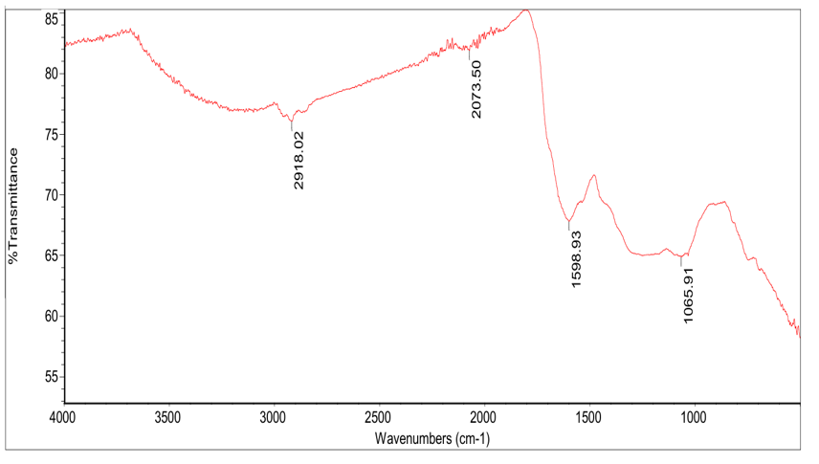

**Figure 2:** FTIR spectra of Activated Bentonite Clay

The FTIR spectra of activated bentonite clay (Figure 2) reveal critical functional groups and chemical interactions governing their adsorption efficacy in transformer oil regeneration. For the Bentonite Clay (Figure 2), Si–O Stretch (~1065.91 cm⁻¹) band corresponds to the stretching vibrations of silicate structures, indicative of the presence of Si–O–Si and Si–O–Al bonds. These structures contribute to the high surface area and porosity of bentonite and palm kernel shell, enhancing its capacity to adsorb polar compounds such as acids and moisture from transformer oil. ​C=C–C Stretch (~1598.93 cm⁻¹) is associated with aromatic ring structures, this band suggests the presence of π-electron-rich regions. These regions can interact with unsaturated hydrocarbons and aromatic compounds in transformer oil through π–π interactions, facilitating their adsorption.​ C≡N Stretch (~2073.5 cm⁻¹) indicates presence of nitrile group. Their presence may enhance the adsorption of certain nitrogen-containing impurities through dipole–dipole interactions.​ C–H Stretch (~2918.02 cm⁻¹) is characteristic of aliphatic C–H stretching vibrations, suggesting the presence of alkane groups. These hydrophobic regions can interact with non-polar impurities in transformer oil, aiding in their removal.​ The absence of bands corresponding to O–H stretching vibrations (3200–3700 cm⁻¹) indicates a reduction in hydroxyl groups due to acid activation. This dehydroxylation process increases the surface acidity and porosity of bentonite, enhancing its adsorption capacity for polar impurities such as acids and moisture.

**3.4 Surface Morphology of Activated Bentonite and Palm Kernel Shell (PKS)**

The surface morphology of the activated PKS and bentonite was investigated by Scanning electron microscopy (SEM), and the images were shown with 534µm magnification in Figures 3-4.

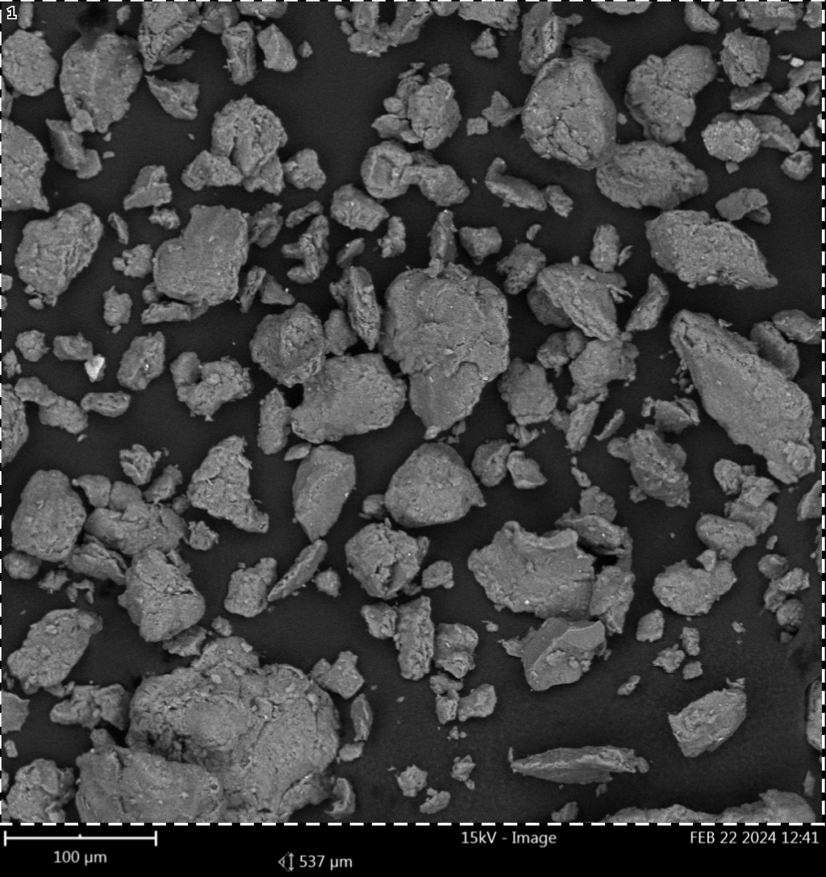

**Figure 3:** SEM Micrograph of Activated Bentonite Clay

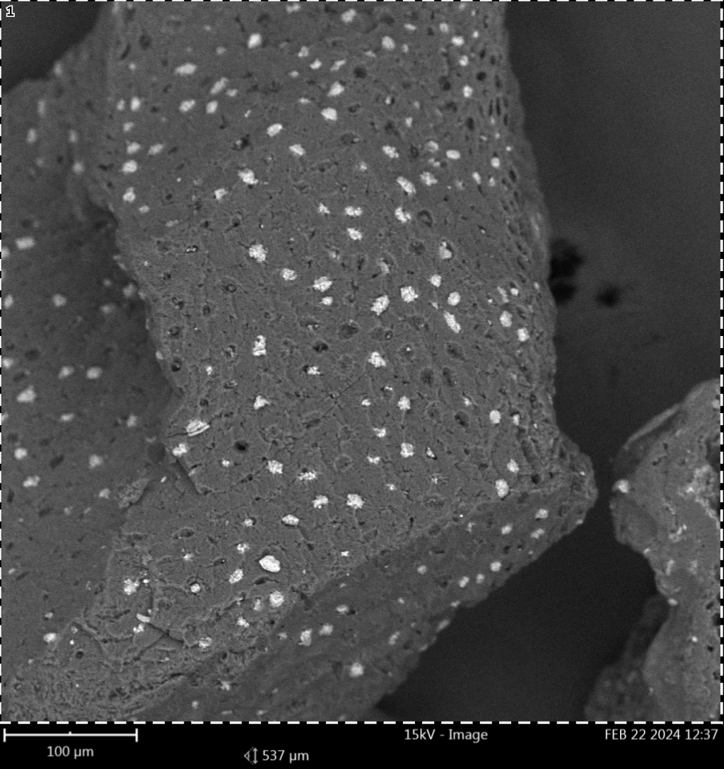

**Figure 4:** SEM Micrograph of Activated Palm Kernel Shell

SEM images (Figures 3–4) elucidate morphological changes induced by acid activation: For Bentonite Clay (Figure 3), it reveals exfoliated layers and honeycomb-like pores, corroborating FTIR-derived porosity enhancement. Then, Palm Kernel Shell (Figure 4), 7N treatment introduces fissures and cavities, aligning with FTIR data on hemicellulose removal. It is important to note that the 7N treatments optimize adsorbent morphology, with bentonite developing mesopores (ideal for large oil molecules) and PKS acquiring a cracked texture (increasing surface area).

* 1. **Comparative analysis of regenerated transformer oils and spent transformer oil**

The properties of the regenerated transformer oil are compared with those of spent transformer oil in Table 6.

**Table 6: Comparison of regenerated transformer oils with spent transformer oil**

|  |  |  |
| --- | --- | --- |
| **Oil Properties** | **Spent Transformer Oil (STO)** | **Regenerated Transformer Oil (RTO)** |
| Water Content(ppm) | 35.42 | 10.254 (71.05 %) u |
| Acidity(mgKOH/g) | 0.821 | 0.003 (99.64 %) u |
| Kinematic Viscosity at 40oC (mm2/s) | 18.3 | 10.34 (43.50 %) u |
| Density at 20oC | 0.975 | 0.8342 (14.44 %) u |
| Flashpoint (oC) | 144 | 150 (4.17 %) u |
| Fire point (oC) | 156 | 160 (2.56 %) u |
| Breakdown Voltage (kV) | 10 | 60 (83.33 %) u |

u Values in parentheses indicate the percent removal of the used transformer oil.

This provides a comparative evaluation of key physicochemical and electrical properties between the used transformer oil (STO) and regenerated transformer oil (RTO) activated with 7N acid concentration. The regeneration process led to significant improvements across all measured parameters.​ Water Content reduced from 35.42 ppm in STO to 10.254 ppm in RTO, indicating a 71.05% decrease, which enhances the dielectric strength of the oil.​ The acid number decreased from 0.821 mg KOH/g to 0.003 mg KOH/g, representing a 99.64% reduction, thereby mitigating the risk of corrosion and extending the service life of transformer components.​ Kinematic Viscosity was reduced from 18.3 mm²/s to 10.34 mm²/s, a 43.50% reduction, improving the oil's cooling efficiency and flow characteristics.​ Density decreased from 0.975 g/cm³ to 0.8342 g/cm³, a 14.44% reduction, which can contribute to better thermal conductivity and reduced energy losses.​ Flash Point increased from 144°C to 150°C, a 4.17% improvement, enhancing the safety margin against fire hazards.​ Fire Point increased from 156°C to 160°C, a 2.56% increase, further contributing to operational safety.​ Breakdown Voltage (BDV) significantly improved from 10 kV to 60 kV, marking an 83.33% increase, which substantially enhances the insulating properties of the oil.

1. **CONCLUSION**

This study successfully demonstrated the effectiveness of bentonite clay and palm kernel shell-activated carbon (PKS-AC) as sustainable and cost-effective adsorbents for regenerating spent transformer oil. The activated adsorbents exhibited good performance, achieving 99.64% acidity removal and 71.05% moisture reduction, while restoring key oil properties such as viscosity, density, flash point, and breakdown voltage to within acceptable industrial standards. The optimal regeneration conditions (3.4g PKS-AC/30ml oil, 3.8g bentonite/30ml oil, 77°C, 77 minutes, 744 rpm) highlight the synergistic potential of these natural materials in oil treatment processes.

The characterization of adsorbents (FTIR, SEM, physico-chemical analysis) confirmed enhanced porosity, surface area, and functional group availability, leading to improved contaminant adsorption. The regenerated oil met standard specifications, validating the feasibility of this eco-friendly approach as an alternative to conventional, chemically intensive methods. This research contributes to sustainable waste management by repurposing agricultural byproducts (palm kernel shells) and natural clays (bentonite), reducing environmental impact while maintaining cost efficiency. To further advance this research, multiple efficiency of bentonite and PKS-AC to determine their reusability and potential cost savings need to be investigated.

**REFERENCES**

Adekoya, D.O and Adejumobi, I.A. (2017). Analysis of Acidic Properties of Distribution Transformer Oil Insulation: A Case Study Of Jericho (Nigeria) Distribution Network. Nigerian Journal of Technology (NIJOTECH), Vol. 36, No. 2, pp. 563 – 570

Ahmetović, M., Šestan, I., Odobašić, A., Papraćanin, E., Keran, H., Đozić, A., & Junuzović, H. (2024). The Potential of Bentonite as a Low-cost Adsorbent for the Removal of Heavy Metal Ions from Multicomponent Aqueous Systems of the Galvanic Industry. International Research Journal of Pure and Applied Chemistry, 25(2), 28–39. https://doi.org/10.9734/irjpac/2024/v25i2848

Aliev, A., Ganieva, S., Smanov, B., Adizov, B., & Rakhimov, B. (2023). Environmentally friendly regeneration of used energy oils. E3S Web of Conferences, 390, 05043. https://doi.org/10.1051/e3sconf/202339005043

Arsad, S.R., Ker, P.J., Jamaludin, M.Z., Choong, P.Y., Lee, H.J., Thiviyanathan, V.A., Yang Ghazali, Y.Z. (2023). Water Content in Transformer Insulation System: A Review on the Detection and Quantification Methods. Energies 16, 1920. https://doi.org/10.3390/en16041920

Babayemi, A. K. (2017). Performance Evaluation of Palm Kernel Shell Adsorbents for the Removal of Phosphorus from Wastewater. Advances in Chemical Engineering and Science, 07(02), 215–227. https://doi.org/10.4236/aces.2017.72016

Bakrutheen, M., Raymon, A., Pakianathan, P.S. and Rajamani, M.P.E. and Karthik, R. (2014). Enhancement of Critical Characteristics of Aged Transformer Oil using Regenerative Additives. Australian Journal of Electrical and Electronics Engineering, 11:1, 77-86

Boadu, K.O, Joel, O.F, Essumang, D.K and Evbuomwan, B.O., (2018). Comparative Studies of the Physicochemical Properties and Heavy Metals adsorption Capacity of Chemical Activated Carbon from Palm Kernel, Coconut and Groundnut Shells. J. Appl. Sci. Environ. Manage. Vol. 22 (11) 1833–1839, ISSN 1119-8362, DOI: https://dx.doi.org/10.4314/jasem.v22i11.19

Hadjadj, Y. and Fofana, I. (2015). Assessing Insulating Oil Degradation by Means of Turbidity and UV/Vis Spectrophotometry Measurements. IEEE Transactions on Dielectrics and Electrical Insulation Vol. 22, No. 5, pp 2653-2660

Inyinbor, A.A., Adekola, F.A and G.A. Olatunji, G.A. (2016). Liquid Phase Adsorption of Rhodamine B Dye onto Acid-treated Raphia hookeri Fruit Epicarp: Isotherms, Kinetics and Thermodynamics Studies. S. Afr. J. Chem., 2016, 69, 218–226

Jaber Ibrahim, A., Abdul Wahid Dwesh, H., & R.Y. Al-Sawad, A. (2023). Adsorption of methylene blue dye onto bentonite clay: Characterization, adsorption isotherms, and thermodynamics study by using UV-Vis technique. Analytical Methods in Environmental Chemistry Journal, 6(3), 5–18. https://doi.org/10.24200/amecj.v6.i03.243

Lai, J. Y., & Ngu, L. H. (2024). Post-combustion carbon dioxide adsorption of concurrent activated and surface modified palm kernel shell-derived activated carbon. Greenhouse Gases: Science and Technology, 14(3), 492–525. https://doi.org/10.1002/ghg.2274

Mariprasath, T. and Kirubakaran, V. (2016). Thermal degradation analysis of pongamia pinnata oil as alternative liquid dielectric for distribution transformer. Indian Academy of Sciences, Sadhana Vol. 41, No. 9, pp. 933–938

Medeiros, A. D. M. D., Silva Junior, C. J. G. D., Amorim, J. D. P. D., Durval, I. J. B., Costa, A. F. D. S., & Sarubbo, L. A. (2022). Oily Wastewater Treatment: Methods, Challenges, and Trends. Processes, 10(4), 743. https://doi.org/10.3390/pr10040743

Mohammed, A.-H. A.-K., & Kadhum, M. A. (2010). REGENERATION OF SPENT TRANSFORMER OIL. Journal of Engineering, 16(04), Article 04. https://doi.org/10.31026/j.eng.2010.04.08

Motlagh, M.M, Youzbashi, A.A and Rigi, Z.A (2011). Effect of Acid Activation on Structural and Bleaching Properties of a Bentonite. Iranian Journal of Materials Science & Engineering Vol. 8, Number 4.

Naswir, M., Arita, S., Hartati, W., Septiarini, L., Desfaournatalia, D., & Wibowo, Y. G. (2019). Activated Bentonite: Low-Cost Adsorbent to Reduce Phosphorus in Waste Palm Oil. International Journal of Chemistry, 11(2), 67. https://doi.org/10.5539/ijc.v11n2p67

Pahlavanpour, B. and Habibollahi, H. (2019). Characterisation of Insulating Oils. 6th Distribution Networks Conference

Permady, M. W. E., & Mustakim, Z. (2024). ADSORPTION OF METHYLENE BLUE DYES USING PALM KERNEL SHELLS AS ADSORBENTS. Jurnal Integrasi Proses Dan Lingkungan, 1(2), Article 2. https://doi.org/10.30587/jipl.v1i2.7130

Salvi, S. and Paranjape, A.P. (2017). Study of Transformer Oil Purification, SSRG International Journal of Electrical and Electronics Engineering, vol. 4, no. 3, pp. 16-19

Sambo, G. N., Adeola, A. O., & Muhammad, S. A. (2024). Oil palm waste-derived adsorbents for the sequestration of selected polycyclic aromatic hydrocarbons in contaminated aqueous medium. Applied Water Science, 14(6), 113. https://doi.org/10.1007/s13201-024-02171-w

Sterpu, A.-E., Dumitru, A. I., & Popa, M.-F. (2012). Regeneration of used engine lubricating oil by solvent extraction. Analele Universitatii “Ovidius” Constanta - Seria Chimie, 23(2), 149–154. https://doi.org/10.2478/v10310-012-0025-2

Sun, W.-J., Tang, Q.-T., Lu, T.-H., Fan, R.-D., Sun, G.-G., & Tan, Y. (2024). Adsorption performance of bentonite and clay for Zn(II) in landfill leachate. Geoenvironmental Disasters, 11(1), 4. https://doi.org/10.1186/s40677-023-00265-2

Taha, G., Nasrat, L. and Younes, G (2020). Improvement of Some Chemical and Electrical Properties of Aged Transformer Oil using Eco-Friendly Fillers. Aswan University Journal of Environmental Studies (AUJES), Vol. 1, No. 2, pp. 137-146, DOI: 10.21608/aujes.2020.127569

Thanigaiselvan, R. and Raja, T.S. (2016). Enrichment of used Transformer Oil using Activated Bentonite and Comparison of Various Transformer Oils with Vegetable Oil. International Journal of ChemTech Research, Vol.9, No.01 pp 128-133

Tiwari, R., Agrawal, P. S., Belkhode, P. N., Ruatpuia, J. V. L., & Rokhum, S. L. (2024). Hazardous effects of waste transformer oil and its prevention: A review. Next Sustainability, 3, 100026. https://doi.org/10.1016/j.nxsust.2024.100026

Vanitha, M., Narmadhai, N. and Karthik, M. (2016). Investigation of Critical Characteristics of Transformer Oil with Activated Carbon. Circuits and Systems, 7, 2521-2529. http://dx.doi.org/10.4236/cs.2016.79218

Yassin, J.M., Shiferaw, Y. and Tedla, A. (2022). Application of acid activated natural clays for improving quality of Niger (Guizotia abyssinica Cass) oil. Heliyon 8 (2022) e09241

Zambrano, M.V., Dutta, B., Mercer, G.D., Heather L. MacLeana, L.H. and Touchie, M.F. (2019). Assessment of moisture content measurement methods of dried food products in small-scale operations in developing countries: A review. Trends in Food Science & Technology 88 (2019) 484–496

Zhang, Q.Y., Wu, J.F., Ma, P.H., Cai, J. and Zhang, Y.T. (2015). Acid Value Determination and Pre-Esterification of Crude Euphorbia lathyris L. Oil. World Journal of Engineering and Technology, 3, 70-75. http://dx.doi.org/10.4236/wjet.2015.32007