**Original Research Article**

**Natural coagulants as phytoremediation: An *in-silico* approach to distillery effluent treatment.**

**ABSTRACT:**

Distillery effluents are among the most challenging industrial pollutants, characterized by high organic load and toxicity, posing severe threats to environmental health. This study employs a novel in-silico strategy to evaluate the bioremediation potential of plant-derived proteins as natural coagulants for distillery wastewater treatment. Key effluent-associated ligands were identified and docked against selected proteins from Moringa oleifera, Hibiscus, and Lantana camara using AutoDock Vina within the PyRx platform. Protein stability was validated via Ramachandran plot analysis, ensuring structural integrity. Among the tested candidates, Lectin (PDB ID: 5GQT) from Lantana camara exhibited the strongest binding affinities across multiple ligands, indicating its high potential for pollutant sequestration. These findings underscore the promise of plant-based proteins, particularly lectins, as effective, eco-friendly agents in phytoremediation and sustainable industrial wastewater management.

***Keywords:*** *Molecular Docking, Ramachandran Plot, Distillery effluent, Water Pollution, Sever treatment*

1. **INTRODUCTION**

Distilleries rank among the most polluting industries, with approximately 88% of their raw materials converted into waste, much of which is discharged into water bodies, thereby contributing significantly to water pollution. For every litre of alcohol produced, around 15 litre of spent wash—a highly polluting effluent—is generated (Ravikumar et al., 2007). Alcohol serves as a fundamental feedstock for a wide array of chemical industries, and consequently, its demand is expected to surge in the coming years. Distilleries are playing a crucial role in meeting this growing demand.

The global interest in ethanol production from agricultural biomass as an alternative fuel is escalating due to the dwindling reserves of non-renewable energy sources and the fluctuating prices of oil and natural gas. In India, this demand is anticipated to rise, particularly considering legislation mandating the blending of 5% ethanol with petrol, with a target to increase this proportion to 10% (The Gazette of India, 2002).

Many large-scale distilleries in India are integrated with sugar mills and typically use molasses as a raw material. On average, such distilleries produce 15 litre of spent wash per litre of alcohol (Beltran et al., 2001). Molasses-based spent wash (MSW) poses significant disposal challenges due to its low pH, elevated temperature, dark brown hue, high ash content, and substantial concentrations of dissolved organic and inorganic matter (Beltran et al., 1999). The effluent’s high biochemical oxygen demand (BOD) and chemical oxygen demand (COD)—ranging from 35,000–50,000 mg L⁻¹ and 100,000–150,000 mg L⁻¹ respectively, reflect its severe environmental impact (Nandy et al.,2002).

The release of spent wash into the environment leads to widespread soil and water contamination. In response, the Central Pollution Control Board (CPCB), India’s premier environmental regulatory authority, mandated that all distilleries achieve zero liquid discharge (ZLD) of spent wash by December 2005 (CPCB, 2003).

Over the years as the size and number of distilleries have grown, larger conventional aerobic-treatment plants have been built to handle constantly increasing effluent volumes. Space and money to construct these installations are the biggest hindrances to such investments (Fumi et al., 1995).

Bioremediation research involves proteins from plant extracts, which exhibit a strong affinity for pollutants in spent wash. It helps in enhancing treatment efficiency: Designing engineered enzymes or selecting microbes that target key pollutants.

While traditional treatment of distillery effluents focuses on physical, chemical, or biological methods, molecular docking offers insights into the biodegradation mechanisms at the molecular level.

Molecular docking is a widely used computational technique in structure-based drug design that predicts the optimal orientation of a ligand when bound to a target macromolecule, such as a protein, to form a stable complex. This approach provides insights into binding affinity and interaction patterns, which are crucial for understanding structure activity relationships and identifying potential drug candidates. Molecular docking also enables high throughput virtual screening, significantly accelerating the early phases of drug discovery while reducing time and cost compared to experimental methods (Morris & Lim-Wilby, 2008).

In this research article, molecular docking of distillery wastewater is done to explore how pollutants in the wastewater interact with biological molecules like proteins and play a crutial role in building up sustainable environment.

1. **MATERIAL AND METHODS**

Discovery Studio 3.5 Client was used for visualization, OpenBabel for the format interconversion, and PyRx for the Molecular docking. Supporting web based tools include PubChem (<https://pubchem.ncbi.nlm.nih.gov>) for ligand, protein (<https://www.rcsb.org/>), CASTp (<http://sts.bioe.uic.edu/castp/index.html?1ycs>) for active prose determination, and PROCHEK integrated with PDBSum for Ramachandran plot (https://www.ebi.ac.uk/thornton-srv/databases/pdbsum/).

***2.1 Ligand Preparation***

The primary material used in the study was the 3-dimensional structure of the ligands present in distillery effluent. Based on the literature survey, the structures (3-D) of different ligands present in distillery effluent were downloaded from PubChem. The ligands used in present study are shown in Table 1.

Table 1: Ligands used in the study

|  |  |  |
| --- | --- | --- |
| **Sl. No.** | **Ligand names** | **Abbreviation** |
| 1 | 1,2,4,5-tetrahydro-2-methyl-3H-2-benzazepine-3-one | Lig_1 |
| 2 | 3H-thieno[3,4-c] thiophene | Lig_2 |
| 3 | Butanoic acid | Lig_3 |
| 4 | 4-(p-cumylphenoxy) phthalonitrile | Lig _4 |
| 5 | Hexadecenoic acid | Lig _5 |
| 6 | Butyl ester | Lig _6 |
| 7 | Squalene | Lig _7 |

***2.2 Protein preparation***

Protein was optimised by downloading three-dimensional (3D) X-ray crystallographic structures in (.cif) format and later converted to pdb format using OpenBabel GUI software. The Proteins were also checked for their stability using Ramachandran plot (Ramachandran et al., 1963; Laskowski et al., 1993). The proteins used for the study are shown in Table 2.

Table 2: Various proteins used for the study and their biological activities

|  |  |  |  |  |
| --- | --- | --- | --- | --- |
| **Sl.no** | **Proteins** | **PDB ID** | **Biological activity** | **References** |
| *Moringa oleifera* seed protein | | | | |
| 1 | 2S Albumin | 1GP6 | Sulphur rich seed storage protein(methionine & cysteine). Exhibit anti-microbial property. | Shewry & Tatham, 1995. |
| 2 | Morintides mO1 | 5WUZ | Cysteine rich peptide, it leads to exceptional stability, making mo1 resistant to thermal and enzymatic degradation, antifungal | Kini et al., 2017 |
| 3 | (Mo-CBP4) | 6VJO | Chitin binding protein, antifungal & anti-inflammatory | Leite Pereira et al., 2011 |
| 4 | Mo-CBP3-4 | 6S3F | Chitin binding protein, antifungal & anti-inflammatory | Moulin et al., 2019 |
| *Moringa oleifera* leaf protein | | | | |
| 5 | Leucin | 5ECM | Stress response and metabolism | Sadak et al., 2020 |
| 6 | Glutamic acid | 6R85 | Plant nitrogen metabolism and stress tolerance | Qui et al., 2020 |
| 7 | Albumin | 2EFD | Anti-microbial | Shewry, & Halford, 2002. |
| 8 | Prolamin | 4GG6 | Anti-microbial | Xie et al., 2011 |
| 9 | Globulins | 3KSC | Viscoelastic property, autoimmune development | Shewry, & Halford 2002. |
| *Hibiscus* leaf protein | | | | |
|  |  | | |  |
| 6 | Glutamic acid | 6R85 | Plant nitrogen metabolism and stress tolerance | Forde & Lea, 2007 |
| 7 | Albumin | 2EFD | Anti-microbial | Shewry & Halford, 2002. |
| 9 | Globulins | 3KSC | Viscoelastic property, autoimmune development | Shewry & Halford, 2002. |
| 10 | aspartic acid | 3AUP | Nitrogen metabolism, stress response | Gilli ,1995 |
| *Lantana camera* leaf protein | | | | |
| 11 | Lectin | 5GQT | Defence mechanism, symbiotic interaction, cell signalling, growth regulation, used for glycoprotein detection and cell typing | Hiremath et al., 2020 |

***2.3 Molecular Docking***

The ligand and the proteins were subjected for the molecular docking studies (Jain et al., 2021). Molecular docking studies was carried out using AutoDock Vina program integrated with the PyRx software. The active prose required for the protein was retrieved from webtool CASTp. This prose was used for the docking of the ligand into it. The docked ligand was saved in the pdb format and was used for the visualization for the interaction with the amino acid residues of the proteins.

1. **RESULTS AND DISCUSSION**

The 3-D structures of the ligands present in the distillery effluents were downloaded and the same are represented in Figure 1.

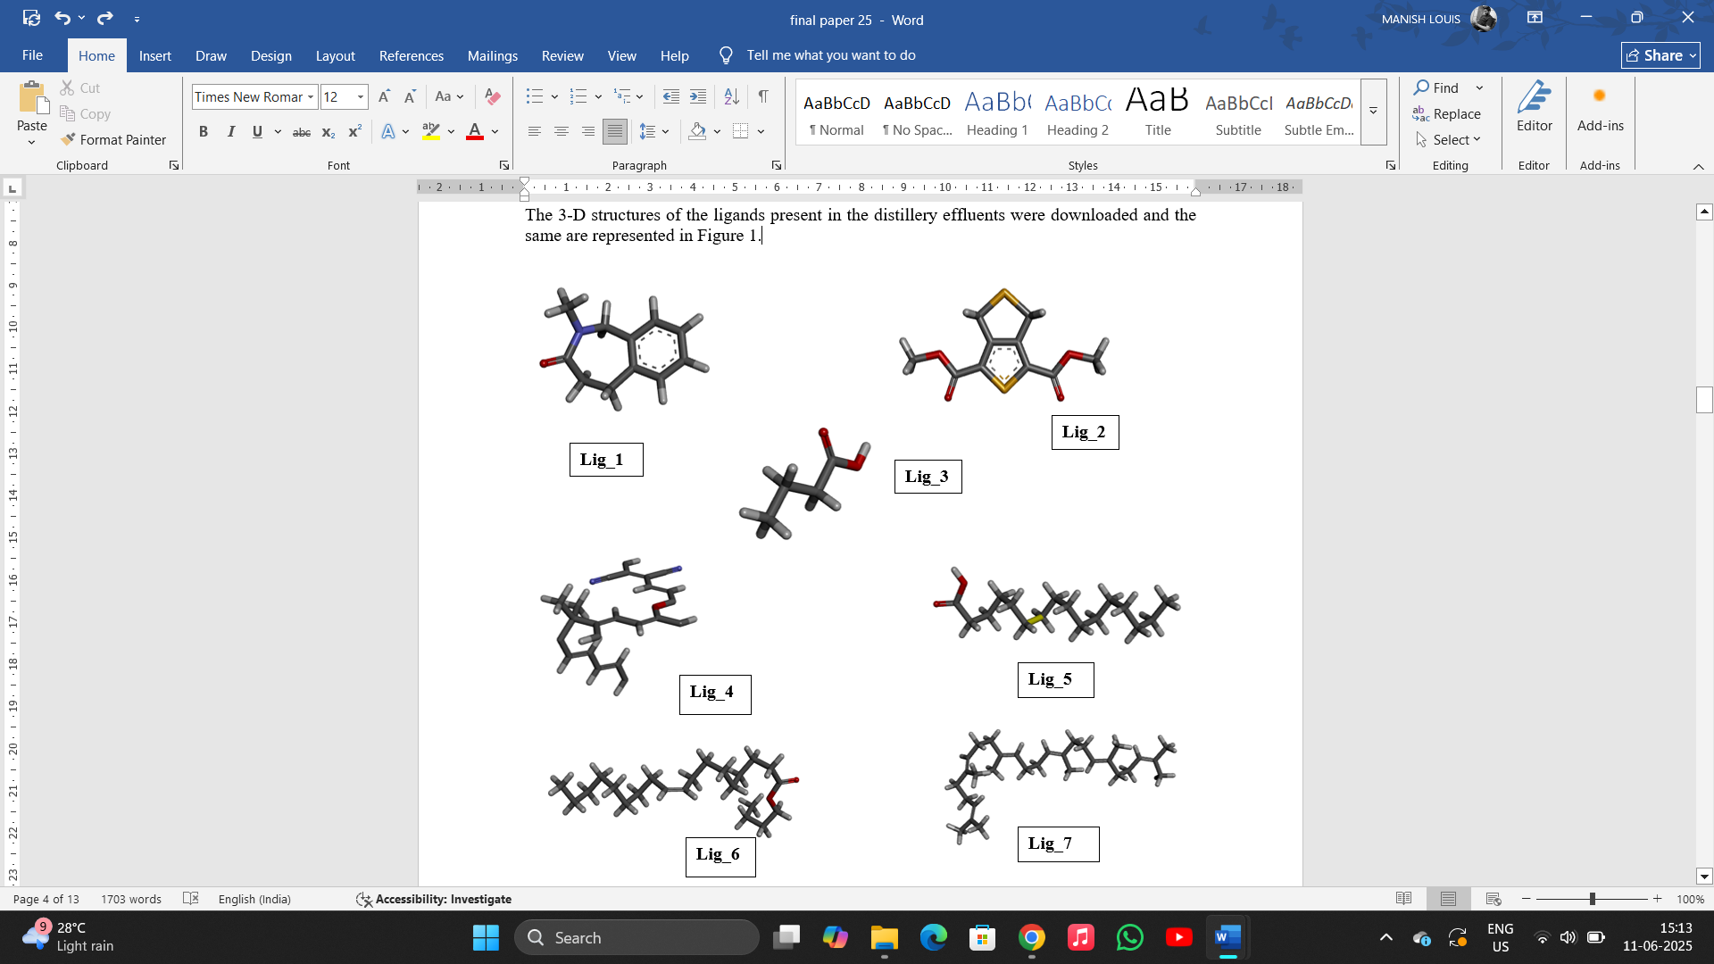

Fig.1. 3-D structures of the Ligands

**3.1 Protein validation**

The Ramachandran Plot is a critical tool in structural biology used to evaluate the quality and validity of protein models by analysing the backbone dihedral angles, phi (Φ) and psi (Ψ), of amino acid residues. Protein validation by a Ramachandran plot is a key method for assessing the quality of a protein structure (Ramachandran, 1963). Ramachandran plot of all the proteins revealed (Figure 2) that the around 90% of the amino acid residues of the proteins used are falling in the allowed/favourable region of the plot suggesting that the proteins are of good quality and are stable in nature.

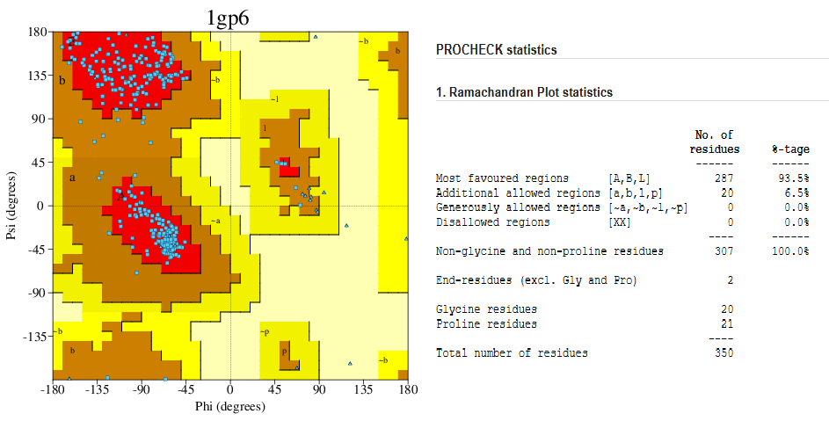

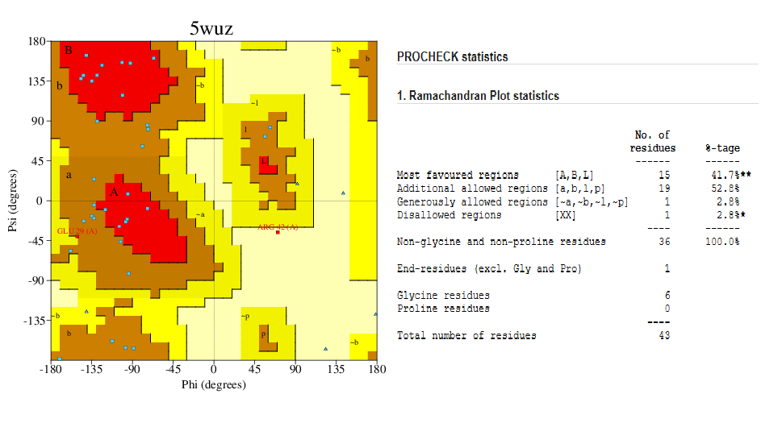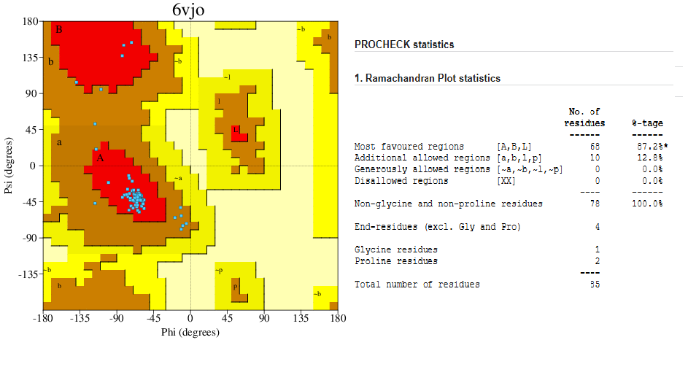

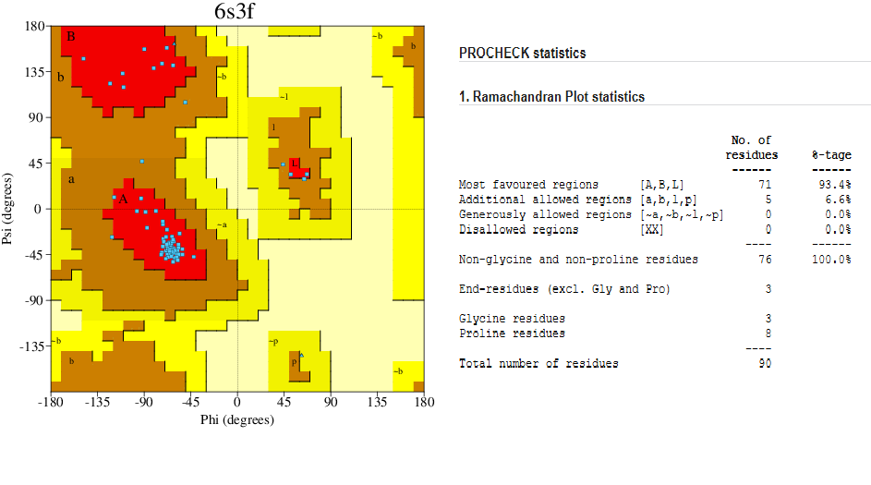

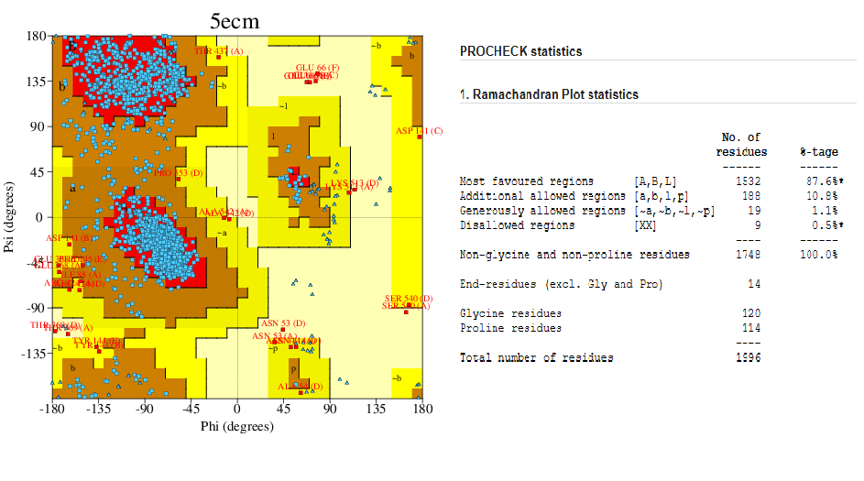

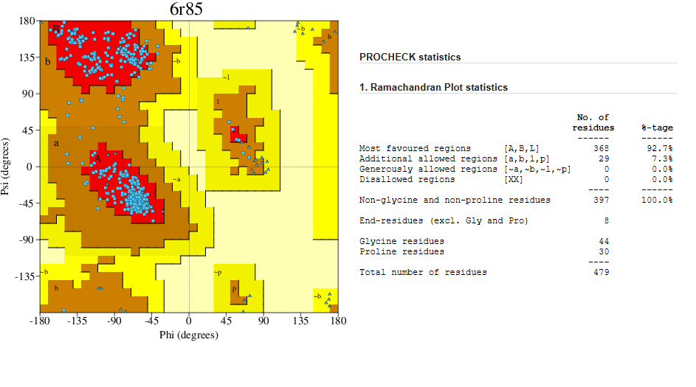

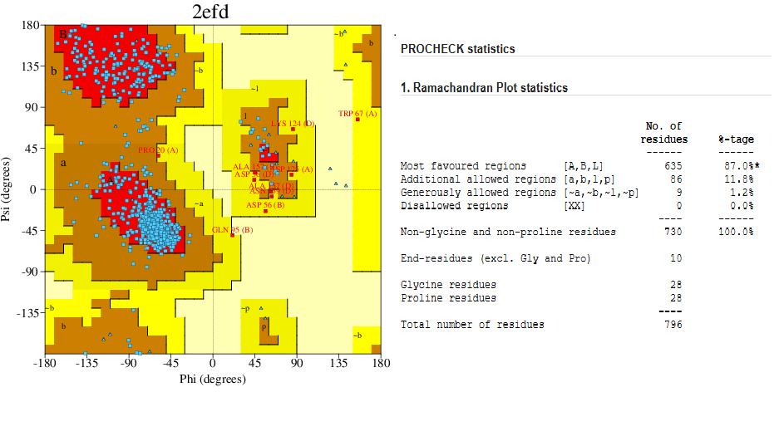

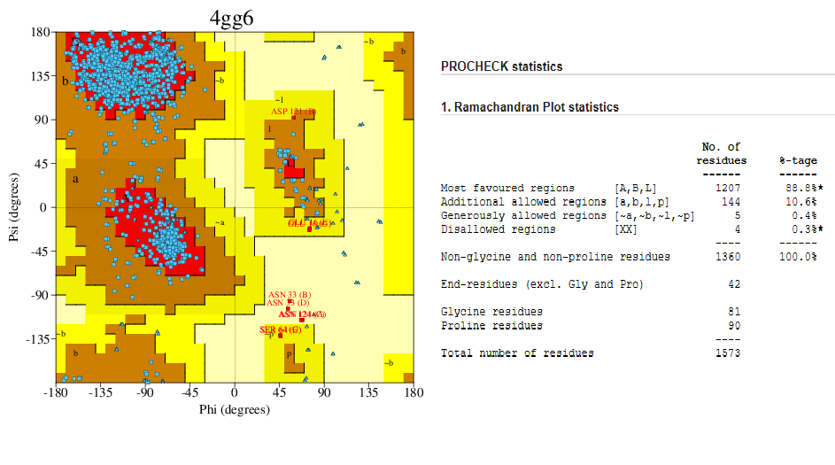

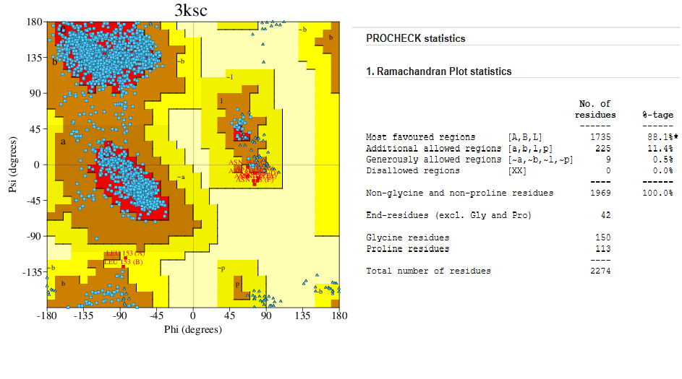

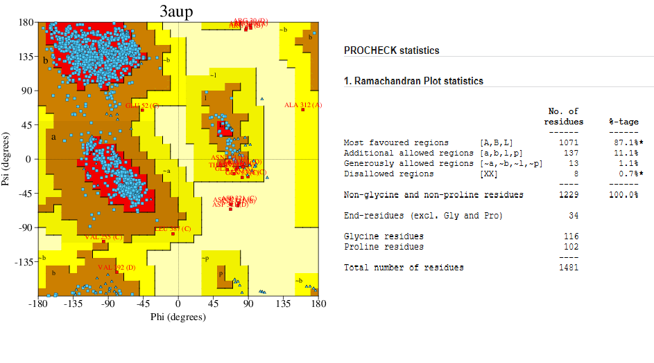

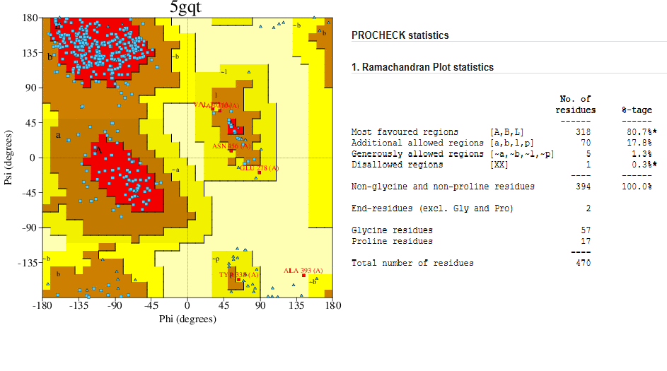

Fig.2. Ramachandran Plot of the proteins extracted from various plants.

***3.2 Molecular docking***

To evaluate the potential binding interactions between selected ligands and target proteins, molecular docking studies were performed using AutoDock Vina, integrated within the PyRx virtual screening tool. This computational approach enabled the prediction of binding affinities (expressed in kcal/mol) by simulating the interaction of each ligand with a set of 11 distinct protein targets. The docking results, summarized in Table 3, provide insight into the strength and specificity of these interactions. Ligands demonstrating binding affinities more negative than −6.0 kcal/mol were considered to exhibit strong binding potential, as this threshold is commonly associated with biologically significant interactions in a biochemical context (Copeland et al., 2006).

Table 3: Molecular docking studies result showing the binding affinity (kcal/mol) of the ligands with the corresponding Proteins

Ligand

|  |  |  |  |  |  |  |  |  |
| --- | --- | --- | --- | --- | --- | --- | --- | --- |
| Sl. No. | Proteins | Lig_1 | Lig_ 2 | Lig_3 | Lig_ 4 | Lig_ 5 | Lig_6 | Lig_7 |
|  | 1GP6 | -7.3 | -7.2 | -3.8 | -9.3 | -6.4 | -4.3 | -6.1 |
|  | 5WUZ | -4.5 | -4.4 | -2.6 | -5.3 | -3 | -2.9 | -3.6 |
|  | 6VJO | -5.6 | -4.7 | -3.3 | -7.3 | -4.4 | -3.5 | -5.5 |
|  | 6S3F | -4.9 | -3.7 | -3.3 | -5.4 | -4.7 | -3.6 | -5.1 |
|  | 5ECM | -7 | -6.6 | -4.1 | -7.2 | -6.2 | -4.2 | -5.5 |
|  | 6R85 | -4.9 | -5.3 | -3.4 | -6.1 | -3.6 | -3.5 | -4.3 |
|  | 2EFD | -6.5 | -6.2 | -3.7 | -8.8 | -4.9 | -4.4 | -6.7 |
|  | 4GG6 | -5.8 | -6.4 | -3.5 | -7.7 | -4.2 | -3.6 | -4.8 |
|  | 3KSC | -6.4 | -6.9 | -4 | -7.4 | -4.6 | -4.4 | -6 |
|  | 3AUP | -5.9 | -6 | -3.8 | -8.1 | -5.3 | -4 | -5.2 |
|  | 5GQT | -7.7 | -7.3 | -4 | -9.8 | -5.8 | -4.5 | -6.9 |

The analysis highlights that 5GQT protein is much more efficient in forming the stable dead-end complex with most of the ligand suggesting that the protein Lectin present in the *Lantana camera* will be useful in pelleting the compounds present the industrial distillery effluent in a more efficient way as compared to the other proteins used in this study. The interaction of the amino acid residues of the of Lectin (PDB ID: 5GQT) with the ligands is shown in Figure 3.

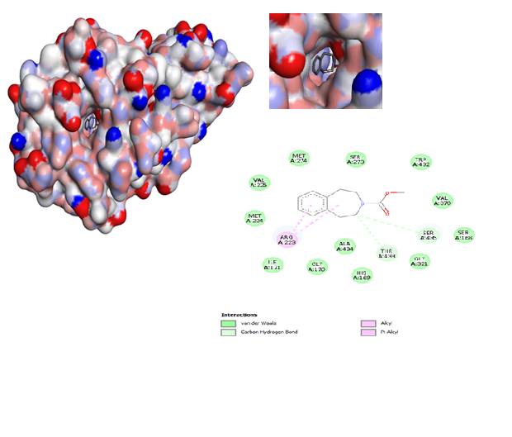

**A.**

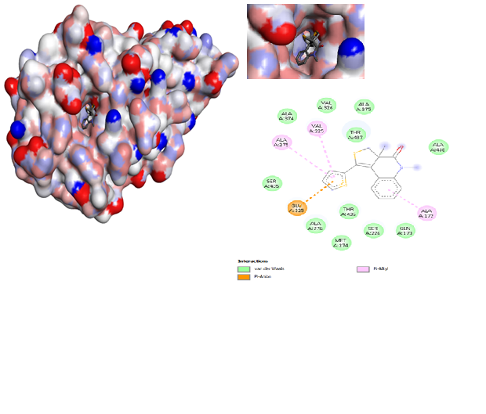

**B.**

**C.**

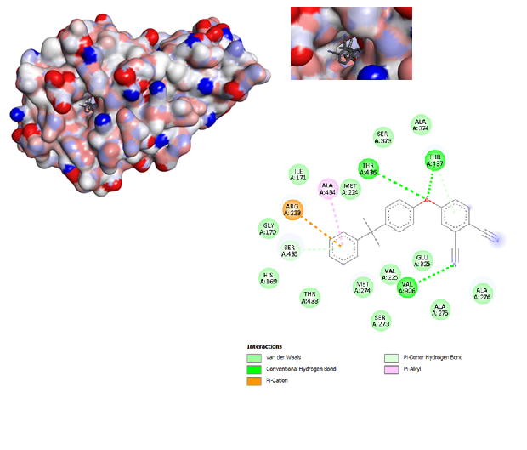

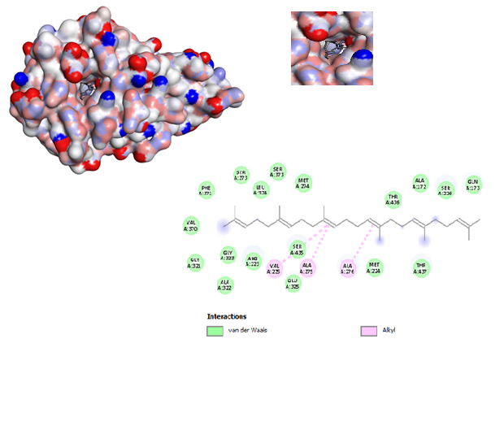

**D.**

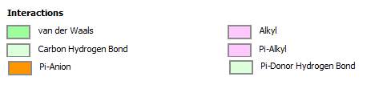

Fig.3. The 3-D and 2-D structures of the ligands docked with Lectin (PDB ID: 5GQT), **A**. Lig_1, **B**. Lig_2, **C**. Lig_4, and **D**. Lig_7

1. **CONCLUSION**

In this study, a comparative analysis of various proteins was performed to assess their binding affinity to a selected ligand, with the aim of identifying potential candidates for reducing the physical parameters of distillery effluent. Among the proteins analysed, Protein 1 was identified as albumin derived from *Moringa* seed, while Protein 12 was lectin obtained from *Lantana* leaf. Additionally, Proteins 5 and 7 represented leaf proteins from *Moringa*, corresponding to leucin and albumin, respectively.

Among all the tested leaf proteins, the lectin from *Lantana* leaf (Protein 11) exhibited the highest binding affinity to the ligand. This strong interaction suggests that *Lantana* lectin has a significant potential in binding and neutralizing target molecules present in distillery effluent. Consequently, its application resulted in a marked improvement in the reduction of key physical parameters (such as turbidity, and organic load) of the effluent.

These findings highlight the promise of plant-derived proteins, particularly lectins from *Lantana,* as effective bio-remediation agents in treating industrial wastewater. Future work may further optimize the use of such proteins in large-scale effluent treatment systems.

**REFERENCES**

Beltrán, F. J., García-Araya, J. F., & Álvarez, P. M. (1999). Wine distillery wastewater degradation. 1. Oxidative treatment using ozone and its effect on the wastewater biodegradability. *Journal of Agricultural and Food Chemistry*, *47*(9), 3911-3918.

Beltrán-Heredia, J., Torregrosa, J., Garcia, J., Domínguez, J. R., & Tierno, J. C. (2001). Degradation of olive mill wastewater by the combination of Fenton's reagent and ozonation processes with an aerobic biological treatment. *Water Science and Technology*, *44*(5), 103-108.

Central Pollution Control Board (CPCB) (2003) Environmental Management in Selected Industrial Sectors Status and Needs, PROBES/97/2002-03, CPCB, Ministry of Environment and Forest, New Delhi.

Copeland, R. A., Pompliano, D. L., & Meek, T. D. (2006). Drug–target residence time and its implications for lead optimization. *Nature reviews Drug discovery*, *5*(9), 730-739.

Forde, B. G., & Lea, P. J. (2007). Glutamate in plants: metabolism, regulation, and signalling. *Journal of experimental botany*, *58*(9), 2339-2358.

Fumi, M. D., Parodi, G., Parodi, E., Silva, A., & Marchetti, R. (1995). Optimisation of long-term activated-sludge treatment of winery wastewater. *Bioresource Technology*, *52*(1), 45-51.

Galili, G. (1995). Regulation of lysine and threonine synthesis. *The Plant Cell*, *7*(7), 899.

Hiremath, K. Y., Jagadeesh, N., Belur, S., Kulkarni, S. S., & Inamdar, S. R. (2020). A lectin with anti-microbial and anti proliferative activities from Lantana camara, a medicinal plant. *Protein expression and purification*, *170*, 105574.

Jain, A.S., Sushma, P., Dharmashekar, C., Beelagi, M.S., Prasad, S.K., Shivamallu, C., Prasad, A., Syed, A., Marraiki, N., Prasad, K.S. (2021). In silico evaluation of flavonoids as effective antiviral agents on the spike glycoprotein of SARS-CoV-2, *Saudi Journal of Biological Sciences.*1040-51

Kini, S. G., Wong, K. H., Tan, W. L., Xiao, T., & Tam, J. P. (2017). Morintides: cargo-free chitin-binding peptides from Moringa oleifera. *BMC plant biology*, *17*, 1-13.

Laskowski, R. A., MacArthur, M. W., Moss, D. S., & Thornton, J. M. (1993). PROCHECK: a program to check the stereochemical quality of protein structures. *Applied Crystallography*, *26*(2), 283-291.

Leite Pereira, M., David de Oliveira, H., Tadeu Abreu de Oliveira, J., Menezes Gifoni, J., de Oliveira Rocha, R., de Oliveira Bezerra de Sousa, D., & Maria Vasconcelos, I. (2011). Purification of a chitin-binding protein from Moringa oleifera seeds with potential to relieve pain and inflammation. *Protein and Peptide Letters*, *18*(11), 1078-1085

Morris, G. M., & Lim-Wilby, M. (2008). Molecular docking. *Molecular modeling of proteins*, 365-382.

Moulin, M., Mossou, E., Signor, L., Kieffer-Jaquinod, S., Kwaambwa, H. M., Nermark, F., ... & Rennie, A. R. (2019). Towards a molecular understanding of the water purification properties of Moringa seed proteins. *Journal of colloid and interface science*, *554*, 296-304.

Nandy, T., Shastry, S., & Kaul, S. N. (2002). Wastewater management in a cane molasses distillery involving bioresource recovery. *Journal of Environmental Management*, *65*(1), 25-38.

Qiu, X. M., Sun, Y. Y., Ye, X. Y., & Li, Z. G. (2020). Signaling role of glutamate in plants. *Frontiers in plant science*, *10*, 1743.

R. Ravikumar, R. Saravanan, NS Vasanthi, J. Swetha, N. Akshaya, M. Rajthilak and KP Kannan.(2007). Biodegradation and decolourization of biomethanated distillery spent wash. *Indian Journal of Science and Technology*. 1(2)

Ramachandran, G. N. (1963). Protein structure and crystallography. *Science*, *141*(3577), 288-291.

Ramachandran, G. N., Ramakrishnan, C., & Sasisekharan, V. (1963). Stereochemistry of polypeptide chain configurations. Journal of Molecular Biology, 7(1), 95–99.

Sadak, M. S., Abdalla, A. M., Abd Elhamid, E. M., & Ezzo, M. I. (2020). Role of melatonin in improving growth, yield quantity and quality of Moringa oleifera L. plant under drought stress. *Bulletin of the National Research Centre*, *44*, 1-13.

Shewry, P. R., & Halford, N. G. (2002). Cereal seed storage proteins: structures, properties and role in grain utilization. *Journal of experimental botany*, *53*(370), 947-958.

Shewry, P. R., Napier, J. A., & Tatham, A. S. (1995). Seed storage proteins: structures and biosynthesis. *The plant cell*, *7*(7), 945-946.

Xie, Y., Fleming, E., Chen, J. L., & Elmore, D. E. (2011). Effect of proline position on the antimicrobial mechanism of buforin II. *Peptides*, *32*(4), 677-682.