**Innovations and Achievements in Small Wind Turbines: A State-of-the-Art Review**

.

**ABSTRACT**

**Aims:** This study aims to provide a critical and comparative review of recent technological innovations in small wind turbines (SWTs), focusing on their relevance for decentralized energy production in both urban and remote environments.

**Study design:** A descriptive and analytical review study based on a comparative evaluation of small wind turbine technologies reported in the scientific literature from 2019 to 2024.

**Methodology:** Five representative small wind turbine models were selected: Liam F1 Urban Wind Turbine (UWT), Aeroleaf, IceWind, AeroMINE, and Harmony. A multi-criteria assessment framework was applied, considering performance under various wind conditions, aerodynamic configurations, materials used, installation contexts, and technological innovations. Evaluation criteria included energy efficiency, acoustic footprint, cost-effectiveness, durability, and environmental adaptability.

**Results:** The analysis revealed heterogeneous performance across technologies. Harmony and AeroMINE systems demonstrated higher adaptability to variable urban winds, while IceWind offered robust operation in remote and harsh climates. Liam F1 and Aeroleaf emphasized low-noise performance and aesthetic integration. Aerodynamic design and the use of intelligent control systems were found to significantly influence energy conversion efficiency. Material selection and modular design emerged as key factors in durability and cost optimization.

**1. Introduction**

Over the past decades, wind turbine technology has experienced significant growth, establishing itself as one of the most widespread and strategic sources of renewable energy worldwide. The sector is currently dominated by China due to its high installed capacity [1]. The expansion of wind energy has been strongly influenced by responses to energy crises, particularly the one linked to the war in Ukraine, which have redirected investments toward renewables to ensure energy security and price stability [2]. While large-scale onshore and offshore installations still dominate energy production [3], the growing interest in small wind turbines reflects a desire for citizen control over energy [4], a reduction in dependence on centralized grids, and the valorization of local resources, especially in urban or remote areas, as emphasized by Tang and al.[5].

In regions with low solar irradiance, small wind turbines represent an essential alternative to photovoltaics to ensure reliable electrification [6]. These technologies are currently used in a variety of contexts: powering isolated homes, smart urban infrastructure, hybrid systems with solar panels, and autonomous equipment such as weather stations and relay antennas. The global market for small wind turbines is experiencing sustained growth, driven by technological innovations and targeted policy incentives. However, as noted by Li and al. [7], practical conditions must be met to ensure their economic viability. Incentive measures such as low-interest loans or investment subsidies are crucial to promote their large-scale adoption.

Despite these advances, scientific literature shows that research remains focused primarily on large-scale turbines or standard prototypes [8], often overlooking the specific challenges of small wind turbines, such as low wind speeds, increased turbulence, architectural integration issues, and concerns related to noise and maintenance [9]. This gap calls for a critical reassessment of current approaches [10], in light of recent technological innovations.

In this context, the present article undertakes a critical review of recent developments in small wind turbine technology, drawing on a representative corpus of devices developed by startups around the world. The goal is to go beyond marketing claims and examine the actual performance of these technologies, their technical limitations, and optimization prospects, in order to support their long-term integration into decentralized energy systems.

**2. Overview of Wind Turbines**

A wind turbine is an electromechanical conversion device designed to harness the kinetic energy of moving air. The conversion process involves two successive stages: transforming kinetic energy into mechanical rotational energy, followed by its conversion into electrical energy through electromagnetic induction.

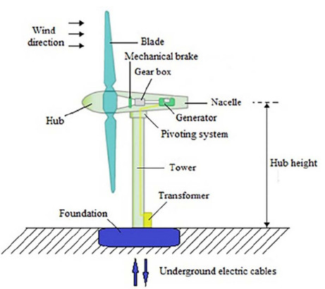

**Fig. 1: Overview of the main components of a HAWT (Horizontal Axis Wind Turbine) [11]**

**2.1 Classification of wind turbines by rotor size, swept area, and rated power**

According to Tummala and al. [12], small wind turbines differ from large-scale systems by having a rotor diameter between 1.25 and 3 meters and a rated power output ranging from 0.25 to 1.4 kW. The following table summarizes this classification:

**Table 1. HAWT classification by rotor diameter and power output [12]**

|  |  |  |  |  |
| --- | --- | --- | --- | --- |
| **Scale** | **Rotor (m)** | **Swept Area (m²)** | **Power (kW)** | **Typical Applications** |
| Micro | 0,5 – 1,25 | 0,2 – 1,2 | 0,004 – 0,25 | Remote sites, boats, caravans |
| Mini | 1,25 – 3 | 1,2 – 7,1 | 0,25 – 1,4 | Small domestic needs, water pumping |
| Domestic | 3 – 10 | 7 – 79 | 1,4 – 16 | Electricity production for households |
| Small commercial | 10 – 20 | 79 – 314 | 25 – 100 | Small businesse, farms |
| Medium commercial | 20 – 50 | 314 – 1963 | 100 – 1000 | Medium businesses, small communities |
| Large commercial | 50 – 100 | 1963 – 7854 | 1000 – 3000 | Large companies, wind farms |

The relationship between rotor diameter and swept area is mathematically defined by:

  (1) $A =\frac{πD^{2}}{4}$

This fundamental aerodynamic equation [13] shows that a linear increase in diameter (D) results in a quadratic increase in the area for extracting wind energy.

**2.2 Classification by rotor axis orientation**

Small wind turbines can be categorized into two main families based on rotor orientation:

**2.2.1 Vertical Axis Wind Turbines (VAWT)**

These turbines are characterized by a vertical rotation axis, which allows omnidirectional wind capture without requiring an orientation mechanism. Two main types are identified:

The Savonius turbine, invented in 1922 by Finnish engineer S. J. Savonius, operates based on the drag force exerted by wind on curved blades. It is known for its simple design, low-speed wind startup capability, and reliability under moderate wind conditions.

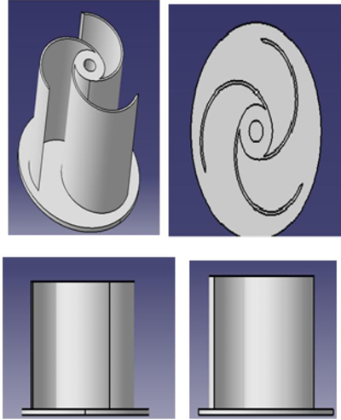

**Fig. 2: Isometric, top, front, and side views of the Savonius rotor blade [14]**

In contrast, the Darrieus-type wind turbine, designed in 1925 by French engineer G. J. Darrieus, relies on lift generated by airfoil-shaped blades. Although more complex than the Savonius model, it offers higher efficiency, especially at high wind speeds. Its various design variants allow for adaptation to different needs and installation conditions.

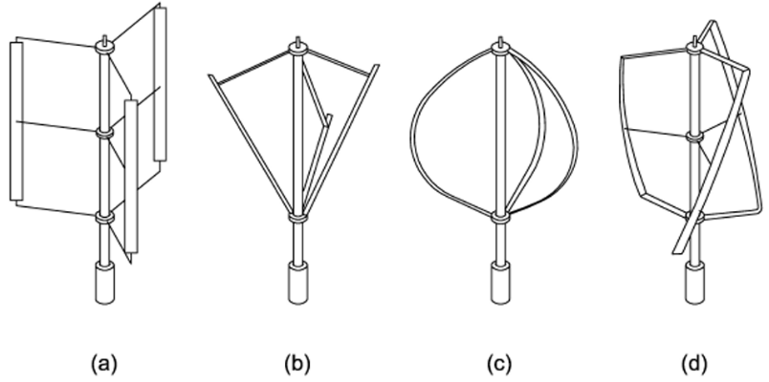

**Fig. 3: Possible variations of the Darrieus VAWT: (a) H-shape, (b) V-shape, (c) Troposkein shape, and (d) Gorlov shape [14]**

**2.2.2 Horizontal Axis Wind Turbines (HAWT)**

Horizontal Axis Wind Turbines dominate the wind energy sector (see Figure 1), accounting for over 90% of global installations. Their design, which orients the rotor into the wind using a yaw system, allows for efficient energy capture. They achieve power coefficients (Cp) close to Betz’s limit (0.45–0.55) and overall efficiencies of 35–45% [15]. Modern models, such as the 12 MW Haliade-X, can generate up to 67 GWh per year, enough to power about 16,000 European households [16]. Installed at heights of 80 to 150 meters, they benefit from steadier wind, especially offshore where capacity factors can exceed 50%. However, their large size and space requirements limit urban integration, and their logistical costs remain high.

**2.3 Analyze comparative: HAWT vs VAWT**

The table below summarizes the key differences between HAWTs and VAWTs, highlighting their respective advantages and constraints:

**Table 2. Technical comparison of HAWT and VAWT**

|  |  |  |
| --- | --- | --- |
| **Criterion** | **HAWT** | **VAWT** |
| Wind orientation | Requires yaw mechanism | Omnidirectional capture |
| Self-starting | Generally present | Darrieus : rarely / Savonius : intrinsic |
| Generator location | At top of the tower (maintenance harder) | At base (easier maintenance) |
| Power coefficient (Cp) | 0,35 – 0,45 | Darrieus : 0,3 – 0,4 / Savonius : 0,15 – 0,3 |
| Turbulence sensitivity | High (depends on orientation) | Lower, suited for urban environments |
| Typical applications | Rural areas with steady wind | Urban rooftops, isolated environments |

According to Manwell and al. [13], the performance of a wind turbine depends not only on its geometric and mechanical characteristics, but also on local environmental conditions. Therefore, the choice between HAWT and VAWT should be guided by a cost-efficiency optimization approach, considering architectural integration and maintenance constraints.

In the context of urban and personal wind energy, VAWTs offer significant advantages. Their ability to capture wind from any direction and their lower sensitivity to turbulence make them especially suitable for urban environments, where airflow is often disturbed by surrounding structures [17]. Additionally, locating the generator at the base facilitates maintenance and reduces associated costs.

Beyond technical constraints, the economic and environmental feasibility of DIY (Do It Yourself) solutions for personal wind energy holds great potential for small-scale energy transitions. Community-based projects and handcrafted mini-turbines using recycled materials have emerged in response to economic and environmental constraints. These initiatives, complementing the analyses of Manwell and al. [13] and urban wind case studies, illustrate how local innovation can help overcome limitations inherent in industrial approaches within complex settings [18].

**3. State of the Art of Innovative Small Wind Turbines**

In response to the growing demand for renewable urban energy, many companies have recently developed innovative small wind turbines that combine compactness, low noise levels, and performance at low wind speeds. This section presents a representative selection of emerging technologies, grouped according to their structural or functional approaches. The selection focuses on five devices considered representative based on the following criteria: innovative character, availability of performance data (in the scientific literature), and technological feasibility.

**3.1 Bio-inspired and optimized design small wind turbines**

* **Liam F1 UWT**

The Liam F1 Urban Wind Turbine (UWT), developed in the Netherlands, is a horizontal-axis small wind turbine inspired by the Archimedean screw, designed for urban use. Two complementary approaches have been used to assess its performance: a study by Jang and al. [19], which combined Computational Fluid Dynamics (CFD) simulations, wind tunnel testing, and on-site trials, achieving a maximum power coefficient (Cp) of 0.293 at a wind speed of 12.7 m/s; and a study by Cárdenas Magaña [20], which focused on low-cost reproducibility through a 3D-printed prototype at a 1:3 scale.

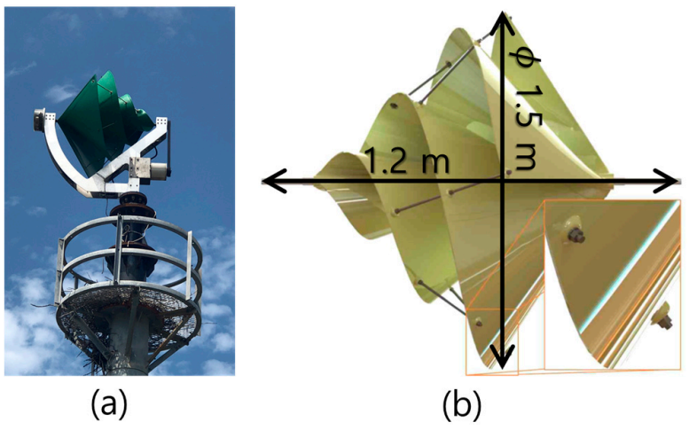

**Fig. 4: Geometric Shape of the Wind Turbine: (a) wind turbine installed during performance tests; (b) 3D model file used for simulation [19]**

The results indicate good aerodynamic efficiency and suitability for educational or experimental applications, although commercial deployment remains limited.

* **Aeroleaf**

The Aeroleaf is a biomimetic vertical-axis micro wind turbine designed by NewWind, integrating photovoltaic elements for hybrid energy production. Several studies have evaluated its performance : Emeara and al. [21] demonstrated its ability to start operating at a wind speed as low as 1.94 m/s in a hybrid system, while Rathore and al. [22] tested a wind tree with five modules generating up to 2.77 W at 5.68 m/s. Nugraha and al. [23]simulated a scaled-down model (1:4), achieving a maximum power coefficient (Cp) of 0.134, with sufficient efficiency to power an LED. Although its design is well-suited for urban environments, its high cost (~36,500 USD) currently limits widespread adoption.

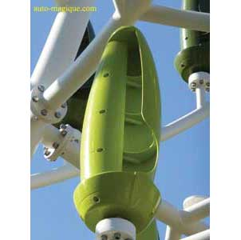

**Fig. 5: Aeroleaf Wind Turbine [24]**

**3.2 Developments in Savonius turbines**

* **IceWind**

Developed in Iceland, the IceWind is a vertical-axis micro wind turbine derived from the Savonius model, optimized for low wind speeds. Several studies have assessed its performance through wind tunnel experiments and CFD simulations. It reaches a rotational speed of 850 rpm at 15.8 m/s and a maximum static torque of 0.064 N·m [25]. Three-dimensional Fluid-Structure Interaction (FSI) simulations show greater efficiency than the conventional Savonius design at low-speed regimes, with good behavior at very low Tip Speed Ratios (TSR), the ratio between blade tip speed and wind speed [26]. The three-blade configuration proved to be the most efficient [27], offering an attractive balance between stability, efficiency, and compactness [28]. Its curved, silent, and robust aluminum design makes it a promising candidate for regions with moderate or unstable wind conditions.

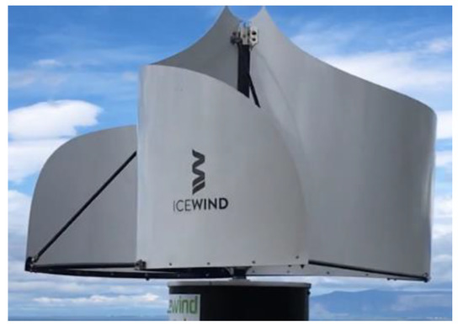

**Fig. 6: CW IceWind Wind Turbine [28]**

**3.3 Unconventional and hybrid systems**

* **AeroMINE**

The AeroMINE (Aero Motionless, Integrated, and Noiseless Extractor) is a non-conventional wind energy technology with no external rotating rotor, designed to be integrated into building facades. It relies on the Venturi effect to concentrate airflow toward an internal turbine. Two major studies [29] [30], conducted in wind tunnels and on-site at Sandia Labs, demonstrated mechanical efficiency reaching 27% at a 15° angle and 25% under real-world conditions at wind speeds of ≥ 9 m/s (the minimum wind speed for optimal performance). This system shows excellent stability under wind misalignment up to ±30°, with performance loss limited to 20% at 45°. Although still in the experimental phase, AeroMINE offers a silent, modular, and turbulence-resilient solution, particularly well-suited for building-integrated urban wind power applications.

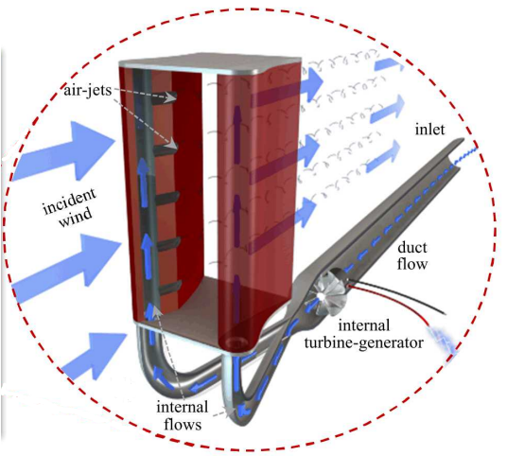

**Fig. 7: Operation of an AeroMINE pair [31]**

* **Harmony**

The Harmony turbine is a vertical-axis micro wind turbine with a helical geometry, developed for low wind potential environments. Three studies have explored its performance. It demonstrates a start-up capability at just 2.5 m/s and operates silently thanks to a passive furling system [32]. The Scoop Harmony profile [33] shows a 31% increase in rotational speed compared to a conventional Savonius turbine, reaching 783 rpm at 10 m/s. Experimental tests confirm moderate power output (up to 13 mW at 69 rpm) using a low-voltage generator, making it suitable for off-grid or educational applications [34]. Its compact, lightweight design, made of PLA (polylactic acid, a biodegradable polymer used in 3D printing) or PVC (polyvinyl chloride), and low cost make it an accessible solution for micro energy applications.

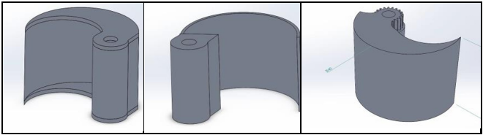

**Fig. 8: Isometric View of the wind turbines: VAWT Savonius (left), Solid Harmony (center), and Scoop Harmony (right) [33]**

To facilitate the comparison between the studied small wind turbines, the table below summarizes the main technical, contextual, and environmental characteristics of the five innovative devices analyzed. It highlights their specific advantages as well as the design-related trade-offs, enabling a cross-evaluation based on performance, cost, and adaptability criteria.

**Table 3. Comparative table of innovative small wind turbines**

|  |  |  |  |  |  |  |  |  |  |
| --- | --- | --- | --- | --- | --- | --- | --- | --- | --- |
| **Model** | **Type & Configuration** | **Max Cp** | **Max RPM (ref. wind)** | **Start-up** | **Max Power (ref. wind)** | **Main Materials** | **Noise** | **Typical Application** | **References** |
| Liam F1 UWT | Bio-inspired HAWT, 3 blades, axial rotor | 0,293 @12.7 m/s | 330 rpm @12.7 m/s | ~2,5 m/s | 500 W @12.7 m/s | Metal (real), PLA (prototype) | ≤ 40 dB | Urban lighting, educational | [19], [20] |
| Aeroleaf | Modular biomimetic VAWT, hybrid with PV | 0,134 @9 m/s | 1450 rpm @5 m/s | 1,94 m/s | 2,77 W @5.68 m/s | PLA, composite + integrated PV | Very low | Microgrid, urban building | [21], [22], [23] |
| IceWind | Savonius-derived VAWT, 2–4 blades | ~0,18 (3 blades) | ~700 rpm @14 m/s | ≤ 2 m/s (efficient TSR<0.1) | ~0,18 N·m (static torque) | Aluminium (prototype) | Moderate | Remote areas, cold climates | [25], [26], [27], [28] |
| AeroMINE | Fixed system, no rotor, Venturi effect | 0,25–0,27 | – | ≥ 5 m/s | Up to 27% mechanical efficiency | Structural composite | Inaudible | Industrial façades | [29], [30] |
| **Harmony** | Helical VAWT, scoop/3D-printed blades | 0,6 (Scoop) | 783 rpm @10 m/s (Scoop) | 2,5 m/s | 13,25 mW @69 rpm | PLA, PVC, 3D printing | Very low | Off-grid, educational | [31], [32], [33], [34] |

For informational purposes, Cp and RPM values are derived from simulations, wind tunnel tests, or experimental data, depending on the study. Maximum power output depends on the specific system tested and may not reflect standardized conditions. The Harmony model includes various profiles (Solid, Scoop), with only some achieving higher performance levels.

**3.4 Comparative analysis**

The comparative study of the Liam F1 UWT, Aeroleaf, IceWind, AeroMINE, and Harmony turbines reveals significant differences in terms of efficiency, design, environmental adaptability, and technological maturity. Each technology tackles specific challenges but comes with structural, functional, or contextual limitations to consider.

**3.4.1 Aerodynamic efficiency (Cp) and energy performance**

Power coefficient (Cp) values, although dependent on experimental conditions, allow for a preliminary ranking of performance. The AeroMINE turbine demonstrates aerodynamic efficiencies ranging from 18% to 27% depending on the angle of attack (Pol and al. [29]), which corresponds to about 42% of the Betz limit. This efficiency, however, remains below that of optimized lift-based turbines. Similarly, the Liam F1 UWT reaches a maximum Cp of 0.293 (Jang and al. [19]), a respectable performance for a drag-type turbine, but the overall efficiency drops to 33.6% due to electrical losses. In comparison, the Aeroleaf shows a simulated Cp of 0.134 (Nugraha and al. [35]), while the IceWind lags behind, with low torque (0.064 N·m) and Cp values generally below those of Savonius turbines above 4 m/s. The Harmony turbine, although optimized for low-speed start-up, achieves only modest efficiencies due to its low-RPM single-phase generator

**3.4.2 Structural robustness, durability, and scalability**

Material strength and scaling effects are especially significant for prototypes made of PLA or 3D-printed materials. The Liam F1 UWT tested at a 1:3 scale (Cárdenas Magaña [20]) and the Aeroleaf (Nugraha and al. [35]) at 1:4 both show mechanical limitations. In these cases, small-scale performance cannot be directly extrapolated to real-world conditions. Although lightweight and quiet, the Harmony turbine also raises concerns regarding the durability of its PLA components under UV exposure and weather conditions (Raut and al. [32]). In contrast, the AeroMINE features a fixed structure with no external moving parts, offering notable advantages in terms of maintenance and durability in harsh environments. However, its modular integration complexity may pose technical challenges.

**3.4.3 Aerodynamic stability and turbulence response**

IceWind and AeroMINE both display significant instabilities under transient conditions. IceWind, in particular, generates extended three-dimensional vortices that reduce aerodynamic stability at high speeds (Mansour & Afify [28]). AeroMINE, on the other hand, can see efficiency drop as low as 10% in cases of misalignment or asymmetric flow, although its resilience up to 45° misalignment remains acceptable (Houchens and al. [31]). By comparison, the Liam F1 UWT lacks active regulation systems (yaw/pitch), making it less responsive to shifting wind directions.

**3.4.4 Integration, modularity, and urban applicability**

In terms of urban integration, the Aeroleaf and Harmony turbines are the most advanced, both in aesthetics and compatibility with domestic microgrids. However, the Aeroleaf features technical complexity in serial wiring of modules, with risks of cascading failure. Harmony offers a compact system with a boost converter and LM317 regulator but remains limited to low-power applications. AeroMINE provides an interesting modular solution for industrial or residential buildings with virtually no acoustic footprint, although its dependence on a specific architectural setup makes it less flexible than compact vertical turbines.

**3.5 Evaluation**

Each small wind turbine was evaluated using a Multicriteria Decision-Making (MCDM) approach, based on seven qualitative criteria: estimated cost, energy efficiency, maintenance requirements, ease of installation, noise level, environmental adaptability, and material durability. The qualitative ratings (low, moderate, high) were assigned based on the synthesis of experimental data and simulation results presented in the previous sections, particularly Section 3.4.

* *Low:* performance significantly below the standard or below the median of the devices compared.
* *Moderate*: average performance or equivalent to the median of the devices.
* *High*: performance above average, demonstrated experimentally or through validated simulation.

The overall score out of 5 corresponds to a fair weighted average of these seven criteria, calculated using the following equation:​

  (2) $Overall score =\frac{1}{7}\sum_{i=1}^{7}{{Criterion score}_{i}}$

Each criterion is rated out of 5: Low = 2, Moderate = 3, High = 4, Very high = 5. This approach allows for an overall hierarchy, while preserving the functional diversity of the devices analyzed.

The values presented in Table 4 result from the application of the MCDM framework described above. They are based on a synthesis of experimental results reported in the literature, complemented by simulation data and normalized estimations. When specific values were not directly available from references, the qualitative scores were inferred from the comparative performance indicators discussed in Section 3.4. A scoring scale adapted from similar studies on microgeneration systems was used to ensure consistency and objectivity in the evaluation process.

**Table 4. Multicriteria analysis of innovative small wind turbines**

|  |  |  |  |  |  |  |  |  |
| --- | --- | --- | --- | --- | --- | --- | --- | --- |
| **Model** | **Estimated Cost** | **Efficiency** | **Maintenance** | **Installation** | **Noise** | **Environmental Adaptability** | **Durability** | **Overall score (1-5)** |
| Liam F1 UWT | High (4) | High (4) | Moderate (3) | Easy (4) | Very low (5) | Good (4) | Good (4) | **4.0** |
| Aeroleaf | High (4) | Moderate (3) | Low (2) | Easy (4) | Very low (5) | Urban only (3) | Good (4) | **3.6** |
| IceWind | Moderate (3) | Moderate + (3.5) | Good (4) | Moyenne (3) | Average (3) | Polaire, rural (4) | Very Good (5) | **3.6** |
| AeroMINE | Very high (5) | Moderate + (3.5) | Low (2) | Complex (2) | None (1) | Industrial only (3) | Good (4) | **2.9** |
| Harmony | Low (2) | Low+ (2.5) | Fréquent (2) | Very easy (5) | Very low (5) | Versatile (4) | Moderate (3) | **3.4** |

The analysis of small wind turbines reveals notable differences between models. The Liam F1 UWT stands out with an overall score of 4.0, thanks to its high efficiency, easy installation, and low noise level, making it well-suited for urban environments. The IceWind, scoring 3.6, performs well in extreme environments but shows moderate efficiency. The Aeroleaf, also scoring 3.6, is notable for its easy installation but suffers from lower energy yields. The AeroMINE, with a score of 2.9, is less competitive due to its high cost and complex installation. Finally, the Harmony scores 3.4, showing weaknesses in energy efficiency and material durability, although it is highly versatile.

**5. Conclusion**

This critical review of recent innovations in small wind turbines highlights the technological and energy potential of devices tailored to urban and remote environments. The comparative analysis of five representative models (Liam F1 UWT, Aeroleaf, IceWind, AeroMINE, and Harmony) reveals a diversity of designs, aerodynamic strategies, and levels of technological maturity. These systems differ not only in efficiency across wind conditions but also in architectural integration, maintenance ease, and environmental adaptability.

While some technologies demonstrate promising performance under controlled conditions, their large-scale deployment remains dependent on several key factors: material durability, system robustness against turbulence, scalability, and production cost. Moreover, the limitations observed in 3D-printed prototypes or those made with polymer-based materials underscore the need for more robust engineering to ensure long-term viability.

The study highlights how embedded intelligence, modular designs, and adaptive control help optimize real-world performance. Future research directions should therefore adopt a multidisciplinary approach, integrating engineering sciences, sustainable urban planning, and life cycle analysis. The development of full-scale prototypes, combined with rigorous experimental validation and socio-economic assessment, represents a strategic lever to enhance the acceptability and territorial impact of small wind turbines.

Ultimately, innovative small wind turbines, as decentralized energy technologies, are poised to play a central role in the energy transition. However, realizing their full potential over the next decade will require that key technological, economic, and regulatory barriers be addressed through targeted policies and strategic partnerships. A clear research roadmap should focus on three key axes:

* Aerodynamic and energy optimization, with a focus on hybrid wind-solar designs to ensure stable energy output.
* Material innovation, replacing fragile PLA components with durable composites adapted to harsh operating environments.
* Intelligent control and IoT-based monitoring, to enhance adaptability and long-term operational performance.

These directions underscore the need for multidisciplinary collaboration and real-world prototyping to secure the long-term viability and societal acceptance of small wind energy solutions.

**References**

[1] S. Zhang, J. Wei, X. Chen, et Y. Zhao, « China in global wind power development: Role, status and impact », *Renew. Sustain. Energy Rev*., vol. 127, p. 109881, juill. 2020, doi: 10.1016/j.rser.2020.109881.

[2] International Energy Agency (IEA), « Renewable Energy Market Update - June 2023 », 2023. [En ligne]. Disponible sur: <https://www.iea.org/reports/renewable-energy-market-update-june-2023>

[3] K. Linnerud, A. Dugstad, et B. J. Rygg, « Do people prefer offshore to onshore wind energy? The role of ownership and intended use », *Renew. Sustain. Energy Rev.*, vol. 168, p. 112732, oct. 2022, doi: 10.1016/j.rser.2022.112732.

[4] A. Bianchini *and al.*, « Current status and grand challenges for small wind turbine technology », *Wind Energy Sci.*, vol. 7, no 5, p. 2003‑2037, oct. 2022, doi: 10.5194/wes-7-2003-2022.

[5] X. Tang, X. Huang, R. Peng, et X. Liu, « A Direct Approach of Design Optimization for Small Horizontal Axis Wind Turbine Blades », *Procedia CIRP*, vol. 36, p. 12‑16, 2015, doi: 10.1016/j.procir.2015.01.047.

[6] A. López-González, M. Ranaboldo, B. Domenech, et L. Ferrer-Martí, « Evaluation of small wind turbines for rural electrification: Case studies from extreme climatic conditions in Venezuela », *Energy*, vol. 209, p. 118450, oct. 2020, doi: 10.1016/j.energy.2020.118450.

[7] Z. Li, F. Boyle, et A. Reynolds, « Domestic application of micro wind turbines in Ireland: Investigation of their economic viability », *Renew. Energy*, vol. 41, p. 64‑74, mai 2012, doi: 10.1016/j.renene.2011.10.001.

[8] P. Veers *and al.,* « Grand challenges in the design, manufacture, and operation of future wind turbine systems », *Wind Energy Sci.*, vol. 8, no 7, p. 1071‑1131, juill. 2023, doi: 10.5194/wes-8-1071-2023.

[9] A. Khedr et F. Castellani, « Critical issues in the moving reference frame CFD simulation of small horizontal axis wind turbines », *Energy Convers. Manag. X,* vol. 22, p. 100551, avr. 2024, doi: 10.1016/j.ecmx.2024.100551.

[10] L. Zajicek, M. Drapalik, I. Kral, et W. Liebert, « Energy efficiency and environmental impacts of horizontal small wind turbines in Austria », *Sustain. Energy Technol. Assess*., vol. 59, p. 103411, oct. 2023, doi: 10.1016/j.seta.2023.103411.

[11] E.-V. Năstase, « Influence of the material used to build the blades of a wind turbine on their starting conditions », *MATEC Web Conf*., vol. 112, p. 10017, 2017, doi: 10.1051/matecconf/201711210017.

[12] A. Tummala, R. K. Velamati, D. K. Sinha, V. Indraja, et V. H. Krishna, « A review on small scale wind turbines », *Renew. Sustain. Energy Rev*., vol. 56, p. 1351‑1371, avr. 2016, doi: 10.1016/j.rser.2015.12.027.

[13] J. F. Manwell, J. G. McGowan, et A. L. Rogers, *Wind Energy Explained: Theory, Design and Application*, 2e éd., Chichester, UK: Wiley, 2009.

[14] P. K. Chandrashekhar, S. Managuli, et A. Shashank, « Design of Small Scale Vertical Axis Wind Turbine », in *2019 International Conference on Power Electronics Applications and Technology in Present Energy Scenario (PETPES)*, Mangalore, India: IEEE, août 2019, p. 1‑5. doi: 10.1109/PETPES47060.2019.9003999.

[15] B. Pitchia Krishnan, M. Mathanbabu, G. Sathyamoorthy, K. Gokulnath, et L. Govind Sanjeev Kumar, « Performance estimation and redesign of horizontal axis wind turbine (HAWT) blade », *Mater. Today Proc.*, vol. 46, p. 8025‑8031, janv. 2021, doi: 10.1016/j.matpr.2021.02.777.

[16] J. Winters et Z. Saunders, « The Largest Wind Turbine Ever », *Mech. Eng*., vol. 140, no 12, p. 31, déc. 2018, doi: 10.1115/1.2018-DEC-2.

[17] S. Mertens, G. van Kuik, et G. van Bussel, « Performance of an H-Darrieus in the Skewed Flow on a Roof », *J. Sol. Energy Eng*., vol. 125, no 4, p. 433‑440, nov. 2003, doi: 10.1115/1.1629309.

[18] A. G. A. Mubarok, W. Djatmiko, et M. Yusro, « Design of Arduino-based small wind power generation system », *E3S Web Conf*., vol. 67, p. 01006, 2018, doi: 10.1051/e3sconf/20186701006.

[19] H. Jang, D. Kim, Y. Hwang, I. Paek, S. Kim, et J. Baek, « Analysis of Archimedes Spiral Wind Turbine Performance by Simulation and Field Test », *Energies,* vol. 12, no 24, p. 4624, déc. 2019, doi: 10.3390/en12244624.

[20] J. A. C. Magaña, « Evaluación Experimental de Turbinas Eólicas de Pequeña Escala con Generadores de Corriente Directa y Pruebas en Túnel de Viento », Tesis de Maestría, Universidad Nacional Autónoma de México, 2024.

[21] M. S. Emeara, A. F. AbdelGawad, et E. H. Ahmed, « Hybrid Renewable Energy System for A Sustainable House-Power-Supply », *J. Adv. Res. Fluid Mech. Therm. Sci*., vol. 87, no 1, p. 91‑107, sept. 2021, doi: 10.37934/arfmts.87.1.91107.

[22] M. K. Rathore, M. Agrawal, P. Baredar, A. K. Shukla, G. Dwivedi, et P. Verma, « Fabrication and Performance Analysis of the Aero-Leaf Savonius Wind Turbine Tree », Energies, vol. 16, no 7, p. 3015, mars 2023, doi: 10.3390/en16073015.

[23] A. D. Nugraha *and al.*, « Comparison of “Rose, Aeroleaf, and Tulip” vertical axis wind turbines (VAWTs) and their characteristics for alternative electricity generation in urban and rural areas », *Results Eng*., vol. 25, p. 103885, mars 2025, doi: 10.1016/j.rineng.2024.103885.

[24] R. Ray, « A Wind Turbine that Looks Like a Tree… Kind Of », Power Engineering, 16 avr. 2025. [En ligne]. Disponible sur: <https://www.power-eng.com/renewables/wind-energy/a-wind-turbine-that-looks-like-a-tree-kind-of/>

[25] R. Afify, « Experimental Studies of an IceWind Turbine », *Int. J. Appl. Eng. Res.*, vol. 14, no 17, p. 3633–3645, 2019.

[26] Z. Lillahulhaq et V. S. Djanali, « Unsteady simulations of Savonius and Icewind turbine blade design using fluid-structure interaction method », présenté à *THE 4TH BIOMEDICAL ENGINEERING’S RECENT PROGRESS IN BIOMATERIALS, DRUGS DEVELOPMENT, HEALTH, AND MEDICAL DEVICES: Proceedings of the International Symposium of Biomedical Engineering (ISBE) 2019*, Padang, Indonesia, 2019, p. 020009. doi: 10.1063/1.5138264.

[27] T. Gad, A. Shokry, R. Afify, E. Saber, et M. Hassan, « Experimental Study of Two, Two-Reversed, Three and Four Blade IceWind Turbine », *Int. J. Appl. Eng. Res.*, vol. 15, no 12, p. 1122–1134, 2020.

[28] H. Mansour et R. Afify, « Design and 3D CFD Static Performance Study of a Two-Blade IceWind Turbine », *Energies*, vol. 13, no 20, Art. no 20, janv. 2020, doi: 10.3390/en13205356.

[29] S. Pol, B. C. Houchens, D. Marian, et C. Westergaard, « Performance of AeroMINEs for Distributed Wind Energy », in *AIAA Scitech 2020 Forum*, Orlando, FL, janv. 2020, doi: 10.2514/6.2020-1241.

[30] B. Houchens, D. Marian, S. Pol, et C. Westergaard, « High Wind Speed Performance of AeroMINE at Pilot-Scale », in *TORQUE 2022 Conference*, Delft, Netherlands, juin 2022, US DOE, doi: 10.2172/2003150.

[31] B. C. Houchens et D. V. Marian, « Air-jet Design and Scaling Performance of AeroMINE Distributed Wind Energy Harvesters », *Sandia National Laboratories*, Livermore, CA, USA, Rapport technique, 2020.

[32] S. Raut, K. Sawant, M. Yadhav, H. Sawant, et V. D. Patel, « Design and Development of Harmony Wind Turbine », *Int. J. Eng. Res. Technol.*, vol. 9, no 3, p. 1–5, févr. 2021, doi: 10.17577/IJERTCONV9IS03117.

[33] A. A. T. Syahin, M. Zinnyrah, R. A. Sofea, M. R. A. Rahman, et M. R. Saad, « Vertical Axis Wind Turbine for Low Wind Speed Environment: Effect of Scoop Harmony Blade », *E3S Web Conf*., vol. 477, p. 00031, 2024, doi: 10.1051/e3sconf/202447700031.

[34] K. Malvadkar, A. Mali, N. Yemul, et M. Patted, « Harmony Vertical Axis Wind Turbine », *SSRN Electron. J.*, 2019, doi: 10.2139/ssrn.3419792.

[35] A. D. Nugraha and al., « Comparison of “Rose, Aeroleaf, and Tulip” vertical axis wind turbines (VAWTs) and their characteristics for alternative electricity generation in urban and rural areas », *Results Eng.*, vol. 25, p. 103885, mars 2025, doi: 10.1016/j.rineng.2024.103885.