**Exploring the Perspectives of Employers on the Influence of CQC-Regulated Services on Providers in the Health and Social Care Sector in United Kingdom**

**Abstract**

Within the United Kingdom, particularly England, this work is an exploration of the health and social care employees’ perspective on the impacts of Care Quality Commission (CQC) regulated services. The CQC plays a paramount role in sustaining, maintaining, and improving the quality-of-service delivery, being the primary regulator. Nonetheless, these roles have practical implications for health and social care frontliners. The CQC regulations influences the quality-of-service delivery in England. Based on the foregoing, the present study examines the impact assessment of CQC regulated activities through the health and social care personnel perspective, covering areas like roles, practices, outcomes, and quality of care. This study uses quantitative research method, as well as survey method to gather data from various health care providers. Data was analysed through the lens of descriptive statistics and correlation analysis. The findings highlight the challenges and the positive aspects of CQC regulation. The research provides substantial input to the ongoing discussion in both academic and health settings regarding regulation in care settings. It also offers service enhancement insight to regulatory bodies, policymakers, and health providers.

**1.0 Introduction**

To ensure that essential care quality and safety standards are met in England, the Care Quality Commission shoulders this critical responsibility. Its roles in improving care outcomes, safeguarding the service users, and keeping the public informed are commonly known. An aspect of its regulatory roles remains a topic of increasing interest and discussion—thus the topic: Exploring the Perspectives of Health and Social Care Workers on the Influence of CQC-Regulated Services on Providers in the Health and Social Care Sector. This study aims to answer an aspect of this question and to provide an in-depth understanding that adds to the body of literature. It will also add the advantages of "knowing" by asking the public. It will illustrate the challenges and possible unintended consequences of regulatory frameworks on healthcare workers. Finally, this work will inform further studies linking Healthcare workers or employees’ well-being and high-quality care to CQC roles.

The Care Quality Commission (CQC) is an integral executive non-departmental public body of the Department of Health and Social Care in England, United Kingdom. It is an agency regulating health and social care in England. It was established in 2009 by merging three commissions: the Commission for Social Care Inspection, the Healthcare Commission, and the Mental Health Act Commission. The role of the commission in healthcare regulation includes to maintain high quality of care, safety, and efficiency by supervising, inspecting and monitoring care providers. As an independent regulator, CQC achieved these via ratings, inspection, and enforcement action. These areas are of particular concern to academia and the public as topic of debate. The discussions are essentially on the impacts of these regulations on health and social care settings relative to standard improvement, service rendered and compliance.

CQC has over three thousand sixty-three (3,063) members of staff. According to CQC financial data for 2022/23 as against 2021/22 (CQC annual report, 2023), it provides critical income and expenditure trends over the two fiscal years. Revenue generated from contracts with clients increased from £210.7 million in 2021/22 to £218.6 million in 2022/23, which is approximately a 3.7% increase. The operating income increased by £8.04 million, demonstrating growth in revenue generation. The revenue growth is as a result of an increase in regulatory fees or increased regulatory activities. Conversely, the expenditure trends showed a 5.1% increase in staff costs, from £177.4 million to £186.4 million in 2021/22 and 2022/23, respectively. While the net expenditure for the year had approximately a 31% rise, increasing from £22.87 million to £29.92 million. This is an indication of increased financial pressure on the agency (Gov UK, 2023; CQC annual report, 2023).

According to available evidence (Smithson et al., 2018; Griffin, 2022; Walshe, 2024; Rayner, 2022; Towers et al., 2021), at the front line of service provision are the health and social care workers and personnel. Therefore, they are directly and indirectly impacted by the Care Quality Commission regulatory framework. These frontliners are inclusive of medical professionals, nurses, midwives, pediatricians, and healthcare support staff such as the healthcare assistants and pharmacy technicians; the mental health and well-being professionals; and the allied health professionals such as the physiotherapists, paramedics, and orthoptists. Community and public health professionals, managers and administrators, social care workers like care assistants and residential care workers, and social workers, to mention but a few.

Healthcare personnel’s perspectives offer invaluable insights and nuance of comprehension of how CQC regulatory frameworks influence and impact routine day-to-day service operations, patient care and outcome, and effectiveness of service (Boyd, Moralee, and Ferguson, 2020). While regulatory oversight is targeted at enhancing standards and security (O'Neill, 2025; Griffin, 2022), it may, however, present issues like increased administrative workload, resource allocation issues, and operational constraints.

According to Gupta (2015) and Wang et al. (2020), the process of how we view, comprehend, and interpret things around the world using either experiences, beliefs, or senses is perception. On the other hand, a health care provider’s perception relative to CQC includes the provider’s viewpoints and the manner and way the provider interprets the behaviors, attitudes, qualities, and capacity of CQC. Moreover, perception's critical role is seen in communication, relationships, and decision-making; therefore, the health and social workers’ perception of CQC encompasses leadership, professionalism, reliability, performance, job roles, and experiences, to mention but a few.

**1.1 Problem Statement**

The regulatory roles played by the Care Quality Commission (CQC) are part of a government mechanism that ensures high care quality, safety of the service users, and accountability. The existing body of knowledge and research study on CQC focuses on the managers, policymakers, and organizational leaders’ perspectives. Nevertheless, there is limited emphasis on the perspective and experiences of the frontline workers in health and social care. A key research need is presented by this gap in understanding, as these health and social care workers shoulder an integral role in the day-to-day routine implementation of CQC, and they have an experiential knowledge of the impacts of regulatory oversight on the rendering of services. CQC oversight is an enormous challenge encountered by healthcare personnel, and there is insufficient exploration of that issue. According to Sengupta et al. (2021), existing studies buttress the common challenge faced by care providers, but often there are drawbacks: the lack of an in-depth investigation on the genuine barriers, challenges, and issues frontline care workers face, like workplace stress, increased administrative burden, and constraints in operation. The question that arises from this would be whether the regulatory framework obstructs or supports the capacity for adequate care delivery, and this assessment cannot be done without this insight.

             Furthermore, there arises a need to pinpoint the various opportunities for critical improvement and advancement in the implementation of CQC regulations. A comprehension of the frontliners' perspective assists in the areas where regulatory processes are overly unproductive, difficult, or misplaced with the reality of the need for care delivery. If these gaps are addressed, it could yield enhancement in CQC oversight that could translate to better support to service providers, effective communication, and CQC and healthcare provider collaboration, thereby improving overall wellbeing of service users.

Consequently, this research work is targeted at filling these gaps by exploring the Perspectives of Health and Social Care Workers on the Influence of CQC-Regulated Services on Providers in the Health and Social Care Sector. By so doing, this study would make an enormous contribution to the body of knowledge. It will inform policy decision-making and offer recommendations that are practicable for optimizing regulatory productiveness in the industry.

**1.2 Research questions**

RQ1: What are the views of health and social care workers on the effectiveness of CQC regulation in improving service quality within the health and social care sector?

RQ2: How does CQC-regulated services influence the overall performance and outcomes of providers in the industry?

**1.3 Objectives of the study**

1.       To investigate the viewpoints of health and social care workers on the effectiveness of CQC regulation in enhancing service quality within the health and social care sector.

2.       To explore how CQC-regulated services influence the overall performance and outcomes of providers in the industry.

**1.4 Theoretical Framework and Conceptual Framework**

The combination and integration of regulatory theories, quality improvement models, and organizational performance theories are used to form the theoretical framework for this analysis. The analysis is on the effectiveness of CQC regulations in improved service standards and structural methodology that investigates the perspectives of health and social care personnel. For instance, the regulatory compliance theory describes the reaction or response to regulatory standards imposed by agencies on organizations. This theory explains the extent to which establishments comply with regulations relative to legal obligations, requirements, incentives, and prestige concerns. Consequently, the application of this theory to study would investigate how health providers perceive and react to CQC regulations. It analyses whether or not CQC quality, standard is followed out of necessity for legal action and enforcement or as part and parcel of the overall commitment to standards and improvement. The theoretical model that examines healthcare standard and quality relative to the three elements, the variables of structure, process, and outcome. These encompass staff qualifications, resources, policies, protocol compliance, service user engagement, effectiveness, safety, and satisfaction. According to Cinaroglu and Baser (2018), Lloyd (2019), and Goedhart et al. (2017), the outcome is a reflection of the result of care. Mariko (2003) and Goedhart et al., (2017) describe process as the manner in which care is administered and structure as organizational factors. The application of this model to this study would provide some degree of nuance on how CQC regulation impacts staffing, care delivery, documentation, service users’ experiences, and health outcomes. While the continuous quality improvement model emphasizes ongoing feedback, assessment, and improved quality modification with leadership commitment, decision-making based on data and staff involvement in care are the main focus. Thus, the application of this study reinforces it and examines whether or not there is a culture of continuous improvement in care settings (Cinaroglu and Baser, 2018; Mariko, 2003; Lloyd, 2019; Goedhart et al., 2017).

**Conceptual Framework**

**INDEPENDENT VARIABLES** **DEPENDENT VARIABLE**

**Health and Social care workers’ perspectives**

1. Attitudes
2. Belief
3. Services
4. Positive perception
5. Concerns
6. Suggestion of improvement

***CQC monitoring and inspection***

1. Effectiveness, caring, responsiveness, leadership, safety.
2. Unannounced visits, interviews, patients feedback

***CQC rating***

1. Publish report
2. Rating: outstanding, good,required improvement, inadequate.

**CQC**

Fig. 1Conceptual Framework Sources: researcher’s model, 2025

**1.5 Scope of the Study**

This research work is organisational and country-specific – as it was carried out in England, United Kingdom. Participants include health and social care professionals, staff members, nurses, carers, support workers, and nurse assistants within England. It does not encompass the opinion of health and social care managers and the administrative team. It is primary research that involves the development of a Likert-scale questionnaire, and it is administered to less than 250 individuals in health and social care settings. This work is limited to descriptive analysis and correlation analysis of the data. It does not employ regression analysis and hypothesis testing, which would have provided us a dimensional knowledge and understanding of the study.

**1.6 Significance of the Study**

Understanding the health and social care perspective of CQC would assist in pinpointing areas of weaknesses as well as strengths, thereby enhancing service quality. Furthermore, by exploring the issues and problems frontliners encounter under CQC oversight or inspection, this study sheds enormous insight into areas in need of support and resources, thereby increasing well-being and job satisfaction among health and social care personnel. This study will go a long way to inform policymakers and stakeholders to make informed decisions in CQC regulation; it instructs the educational sector, adding to the overall body of knowledge. This study will also guide future prospects, initiatives, and interventions to best align the perspectives and needs of individuals directly participating in care delivery.

**1.7 Review of the literature:**

  In 2023, the Office for National Statistics (ONS) provided some data that illustrates that there are about 372,035 service users in care settings in England. Many of these service users received low service delivery and a low standard of life in care settings. The descriptive responsibility of the CQC is to provide guidelines and regulatory frameworks for all health and social businesses in the country, thereby supporting and promoting the well-being and health of residents. In England, according to the report, the CQC measure of the standard of care offered is in a spectrum that ranges from one end—outstanding—to another end—inadequate. And this is contingent upon the service performance by registered care providers. The required standards of assessment are whether the service is safe, caring, effective, responsive, and well led (Office for National Statistics, 2023; 2021). Using CQC data based on ratings and active care facilities in England, a 2024 study that adopted a descriptive design shows a significant relationship between standard of care and location. The result is indicative of caring, responsive, and effective care facilities that lack leadership and safety. The result also shows a direct relationship between closure and ownership of care facilities (Aminaho and Onoshakpor, 2025). From the existing body of knowledge, the impact of CQC regulation on health and social care providers offers invaluable insight. According to Boyd's (2018) work, it highlights workforce challenges, compliances, inspections, perceptions, and service users’ outcomes. Further research shows that CQC regulation has resulted in increased compliance with regulatory frameworks and improvement in care standards. While Rayner (2022) and Tower et al. (2021) suggested that inspections enhance improvement by making sure that health and social care providers are held accountable for reaching standards and quality of care delivered. Boyd (2018) equally buttresses how instrumental CQC feedback is in fostering improvement but more so in assisting care providers in pinpointing areas of weakness. Notwithstanding, other works highlight compliance efforts that most times prioritize meeting regulatory obligations and requirements over other genuine standard enhancements.

Mahase (2020), McHale and Noszlopy (2025), and Stirton (2017) suggested that health and social care staff members show increased concerns over administrative burden imposed by CQC. Similarly, Torjesen (2021), Ojeme (2023), and Harris (2022) expressed that there is a significant level of stress and burnout for staff as a result of documentation and procedural demands required to meet CQC compliance. It further suggested that excessive paperwork distracts from direct service users' care and well-being and results in an increased perception of regulatory bureaucratic activities rather than a mechanism for quality and standard healthcare delivery improvement. Conversely, other literature (Furnival, Boaden, and Walshe, 2018) suggested that clarity in guidelines is provided through a well-structured regulatory framework that improves professional integrity and consistency in care outcomes and delivery.

The perception of how fair, effective, and productive CQC inspections are, is surrounded by mixed reactions and evidence. According to Boyd et al. (2017), Castro (2018), Mongan, and Thomas (2021), it is found that personnel in health and social care insinuate that variability in inspection teams results in subjectivity in ratings. This springs from CQC inconsistent assessments. Conversely, accountability, standardized regulatory practice, and transparency are immense inputs that increase confidence, trust, and acceptance among providers. Resource limitation also contributes to the struggle with compliance encountered by smaller care providers. Therefore, bring about equity concerns in obligational expectations. Others believe that CQC has not lived up to his obligational expectations; thus, there is something wrong with the commission (Mahase, 2020; Burton, 2017). For instance, BBC Panorama (2016)—the CQC had inspected two or three times a year for the last three years, finding the Cornish home in question “needed improvement” even when it was rated “good” for proficiency in caring. Meanwhile, underplay and neglect abuse and widespread poor providers. Evidence further suggested that CQC closed up good places while allowing bad ones to continue operating. According to a report of 1164 practices inspected by the CQC in 2015, 2.8%, 2.4%, 56%, and 9.1% have been rated inadequate, outstanding, good, and requiring improvement, respectively. Presently, the number of care providers registered with the CQC has risen to 9325; all share the common attribute of being rated as inadequate following a CQC inspection (Rendel, Crawley, and Ballard, 2015). According to Richardson et al. (2019), there has been an increased concern about the regulatory system for health and social care workers due to the high rate of failure in care within the NHS system. Thus, resulting in the CQC regulatory regime's total overhaul, thereby leading to CQC drift to inspection that is expert, evidence-based, and data-oriented. While previously underplaying the importance of expert knowledge and experience. According to literature by Richardson et al. (2019), it suggested that a perspective from a patient representative indicated that participation of experts by experience is imperative as it brings multiple perspectives on care through a wealth of knowledge, deep insight, and experience.

**1.8 Methodology:**

In this section, a quantitative research approach was adopted. This is carried out by administering a well-structured google form (survey questionnaire) to about 250 persons. About 143 participating individuals within the health and social care sector responded. A structured Likert-scale questionnaire was administered to health and social care workers to gather data on healthcare workers' perception of the CQC. With each Likert option, the scale adopted a mixture of quality and agreement scales that allows participants to rate their experiences, perceptions, and opinions on both level of agreement and quality. Subsequently, descriptive statistical analysis (pie chart, histogram, mean, and standard deviation) is carried out to discuss, interpret, and analyse the findings.

Saunders, in his research onion, proffers a systematic approach of conceptualizing them (Melnikovas, 2018). It ensures that the various stages and components of research are aligned and coherent.

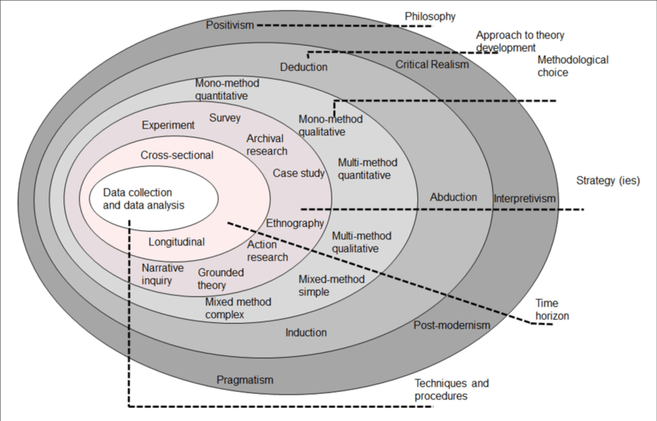

Fig.2 Research onion (Saunders Lewis and Thornhill, 2019)

**1.8.1 Data collection**

This research used the survey questionnaire method administered via the prestigious Google Forms, which consists of three demographic questions and 8 questions that respondents should choose from. It ranges from **1** – Very Poor/Strongly disagree, **2** – Poor/disagree, **3** – Average/neutral, **4** – Good/agree, **5** – Excellent/Strongly agree. Primary data were obtained through the survey method. It was spread across different health and social care settings. To ensure that data was reliable and relevant to research objectives a random sampling method was also adopted.

**1.8.2 Data analysis**

Specifically, a qualitative analysis technique is adopted while using descriptive statistics to analyze and interpret the data gathered from the Google Form survey using the Google Spreadsheet—the mean and standard deviation of the group variables and the survey question are calculated, and a correlation analysis of the data.

**1.9 Summary of the Research Process**

Fig 3.

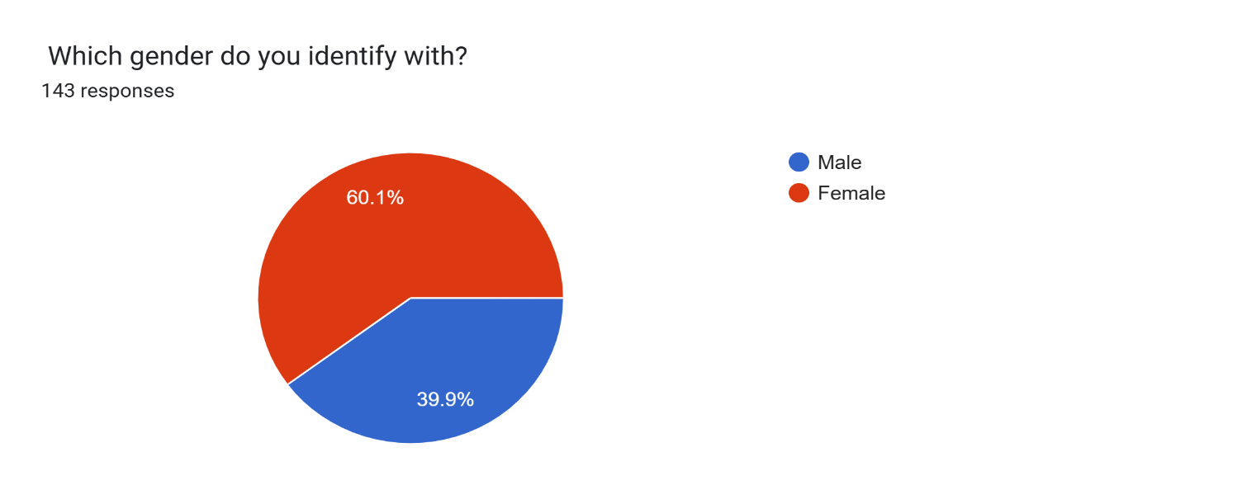

Fig.4

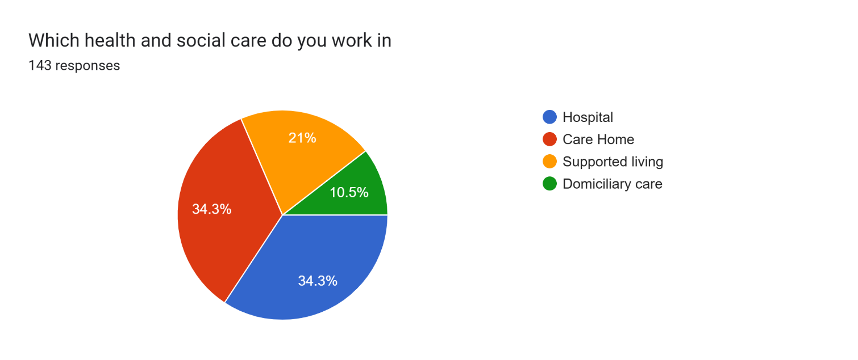

Fig.5

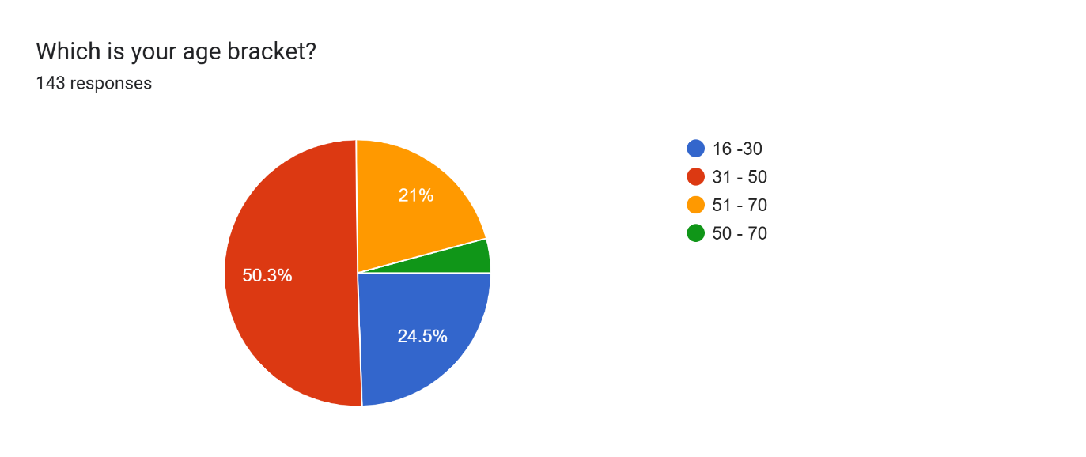

Fig.6

Forms response chart. Question title: How would you rate the overall impact of CQC monitoring on the quality of care provided in your healthcare facility?

. Number of responses: 143 responses.

Fig.7

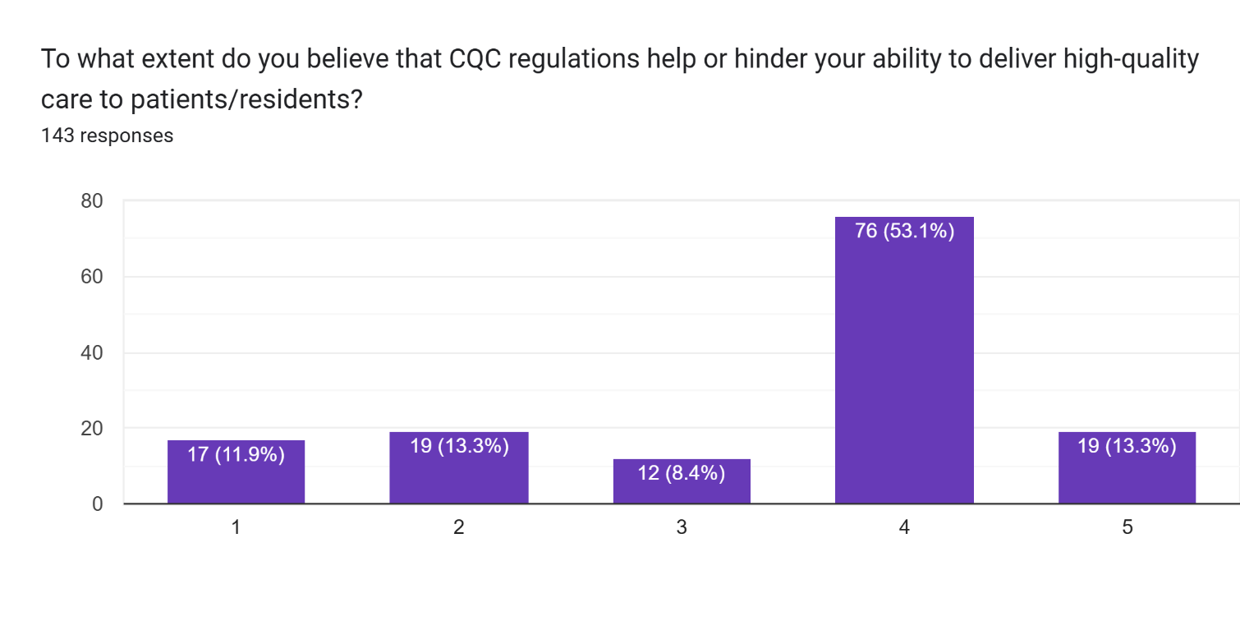

Fig.8

Forms response chart. Question title: In your own opinion, the CQC assigned ratings of your healthcare facility is accuracy and fair ?

. Number of responses: 143 responses.

Fig. 9

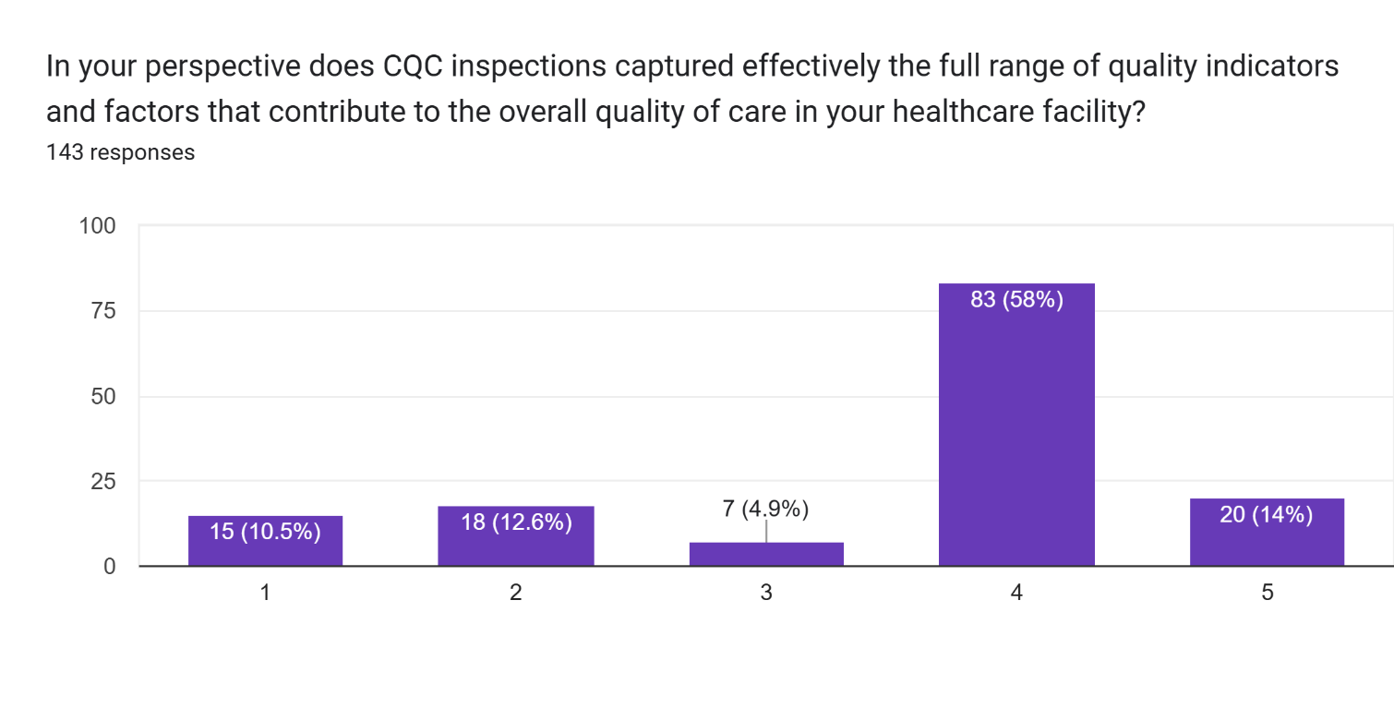

Fig.10

Forms response chart. Question title: In your own perspective does CQC monitoring and regulation adequately consider the challenges and constraints faced by healthcare workers in delivering care?

. Number of responses: 143 responses.

Fig.11

Forms response chart. Question title: Do you feel CQC plays a good role in promoting a culture of continuous improvement and learning within your healthcare organization?

. Number of responses: 143 responses.

Fig.12

Forms response chart. Question title: To what degree do you feel CQC ratings reflect the true standard and quality of care provided, as experienced by both staff and service users?

. Number of responses: 143 responses.

Fig13

Forms response chart. Question title: Following inspections and assessments of your healthcare facility by CQC, how transparent do you find the communication and feedback provided by the CQC ?

. Number of responses: 143 responses.

Fig14

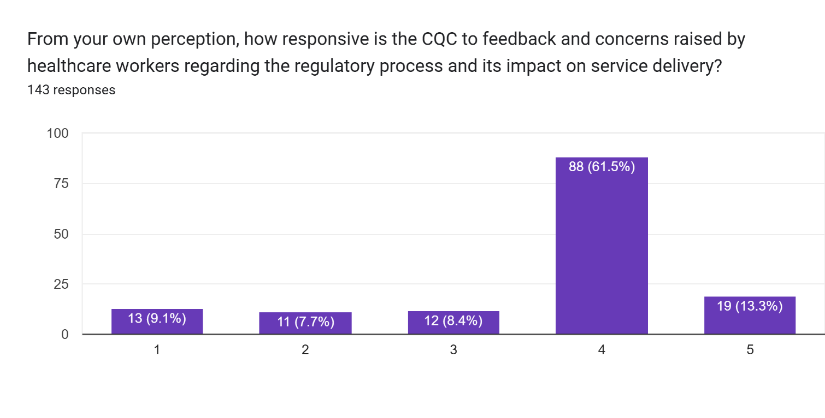

**1.10 Research findings**

Demographics: From Figure 5, it is revealed that 71.3% of the respondents fall within the age range of 31–70, while 24.5% fall within the age range of 16–30. These results show that there are fewer young adults coming into the health and social care sector than there are older adults. These findings agree with the works of Yar, Dix, and Bajekal, (2006) on Socio-demographic characteristics of the healthcare workforce in England and Wales–results from the 2001 Census.  Moreover, the female-to-male representation in Figure 3 shows there are fewer males coming into the health and social care sector profession. These findings agree with Belasen et al. (2021), Kalaitzi et al. (2019), and Wright (2022), whose works suggested high female representation is common in healthcare settings. The findings reveal 60.1% and 39.9% male and female respondents, respectively. Figure 4 shows 21%, 34.3%, 34.3%, and 34.4% for supported living, care homes, domiciliary care, and hospitals, respectively. This is suggestive of a growing number of participants in community-based care settings (Yar, Dix, and Bajekal, 2006).

**Table 1.** **shows the comprehensive list of the research survey questions and analysis**

|  |  |  |
| --- | --- | --- |
| **S/N** | **Survey questionnaires** | **Results and findings and analysis** |
| 1 | How would you rate the overall impact of CQC monitoring on the quality of care provided in your healthcare facility? | From the histogram in figure 6, result showed that 58.1% of respondents believe CQC has a significant positive impact in health and social care settings. Following the result, 49% of the 70 respondents rated four which is a positive impact of CQC monitoring while 9.1% rated 5 and 17.5% of 25 respondents rated 2. Only 7.7% showed negative or neutral impact. |
| 2 | To what extent do you believe that CQC regulations help or hinder your ability to deliver high-quality care to patients/residents? | 53.1% of 76 respondents believes CQC regulation assists with quality care provision while 11.9% of 17 respondent strongly thinks CQC regulations hinders performance. This result suggested that CQC regulation is viewed as beneficial by more than half of the respondents but still require improvement to account for the gap expressed by 11.9% of the respondents. |
| 3 | In your own opinion, the CQC assigned ratings of your healthcare facility is accuracy and fair? | Following the result of the rating, 56.6% believe CQC ratings are accurate and fair contrary to 7% and 16.1% of the respondent who disagreed. The results also showed that 7.7% of the respondent were either undecided or sceptical. |
| 4 | In your perspective does CQC inspections captured effectively the full range of quality indicators and factors that contribute to the overall quality of care in your healthcare facility? | Rating of 1, 2 and 3 are reflection of 7%, and 9.8% of the survey. These percentages showed that participants felts CQC does not promotes continues improvement rating as against 64.3% and 15.4% of the respondents that believes CQC promotes continues improvement. Again, the results indicated that CQC drives improvement in health and social care even though 3.5% of respondents were undecided as to whether CQC facilitate service improvement or not. |
| 5 | In your own perspective does CQC monitoring and regulation adequately consider the challenges and constraints faced by healthcare workers in delivering care? | From the results of the experimentation, it is shown that more participants feel supported however, there remains a significant concern about CQC awareness of health and social workers struggles. 60.8% believe CQC considers the challenges encountered by care workers while 12.6% and 11.9% believe otherwise. |
| 6 | Do you feel CQC plays a good role in promoting a culture of continuous improvement and learning within your healthcare organization? | Rating of 1, 2 and 3 are reflection of 7%, and 9.8% of the survey. These percentages showed that participants felts CQC does not promotes continues improvement rating as against 64.3% and 15.4% of the respondents that believes CQC promotes continues improvement. Again, the results indicated that CQC drives improvement in health and social care even though 3.5% of respondents were undecided as to whether CQC facilitate service improvement or not. |
| 7 | To what degree do you feel CQC ratings reflect the true standard and quality of care provided, as experienced by both staff and service users? | There is an indication from 64.3% of the respondents which is a significant number believes that CQC ratings reflects care quality while 7.7% and 10.5% suggests some doubts. These doubts provide room for critical examination of how CQC ratings can drive improvement. |
| 8 | Following inspections and assessments of your healthcare facility by CQC, how transparent do you find the communication and feedback provided by the CQC? | 64.3% and 15.4% revealed in the results indicates CQC communication is fairly transparent and open. |
| 9 | From your own perception, how responsive is the CQC to feedback and concerns raised by healthcare workers regarding the regulatory process and its impact on service delivery? | While 61.5% agree CQC is responsive to feedback, some healthcare workers felt CQC’s feedback is not fully considered. These were reflected in the 9.1% and 7.7% of respondents. |

**Table 2 shows the mean of the research survey questions**

|  |  |  |
| --- | --- | --- |
| **S/N** | **Survey questionnaires** | **Mean (Fx)** |
| 1 | How would you rate the overall impact of CQC monitoring on the quality of care provided in your healthcare facility? | 3.160839161 |
| 2 | To what extent do you believe that CQC regulations help or hinder your ability to deliver high-quality care to patients/residents? | 3.426573427 |
| 3 | In your own opinion, the CQC assigned ratings of your healthcare facility is accuracy and fair? | 3.517482517 |
| 4 | In your perspective does CQC inspections captured effectively the full range of quality indicators and factors that contribute to the overall quality of care in your healthcare facility? | 3.524475524 |
| 5 | In your own perspective does CQC monitoring and regulation adequately consider the challenges and constraints faced by healthcare workers in delivering care? | 3.405594406 |
| 6 | Do you feel CQC plays a good role in promoting a culture of continuous improvement and learning within your healthcare organization? | 3.685314685 |
| 7 | To what degree do you feel CQC ratings reflect the true standard and quality of care provided, as experienced by both staff and service users? | 3.608391608 |
| 8 | Following inspections and assessments of your healthcare facility by CQC, how transparent do you find the communication and feedback provided by the CQC? | 3.741258741 |
| 9 | From your own perception, how responsive is the CQC to feedback and concerns raised by healthcare workers regarding the regulatory process and its impact on service delivery? | 3.622377622 |

**Table 3. Regrouping of the research survey questions**

|  |  |  |
| --- | --- | --- |
| S/N | CQC | **Survey questionnaires** |
| 1 | CQC Monitoring | **Q1**: How would you rate the overall impact of CQC monitoring on the quality of care provided in your healthcare facility?  **Q5**: In your own perspective, does CQC monitoring and regulation adequately consider the challenges and constraints faced by healthcare workers in delivering care?  **Q6**: Do you feel CQC plays a good role in promoting a culture of continuous improvement and learning within your healthcare organization? |
| 2 | CQC Regulation | **Q2**: To what extent do you believe that CQC regulations help or hinder your ability to deliver high-quality care to patients/residents?  **Q9**: From your own perception, how responsive is the CQC to feedback and concerns raised by healthcare workers regarding the regulatory process and its impact on service delivery? |
| 3 | CQC Inspections | **Q4**: In your perspective, does CQC inspection effectively capture the full range of quality indicators and factors that contribute to the overall quality of care in your healthcare facility?  **Q8**: Following inspections and assessments of your healthcare facility by CQC, how transparent do you find the communication and feedback provided by the CQC? |
| 4 | CQC Rating | **Q3**: In your own opinion, is the CQC-assigned rating of your healthcare facility accurate and fair?  **Q7**: To what degree do you feel CQC ratings reflect the true standard and quality of care provided, as experienced by both staff and service users? |

**Table 4. Shows the mean and Standard deviation for each continuous variable**

|  |  |  |  |
| --- | --- | --- | --- |
| **S/N** | **CQC** | **Mean (Fx)** | **Standard Deviation (SD)** |
| 1 | CQC Monitoring | 3.417249417 | 0.8559572598 |
| 2 | CQC Regulation | 3.524475524 | 0.9147751287 |
| 3 | CQC Inspections | 3.632867133 | 0.9769208243 |
| 4 | CQC Rating | 3.562937063 | 0.9100586565 |

**1.10.1 Correlation Matrix analysis**

**Table 5: correlation table**

Table 5 above reveals CQC ratings and inspections, with the highest correlation value being 0.6764879424. What this indicates is the fact that the standard, quality, frequency, and intensity of inspection all have a strong impact and influence on ratings issued to services in health and social care. There is also a higher correlation between monitoring and rating of services, suggesting that CQC monitoring that are consistent can lead to better ratings. However, the correlation between regulations and these other factors like rating, inspection, and monitoring were 0.6359, 0.5886, and 0.5484, respectively. These are indications of how regulation underpins the CQC frameworks. As the various components are positively correlated suggesting the interdependent process within the institution's framework. It goes to say that regulations remain the rudimentary element that influences others to a certain degree.

**RQ1 What are the views of health and social care workers on the effectiveness of CQC regulation in improving service quality within the health and social care sector?**

Suggestive of the survey findings is that care quality commission regulations are profitable in the improvement of service quality. A significant number of respondents feel CQC monitoring has a positive effect on care quality, as shown in the 58.1% and 49% rating scale of 4 or 5, indicating a positive perception. It further reflects from the participant perspective that CQC regulatory oversight is a mechanism driving good service delivery in the health and social care sector. This is given credence by the works of Beaussier, et al., (2016), Shahzad, (2020) and Grote, et al., (2021). 58% of respondents demonstrated confidence in the understanding of the regulatory frameworks, as this percentage believes CQC inspections capture the full range of quality and standard indicators. Conversely, while 10.5% and 12.6% expressed concern relative to gaps in the regulatory approach and the inspections, generally suggestive of the probability of overlooking the critical elements impacting care standards and quality. Nonetheless, while 12.6% and 11.9% feel the monitoring frameworks fail to consider the problems encountered by healthcare workers, 64.3% and 15.4% of health and social care workers feel CQC ensures a culture of improvements and continuous learning, which is pivotal in placing the commission at the center of being a catalyst for standard and quality enhancement. Thus, contrary to the percentage reflecting the concern on the feasibility of implementation in CQC best practice recommendations.  Overall, the findings indicate why CQC regulations are perceived largely as profitable. However, despite the enormity of the positive perception, some participants believe that CQC’s regulatory framework falls short in representation of the true quality of care provided. This could suggest possible bias in CQC rating methodologies or underlying personal grievances, lack of proper preparation for the CQC supervision, or dislike of CQC personnel or modus operandi.

**RQ2 How does CQC-regulated services influence the overall performance and outcomes of providers in the industry?**

The performances and outcomes of health and social care providers are shaped by CQC-regulated services, as they play a critical role in these. Following the results of the findings, 53.1% of participants feel that instead of hindering their capacity to perform, CQC regulations assist them in delivering a high standard of care. The results are indicative that complying with regulatory frameworks often yields an improvement in performance through a set of standards and clear expectations. Castro (2018), Laing (2023), Dixon et al. (2015), and Moran et al. (2021) argued that a critical indicator of influence is always transparency and accountability. Therefore, after inspection, the 64.3% of respondents is indicative of transparency in CQC communications and feedback.

Additionally, influencing external perceptions and impacting internal and operational strategies of a care setting is the CQC rating that serves as a benchmark for standard and quality improvement. The 64.3% and 15.4% participation indicate that the CQC rating meets the true standards of care. Suggesting that CQC ratings are dependable indicators for quality and performance within the healthcare setting. Whether or not CQC fully accounts for challenges encountered by workers is debatable and of much concern to healthcare workers. That is why the result had 12.6% and 11.9% of respondents who felt CQC should consider healthcare workers' concerns as well rather than squarely facing ratings. Therefore, the question of fairness and accuracy in CQC ratings remains a subject of concern and discussion, as expressed by Boyd et al. (2018), Burton (2017), Harris (2017), and Wise (2024), as there are also other concerns about the practice applications, reliability, and accuracy of assessment. From the findings, it is noted that CQC-regulated services significantly and positively influence health and social care provider performance by enforcing and reinforcing quality standards, promoting transparency, and advocating accountability.

**1.11 Critique of the Process and Limitations of the Project**

As time allocation was limited, an in-depth analysis would have been done through regression analysis; a hypothesis could have been developed from the conceptual framework and then tested either using multiple regression analysis or hierarchical regression analysis, as descriptive statistics are not sufficient. A participant of over two hundred would have given a more substantial analysis.

**References:**

Aminaho, F. and Onoshakpor, C., (2025). *Analysis of CQC Ratings of Care Home Business Performance in England: Implications for Quality Improvement*.

BBC Panorama (2016) online: 20th Nov.

Beaussier, A.L., Demeritt, D., Griffiths, A. and Rothstein, H., (2016). *Accounting for failure: risk-based regulation and the problems of ensuring healthcare quality in the NHS*. Health, risk & society, 18(3-4), pp.205-224.

Belasen, A.T., Belasen, A.M., Belasen, A.R. and Belasen, A.R., (2021). *A win-win for health care: promoting co-leadership and increasing women’s representation at the top*. Gender in Management, 36(6), pp.762-781.

Boyd, A., Addicott, R., Robertson, R., Ross, S. and Walshe, K., (2017). *Are inspectors’ assessments reliable? Ratings of NHS acute hospital trust services in England*. Journal of health services research & policy, 22(1), pp.28-36.

Boyd, A., Moralee, S. and Ferguson, J., (2020). *CQC’s impact on the quality of care: An assessment of CQC's contribution, and suggestions for improvement*.

Boyd, A., Ross, S., Robertson, R., Walshe, K. and Smithson, R., (2018). *How hospital survey teams function: an analysis of care quality commission inspections of acute hospitals in England*. Journal of health organization and management, 32(2), pp.206-223.

Burton, J., (2017). *What’s Wrong with CQC*.

Castro, A.C., (2018). *Evaluating the effect of external inspections of the Care Quality Commission of acute NHS hospitals in England* (Doctoral dissertation, University of York).

Cinaroglu, S. and Baser, O., (2018). *Understanding the relationship between effectiveness and outcome indicators to improve quality in healthcare*. Total Quality Management & Business Excellence, 29(11-12), pp.1294-1311.

CQC (2022-23)-annual-report-statement-of-comprehensive-net-expenditure_0

Dixon, J., Spencelayh, E., Howells, A., Mandel, A. and Gille, F., (2015). *Indicators of quality of care in general practices in England*. London, England.

Furnival, J., Boaden, R. and Walshe, K., (2018). *Assessing improvement capability in healthcare organisations: a qualitative study of healthcare regulatory agencies in the UK*. International Journal for Quality in Health Care, 30(9), pp.715-723.

Goedhart, N.S., van Oostveen, C.J. and Vermeulen, H., (2017). *The effect of structural empowerment of nurses on quality outcomes in hospitals: a scoping review*. Journal of Nursing Management, 25(3), pp.194-206.

Gov.Uk (2024). *Review into the operational effectiveness of the Care Quality Commission: interim report*. Department of Health and Social Care.

Griffin, S., (2022). *CQC is reviewing GP service provider’s use of less qualified staff after BBC investigation*.

Grote, H., Toma, K., Crosby, L., Robson, C., Palmer, C., Land, C., Ball, J. and Baker, E., (2021). *Outliers from national audits: their analysis and use by the Care Quality Commission in quality assurance and regulation of healthcare services in England*. Clinical Medicine, 21(5), pp.e511-e516.

Gupta, M., (2015). *A study on employees perception towards employee engagement*. Globsyn Management Journal, 9(1/2), pp.45-51.

Harris, D., (2022). *Supervision Practices in an English National Health Service Organisation: Complexity and Paradox* (Doctoral dissertation, University of Brighton).

Harris, R., (2022). *CQC Inspections: When an inspector calls*. BDJ In Practice, 35(5), pp.31-31.

Kalaitzi, S., Czabanowska, K., Azzopardi-Muscat, N., Cuschieri, L., Petelos, E., Papadakaki, M. and Babich, S., (2019). *Women, healthcare leadership and societal culture: a qualitative study*. Journal of healthcare leadership, pp.43-59.

Laing, J., (2023). *Independent mental health monitoring: Evaluating the Care Quality Commission in England's approach to regulation, rights, and risks*. In Routledge Handbook of Mental Health Law (pp. 34-54). Routledge.

Lloyd, R.C., (2019). *Quality health care: a guide to developing and using indicators*. Jones & Bartlett Learning.

Mahase, E., (2020). *CQC review raises “serious concerns” over private provider running 113 mental health facilities*. BMJ: British Medical Journal (Online), 368, p.m148.

Mariko, M., (2003). *Quality of care and the demand for health services in Bamako, Mali: the specific roles of structural, process, and outcome components*. Social science & medicine, 56(6), pp.1183-1196.

McHale, J.V. and Noszlopy, L., (2025). *Legal Regulation of Adult Social Care Provision in England*. In Adult Social Care Law and Policy (pp. 62-115). Bristol University Press.

Melnikovas, A., (2018). *Towards an Explicit Research Methodology: Adapting Research Onion Model for Futures Studies*. Journal of futures Studies, 23(2).

Mongan, C. and Thomas, W., (2021). *Understanding good leadership in the context of English care home inspection reports*. Leadership in health services, 34(2), pp.167-180.

Moran, V., Allen, P., Sanderson, M., McDermott, I. and Osipovic, D., (2021). *Challenges of maintaining accountability in networks of health and care organisations*. Social Science & Medicine, 268, p.113512.

O’Neill, A., (2025). *Turning complaints into care improvements*. BDJ In Practice, 38(3), pp.93-93.  
Office for National Statistics [ONS] (2023). *Care homes and estimating the self-funding population, England: 2022 to 2023*.

ONS (2021). *Population and household estimates, England and Wales: Census 2021*.

Ojeme, R., (2023). *Lived Experiences of Stress among NHS Mental Health Support Workers: A Qualitative Study* (Doctoral dissertation, Newcastle University).

Rayner, M., (2022). *The Care Quality Commission: A Regulatory Evolution*. Judicial Review, 27(2), pp.126-131.

Rendel, S., Crawley, H. and Ballard, T., (2015). *CQC inspections: unintended consequences of being placed in special measures*. The British Journal of General Practice, 65(639), p.e640.

Richardson, E., Walshe, K., Boyd, A., Roberts, J., Wenzel, L., Robertson, R. and Smithson, R., (2019). *User involvement in regulation: A qualitative study*. Health Expectations, 22(2), pp.245-253.

Saunders, M., Lewis, P. and Thornhill, A., (2019). *Research Methods for Business Students*. 8th ed. London; Pearson Education.

Sengupta, M., Roy, A., Ganguly, A., Baishya, K., Chakrabarti, S. and Mukhopadhyay, I., (2021). *Challenges encountered by healthcare providers in COVID-19 times: an exploratory study*. Journal of Health Management, 23(2), pp.339-356.  
Shahzad, M.W., (2020). *Signalling Quality: An Assessment of the Effectiveness of Regulator Quality Ratings for Care Homes* (Doctoral dissertation, University of Leicester).

Smithson, R., Richardson, E., Roberts, J., Walshe, K., Wenzel, L., Robertson, R., Boyd, A., Allen, T. and Proudlove, N., (2018). *Impact of the care quality Commission on provider performance: room for improvement?*. King's Fund.

Stirton, R., (2017). *The Health and Social Care Act 2008 (regulated activities) regulations 2014: a litany of fundamental flaws?*

Torjesen, I., (2021). *“Exhausted and depleted” staff pose risk to quality of NHS and social care, warns CQC*.

Towers, A.M., Smith, N., Allan, S., Vadean, F., Collins, G., Rand, S., Bostock, J., Ramsbottom, H., Forder, J., Lanza, S. and Cassell, J., (2021). *Care home residents’ quality of life and its association with CQC ratings and workforce issues: the MiCareHQ mixed-methods study*.

Walshe, K., (2024). *The Care Quality Commission has lost its way*. BMJ, 386.

Wang, Y., Kim, S., Rafferty, A. and Sanders, K., (2020). *Employee perceptions of HR practices: A critical review and future directions*. The International Journal of Human Resource Management, 31(1), pp.128-173.

Wise, J., (2024). *Care Quality Commission branded “not fit for purpose” as review finds “significant failings”*. BMJ: British Medical Journal (Online), 386, p.q1686.

Wright, K., (2022). *An application of the theory of representative bureaucracy, gender concordance, and symbolic representation in the health care context*. The American Review of Public Administration, 52(2), pp.139-153.

Yar, M., Dix, D. and Bajekal, M., 2006. Socio-demographic characteristics of the healthcare workforce in England and Wales–results from the 2001 Census. *Health Stat Q*, *32*, pp.44-56.