A rare case of angina due to left main coronary artery compression in a patient with severe pulmonary arterial hypertension

Abstract

This report presents a case of a 42-year-old patient diagnosed with ostium secundum atrial septal defect (ASD) with severe pulmonary arterial hypertension (PAH). The patient presented with progressive chest pain and dyspnea and was found to have a lesion in the left main coronary artery (LMCA) ostium by coronary angiography. Computed tomography (CT) imaging revealed a significant enlargement of the main pulmonary artery (PA), which indicated possible compression of the LMCA by the PA which was subsequently confirmed by coronary angiography and intravascular ultrasound (IVUS).
Our patient underwent IVUS guided percutaneous coronary intervention by which a stent was deployed in the ostial LMCA, leading to near resolution of the patient's symptoms. Currently, the patient is under follow-up. This case highlights an often-overlooked cause of chest pain and dyspnea in patients with PAH. Although these patients often experience typical and atypical angina due to elevated right-sided pressures, the current report reveals that external compression of the LMCA by an enlarged PA can also cause coronary ischemia.
Physicians should consider LMCA compression when assessing PAH patients with chest pain, as percutaneous coronary intervention and stenting can safely and effectively manage this condition.

- Introduction

Pulmonary arterial hypertension (PAH) entails a poor prognosis irrespective of the underlying etiology.^{1,2,3}

Typical symptoms are largely nonspecific, including dyspnea, fatigue, and chest pain on exertion. Angina-like symptoms are frequent despite angiographically normal coronary arteries, and classically, have been attributed to right ventricular ischemia resulting from the increased metabolic needs of the overloaded, hypertrophied right ventricle or painful distention of the pulmonary artery (PA) ^{1,2,3}
A severely dilated PA may compress adjacent anatomical structures including the left main coronary artery¹⁶(LMCA) (causing myocardial ischemia), the left recurrent laryngeal nerve (causing hoarseness; i.e., Ortner's syndrome), and the tracheobronchial tree (large airway obstruction) ⁴

External compression of the Left main coronary artery¹⁷ (LMCA) by a dilated main pulmonary artery (MPA) is a rare condition, but it can cause chest pain in patients with pulmonary hypertension. However, extrinsic compression of the left main coronary artery (LMCA) by a dilated pulmonary artery (PA) main trunk is increasingly recognized as a cause of angina in PAH. Despite multiple case reports^{5,6} the incidence of LMCA compression in PAH is not well established. A small case series reported that, of 26 patients with PAH and angina, 7 (26.9%) had LMCA compression.⁷
Along with angina, LMCA compression may be associated with additional complications of severe myocardial ischemia, including myocardial infarction (MI)⁸, left ventricle dysfunction, arrhythmia, and eventually, sudden death⁹ Because >25% of deaths in patients with PAH are related to sudden death¹⁰, some of these events might be attributable to LMCA compression, a potentially correctable complication.
Currently, coronary computed tomography angiography (CTA) provides a precise assessment of the anatomical relationship between the LMCA and the enlarged PA.⁷

Traditionally, coronary artery bypass graft surgery is used to treat LMCA disease. However, in the case of LMCA compression caused by a dilated MPA, coronary angioplasty with stenting has shown promising results and might be a better option for some high-risk patients who cannot undergo surgery.

2. Case presentation

A 42-year-old male patient, with no medical history in the past, visited us with progressively worsening dyspnea (NYHA class II) and exertional chest pain over a period of two years. On physical examination, we observed pectus excavatum of the anterior chest wall(see fig.3), a blood pressure of 100/80 mmHg, a heart rate of 80 beats/minute, and no signs of left or right-sided heart failure. The saturation levels in all four limbs were checked and recorded at room temperature.

R UL = 91% | L UL = 91%
R LL = 92% | L LL = 91%

On cardiac examination, the patient was found to have a loud P2 with an ejection systolic murmur of grade 3/6 in the pulmonary area. However, there was no elevated jugular venous pressure or pedal edema observed. The patient's breath sounds were normal. The ECG indicated right ventricular hypertrophy with a strain pattern (see fig.1), while the chest X-ray showed a prominent pulmonary artery shadow, suggesting a dilated pulmonary artery (see fig.2). During a 6-minute walk test, the patient experienced chest pain around the chest after walking for 4 min and was unable to complete the test. The distance covered by the patient was 280m and pulmonary function testing was suggestive of mild restrictive pattern
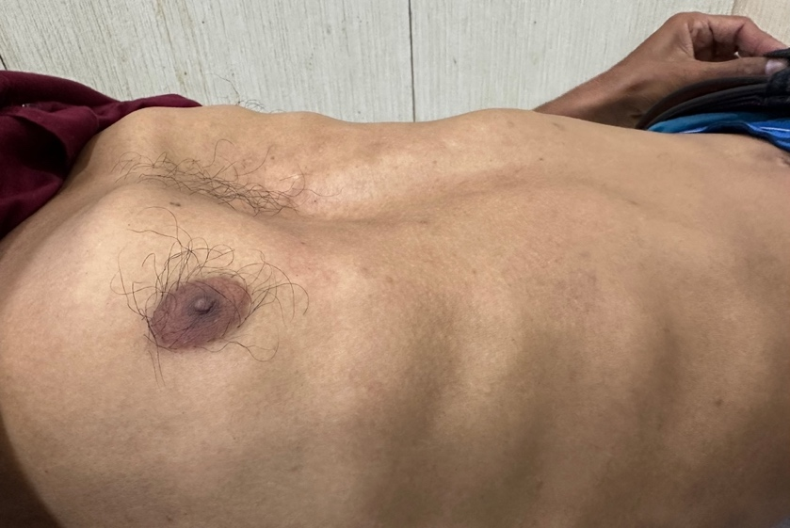

Figure 1: pectus excavatum
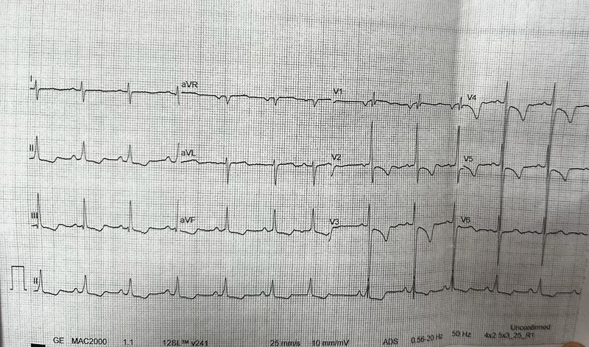  Figure 2 : Right ventricular hypertrophy with strain pattern | 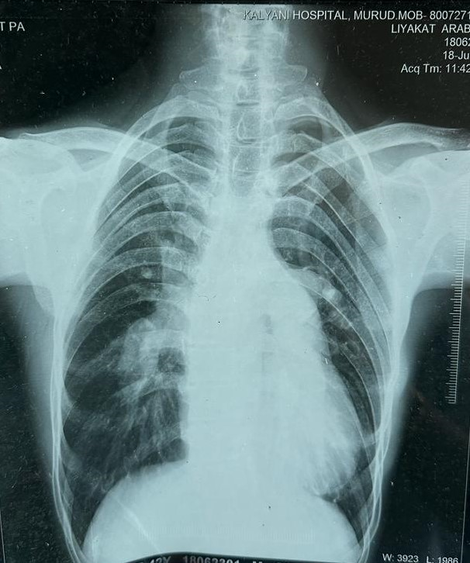  Figure 3 : CXR showing Prominent pulmonary artery

Further testing with transthoracic echocardiography showed a large Ostium Secundum atrial septal defect of size 20.3mm with a bi-directional shunt (see fig. 4,5,6,7). The right atrium (RA) and right ventricle (RV) were both dilated, with an estimated systolic RV pressure (RVSP) of 107 mmHg and a tricuspid annular plane systolic excursion (TAPSE) of 15.5 mm. The left ventricle (LV) appeared 'D'-shaped and small, with an end-diastolic diameter of 18.9 cm. However, the LV systolic function was normal, with an ejection fraction of 62%. The main pulmonary artery (PA) was also dilated, with a diameter of 32 mm. After performing a coronary angiogrpahy from the right femoral artery, a short segment eccentric ostial LMCA stenosis was discovered, followed by a mid left anterior descending artery (LAD) myocardial bridge (see fig. 8). There were no other atherosclerotic changes or stenosis of the coronary arteries. Intravascular ultrasound (IVUS) showed that the ostium of the LMCA was narrowed to a slit without evidence of underlying atherosclerosis (see fig. 9). Cardiac computed tomography (ECG-gated multidetector computed tomography [MDCT]) confirmed high origin of LMCA from the left cusp with significant narrowing at its origin and no obvious wall calcification (CADRADS 3/4) caused by a severely dilated PA trunk (see fig. 10,11). A large OS- ASD of 22mm with dilated RA, RV, and pulmonary artery was also confirmed. The aortopulmonary ratio was 0.7, which was suggestive of pulmonary hypertension.

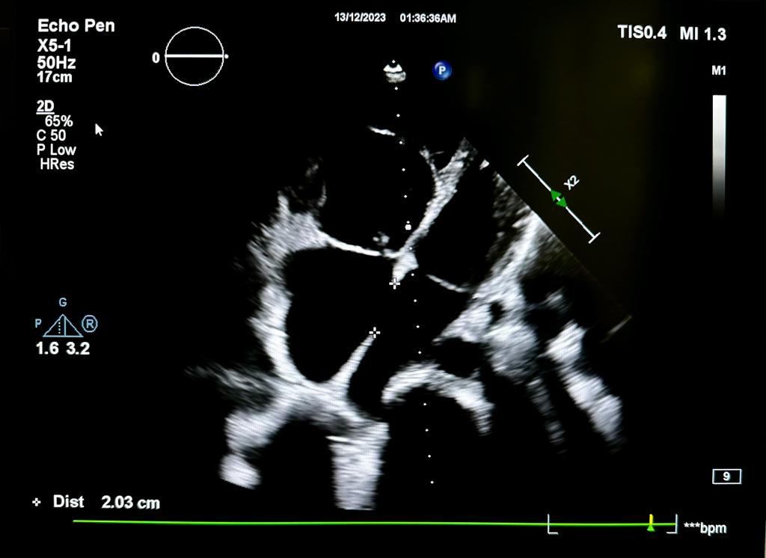  Figure 4 : Ostium secundum atrial septal defect of size 20.3mm | 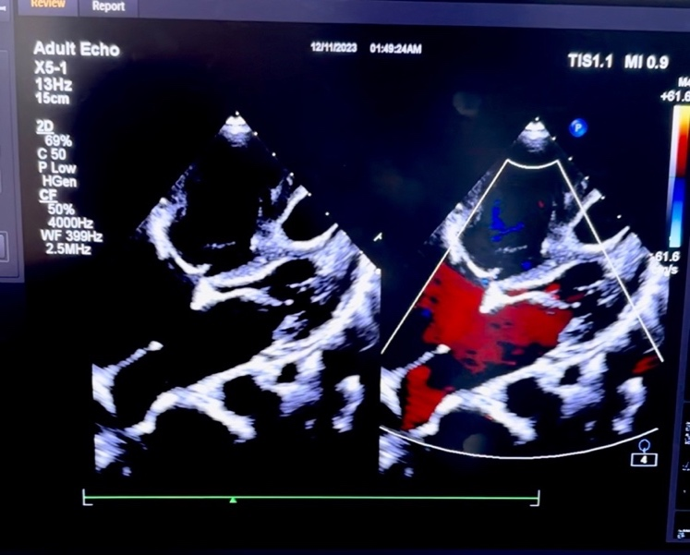  Figure 5 : colour doppler across septal defect
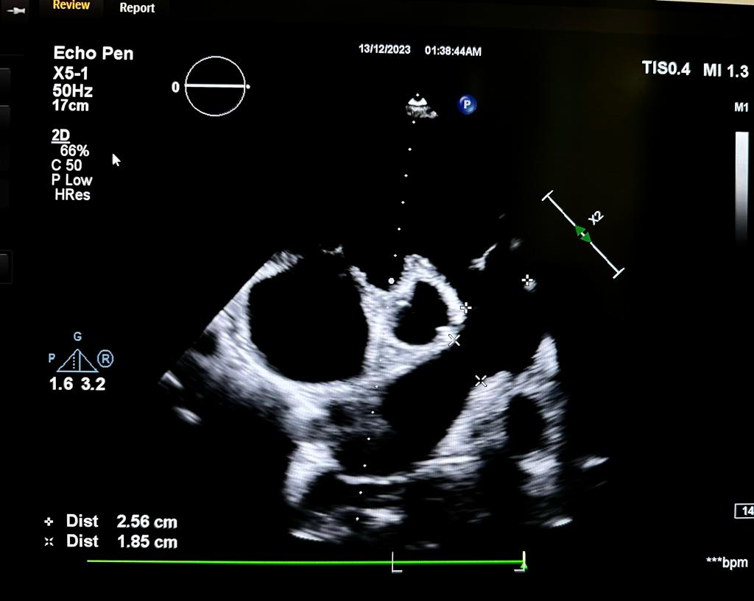  Figure 6 : dilated pulmonary artery | 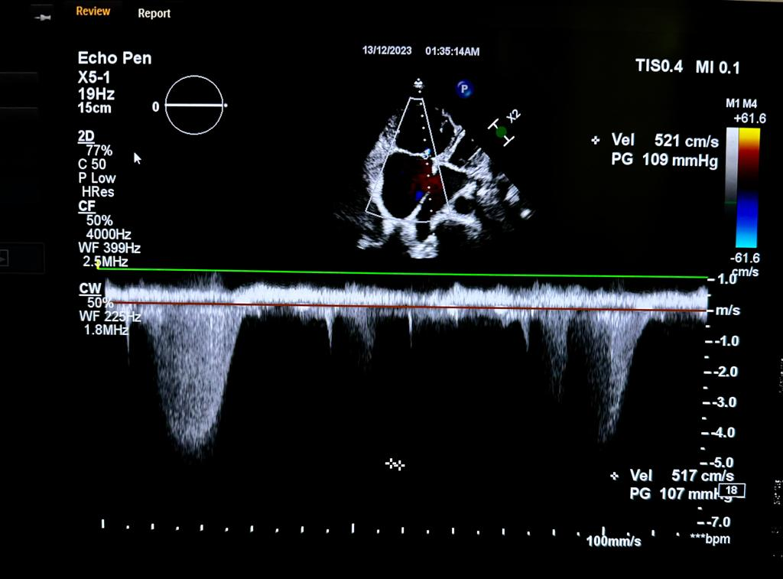  Figure 7 : right ventricular systolic pressure – 107mmhg

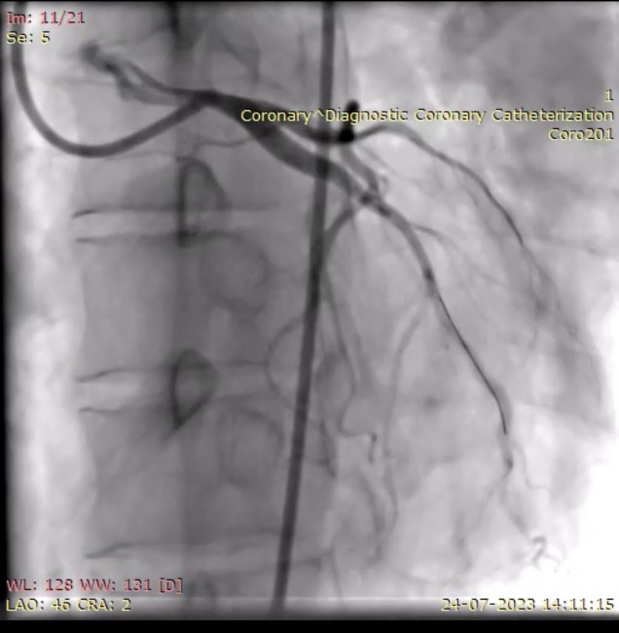  Figure 8 : Coronary angiography demonstrating eccentric 60% stenosis of the ostium of the left main coronary artery (LMCA). No other atherosclerotic changes noted. | 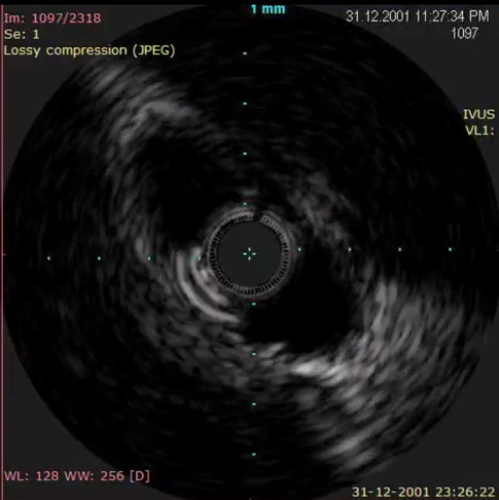  Figure 9 : IVUS showing ostial LMCA narrowed to a slit
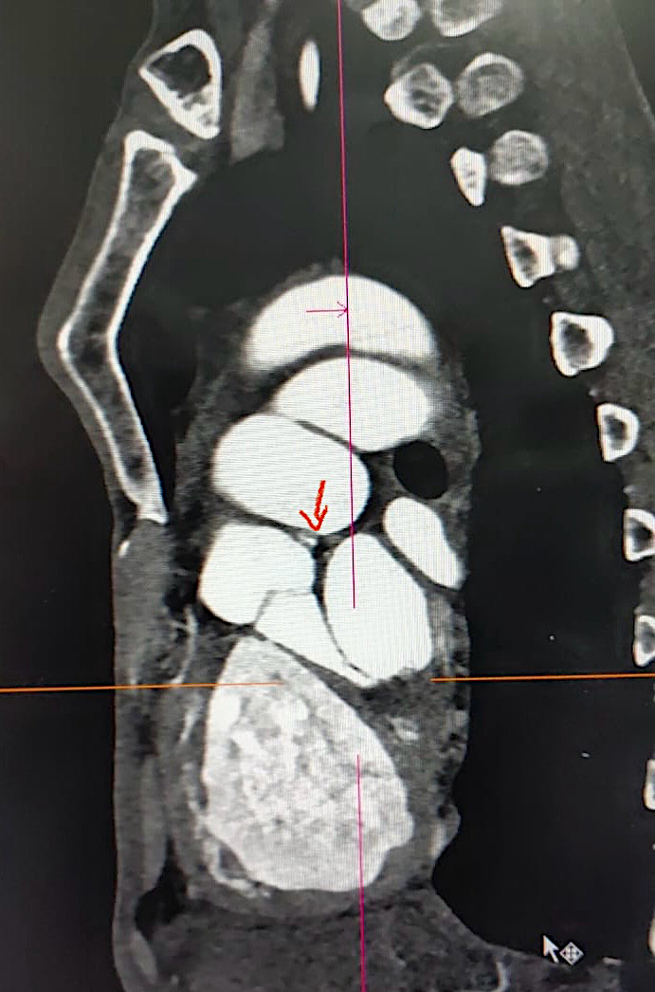  MPA  Aortic root  Figure 10: High origin of LMCA from left cusp with significant narrowing at its origin and no obvious wall calcification (CADRADS 3/4) | LMCA compression  MPA  Figure 11: external compression of LMCA at the ostium by dilated PA.

- Procedure

Our patient underwent a percutaneous coronary intervention (PCI) of the left main artery ostium using a bare metallic stent RENOFIT 6*15mm guided by intravascular ultrasound (IVUS). (see fig. 12,13,14). The post-procedure stent was well opposed, and the narrowing of the LMCA ostial disappeared. There was no evidence of flap, dissection or residual ostial lesion post stenting. The same findings were confirmed by IVUS and the minimal stent area (MSA) was found to be 9.4 mm². (see fig. 14). To assess the reversibility of pulmonary artery hypertension (PAH), cardiac catheterization was done, which showed irreversible PAH (PVR 11 wood units). An attempt to close the atrial septal defect (ASD) with a device was not made in this case due to increased pulmonary vascular resistance and a significant increase in LVEDP on balloon occlusion of the septal defect. The patient's symptoms have been resolved after the PCI, and he is currently undergoing medical management for pulmonary hypertension and is on follow-up.

Pre occlusion | 3 min | 6 min | 10 min
LVEDP (mmhg) – 5 | 16 | 30 | 37

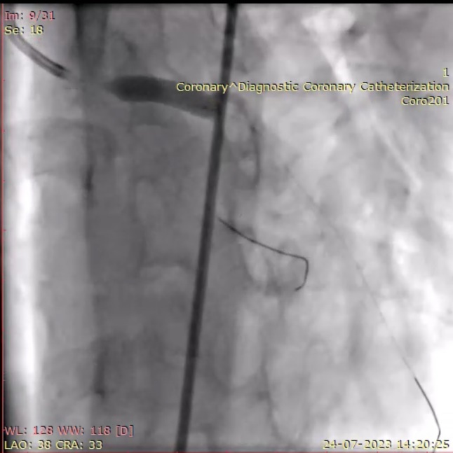  Figure 12: Left main coronary artery from the ostium stented using RENOFIT 6x15mm bare metallic stent. | 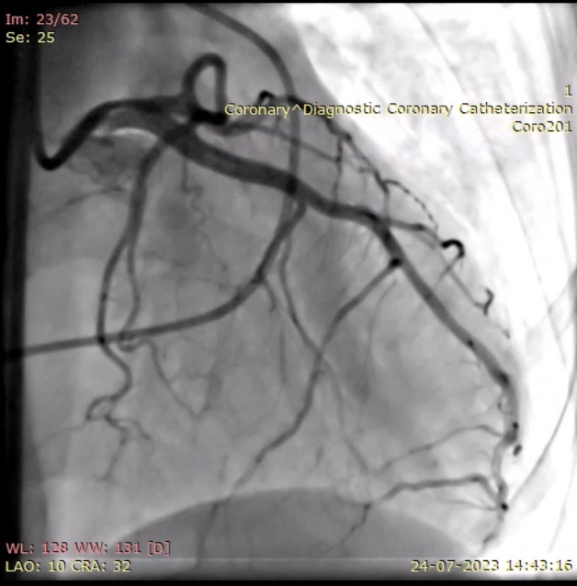  Figure 13: Stent well opposed, TIMI 3 flow.

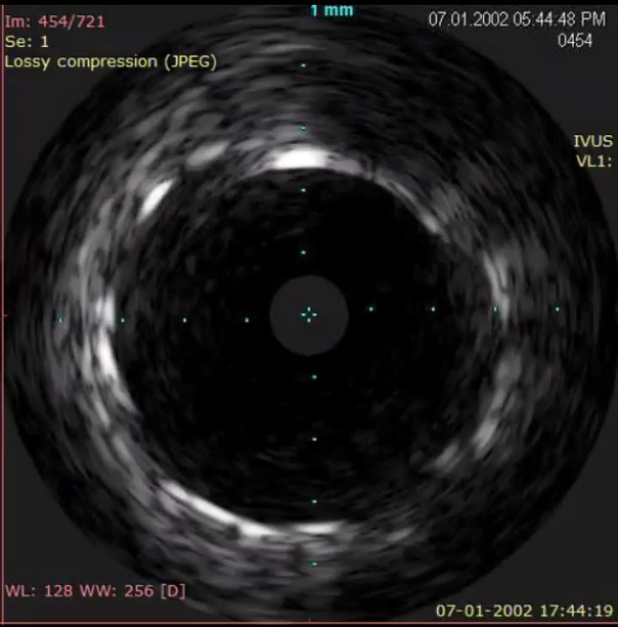

Figure 14 : IVUS of LMCA post stent deployment showing well opposed stent with large calibre vessel. (MSA – 9.4mm2 )

- Discussion
Extrinsic compression of the left main coronary artery (LMCA) due to a dilated pulmonary artery (PA) has been previously reported.¹¹ This condition can present with exercise-related chest pain, cardiogenic shock, malignant arrhythmias caused by myocardial ischemia, or sudden death. The incidence of LMCA compression due to PA dilatation is not well established, but it ranges between 5% and 44% according to different case series.^{7,12}

Because of a low pretest probability for atherosclerotic coronary artery disease in young PH patients, coronary angiography is rarely performed. However, the extrinsic compression of the LMCA due to an enlarged PA is becoming increasingly recognizable and should always be considered in PH patients with exercise-induced chest pain, which is the most common clinical presentation of this problem.^{13,14} In one study, the origin of the LMCA from the right sinus of Valsalva was considered to convey a higher risk for extrinsic compression compared with the normal origin from the left sinus.¹⁵ In another study, risk factors predisposing to LMCA compression in PAH were younger age, severe pulmonary trunk dilatation (>40 mm; normal: 25–30 mm), and a PA trunk/aorta ratio >1.2 (normal: 1.0).⁷

Our patient was young and suffered from severe pulmonary hypertension. The pulmonary trunk size was 35mm with a PA trunk/aorta ratio of 1.45, with MPA 35mm and aorta 24mm. As there were no signs of atherosclerosis, a short bare metallic stent was used, and aggressive post dilation was avoided. Additionally, as left main artery stenting was involved, IVUS was utilized for stent optimization to avoid any complications.

In cases where extrinsic compression of the LMCA by an enlarged PA occurs, PCI is a reasonable first therapeutic option considering its high likelihood of success. The procedure provided persistent symptomatic and prognostic benefits for our patient.
Patient was prescribed DAPT, tadalafil and ambrisentan on discharge. On follow up patient has been symptomatically better and his exercise capacity has improved
List 1 : Pre-procedure and post-procedure Assessment
 | Pre procedure | Post procedure (3 months)
Symptoms | Angina + | No angina
 | Dyspnea NYHA III | NYHA I
6MWD | 280 | 430m
RVSP | 107 mmhg | 86mmhg

Conclusion
Extrinsic compression of the left main coronary artery (LMCA) by an enlarged pulmonary artery (PA) is rare but a significant cause of angina in patients with pulmonary arterial hypertension (PAH). This condition should be suspected in a case where a PAH patient shows typical or atypical anginal symptoms. The most appropriate initial test to evaluate this condition is computed tomography coronary angiogram (CTCA). Coronary angiography is required to confirm LMCA stenosis and to enable percutaneous coronary intervention (PCI) with stent deployment. PCI with stent deployment is a safe and effective treatment that can lead to long-term improvement in symptoms.
Physicians should consider LMCA compression when assessing PAH patients with chest pain, as percutaneous coronary intervention and stenting can safely and effectively manage this condition.
In summary, extrinsic compression of the LMCA by an enlarged PA can cause chest pain in patients with advanced PAH, and CTCA is the first step in evaluating it. PCI with stent deployment is a safe and effective treatment for this condition.

References
- E.A. Demerouiti, A.N. Manginas, G.D. Atha, G.T. Karatasakis
Complications leading to sudden cardiac death in pulmonary arterial hypertension

- M.S. Lee, J. Oyama, R. Bhatia, Y.H. Kim, S.J. Park
Left main coronary artery compression from pulmonary enlargement due to pulmonary hypertension: a contemporary review and arguments for percutaneous revascularization

- N. Galiè, M. Humbert, J.L. Vachiery, et al.
2015 ESC/ERS guidelines for the diagnosis and treatment of pulmonary hypertension: The Joint Task Force for the Diagnosis and Treatment of Pulmonary Hypertension of the European Society of Cardiology (ESC) and the European Respiratory Society (ERS)

- W. Dakkak, A.R. Tonelli
Compression of adjacent anatomical structures by pulmonary artery dilation

- V.A. de Jesus Perez, F. Haddad, R.H. Vagelos, W. Fearon, J. Feinstein, R.T. Zamanian
Angina associated with left main coronary artery compression in pulmonary hypertension

- W. Karrowni, G. Sigurdsson, P.A. Horwitz
Left main coronary artery compression by an enlarged pulmonary artery

7. S.M. Mesquita, C.R. Castro, N.M. Ikari, S.A. Oliveira, A.A. Lopes
Likelihood of left main coronary artery compression based on pulmonary trunk diameter in patients with pulmonary hypertension

- M. Vaseghi, J.S. Lee, J.W. Currier
Acute myocardial infarction secondary to left main coronary artery compression by pulmonary artery aneurysm in pulmonary arterial hypertension

- E.A. Demerouti, A.N. Manginas, G.D. Athanassopoulos, G.T. Karatasakis
Complications leading to sudden cardiac death in pulmonary arterial hypertension

- G.E. D'Alonzo, R.J. Barst, S.M. Ayres, et al.
Survival in patients with primary pulmonary hypertension. Results from a national prospective registry

- Lee MS, Oyama J, Bhatia R, Kim YH, Park SJ. Left main coronary artery compression from pulmonary artery enlargement due to pulmonary hypertension: a contemporary review and argument for percutaneous revascularization. Catheter Cardiovasc Interventions 2010;76:543–550.

- Mitsudo K, Fujino T, Matsunaga K, Doi O, Nishihara Y, Awa J, Goto T, et al. Coronary arteriographic findings in the patients with atrial septal defect and pulmonary hypertension (ASD + PH)—compression of left main coronary artery by pulmonary trunk [in Japanese]. Kokyu To Junkan 1989;37:649–655.

- Kanjwal MY, Carlson DE Jr., Schwartz JS. Chronic/subacute total occlusion of the left main coronary artery—a case report and review of literature. Angiology 1999;50:937–945.

- Shen AY, Jandhyala R, Ruel C, Lundstrom RJ, Jorgensen MB. Predictors of survival after coronary bypass grafting in patients with total occlusion of the left main coronary artery. Am J Cardiol 1998;81:343–346.

- Kajita LJ, Martinez EE, Ambrose JA, Lemos PA, Esteves A, Nogueira da Gama M, Jatene AD, Ramires JA. Extrinsic compression of the left main coronary artery by a dilated pulmonary artery: clinical, angiographic, and hemodynamic determinants. Catheter Cardiovasc Interventions 2001;52:49–54.

- Nabawi, H., Boutgourine, M., Maatouf, B., Rhoujati, I., Eljamili, M., & Elhattaoui, M. (2022). Coronary Artery Connection Abnormality Revealed by Acute Coronary Syndrome: A Case Report and Review of the Literature. Cardiology and Angiology: An International Journal, 11(4), 416–421. https://doi.org/10.9734/ca/2022/v11i4295

- Naaim, M., Ztati, M., Jamili, M. E., Karimi , S. E., & Hattaoui, M. E. (2023). Heart Arrest Revealing a Killer Coronary Artery. Asian Journal of Cardiology Research, 6(1), 414–419. Retrieved from https://journalajcr.com/index.php/AJCR/article/view/188

