AN OVERVIEW ON SARS-CoV-2: NATURE OR NUTURE?

Abstract
SARS-CoV-2 belongs to the family of coronaviridae and genus coronavirus and is the causative agent of COVID-19 disease that originated in Wuhan, China, a disease characterized by shortness of breath, severe fever, and cough. Scientists continue to be divided as to the origin of the virus with some scientists proposing the emergence of the SARS-CoV-2 as a consequence of evolutionary mutation, implicating the Bat corona virus as a possible ancestor while some scientists propose a laboratory leak and a possible consequence of a laboratory creation. This is further complicated because of the unique polybasic sequence at the furin cleavage site within the S1/S2 spike protein, a characteristic not found in any close family of the SARS-CoV-2, but found in its distant relatives. While the origins of SARS-CoV-2 continue to be a subject of debate, this review is an attempt on the presentation of facts that may give clues as to the origin of the virus and a call for extensive research on the repurposing of drugs apart from ivermectin and hydrochloroquin which may be beneficial among low and middle income populations.
Introduction
The SARS-CoV-2 disease spread began in China, having Wuhan as its epicenter in December, 2019 (Zhu et al., 2020; Zhan et al., 2020). At first, international response was slow but the high rate of infectivity of the novel virus began to draw global attention. This was accompanied by quarantine of infected persons in Wuhan and other places in China but unfortunately, there was an international and intercontinental spread of the virus. Coronavirus Disease 2019 (COVID-19) was declared a pandemic by the World Health Organization on March 11th, 2020 mainly due to the speed and scale of the transmission of the disease (WHO, 2020). The etiologic agent of COVID-19 was isolated and identified as a novel coronavirus, initially designated as 2019-nCoV (Gralinski and Menachery, 2020) and was named severe acute respiratory syndrome coronavirus-2 (SARS-CoV-2) by the International Committee for Taxonomy of Viruses.
There are different schools of thought on the origin of the SARS-CoV-2. While some scientists believe in the natural origins of the SARS-CoV-2 citing genetic similarities with other corona viruses, other scientists believe that the natural origins of the virus is highly unlikely citing the unique inserts of furin cleavage site on the spike protein as one of the evidence of natural origin of SARS-CoV-2 being an unlikely fortuitous event. This review is an attempt to present an overview of the virus and presentation of facts on the SARS-CoV-2 that may provide clearer insights into its origins.
Virus
Viruses are small obligate parasites infectious agent having either a RNA or DNA genome surrounded by a protective that can only replicate within a host organism (Gelderblom, 1996). Viruses can infect a variety of living organisms, including bacteria, plants, and animals. Attempts have been made on the definition of viruses and has been complicated with regards to origin nature and role of viruses especially after the discovery of the Mimiviruses and Pandoraviruses. Raoult and Forterre (2008) classified the living world into two major realms: Capsid encoding organisms (viruses) and ribosome encoding organisms (archaea, Bacteria, Eukarya). Viral infectious particles, or virions, are composed of a nucleic acid (DNA or RNA) surrounded by a protein shell (the capsid) and sometimes by an additional lipid envelope. The infective cycle begins when a virion injects or releases its nucleic acid in a cell, leaving its capsid and envelope outside. In eukaryotic cells, virions can be incorporated in endocytotic vesicles where their capsid is degraded before the nucleic acid gets released into the cytoplasm. Viruses are classified based on the structure of their nucleic acid and its mode of replication, the type of symmetry of the virus capsid (helical vs. icosahedral) and the presence or absence of a lipid envelope.

Coronaviruses are positive-sense, enveloped RNA viruses that cause various illnesses in mammals and birds and was first discovered in 1960 (Masters, 2006; Kahn and MacIntosh, 2005). Coronaviruses belong to the family Coronaviridae in the order Nidovirales (Enjuanes et al., 2006; Perlman and Netland, 2009). They are classified into four genera: Alphacoronavirus, Betacoronavirus, Gammacoronavirus, and Deltacoronavirus (Snijder et al., 2006). Among them, alpha- and betacoronaviruses infect mammals, gammacoronaviruses infect avian species, and deltacoronaviruses infect both mammalian and avian species (Li, 2016). Structurally, coronaviruses are characterized by an unusually large RNA genome and club-like glycoprotein spikes that project from the surface of its envelope (Fehr, 2015). Coronaviruses (CoVs) are emerging and re-emerging pathogens and several of them have caused serious problems in humans and animals (Lau and Chan, 2015). SARS-CoV-2 belongs to the beta subgrouping of the Coronaviridae family and are enveloped virus containing a positive-sense, single-stranded RNA with 29,891 bases of size (Chen et al., 2020; Paraskevis et al., 2020) and like other corona viruses, are characterized by the presence of spikes on their surfaces (Schoeman and Felding, 2019).
MOLECULAR BIOLOGY OF SARS-COV-2
SARS-CoV-2 are roughly spherical with average diameter of 80–120 nm. The surface spikes of the coronaviruses projects about 17–20 nm from the surface of the virus particle and have been described as having a club-like, pear-shaped, or petal-shaped and a thin base with a width of approximately 10 nm at the distal extremity (Masters, 2006). The genome encodes for 29 proteins involved in the infection, replication and virion assembly process but specifically four structural proteins: the Spike(S) protein, the Nucleocapsid (N) protein, the membrane (M) protein and the envelope proteins. Like other coronaviruses, SARS-CoV-2 are characterized by the presence of crown-like spikes on their surface (Schoeman et al., 2019; Bai et al., 2021). The corona virus proteins undergo post translational modification which play a role in enzymatic activity, sub cellular localization, folding (Fung and Liu, 2018).
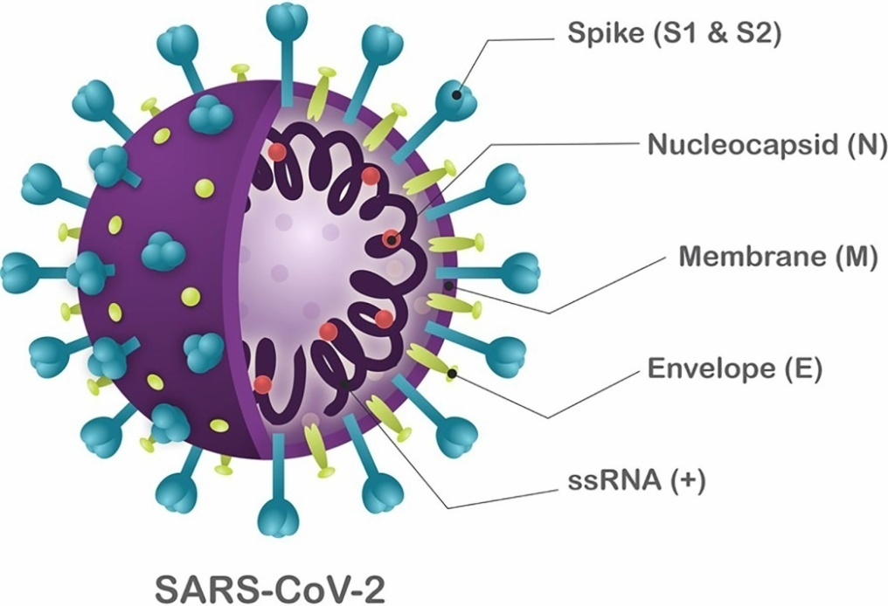
Fig 1: Schematic structure of SARS-CoV-2. Santos et al., (2020). Antivirals Against Coronaviruses: Candidate Drugs for SARS-CoV-2 Treatment?
The entire replication process of the SARS-CoV-2 is not clear but it is known to enter host cells through binding to unique cells possessing the Angiotensin-converting enzyme 2(ACE2) hence defining cell tropism for cells that express this receptors such as intestinal, pulmonary and renal human cells are known to possess ACE2 (Hoffman et al.,2020; Chu et al., 2020). The spike protein contains the receptor binding domain (RBD) of the coronavirus which binds to the human angiotensin-converting enzyme 2 (ACE2) and leads to virion endocytosis and endosome formation (Yan et al., 2020; Rabi et al., 2020). The recognition of the ACE2 receptor by SARS-CoV-2 followed by conformational changes in the S protein that promote viral-host cell membrane fusion are critical steps to infection (Mittal et al., 2020).
The spike protein
The structure of the S protein has a high sequence divergence amongst various family of corona viruses and is of great importance as it has become the focus of development of vaccines (Zech et al., 2024). The S protein is a glycosylated transmembrane protein divided into three parts; ectodomain, the transmembrane domain and the endodomain with two subunits S1 and S2 made up of 1162 to 1452 residues and plays an important role in attachment to the host and fusion between the viral and host membranes (Walls et al., 2020; Artika et al., 2020). The spike protein contains the receptor binding domain of the coronavirus which binds to ACE2 and leads to virion endocytosis and endosome formation (Artika et al., 2020)

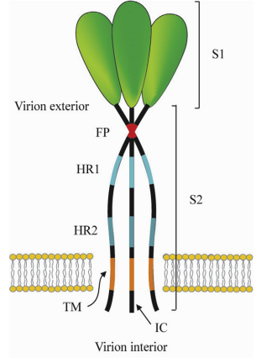
Fig 2: Corona virus spike protein (Masters, 2006; Li, 2016). Heptad repeat regions (HR 1 and 2), Transmembrane domain (TM), Intracellular tail (IC), Fusion peptide (FP)
Cleavage of spike into its component units SI and S2 can occur at different points depending on the sequence of spike protein. It can either occur during trafficking in the producer cells by host furin-like enzymes or serine proteases such as Serine 2/TMPRSS2 or by cathepsin (Matsuyama et al., 2010; Simmons et al., 2005). The S2 subunit therefore allows fusion of the viral envelop with endosome membrane and consequently release of the capsid into the cytoplasm (Matsuyama et al., 2020). In the cytoplasm, the CoV viral genome is uncoated, and the viral RNA is released. The positive-sense RNA viral genome is translated to produce nonstructural proteins (nsps) from two open reading frames (ORFs), ORF1a and ORF1b. The ORF1a encodes the polyprotein pp1a that is cleaved in 11 nsps, while the ORF1b encodes the polyprotein pp1ab, which is cleaved into 15 nsps. The proteolytic cleavage is performed by viral proteases nsp3 and nsp5 (Lai and Stohlman, 1981; Kim et al., 2020).
One key importance of the corona virus spike protein in infectivity is that changes in the regions that interact with entry receptors can modify or alter the host, tissue or cellular tropism of the corona viruses (Masters, 2016). Greater focus will be placed on the spike protein because it is the major antigen and induces the major immune response and also is target to neutralizing antibodies (Li, 2016). The spike glycoproteins of coronaviruses are important determinants of tissue tropism and host range and are critical targets for vaccine development (Du et al., 2013).
Unique Furin cleavage site of SARS-CoV 2: The Holy Grail
The majority of attention has focused on a potentially critical insertion of a furin cleavage site upstream of the S1 cleavage site in spike (Courtard et al., 2020). Coronaviruses enter host cells via their spike glycoprotein which is synthesized as an inactive precursor that must be cleaved to mediate membrane fusion (Peacock et al., 2021). Unlike its closest known relatives, the SARS-CoV-2 spike (S) protein contains a furin cleavage site at the S1/S2 junction that enhances SARS-CoV-2 replication in airway cells and contributes to virus pathogenicity and transmissibility which is lacking in the S protein of SARS-CoV-1 (Walls et al., 2020). Another distinctive molecular characteristics of the SARS-CoV-2 is the presence of a polybasic cleavage site (PRRA) at the junction of S1 and S2 of the S protein due to four amino acid residue insertion (PRRA) at SARS-CoV-2 S positions 681–684 (Andersen et al., 2020; Walls et al., 2020) and this amino acid insert has been implicated as the potential cleavage site for the protease furin (Jaimes et al., 2020; Walls et al., 2020). Furin is an enzyme expressed by human cells that separates the spike protein subunits at the cleavage site, enabling the virus to bind more efficiently to human cells and release its genetic material into them which explains why SARS-CoV-2 is so easily transmissible (Xia et al., 2020). To demonstrate the importance of the PPRA insert and hence a focus for future research on the origins of the virus, a ΔPPRA SARS-CoV-2 (mutant SARS-CoV-2) and WT SARS-CoV-2 (wild type) was transfected in Calu3 2B4, a human lung adenocarcinoma characterized by ACE2 expression. Results from this studies showed that there was robust replication of WT SARS-CoV-2 in contrast to the ΔPPRA mutant virus where replication was reduced (Johnson et al., 2020).
This furin recognition motif permits effective cleavage by furin and other protease and determines viral infectivity and host range. While the functional consequences of the polybasic cleavage site of the SARS-CoV-2 are yet to be elucidated, it is found to increase the virus infectivity and have impact on transmissibility and pathogenicity of the virus (Andersen et al., 2020; Zhang et al., 2020b; Walls et al., 2020). The Polybasic cleavage sites have not been observed in related ‘lineage B’ betacoronaviruses, although other human betacoronaviruses, including HKU1 (lineage A), have those sites and predicted O-linked glycans.
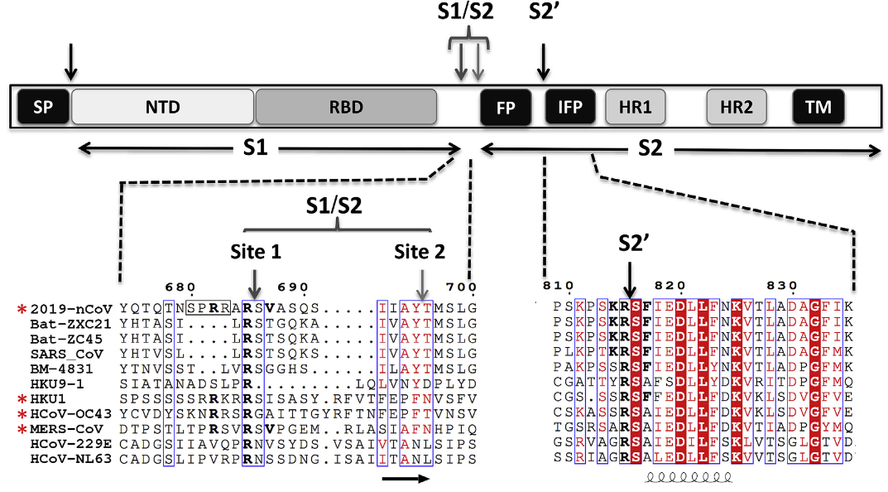

Fig 3: Schematic representation of the spike protein with comparison of its sequence with other viruses (Coutard et al., 2020).
The unique furin cleavage site on the SARS-CoV-2 has attracted the attention of eminent scientists such as the Nobel laureate David Baltimore and other researchers with obvious reasons. This is because the polybasic amino acid sequence on the furin cleavage site is found nowhere else in the entire genus of SARS-related betacoronaviruses and SARS-CoV-2 is the only one that has it (Coutard et al., 2020). In addition, while other more distant coronaviruses do have furin cleavage sites, the protein components (amino acids) in the SARS-CoV-2 furin cleavage site are coded for by a unique set of nucleotides in its RNA, not found in the other viruses which has fueled interest as to its origins. The furin cleavage sites have been observed in other virulent pathogens like HIV, avian influenza strains (H5 and H7) as well as Ebola (Brau and Sauter, 2019). In fact, furin cleavage sites are found in a number of other CoV family members including MERS-CoV, HKU1-Cov, and OC43-CoV (Kirchdoefer et al., 2016); given the range of disease associated with these CoV strains, the furin cleavage site does not necessarily predetermine virulence. However, given its absence in other group 2B CoVs and the major differences in disease compared to SARS-CoV raises fundamental questions about its origin.
Again the mutation and diversification rates of SARS CoV-2 which were previously though to be higher were actually much lower compared to other RNA viruses, such as human immunodeficiency virus (HIV) or hepatitis C virus (HCV) due to the improved proofreading activity of the corona virus polymaerase activity, a characteristic extremely rare in RNA viruses (Sanjuan et al., 2010; Moeller et al., 2022).

Symptoms of SARS-CoV-2
Because of the overlap in the manifestation of symptoms seen in SARS-CoV-2 and other respiratory infections like MERS and SARS, patients are advised to present themselves to a doctor (Ohrabi et al., 2020). Symptoms like fever and cough are associated with other respiratory diseases such as influenza and are the most reported and reliable features of those infected with the SARS-Cov-2 (Ghayda et al., 2020). Previous studies have shown that the symptoms presented by SARS-CoV-2 varies with respect to the stage of infection; which can be mild, moderate or severe. In a study carried out by Guan et al. (2020), 67% of the patients admitted to hospitals in mainland china manifested cough, 44% fever, and 38% experienced fatigue. As high as 75% of non-admitted patients had fever and in severe cases, shortness of breath and cough (88%) were common in patients in intensive care units admitted in a hospital in Washington D.C, USA (Bhatraju et al., 2020). Loss of sense of smell or taste was also found in 64% of patients participating in an Italian study (Spinato et al., 2020). Individuals infected with SARS-CoV-2 can either be symptomatic or asymptomatic with 80% of the infected individuals found to be asymptomatic. Asymptomatic individuals may be due to improved immune system but still possess the ability to infect individuals (Wagner, 2020). The severity of the disease seems to be strongly associated with underlying host conditions including age, sex and overall health. The latter seems to play a critical role in susceptibility and contribute to the risk of infection.
TREATMENT OF SARS-COV-2
Treatment varies depending on the severity of the disease which can be mild, moderate, severe, and critical manifestations of COVID-19. It is often recommended that patients who are suspected or confirmed to be infected with the SARS-CoV-2 be isolated either by staying at home or in recommended isolation centers but the best way to prevent transmission and illness is to avoid being exposed to the virus (Aguirre-Duarte, 2020) and sanitary measures like social distancing, wearing of nose mask, washing of hands, and disinfecting surfaces that are constantly touched. It is also recommended by WHO that prompt recognition of signs and symptoms is paramount to halt the spread of the disease (Qin et al., 2020). The most common treatment approaches had a similar range of prevalence and included antiviral measures, antibiotics, immunomodulators and oxygen inhalation (Ghayda et al., 2020). Initially, the focus of treatment of patients with SARS-CoV-2 was directed towards the use of known drugs like hydroxychloroquin and ivermectin repurposed to combat the spread of the disease in low and middle income countries, new approaches are focused on developing new drugs which are in most cases expensive and so the repurposing of these old drugs for their possible role in mitigating the spread of the virus continues (Buonfrate et al., 2021)
Antivirals
The entry of human CoVs into the host cells is mainly related to the binding of viral S protein to the ACE2 receptor (Prabakaran et al., 2004). Pre-clinical and clinical trials for the treatment of COVID-19 have been ongoing in various centers across the world. Currently, there are 2271 clinical trials involving therapeutic or preventative interventions. Some of the drugs used used in the treatment of COVID-19 include:
- Remdesvir. Coronavirus uses an RdRp enzyme to carry out its replication and transcription of its genome (Hilgenfeld and Peiris, 2013). Remdesvir is a phosphoaramidate prodrug that is metabolized in the cell to its functional NTP referred to as Remdesvir Triphosphate (RTP). RdRp enzyme uses RTP as a substrate and incorporates its mononucletide form into the growing RNA chain. The result is a stalling of growing chain three nucleotides are added by RdRp. The stalling has been shown to be as a result of translocation barrier caused by Remdesvir incorporation (Kokic et al.,2021).

- Ribavirin: ribavirin molecule has different antiviral mechanisms of action against different viruses (Graci and Cameron, 2006). It can be said, therefore, that ribavirin may affect the spike protein binding to ACE2 directly. A study was carried out to determine the effect of ribavirin in TMPRSS which enable virus entry (Bertram, 2013). Ribavirin led to a significant two-fold decrease in TMPRSS2 expression in Vero E6 cells (Unal et al.,2021).

- Lopinavir/ritonavir: SARS-CoV-2 has two proteases. a papain-like cysteine proteinase (PLpro, nsp3) and a 3C-like proteinase (3CLpro or Mpro, nsp5). Lopinavir is coadministered with ritonavir because of its low oral bioavailability and extensive metabolism by CYP3A4. This combination is used in HIV-1 treatment but its efficacy in the treatment of SARS-CoV-2 is not so clear.
Hydroxychloroquine
Hydroxychloroquine a derivative of chloroquine both belong to a class of drugs called 4-aminoquinolines. It differs from chloroquine due to the presence of hydroxyl group in its structure. Though the exact mechanism of action of Hydroxychloroquine is yet to be be known, Chloroquine and hydroxychloroquine increase pH within intracellular vacuoles and alter processes such as protein degradation by acidic hydrolases in the lysosome, assembly of macromolecules in the endosomes, and posttranslational modification of proteins in the Golgi apparatus (Fox, 1993). It has also been reported to suppress the immune system through inhibition of the cytokine receptor and Toll-like receptor pathways (Rainshford, 2015). Chloroquine accumulates in lysosomes (lysosomotropism), and by increasing their pH, interrupts with the activities of cathepsin L which facilitates the entry of corona viruses (Simmons et al., 2005; Ou et al., 2020), interferes with the glycosylation of cellular receptor of SARS-CoV-2, thereby inhibiting the infection of virus (Pahan et al., 2020).

Azythromycin
Azithromycin is a macrolide antibiotic with bactericidal and bacteriostatic actions. It inhibits bacterial protein synthesis by reversibly binding to the 50S ribosomal subunit of the sensitive microorganisms, thereby inhibiting the translocation step, leading to cell growth inhibition and cell death (Pubchem, 2021). Among outpatients with SARS-CoV-2 infection, treatment with a single dose of azithromycin compared with placebo did not result in greater likelihood of being symptom free at day 14. Preliminary results also suggest a synergistic effect of the combination of Hydroxychloroquine and azithromycin. An open-label non-randomized trial with 36 positive COVID-19 patients found hydroxyquinoline and azithromycin significantly reduced viral load (Gautret et al., 2020).
Ivermectin
Ivermectin belongs to a group of avermectins, which is a group of 16 membered macrocyclic lactone compounds discovered at the Kitasato Institute of Japan in 1967 during actinomycetes cultures with Streptomyces avermitili (Crump and Ōmura, 2011). It is a broad spectrum anti-parasitic agent that has been found in recent times by various researchers to have anti-viral activities (Caly et al., 2020). It was initially found to inhibit the interaction between the integrase (IN) protein of HIV-1 and the importin (IMP) α/β1 heterodimer responsible for IN nuclear import, in other words, it prevents viral protein from entering the nucleus (Wagstaff et al., 2011). It has been found to have inhibitory effects on a number of virus including west nile virus and influenza owing to the common mode of transmission employed by many viruses that use IMPα/β1during infection. Some researchers have shown that ivermectin possesses antiviral activities in vitro at high doses (Buonfrate et al., 2022). A number of mechanisms of action has been demonstrated explaining this antiviral activity. Ivermectin has been shown to dock in the region of leucne 91 of the spike protein and histidine 378 of the ACE-2 receptor and also bind IMPα component of the IMPα/β1 heterodimer thereby preventing its nuclear transport of viral protein (Zaidi and Dehgani-Mobaraki, 2022)
Discussion
The coronavirus 2019 (COVID-19) pandemic represents the strongest global public health threat since the influenza outbreak in 1918 and has rapidly resulted in health and economic burdens worldwide (Lythgoe and Middleton 2020) but it is quite strange that several years after the discovery of SARS-CoV-2, scientists are still divided on its true origins despite the cutting edge technology at our disposal. This is largely due to the polybasic basic cleavage site absent among SARS-CoV-2 closest relatives but present in distant relatives which raises a crucial question on its origin because the polybasic site has been found through previous studies to be a critical feature of the pathogenic avian influenza (Kawaoka and Websster, 1988). The SARS-CoV-2 responsible for COVID-19 has a 96.2% genome sequence identity with the bat coronavirus RaTG13, 82.3% amino acid sequence similarity with bat coronavirus SL-CoVZC45, 77.2% identity with SARS-CoV. What has continued to mystify the scientific community is the origin of the 12 nucletotide insertion sequence (CCT CGG CGG GCA) coding for four amino acids (aa 681-684, PRRA) found exclusively in SARS-CoV 2 and not present in any of the three aforementioned viruses (Ambati et al., 2022). The consecutive CGG codons coding for arginine is rare in coronaviruses and even though point mutations exists between the viruses aforementioned, it did not exceed three nucleotides (Ambati et al., 2022).
The outbreak of the virus has led to a polarization of the scientific community in terms of thought, treatments and ethics, unprecedented in modern history. What is even more worrisome is that there has been an open criticism of scientists who expressed divergent views on the origins of the virus and mode of treatment different from those propagated by mainstream media and big pharmaceutical companies. In recent times, scientists in universities and pharmaceutical research organizations have focused heavily on drug repurposing in order to reduce time and financial burden of developing molecules or drugs and some of the drugs mentioned in this article were found to be effective against SARS-CoV-2 through repurposing studies and have been beneficial to the patients. The low cost of some of the repurposed drug and the ease of accessibility also supports these drugs as the preferred treatment alternative among the larger population especially in the low and middle income country. And this begs the following questions: why are these treatment alternatives not promoted apart from vaccines? When has a divergent opinion in scientific circles become a crime as to warrant an ostracization in the medical and research community? Are facts no longer the basis of scientific arguments?
Conclusion
There is a growing evidence that suggest that the possibility of natural evolution of the polybasic furin cleavage site of SARS CoV-2 is highly unlikely. There are strong evidence to support the laboratory origins of the SARS-CoV as revealed in its distinctive features within its genome. The novel multibasic furin cleavage site (FCS) confers numerous pathogenically advantageous capabilities, the existence of which is difficult to explain though natural evolution. SARS-CoV-2 to human ACE2 binding is far stronger than in SARS-CoV, yet there is no indication of amount of evolutionary adaptation that SARSCoV or MERS-CoV underwent, in particular, a four amino acid insert found within the S1/S2 site of the Spike glycoprotein. This finding has garnered interest because of the possible introduction of a furin recognition motif at the S1/S2 site especially since no known member of the genus of betacoronavirus possess this motif. More research should be carried out with a focus on the true origins of the virus which will lead to a better treatment strategy, better informed strategy on containment and prevention of another outbreak.

References
Artika, I. M., Dewantari, A. K., & Wiyatno, A. (2020). Molecular biology of coronaviruses: current knowledge. Heliyon, 6(8).
Rainsford KD, Parke AL, Clifford-Rashotte M, Kean WF. Therapy and pharmacological properties of hydroxychloroquine and chloroquine in treatment of systemic lupus erythematosus, rheumatoid arthritis and related diseases. Inflammopharmacology. 2015;23:231–69
Pahan P, Pahan K. Smooth or risky revisit of an old malaria drug for COVID-19? J Neuroimmune Pharmacol. 2020. https://doi. org/10.1007/s11481-020-09923-w
Simmons G, Gosalia DN, Rennekamp AJ, Reeves JD, Diamond SL, Bates P. Inhibitors of cathepsin prevent severe acute respiratory syndrome coronavirus entry. Proceedings of the National Academy of Sciences. 2005; 102(33):11876–81. https://doi.org/10.1073/pnas.0505577102 PMID: 16081529
Ou X, Liu Y, Lei X, Li P, Mi D, Ren L, et al. Characterization of spike glycoprotein of SARS-CoV-2 on virus entry and its immune cross-reactivity with SARS-CoV. Nature communications. 2020; 11(1):1–12. https://doi.org/10.1038/s41467-019-13993-7 PMID: 3191165
PubChem. Bethesda (MD) National Library of Medicine (US), National Center for Biotechnology Information 2004 PubChem Compound Summary for CID 447043, Azithromycin Available from: https://pubchem.ncbi.nlm.nih.gov/compound/Azithromycin [Last accessed on 2021 Apr 23]
Gautret P, Lagier JC, Parola P, et al. Hydroxychloroquine and azithromycin as a treatment of COVID-19: results of an open-label non-randomized clinical trial. Int J Antimicrob Agents 2020;56:105949. https://doi.org/10.1016/j.ijantimicag.2020.105949
Ohrabi C, Alsafi Z, O’Neill N, Khan M, Kerwan A, Al-Jabir A,et al. World Health Organization declares global emergency: a review of the 2019 novel coronavirus (COVID-19). Int J Surg. (2020) 76:71–6. doi: 10.1016/j.ijsu.2020.02.034
Guan WJ, Ni ZY, Hu Y, et al. Clinical characteristics of coronavirus disease 2019 in China. N Engl J Med 2020; 382(18):1708–20.
Bhatraju PK, Ghassemieh BJ, Nichols M, et al. Covid-19 in critically ill patients inthe Seattle region - case series. N Engl J Med 2020; 382:2012–22.
Spinato G, Fabbris C, Polesel J, et al. Alterations in smell or taste in mildly symptomatic outpatients with SARS-CoV-2 infection. JAMA 2020; 323:2089–90
Kahn, J. S., and McIntosh, K. (2005). History and recent advances in coronavirus
discovery. Pediatr. Infect Dis. J. 24(11 Suppl), S223-S227.
Rabi, F. A., Al Zoubi, M. S., Kasasbeh, G. A., Salameh, D. M., and Al-Nasser,
A. D. (2020). SARS-CoV-2 and Coronavirus disease 2019: what we know so
far. Pathog. Basel Switz. 9:231. doi: 10.3390/pathogens9030231
Walls, A. C., Park, Y.-J., Tortorici, M. A., Wall, A., McGuire, A. T., and Veesler,
D. (2020). Structure, function, and antigenicity of the SARS-CoV-2 spike
glycoprotein. Cell 181, 281e6–292.e6. doi: 10.1016/j.cell.2020.02.058
Matsuyama, S., Nao, N., Shirato, K., Kawase, M., Saito, S., Takayama, I., et al. (2020). Enhanced isolation of SARS-CoV-2 by TMPRSS2-expressing cells. Proc. Natl. Acad. Sci. U.S.A. 117, 7001–7003. doi: 10.1073/pnas.200258911
N. Zhu, D. Zhang, W. Wang, X. Li, B. Yang, J. Song, X. Zhao, B. Huang, W. Shi, R. Lu, P. Niu, F. Zhan, X. Ma, D. Wang, W. Xu, G. Wu, G.F. Gao, W. Tan, China Novel Coronavirus Investigating and Research Team, A novel coronavirus from patients with pneumonia in China, 2019, N. Engl. J. Med. 382(8)(2020) 727–733, https://doi.org/10.1056/NEJMoa2001017.
M. Zhan, Y. Qin, X. Xue, S. Zhu, Death from Covid-19 of 23 health care workers in China, N. Engl. J. Med. (2020) NEJMc2005696, , https://doi.org/10.1056/ NEJMc2005696 Advance online publication
L.E. Gralinski, V.D. Menachery, Return of the coronavirus: 2019-nCoV, Viruses 12 (2) (2020) 135, https://doi.org/10.3390/v12020135.
Wagner G. (2020).Natural history of COVID-19 and current knowledge on treatment therapeutic options
Gelderblom, H. R. (1996). Structure and classification of viruses. Medical Microbiology. 4th edition.
N. Aguirre-Duarte, Can people with asymptomatic or pre-symptomatic COVID-19 infect others: a systematic review of primary data, medRxiv (2020), https://doi. org/10.1101/2020.04.08.20054023
Ghayda RA, Lee J, Lee JY, et al. Correlations of clinical and laboratory characteristics of covid-19: a systematic review and meta-analysis. Int J Environ Res Public Health 2020;17:1e15. https://doi.org/10.3390/ijerph17145026.
Qin J, You C, Lin Q, et al. Estimation of incubation period distribution of COVID-19 using disease onset forward time: a novel cross-sectional and forward follow-up study. Sci Adv 2020;6:1e7. https://doi.org/10.1126/sciadv.abc1202.
Prabakaran, P., Xiao, X., and Dimitrov, D. S. (2004). A model of the ACE2 structure and function as a SARS-CoV receptor. Biochem. Biophys. Res. Commun. 314, 235–241. doi: 10.1016/j.bbrc.2003.12.081
Hilgenfeld, R. & Peiris, M. From SARS to MERS: 10 years of research on highly pathogenic human coronaviruses. Antivir. Res. 100, 286–295 (2013)
Goran Kokic, Hauke S. Hillen, Dimitry Tegunov , Christian Dienemann1,4, Florian Seitz3,4, Jana Schmitzova , Lucas Farnung , Aaron Siewert, Claudia Höbartner & Patrick Cramer 1.Mechanism of SARS-CoV-2 polymerase stalling by remdesivir.

Mehmet Altay Unal, Ceylan Verda Bitirim, Gokce Yagmur Summak, Sidar Bereketoglu, Inci Cevher Zeytin, Omur Besbinar, Cansu Gurcan, Dunya Aydos, Ezgi Goksoy, Ebru Kocakaya, Zeynep Eran, Merve Murat, Nil Demir, Zeynep Busra Aksoy Ozer, Julia Somers, Emek Demir, Hasan Nazir, Sibel Aysil Ozkan, Aykut Ozkul, Alpay Azap, Acelya Yilmazer, and Kamil Can Akcali. Ribavirin shows antiviral activity against SARS-CoV-2 and downregulates the activity of TMPRSS2 and the expression of ACE2 in vitro

Bertram, S., Dijkman, R., Habjan, M., Heurich, A., Gierer, S., Glowacka, I., et al. 2013. TMPRSS2 activates the human coronavirus 229E for cathepsinindependent host cell entry and is expressed in viral target cells in the respiratory epithelium. J. Virol. 87(11): 6150–6160. doi:10.1128/JVI.03372-12. PMID:23536651
Masters PS. The molecular biology of coronaviruses. Adv Virus Res 2006;65:193e292. https://doi.org/10.1016/S0065- 3527(06)66005-3.
Li, F. (2016). Structure, function, and evolution of coronavirus spike proteins. Annual review of virology, 3, 237-261.
Kahn JS, McIntosh K. History and recent advances in coronavirus discovery. Pediatr Infect Dis J 2005;24:S223e7. https://doi.org/10.1097/01.inf.0000188166.17324.60
Fehr AR, Perlman S. Coronaviruses: an overview of their replication and pathogenesis. Coronaviruses methods protoc, vol. 1282. Springer New York; 2015. p. 1e23. https://doi.org/10.1007/978-1-4939-2438-7_1.
Y. Chen, Q. Liu, D. Guo, Coronaviruses: genome structure, replication, and pathogenesis, J. Med. Virol. 92 (4) (2020) 418–423, https://doi.org/10.1002/jmv. 25681.
D. Paraskevis, E.G. Kostaki, G. Magiorkinis, G. Panayiotakopoulos, G. Sourvinos, S. Tsiodras, Full-genome evolutionary analysis of the novel corona virus (2019- nCoV) rejects the hypothesis of emergence as a result of a recent recombination event, Infect. Genet. Evol. 79 (2020) 104212, https://doi.org/10.1016/j.meegid. 2020.104212.
D. Schoeman, B.C. Fielding, Coronavirus envelope protein: current knowledge, Virol. J. 16 (69) (2019) 1–22, https://doi.org/10.1186/s12985-019-1182-0
M. Hoffmann, H. Kleine-Weber, S. Schroeder, N. Krüger, T. Herrler, S. Erichsen, T.S. Schiergens, G. Herrler, N.H. Wu, A. Nitsche, M.A. Müller, C. Drosten, S. Pöhlmann, SARS-CoV-2 cell entry depends on ACE2 and TMPRSS2 and is blocked by a clinically proven protease inhibitor, Cell 181 (2) (2020) 271-280
Fung, T.S., Liu, D.X., 2018. Post-translational modifications of coronavirus proteins: roles and function. Future Virol. 13, 405–443. https://www.ncbi.nlm.nih.gov/pmc/artic les/PMC7080180/
Yan, R., Zhang, Y., Li, Y., Xia, L., Guo, Y., Zhou, Q., 2020. Structural basis for the recognition of SARS-CoV-2 by full-length human ACE2. Science 367, 1444–1448. https://www.ncbi.nlm.nih.gov/pmc/articles/PMC7164635/.
o, S., Kim, S., Shin, D.H., Kim, M.-S., 2020. Inhibition of SARS-CoV 3CL protease by flavonoids. J. Enzyme Inhib. Med. Chem. 35, 145–151. https://www.ncbi.nlm.nih .gov/pmc/articles/PMC6882434/.
Mittal A, Manjunath K, Ranjan R, et al. COVID-19 pandemic: insights into structure, function, and hACE2 receptor recognition by SARS-CoV-2. Plos Pathog 2020;16:e1008762.
Made Artika a,b,* , Aghnianditya Kresno Dewantari c , Ageng Wiyatno. (2020). Molecular biology of coronaviruses: current knowledge
Kirchdoerfer, R.N., Cottrell, C.A., Wang, N., Pallesen, J., Yassine, H.M., Turner, H.L., Corbett, K.S., Graham, B.S., McLellan, J.S., Ward, A.B., 2016. Pre-fusion structure of a human coronavirus spike protein. Nature 531, 118–121. https://www.nature.com/a rticles/nature17200.
Andersen, K.G., Rambaut, A., Lipkin, W.I., Holmes, E.C., Garry, R.F., 2020. The proximal origin of SARS-CoV-2. Nat. Med. 89, 44–48. https://doi.org/10.1038/s41591-020-0820-9
Jaimes, J.A., Andre, N.M., Millet, J.K., Whittaker, G.R., 2020a. Structural modeling of 2019- novel coronavirus (nCoV) spike protein reveals a proteolytically-sensitive activation loop as a distinguishing feature compared to SARS-CoV and related SARS-like coronaviruses. https://doi.org/10.1101/2020.02.10.942185
Fox Y (1993). Mechanism of Action of Hydroxychloroquine as an Antirheumatic Drug. Chan,
Chan, C.-M. et al. Exp. Biol. Med. 233, 1527–1536 (2008).
Raoult, D and Forterre, P: Redefining viruses: lessons from Mimivirus. Nat. Rev. Microbiol. 6, 315-319(2008)
Furin Cleavage Site Is Key to SARS-CoV-2 Pathogenesis. Bryan A. Johnson 1*
, Xuping Xie 2*
, Birte Kalveram 3 , Kumari G. Lokugamage1 , Antonio Muruato 1 ,
Jing Zou 2 , Xianwen Zhang 2 , Terry Juelich3 , Jennifer K. Smith 3 , Lihong Zhang 3 , Nathen Bopp 3 ,
Craig Schindewolf 1 , Michelle Vu1 , Abigail Vanderheiden5,6,7 , Daniele Swetnam 2 , Jessica A.
Plante1 , Patricia Aguilar3 , Kenneth S. Plante1 , Benhur Lee8 , Scott C. Weaver1,4 , Mehul S.
Suthar5, 6,7 , Andrew L. Routh 2 , Ping Ren 3 , Zhiqiang Ku9 , Zhiqiang An 9 , Kari Debbink 10 , Pei Yong
Shi 2,4,# , Alexander N. Freiberg 3,4,# , Vineet D. Menachery1,4,

Joel Zinberg, M.D., J.D., is a senior fellow at the Competitive Enterprise Institute and an associate clinical professor of surgery at the Icahn School of Medicine at Mount Sinai in Manhattan. Adapted with permission from City Journal. Letter confirms Wuhan lab’s COVID-19 leak was funded by US taxpayers

Snijder, E. J., Van Der Meer, Y., Zevenhoven-Dobbe, J., Onderwater, J. J., Van Der Meulen, J., Koerten, H. K., & Mommaas, A. M. (2006). Ultrastructure and origin of membrane vesicles associated with the severe acute respiratory syndrome coronavirus replication complex. Journal of virology, 80(12), 5927-5940.
Jaimes, J. A., Millet, J. K., & Whittaker, G. R. (2020). Proteolytic cleavage of the SARS-CoV-2 spike protein and the role of the novel S1/S2 site. IScience, 23(6).

Moeller, N. H., Shi, K., Demir, Ö., Belica, C., Banerjee, S., Yin, L., ... & Aihara, H. (2022). Structure and dynamics of SARS-CoV-2 proofreading exoribonuclease ExoN. Proceedings of the National Academy of Sciences, 119(9), e2106379119.

Cao, C., Cai, Z., Xiao, X., Rao, J., Chen, J., Hu, N., ... & Xue, Y. (2021). The architecture of the SARS-CoV-2 RNA genome inside virion. Nature communications, 12(1), 3917.

Kawaoka, Y., and Webster, R.G. (1988). Sequence requirements for cleavage activation of influenza virus hemagglutinin expressed in mammalian cells. Proc. Natl. Acad. Sci. U S A 85, 324–328
Ambati, B. K., Varshney, A., Lundstrom, K., Palú, G., Uhal, B. D., Uversky, V. N., & Brufsky, A. M. (2022). MSH3 homology and potential recombination link to SARS-CoV-2 furin cleavage site. Frontiers in Virology, 2, 834808.
Xia, S., Lan, Q., Su, S. et al. The role of furin cleavage site in SARS-CoV-2 spike protein-mediated membrane fusion in the presence or absence of trypsin. Sig Transduct Target Ther 5, 92 (2020). https://doi.org/10.1038/s41392-020-0184-0
Buonfrate, D., Chesini, F., Martini, D., Roncaglioni, M. C., Fernandez, M. L. O., Alvisi, M. F., ... & Bisoffi, Z. (2022). High-dose ivermectin for early treatment of COVID-19 (COVER study): a randomised, double-blind, multicentre, phase II, dose-finding, proof-of-concept clinical trial. International journal of antimicrobial agents, 59(2), 106516.
Caly L, Druce JD, Catton MG, Jans DA, Wagstaff KM. "The FDA-approved Drug Ivermectin inhibits the replication of SARS-CoV-2 in vitro Antiviral Res, from https://www.ncbi.nlm.nih.gov/pubmed/32251768 (Caly et al. 2020), Apr 3. 2020
Zaidi, A. K., & Dehgani-Mobaraki, P. (2022). The mechanisms of action of ivermectin against SARS-CoV-2—an extensive review. The Journal of antibiotics, 75(2), 60-71.

