Review Article
Tiny Beetle, Big Threat: A Review of Cigarette Beetle Infestation in Grains and Stored Commodities

Abstract
The modernization of agricultural production has significantly boosted food production but also increased vulnerability to stored grain pests, including the cigarette beetle (Lasioderma serricorne). This coleopteran pest infests a wide range of stored products, causing substantial economic and qualitative losses globally. With a lifecycle adapted to diverse environments and a preference for dried products, it poses challenges to food safety and security. Effective management strategies include sanitation, physical methods (temperature and controlled atmosphere treatments), biological controls and botanical repellents. Advances in nanotechnology and pheromone traps show promise in mitigating its impact.
Keywords: Cigarette beetle, stored grains, post-harvest losses, pest management, Lasioderma serricorne
Introduction
Modernization of the agricultural production system led to a significant increase in annual food production intended to meet the ever-growing consumer demand. These stored grains, in general are directly or indirectly infested by various pest, resulting in severe grain damages and storage losses, thus, causing a threat to food safety and security. Post-harvest losses account for about 10 per cent of total food grains due to, Insects (2.55 to 4.2%), Rodents (2.50%), Birds (0.85%), Moisture (0.68%). In India, annual storage losses have been estimated 14 –million tonnes worth of Rs. 7,000 crores in which insects alone account for nearly Rs. 1,300 crores (Anonymous, 2023). Majority of storage insect pests belong to the orders coleoptera and lepidoptera (Srivastava and Subramanian, 2016) including the rice weevil, khapra beetle, red rust flour beetle, cigarette beetle, lessor grain borer, Indian meal moth, potato tuber moth, rice moth etc. in which cigarette beetle is one of the major damages causing insect in stored grains and commodities. It is the major pest of stored tobacco hence it is commonly called “tobacco beetle” or “cigarette beetle” (Minor, 1978). It was first described in France in 1792 from specimens collected in America, but the oldest record of occurrence of the tobacco beetle comes from Egypt, remains of the insect having been found in the tomb of Tutankhamen. These beetles are therefore probably indigenous to Egypt and they have scarcely altered morphologically in the 3,500 years that have elapsed (Reed and Vinzant, 1942).
As a worldwide pest of stored products, the cigarette beetle (Lasioderma serricorne Fab.) of the coleopteran order causes significant financial harm to grain that is kept in storage. The beetle's preferred food source is dried tobacco, which includes cigars, chewing tobacco and leaves. The cigarette beetle damages a wide range of items that are kept in storage, including cereal, dates, dried fish, ginger, grain, pepper, pharmaceuticals, raisins and seeds. They may consume medicines, leaves and book bindings in addition to common crops like wheat and grain. They can also spoil a lot more food than they actually consume (Anonymous, 2022). Bamboo, beans, biscuits, cassava, chickpea, cocoa, coffee beans, copra, coriander, cotton seed before and after harvesting, cotton seed meal, atta, cumin, dates, dried banana, dried cabbage, dried carrot, ginger, grain, groundnut, nutmeg, raisins, rice, tobacco, dried fish, fish meal and leather are all the wide host range of L. serricorne (Howe, 1957). This cosmopolitan pest is predominantly found in tropical regions where temperatures exceed 10°C and humidity levels supress 30% (Hill, 1983). However, it can also thrive in heated stores in temperate regions. Lefkovitch (1964) emphasized its pest status, noting that under favourable conditions, its population can multiply 4-6 times its original size every three weeks.
Morphology and biology
Egg:
Females oviposit directly on to dried material from within one day of the sexually mature adult emerging from the pupae (Cooper and Bengston, 1974). The eggs of L. serricorne are pearly white with numerous spines at the end of the egg from which the larva emerges (Sivik et al., 1957). Average lengths are between 0.4-0.5 mm and widths slightly over 0.2 mm. The eggs weigh approx. 8.4 µg each and although fragile, have a waxy shell which protects them from desiccation. The eggs hatch in 6-8 days (Retief and Nicholas, 1988) and the egg shell is eaten by the newly emerged larva (Pant, 1972). Female beetles lay between 10 and 100 eggs, typically in the evening or night. The number of eggs laid can depend on the type of substrate they are laid upon (Fig. 1).
Larvae:
The first instar or first stage larvae are less than 1 mm long and covered in fine hair (Sivik et al., 1957). The insect generally completes four larval instars before pupation, when they weigh from 2.5 to 5.0 mg and are approx. 4.5 mm long. The larvae are creamy or greyish white and thickly covered with fine hairs that appear as light brown on fully grown individuals. The first three instars are approximately of equal duration, with the fourth being twice as long. Larval mortality is highest in the first instar (Howe, 1957). They tend to penetrate deeply into loosely packed commodities, but generally remain peripheral in tightly packed containers such as hogsheads of tobacco strips (Fig. 1).
Pupae:
Fully grown larvae stop feeding and form a pupal cell or cocoon (Fig. 1), usually fastened to a firm surface, sometimes with a thin layer of opaque cement (Howe, 1957). The cell is made of food and waste material cemented together by a secretion produced by the midgut. Soon after completing the cell the larva becomes a prepupa and casts the larval skin after 2-4 days (at 30°C) in the cell. Sex determination of the pupae is by examination of the genital papillae in the males these organs are globular and not projecting, while in the female they are three-segmented and divergent (Halstead, 1963).
Adult:
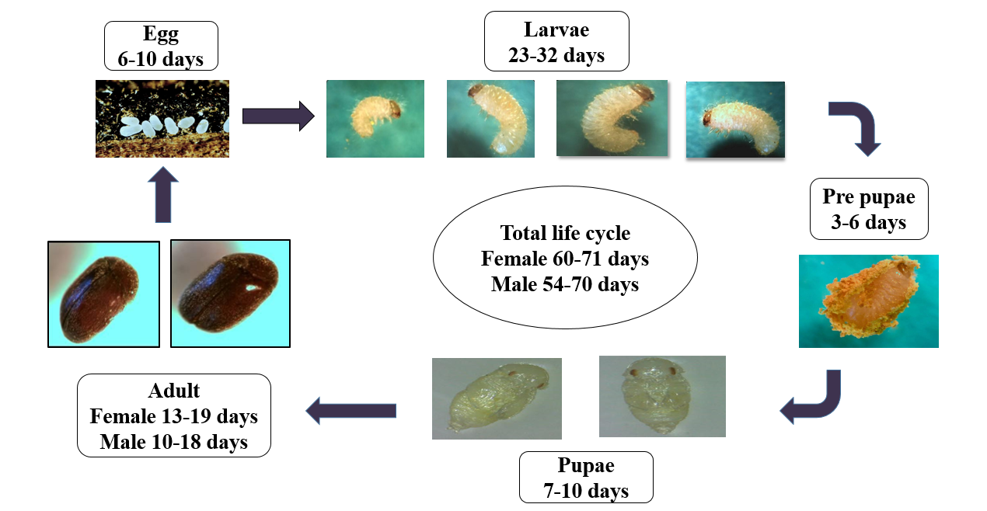
The adult beetle is small (2.0-3.7 mm) (Retief and Nicholas, 1988), weighs from 1.6 to 4.4 mg and is a light to dark brown colour. Colour and size of the insect depend upon the type of food, temperature and humidity encountered during development (U.S.D.A., 1972). Although size of the adults is affected by the quality of larval food (Jones, 1913), larger beetles tend to be females with this difference first occurring in the penultimate larval instar (Lefkovitch, 1963). The overall sex ratio is 1:1 (Sivik et al., 1957). The adult beetle is oval with the head and prothorax bent downward, giving the insect a humped, convex appearance. The head is deflexed and is almost completely obscured from above. The elytra are not striated and appear rather smooth. The antennae are serrate with a saw-like appearance and are the same thickness from base to tip (Fig. 1). These can be used as an identification feature since they differ from the typical anobiid antennae which form a broad three segmented club. The tarsal formula is 5-5-5. Adult mandibles are somewhat triangular with two triangular apical teeth and no molar projection (Howe, 1957; Klein, 1986).
Fig. 1: Lifecycle of Lasioderma serricorne (Saroja, 2015)

Nature of damage
L. sericcorne is an exceptionally polyphagous pest (Fig. 2). Fundamentally, the most destructive phase of L. sericcorne is larvae. The larvae damage by eating small cylindrical galleries through the host material (Sivik et al., 1957). While adults are known to cause damage by cutting holes to escape frompackaged commodities (Highland, 1991). As a result of intensive feeding on products, they cause weight losses, seed losses and decrease the commercial value. The percentage of weight loss caused by L. serricorne in vermicelli ranged from 18.00% to 68.00% (Dodiya et al.,2024). In addition to feeding damage, the presence of dead insects, residues from different life stages such as cast skins or pupal cases and frass become contaminants in commodities and render them undesirable for human consumption. The cigarette beetle caused a quantitative weight loss in turmeric of 7.15 per cent at three months and 22.75 per cent at six months after storage (Vidya and Awaknavar, 2004).
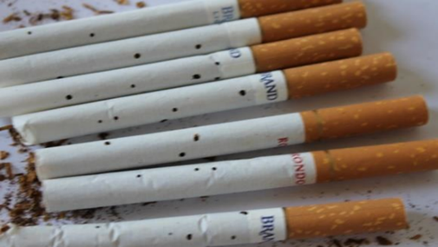
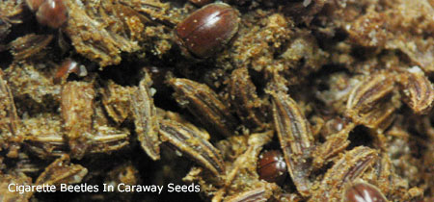
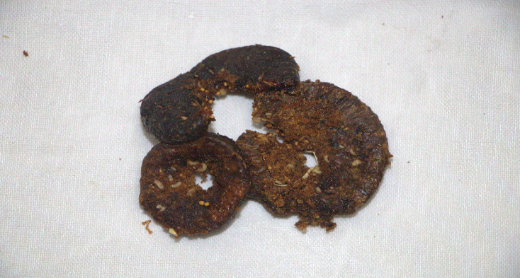
(A) (B) (C)
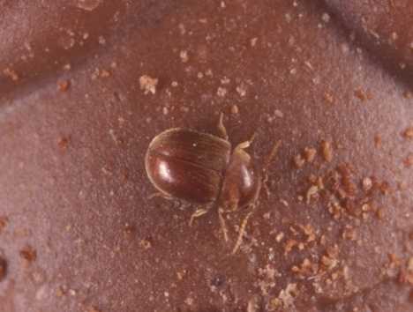
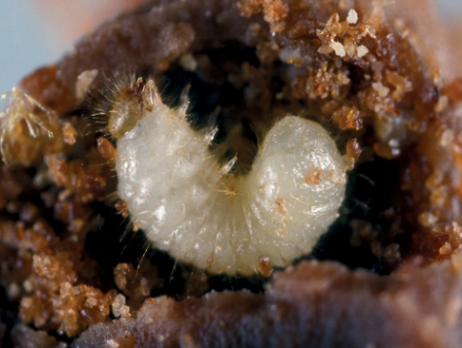

(D) (E) (F)

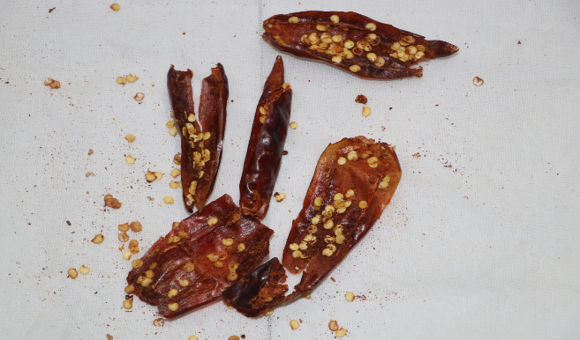
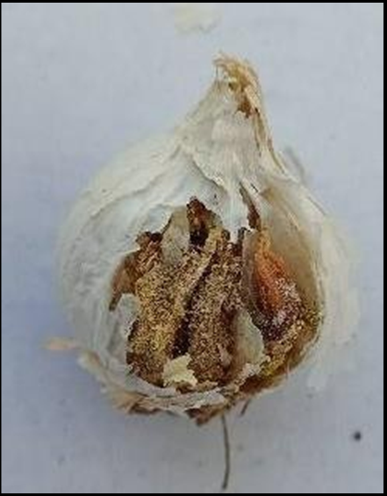
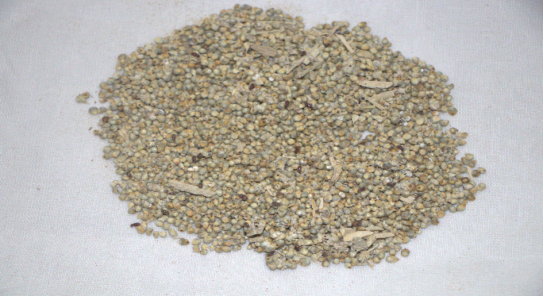
(G) (H) (I)
Fig. 2. Damage caused by L. serricorne in stored products
(a) Fig; (b) Cumin; (c) Cigar tobacco; (d) BD tobacco; (e) Pancake; (f) Chocolate candy; (g) Pearl millet; (h) Garlic and (i) Dried chilli
Food preference
It is a well-known fact that food constituents play a vital role in the survival and reproduction potential of the insects and different physico-chemical properties of the commodity also interfere with the normal biology of the pest (Saroja, 2015). Kohno et al. (1983) tested the olfactory response of L. serricorne to various host foods and tobacco varieties to determine the reactions of the insect to different foods. L. serricorne is a nicotine-tolerant species (Yamamoto and Fraenkel, 1960) which metabolizes and detoxifies nicotine into cotinine and other alkaloids (Self et al., 1964) but the larvae are unable to survive on a tobacco diet containing 8.25% nicotine. At high concentrations, nicotine is directly toxic to L. serricorne whilst at the lower concentrations of 2% and 4% an additional deleterious effect is the inhibition of the yeast-like symbionts providing vitamins to the beetles (Milne, 1963). Carbohydrate diet seemed a better substrate for L. serricorne reproduction and development than oil crops, legumes and dried fruits (Babarinde et al., 2008).
Microbiome Plasticity
The microbiome plasticity of the cigarette beetle has provided significant insights into how this pest adapts to diverse environments and food sources. Studies have shown that the beetle's gut microbiota undergoes substantial changes when its diet is altered. For example, shifts between diets such as wheat, rice flour and soybean resulted in distinct microbiome configurations tailored to each food source. Remarkably, when the beetles returned to their original diet, their microbiome reverted to its initial structure, a process termed microbial resilience. This adaptability underscores the beetle's ability to exploit a wide variety of stored products, ranging from grains and spices to processed goods like tobacco. The role of the microbiome extends beyond digestion, potentially aiding in detoxifying harmful compounds in products such as tobacco, further enhancing the beetle’s survival. These findings also point to opportunities for innovative pest management strategies. By targeting the beetle’s microbial communities, researchers could disrupt key processes critical for its survival, offering alternatives to traditional chemical methods. Additionally, understanding these microbiome dynamics highlights the evolutionary success of the cigarette beetle as a global pest, capable of thriving in varied ecological and dietary conditions. This emerging knowledge paves the way for sustainable approaches to controlling L. serricorne populations while reducing economic losses in stored product industries (Childs et al., 1966; Srinivasan et al., 2024).
Management
Sanitation:
Sanitation is the most effective way to manage stored grain pests by avoiding them altogether. The goal is to eliminate insect eggs, pupae and adults. Never put newly harvested grain into bins containing old grain, as small amounts of old grain or fines left in the bins can harbor insects. Once the bins are clean, inspect and repair any cracks or holes that could allow moisture or insects to enter (Barbercheck, 2020).
Physical method:
A. Temperature treatments
Temperature significantly affected the developmental time, longevity, oviposition period and fecundity of L. serricorne (Wang et al., 2021). Heat treatment of the entire building can be an effective fumigant alternative for killing stored-product insects, including all life stages of the cigarette beetle (Alder, 2003).Temperatures and exposure times to obtain good insect kill have been reviewed (Fields, 1992) and include a minimum of 45 ° C for 12-24 h. Technology is available for bringing in portable heating units or installing permanent units to existing steam generation and distribution systems. As an alternative to heat, freezing cold temperatures can also control pest insects. However, cold is not practical to apply to entire buildings as can be done with heat. A temperature of -20 °C will kill unprotected insects in a matter of minutes (Fields, 1992). Eggs of L. serricorne were consistently the most heat tolerant of all stages tested at 46 to 54°C then the other stages of cigarette beetle (Yu et al., 2011). Thermal treatment using microwave is a promising non-chemical alternative to control insects in postharvest agricultural products (Wang and Tang, 2001).
B. Nano particles
Nano particles hold great promise regarding their application in plant protection due to their size dependent qualities, high surface to volume ratio and unique optical properties. (Bhattacharyya et al., 2010). They kill the arthropods by removing the epicuticular lipid layers causing excessive water loss through cuticle (Stadler et al., 2010). Kumar et al. 2017 found that among the three nanocides, nano silica applied at 0.5 and 0.25 g/kg dosages showed the superior performance of the other treatments at one day after treatment which caused 100 per cent mortality, relatively less egg laying and no adult emergence of L. serricorne and has a great promise in cigarette beetle pest management.
C. Controlled atmosphere treatment
Storage insect pests are requiring oxygen for their survival. Controlled atmosphere treatment (CA) offers an alternative that is safe and environmentally benign to the treated materials (Navarro, 2012). During the CA treatment, oxygen concentrations within a storage enclosure can be altered to the lethal O₂ concentration to the insect pests by adding N₂ or CO₂ (Navarro, 2012; Edde, 2019). Xiao et al. 2019 study on the mortality of L. serricorne under the nitrogen treatment (O₂ ≤ 2%concentration) no live cigarette beetles were found on different linings of tobacco leaves after 45 days exposure.
Mechanical method:
Using traps
Pheromone traps are used to monitor the density and spatial patterns of cigarette beetles, providing early warnings so that insecticides are only applied when and where necessary. In Carvalho's 1998 study, five types of commercially available pheromone traps were compared: Flit-Trak M2, New Serrico, Loline, Borgwalt and Mini Delta. The Mini Delta trap in 28 observations presented 889 male beetle caught, followed by the New Serrico which caught 723 adult beetle of both sexes.According to Edde (2019), placing pheromone traps 1.5-2.0 meters above the floor is optimal for monitoring cigarette beetles in most agricultural landscapes. However, male cigarette beetles account for 90% or more of the beetles captured in pheromone-baited traps due to female sex pheromone serricornin.
Insects are sensitive to light in the ultraviolet (UV) spectrum and are easily attracted to UV sources where they can be trapped UV-LED light trap combined with a sex pheromone is the best solution for monitoring and controlling L. serricorne (Miyatake et al., 2016). Also Katsuki et al.(2013) observed that UV-LED is more effective as a practical light trap to attract the both sex of cigarette beetle compared with the other wavelengths produced by the LEDs.

Biological method:
The most important of these are Anisopteromalus calandrae and Tyrophagus putrescentiae (Bare, 1942). A. calandrae is a pteromalid wasp, easily reared in the laboratory whereas T. putrescentiae is a predatory mite which kills and feeds on the larval and pupal stages of cigarette beetle (Canevari et al., 2012). Primary pupal parasitoid Anisopteromalus calandrae was also found parasitizing the L. serricorne on stored garlic (Dodiya et al., 2023). Other parasites and predators include two pteromalids, Lariophagus distinguendus and Chaeotospilu eleguns; two beetles, Tenebroides mauritanicus and Pediculoides ventricosus and mites of the genus Seiulus sp. (Bare, 1942; Livingstone and Reed, 1936). Also Bacillus thuringiensis β-exotoxin thuringiensin has also shown some potential as a cigarette beetle control agent (Keever, 1994).
Botanical method:
Plant powders like neem seed kernel powder 0.5 per cent and clove powder 0.2 per cent were effective treatment in reducing egg laying with 30.67 eggs and 32 eggs respectively also reducing adult emergence with 11.33 adults and 13.33 adults of cigarette beetle (Saroja, 2015). Plant oils neem, karanj and lemongrass oils at 1.0 ml/100g seeds were found effective in increasing the developmental period and reducing adult emergence, longevity of adults, seed damage and weight loss (Rolania and Bhargawa, 2015). Luffa aegyptiaca (sponge gourd) proved to be the best repellent botanical extract against the tested beetles of cigarette beetle (Kamal et al., 2019). Also fumes of plant leaves were created by burning the leaves inside the honeybee smoker and injected into the container through plastic tube to the tested adult beetle. The plant leaves fumes neem fumes and eucalyptus fumes were more effective with 100 per cent mortality of cigarette beetle (Naveena et al., 2021).
Insecticide Resistance:
Resistance to beta-cyfluthrin, a widely used pyrethroid insecticide, has been documented in L. serricorne populations, particularly in tobacco manufacturing facilities. This resistance is primarily mediated by elevated activity of detoxifying enzymes such as carboxylesterases, glutathione S-transferases (GSTs) and cytochrome P450 monooxygenases. These enzymes enhance the beetle's ability to metabolize and detoxify insecticides, diminishing their effectiveness and allowing resistant populations to thrive. The resistance poses a significant challenge for pest control programs, as over-reliance on a single class of insecticides increases selection pressure for resistant phenotypes. To address this, integrated pest management (IPM) strategies are being explored. These include rotating insecticides with distinct modes of action, deploying synergists to inhibit detoxifying enzymes, and incorporating non-chemical measures such as biological control agents and insect growth regulators (IGRs). Advances in molecular diagnostics and resistance monitoring tools also play a crucial role in identifying resistance early, enabling more targeted interventions (Prabha et al., 2011; Nancy et al., 2012; Srinivasan et al., 2024).
Future scope:
Future research on L. serricorne will explore key areas such as its biology, genetics, and innovative pest management strategies. Understanding how the beetle adapts to various diets and its environmental responses will be critical for controlling its spread in storage facilities. Utilizing techniques like CRISPR and genomic sequencing, promises to uncover resistance mechanisms to insecticides, particularly pyrethroids and offer tools for early detection of resistance. Additionally, Nanomaterials, such as nanoparticle-based insecticides, could provide more efficient and targeted control, reducing environmental impact. Combining these approaches, including biological controls like parasitoids, could lead to more sustainable pest management strategies and help mitigate economic losses in stored product industries.
References
Adler, C. (2003). Efficacy of heat treatments against the tobacco beetle Lasioderma serricorne F. (Col., Anobiidae) and the lesser grain borer Rhyzopertha dominica F. (Col., Bostrichidae). Advances in stored product protection. Proceedings of the 8th International Working Conference on Stored Product Protection, York, UK. 617-621 ref. 9.
Anonymous (2022). https://entnemdept.ufl.edu/creatures/urban/stored/cigarette_beetle.htm
Anonymous (2023). https://igmri.dfpd.gov.in/igmri/foodgrain-storage
Babarinde, S. A., Adebayo, T. A., Pitan, O. R., & Folorunso, J. T. (2008). Host influence on population growth and damage by cigarette beetle (Lasioderma serricorneFabricius) in Ogbomoso, Nigeria. Crop Research, 35(3), 268-272.
Barbercheck, M. (2020). Management of stored grain pests in organic systems. Organic Grain Production Resource Book, 182-202.
Bare, C. O. (1942). Some enemies of stored-tobacco insects, with biological notes. Journal of Economic Entomology, 35(2), 185-189.
Bhattacharyya, A., Bhaumik, A., Rani, P. U., Mandal, S.,& Epidi, T. T. (2010). Nano-particles-A recent approach to insect pest control. African Journal of Biotechnology, 9(24), 3489-3493.
Canevari, G. D. C., Rezende, F., Silva, R. B. D., Faroni, L. R. D. A., Zanuncio, J. C., Papadopoulou, S., & Serrão, J. E. (2012). Potential of Tyrophagus putrescentiae (Schrank)(Astigmata: Acaridae) for the biological control of Lasioderma serricorne (F.)(Coleoptera:Anobiidae). Brazilian Archives of Biology and Technology, 55(2), 299-303.
Carvalho, M.O. (1998). Studies on efficacy of five types of pheromone traps for monitoring Lasioderma serricorne Fabricius (Coleoptera: Anobiidae) in stored tobacco. IOBC Bull, 21(3), 119-126.
Childs, D.P., Phillips, G.L., & Press, J. A. (1966). Control of the cigarette beetle in tobacco warehouses with automatic dichlorvos aerosol treatments. Journal of Economic Entomology, 59(2), 261-264.
Cooper, L. M., & Bengston, M. (1974). Tobacco beetle and its control. Aust Tob Grow Bull, 21, 40.
Dodiya, R. D., Patel, R. M., Chaudhary, F. K., & Patel, P. S. (2023). First report of cigarette beetle, Lasioderma serricorne (Fabricius) infesting domestically stored garlic from Gujarat, India. Insect Environment, 26(1), 17-20.
Dodiya, R. D., Pathan, N. P., Goswami, S. M., Chachpara, B. A.,& Sondarava, P. M. (2024). First report onthe invasion of vermicelli by Lasioderma serricorne. Journal of Agriculture and Ecology, 19, 77-84.
Edde, P. A. (2019). Biology, ecology and control of Lasioderma serricorne (F.) (Coleoptera: Anobiidae): A review. Journal of Economic Entomology, 112(3), 1011-1031.
Fields, P. G. (1992). The control of stored-product insects and mites with extreme temperatures. Journal of Stored Products Research, 28(2), 89-118.
Halstead, D. G. H. (1963). External sex differences in stored-products Coleoptera. Bulletin of Entomological Research, 54(1), 119-134.
Highland, H. A. (1991). Protecting packages against insects. Ecology and Management of Food-Industry Pests, FDA Technical Bulletin, 4, 345-350.
Hill, D. S. (1983). Agricultural Insect-Pests of Tropics and their Control, 2nd edition Cambridge University Press, London, New York. pp. 455.
Howe, R. W. (1957). A laboratory study of the cigarette beetle, Lasioderma serricorne (F.) (Col., Anobiidae) with a critical review of the literature on its biology. Bulletin of Entomological Research,48(1), 9-56. Doi: https://doi.org/10.1017/S0007485300054079
Jones, C. R. (1913). The cigarette beetle (Lasioderma serricorne Fabr.) in the Philippine Islands. Philippine Journal of Science, 8, 1-42.
Kamal, W., Ahmad, S., Saeed, M., Rehman, A., Zada, H., Latif, A., ... & Rehman, A. U. (2019). Repellency evaluation of botanical extracts against Lasioderma serricorne (Anobiidae: Coleoptera) under laboratory condition. Journal of Entomology and Zoology Studies, 7(1), 479-481.
Katsuki, M., Arikawa, K., Wakakuwa, M., Omae, Y., Okada, K., Sasaki, R., ... & Miyatake, T. (2013).Which wavelength does the cigarette beetle, Lasioderma serricorne (Coleoptera: Anobiidae), prefer? Electrophysiological and behavioral studies using light-emitting diodes (LEDs). Applied Entomology and Zoology, 48, 547-551.
Keever, D. W. (1994). Reduced population growth and delayed development of the cigarette beetle (Coleoptera: Anobiidae) due to thuringiensin. Tobacco Science, 38, 35-37.
Klein, R. M. (1986). Pictorial guide for rapid identification of common adult storage insects. Journal of Food Protection, 49(2), 154-160.
Kohno, M., Chuman, T., Kato, K., & Noguchi, M. (1983). The olfactory response of the cigarette beetle, Lasioderma serricorne Fabricius, to various host foods and cured tobacco extracts. Applied Entomology and Zoology, 18(3), 401-406.
Kumar, K. R., Reddy, C. N., Lakshmi, K.V., Rameash, K., Keshavulu, K., & Rajeswari, B. (2017). Effect of Nano particles against cigarette beetle (Lasioderma serricorneFabricius) in curedturmeric rhizomes (Curcuma longa Linnaeus). Journal of Entomology and Zoology Studies, 5(3), 1728-1732.
Kumari, C., Sivadasan, R.,& Jose, A. (2011). Microflora associated with the red flour beetle, Tribolium castaneum (Coleoptera: Tenebrionidae). Journal of Agricultural Technology, 7, 1625-1631.
Lefkovitch, L. P. (1963). Census studies on unrestricted populations of Lasioderma serricorne (F.) (Coleoptera: Anobiidae). The Journal of Animal Ecology, 32,221- 231.
Lefkovitch, L. P. (1964). The growth of restricted populations of Lasioderma serricorne (F.) (Coleoptera, Anobiidae). Bulletin of Entomological Research, 55(1), 87-96.
Livingstone, E. M., & Reed, W.D. (1936). Insect fauna of cured tobacco in storage in the United States. Journal of Economic Entomology, 29(5), 1017-1022.
Milne, D. L. (1963). A study of the nutrition of the cigarette beetle, Lasioderma serricorne F., (Coleoptera: Anobiidae) and a suggested new method for its control. Journal of the Entomological Society of Southern Africa, 26(1), 43-63.
Minor, M. F. (1978). Do adult cigarette beetles feed? Tobacco Science, 23, 61-64.
Miyatake, T., Yokoi, T., Fuchikawa, T., Korehisa, N., Kamura, T., Nanba, K., ... & Shinoda, K. (2016). Monitoring and detecting the cigarette beetle (Coleoptera: Anobiidae) using ultraviolet (LED) direct and reflected lights and/or pheromone traps in a laboratory and a storehouse. Journal of Economic Entomology, 109(6), 2551- 2560.
Nancy, A., Moran, Allison, K., Hansen, & J. Elijah, Powell. (2012). Distinctive Gut Microbiota of Honey Bees Assessed Using Deep Sampling from Individual Worker Bees. PLoS ONE. 7(4), DOI: 10.1371/journal.pone.0036393
Navarro, S. (2012). The use of modified and controlled atmospheres for the disinfestation of stored products. Journal of Pest Science, 85(3), 301-322.
Naveena, K., Sridhar, R. P., & Roseleen, S. S. J. (2021). Management of cigarette beetle, Lasioderma serricorne (F.)(Coleoptera: Anobiidae) infesting stored turmeric,Curcuma longa (L.) with phyto-fumigation. Journal of Entomology and Zoology Studies,9(1), 725-728.
Pant, N. C. (1972). Physiology of symbiotes in insects. In Insect Physiology and Anatomy (Edited by Pant N. C. and Ghai S.). Commonwealth Institute of Entomology, London.
Reed, W. D., & Vinzant JP. 1942. Control of insects attacking stored tobacco and tobacco products. U.S. Department of Agriculture, Circular No. 635.
Retief, E., & Nicholas, A. (1988). The cigarette beetle Lasioderma serricorne (F.)(Coleoptera:Anobiidae): A serious herbarium pest. Bothalia, 18(1), 97-99.
Rolania, K., & Bhargawa, M. C. (2015). Evaluation of different plant oils against Lasioderma serricorne Fab. on fennel. Journal of Applied and Natural science, 7(1), 83-87.
Saroja. (2015). Biology and management of Cigarette beetle, Lasioderma serricorne on turmeric powder. [M.Sc. (Agri.) Thesis submitted to N. M. College of Agriculture, Navsari.]
Self, L. S., Guthrie, F. E., & Hodgson, E. (1964). Metabolism of nicotine by tobacco-feeding insects. Nature, 204(4955), 300-301.
Sivik, F. P., Tenhet, J. N.,& Delamar, C. D. (1957). An ecological study of the cigarette beetle in tobacco storage warehouses.Journal of Economic Entomology, 50(3), 310-316.
Srinivasan, T. S., Premachandran, K.,&Clinton, P.X. (2024). Bacterial microbiome associated with cigarette beetle Lasioderma serricorne (F.) and its microbial plasticity in relation to diet sources. Plos one, 19(1), e0289215.
Srivastava, C., & Subramanian, S. (2016). Storage insect pests and their damage symptoms: an overview. Indian Journal of Entomology, 78(special), 53-58.
Stadler, T., Buteler, M., & Weaver, D. K. (2010). Novel use of nanostructured alumina as an insecticide. Pest Management Science: Formerly Pesticide Science, 66(6), 577-579.
U.S.D.A. (1972). Stored Tobacco Insects-Biology and Control. U.S. Department of Agriculture, Handbook no. 233.
Vidya, V. H., & Awaknavar, J. S. (2004). Host suitability of different spices to cigarette beetle, Lasioderma serricorne Fab. (Anobiidae: Coleoptera). Insect Environment, 10 (4), 176-177.
Wang, S., & Tang, J. (2001). Radio frequency and microwave alternative treatments for insect control in nuts: a review. Agricultural Engineering Journal, 10(3 and 4), 105- 120.
Wang, T., Ren, Y. L., Tian, T. A., Li, Z. T., Wang, X. N., Wu, Z. Y., ... & Liu, J. F. (2021). Determining the effect of temperature on the growth and reproduction of Lasioderma serricorne using two-sex life table analysis. Insects, 12(12), 1103.
Xiao, G. W., Hu, J. X., Chen, H., Shao, S. Z., & Liu, Y. (2019). Insect-proof effect of mechanical nitrogen-filled nitrogen on different lining tobacco leaves. J Anhui Agric Sci (Chinese), 47, 144-146.
Yamamoto, R. T., & Fraenkel, G. (1960). The suitability of tobaccos for the growth of the cigarette beetle, Lasioderma serricorne. Journal of Economic Entomology, 53(3), 381-384.

