*Original Research Article*

Livestock Breed Selection Strategies Adopted by Dairy Farmers in Shahpur Block,

District –Betul (MP) India

.

ABSTRACT

|  |
| --- |
| **Aims:** The main objective of this study to evaluate and observe the livestock breed selection strategies in rural area of Betul, MP, India specially for Shahpur Block. It’s a tribal dominated area and provide key solutions to improve breed selection practices among dairy farmers.  **Study design:** A Google form questionnaire with 23 questions was created for dairy units and dairy farms. Farmers were questioned about what they were doing. Dairy worker and farmer identity, animal production traits, breed selection strategies, milk production technology and animal nutrition were among the inquiries. Included were increases in milk fat diet or the use of herbs for milk and animal management.  **Place and Duration of Study:** This study was conducted in the Shahpur block area of the tribally dominated district of Betul (M.P.) in India between September and October of 2024.  **Methodology:** Using a Google Form, a door-to-door survey of 383 dairy farmers and 129 dairy workers engaged in animal husbandry in the village was carried out and all type of statistical analysis were done.  **Results:** This survey is being conducted among 512 dairy producers and dairy workers. Twenty-five percent of the answers were from dairy workers. We found that 95.1% of males and 4.9% of women are employed in the dairy business under investigation. 3.1% Sahiwal, 0.2% Malvi, 0.6% cross-breed, other 5.2% cows, 2.7% Gir, 10.8% Jersey, 3.1% Sahiwal, and, in addition, 36.3% Murrah buffalo, 49.9% Desi buffalo, 0.5% hybrid buffalo, 0.3% Nagpuri buffalo, and the remaining 13.1% buffaloes are raised in the study area. 34.4% of dairy farmers fed 60% green and 40% dry feed, 40.8% fed 50% green and 50% dry feed, and 18.9% provided 70% green and 30% dry feed, according to the poll. 3.1% of dairy farmers treat their animals themselves, 10.1% of farmers have their animals checked by a veterinarian periodically, and 86.8% of farmers do not regularly get their animals checked.  **Conclusion:** Future breeding initiatives might utilize all the desired traits that were impacted by socioeconomic variables to boost dairy cattle output. Suggestions for improving livestock breeding in the study area include: supplying farmers with healthy bulls or males for mating with good characteristics; providing dairy farmers with appropriate training at the local level; implementing government schemes at the ground level; promoting artificial insemination; emphasizing the purity of indigenous breeds; providing financial support to dairy farmers; and organizing "Pashu mela" at the panchayat level to promote animal husbandry. |

*Keywords: dairy cattle; livestock breed; animal breeding; dairy farmer; dairy industry.*

1. INTRODUCTION

The second half of the 20th century saw an increase in livestock productivity at the animal level, which can be largely related to breeding and genetic development in cattle. However, the development of techniques for genetic evaluation, the creation of selection indices, and the creation of mathematical techniques to integrate genomic data into breeding programs have overtaken the scientific literature's examination of the factors influencing farmer’s adoption of breeding tools and involvement in breeding programs. These studies have so far concentrated on analyzing farmers' preferences for animal features in order to guide the creation or revision of breeding objectives meant to boost farmer involvement in breeding programs (ND et al., 2024). The absence of standardized instruments to gauge farmers' opinions regarding livestock genetic modification techniques is one of the primary issues with this investigation. The creation of a reference scale measuring farmer’s opinions about genetic enhancement technologies, such to those often employed in other scientific domains, might address this issue (Martín-Collado et al. 2021, Wuletaw et al.2006, Roessler R., 2019).

The goal of this study is to give the livestock breeding industry a benchmark for evaluating farmer’s attitudes toward animal breeding technology. We focus on rural area of central India to identify livestock breeding practices adopted by dairy farmers and give solution to dairy farmers in this regard. The livestock industry is quite dynamic on a global scale. It is changing in developing nations as a result of the sharp rise in demand for animal products. While many production systems are becoming more environmentally sustainable and efficient, the market for animal products in industrialized nations is stagnating (Thornton et al. 2010, Traore et al. 2017).

**2. LIVESTOCK BREED SELECTION STRATEGIES IN RURAL INDIA**

Numerous factors, including the weather, the availability of feed, and the demands of the farmers, influence the choice of livestock breeds in villages (Kumar et al. 2017, Tesfa et al. 2017, Ouedraogo et al. 2020, Widyas et al. 2022). Typical tactics include:

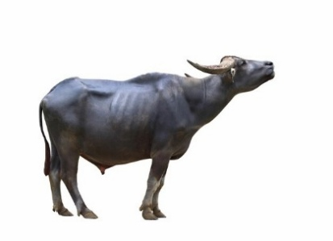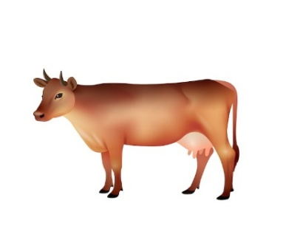

**Fig. 1 Showing livestock breed selection strategies**

**2.1 Selecting local breeds:** These are typically more suited to the climate and environment of the area. (Kosgey I.S., 2004) Here are described some benefits of local breeds:

1. Adaptability: Local breeds are well-adapted to the local climate, geography, and management systems.

2. Disease Resistance: Local breeds have developed natural resistance to local diseases, reducing the need for antibiotics and veterinary care.

3. Heat Tolerance: Local breeds are more heat-tolerant, reducing heat stress and improving productivity.

4. Low Input: Local breeds require fewer inputs, such as feed and water, making them more sustainable.

5. Cultural Significance: Local breeds are often an important part of local culture and tradition.  
**2.2 High-yielding breed selection:** Some farmers want to choose breeds that provide more meat, eggs, or milk. (Fig.1) These breeds generally require better nutrition and attention. Choosing breeds with high yields can be a good method to increase the output of milk or meat. When choosing high-yielding breeds, keep the following things in mind:

1. Production of Milk or Meat: Determine the precise production objective (meat or milk) and choose breeds that are highly skilled in that field.

2. Genetic Potential: Take into account elements such as breeding values and genetic indices when assessing the breed's genetic potential for high yields.

3. Feed Efficiency: Take into account breeds that efficiently turn feed into meat or milk, which lowers production costs.

4. Disease Resistance: To lower health problems and veterinary expenses, choose breeds that are naturally resistant to or tolerant of disease.

5. Conception and Reproduction: Consider breeds that have good reproductive performance to ensure simple calving and high conception rates.

6. Growth Rate: To swiftly attain market weight for meat production, breeds with rapid growth rates should be taken into consideration.

7. Body Type and Size: For particular production systems (such as dairy or beef), choose breeds with appropriate body types and sizes.

8. Temperament and Management: Take into account breeds that are easy to handle and have calm dispositions.

**2.3 Hybrid Breed**: Breeds that have been crossed between two different breeds are referred to be hybrid breeds. Many people consider these breeds to be strong and productive.   
Crossbreeding two distinct purebred breeds to combine their desired qualities results in hybrid breeds. Examples of hybrid breeds and their advantages are as follows:

1. Better performance: Hybrid breeds frequently display hybrid vigor, which leads to better fertility, growth rates, and general performance.

2. Enhanced disease resistance: The disease resistance of both parent breeds can be advantageous to hybrids.

3. Greater adaptability: Hybrid breeds are better able to adjust to various management styles and conditions.

4. Distinctive traits: Hybrid breeds may display distinctive traits like better-tasting meat or milk.

**2.4 Special Purpose Breeds:** Some farmers need certain breeds to meet their specific needs. While sheep ranchers might choose to breed for wool, horse ranchers might choose to breed for running. (Yakubu et al., 2019) Examples of Special Purpose Breeds include the following:

**Breeds of Dairy Products**

1. Holstein Friesian: A popular breed in dairy farming, known for producing large amounts of milk.   
2.Jersey: Produces premium milk with a healthy amount of protein and fat.  
3. Guernsey: Provides rich, creamy milk that contains a lot of butterfat.

**Breeds of Beef**

1. Angus: Known for finely marbled, premium beef.

2. Simmental: Provides high-yielding carcasses and rapid growth rates.

3. Charolais: This breed yields fine-grained, lean beef that grows quickly.

**Breeds for Dual Purposes**

1.Brown Swiss: Used in the production of both milk and beef.   
2.Milking Shorthorn: Provides a balance between the production of milk and beef.   
3.Red Poll: Known for its resilience and manageability, this breed is used to produce both milk and beef.

**Draft Animals**

1.Oxen: For draft applications including hauling and plowing.

2.Brahman: Originally from India, it is utilized as a draft in hotter regions.   
3.Nellore: Known for its ability to withstand high temperatures, it is used for draft applications in India.

When selecting a breed, there are a few additional factors to take into account, like the breed's cost and the quantity of information available about it. Additionally, it can assist you choose the proper breed by determining the purpose for which you wish to keep your cattle.   
Therefore, in general, the type of livestock breeds kept in villages are determined by the conditions and the purpose of the farmer.

3. material and methods

**3.1 Study Period**

Between September and October of 2024, this study was conducted in the Shahpur block area of the tribally dominated district of Betul (M.P.) in India.

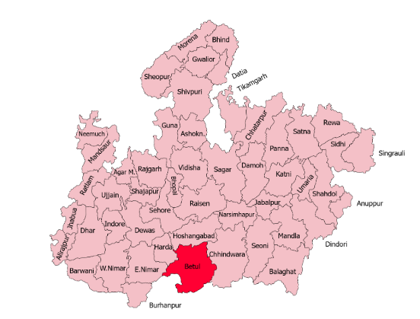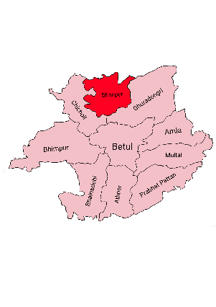

**A. B.**

**Fig. 2. A. MP Map with Betul, B. Map Betul District (MP), Shahpur Block (Study Area)**

**3.2 Study Area**

In this study, Shahpur Block in Betul District (MP) India, which is situated between latitudes 21.23 and longitudes 76.33 in the north, receives an average of 209 millilitres of rain per year. (Fig.2) This allows for year-round intensive animal production during the rainy season. This area is a component of the Satpura mountain range and is 238 meters (781 feet) above sea level.

**3.3 Study Population**

***3.3.1 Target Population*-**India has the largest milk-producing herd in the world, with almost 300 million cattle, producing roughly 187 million tons of milk a year. According to the 2019 livestock census, India is home to 109.85 million buffaloes and 145.12 million cows, including 50.42 million Cross breed and 142.11 million indigenous breeds. In all, there are 18.7 million cows in M.P., comprising 10.3 million buffaloes.

***3.3.2 Study Population*-**The Betul District is home to 2.07 lac breedable female indigenous cattle and 0.18 lakh cross breed cattle. 1.02 lakh female buffaloes found in this district. According to the 2011 census, there are 113306 people living in Shahpur block in Betul district, with 94.7% of them residing in rural areas and 5.3% in urban areas. In Shahpur block, Madhya Pradesh, 66.4% of the population is Scheduled Tribe and 7.5% is Scheduled Caste.

**3.4 Method of Survey**

In addition to the respondent’s personal information, a Google form questionnaire with 23 questions was created for dairy units and dairy farms. Farmers were questioned about what they were doing. Dairy worker and farmer identity, animal production traits, breed selection strategies, milk production technology, and animal nutrition were among the inquiries. Included were increases in milk fat diet or the use of herbs for milk and animal management.

**3.5 Respondent’s details**

The Korku and Gond are among the tribes in Betul, Madhya Pradesh. The Betul district, which lies between the Berar plains and the Satpura hills, is renowned for its tribal culture. Yadav community have traditional knowledge about animal care and diary business in this area. Although the majority of Yadavs today are farmers, they have historically worked as milk dealers, cowherds, and herders. All local dairy farmers including tribals, Yadavs and others are interviewed in this survey. They were residents of the Shahpur block in Betul. District (MP) India.

4. results

512 dairy farmers and dairy workers are the subjects of this poll. Dairy workers accounted for 25.2% of the responses. We discovered that 4.9% of women and 95.1% of men work in the dairy industry under study. Using a Google Form, a door-to-door survey of 383 dairy farmers and 129 dairy workers engaged in animal husbandry in the village was carried out, with 77.3% deshi cow breed in the study area. 3.1% Sahiwal, 0.2% Malvi, 0.6% cross-breed, other 5.2% cows, 2.7% Gir cow, 10.8% Jersey cow, 3.1% Sahiwal and 36.3 % Murrah Buffalo,49.9% Desi buffalo, 0.5% hybrid, 0.3% Nagpuri, and the remaining 13.1% other buffaloes are raised. It was declared during the survey that 34.4% of dairy producers fed 60% green and 40% dry feed, 40.8% fed 50% green and 50% dry feed, and 18.9% fed 70% green and 30% dry feed. While 10.1% of farmers occasionally have their animals checked, 3.1% of dairy farmers do self-treatment of their animal, and 86.8% of farmers do not get their animals checked on a regular basis. The outcomes of the survey are presented in the tables given below:

**Table 1. Experience of dairy farmers & dairy workers**

|  |  |  |
| --- | --- | --- |
| S. No. | EXPERIENCE GROUP | RESPONDENT’S EXPERIENCE IN DAIRY FIELD (%) |
| 1 | 1-5 Years | 15.70% |
| 2 | 5-10 Years | 16.80% |
| 3 | 10-15 Years | 14.30% |
| 4 | 15-20 Years | 12.70% |
| 5 | 20-25 Years | 10.60% |
| 6 | More than 25 Years | 29.90% |

According to Table 1, which shows the number of years of experience farmers have in animal husbandry, 29.9% of farmers have worked in the dairy industry for more than 25 years.The numbers and percentages of eight different cow breeds were examined in Fig.3 Research revealed that Nimari and Tharparkar cows are not found in this region, and that 77.3% (371) of the cows were Mulki (Desi/Indigenous) cows.

**Fig. 3. Showing % of cow breeds in the study area**

Fig. 4 lists the various buffalo breeds and their percentages, with Desi (Indigenous) buffalo accounting for 49.9% of the total. The study region does not contain Mehsana, Haryani, Jafarabadi, or Nagpuri buffalos.

**Fig. 4. Showing % of buffalo breeds in the study area**

The majority of dairy farmers and dairy workers used cotton seed cake, wheat husk, corn or sugarcane cake, jaggery, giloy leaves, and fenugreek seeds to increase milk productivity, milk quality, and milk fat. The survey also found that full-time farmers managed their animals according to their traditional knowledge, while newcomers to the milk production sector showed interest in new management but lacked their traditional knowledge. Rural dairy farmers face numerous challenges, including increased milk production, milk fat, fodder demand, and prices resulting from the constant reduction of pasture areas due to urbanization.

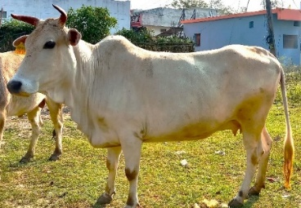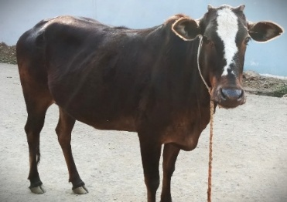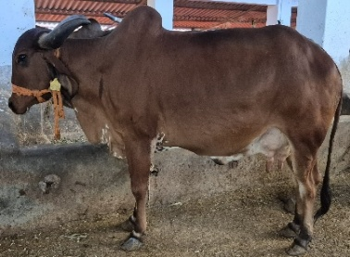

**A. Mulki (Deshi) Cow B. Hybrid Cow C. Gir Cow**

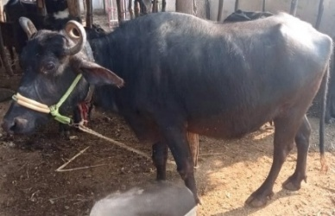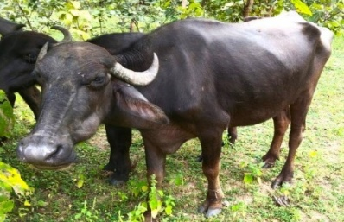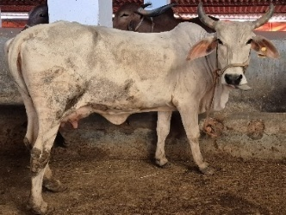

**D. Murrah Buffalo E. Deshi Buffalo F. Tharparkar Cow**

**Fig. 5. Some Cows and Buffalos breeds (In study area)**

5. DISCUSSION

This survey has focused on the dairy-related issues faced by farmers in the Shahpur area of Betul MP. According to this poll, dairy producers deal with a wide range of issues pertaining to breed selection in dairy cattle. Results revealed the breed selection methods employed by dairy farmers, who deal with the following particular practices: 1. Breed production: Priority is given to breeds that provide a lot of milk, such as Gir, Sahiwal(Fig.5), and Holstein Friesian; 2. Heat tolerance: Gir, Sahiwal, and Tharparkar are among the breeds that are favoured because they can tolerate the heat environment; 3. Disease resistance: To save veterinary expenses, breeds with innate disease resistance, such as Gir and Sahiwal, are favoured; 4. Availability of feed: Farmers select breeds that can thrive on locally accessible feed sources, like grasses and crop leftovers; 5. Market demand: Rural dairy farmers consider the market demand for milk and milk products while selecting breeds. Some inaccurate practices of dairy farmers regarding breeding were also noticed like doesn’t maintain breeding record in writing, don’t select bull/male with good genetic characteristics, give preference to traditional knowledge in place of expert advice, avoid artificial insemination and depend on natural mating. The primary goal of selecting cattle breeds for a rural location should be to choose breeds that are compatible with the local climate, feed supply, disease problems, and farming methods. Priorities should be given to good temperament, disease resistance, fertility, and moderate milk output. Depending on the herd's main use (dairy, beef, or dual-purpose), the possibility of crossbreeding to improve desired qualities should also be taken into account. Calving interval was the most important feature in the research area for breeding stock selection, followed by body size, disease resistance, and milk supply.

6. Conclusion

In order to increase cattle productivity, future breeding programs could take use of all the preferred qualities that were influenced by socioeconomic factors. After this study, we found some key solutions for improving livestock breed in the study area. All the suggestions are useful for Indian dairy sector and dairy farmers. Provide healthy bulls/males to farmers for mating with good characteristics, give proper training to dairy farmers at local level, need to implementation of government schemes at ground level, encourage artificial insemination, focus on purity of indigenous breeds, financial support to dairy farmers, organize ‘Pashu mela’ at panchayat level to encourage animal husbandry are suggestions to improve livestock breed in study area.

**DISCLAIMER (ARTIFICIAL INTELLIGENCE)**

The authors hereby declare that NO generative AI technologies such as Large Language Models (ChatGPT, COPILOT, etc.) and text-to-image generators have been used during the writing or editing of this manuscript.

References

ND, C. P., Kadian, K., Jarial, S., Bellagi, R. D., Patil, D., Jha, S. K., & Mukharjee, S. (2024). Farmers’ preferences and breeding practices for indigenous cattle breeds in breeding tract of Karnataka. *The Indian Journal of Animal Sciences*, *94*(11), 1000-1005.Kumar, C., Kamboj, M. L., Chandra, S., & Kumar, A. (2017). Dairy cattle welfare in India: A review. *Asian Journal of Dairy and Food Research*, *36*(2), 85-92. 10.18805/ajdfr. v36i02.7950

Martín-Collado, D., Díaz, C., Benito-Ruiz, G., Ondé, D., Rubio, A., & Byrne, T. J. (2021). Measuring farmers' attitude towards breeding tools: the Livestock Breeding Attitude Scale. *animal*, *15*(2), 100062.

Wuletaw, Z., Ayalew, W., & Sölkner, J. (2006). Breeding scheme based on analysis of community breeding objectives for cattle in north-western Ethiopia. *Ethiopian Journal of Animal Production*, *6*(2), 53-66.

Roessler, R. (2019). Selection decisions and trait preferences for local and imported cattle and sheep breeds in Peri-/Urban livestock production systems in Ouagadougou, Burkina Faso. *Animals*, *9*(5), 207.

Thornton, P. K. (2010). Livestock production: recent trends, future prospects. *Philosophical Transactions of the Royal Society B: Biological Sciences*, *365*(1554), 2853-2867.

Traoré, S. A., Markemann, A., Reiber, C., Piepho, H. P., & Zárate, A. V. (2017). Production objectives, trait and breed preferences of farmers keeping N’Dama, Fulani Zebu and crossbred cattle and implications for breeding programs. *Animal*, *11*(4), 687-695.

Kumar, C., Kamboj, M. L., Chandra, S., & Kumar, A. (2017). Dairy cattle welfare in India: A review. *Asian Journal of Dairy and Food Research*, *36*(2), 85-92.

Tesfa, A., Kumar, D., Abegaz, S., & Mekuriaw, G. (2017). Conservation and improvement strategy for Fogera cattle: A lesson for Ethiopia ingenious cattle breed resource. *Advances in Agriculture*, *2017*(1), 2149452.

Ouédraogo, D., Soudré, A., Ouédraogo-Koné, S., Zoma, B. L., Yougbaré, B., Khayatzadeh, N. & Sölkner, J. (2020). Breeding objectives and practices in three local cattle breed production systems in Burkina Faso with implication for the design of breeding programs. *Livestock Science*, *232*, 103910.

Widyas, N., Widi, T. S. M., Prastowo, S., Sumantri, I., Hayes, B. J., & Burrow, H. M. (2022). Promoting sustainable utilization and genetic improvement of Indonesian local beef cattle breeds: A review. *Agriculture*, *12*(10), 1566.

Kosgey, I. S. (2004). *Breeding objectives and breeding strategies for small ruminants in the tropics*. Wageningen University and Research.

Yakubu, A., Dahloum, L., & Gimba, E. G. (2019). Smallholder cattle farmers’ breeding practices and trait preferences in a tropical guinea savanna agro-ecological zone. *Tropical animal health and production*, *51*, 1497-1506.