**Study of the development of cashew (*Anacadium occidentale* L.) yield components at tree level in northern Côte d'Ivoire**

**ABSTRAT**

The study was conducted at the Lataha research station in the Poro region, which has a Sudanese climate with two distinct seasons. The aim was to assess cashew yield components through agromorphological and phenological analysis in three orchards of different ages (8, 12 and 39 years). An experimental block design was set up with three 50 m × 50 m plots. Twelve trees were selected and monitored. Span, height and trunk circumference were measured. Quadras were used to monitor twig development (vegetative, flowering, fruiting) every two days. Statistical analysis revealed that trunk span and circumference were strongly correlated with the number of vegetative shoots (r = 0.94 and r = 0.77). A strong linear regression was observed between span and the number of vegetative shoots (R² = 0.97). Branching and fruit production increased with tree age. East and west directions favoured higher shoot and fruit production, probably related to exposure to light. Male flowers are the most common, regardless of cardinal direction, followed by hermaphroditic flowers, which are more common in the east and south. The length of the flowering cycle increases with age: 34 days for young trees, 45 days for intermediate trees and 51 days for old cashew trees. Fruit production was significantly higher in the oldest trees. The study concludes that the age of the tree, its morphological characteristics and the cardinal orientation of the branches have a strong influence on flowering, fruiting and therefore yield.

Key word : Cashew tree, Flowering, Fructification, Plot and Yield

**INTRODUCTION**

The cashew tree (*Anacardium occidentale* L.) is a fruit species of growing economic importance in West Africa, particularly in Côte d'Ivoire, which is one of the world's largest cashew nut producers (FAO, 2020). This crop is a major source of income for many farmers and represents a strategic asset for rural development. However, despite its socio-economic importance, cashew productivity often remains below its genetic potential due to a number of agroecological and technical factors that are poorly controlled (Aliyu, 2005; Ndiaye et al., 2019).

Optimising cashew yield necessarily involves a better understanding of its biology, particularly its agromorphological parameters and reproductive cycle. Among these parameters, the number of vegetative, flowering and fruiting branches appears to be a good indicator of the tree's productive potential (Djaha et al., 2012; Smith and Dupont, 2018). These branches, which ensure growth, flowering and fruiting respectively, are strongly influenced by the age of the tree, its morphological characteristics, as well as environmental factors such as light, temperature and the cardinal direction of exposure (Bonnesoeur, 2016; Diallo and Kouadio, 2015).

In addition, the cashew tree's floral structure, which is dominated by a high proportion of male flowers compared with hermaphrodite flowers, may also influence its ability to set fruit (Lacroix and Éric, 2003; Adiga, 2019). A predominance of male flowers, observed in several studies, is a constraint on fruit set and therefore productivity (Aliyu, 2005; Ndiaye et al., 2019). In this context, the present study aims to analyse the components of cashew yield as a function of orchard age and cardinal exposure. It focuses in particular on the relationships between morphological traits (span, trunk circumference, height) and reproductive structures (branches, flowers, fruit) in order to identify the factors that determine yield. The results of this research could help to improve cultivation practices and select high-performance plants suited to the ecological conditions of the Poro region.

**MATERIAL AND METHOD**

**Study site**

The study was carried out at the Lataha research station (Figure 1). The climate of the Poro region, which is of the Sudanese type, is characterised by two seasons: a dry season from November to April and a rainy season from May to October. From 2021 to 2022, monthly rainfall ranged from 00 mm to 884.40 mm. The average monthly temperature was between 26.93°C and 27.02°C.

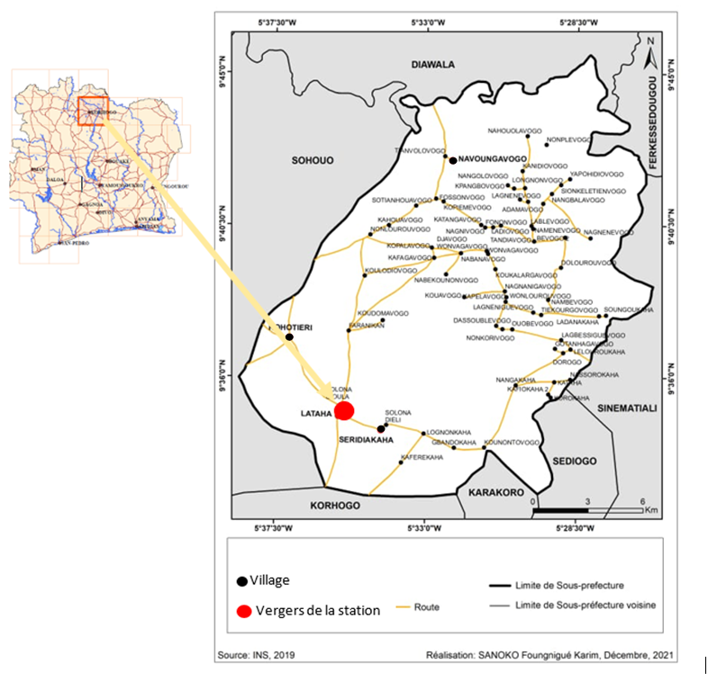

Figure 1: Map of the study site

**Plant material**

The plant material studied in this study was cashew. The study consisted of selecting cashew trees in three orchards at the Lataha research station.

**Technical equipment**

The technical equipment used during our study consisted of a decameter to measure the dimensions of the cashew trees; paint cans to mark the trunks of the selected cashew trees; a graduated wooden ruler to determine the height of the cashew trees; a quadra measuring one metre square to select and monitor the branches; junta bags for storing the nuts; a 25-kilogram scale and a 500-gram electronic scale for weighing the nuts per tree; buckets for collecting the nuts per tree; data sheets for recording the weight of the nuts and the number of nuts per tree; a performent canon camera for taking photos in the field.

**Orchard selection**

To assess cashew yield components, three orchards of different ages were selected at the Lataha research station: 8 years (young orchard), 12 years (intermediate-age orchard) and 39 years (old orchard). The orchards were selected on the basis of specific criteria: the presence of cashew trees of productive age in each of the three selected orchards, each of the three orchards had an area of at least one hectare and the orchards were at least 500 m apart to avoid having the same microclimate.

**Experimental set-up**

A 50 m × 50 m plot was set up in each of the three selected orchards and all the trees in each plot were numbered (Figure 2). Within each plot, four trees were randomly selected, for a total of 12 cashew trees monitored in the three plots. A one-metre square quadra was laid on each of the trees, in each cardinal direction. The vegetative branches, circumscribed by quadra, were then labelled during the vegetative phase and monitored every two days during the study.

**39 years old**

**08 years old**

**12 years old**

**N**

**50 m**

**50 m**



**50 m**



**50 m**



**50 m**



**50 m**



Figure 2 : File block experimental set-up

**Agromorphological characterisation of the trees studied**

The measurements taken concerned the span, the circumference of the trunk at 5 cm from the ground and the height of the trees. These variables were measured using a graduated wooden ruler (for tree height) and a decameter (for span and trunk circumference). The span of the tree corresponds to the diameter or extent of the foliage, in the north-south and east-west directions. The circumference of the tree trunk was measured by determining the circumference of the bole 5 cm from the ground. The height of the tree was measured from the collar to the top (last leaf of the main branch). This means holding the ruler vertically, closing one eye and matching the base of the tree to the lower end of the ruler, adjusting until the top reaches a scale.

**Monitoring vegetative shoots**

Monitoring the labelled vegetative shoots in each quadra consisted of observing them every two days in order to determine the dates of their transformation into flowering and fruiting shoots. The different types of flowers (hermaphrodite, male and abnormal) and fruits were then counted on each of the labelled shoots during the flowering and fruiting stages respectively.

**Length of the cashew tree flowering cycle**

The length of the flowering cycle, which consists of counting the number of days between the date of appearance of the flower bud and the date of fruit set, was determined for the four trees in each orchard. The dates of appearance of the flower buds were determined for each marked vegetative branch. The same was done for fruit set.

**Prediction of the number of vegetative shoots**

In order to predict the number of vegetative shoots in cashew trees, a linear regression was carried out between the number of vegetative shoots counted and the span of the trees. The quality or level of the prediction was defined by the coefficient of determination (R²).

**Statistical analysis**

Quantitative morphological data were first subjected to a descriptive analysis. Means and standard deviations were determined for all quantitative traits. The effect of agro-morphological parameters on cashew nut yield development was tested with analyses of variance (ANOVA) at a threshold of 5%. Correlations between variables were performed using the Pearson test at the 5% significance level. Analyses were performed using R software.

**RESULTS**

**Correlations between observed variables**

The correlation coefficients obtained between the characters ranged from -0.19 (tree height and trunk circumference) to 0.94 (mean span and number of vegetative shoots) [Figure 3]. Three of these correlations were significant. These were: mean span and number of vegetative shoots (r = 0.94); trunk circumference and mean span (r = 0.77); trunk circumference and number of vegetative shoots (r = 0.77). The agro-morphological parameters correlated with the number of vegetative shoots were mean span and number of vegetative shoots (r = 0.94) and trunk circumference and number of vegetative shoots (r = 0.77).

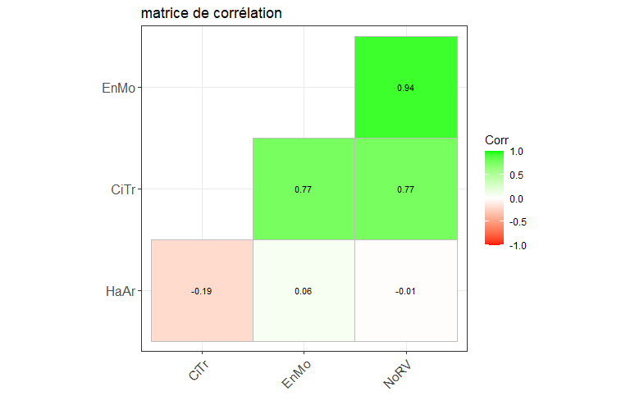

NoRV: number of vegetative shoots; CiTr: trunk circumference; EnMo: average wingspan

**Figure 3: Correlation matrix**

**Linear regression between the number of vegetative shoots and span**

A positively strong and significant linear relationship (r²= 0.97; p<0.05) was observed between the number of vegetative shoots and the average span. The coefficient of determination of this linear regression was very high (R²=0.97). This indicates that the number of vegetative shoots is well predicted.

**Effect of cardinal directions on the different types of branch and the number of nuts**

Whatever the type of branch, a significant difference was observed between the cardinal directions. Figure 4 below illustrates the evolution of the different types of branch (vegetative, flowering, fruiting) and the number of nuts as a function of cardinal direction by age group (young cashew trees, intermediate cashew trees and old cashew trees). In terms of vegetative shoots, the results showed an overall increase in the number of vegetative shoots with age (young cashew < intermediate cashew < old cashew). The West direction recorded the highest number of vegetative shoots for all age groups, while the North direction obtained the lowest values. Flowering shoots followed a similar trend, increasing with age. Twigs in the east and west directions were significantly more numerous in intermediate and old cashew trees. North-facing flowering shoots were significantly lower in young and intermediate cashew trees than in old cashew trees. Fruiting shoots also increased with age, particularly in the east and west directions. Significant differences between age groups are evident, with young cashew trees showing significantly lower values than intermediate and old cashew trees. Values for the North direction remain among the lowest for all age groups. Fruit production was higher in the east and west directions for all age groups. The age group (old cashew trees) systematically had the highest number of fruits, with significant differences from the young and intermediate cashew age groups. The North direction showed the lowest values, especially in the young cashew bracket, where a significant difference is noted (‘d’).

**a)**

**b)**

Categories with different letters show significant differences.

**c)**

**d)**

Categories with different letters show significant differences.

**Legends:**

a : Number of vegetative shoots per cardinal direction

b: Number of flowering shoots per cardinal direction

c: Number of fruiting shoots per cardinal direction

d: Number of fruit per cardinal direction

Figure 4: Number of branches and fruit per cardinal direction

**Quantification of flower types according to cardinal direction**

Figure 5 shows the frequencies of the different flower types (male flowers (FM), hermaphrodite flowers (FH), and sterile flowers (FS)) according to cardinal directions (N: North, S: South, E: East, W: West). Whatever the cardinal direction, male flowers were the most dominant, unlike hermaphrodite and sterile flowers. In the northern direction, FM flowers predominated with a frequency of 70%. FH flowers represented 19% and FS flowers were the least frequent with only 5%. In the south, FM flowers also dominate, with a frequency of 71%. FH flowers make up 24%. FS flowers were present at 5%. In the east direction, FM flowers dominated with 68%. FH flowers are slightly more frequent at 28% and FS flowers remain at 4%, similar to the North direction. In the West direction, FM flowers still represent the majority at 67%. FH flowers increased to 29%, close to their frequency in the East direction, and FS flowers were the least represented at 4%, as in the South direction.

Figure 5: Frequency of the three types of flowers observed on twigs by cardinal direction

**Length of flowering cycle**

the distribution of the duration of the flowering cycle in cashew trees was divided according to each age group: young cashew, intermediate cashew and old cashew. The results of the analysis showed that young cashew trees had a flowering cycle of 34±5.4 days, making them the shortest of the three age groups. In the intermediate cashew trees, the duration of the flowering cycle was 45±6.4 days, indicating an intermediate duration. The oldest cashew trees recorded the longest flowering duration, up to 51±4.3 days.

**Production of monitored trees**

The production of the twelve cashew trees monitored was similar (P>0.05) within each age group. A significant difference in production was observed between the three age groups. Generally speaking, production changes with age. The oldest cashew trees were the most productive (65) compared to the intermediate (41) and young (24) cashew trees.

**DISCUSSION**

Concerning the study on the development of yield at tree level, the span and circumference of the trunk of the trees monitored were the variables most correlated with the number of vegetative shoots. In addition, a strong linear regression was established between span and the number of vegetative shoots (R²=0.94). The fact that the coefficient of determination is equal to 0.94 indicates a high level of prediction of the number of vegetative shoots based on the measurement of span. The study by Djaha et al. 2012 indicated that trunk diameter and span are the best predictors of the number of grafts. Our results confirm their observations as these two variables were the most correlated with the number of vegetative shoots in our study. The fact that span was the most correlated with the number of vegetative shoots is due to the fact that vegetative shoots are borne by the aerial part of the tree (Ndiaye et al., 2019). Thus, a phenomenon affecting the aerial part also has an impact on the number of branches and therefore vegetative shoots. The cashew tree develops different types of branches as it grows, including vegetative, flowering and fruiting branches. These branches play distinct roles in the tree's development and reproduction. In the case of our study, the analysis showed an overall increase in the number of vegetative, flowering and fruiting branches with age. This could be explained by the fact that trees undergo physiological changes during their development. As they age, they accumulate energy reserves, particularly in the form of carbohydrates stored in their woody tissues. These reserves allow a better allocation of resources to the processes of growth and differentiation of tissues, particularly twigs (Smith and Dupont, 2018). In addition, the East and West directions recorded the highest number of twigs compared with the North and South directions. These directions would therefore favour better tree growth and production. The differences observed could be explained by the fact that the East-West directions receive a significant amount of sunlight at critical times of the day. Exposure to direct light in the morning (East) and afternoon (West) promotes photosynthesis, which increases energy production and growth (Diallo and Kouadio, 2015). In addition, Bonnesoeur (2016) reported that east and west directions are most often less exposed to prevailing winds in many regions, reducing mechanical stresses. The results of this study also showed that whatever the cardinal direction, male flowers were the most abundant, representing at least 70% of all flowers. Hermaphroditic flowers ranged from 16% to 29%, with a higher proportion in the east and south directions. These results suggest that there are environmental or climatic factors such as sunshine, humidity, temperature and wind specific to cardinal directions that favour flower dominance. Adiga (2019) and Lacroix and Eric (2003) have shown that both types of flowers (hermaphrodite and male) are produced at the terminal parts of shoots where the sun reaches the buds. The abundance of male flowers has also been observed in various studies. For example, a study conducted in the department of Goudomp in Senegal (Ndiaye et al., 2019) revealed a predominance of male flowers in cashew to the detriment of other flowers. Our results also corroborate those of Aliyu (2005) and Lefebvre (1969), who also highlighted the concomitant presence of male and hermaphrodite flowers in varying proportions in cashew. The length of the flowering cycle in cashew trees (Anacardium occidentale L.) varied according to the age of the tree. Young cashew trees (8 years old) had an earlier flowering cycle (34 days) than cashew trees aged 12 years (45 days) and 39 years (51 days). This variation is thought to be due to a number of biological and environmental factors. Young cashew trees have a shorter flowering cycle because they have not yet fully developed their reproductive capacity. As the tree ages and its tissues develop, it becomes more capable of producing flowers and fruit, resulting in a longer flowering cycle (Rivals, 1965 and Normand, 2014). Also, mature cashew trees are better established and more resistant to variable environmental conditions, such as climatic fluctuations, droughts, and periods of stress, which can influence the duration and regularity of flowering (Lacape et al., 2014). Regarding production, 39-year-old cashew trees were the most productive compared to 12-year-old and 8-year-old cashew trees. The differences observed in productivity can be attributed to physiological, morphological and ecological factors related to the growth and fruiting dynamics of the species. Moreover, at an advanced age (around 30 to 40 years), cashew trees generally reach full physiological maturity. Their root system is well developed, giving them a better capacity to absorb nutrients and water, which supports higher production (Omoregie et al., 2018). Older trees also have a more extensive canopy, providing a large photosynthetic surface. This large photosynthetic capacity favours the synthesis of sugars and other compounds needed for flowering and fruiting (Aliyu and Awopetu, 2007). Similarly, cashew yield increases progressively from the time the tree sets fruit (at around 3-5 years of age) and reaches an optimum plateau between 15 and 40 years of age, before gradually declining. Trees that are 39 years old are probably at the end of their optimum production phase (FAO, 2001).

**Conclusion**

The study of cashew yield components at the tree level highlights significant correlations between certain agromorphological parameters, particularly between average trunk width, trunk circumference, and the number of vegetative branches. A strong linear relationship between width and the number of vegetative branches (R² = 0.97) highlights the possibility of reliable prediction. Furthermore, cardinal directions significantly influence branch distribution (vegetative, flowering, fruiting) and fruit production, with East and West directions dominating. Flowering is marked by a predominance of male flowers in all directions, although hermaphrodite flowers are more frequent in the East and West. The duration of the flowering cycle increases with tree age, ranging from 34 days in young cashew trees to 51 days in older ones. Finally, fruit production follows a similar trend, increasing significantly with tree age, thus confirming the determining role of physiological maturity in the productive performance of the cashew tree.

**COMPETING INTERESTS DISCLAIMER:**

Authors have declared that they have no known competing financial interests OR non-financial interests OR personal relationships that could have appeared to influence the work reported in this paper.

**REFERENCE**

**Adiga, S. (2019). Morphological and reproductive analysis in cashew. International Journal of Botany Studies, 4(2), 45–52.**

**Aliyu, O. M. and Awopetu J. A. (2007). Fruit size and yield variability in cashew (Anacardium occidentale L.): Implications for selection. Journal of Applied Sciences Research, 3(10), 1065–1070.**

**Aliyu, O. M. (2005). Comparative floral biology and breeding systems in cashew (Anacardium occidentale L.). International Journal of Plant Sciences, 166(4), 493–500.**

**Bonnesoeur, V. (2016). Effects of directional exposure on the growth and mechanical resistance of tropical trees. Doctoral thesis, University of Montpellier.**

**Diallo, K. and Kouadio, E. (2015). Influence of sunlight on the growth of young cashew plants in Côte d'Ivoire. Ivorian Journal of Science and Technology, 25, 101–110.**

**Djaha, A., and Kouamé, K.L. (2012). Influence of tree morphology on graft production in cashew trees. Journal of Applied Biosciences, 55, 4011–4018.**

**FAO (2020). Statistical Yearbook: World cashew production data. Rome.**

**FAO. (2001). Cashew Production and Processing. Food and Agriculture Organization of the United Nations.**

**Lacape J-M., Loison R., Foncéka D. (2014). Improving crop adaptation to drought in the African savannah zone. 12p.**

**Lacroix, B. and Éric, C. (2003). Floral development and sexual reproduction in tropical plants. Revue Française de Botanique Tropicale, 51, 89–102.**

**Lefebvre, A. (1969). "The cashew tree, a treasure of Madagascar." Fruits, 24(1), 3–17.**

**Ndiaye, B., and Sarr, E. (2019). Study of the floral characteristics of the cashew tree (Anacardium occidentale L.) in the Goudomp department (Senegal). Journal of Experimental Biology and Agricultural Sciences, 7(1), 150–157.**

**Normand, F. (2014). Reproductive biology of tropical fruit trees: influence of climate and age. Acta Horticulturae, 1047, 103–110.**

**Omoregie A. U., Ajayi, O. C. and Nwagbara M. O. (2018). Growth and Yield of Cashew Trees of Different Ages in Nigeria. African Journal of Agricultural Research, 13(25), 1292–1299.**

**Rivals, P. (1965). Contribution to the study of flowering in the cashew tree. Tropical Agronomy, 20(2), 112–122.**

**Smith, J. and Dupont, L. (2018). Physiological factors affecting branching and flower initiation in tropical fruit trees. Tree Physiology, 38(9), 1320–1329.**