**Mathematical Model of Copper Nanofluid Flow Past a Spherical Enclosure**

**Abstract**

The study examined mathematical models for describing the behavior of copper nanoparticles in water base fluid. Coupled hydrodynamic governing equations of momentum, energy and concentration were non dimensionalized and solved using installed Laplace transform technique in Mathematica 12.3. The solution obtained were used to analyze the effect of the material parameters on the concentration, temperature and velocity profiles of the copper nanofluid. Results of the study using graphs reveal that an enhancement of the nanoparticle size results in a depreciation of the concentration of the copper nanofluid and escalate the temperature and velocity profiles of the copper nanofluid. Also, the twin effect of an increase in Thermophoresis and Brownian motion bring about a decrease in the concentration of the nanofluid and an increase in the temperature and velocity of the nanofluid. An increase in the radiation parameter, enhanced the temperature of the nanofluid and depreciate the concentration and velocity of the nanofluid while an increase in the magnetic Hartmann number inhibits the velocity of the nanofluid, while an enhancement of the Lewis and Prandtl numbers led to a depreciation of the concentration, an increase in the temperature is observed, for the velocity, it is enhanced by sharp increase in the lewis number and accordingly depreciates by an increase in the Prandtl number. The Reynolds number increase also escalates the velocity profile of the copper nanofluid. Generally, it was observed that the copper nanofluid in some cases react abnormally in the presence of some material parameters under investigation which is a reflection of its characteristics.

**Keywords: Copper nanoparticles; water; Laplace transform; spherical coordinate; Hydrodynamic equations.**

**INTRODUCTION**

The demand for sustainable manufacturing and for better performance in material processing is the driving force for scientific advancement and technological development. One of the foremost developments in this regard, is in the discovery of nanofluid which has shown to possess improved thermal conductivity and mean viscosity that has enabled its application.

Nanofluids are made-up of nanoparticles which are added to base fluid such as water, ethylene glycol etc. There have been several published works on the effect of thermal conductivity of fluid containing nanoparticles [1-2] and which has given rise to outstanding discoveries on which recent research on nanofluid are hinged on. The kernel which is the revelation that the exploitations of the properties of the tribo-chemical and thermo-physical properties of nanofluids can be utilized as an effective control of the surface integrity, tool life, generation and removal of heat evolution, energy consumption just to mention but a few, for enhanced performance of these operations[3].

As a result of the myriad of applications of the nanofluid, it has become an area of keen interest by researchers in a bid to expanding its frontiers. For instance, [4] sought to improve the chilling performance of air conditioning systems. They attempted this by increasing the volume fraction of nanofluid and obtained an increase in its thermal conductivity. Also, From the report of [5-6], better cell phones displays, miniature camera lenses and other fluidic micro-scale devices can be obtained for stability and enhanced performance when electric fields interacts with nanofluid. It is important to state that [7-19] had also chronicled the various applications of nanofluid, ranging from nanofluid as coolant in machining, Nano-refrigerants, space and military, nanofluid in detecting knock occurrence in a gas powered engines, nanofluids used as heat treatment of materials, Solar applications, and magnetic sealing to transportation. In addition, one of the nanoparticles added to a fluid to make it a nanofluid is copper. Copper (Cu) is particularly attractive because of its high natural abundance, its low cost and its practical and straight forward multiple ways of preparing Cu-based nanomaterials [20-24]. It falls under the category of 3rd transition metal whose physical and chemical property arouses curiosity. As a result of Cu far-reaching accessible oxidation states, this permits reactivity through both one and two electrons pathway. The choice of copper-based nanocatelysts is as a result of its wide applicability in nanotechnology, which includes but not limited to photocatalysis, electrocatalysis and catalytic or gene transformation [25-35].

Copper has been found to play a pivotal role in nanofluid. Interestingly, some works centering on the application of copper oxide nanofluid on the performance of various materials have been tackled by numerous authors [36-43]. Swetapadma et al [44], discussed the mass and heat transfer of copper hybrid nanofluid over a stretching sheet. From their report, they considered water and aluminum oxide (Al2O3) as the base fluid and copper oxide as the nanoparticle. Souayeh et al [45], investigated the functions of alumina and copper oxide for heat transfer in a nanofluid. Swain and Mishra [46], analyzed water-based copper nanofluid over a stretching linear sheet. Also, three-dimensional transfer of heat of a copper hybrid nanofluid with slip and heating effect over a wedge was looked at by Rena et al [47]. In nanofluids study, the twin concepts of Brownian motion and thermophoresis, result in rapid enhancement of thermal conductivity. The interplay of the two principles is vital in the manufacturing of communication engineering silicon and germanium (iv) oxide optical fibres. Works such as [48 - 53], tackled the twin effect of Brownian motion and thermophoresis and deduced that increase in the thermophoresis parameter, escalate the temperature of the nanofluids but decreases the specie diffusion while increase in the Brownian motion, raises the heat and mass diffusion in the nanofluids. Magnetic field exist everywhere in the universe and its effect in classical and quantum systems cannot be overemphasized. Its presence usually inhibits the flow of nanofluids and rigorous studies are ongoing on how to use the magnetic field in transporting heat away from nuclear power stations. Some studies such as [54 - 57] highlighted the effects of magnetic field on the nanofluids flow geometry. Radiation which is the flow of energy also plays a crucial role in heat and mass transfer of nanofluids. Hajizadeh et al [58] and other studies such as [59 - 62], examined the presence of radiation and other parameters in the study of nanofluids and reported that an increase in the radiation parameter, depreciated the temperature profiles of nanofluids. In all the listed studies, the flow of copper nanofluid in spherical enclosure with interplay of Brownian motion and thermophoresis in addition to a fixed fractal model for predicting the effective thermal conductivity of nanofluid is yet to be considered. Therefore, the main aim of this research is to examine the effect of Hartmann number on the flow configuration and the relationship between Brownian motion and thermophoresis on copper nanofluid.

**Mathematical Formulation**

The equation of motion depicting the character and direction of the flow are governed by the equation of continuity, the momentum equation, the energy equation and the specie concentration equation in spherical coordinate system and are stated respectively as

 (1)

 (2)

 (3)

 (4)

Transforming the governing equations (1), (2), (3) and (4) into nanofluid model and simplify, result into

 (5)

 (6)

 (7)

 (8)

where r is the radius of the spherical enclosure,  is dynamic nanofluid viscosity,  is the magnetic induction,  is the electrical conductivity,  is the velocity of the nanofluid,  is the nanofluid volumetric coefficient of thermal expansion due to temperature,  is the nanofluid volumetric coefficient of thermal expansion due to concentration, g is the acceleration due to gravity, T is the temperature,  is the characteristic temperature,  is the concentration of nanofluid,  is the characteristic concentration,  is the thermal conductivity of nanofluid,  is the specific heat at constant pressure of nanofluid,  is mass diffusivity,  is the thermal diffusion ratio,  is the mean nanofluid temperature,  is concentration susceptibility,  is the radiation term,  is the nanofluid density, D is the molecular diffusivity and t is the time.

Subject to the boundary conditions [63]

 as  (9)

 as  (10)

According to [64], a fractional model based on the multi – component Maxwell model for the ratio of thermal conductivity of particle clusters is given as

 (11)

The study assumed that the thermal conductivity of the particle clusters is fixed, therefore equation (11) reduced to

 (12)

Also, the Robinson [65] ratio of viscosity model is stated as

 (13)

In the works of [66 - 67], the density, thermal expansion coefficients due to temperature and concentration and heat capacitance of nanofluids are respectively stated as

 (14)

 (15)

 (16)

 (17)

where  is the nanoparticle volume fraction,  is the density of the base fluid,  is the nanoparticle,  is the volumetric coefficient of thermal expansion due to temperature of base fluid,  is the volumetric coefficient of thermal expansion due to temperature of nanoparticle,  is the volumetric coefficient of thermal expansion due to concentration of base fluid,  is the volumetric coefficient due to concentration of nanoparticle,  is the specific heat at constant pressure of the base fluid and  is the specific heat at constant pressure of the nanoparticle

According to [68], the radiative heat flux as described by the Rosseland approximation for optically thick medium is given by

 (18)

where  is the Stefan – Boltzmann constant and  is the mean absorption coefficient.

Using Taylor series expansion of  about  and neglecting higher order terms, result into

 (19)

**Dimensional Analysis**

** ,  ,**  ,   ,  ,  ,  ,  ,  , ** ,  ,** 

Using the dimensionless variables in addition to the under listed expressions

 ,  ,  ,  ,  , 

equations (5) – (8) can be rewritten as

 (20)

 (21)

 (22)

 (23)

With the boundary conditions

 as  (24)

 as  (25)

where Re is Reynolds number, Ha is Hartmann number, Gr is Grashof number, Gc is modified Grashof number, Pr is Prandtl number,  is dimensionless Brownian motion term, N is dimensionless radiation term, Le is Lewis number,  is Dimensionless thermophoresis term, v is dimensionless velocity, r is dimensionless radius of the spherical enclosure,  is the dimensionless temperature and C is the dimensionless concentration.

Since the nanofluid under consideration is incompressible, then equation (20) results in

 (26)

where  is a constant of integration.

Since the flow situation continues for long, steady state is assumed and the resulting model equations (21) – (23) with the use of equation (26), as well as simplification, transformed into

 (27)

 (28)

 (29)

**Method of Solution**

The following Laplace transform techniques









,

are stated.

where is the Gamma function.

Applying the above stated Laplace transform techniques to equations (28) – (29) and simplify, the expressions take the form

 (30)

 (31)

where  , , 

 ,  , 

Equations (30) and (31) can be written in matrix form of the type

 (32)

Solution to equation (32), using determinant method [69], result in

 (33)

 (34)

Putting back the values of the expressions in equations (33) and (34) and simplify, they take the form

 (35)

 (36)

where



The numerator and denominator of equations (35) and (36) are multiplied by  and having used the numerical values of the parameters under consideration (ie the first values of the parameters in **Table 2**) and the thermo physical properties of water and copper (**Table 1**) as well as resolving the resulting expressions into partial fractions using Mathematica 12.3, give the Laplace transforms of the dimensionless specie concentration and dimensionless temperature equations respectively as

 (37)

 (38)

The inverse Laplace transform  of equations (37) and (38) are respectively stated as

 (39)

 (40)

Equations (39) and (40) are put into equation (27) and simplify, the resulting expression having multiplied by  is given as

(41)

Using the first numerical values of the parameters under consideration and taking the Laplace transform of equation (41), convert the expression into the form



(42)

Simplification of equation (42), for the purpose of determining the inverse Laplace transform, results in

(43)

The inverse Laplace transform  of equation (43) is given as

(44)

**Shear stress**

The shear stress  is determined by the relation



**Skin friction**

Skin friction at the surface of the enclosure for and  from [70] are given as

, 

**Coefficient of friction**

The mean nanofluid flow velocity for the study following [70] is



The coefficient of friction  corresponding to is



Similarly, the coefficient of friction  corresponding to is



The mean  is used in describing the energy losses at the walls past the nanofluid flow

**Nusselt number (Nu)**

The dimensionless heat transfer coefficient is given by



**Sherwood number (Sh)**

The dimensionless mass transfer coefficient is given by



**Table 1**: Thermophysical properties of water and copper [71]

|  |  |  |  |  |  |
| --- | --- | --- | --- | --- | --- |
|  |  |  |  |  |  |
| Pure water | $$997.1$$ | $$4179$$ | 0.61 | $$21$$ |  |
| Copper | $$8933$$ | $$385$$ | 401 | $$1.67$$ |  |

**Table 2**: Varying values of the material parameters under investigation

|  |  |  |  |
| --- | --- | --- | --- |
| Parameters | 1st value | 2nd value | 3rd value |
|  |  |  |  |
| Prandtl number (Pr) | 0.71 | 0.81 | 0.91 |
| Radiation (N) | 0.21 | 0.31 | 0.41 |
| Lewis number (Le) | 0.63 | 0.73 | 0.83 |
| Thermophoresis (Tm) | 0.35 | 0.45 | 0.55 |
| Brownian motion (Bm) | 0.10 | 0.20 | 0.30 |
|  |  |  |  |
| Constant | 1 |  |  |
| Grashof number (Gr) | 0.92 | 1.02 | 1.05 |
| Modified Grashof number (Gc) | 0.44 | 0.46 | 0.48 |
| Hartmann number (Ha) | 0.12 | 0.14 | 0.16 |
| Nanoparticle size | 0.001 | 0.002 | 0.003 |
| Reynolds number (Re) | 100 | 200 | 300 |

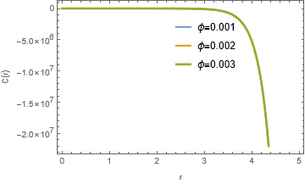

**Figure 1**: Plot of concentration against radius of sphere with nanoparticle volume fraction varying

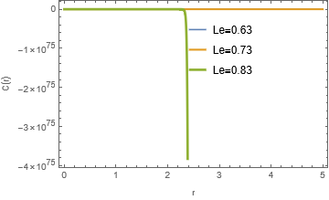

**Figure 2**: Plot of concentration against radius of sphere with Lewis number varying

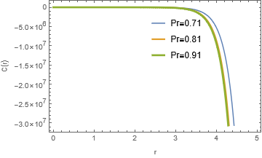

**Figure 3**: Plot of concentration against radius of sphere with Prandtl number varying

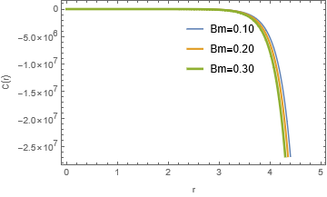

**Figure 4**: Plot of concentration against radius of sphere with Brownian motion term varying

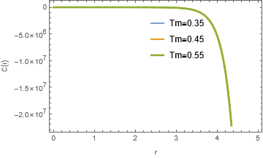

**Figure 5**: Plot of concentration against radius of sphere with thermophoresis term varying

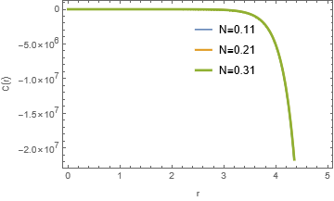

**Figure 6**: Plot of concentration against radius of sphere with radiation term varying

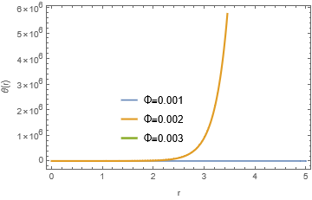

**Figure 7**: Plot of temperature against radius of sphere with nanoparticle volume fraction varying

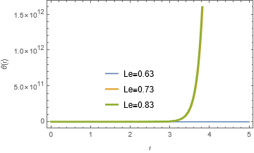

**Figure 8**: Plot of temperature against radius of sphere with Lewis number varying

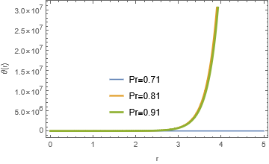

**Figure 9**: Plot of temperature against radius of sphere with Prandtl number varying

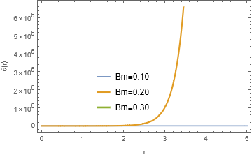

**Figure 10**: Plot of temperature against radius of sphere with Brownian motion term varying

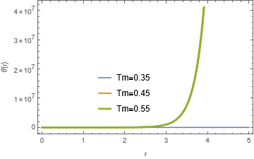

**Figure 11**: Plot of temperature against radius of sphere with thermophoresis term varying

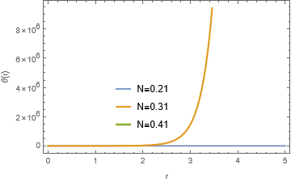

**Figure 12**: Plot of temperature against radius of sphere with radiation term varying

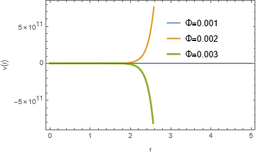

**Figure 13**: Plot of velocity against radius of sphere with nanoparticle volume fraction varying

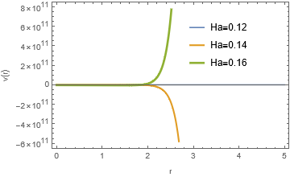

**Figure 14**: Plot of velocity against radius of sphere with Hartmann number varying

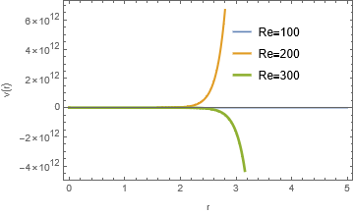

**Figure 15**: Plot of velocity against radius of sphere with Reynolds number varying

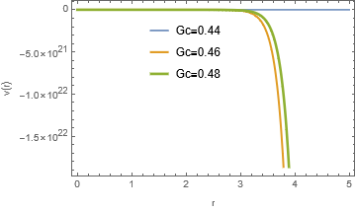

**Figure 16**: Plot of velocity against radius of sphere with modified Grashofs number varying

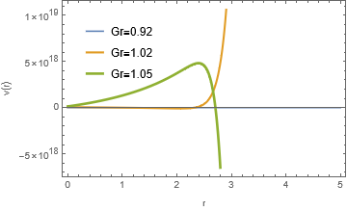

**Figure 17**: Plot of velocity against radius of sphere with Grashofs number varying

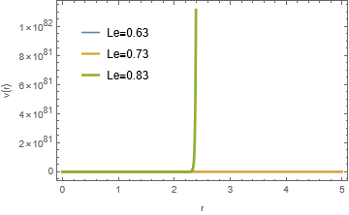

**Figure 18**: Plot of velocity against radius of sphere with Lewis number varying

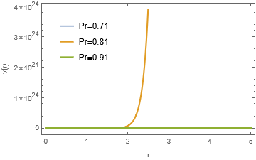

**Figure 19**: Plot of velocity against radius of sphere with Prandtl number varying

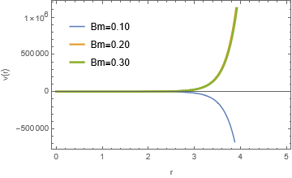

**Figure 20**: Plot of velocity against radius of sphere with Brownian motion term varying

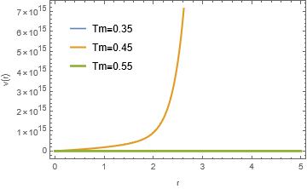

**Figure 21**: Plot of velocity against radius of sphere with thermophoresis term varying

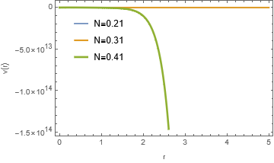

**Figure 22**: Plot of velocity against radius of sphere with radiation term varying

**Discussion**

Figure 1 shows that an increase in the nanoparticle volume fraction decreased the concentration of the nanofluid and later attain saturation point. An increase in the Lewis number as depicted in Figure 2 reveals a sharp decrease likened to the behavior of superconductor curve of the concentration of the copper nanofluid. This observation is consistent with the studies of [53-54]. As the Prandtl number increases, a corresponding decrease in the concentration of the copper nanofluid is observed as shown in Figure 3. As the Brownian motion and thermophoresis parameter are enhanced as shown in figures 4 and 5 respectively, the concentration of the nanofluid depreciated in the both cases. However, for the case of the thermophoresis parameter, saturation point is reached in the concentration of the nanofluid and these observations are in agreement with the works of [50-51]. The energy flow curve as shown in Figure 6, depreciated and later attained saturation point as radiation parameter is enhanced. As the nanoparticle volume fraction and Lewis number are enhanced as shown in Figures 7 and 8 respectively, it is observed that temperature rises and later reached saturation point as shown in Figure 7. The temperature is raised and later marginally as the Prandtl number is increased, this is the observation shown in Figure 9. Increase in the Brownian motion term led to an increase in the temperature and later attained saturation point as shown in Figure 10. This observation is in line with the works of [49, 52] where temperature rises marginally over a prolong increase in the Brownian motion. Figure 11 shows clearly that as the thermophoresis term is enhanced, the temperature rises too and the observation is in agreement with the works of [51-52]. The impact of radiative heat on the temperature distribution of copper nanofluid is presented in Figure 12. It is evident that as the radiation term is enhanced the temperature rises and later attained saturation point. As the nanoparticle size is increased, the velocity of the copper nanofluid appears to increase initially and later normalizes by decreasing as presented in Figure 13. The magnetic Hartmann number is a resistive force term and its presence decreased the velocity of the copper nanofluid though later increase is shown in Figure 14. As the Reynolds number increases, the velocity of the copper nanofluid is enhanced though seen to decrease later as presented in Figure 15. Increase in the modified Grashof number, takes the velocity of the nanofluid to saturation point and later fluctuates about the origin as shown in Figure 16. As the Grashof number is enhanced, the velocity of the copper nanofluid fluctuates between up and down about the origin 0 as presented in Figure 17. An increase in the Lewis number, brings about a corresponding sharp increase similar to the shape of a superconductor in the velocity of the copper nanofluid as shown in Figure 18. This behavior is synonymous with abnormal thermal conductivity of nanofluid and is consistent with the study of [50]. Figure 19, displayed the relationship between the radius of the spherical enclosure and the velocity of the copper nanofluid. It is observed that as the Prandtl number is enhanced, the velocity decreases with initial attainment of saturation point. This observation is in line with the study of [55]. Figure 20 shows that, an increase in the Brownian motion term brings about a corresponding fluctuation of the velocity about the origin of the curve. This view is corroborated by the study of [51]. Increase in the thermophoresis term results in the enhancement of the velocity of the nanofluid as shown in Figure 21 and this is consistent with the works of [54]. As the radiation parameter increases, the velocity depreciated with initial saturation as shown in Figure 22. This observation is in agreement with the study of [58].

**Conclusion**

The solutions of the study, discarded the complex part of the solution of the velocity, temperature and concentration profiles of the copper nanofluid. This is because, only real quantities are measurable with physical instruments. Some authors [53 -54] are of the view that temperature does not affect the Brownian motion of nanofluid, others [50 - 51] are of the opinion that a marginal rise in temperature is observed. Results of this study incorporates the divergent views of the different authors position by revealing that an increase is observed and later attained saturation or stability. Generally, the behavior of the velocity profiles on the increase of the material parameters under investigation in Figures 13, 14 and 15 are in agreement at the early stage but changes slightly later, may be due to approximations. The abnormal behavior of copper nanofluid may also be a possibility. However, it has been observed that to identify an established theory or model to predict accurately the heat transfer characteristics of nanofluid is a challenge.

**References**

[1] Xuan, Y. and Roetzel, W. (2000). Conceptions for heat transfer correlation of nanofluids. International Journal of Heat and Mass Transfer, 43: 3701– 3707

[2] Abu-Nada, E, Masoud, Z., Hijazi, A. (2008). Natural convection heat transfer enhancement in horizontal concentric annuli using nanofluids. International Communications in Heat and Mass Transfer, 35(5): 657–665

[3] Choi, S. U. S, Zhang, Z. G. and Yu, W. (2001). Anomalously thermal conductivity enhancement in nano-tube suspensions. Journal of Applied Physics Letters.79(14): 2252–2254

[4] Khan, W.A. and Pop, I. (2015) Boundary-layer flow of nanofluid past a stretching sheet. International journal of heat and mass transfer*.* 53(11): 2477-2483.

[5] Krajnik, P, Pusavec, F and Rashid, A. (2011). Nanofluids: Properties, Applications and Sustainability Aspects in Materials Processing Technologies. In: Seliger, G., Khraisheh, M., Jawahir, I. (eds) Advances in Sustainable Manufacturing. Springer, Berlin, Heidelberg. https://doi.org/10.1007/978-3-642-20183-7-16

[6] Saidur, R, Leong, K.Y and Mohammad, H. A. (2011). A Review on Applications and Challenges of Nanofluids. Renewable and Sustainable Energy Reviews*.* 15: 1646–1668

[7]. Top-News. (2009). http://www.topnews.in/nanofluids-be-used-make-newtypes- cameras-microdevices-and-displays-221378.

[8] Ollivier, E, Bellettre, J, Tazerout, M. and Roy, G. C. (2006).Detection of knock occurrence in a gas SI engine from a heat transfer analysis.Energy Convers Manage. 47(7–8): 879–93.

[9] Srikan, R. R, Rao, D. N, Subrahmanyam, M.S and Vamsi, K.P. (2009). Applicability of cutting fluids with nanoparticle inclusion as coolants in machining. Proceedings of Mechanical Engineering Part J: Engineering Tribology.L, 223.

[10] Hassoni, S.M, Azpen, Q. M, Assi A. D and Ismael, M.K. (2020). The Role of ZnO Nano-fluids on Heat Treatments of Medium Carbon Steel. 3rd International Conference on Sustainable Engineering Techniques (ICSET 2020), IOP Conf. Series: Materials Science and Engineering. 881: 012095. doi:10.1088/1757-899X/881/1/012095

[11] Devendiran, D.K and Amirtham, V. A (2016). A review on preparation, characterization, properties and applications of nanofluids. Renewable and Sustainable Energy Reviews. 60: 21- 40.

[12] Kaggwa, A. and Wang, C (2016). Investigation of thermal-hydrodynamic heat transfer performance of R- 1234ze and R-134a refrigerants in a microfin and smooth tube. Journal of Enhancement of Heat Transfer. 23: 221– 239.

[13] Mendoza-Miranda, J.M, Mota-Babiloni, A, Ramírez-Minguela, J.J, Muñoz-Carpio, V.D, Carrera-Rodríguez, M, Navarro- Esbrí, J, and Salazar-Hernández, C. (2016). Comparative evaluation of R1234yf, R1234ze(E) and R450A as alternatives to R134a in a variable speed reciprocating compressor. Journal of *Energy*. 114: 753–766. doi.org/10.1016/j.energy.2016.08.050

[14] Ebrahimnia-Bajestan, E, Charjouei M, M, Niazmand, H, Daungthongsuk, W and Wongwises, S. (2016). Experimental and numerical investigation of nanofluids heat transfer characteristics for application in solar heat exchangers. International Journal of Heat and Mass Transfer 92: 1041–1052. <https://doi.org/10.1016/j.ijheatmasstrans>

[15] Luo, Y, Du, X, Awad, A and Wen, D (2017). Thermal energy storage enhancement of a binary molten salt via in situ produced nanoparticles. International Journal of Heat and Mass Transfer 104: 658–664. https://doi.org/10.1016/j.ijheatmass transfer.

[16] Yu, W, Xie, H, Chen, L and Li, Y (2009). Investigation of thermal conductivity and viscosity of ethylene glycol based ZnO nanofluid. Thermochimica Acta, 491(1-2): 92–96.

[17] Xie H, and Chen, L (2009). Adjustable thermal conductivity in carbon nanotube nanofluids. Physics Letters Section A. 373(21): 1861–1864.

[18] Kole, M and Dey, T. K (2010). Thermal conductivity and viscosity of Al2O3 nanofluid based on car engine coolant, Journal of Physics *D*. 43(31): 765 – 763.

[19] Tzeng, S. C, Lin, C. W and Huang, K. D (2005). Heat transfer enhancement of nanofluids in rotary blade coupling of four wheel-drive vehicles. Acta Mechanica. 179(1-2): 11–23.

[20] Ali, M, El-Leathy, A. M and Al-Sofyany, Z (2014). The effect of nanofluid concentration on the cooling system of vehicles radiator, Advances of Mechanical Engineering 962510

[21] Evan O, Blanched N and Tuomi M, (2008). Copper mediated coupling reactions and their application in natural products and design biomedical synthesis American chemical society. 108(8): 3054-3131.

[22] Li G, Li X. H, and Zhang, Z, J (2011). Preparation method of copper nanofluids. Process in chemistry. 23: 1644-1656.

[23] Huang H, Huang W, Xu ,Y, Ye ,X, Wu, N. M, Shao, Q, Ou, G, Peng Z, Shi, J, Chen, J, Feng, Q, Zan Y, Huang, H and Hu, P (2015). Catalytic Oxidation of gaseous benzene with ozone over zeolite supported metal oxide nanoparticles at room temperature. Catalysis today. 258, 627-633.

[24] Ahmed A., Elvati P and Violi, A. (2005). Size and phases-dependent structure of copper (II) oxide nanoparticles. Royal society of chemistry. 5(44), 35033-35041.

[25] Baig N.B.R and Varma R.S. (2013). Copper modified magnetic bimetallic nano-catalysts ligan regulated catalytic activity. Current organic chemistry. 17(20): 2227-2237.

[26] Renu B.C. Dey, R, Chetterjee, T. and Ahammed, S. (2012). Copper nanoparticles-catalyzed carbon-carbon and carbon-heteroatom bond formation with a greener perspective. Chem SuS Chem 5(1): 22-44.

[27] Allen S.E., Walwood, R.R. Padilla-Salinas, R. and Kozlowski M.C., (2003). Aerobic copper-catalyzed organic reactions. Reactions chemistry review. 113(8): 6234-6458.

[28] Pan K, Ming H, Yu H, Liu Y, Kang Z, Zhang H and Lee S. (2011). Different copper oxide nanostructure synthesis characterization and application for C-N cross-coupling catalysis. Crystal research and technology. 46(11): 435-442

[29] Shih Z.Y, Pariasamy, A.P, Hsu P. C and Chang, H. T (2013). Synthesis and catalysis of copper sulfide/carbon nanodots for oxygen reduction in direct methonal fuel cells. Applied catalysis, B-Enviromental. 132-133: 366-369.

[30] Kaur, R. and Pal, B. (2015). Cu-nanostructures of various shapes and sizes as superior catalysts for Nitro-aromatic reduction and co-catalysts for Cu/TiO2 photocatalysis. Appliedcatalysis A general. 491: 28-36. http://dx.doi.org/10.1016/j.apcata.2014.10.035

[31] Rajendra C. P, Choi, D, Lee, J and Lee, C.S (2015). Formation of polar surfaces in microstructured ZnO by doping with Cu and applications in photocatalysis using visible light, Materials Chemistry and Physics. 151, 167-180. https://doi.org/10.1016/j.matchemphys.2014.11.051.

[32] Yin G, Nishikawa M, Nosaka Y, Srinivasan N, Atarashi D, Sakai E and Miyuachi M. (2015). American chemical society. 9(2): 2111-2119.

[33] Zhu Y, Kong X, Li, x, Ding G, Zhu Y, and Li Y-W (2014). Cu Nanoparticles in laid mesoporous Al2O3 as a high performance bifunctional catalyst for ethanol synthesis via Dimethyl oxalate hydrogenation. American chemical society*.* 4: 3612-3620.

[34] Goncalves R.V, Wojciezak, R, Nender, H, Dias, C. S. B, Vono, L. L. R, Eberhardt D, Treixeira, S.R and Rossi, L.M (2015). Easy access to metallic copper nanoparticles with high activity and stability for CO oxidation. American Chemical Society. 7: 7987-7994.

[35] Alabaladego, M.J. Alonso, F, Gonzalez-Soria, M.J (2015). Synthetic and mechanistic studies on the solvent-dependent copper-catalyzed formation of indolizines and chalcones. American chemical society*.* 5: 3446-3456.

[36] Ahn Y, Jeong Y, Lee Y. (2015). Copper nanowire-graphene core-shell nanostructure for highly stable transport conductivity electrodes. American chemical society. 9(3): 234-243

[37] Tiwari, A.K, Chatterjee, K and Deolia, V.K(2023). Application of Copper Oxide Nanofluid and Phase Change Material on the Performance of Hybrid Photovoltaic–Thermal (PVT) System. Processes, 11: 1602. <https://doi.org/10.3390/>

[38] Akhavan-Behabadi, M.A, Hekmatipour, F, Mirhabibi, S.M, Sajadi, B ( 2016). Experimental investigation of thermal–rheological properties and heat transfer behavior of the heat transfer oil–copper oxide (HTO–CuO) nanofluid in smooth tubes. Experimental Thermal Fluid Science 68: 681–688.

[39] Lee, B, Kim, Y, Yang, S, Jeong, I and Moon, J (2009). A Low-Cure-Temperature Copper Nano Ink for Highly Conductive Printed Electrodes. Current Applied Physics. 9(2): 157-163

[40] Kumar, S.A., Meenakshi, S.K., Narashimhan, B.R.V., Srikanth, S, and Arthanareeswaran, G. (2009). Synthesis and characterization of copper nanofluid by a novel one-step method, Materials Chemistry and Physics. 113(1): 57-62. doi.org/10.1016/j.matchemphys.2008.07.027.

[41] Qi, L. M, Ma, J. M., Shen, J. L. (1997). Synthesis of Copper Nanoparticles in Nonionic Water-in-Oil Microemulsions, Journal of Colloid and Interface Science 186: 498-506

[42] Pfeifer, P, Schubert, K, Emig, G, (2005). Preparation of Copper Catalyst Washcoats for Methanol Steam Reforming in Microchannels based on Nanoparticles, Applied Catalysis. 286(2): 175-183

[43] Mohammed, A, Gopakumar, G, Shoba, T. L., Mulla, I. S, Vijayamohanan, K, Kulkarni, S. K, Urban, J, Vogel, W (2002). Formation of Cu and Cu2O Nanoparticles by Variation of the Surface Ligand: Preparation, Structure, and Insulating-to-Metallic Transition, Journal of Colloid and Interface Science. 255: 79-87

[44] Kapoor, S, Palit, D. K., Mukherjee, T. (2002). Preparation, Characterization and Surface Modification of Cu Metal Nanoparticles, Chemical Physics Letters*.* 355: 383-395

[45]. Swetapadma M., Kharabela S. and Renuprava D. (2022). Heat and mass transfer of water-based copper and alumina hybrid nanofluid over a stretching sheet. Heat Transfer. 52(2): 1198-1214. [**https://doi.org/10.1002/htj.22736**](https://doi.org/10.1002/htj.22736)

[46] [Souayeh](https://pubmed.ncbi.nlm.nih.gov/?term=Souayeh%20B%5BAuthor%5D), B, [Abro](https://pubmed.ncbi.nlm.nih.gov/?term=Abro%20KA%5BAuthor%5D), K.A,   [Siyal](https://pubmed.ncbi.nlm.nih.gov/?term=Siyal%20A%5BAuthor%5D), A , [Hdhiri](https://pubmed.ncbi.nlm.nih.gov/?term=Hdhiri%20N%5BAuthor%5D),N,  [Hammami](https://pubmed.ncbi.nlm.nih.gov/?term=Hammami%20F%5BAuthor%5D) F,  [Al-Shaeli](https://pubmed.ncbi.nlm.nih.gov/?term=Al-Shaeli%20M%5BAuthor%5D), M, [Alnaim](https://pubmed.ncbi.nlm.nih.gov/?term=Alnaim%20N%5BAuthor%5D), N,  [Raju](https://pubmed.ncbi.nlm.nih.gov/?term=Raju%20SS%5BAuthor%5D), S.S.K.  [Alam](https://pubmed.ncbi.nlm.nih.gov/?term=Alam%20MW%5BAuthor%5D), M. W, and Alsheddi T. (2022). Role of copper and alumina for heat transfer in hybrid nanofluid by using fourier sine transformation. Scientific reports*.* 12: 11307. doi: [10.1038/s41598-022-14936-x](https://doi.org/10.1038%2Fs41598-022-14936-x)

[46] Swain, K and Mishra, S.( 2021). Flow and heat transfer analysis of water-based copper nanofluid over a nonlinearly stretching sheet: a numerical approach. International Journal of Ambient Energy. [doi:10.1080/01430750.2021.1995490](https://doi.org/10.1080/01430750.2021.1995490).

[48] Rana P, Gupta S, Pop I and Gupta G  (2022). Three-dimensional heat transfer of 29 nm CuO–H2O nanoliquid with Joule heating and slip effects over a wedge surface. International Communication in Heat and Mass Transfer.  134:106001.

[49] Sulochana, C, Ashwinkumar, G. P, and Sandeep, N (2017). Joule heating effect on a continuously moving thin needle in MHD Sakiadis flow with thermophoresis and Browian motion. The European Physics Journal Plus 132. <https://doi.org/10.1140/epjp/i2017-11633-3>.

[50] Reddy, Y. R. O, Reddy, M. S Reddy, P. S and Chamkha, A. J. (2017). Effect of Brownian motion and thermophoresis on heat and mass transfer flow over a horizontal circular cylinder filled with nanofluid. Journal of Nanofluids 6(4): 702 – 710.

[51] Sucharitha, G, Sreenadh, S, Lakshminarayana, P and Sushma, K. (2017). Brownian motion and thermophoreisis effect on peristaltic slip flow of a MHD nanofluid in a symmetric/asymmetric channel, IOP Conference Series; Materials Science and Engineering. 263, 062025. doi.org/10.1088/1757-899x/263/6/062025.

[52]Kandasamy, R, Muhaimin, I and Mohamad, R (2013). Thermophoresis and Brownian motion effect om MHD boundary – layer flow of a nanofluid in the presence of thermal stratification due to solar radiation. International Journal of Mechanical Science, 70: 146 – 154. doi.org/10.1016/j.ijmecsci.2013.03.007.

[53] Reddy, J. V. R, Sugunamma, V and Sandeep, N (2017). Thermophoresis and Brownian motion effect on unsteady MHD nanofluid flow over a slandering stretching surface with slip effects. Alexendria Engineering Journal. doi.org/10.1016/j.aej.2017.02.014.

[54] Anbuchezhia, N, Srinivasan, K, Chandrasekaran, K and Kandasamy, R (2012). Thermophoresis and Brownian motion effect on boundary layer flow of nanofluid in presence of thermal stratification due to solar energy. Application of Mathematics and Mechanics. 33(6): 765 – 780. doi.org/10.1007/s10483-012-1585-8.

[55] Reddy, N. B, Poornima, T, and Sreenivasulu, P (2016). Radiative heat transfer effects on MHD slip flow of dissipating nanofluid past an exponential stretching porous sheet. International journal of Pure and Applied Mathematics. 109(9): 134-142.

[56] Sreenivasulu, P, Poornima, T and Reddy, N. B (2016). Thermal radiation effects on MHD boundary layer slip flow past a permeable exponential stretching sheet in the presence of joule heating and viscous dissipation. Journal of Applied Fluid Mechanics. 9(1): 267-278.

[57] Abbas, Z, Naveed, M and Sajid, M (2016). Hydromagnetic slip flow of nanofluid over a curved stretching surface with heat generation and thermal radiation. Journal of Molecular Liquid. 215: 756-762.

[58] Pantokratoras, A and Fang, T. (2013). Sakiadis flow with nonlinear Rosseland thermal radiation. Physica Scripta 87(1): doi.org/10.1088/0031-8949/87/01/015703

[59]Bhatti, M. M, Zeeshan, A, Ellahi, R and Ijaz, N. (2016). Heat and mass transfer of two- phase flow with electric double layer effects induced due to peristaltic propulsion in the presence of transverse magnetic field. Journal of Molecular Liquid. 230: 237-246

[60] Bhatti, M. M, Abbas, T, Rashidi, M. M, Ali, M. E and Yang, Z. (2017). Entropy generation on MHD Eyring-Powell nanofluid through a permeable stretching surface. Entropy. 18(6): 224-235.

[61] Nayak, M. KAkbar, N. S, Tripathi, D and Pandey, V. S. (2017). Three dimensional MHD flow of nanofluid over an exponential porous stretching sheet with convective boundary conditions. Thermal Science and Engineering Progress 3: 133-140. doi.org/10.1016/j.tsep.2017.07.006.

[62] Md, S. K, Tausif, D,Kalidas, K and Kumar, P. (2016). Effect of magnetic field on slip flow of nanofluid induced by a non-linear permeable stretching surface. Application of Thermal Engineering. 104(5): 758-766. Doi.org/10.1016/j.applthermaleng.2016.05.129.

[63] Bird, R. B, Stewart, W. E and Lightfoot, E. N. (2002) Transport Phenomena.(second edition) John Wiley and Sons Incorporated.

[64] Wang, B. X, Zhou, L. P and Peng, X. F (2003). A fractal model for predicting the effective thermal conductivity of liquid with suspension of nanoparticles. International Journal of Heat and Mass Transfer, 46: 2665 - 2672

[65] Robinson, J (1949). The viscosity of suspension of spheres. Journal of Physical and Colloid Chemistry. 53: 1042 – 1056.

[66] Tiwari, R. K and Das, M. K. (2007). Heat transfer augmentation in a two-sided lid-driven differentially heated square cavity utilizing nanofluids. International Journal of Heat and Mass Transfer. 50: 9-10.

[67] Asma, K, Khan, I and Sharidan, S. (2015). Exact solution for free convecton flow of nanofluids with ramped wall Temperature. The European Physical Journal-Plus. 130: 5771-5781

[68] Cogley, A, Vincent, W. G and Giles, S. E (1968). Differential approximation to radiative heat transfer in a non-grey gas near equilibrium, The American Institute of Aeronautics and Astronautics. 6: 551–553.

[69] Gupta, B. D (2004). Mathematical physics (Third edition), Viskas Publishing House PVT LTD

[70] Raisinghania, M. D. (2003) Fluid dynamics (with hydrodynamics). S. Chand and Company LTD, New Delhi.

[71] Hajizadeh, A, Shah, N. A, Shah, S. I. A, Animasaun, I. L, Rahimi – Gorji, M and Alarifi, I. M. (2019) Free convection flow of nanofluids between two vertical plates with damped thermal flux. Journal of Molecular Liquids. 289: 110964. Doi.org/10.1016/j.molliq.2019.110964.