***Original Research Article***

**Antagonistic Potential of Biocontrol Agents Agains’t Macrophomina phaseolina in Green Gram**

**ABSTRACT**

|  |
| --- |
| Macrophomina blight caused by Macrophomina phaseolina, is one of the most destructive diseases affecting green gram (Vigna radiata L.) particularly under drought and high-temperature conditions. The pathogen's ability to persist in the soil and rapidly colonize host tissues makes management difficult through conventional means. In an effort to identify effective biological alternatives an *in vitro* study was conducted to evaluate the antagonistic performance of selected fungal and bacterial bioagents against M. phaseolina. The experiment involved six biocontrol agent’s four fungal species from the Trichoderma genus and two bacterial strains, Bacillus subtilis and Pseudomonas fluorescens. Dual culture and streak plate techniques were employed on PDA medium to assess their efficacy. Results revealed significant variation in pathogen suppression, with Trichoderma harzianum exhibiting the highest growth inhibition at 87.77%, followed by Trichoderma hamatum and Trichoderma asperellum. In contrast, the bacterial antagonists showed comparatively lower inhibition levels. The outcomes of this study highlight the potential of Trichoderma harzianum as a promising biocontrol agent for managing Macrophominablight in green gram under eco-friendly disease management practices. |

***Key words:*** *Vigna radiata, Macrophomina phaseolina,* Growth*, Trichoderma*

1. **INTRODUCTION**

Pulses, a remarkable gift from nature, plays a dual role in sustaining soil health and fertility while serving as a highly nutritious food source. Their benefits make them an indispensable element of sustainable agriculture in arid tropical regions. Pulses belong to the Fabaceae family and their green, mature dry seeds are vital component of the human diet. Renowned for their high protein content, pulses also enhance soil fertility by fixing atmospheric nitrogen through symbiotic associations with nitrogen-fixing *Rhizobacteria*. (Muchomba *et al*. 2023).

Green gram is a versatile and widely cultivated crop grown across various regions in India. Total area of mung bean in India during 2023-2024 is 5.50 million hectares (Mha) Maharashtra typically accounts for 8-9 % of India’s green gram area. Production of green gram in India in 2023-2024 is 3.03 MMT and for Maharashtra 0.24 MMT. India's *kharif* productivity for green gram is 600-700 kg/ha. (Ministry of Agriculture and Farmers Welfare. (2024). Final estimates of production of major agricultural crops for 2023-24. Government of India.) Green gram is a highly nutritious pulse, rich in proteins, carbohydrates, dietary fiber, essential vitamins and minerals, while being naturally low in fat. Due to its high protein content, it serves as an excellent plant-based alternative to meat, particularly for vegetarian diets. Beyond its nutritional value, green gram is known for a range of health-promoting properties, including antioxidant, anti-inflammatory, anticancer and cholesterol-lowering effects. (Mekkara and Bukkan 2021)

Mungbean is a rich source of essential minerals like potassium and phosphorus and provides high-quality protein, making it a valuable crop for nutritional security. India ranks among the top global producers of mungbean (Mallaiah and Krishna, 2018).

Globally, India is the major producer as well as user of green grams. Its output makes up between 10 and 12 percent of the nation overall pulse production. Due to the devastating foliar fungal diseases cause production loss of mung bean. It is crucial to provide knowledge about foliar fungal pathogens and how to manage them. For most people in our community pulses constitute an affordable and high-quality source of protein. Only India makes for 22% of the world pulse production and 33% of the world's area. (Sandhu and Dhaliwal. 2016)

In Maharashtra, diseases like *Macrophomina* blight and powdery mildew are considered among the most damaging, often leading to substantial financial losses for farmers (Zote *et al*., 1983).

Macrophomina phaseolina is considered a heat-favoring pathogen, with its disease impact becoming more severe as both air and soil temperatures increase between 28°C and 35°C, especially when soil moisture is low (Gary *et al*., 1991).

Macrophomina phaseolina-induced leaf blight in green gram has shown to significantly impair plant development, causing reductions of 9.38% in height, 26.32% in leaf count, 30% in pod formation and 40% drop in pod weight per plant (Tandel *et al*., 2010).

Eco-friendly and non-chemical approaches are increasingly gaining importance as sustainable alternatives to conventional chemical-based plant disease management. While fungicides have been used to manage Macrophomina blight in green gram, their repeated application poses risks such as environmental degradation and the development of fungicide-resistant pathogen strains. Given the economic importance of green gram in India and the significant yield losses attributed to Macrophomina phaseolina, the present investigation was undertaken to assess the *in* *vitro* efficacy of various biocontrol agents against the causal pathogen.

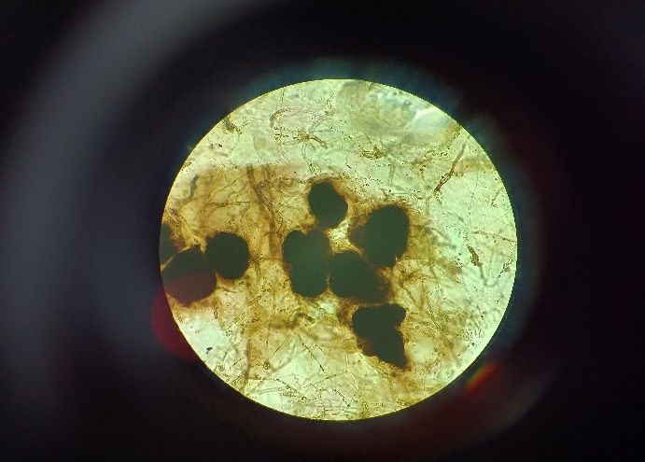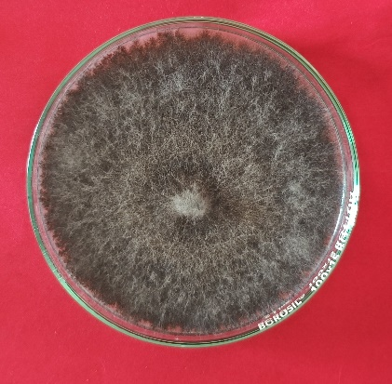

**Picture 1B. Microsclerotia of M. phaseolina**

**Picture. 1 A. Pure culture of *M. phaseolina***

1. **MATERIAL AND METHODS**

Blight-infected samples were washed with tap water and placed on blotter paper to dry. In a laminar air flow chamber, sterilized PDA medium was poured into Petri plates and left to solidify. Small pieces of infected tissue, containing both healthy and diseased parts, were cut with a sterile blade and surface sterilized using 0.1% sodium hypochlorite for two minutes. After rinsing three times with sterile distilled water, the pieces were blot-dried and aseptically placed on PDA plates.

The plates were incubated at 27 ± 2°C and fungal growth was observed after 6–8 days. The pathogen was purified using the single hyphal-tip method and sub-cultured on fresh PDA. Identification was done based on colony characteristics and microscopic features, especially the shape, size and colour of sclerotia (Chavan *et al*. 2023).

**Pathogenicity test**

Pathogenicity of *Macrophomina phaseolina* were proved *in-vitro* (pot culture) by applying Koch's postulates. Surface sterilized seeds of *Macrophomina phaseolina* susceptible mungbean Cv. JL-781 were sown (@10 seeds/pot) in the earthen pots (30 cm diameter) filled with steam sterilized potting mixture of soil: sand: FYM (2:1:1). After a week healthy growing mungbean seedlings in pot were maintained, watered regularly and kept in the green house for further growth. Spore-cum-mycelial suspension of the test pathogen was prepared by harvesting freshly sporulating 7-8 days old culture in plates by flooding with 5-10 ml sterile distilled water. The resultant spore-cum-mycelial suspension was suitably diluted with sterile distilled water to get inoculum concentration of 5 x 106 spores/ml. Thirty days old seedling of mungbean Cv. JL-781 were artificially inoculated by spraying with atomizer containing the sclerotial suspension (5 x 106 sclerotia/ml) of the test pathogen. Seedlings sprayed with sterile water (without inoculum) were also maintained as suitable control. Inoculated plants were incubated in the green house polythene bag is wrapping around the inoculated pot where high humidity (>80%) and optimum temperature (27 ± 2 °C) were maintained for further development of blight symptoms. Characteristic symptoms of *Macrophomina* blight is appeared Pathogen was reisolated from the developed symptoms on artificially inoculated mungbean leaves. The resulting cultures were compared with the original inoculants to fulfill Koch’s postulates.

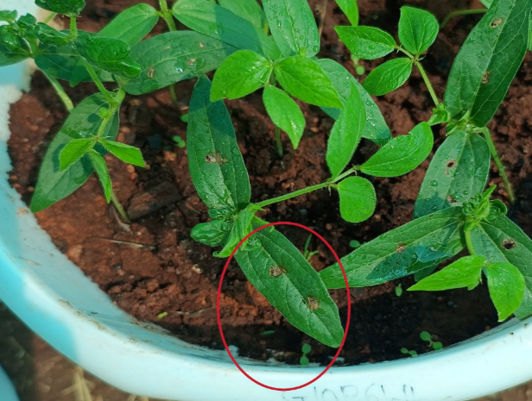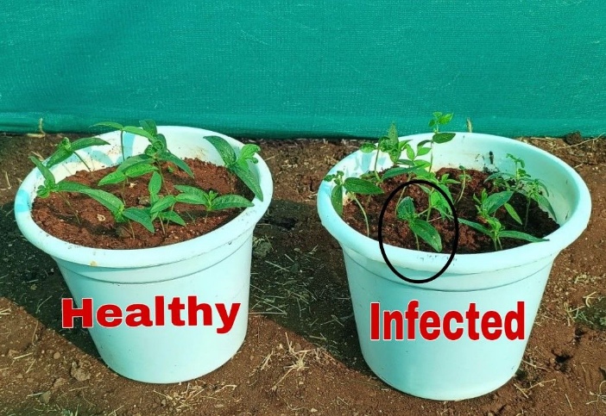

**Picture 2C. Infected region**

**Picture . 2. A. Uninoculated healthy**

**2B. infected plant after inoculation**

**Antimicrobial efficacy of bioagents:**

The efficacy of six biocontrol agents Trichoderma harzianum, Trichoderma asperellum, Trichoderma hamatum, Trichoderma virens, Pseudomonas fluorescens and Bacillus subtilis against Macrophomina phaseolina was evaluated through the dual culture technique.

**Dual Culture Technique**

Potato Dextrose Agar (PDA) was prepared and sterilized at 121°C and 15 psi for 20 minutes. About 20 ml of the medium was poured into 90 mm sterile Petri plates. Once solidified 5 mm disc from a 7-day-old culture of *Macrophomina phaseolina* was placed near the edge of the plate. On the opposite side, a disc of the fungal biocontrol agent was placed at an equal distance. For bacterial antagonists, the culture was streaked on the side opposite the pathogen. Plates with only *Macrophomina phaseolina* served as controls.

**Experimental Procedure**

All inoculated Petri dishes were incubated at a temperature of 27 ± 2°C for a period of seven days. Each treatment was carried out in triplicate. Observations were recorded once the fungal growth in the untreated control plates reached the full diameter of 90 mm. The radial growth of Macrophomina phaseolina was measured in each treatment and the percentage inhibition of fungal growth compared to the control was calculated using the formula proposed by (Vincent 1947).

$$\text{I=}\frac{\text{C ­ T}}{\text{ C }}\text{x 100}$$

Where, I= Per cent Inhibition of fungal growth

C= Colony growth diameter (mm) in control plate

T= Colony growth diameter (mm) in treated plate

1. **RESULT AND DISCUSSION**

The mycoparasitic ability of six biocontrol agents, including fungal species (*Trichoderma* spp.) and bacterial species (*Bacillus subtilis* and *Pseudomonas fluorescens*) was examined for their antagonistic activity against *Macrophomina phaseolina*. The evaluation was carried out by employing dual culture and streak plate technique on the PDA, the base medium. Table 1 and Plate 1 represents the experimental results. The results showed considerable differences in the efficacy of the bioagents tested. Among six bioagents tested, *Trichoderma harzianum* demonstrated the highest inhibition of growth of pathogen with a colony diameter of 11.00 mm and a growth inhibition percentage of 87.77 per cent which is superior compared to the other treatments. This was followed *Trichoderma hamatum,* which exhibited a colony diameter of 49.00 mm and a growth inhibition of 45.55 per cent.

*Trichoderma asperellum* and bacterial bioagents *Bacillus subtilis* showed moderate efficacy with colony diameter of 60.50 mm and 65.83 mm and growth inhibition rates of 32.77 per cent and 27.41 per cent, respectively and *Trichoderma virens* show colony diameter 74.00 mm and growth inhibition 17.77 per cent. The bacterial bioagents *Pseudomonas fluorescens* were least effective with colony diameter of 53.50 mm and 78.33 mm and growth inhibition rates of 12.96 per cent and 36.52 per cent, respectively.

These findings support the observations made by several earlier researchers. Singh *et al.* (2007) examined the inhibitory effects of *Trichoderma* species under laboratory conditions and found that *Trichoderma harzianum* exhibited the highest inhibition rate 71.85 per cent. They reported that *Trichoderma harzianum* showed the best performance.

**Table 1. Efficacy of various bioagents against *Macrophomina phaseolina* under *in vitro* conditions*.***

|  |  |  |  |
| --- | --- | --- | --- |
| **Tr. No.** | **Treatments** | **Colony Diameter of the Pathogen* (mm)** | **% Growth Inhibition** |
| T1 | *Trichoderma harzianum* | 11.00 | 87.77 |
| T2 | *Trichoderma asperellum* | 60.50 | 32.77 |
| T3 | *Trichoderma hamatum* | 49.00 | 45.55 |
| T4 | *Trichoderma virens* | 74.00 | 17.77 |
| T5 | *Pseudomonas fluorescens* | 78.33 | 12.96 |
| T6 | *Bacillus subtilis* | 65.83 | 27.41 |
| T7 | Control | 90.00 | - |
|  | **S.E.(m)±** | **0.51** | - |
|  | **C.D. (0.05)** | **1.57** | - |

*Mean of three replication.

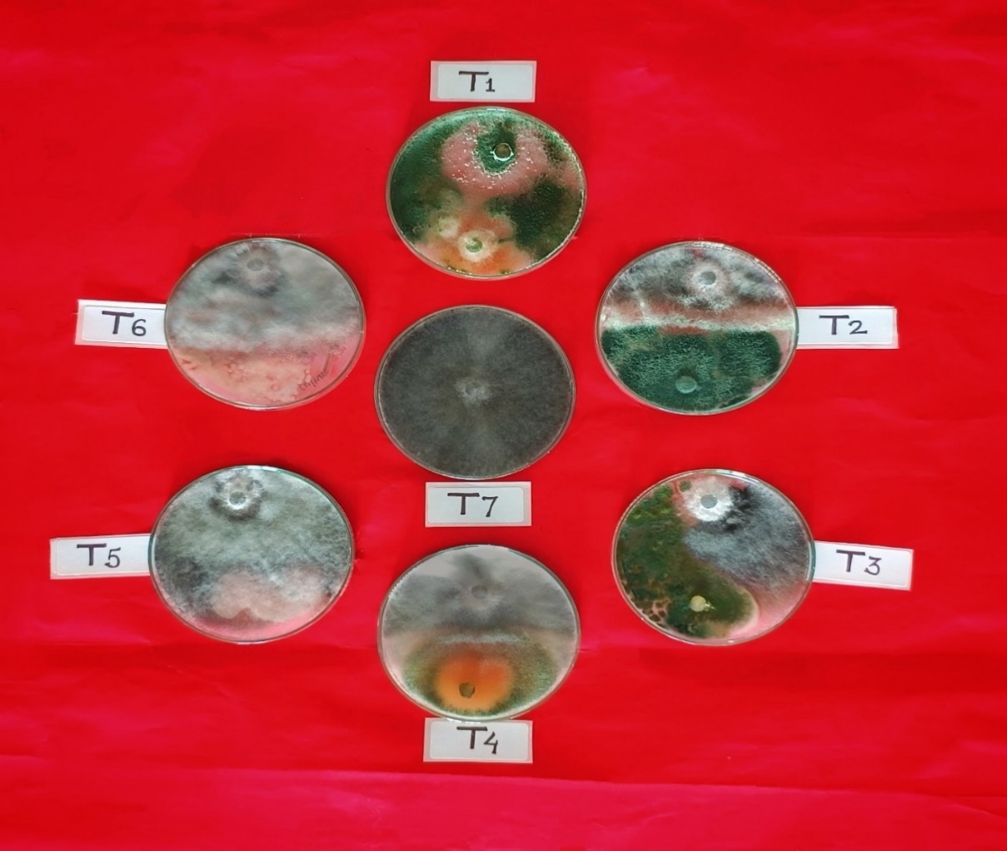

**Plate 1. *In vitro* efficacy of various bioagents against *M. phaseolina***

**Fig.1 *In vitro* evaluation of biocontrol agent against *Macrophomina phaseolina***

**4. CONCLUSIONS**

The *in vitro* assessment of six biocontrol agents indicated that Trichoderma harzianum strong antagonistic activity and achieved the highest inhibition of mycelial growth against the target pathogen.

.

**DISCLAIMER**

Author(s) hereby declares that NO generative AI technologies such as Large Language Models (ChatGPT, COPILOT, etc.) and text-to-image generators have been used during writing or editing of manuscripts. COMPETING INTERESTS: Authors have declared that no competing interests exist.

**REFERENCES**

1. Chavan, V. A., Khaire, P. B., Sawant, C. G., Shinde, A. G. and Yumlembam, R. A. (2023). *In vitro* assessment of efficacy of different fungicides against Macrophomina phaseolina, a green-gram blight pathogen of Western Maharashtra. The Pharma Innovation Journal, **12**(12): 2458–2464.
2. Dennis, C. and Webster, J. (1971). Antagonistic properties of species-groups of Trichoderma: II. Production of volatile antibiotics. Transactions of the British Mycological Society, **57**(1): 41–44.
3. Gary, W. H., Mengistu, A. and Smith, J. R. (1991). Macrophomina phaseolina as a high-temperature, drought-favoring pathogen. International Journal of Advanced Biochemistry Research, **8**(12): 10–15.
4. Mallaiah, B. and VKR. (2018). Integrated management of dry root rot of greengram [Vigna radiata (L.) Wilczek] incited by Macrophomina phaseolina (Tassi) Goid. National Academy of Agricultural Science, **34**(3): 607–614.
5. Mekkara Nikarthil Sudhakaran, S. and Bukkan, D. S. (2021). A review on nutritional composition, antinutritional components and health benefits of green gram (Vigna radiata (L.) Wilczek). Journal of Food Biochemistry, **45**(6): e13743.
6. Ministry of Agriculture and Farmers Welfare. (2024). Final estimates of production of major agricultural crops for 2023–24. Government of India.
7. Muchomba, M. K., Muindi, E. M. and Mulinge, J. M. (2023). Overview of green gram (Vigna radiata L.) crop, its economic importance, ecological requirements and production constraints in Kenya. Journal of Agriculture and Ecology Research International, **24**(2): 1–11.
8. Sandhu, B. S. and Dhaliwal, N. S. (2016). Evaluation of frontline demonstration programme on summer moong in South Western Punjab. Journal of Food Legumes, **29**(3–4): 245–248.
9. Singh, S., Varma, P. and Chand, H. (2007). Evaluation of fungal antagonists against Macrophomina phaseolina causing root rot of mung bean. Legume Research: An International Journal, **30**: 6–8.
10. Tandel, D. H., Sabalpara, A. N., Pandya, H. V. and Naik, R. M. (2010). Effect of leaf blight [Macrophomina phaseolina (Tassi) Goid.] on growth parameters and yield of greengram and its chemical control. International Journal of Plant Protection, **3**(2): 329–331.
11. Vincent, J. M. (1927). Distortion of fungal hyphae in the presence of certain inhibitors. Nature, **159**: 180.
12. Zote, K. K., Dandnaik, B. P. and Khalikar, P. V. (1983). Reaction of mung cultivar to Macrophomina blight. Journal of Maharashtra Agricultural Universities, **8**(2): 147–148.