***Original Research Article***

**Assessment on Compatibility of *Trichoderma asperellum* with Different Fungicides**

**ABSTRACT**

|  |
| --- |
| An *in vitro* study was conducted to evaluate the compatibility of the biological control agent *Trichoderma asperellum* with selected fungicides at both full and half of their recommended concentrations, aiming to enhance integrated disease management strategies. The experiment was carried out at the Department of Plant Pathology, Dr. Sharadchandra Pawar College of Agriculture, Baramati, during 2024–2025, using a Completely Randomized Design (CRD). Seven fungicides—Fosetyl-Al 80% WP, Tebuconazole 25.9% EC, Fluxapyroxad 333 g/L FS, Difenoconazole 25% EC, Kresoxim-methyl 44.3% SC, Propiconazole 25% EC, and Hexaconazole 5% EC—were tested for their compatibility with *T. asperellum* using the poison food technique. Results showed that Fluxapyroxad 333 g/L FS and Kresoxim-methyl 44.3% SC were highly compatible with *T. asperellum* at both full and half doses, allowing more than 90% radial growth. Fosetyl-Al 80% WP demonstrated moderate compatibility at both concentrations, with 65–75% growth. Kresoxim-methyl 44.3% SC also showed moderate compatibility at the recommended concentration. In contrast, Tebuconazole 25.9% EC, Difenoconazole 25% EC, Propiconazole 25% EC, and Hexaconazole 5% EC were incompatible, significantly inhibiting the growth of *T. asperellum*. These findings suggest that Fluxapyroxad and Kresoxim-methyl are suitable for integrated use with *T. asperellum*, while caution should be exercised with Fosetyl-Al. The remaining fungicides should not be used in conjunction with the biocontrol agent to preserve its efficacy. This study supports the selection of compatible chemical partners in integrated plant disease management programs involving biological control agents. |

**Key words*:*** *Trichoderma asperellum*, fungicides, biological control agent, compatibility

1. **INTRODUCTION**

Sustainable agriculture increasingly depends on eco-friendly approaches to managing plant diseases. Among biological control agents, fungi from the genus *Trichoderma* have earned recognition for their ability to combat a wide range of plant pathogens. They do this through several mechanisms such as mycoparasitism, production of antifungal compounds, and competition for space and nutrients (Harman *et al.*, 2004; Vinale *et al.*, 2008). *Trichoderma asperellum* stands out for its effectiveness against both soilborne and foliar diseases, and is commonly used in commercial biocontrol formulations.

Despite growing awareness of the drawbacks of synthetic fungicides—including environmental risks, resistance issues, and harm to non-target organisms—these chemicals remain central to crop protection because of their quick action and broad efficacy (Monte, 2001). To strike a balance between sustainability and efficiency, integrated approaches are gaining ground. One such strategy involves combining biological agents with fungicides under the Integrated Disease Management (IDM) framework.

However, this combination is not always straightforward. Some fungicides can interfere with the growth or activity of *Trichoderma* species, limiting their success in the field (Papavizas, 1985; Mukhopadhyay, 2012). For this reason, compatibility studies are crucial to determine which fungicides can be used alongside biocontrol agents without reducing their performance. These insights help fine-tune IDM programs, ensuring that chemical and biological methods support rather than hinder each other (Srinivasan *et al.*, 2019).

Against this backdrop, the present study evaluates the in vitro compatibility of *Trichoderma asperellum* with a selection of commonly used fungicides, tested at both full and half of their recommended concentrations. The goal is to identify combinations that preserve the efficacy of the biocontrol agent, ultimately contributing to more sustainable and effective disease management practices.

**2. MATERIAL AND METHODS**

**Source of *Trichoderma* culture**

Rhizospheric soil samples were collected from the farm of the College of Agriculture, Baramati to isolate *Trichoderma asperellum*. The samples were processed using the serial dilution method and cultured on Potato Dextrose Agar (PDA) and Trichoderma Selective Medium (TSM), following the procedure outlined by Johnson and Curl (1972). Identification of *T. asperellum* was based on colony morphology, growth pattern, and microscopic features, including the structure of mycelium, conidiophores, phialides, and conidia, as described by Kubicek and Harman (2002). To ensure viability and purity, the fungal cultures were regularly sub-cultured and maintained on PDA and TSM slants under sterile conditions throughout the study.

**Fungicides**

The current research utilized seven systemic fungicides Fosetyl AI 80% WP, Tebuconazole 25.9% EC, Fluxapyroxad 333g/I FS, Difenaconazole 25% EC, Kresoxim methyl 44.3% SC, Propiconazole 25%EC and Hexaconazole 5% EC were obtained from the Plant Pathology Division of Dr. Sharadchandra Pawar College of Agriculture, Baramati and used in this study.

***In vitro* compatibility of *Trichoderma asperellum* with fungicides**

The Standard Poisoned Food Technique was used to assess the compatibility of *Trichoderma* spp. with various fungicides, following the method described by Nene and Thapliyal (1993). The required quantities of each fungicide were calculated based on their active ingredient content and then individually mixed into autoclaved and cooled Potato Dextrose Agar (PDA) to achieve the desired concentrations. The fungicide-amended PDA was aseptically poured into 90 mm Petri plates (20 ml per plate) and allowed to solidify at room temperature.

For each fungicide and its respective concentrations, three replicates were maintained. Once the medium solidified, the plates were inoculated aseptically by placing a 5 mm mycelial disc at the center. The disc was taken from a 7-day-old actively growing culture of *Trichoderma asperellum*, using a flame-sterilized cork borer. All plates were then incubated at 28 ± 1 °C. Petri dishes containing plain PDA without fungicide, inoculated similarly with *T. asperellum*, served as untreated controls.

**Treatment details**

* Design : Completely Randomized Design (CRD)
* Replication : Three
* Treatment : Eight
* Technique : Poison Food technique (Nene and Thapliyal, 1993)

List 1: **Treatment details**

|  |  |  |  |  |
| --- | --- | --- | --- | --- |
| **Tr.**  **No.** | **Treatments** | **Concentration (ppm)** | | **Trade**  **name** |
| **Half of the recommended concentration** | **Recommended concentration** |
| T1 | Fosetyl Al 80% WP | 1000 | 2000 | Bayer Aliette |
| T2 | Tebuconazole 25.9% EC | 750 | 1500 | Bayer Folicur |
| T3 | Fluxapyroxad 333g/I FS | 500 | 1000 | BASF Systiva |
| T4 | Difenaconazole 25% EC | 250 | 500 | Score |
| T5 | Kresoxim methyl 44.3% SC | 250 | 500 | Ergon |
| T6 | Propiconazole 25% EC | 250 | 500 | Tilt |
| T7 | Hexaconazole 5% EC | 250 | 500 | Contaf |
| T8 | Control | - | - | - |

Observations on the mycelial growth of *Trichoderma asperellum* were taken when control plates showed full growth of the fungus. Growth of *Trichoderma* asperellum for each fungicide was determined by measuring mycelial growth diameters. The average data from the replicated plates was taken and the result was expressed as percent inhibition of mycelial growth over the control. The percentage growth inhibition of *Trichoderma asperellum* expressed by using the following formula given by Vincent (1947):

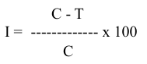

Where,

I = Percent growth inhibition

C = Radial growth of fungus in control plate

T = Radial growth of fungus in treated plate

The range for compatibility based on inhibition percentage is given as- Saha *et al*. (2023)

|  |  |
| --- | --- |
| **Inhibition** | **Nature of compatibility** |
| 0-30% | Highly compatible |
| 31-60% | Moderately compatible |
| 61-90% | Slightly compatible |
| 91-100% | Non-compatible |

**Statistical analysis**

The experimental data were statistically analysed using computer programs designed for Completely Randomized Block Design (CRD). The standard error (SE) and critical difference (C.D.) at a significance level of P=0.05 *(In vitro)* were calculated, and the results were statistically compared. (Panse and Sukhatme, 1967)

**3. RESULTS AND DISCUSSION**

Among the systemic fungicides tested at half of the recommended dose, *Trichoderma asperellum* showed high compatibility with Fluxapyroxad 333 g/L FS and Kresoxim-methyl 44.3% SC, which recorded the lowest levels of mycelial growth inhibition at (8.52% and 19.81%), respectively. In contrast, Fosetyl-Al 80% WP was found to be moderately compatible, causing (47.78%) inhibition of mycelial growth.

However, among the rest of three fungicides tested at half of the recommended concentration *viz.,* Tebuconazole 25.9% EC, Propiconazole 25% EC and Hexaconazole 5% EC were recorded completely incompatible by causing maximum mycelial growth inhibition (94.44%) of *T. asperellum.* The fungicide Difenaconazole 25% EC also resulted incompatible with *Trichoderma asperellum* as its percent mycelial growth inhibition was (91.48%).

At recommended concentration of systemic fungicides tested with *Trichoderma asperellum*, the fungicides Fluxapyroxad 333g/I FS and Kresoxim methyl 44.3% SC were found moderately compatible with less average mycelial growth inhibition (34.08% and 39.53%, respectively) of *T. asperellum.* fungicideFosetyl Al 80% WP resulted slightly compatible with (86.30%) mycelial growth inhibition.

In contrast, remaining three fungicides *viz.,* Tebuconazole 25.9% EC, Difenaconazole 25% EC, Propiconazole 25% EC and Hexaconazole 5% EC appeared to be completely incompatible by causing maximum mycelial growth inhibition of *T. asperellum.*

The results of this study align closely with the observations made by Dinkwar *et al.* (2023), who found that Fluxapyroxad 333 g/L FS worked well in combination with *Trichoderma* isolates, showing high compatibility. In contrast, Tebuconazole 25.9% EC was noted to be strongly incompatible. These findings are further supported by Maheshwary *et al.* (2020), who reported that both Tebuconazole 25.9% EC and Propiconazole 25% EC had adverse effects on the growth of *Trichoderma asperellum*. Bagwan (2010) and Bindu *et al*. (2011), where also reported the incompatibility of Tebuconazole with *Trichoderma*. Results of Kumar *et al*. (2017) are also in agreement with result obtained in present study *i.e.,* propiconazole 25% EC and Hexaconazole are completely incompatible with *T. asperellum.* Saha *et al. (*2023),proved thatKresoxim methyl 44.3% SC is highly compatible with *T. asperelloides.* Dwivedi and Vishunavat (2018) reported incompatibility of Tebuconazole 25.9% EC with *Trichoderma asperellum*.

**Table 1*. In Vitro* Effect of Systemic Fungicides on *Trichoderma asperellum***

|  |  |  |  |  |  |
| --- | --- | --- | --- | --- | --- |
| **Tr. No.** | **Treatments** | **Radial mycelial growth (mm)\*** | | **% Growth Inhibition** | |
| **Half of the recommended concentration** | **Recommended concentration** | **Half of the recommended concentration** | **Recommended concentration** |
| T1 | Fosetyl Al 80% WP | 47.00 | 12.33 | 47.78 | 86.30 |
| T2 | Tebuconazole 25.9% EC | 5.00 | 5.00 | 94.44 | 94.44 |
| T3 | Fluxapyroxad 333g/I FS | 82.33 | 59.33 | 8.52 | 34.08 |
| T4 | Difenaconazole 25% EC | 7.67 | 5.00 | 91.48 | 94.44 |
| T5 | Kresoxim methyl 44.3% SC | 72.17 | 54.42 | 19.81 | 39.53 |
| T6 | Propiconazole 25% EC | 5.00 | 5.00 | 94.44 | 94.44 |
| T7 | Hexaconazole 5% EC | 5.00 | 5.00 | 94. 44 | 94.44 |
| T8 | Control | 90.00 | 90.00 | 00.00 | 00.00 |
|  | **S.E.(m)±** | **0.83** | **0.63** | **-** | **-** |
|  | **C.D. (5%)** | **2.50** | **1.90** | **-** | **--** |

*Mean of three replications

**Plate 1. *In vitro* assessment of *T. asperellum* with systemic fungicides at half of the recommended and recommended concentration.**

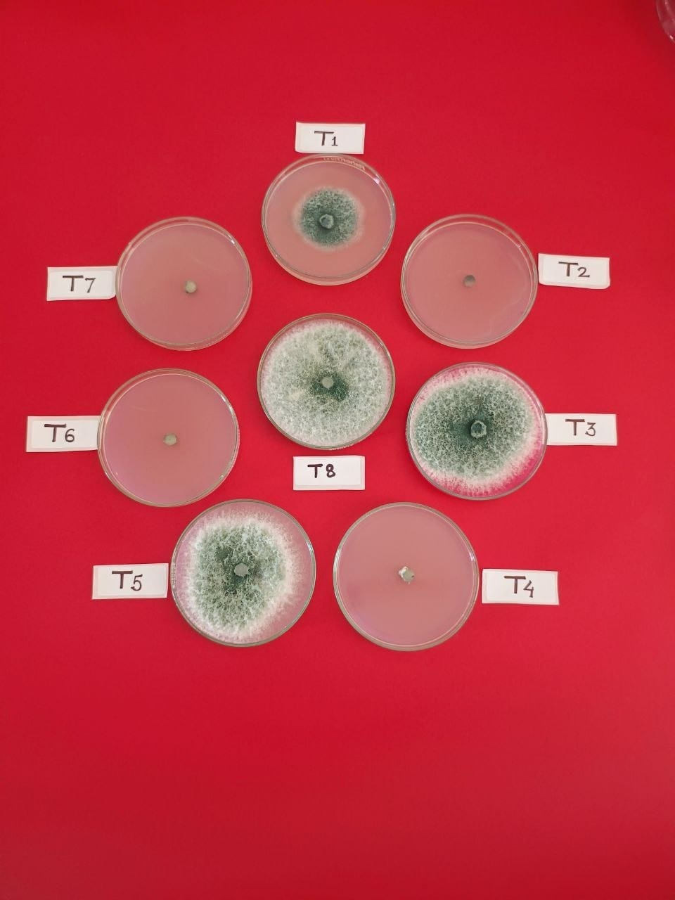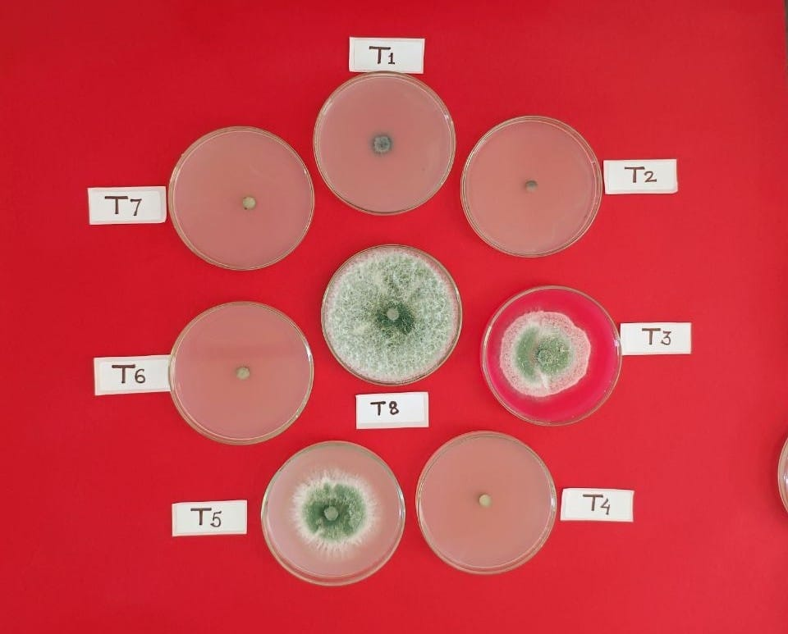

Half of the recommended concentration

Recommended concentration

**Fig. 1 Colony diameter of *T. asperellum* under *in vitro* conditions at half of the recommended and recommended concentration**

**4. CONCLUSIONS**

The *in vitro* evaluation of compatibility of *Trichoderma asperellum* with seven systemic fungicides showed that, Fluxapyroxad 333g/I FS and Kresoxim methyl 44.3% SC were highly compatible. While, Fosetyl Al 80% WP was slightly compatible at both concentrations and remaining fungicides *i.e.,* Tebuconazole 25.9% EC, Difenaconazole 25% EC, Propiconazole 25% EC, Hexaconazole 5% EC showed incompatibility with *Trichoderma asperellum* at both concentrations.

**REFERENCES**

1. Bagwan N. B. (2010) Evaluation of *Trichoderma* compatibility with fungicides, pesticides, organic cakes and botanicals for integrated management of soilborne diseases of soybean [*Glycine max* (L.) Merril]. *International Journal of Plant Protection*., **3**(2): 206-209.
2. Bharadwaz, P., Nath, B. C., Chetia, R., Saikia, S., Bora, P. and Bhattacharyya, P. N. (2023). *In vitro* studies on the compatibility of Trichoderma viride with commonly used agrochemicals in the vegetable cropping system. *Pest Management in Horticultural Ecosystems,* **29**(1): 136-143.
3. Bindu M. G., Bhattiprolu S. L. and Balireddy V. (2011) Compatibility of biocontrol agent *Trichoderma viride* with various pesticides. *Journal Horticulture Science*., **6**(1):71-73.
4. Dinkwar, G. T., Yadav, V. K., Kumar, A., Nema, S. and Mishra, S. (2023). Compatibility of fungicides with potent *Trichoderma* isolates. *International Journal of Plant and Soil Science*., **35**(18): 1934-1948.
5. Harman, G. E., Howell, C. R., Viterbo, A., Chet, I. and Lorito, M. (2004). *Trichoderma* species—opportunistic, avirulent plant symbionts. *Nature Reviews Microbiology.***, 2**(1): 43–56.
6. Johnson L. F. and Crul E. A. (1972) Methods of research on ecology of soil borne pathogens. Minneapolis U.S. Burgess Publ., :247.
7. Kubicek, C. P. and Harman, G. E. (Eds.). (2002). *Trichoderma and Gliocladium: Volume 1. Basic biology, taxonomy and genetics*. London, UK: Taylor and Francis.
8. Kumar, N. and Singh, S. K. (2017). Screening of tolerance and compatibility of *Trichoderma viride* against common fertilizers and fungicides. *International Journal of Chemical Studies.,* **5**(4): 1871-1874.
9. Maheshwary, N., Gangadhara Naik, B., Amoghavarsha Chittaragi, M., Naik, S. K. and Nandish, M. (2020). Compatibility of *Trichoderma asperellum* with fungicides. *The Pharma Innovation Journal*., **9**(8): 136-140.
10. Monte, E. (2001). Understanding *Trichoderma*: Between biotechnology and microbial ecology. *International Microbiology***, 4**(1): 1–4.
11. Mukhopadhyay, A. N. (2012). Biological control of plant diseases: Status in India. In M. S. Reddy (Ed.), *Biological Control of Crop Diseases* (pp. 1–20). Scientific Publishers.
12. Nene, Y.L. and Thapliyal, P.N. (1993). Fungicides in plant disease control, 3rd edition, Oxford, IBH Publishing Company, New Delhi, 531-532.
13. Papavizas, G. C. (1985). *Trichoderma* and *Gliocladium*: Biology, ecology, and potential for biocontrol. *Annual Review of Phytopathology.***, 23**: 23–54.
14. Saha, S., Pharate, S., Thosar, R. U. and Chavan, V. (2023). Compatibility of *Trichoderma asperelloides* with Fungicides Controlling Downy Mildew and Powdery Mildew in Grapes. *Grape Insight.*, **1**(1): 32-36.
15. Srinivasan, K., Santhosh, R. S. and Kumar, V. (2019). Compatibility of *Trichoderma* spp. with commonly used agrochemicals and its implication in IDM. *Journal of Biological Control.,* **33**(2): 132–139.
16. Vinale, F., Sivasithamparam, K., Ghisalberti, E. L., Marra, R., Woo, S. L. and Lorito, M. (2008). *Trichoderma*-plant-pathogen interactions. *Soil Biology and Biochemistry.***, 40**(1): 1–10.
17. Vincent J (1947). Distortion of fungal hyphae in the presence of certain inhibitors. *Nature.,***159**(4051): 850-850.