Comparative Analysis of Conventional and Non-Linear Growing Degree Day Methods for Wheat Yield Prediction in Punjab, India

ABSTRACT

|  |
| --- |
| **Aims:** To evaluate the accuracy and reliability of three Growing Degree Day (GDD) calculation methods—linear (Method 1), improved linear (Method 2), and cosine-wave (Method 3)—for predicting wheat phenological stages and yield in Punjab, India, to optimize agricultural practices in semi-arid regions.  **Study design:** Comparative field-based experimental study.  **Place and Duration of Study:** Research Farms of Punjab Agricultural University, Ludhiana; Research Station, Faridkot, and Research Station, ballowal Saunkhri.  **Methodology:** Field experiments involved the wheat variety Unnat PBW 550, planted on November 15th at three locations. Weather data from Agrometeorological Observatories were used to calculate GDD using three methods. Phenological stages were observed, and GDD was computed for each method. Model performance was assessed using the coefficient of variation (CV), Willmott’s refined index of agreement (dr), and logistic modeling of dry matter accumulation (R² and RMSE).  **Results:** GDD for maturity at Ballowal Saunkhri was 1880.8 ± 34 °C (Method 1), 1710.65 ± 34 °C (Method 2), and 1618 ± 38 °C (Method 3). Method 3 showed the lowest CV (3.5% for tillering) and highest dr (0.98 in 2020 at Ballowal Saunkhri). Logistic modeling indicated Method 3’s superior accuracy (R² = 0.989, RMSE = 0.039 at Ballowal Saunkhri) compared to Method 1 (R² = 0.982, RMSE = 0.047) and Method 2 (R² = 0.970, RMSE = 0.062).  **Conclusion:** The cosine-wave method (Method 3) offers superior precision for GDD estimation, enhancing wheat yield predictions and resource management in semi-arid regions. Further validation across diverse crops and climates is recommended. |

*Keywords: GDD, Cosine-wave, Phenological Modeling, Wheat, Index of Agreement*

1. INTRODUCTION

Accurate estimation of Growing Degree Days (GDD) is pivotal for understanding crop phenology, optimizing agricultural management practices, and improving yield predictions. GDD serves as a thermal index that quantifies heat accumulation over a specified baseline temperature, which is vital for crop development stages such as germination, flowering, and maturation [1]. In recent decades, GDD has emerged as a critical tool in agronomic research, aiding in the development of crop simulation models and decision support systems [2], [3].

Traditional methods for calculating GDD involve simple linear models that assume a constant accumulation of heat above a defined base temperature. Despite their widespread use due to simplicity and minimal data requirements, these methods may oversimplify thermal dynamics and fail to account for daily temperature fluctuations [4]. Improved traditional methods address some of these limitations by incorporating adjustments for diurnal temperature variations and extreme weather conditions [5]. However, recent advancements in computational techniques have led to the adoption of the sine wave method, which provides a more refined estimation of GDD by modeling daily temperature variations as a sine curve [6] [7].

Punjab, a major wheat-producing region of India, presents a unique context for evaluating these methods. The state’s semi-arid climate, characterized by significant diurnal temperature variations and distinct cropping seasons, necessitates precise thermal indices to ensure optimal crop management. While several studies have evaluated GDD estimation techniques in temperate and subtropical climates [8], [9], [10], limited research has focused on the applicability of these methods in the context of Punjab’s agricultural ecosystem. This research seeks to fill this gap by systematically comparing the traditional, improved traditional, and sine wave methods for calculating GDD for wheat crops in Punjab.

The research aims to identify the most suitable GDD estimation technique for Punjab by evaluating the accuracy and reliability of these methods against observed wheat phenological stages and yields. Furthermore, the findings are expected to contribute to a deeper understanding of temperature-driven crop dynamics and inform agricultural policy and practice in similar agro-climatic regions.

2. material and methods

Field experiments were conducted at three distinct locations: the Punjab Agricultural University Farm in Ludhiana, the Research Station in Faridkot, and Ballowal Saunkhri. These sites were chosen to reflect the diverse agro-climatic conditions found across Punjab. The wheat variety Unnat PBW 550, planted on November 15th, was used for the study.

Weather data for the rabi seasons spanning 2017-18 to 2021-22 was collected from the Agrometeorological Observatories at each experimental site. This data was then used to calculate agroclimatic indices, including Growing Degree Days (GDD) at critical phenophases.

**2.1 Methods for GDD calculation**

**Present widely used methods.** [1] proposed two methods for calculating degree days (DD) (Methods 1 and 2) needed for calculating growing degree days (GDD), and both methods have been widely used in recent studies. Method 1, which is simpler than Method 2, calculates DD as:

DD = Tav-Tb

Tav = (Tmax+Tmin)/2

where, Tmax = maximum temperature, Tmin = minimum temperature and Tb = base temperature

Method 2 is an improvement on Method 1. Tb is compared with Tu (upper threshold temperature) before the average temperature (Tavg′) is calculated. Tm and Tn are adjusted if they are <Tb or >Tu. In this method, DD is given by:

DD = Tav’-Tb

Tavg′ = (Tm + Tn)/2

where Tm = min (Tmax, TU), Tn = max (Tm, Tb),

**Cosine-Wave Method Formula**

The cosine-wave method for calculating growing degree days (GDD) was introduced by [11]. The method uses the cosine function to approximate the daily temperature cycle, improving the estimation of degree days compared to simpler methods like the linear or sine-wave approaches. This model is particularly suitable for agricultural and ecological studies that require precise temperature-based calculations for crop growth or phenological development.

Degree Day Calculation (DD):

DD = α[(sinθ2 – sinθ1) + (θ2 – θ1)cos θ2]+(Tav-TL)( θ2- θ1)

Where,

α = Temperature amplitude which is calculated as half the difference between daily maximum and minimum temperatures (Tmax-Tmin)/2.

θ1 = Angle for lower threshold (TL) and is calculated as: θ1 = arccos [(TL-Tav)/α]

θ2 = Angle for upper threshold (TL) and is calculated as: θ2 = arccos [(TU-Tav)/α]

Tav = Daily average temperature (Tmax+Tmin)/2.

**Growing Degree Days (GDD)** are then calculated as following:

GDD=∑DD

**2.2 Model evaluation**

GDD is often used to describe biological processes but no canonical forms are available for calculating GDD. Hence, we used the coefficient of variation (CV) of predictions of developmental stages and the performance of the accumulation of dry matter described by GDD to evaluate the three methods.

Predicting developmental stages: the observed dates of developmental stages from the field data were used to calculate the GDD required to reach a particular stage by all the three methods. However, the GDD required to reach a particular stage calculated by a particular method with observed dates in different years was not always the same. The CV of the dates predicted by one method for calculating GDD was used to test the performance of the method. The lower the CV, the better the prediction. CV was calculated as:

CV= SDGDD/GDDm

Where, SDGDD is the standard deviation of the annual GDD required for a particular developmental stage since sowing, and GDDm is the mean daily GDD during the developmental stage since sowing.

Willomtt proposed a refined index of agreement (dr) for evaluating model performance, defined as:

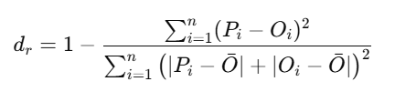​

**Where:**

* Pi​: Predicted value at instance iii.
* Oi​: Observed value at instance iii.
* Oˉ: Mean of observed values.
* n: Number of observations.

dr​ ranges from 0 to 1. dr​=1: Perfect agreement between predicted and observed values. dr​=0: No agreement.

Describing the accumulation of dry matter: The accumulation of dry matter is commonly described by a logistic model as a function of GDD. The normalized logistic model was fitted by GDD to test the performance of the methods for calculating GDD as follows:



where *YO* is the observed amount of dry matter, *Ym* is the maximum amount of dry matter, *y* is the normalized amount of dry matter, and *a* and *b* are coefficients. The fitted amount of dry matter for each location was evaluated by the root mean square error (RMSE), defined as:

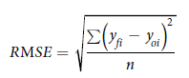

where *yoi* and *yfi* are the observed and fitted amounts of dry matter, respectively, and n is the number of observations.

3. results and discussion

The Growing Degree Days (GDD) required to progress from sowing to various developmental stages were calculated using three different methods for wheat, as illustrated in Figures 1. The GDD values for the same crop at the same location varied depending on the calculation method. For instance, at the Ballowal Saukhri, the GDD needed for wheat to reach maturity was 1880.8 ± 34 °C (Method 1),

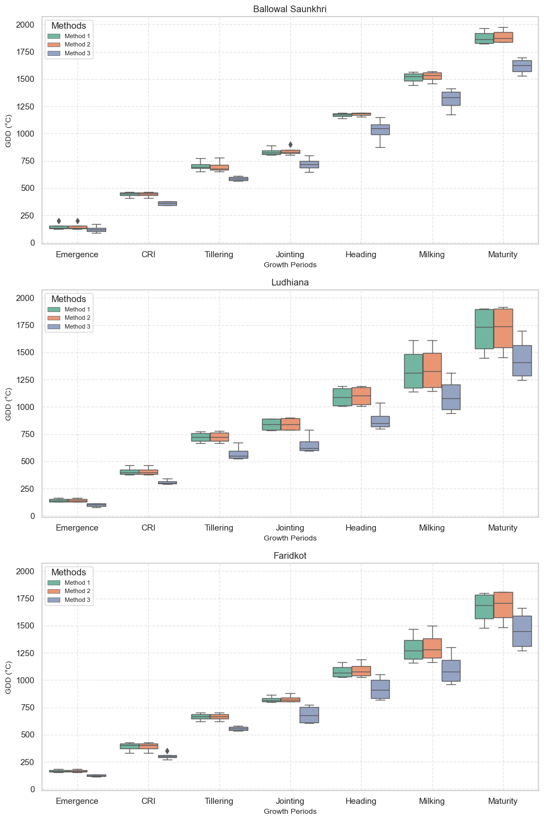

**Fig. 1. Box plots of GDD required to reach the developmental stages after sowing calculated by the three methods for wheat at three stations: Ballowal Saukhri, Ludhiana and Faridkot.**

1710.65 ± 34 °C (Method 2) and 1618 ± 38 °C (Method 3). Similarly, Method 1 determined that wheat required 1702.7 ± 116 °C at the Ludhiana and 1663.2 ± 77 °C at the Faridkot to reach maturity. Method 2 determined GDD requirement as 1710.7 ± 116 °C at the Ludhiana and 1675.8 ± 80 °C at the Faridkot for wheat to reach maturity Method 3 produced significantly lower GDD *viz*., 1439.2 ± 105°C and 1455.6 ± 95°C for wheat at Ludhiana and Faridkot, respectively, compared to Methods 1 and 2.

The coefficient of variation (CV) values for phenological stages across three locations—Ballowal Saunkhri, Ludhiana, and Faridkot—were analyzed to assess the performance of three GDD calculation methods. Low CV values indicate better reliability and precision of GDD estimation, which is critical for accurate phenological modeling [12].

At Ballowal Saunkhri, Methods 1 and 2 showed similar low variation for Emergence (24.4%) and CRI (~5%), suggesting these methods' suitability for early stages with minimal temperature fluctuations. In contrast, the cosine-wave method (Method 3) exhibited slightly higher variation for Emergence (27.2%) but notably lower variation for Tillering (3.5%), reflecting its ability to model temperature dynamics effectively during intermediate stages. The reduced variation in Method 3 during Tillering may result from its capacity to account for diurnal temperature variations more accurately [13].

**Table 1. CV (%) of the predicted developmental stages for wheat.**

|  |  |  |  |  |  |  |  |  |
| --- | --- | --- | --- | --- | --- | --- | --- | --- |
| Location | Method | Emergence | CRI | Tillering | Jointing | Heading | Milking | Maturity |
| Ballowal Saunkhri | Method 1 | 24.4 | 5.2 | 7.1 | 4.7 | 2.01 | 3.6 | 3.6 |
| Method 2 | 24.4 | 5.3 | 7.8 | 5.1 | 1.54 | 3.3 | 3.5 |
| Method 3 | 27.2 | 5.5 | 3.5 | 8.9 | 11.1 | 8.1 | 4.7 |
| Ludhiana | Method 1 | 12.7 | 9.3 | 7 | 7.2 | 8.8 | 16.5 | 13.5 |
| Method 2 | 12.7 | 9.3 | 7.1 | 7.6 | 8.7 | 16.3 | 13.5 |
| Method 3 | 17.2 | 7.1 | 11.8 | 12.7 | 12.1 | 15.4 | 14.4 |
| Faridkot | Method 1 | 8.5 | 11.1 | 5.4 | 3.6 | 5.9 | 10.7 | 9.3 |
| Method 2 | 8.5 | 11.1 | 5.2 | 4.3 | 6.7 | 11.3 | 9.5 |
| Method 3 | 8.1 | 10.6 | 3.9 | 12.6 | 12.2 | 13.9 | 13 |

At Ludhiana, Methods 1 and 2 consistently provided low CV values across all stages, including Emergence (12.7%) and CRI (9.3%), reaffirming their stability for regions with moderate climatic variability. Method 3, however, exhibited slightly higher variation during Tillering (11.8%) and Jointing (12.7%), likely due to its sensitivity to localized temperature extremes. Despite this, Method 3 demonstrated comparable or lower CV values during Heading and Maturity stages, indicating improved precision in later stages.

At Faridkot, the cosine-wave method showed the lowest variation for Emergence (8.1%), outperforming Methods 1 and 2 (8.5%). However, its higher CV for Jointing (12.6%) and Heading (12.2%) suggests the influence of more pronounced temperature oscillations in this region. These results align with findings by [14], emphasizing the need for dynamic GDD models in arid and semi-arid climates.

Overall, Methods 1 and 2 consistently provided low variation for early stages, while Method 3 excelled in mid- to late phenological stages due to its advanced temperature modeling capabilities. The cosine-wave method’s flexibility makes it particularly suitable for regions with variable temperature patterns, aligning with recent studies advocating for refined GDD models in climate-resilient agriculture [15].

The Willmott's refined index of agreement (dr​) was calculated to evaluate the performance of three methods for estimating growing degree days (GDD) across three locations (Ballowal Saunkhri, Ludhiana, and Faridkot) during 2020 and 2021. Higher dr​ values indicate better agreement between observed and predicted values, with values close to 1 signifying superior model performance.

**Table 2. Dr for the prediction of developmental stage using the three methods.**

|  |  |  |  |  |
| --- | --- | --- | --- | --- |
| Location | Year | Method 1 | Method 2 | Method 3 |
| Ballowal Saunkhri | 2020 | 0.80 | 0.86 | 0.98 |
| 2021 | 0.93 | 0.92 | 0.94 |
| Ludhiana | 2020 | 0.94 | 0.94 | 0.95 |
| 2021 | 0.92 | 0.90 | 0.96 |
| Faridkot | 2020 | 0.95 | 0.93 | 0.96 |
| 2021 | 0.90 | 0.84 | 0.91 |

At Ballowal Saunkhri, Method 3 consistently demonstrated the highest agreement (dr = 0.98 in 2020 and 0.94 in 2021), outperforming both Methods 1 and 3. This highlights the advantage of Method 3’s refined temperature threshold adjustments for regions with moderate temperature variability. Method 2 showed moderate agreement (dr ​= 0.86 in 2020 and 0.92 in 2021), while Method 1, though simpler, performed comparably in 2021 (dr = 0.93).

At Ludhiana, all methods displayed strong agreement during both years, with Method 3 achieving the highest dr​ values (0.95 in 2020 and 0.96 in 2021). Methods 1 and 2 performed similarly in 2020 (dr ​= 0.94), but Method 3's performance dropped slightly in 2021 (dr = 0.90). This suggests that Method 2's adjustments to extreme temperatures contributed to its higher consistency.

At Faridkot, Method 3 again outperformed others with the highest dr​ values (0.96 in 2020 and 0.91 in 2021). Method 2 showed reduced agreement in 2021 (dr = 0.84), indicating a decline in performance under more variable climatic conditions. In contrast, Method 1 remained stable but slightly lower in performance compared to Method 3.

Overall, Method 3 consistently achieved the highest dr​ values across all locations and years, reinforcing its effectiveness in modeling GDD under diverse climatic conditions. These findings align with previous studies advocating for refined temperature threshold adjustments to improve model accuracy [1] [15]

**The performance of describing the accumulation of dry matter:**

The logistic model was applied to analyze the relationship between Growing Degree Days (GDD) and Relative Dry Matter (RDM) across three methods and three locations. The R2 and RMSE values from each combination indicate varying levels of model performance, providing insights into the effectiveness of the methods under different environmental conditions. The accumulation of dry matter was described well with the normalised logistic model as a function of GDD calculated by the three methods for the three locations (Fig. 2), with an RMSE between observed and fitted values by the three methods within 0.06. At Ballowal Saunkhri, Method 3 showed the best performance with the highest R2=0.989 and the lowest RMSE of 0.039. Method 1 (R2=0.982, RMSE = 0.047) and Method 2 (R2=0.970, RMSE = 0.062) also performed well but were slightly less accurate compared to Method 3. For Ludhiana, method 3 again outperformed the other methods (R2=0.982, RMSE = 0.047), followed by Method 2 (R2=0.978, RMSE = 0.051), and Method 1 (R2=0.963, RMSE = 0.067). At Faridkot, Method 3 achieved the highest R2=0.988, with RMSE value 0.039. Method 1 (R2=0.980, RMSE = 0.050) and Method 2 (R2=0.972, RMSE = 0.060) demonstrated consistent and reliable performance.

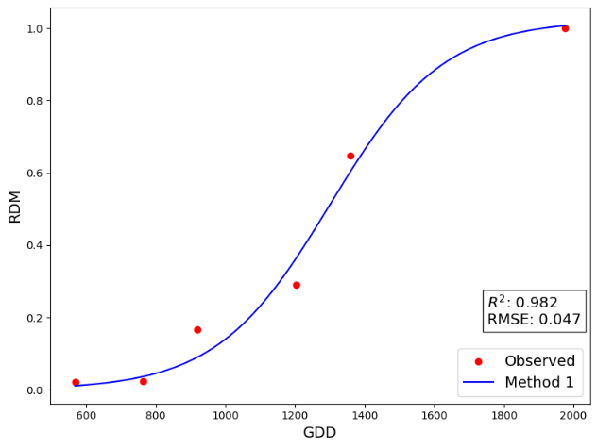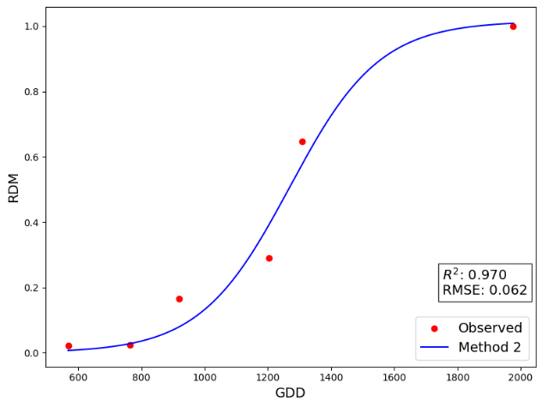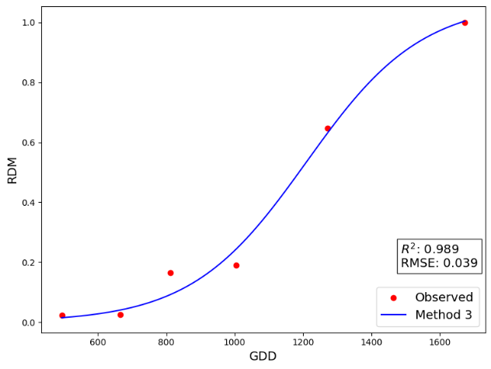

(a)

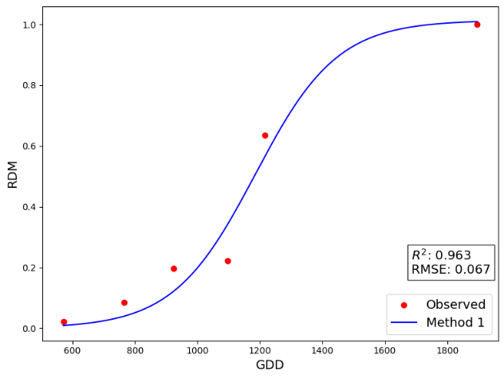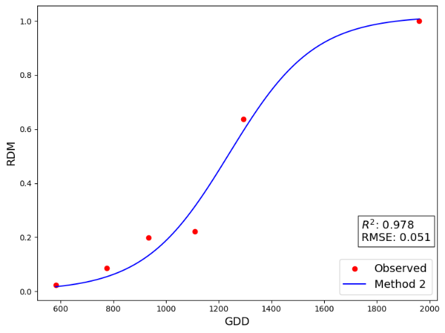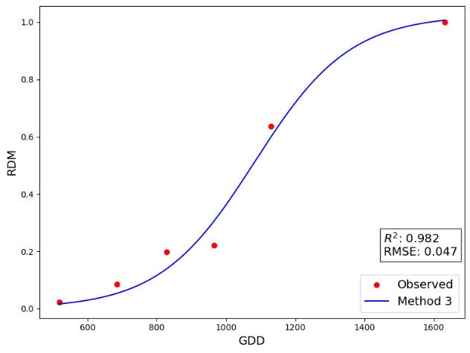

(b)

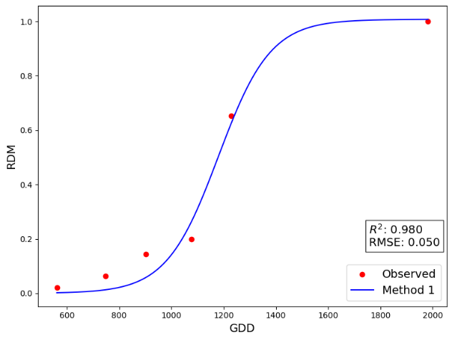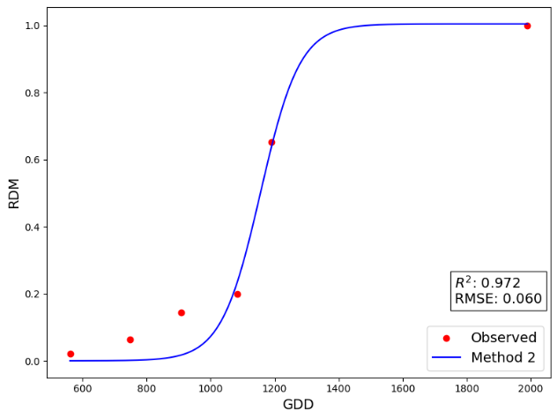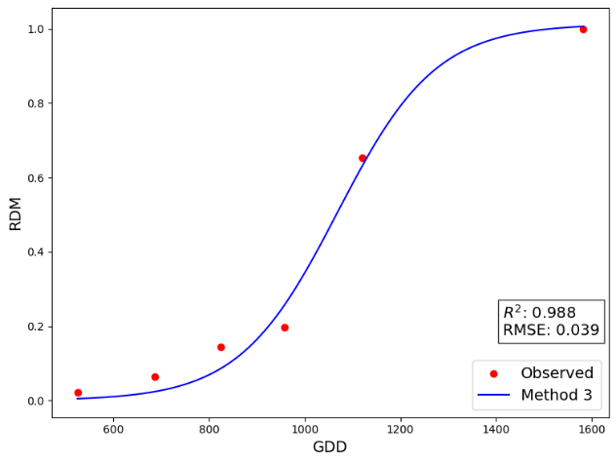

(c)

**Fig. 2.** **Relative accumulation of dry matter (RDM) fitted with a normalized logistic model as function of GDD at (a) Ballowal Saunkhri, (b) Ludhiana, and (c) Faridkot**

The results suggest that Method 3 is the most robust for predicting RDM under different conditions, followed closely by Method 1. These models capture the sigmoidal growth pattern of crops effectively, enabling better prediction of growth stages. This can help farmers optimize agricultural practices, such as determining the best harvest time or managing resources efficiently. The curve for the accumulation of dry matter was steeper for Method 3 than the other methods because GDD was lower for Method 3 in some cases.

Traditional Growing Degree Day (GDD) calculation methods often rely on the average of daily maximum and minimum temperatures, which fail to account for the complexities of temperature fluctuations throughout the day, as temperatures typically peak around midday and drop significantly at night [16]. By modeling temperature variation using a more realistic sine-wave pattern, the cosine-wave method provides a finer estimate of heat accumulation, particularly in regions with temperature extremes occurring at specific times [17]. This approach improves the accuracy of GDD calculations [17] and is essential for crop models that rely on GDD to predict development stages, yield potential, harvest dates, and pest outbreaks [16]. The method’s enhanced precision also aids in optimizing agricultural practices such as irrigation schedules, fertilization, and pest management [17]. Furthermore, the cosine-wave method better fits non-linear temperature profiles and captures the cyclical nature of daily temperature variation, which is particularly beneficial in areas with substantial daily temperature fluctuations, like temperate or semi-arid climates [18. Overall, by accounting for diurnal temperature fluctuations more accurately, the cosine-wave method provides a more reliable measure of heat accumulation, crucial for crop modeling, forecasting, and agricultural management.

**4 Limitations of the study**

While the study provides valuable insights into the benefits of the cosine-wave method for calculating Growing Degree Days (GDD), there are several limitations to consider. Firstly, the study was conducted over a limited number of locations—Ballowal Saunkhri, Ludhiana, and Faridkot—which may not fully represent the diverse agro-climatic conditions across Punjab or other regions with differing climatic patterns. The results may not be generalizable to areas with more extreme weather conditions or those with different crop types. Additionally, the study focused on wheat, and the effectiveness of the cosine-wave method for other crops with varying thermal requirements remains to be explored. Furthermore, while Method 3 provided more accurate GDD estimates, it is computationally more complex compared to traditional methods, which may limit its practical application in resource-constrained settings. Lastly, the study's reliance on specific weather stations for temperature data may not capture microclimatic variations within larger agricultural landscapes.

**5 Conclusion**

In conclusion, the study highlights the superiority of the cosine-wave method (Method 3) for calculating Growing Degree Days (GDD) across different wheat-growing regions, particularly when accounting for complex diurnal temperature variations. Method 3 consistently outperformed traditional GDD calculation methods (Methods 1 and 2) in terms of precision, particularly during mid- to late phenological stages. This was evident in both the lower variation in coefficient of variation (CV) and higher agreement with observed data, as indicated by Willmott's refined index of agreement (dr). Additionally, the logistic model’s performance demonstrated that Method 3 provided the most accurate predictions of Relative Dry Matter (RDM), essential for optimizing crop management practices. The findings underscore the importance of refined GDD models that can accommodate localized temperature dynamics, offering significant potential for improving crop modeling, yield prediction, and climate-resilient agriculture, especially in regions with variable and extreme temperature patterns.

Competing interests

Authors have declared that no competing interests exist.

References

1. McMaster, G.S., Wilhelm, W. W. (1997). Growing degree-days: One equation, two interpretations. Agriculture and Forest Meteorology, 87, 291–300.
2. Baskerville, G. L. & Emin, P. (1969). Rapid estimation of heat accumulation from maximum and minimum temperatures. Ecology, 50, 514–517.
3. Ritchie, J.T. & NeSmith, D. S. (1991). Temperature and crop development. In: Modeling plant and soil systems. ASA, CSSA, and SSSA, pp 5–29.
4. Arnold, C. Y. (1960). Maximum-minimum temperatures as a basis for computing heat units. Proceedings of American Society of Horticulture Science, 76, 682–692.
5. Gilmore, E. C. & Rogers, J. S. (1958). Heat units as a method of measuring maturity in corn. Agron J 50, 611–615.
6. Parton, W. J., Logan, J. A. (1981). A model for diurnal variation in soil and air temperature. Agriculture and Forest Meteorology, 23, 205–216.
7. Prasad, R., Kumar, S. & Singh, M. (2021). Comparison of thermal indices for predicting crop phenology under climate variability. Climate Change, 164, 56. <https://doi.org/10.1007/s10584-021-03014-8>.
8. Bonhomme, R. (2000). Bases and limits to using 'degree.day' units. European Journal of Agronomy, 13,1–10.
9. Timsina, J. & Humphreys, E. (2006). Performance of CERES-Rice and CERES-Wheat models in rice-wheat systems: A review. Agriculture Systems, 90, 5–31.
10. Aggarwal, R., Sharma, P. & Sidhu, H. S. (2022). Advances in thermal indices for crop phenology modelling in Indian agriculture. Journal of Agrometeorology, 24, 1–12.
11. Challinor, A.J., Watson, J., Lobell, D. B., Howden, S. M., Smith, D. R. & Chhetri, N. (2021). Advances in modeling crop phenology under climate variability. Agriculture and Forest Meteorology, 307,108545. <https://doi.org/10.1016/j.agrformet.2021.108545>.
12. Li, Y., Zhao, Q., Wang, H. & Zhang, W. (2022). Dynamic modeling of degree days for phenological stages in crops. Environmental Research Letters, 17, 045003. <https://doi.org/10.1088/1748-9326/ac4e16>
13. Kumar, P., Singh, R., Malik, R.K. & Dhankhar, R. (2023). Evaluating advanced growing degree day models for arid regions. Journal of Agricultural Sciences, 161,101–112.
14. Zhang, X., Li, W., Zhang, H. & Chen, J. (2023). Climate-resilient growing degree day models for crop productivity. Nature Climate Change, 13, 482–489.
15. Liu, X., Zhang, X. & Chen, M. (2019). Application of the cosine-wave method for accurate estimation of Growing Degree Days: A case study. Agriculture Systems, 174,101–109.
16. Hunt, L. L., Basara, J. B., Norman, J. M. (2021). Use of growing degree days for agricultural applications. Agriculture and Forest Meteorology, 113, 253–261.
17. Goudriaan, J. & Van Laar, H. H. (1994). Modelling potential crop growth processes. Kluwer Academic Publishers, Dordrecht. <https://doi.org/10.1007/978-94-011-0750-1>.
18. Ritchie, J. T. (1985). Modeling the effects of temperature and daylength on crop development. In: Crop Modelling and Simulation. Springer, pp 53–73