Adopting Principles of Pedagogical Content Knowledge in Teaching Chemistry: The Case of Secondary Schools in Tanzania

Abstract
Tanzania is currently shifting from content-based to competence-based curriculum implementation, aligning with modern-day demands. This shift is prompted by global educational trends. Despite extensive research on enhancing science teaching methods, there remains a gap in understanding how these innovations diffuse into practice. The role of social networks in educational settings has been noted, yet implementation processes are still inadequately explored. This study focuses on introducing pedagogical content knowledge (PCK) principles into secondary school chemistry education. The study begins by describing this innovative approach to teach secondary school chemistry, then it proceeds to investigate the processes of adopting the innovation, using a mixed approach, case study, and quasi-experiment designs. It also incorporates the use of Online Community of Practice (CoP) and the Higher-Order Thinking with Inclusion and Equity (HOTIE) framework to gain a deeper understanding of the innovation transfer. Data were collected and analyzed based on Moore and Benbasat’s (1991) framework. Results indicated positive perceptions among participating teachers. They voluntarily engaged in the program and found the approach compatible with their needs and experiences, suggesting it as an improvement over traditional method. The study concludes that the innovation holds promise for broader implementation, highlighting its potential scalability within Tanzania’s education system.
Keywords: Adoption, innovation, pedagogical content knowledge, teaching innovation diffusion, innovation diffusion framework
1. Introduction
Studies on the processes of adopting innovations in teaching methods and approaches for science subjects have not been given enough attention as compared to the methods and approaches themselves in today's world. Literature shows that there are a number of aspects to be considered when trying to diffuse innovations regarding teaching and learning processes. Rehrl and Gruber (2007) in Kolleck (2014) argue that despite the clear impact of social networks in educational contexts, little has been done to understand the processes of implementing educational innovations. Furthermore, Lave and Wenger (1991) noted that what people learn, see, and do is situated in their role as member of a community.
Chemistry is considered to occupy an intermediate position between biology and physics. It is one of the core sciences, and sometimes called the central science as it provides students with fundamental scientific ideas and theories about the universe. Chikendu (2022) observes that Chemistry serves as a gatekeeper for secondary school students interested in studying pure and applied science, medicine, pharmacy, engineering, agriculture, and other vocations. Blonder & Mamlok-Naama (2019) observe that despite such benefits, chemistry education has been affected by many factors such as instructional hours and pedagogy.Lati Supasorn & Promarak (2012) observe low performance of students in some chemistry topics especially in the area of chemical reactions. Further to that, Hassan et al., (2017) and Chacha & Onyango (2022) reveal that poor performance in chemistry is due to shortages of well-trained teachers, among other causes. Such state of affairs calls for further researches in chemistry teachers’ capacity building by employing competence-based teaching approaches.
One of the key factors that enhances teachers’ effectiveness in the teaching-learning process is their Pedagogical Content Knowledge (PCK) (Loughran, Berry, & Mulhall, 2006). The pioneer of PCK, Shulman (1986) defines it as a type of knowledge that is unique to teachers and is based on how teachers relate their pedagogical knowledge (what they know about teaching) to their subject matter knowledge (what they know about what they teach). PCK elaborates how the subject matter is transformed for communication with learners and empowers teachers to be effective facilitators of student learning. In their study on the place of subject matter knowledge in PCK, Rollnick et al., (2008) reveal that PCK is considered a unique category of professional knowledge for teachers. Insisting on the importance of employing PCK in teacher professional development, Barut & Wijaya (2020) maintain that there must be systematic effort to develop pedagogical content knowledge through teacher capacity building. They further stipulate that teachers must be equipped with a wide range of knowledge about how particular topics, problems, or issues are organized, represented, and adapted to the diverse interests and abilities of learners. Sæleset & Friedrichsen (2021) hold that newly employed science teachers need to develop a special form of PCK, through a teacher education program; whereas Kind (2009) observes that expert teachers are not born with PCK, rather, it is from a long process for novice teachers to build knowledge and skills needed to become good professional teachers. The adopton of new approaches in teaching science, chemistry in particular, is therefore a lengthy process. It is with this respect that conducting a study on the adoption processes of the use of PCK principles in capacity building of chemistry teachers in Tanzania secondary schools finds its importance.
Currently, there is scanty information on the processes to which localized innovation on employing the principles of PCK in secondary school teaching is adopted in Tanzania. In this study, innovation transfer on the use of the principles of PCK to teach secondary school chemistry was explored. Sampled chemistry teachers, as members of Tanzania community, participated in the implementation of localized modules in Tanzania social environment. The study deployed a framework based on the conceptual principles of PCK (Kind, 2009) and Universal Design for Learning (UDL) (CAST, 2018) to promote higher-order thinking with inclusion and equity (HOTIE) framework in teaching and learning chemistry in secondary school. The study employed a mixed approach, case study and quasi-experiment designs. An Online Community of Practice (CoP) was the other significant aspect of the research design. Wenger (1998) maintains that community of Practice (CoP) is a well-established concept of social, situated, and professional learning through the regular interaction of community members. The design focused on supporting the teachers’ professional development through online modules to gain new professional knowledge, altitude and practice and mobile-based communities of practice to engage in social learning. Furthermore, the Moore and Benbasat’s innovation diffusion framework (1991) was used to study and understand the innovation transfer. Data on the seven characteristics of the framework (Voluntariness, Relative advantage, compatibility, Image, Ease of use, Results demonstrability and Visibility) that comprises the framework were collected and analyzed, where the baseline and end-line data were compared and discussed. As teachers engage with the developed modules, it was expected that their Knowledge, Attitudes and Practices (KAP) would increasingly align with the principles of PCK and UDL. The study focused on investigation of the aspects of localization and adoption of the innovation diffusion programme, with the main objective of gaining a deeper insight on the conditions and context that support adoption of the innovations in use of PCK principles in teaching secondary school chemistry. The main question that the study sought to answer is “How were the local conditions and contexts supported the adoption of the innovation on use of pedagogical content knowledge strategies in teaching secondary school chemistry?” The findings of this study were therefore expected to generate knowledge on the processes of adoption of the innovation transfer for Tanzania local contexts and the conditions that support its scalability. The study was set to fill the knowledge gap in finding out the way teachers adopt to innovation on PCK principles in teaching chemistry.

2. METHODOLOGY
2.1 Research design
Study design was governed by the conceptual framework of PCK which essentially focuses on the importance of core chemistry knowledge and related pedagogy as the key factor in teaching quality. In that regard, a mixed method approach, that is quantitative and qualitative in nature, was adopted to examine the development of PCK, and overall gains in content knowledge and pedagogy.
2.2 Sample selection
The selection of the study sample was done by taking into consideration representation of chemistry teachers across Tanzania mainland. Education-wise, Tanzania mainland has 26 regions and 185 district councils that are geographically distributed into eleven school quality assurance zones. These are, Dar es Salaam, Eastern (Morogoro and Pwani), North-Eastern (Kilimanjaro and Tanga), North-Western (Manyara and Arusha),Central (Dodoma and Singida), Highlands (Mbeya, Songwe, Rukwa, and Katavi), Southern Highlands (Iringa, Ruvuma, and Njombe), Southern (Mtwara and Lindi),Western (Tabora, Shinyanga, and Simiyu), Lake (Mwanza, Mara, and Geita), and Western Lake (Kagera and Kigoma) (MoEST, 2023). For the purpose of this study, these eleven zones of school quality assurance were consolidated into six representative geographical areas. The six representative geographical areas were (1) Eastern: comprising of Dar es Salaam and Eastern zones; (2) Northern: comprising of North-Eastern and Western zones; (3) Central: comprising of Central and Western zones; (4) Highlands: comprising of Highland sand Southern Highlands zones;(5) Southern: comprising of Southern zone, and (6) Lake: comprising of Lake and Western Lake zones. The six clustered geographical areas were each represented by one region, making a total of six regions namely, Dar es Salaam, Arusha, Dodoma, Iringa, Mtwara, and Mwanza. Three secondary schools were selected in each of the six regions. The selection of schools took into consideration representation of the three types of schools, namely public, community and private secondary schools. Therefore, a total of 18 secondary schools were included in the study. In turn, a total of 20 chemistry teachers were sampled out from the representative secondary schools that were involved in this study.
2.3 Data collection tools
Data collection included in-depth interviews (IDIs), observational studies of design laboratory and classroom practice, as well as feedback surveys (questionnaires). Background information of the chemistry teachers enabled analysis on gender and equity issues examined and previous educational performance in Science teaching and Mathematics (STEM) and access to computational devices and data. Pre-test and Post-test were used to examine the development and changes in content knowledge, pedagogical understanding, knowledge and skills for inclusion, knowledge and skills concerning ICT use and Open Educational Resources(OERs), as well as perceptions, attitudes, confidence/self-efficacy, motivation, (self-reported) skills and behaviours regarding content, pedagogies for active learning, use of ICT and OERs. In that regard, three modules were prepared with an intention to test the impact of the innovation.
2.4 Data collection procedure
The following procedure was observed in collecting the data. Interviews were conducted electronically as per the planned schedule, starting with baseline interviews, which were administered parallel with questionnaires. These were in turn followed by classroom observations to see the way chemistry teachers were implementing the PCK principles in the teaching and learning process. Lastly, endline interviews were conducted to the same participants so as to establish if at all innovation transfer took place during the process of adoption of PCK principles.
2.5 Data analysis
The analysis of all the collected data followed common steps across all phases. There were both quantitative data (survey) and qualitative data (interviews and classroom observations), which were generated and analyzed separately. The generated survey data were processed using SPSS version 27version software, the data were presented and analyzed using descriptive statistics. Analysis was done for each category of the corresponding framework to explore possible themes. Using such analysis techniques, researchers could identify the commonalities and differences between the findings from quantitative survey data and the qualitative interview and observation data.
All interview data were transcribed and deductively coded using higher order thinking with inclusion and equity (HOTIE) framework for capturing the subject level impact then Moore and Benbasat’s (1991) seven indicators of innovation diffusion was employed. To capture the holistic picture of teacher practice, all classroom observations and teachers’ pre- and post-observation interviews were also deductively coded using the HOTIE framework and perceptions frameworks after deductive coding into the themes. The qualitative data were summarized to condense it into significant findings presented in the bulk of this report.
3.0 RESULTS AND DISCUSSION
3.1 Teachers’ attitudes regarding inclusion and equity, both during baseline survey and endline survey
The attitude of chemistry teachers on inclusion and equity was assessed against subject matter expertise. Figure 1 shows Chemistry teachers’ attitudes for different question statements regarding inclusion and equity, both during baseline and endline surveys. It can be seen that during the endline survey, Chemistry teachers demonstrated a higher percentage of the desired attitudes (statement 1). This means that Chemistry teachers are capable of modifying instructions to fit the academic abilities of different students.
Statements on inclusion and equity where respondents were required to agree or disagree
1.Not possible to tailor instruction for every student
2.Students should be segregated based on ability
3.Gender,ethnicity and religious differences should be ignored
4.It is difficult to include students with disability
5.Girls are not as motivated in learning as boys
6.Some ethnic/cultural groups are not motivated
7.Better to use students home language
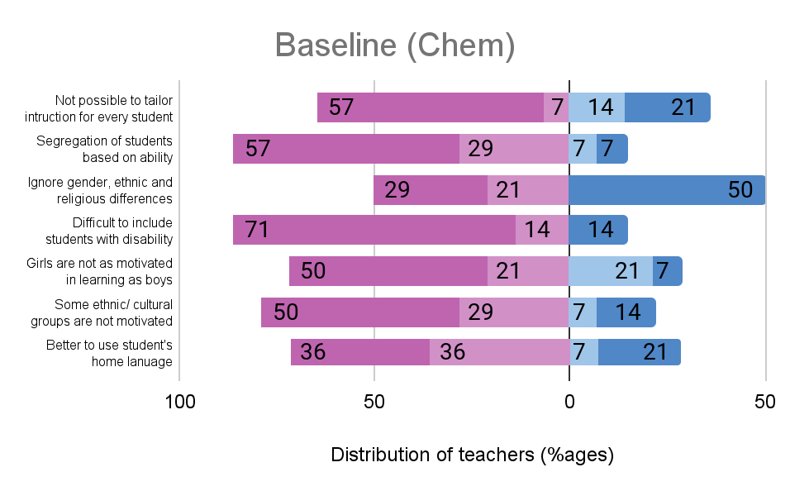  Before intervention | 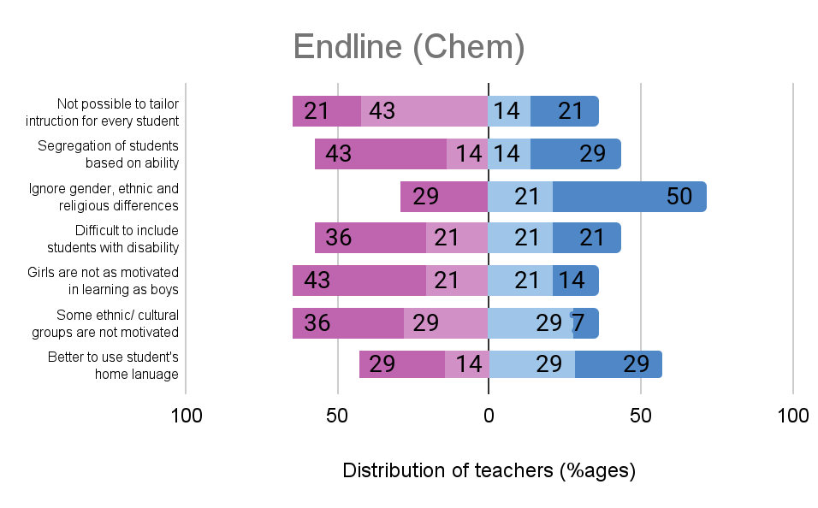 After intervention

Figure 1: Chemistry teachers’ attitudes for different question statements regarding inclusion and equity, both during baseline and endline surveys
Results showed mixed feelings when chemistry teachers were asked about possibility of tailoring instruction to every student (statement 1). Regarding merging low-achiever and high-achiever students in one class (statement 2), the desired attitude decreased when comparing baseline(86%) and endline(57%) results. This means that despite intervention, Chemistry teachers still did not understand how to address a wide range of skills and abilities in the classroom.
With regard to differences in students in terms of gender, ethnic or religious (statement 3), the endline survey data shows that the desired attitude increased by 21%. These results suggest that Chemistry teachers substantially gained knowledge from the modules and participating in online CoP with regard to ignoring gender, ethnic or religious differences among students in their teaching.
The other item on inclusion and equity intended to assess how Chemistry teachers view the inclusion of students with disabilities in Chemistry class (statement 4). It can be seen that during the endline survey, the proportion of disagreeing teachers on statement 4 declined in Chemistry (from 85% to 57%) between the two surveys, thus implying a positive change.
With regard to motivation in learning Chemistry between boys and girls (statement 5), the results from the endline survey show that the proportion of disagreeing teachers on statement 5 decreased from 71% to 64% in Chemistry, a positive change of 7% between the two surveys was noted.The percentage of teachers who felt that girls are not motivated compared to boys decreased, thus implying a slightly positive impact of the intervention.
In question statement 6, subject teachers were asked to respond to the contention that ‘members of some ethnic, cultural or religious groups were not as motivated as other members in learning Chemistry or seeing its relevance, irrespective of the methods a teacher uses’. It can be seen that during the endline, the proportion of disagreeing Chemistry with regard to statement 6 decreased from 79% to 65%. These results indicate that the curated modules and participation in online CoP did help Chemistry teachers to understand that it is the teaching method that will motivate the student to learn Chemistry irrespective of the ethnic, cultural and religious affiliations. Although there was still a reasonable percentage of, participating teachers who still needed support in managing students with special needs and students from different social status.
In question statement 7, subject teachers were asked to respond to the argument that ‘it is better to use students’ home language rather than only English for learning Chemistry’. The results show that during the endline survey, Chemistry teachers disagreed by 43% whereas during baseline survey disagreeing percentage was 72%. This shows that, after the intervention, the proportion of disagreeing Chemistry teachers with regard to statement 7 decreased by 29%. These results indicate that implementation of the modules and participation in online CoP had not significantly affected by the language used , thus when principles of PCK are appropriately observed the teaching and learning process is not affected by the language.
3.2 Responses of Chemistry teachers on how often they have been using a variety of assessment methods
Figure 2 shows the responses of Chemistry teachers on how often they have been using various assessment methods in their teaching. It can be seen that during baseline and endline surveys, the majority of Chemistry teachers (ranging from 68% to 100%) were using different assessment methods. During baseline survey 86% teachers were using standardized tests/exams produced outside school as assessment mode, in the endline survey the percentage decreased to 79%. This implies there was an improvement in understanding about content-based-assessment for Chemistry teachers. This is due to the fact that the frequency of using standardized tests/exams produced outside school as an assessment method decreased by 7%. The results suggest that implementation of PCK innovation was gradually effective to the Chemistry teachers.
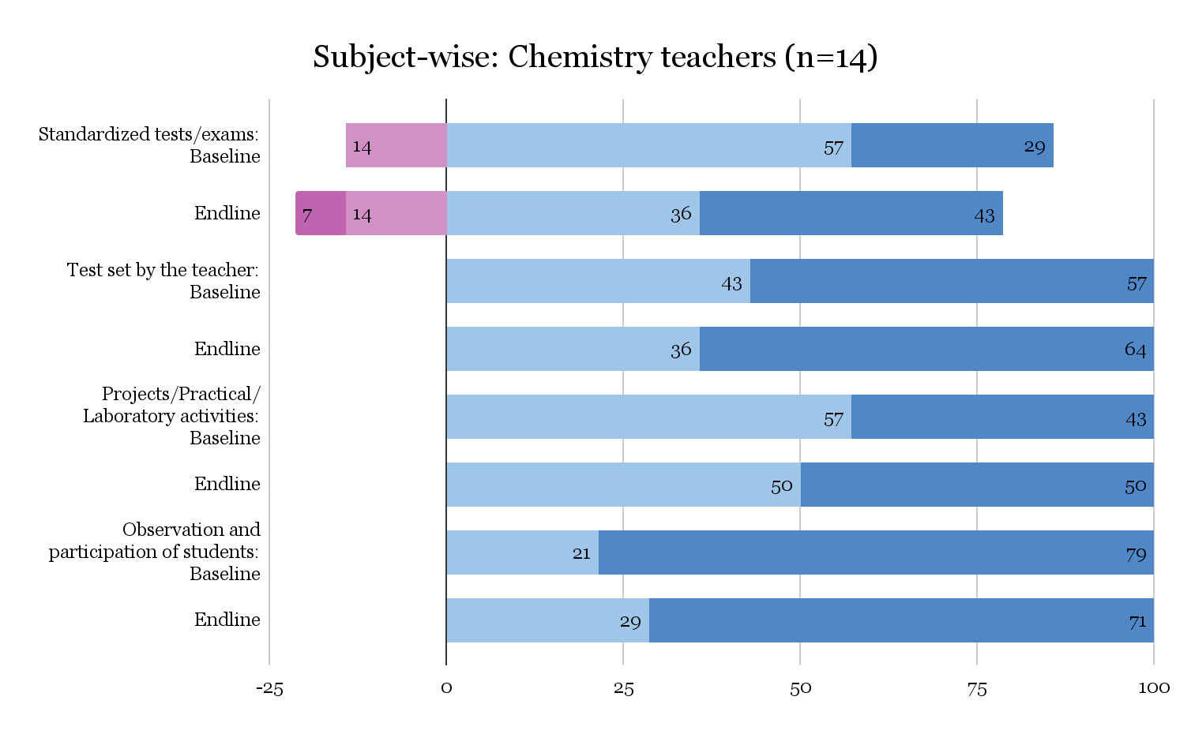

Figure 2 Responses of Chemistry teachers on how often they have been using a variety of assessment methods
With regard to using projects/practical/laboratory activities as assessment methods, the result shows that in the endline survey, the frequencies of using projects/practical/laboratory activities as assessment methods were the same (100%) as those in the baseline survey. Further analysis shows that, during both surveys, the teachers were using observation and participation of students in the classroom as assessment methods equally.
3.3 Chemistry teachers’ perceptions on PCK innovation transfer
Teachers perceptions on PCK innovation were to a large extent tested by using Moore and Benbasat’s (1991) seven indicators of innovation diffusion namely Voluntariness, Relative advantage, compatibility, Image, Ease of use, Results demonstrability and Visibility
3.3.1 Voluntariness
The voluntariness is a factor that allows us to examine the degree to which teachers participate in a new innovation voluntarily. There were two items in the questionnaire that explore voluntariness; (1) “My school principal does not require me to participate in PCK innovation” (2) “Although it might be helpful, participating in PCK innovation is certainly not compulsory”.
The two items on voluntariness explore the role that school administration played in teacher participation, and, whether there was any compulsion in participation. The results from the survey show that the school administration had played an important role to facilitate the Chemistry teachers’ participation in this innovation. The majority (87%) of Chemistry teachers during the baseline survey disagreed that the heads of schools did not require them to participate. Conversely, this means that the principals did not force them to participate in the project but facilitated their participation by identifying and administratively supporting the teachers. This trend was also reflected in the endline survey and remained unchanged as 91% of Chemistry teachers identified that it was the school administration (the principals) that made the teachers participate in the PCK innovation. These results are well presented in Figure 3. below.
In exploring if there was any compulsion on teachers for participation, the survey results pointed that most of the teachers thought that their participation was compulsory as opposed to entirely voluntary (65% teachers: baseline & 57% teachers: endline). However, it is important to note that approximately 31% teachers in the endline survey thought that it was not compulsory for them to participate in PCK innovation.
In a hierarchical structure of education, often the administration plays an important role in in-service trainings for professional development of teachers by facilitating required administrative support, e.g., identifying and recommending the teachers to the higher administration for training; redistributing their workload during the part of training or absence from schools; and, other necessary logistic support.
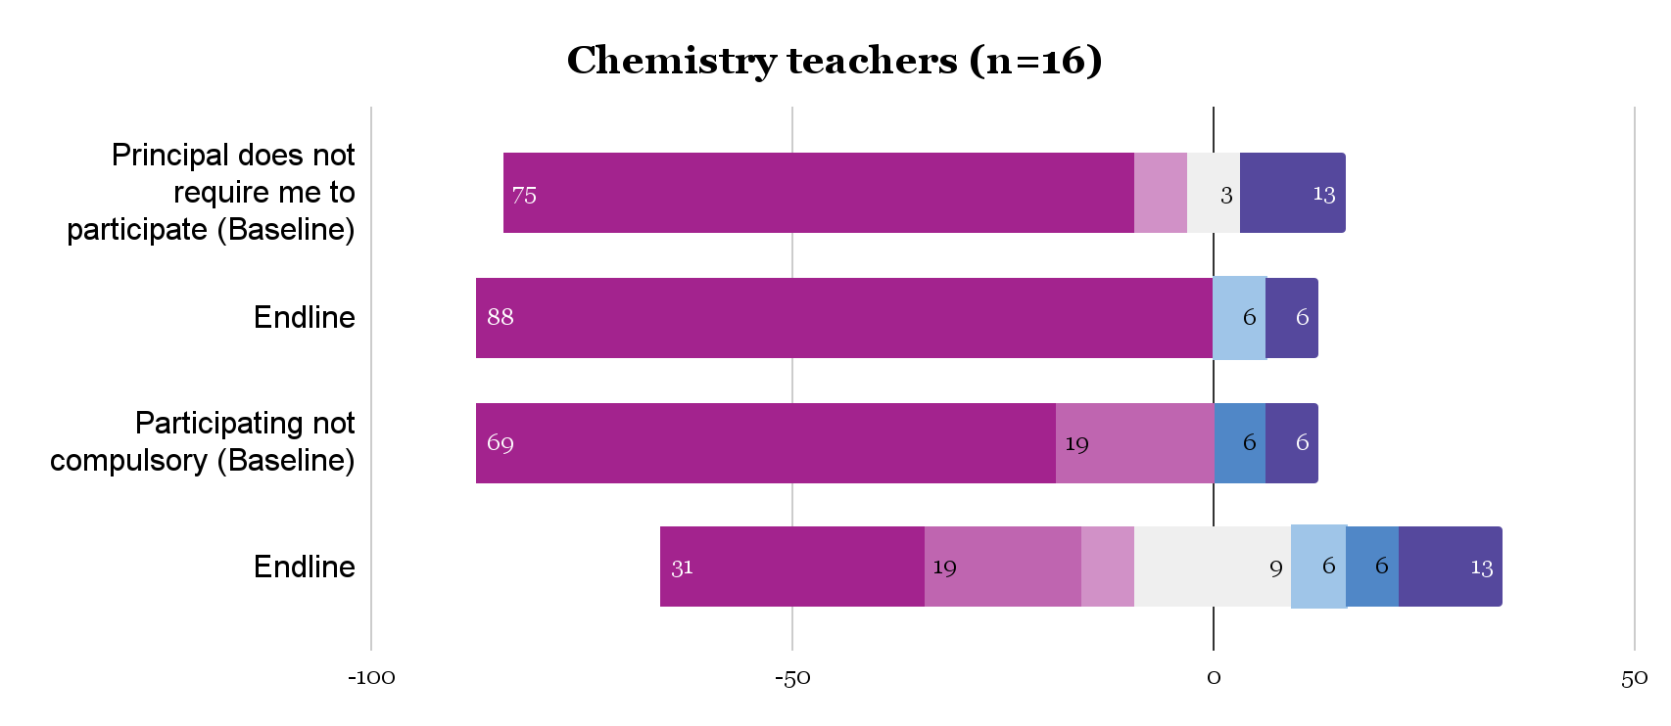

Figure 3: Voluntariness of Chemistry teachers
3.3.2 Relative advantage
The relative advantage is a factor that allows us to examine the degree to which the PCK approach is seen as better than the usual approach to teaching by the participating teachers. There were five items employed to examine the various aspects of relative advantage in the use of PCK innovation in teaching.
Items on relative advantage
Q3: Participating in the PCK innovation will allow me teach Chemistry topics faster
Q4: Participating in the PCK innovation will improve the quality of my teaching
Q5: Participating in the PCK innovation will make it easier for me to teach
Q6: Participating in the PCK innovation will enhance the effectiveness of my teaching
Q7: Participating in the PCK innovation gives me greater control over my teaching
Figure 4 depicts the results pertaining to the surveyed characteristic of relative advantage. The result of the survey shows that on all the items, most of the teachers identified PCK innovation to be advantageous in their teaching. This high proportion of responses towards a strong agreement of teachers that the PCK innovation is relatively advantageous; in all the counts it is consistent between baseline and endline surveys.

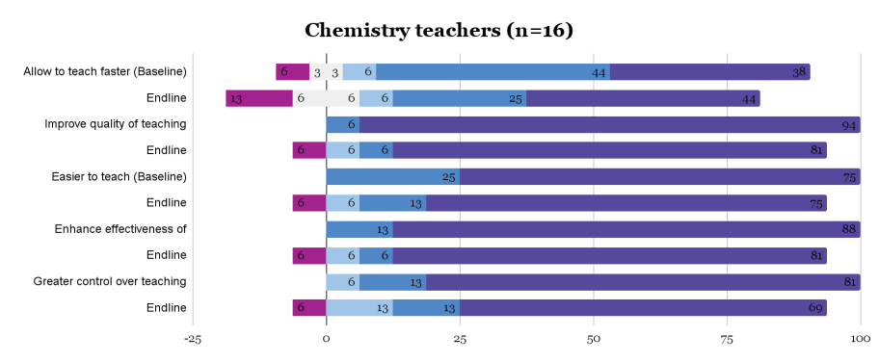

Figure 4: Relative advantage for intervention group teachers
The overall pattern of teachers’ responses shows that, the largest proportion of teachers consistently strongly agreed that the innovation was relatively advantageous for them. It is noted that the proportions of agreeing responses were 100% during the baseline with regard to ‘improve quality of teaching Chemistry’, ‘easiness to teach Chemistry’, ‘enhancing the effectiveness of teaching Chemistry’, and ‘greater control over teaching Chemistry’. However, results show higher proportion of disagreeing responses regarding ‘allowing to teach faster’ in the endline than the baseline. The proportion of disagreeing responses rose from 9.4% to 18.8%. As such, it could be deduced that despite the majority of responses agreeing that the innovation allowed the teachers to teach faster, comparison of data from the two surveys in that regard indicated a negative change on disagreeing criteria. Generally, the proportions of disagreeing responses increased in all aspects of relative advantage (negative change), when comparing baseline and endline surveys. However, these results generally show that the majority of Chemistry teachers were in agreement that this innovation was advantageous, despite varied extents of agreements.
3.3.3 Compatibility
Compatibility is a factor that allows us to examine the degree to which PCK innovation is seen as compatible with existing values, needs, and past experiences of teachers. There were three items through which we investigated the teachers’ perceptions on compatibility. The items explored if teachers perceived PCK innovation as compatible with every aspect of their teaching; if they found it fitting well with both, how they would like to teach, and their style of teaching. Thus, if the teachers find an innovation not compatible with their teaching style or approach, it would have bearings on any possible adoption.
Items on compatibility
Q8: Participating in PCK innovation is compatible with all aspects of my teaching
Q9: I think that approaches in PCK innovation fit well with the way I like to teach
Q10: Participating in PCK innovation fits into my style of working
The results of the survey in Figure 5 generally show that on all the three items, most of the Chemistry teachers found PCK innovation as compatible with their teaching.
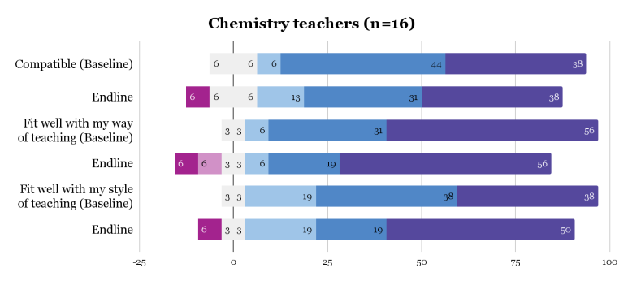

Figure 5: Compatibility for intervention group teachers
Analysis of responses on compatibility shows the majority of participating Chemistry teachers confirmed that the innovation was compatible with their teaching. Again, the proportions of agreeing responses from the baseline were higher than from the endline.
3.3.4 Image
Image is a factor which examines the degree to which participating in PCK innovation is seen to enhance a teacher's image and status in the school. The factor comprises three items, which explored the perceptions related to prestige, profile and status symbol.
A teacher’s perception of her/his/their image while associating with a new innovation plays an important role in possible adoption to that innovation. Thus, the questions explored the perceptions of prestige of the teacher cohorts who participated in PCK innovation in the school; the predisposed perceived profiles of the participant teachers, and, if participating in PCK innovation contributed to the status symbol of the teacher in the school.
Items on image
Q11: Teachers in my school who are participating in PCK innovation have more prestige than the ones who do not
Q12: Teachers in my school who are participating in PCK innovation have a high profile
Q13: Participating in PCK innovation is a status symbol in my school
The results generally show that most of the Chemistry teachers perceived participating in PCK innovation as contributing positively to their image as a teacher in the school, as depicted in Figure 6.
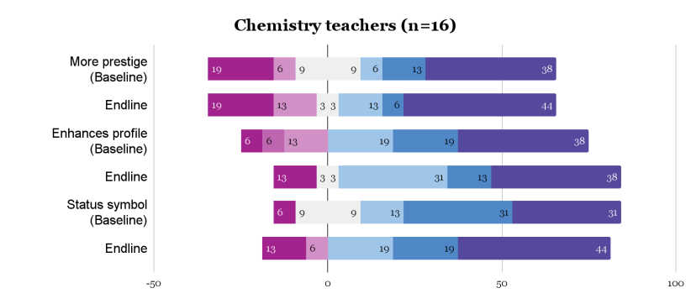

Figure 6: Image for intervention group teachers
A closer look on Figure 6 reveal that in both baseline and endline surveys, Chemistry teachers perceived to have more prestige, higher profiles and a status symbol in their respective schools. Analysis of the proportions of agreeing versus disagreeing responses about the image of teachers, the trends show positive changes in most items. A negative change with regard to image characteristic was also noted in the responses from chemistry teachers for the item which inquired if participating in the intervention was a status symbol (item No.3), in which the proportions were 84.5% and 81.4% from baseline and endline surveys respectively.

3.3.5 Ease of use
The ease of use factor examined the degree to which teachers believed that participating in PCK innovation was free from physical and mental effort. There were four items that explored different aspects of ease of use.
The items in ease of use explored if the PCK innovation modules were clear and easy to understand among teachers; if they were easy for learning new approaches; if it was easy to participate; and, if the teachers perceived navigating the PCK innovation modules and CoP were easy for them.
Items on Ease of Use
Q14: Developed modules are clear and easy to understand
Q15: I believe it is easy to learn new approaches to teaching by participating in PCK innovation
Q16: Overall it is easy to participate in PCK innovation
Q17: Learning to navigate the PCK innovation modules and community of practice is easy for me
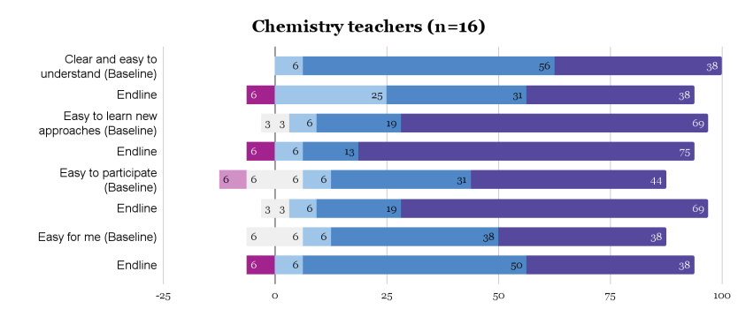

Figure 7: Ease of use for intervention teachers

Results show that the proportions of agreeing responses were higher than disagreeing responses. The responses from chemistry teachers further suggest the positive changes in items 3 and 4, but negative changes in items 1 and 2. For instance, the interview schedule on the question: “Was it easy for you to participate in PCK innovation? Did you find the modules easy to understand?” The majority of respondents to this question in the baseline testified the modules were easy to understand and use, and that the easiness increased as they got more involved in the project, as participant 2508 observed: “At the beginning it was difficult but with time I found that PCK innovation is an interesting project for my professional development.” This is also a view of several other participants in the baseline interview, including no.2521 who said that: “It was very easy to participate in the project and the modules were easy to understand.” These responses suggest a conclusion which confirms the innovation’s high ease of use on one hand, while improving its clarity and effectiveness on the other hand. The analysis of these responses shows negative changes for item 1 (clear and easy to understand). Again, the analysis of responses for item 2 (easy to learn new approaches) shows negative changes from chemistry teachers, whereas responses for item 3 registered a positive change from chemistry teachers. Item 4 responses also registered positive change from chemistry group.
This can therefore derive to a conclusion that; in light of the responses on ease of innovation from the two surveys, the majority of participating teachers viewed the innovation as requiring improvements regarding clarity and easiness to understand, and easiness and empowerment to individual users.
3.3.6 Results demonstrability
The factor result demonstrability examined the degree to which the results of PCK innovation were observable by others. There were four items that examined the result demonstrability.
The items in result demonstrability allowed teachers to reflect on if the results of participating in PCK innovation were clear to them and if they would be able to communicate to other teachers or education administrators about these results.
Items on result demonstrability
Q18: I would have no difficulty telling others about the results of participating in PCK innovation
Q19: I believe I could communicate to others the consequences of participating in PCK innovation
Q20: The results of participating in PCK innovation are clear to me
Q21: I would have difficulty explaining why participating in PCK innovation may or may not be beneficial
The results of the surveys showed very high overall result demonstrability for PCK innovation vis-a-vis participating teachers’ perceptions. Generally, the findings show that PCK innovation was clear to participants and they would be able to explain its benefits to others who did not participate in this project.
Interview responses by great extent showed that it was not difficult to explain about PCK innovation and its results to others who did not participate. The interview responses testified to the perception of participants that it was not difficult to explain what PCK innovation was about, from the beginning during the baseline. Similar views were evident during the endline interviews, as shown in Figure 8 below.

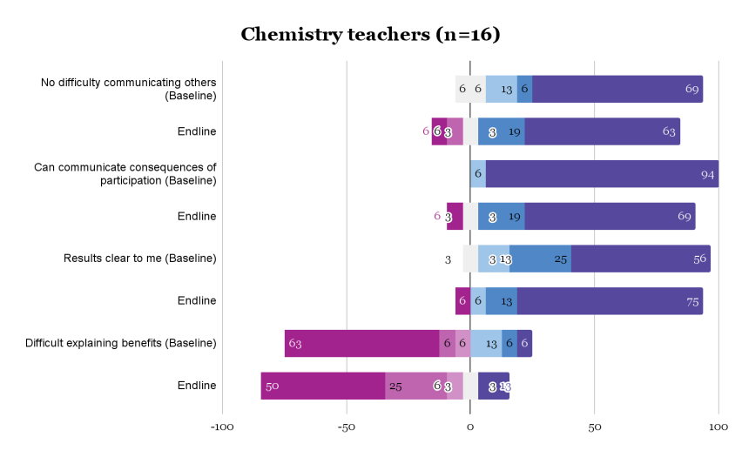

Figure 8: Results demonstrability for intervention group teachers
3.3.7 Visibility
The factor of visibility assessed the degree to which teachers could observe other teachers using PCK innovation. There were two items that explored the different aspects of visibility; one examined if one could see many teachers participating in PCK innovation in the school; and another examined the extent of that visibility, i.e. if it was very visible or not.
Items on visibility
Q22: In my school, one sees many teachers participating in PCK innovation
Q23: Participation in PCK innovation is not very visible in my school.
Figure 9 below depicts the results for chemistry teachers. The results from both the baseline and endline surveys showed that PCK innovation was visible in the schools. It is noted from the responses to item No.22 that the proportion of agreeing answers which were desired was higher than that of disagreeing answers, in both the baseline and endline surveys. It is also noted from the responses to item No.23 that the proportion of disagreeing answers which were desired was higher than that of agreeing answers in both surveys.
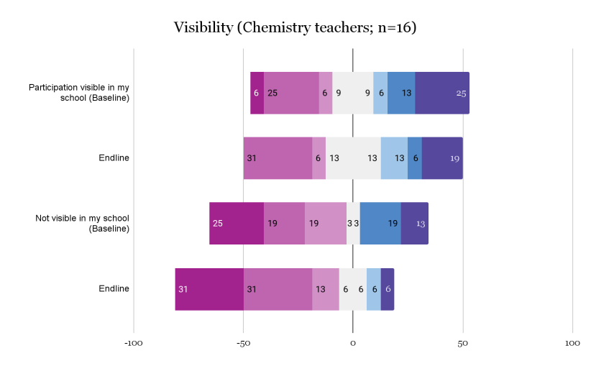

Figure 9: Visibility for intervention group teachers
It is also evident from interview responses that PCK innovation was visible in schools across all phases of implementation through intervention group participants, either by using it to teach their respective lessons or deliberately sharing the information about it to others who were not direct participants in this project. During the baseline interview, one participant who seemed to represent others had this to say: “All chemistry teachers who are participating in PCK innovation in my school are implementing it in school and other teachers outside the project love and talk much about it”. Such insights prevailed in midline and endline surveys as well, testifying other teachers’ eagerness to know more about PCK innovation, as another participant noted during the midline interview: “... other teachers are curious about the project and they are eager to learn from us”. From these responses we could conclude that other teachers were curious because they were aware of the existence of PCK innovation, partly because it was visible.
Conclusion
Findings have shown that innovation in secondary chemistry teaching can be effectively transferred when participating teachers are involved in the localization of the innovation and the social networks are taken care. Findings from this study suggests that the implementation of the innovation in use of PCK principles by teachers in teaching secondary school chemistry was effective though in some areas further researches are required. Positive impact results were observed in voluntariness, relative advantage, compatibility, ease of use,result demonstrability and visibility. However, despite of the intervention chemistry teachers still did not understand well how to address the issues of inclusion and equity in the classroom. Furthermore, negative change with regard to image characteristic was also noted. It is therefore concluded that the intervention had a positive impact on the adoption of the innovation on the use of PCK principles in the chemistry modules development, implementation and evaluation.

References
Afandi, A., Sajidan, S., Akhyar, M., &Suryani, N. (2018). Pre-Service Science Teachers' Perception about High Order Thinking Skills (HOTS) in the 21st Century. International Journal of Pedagogy and Teacher Education, 2(1), 107-114.https://doi.org/10.1063/1.5054436
Arrigo, V., Lorencini Junior, A. L., &Broietti, F. C. D. (2022). The pedagogical content knowledge (PCK) of a chemistry student teacher: An experience in pre-service education. International Journal of Research in Education and Science (IJRES), 8(1), 167-186. https://doi.org/10.46328/ijres.2560
Barut, M. E. O. and Wijaya, A. (2020) J. Phys.: Conf. Ser. 1581 012062 DOI 10.1088/1742-6596/1581/1/012062
Billig, S. H., & Waterman, A. S. (Eds.). (2014). Studying service-learning: Innovations in education research methodology. Routledge. DOI 10.1007/s11618-014-0547-9
https://d1wqtxts1xzle7.cloudfront.net/47466827/Innovations_through_networks

Chacha, J. & Onyango, D. (2022). Challenges faced by teachers in implementing competence-based chemistry curriculum in public secondary schools in Nyamagana District, Mwanza, Tanzania. Journal of Research Innovation and Implications in Education, 6(1), 346 – 358.https://jriiejournal.com/wp-content/uploads/2022/03/JRIIE-6-1-034.pdf

Chikendu Rebecca E (2022). FACTORS AFFECTING CHEMISTRY STUDENTS’ ACADEMIC PERFORMANCE IN SENIOR SECONDARY SCHOOLS IN ANAMBRA STATE International Journal of Research in Education and Sustainable Development | ISSN: 2782-7666 Vol. 2, Issue 3 (March, 2022) | www.ijaar.org

Gess-Newsome, J. (1999). Pedagogical Content knowledge: an introduction and orientation. In: Gess-Newsome, J., & Lederman, N. G. (Eds.). Examining pedagogical content knowledge: the construct and its implications for science teaching (pp. 3-17). Kluwer Academic Publishers. https://studylib.net/doc/14611489
Grossman, P. L. (1990). The making of a teacher: Teacher knowledge and teacher education. New York, NY: Teachers College Press https://lccn.loc.gov/90038509
Haryani, E., Coben, W. W., Pleasants, B. A., & Fetters, M. K. (2021). Analysis of Teachers' Resources for Integrating the Skills of Creativity and Innovation, Critical Thinking and Problem Solving, Collaboration, and Communication in Science Classrooms. JurnalPendidikan IPA Indonesia, 10(1), 92-102. https://doi.org/10.15294/jpii.v10i1.27084
Hassan, A. A., Ali, H. I., Salum, A. A., Kassim, A. M., Elmoge, Y. N., & Amour, A. A. (2017). Factors affecting students’ performance in chemistry: Case study in Zanzibar secondary schools. International Journal of Educational and Pedagogical Sciences, 9(11), 4086-4093. https://www.researchgate.net/profile/Ahmed-Hassan-20/publication/312147240
Kind, V. (2009). Pedagogical content knowledge in science education: Potential and perspectives for progress. Studies in Science Education, 45(2), 169–204
https://doi.org/10.1080/03057260903142285
Kolleck, N. (2014). Innovations through networks: Understanding the role of social relations for educational innovations. ZeitschriftfürErziehungswissenschaft, 17(5), 47-64.
Lati, W., Supasorn, S., & Promarak, V. (2012). Enhancement of learning achievement and integrated science process skills using science inquiry learning activities of chemical reaction rates. Procedia - Social and Behavioral Sciences, 46, 4471-4475. http://doi.org/10.1016/j.sbspro.2012.06.279
Lave, Jean; Wenger, Etienne (1991). Situated Learning: Legitimate Peripheral Participation. Cambridge: Cambridge University Press. ISBN 978-0-521-42374-8.; first published in 1990 as Institute for Research on Learning report 90-0013
Lippincott, W.T. (1979). Why Students Hate Chemistry. Journal of Chemical Education, 56, 1.
Jeannette Musengimana, Edwige Kampire, Philothère Ntawiha Factors Affecting Secondary Schools Students’ Attitudes toward Learning Chemistry: A Review of Literature EURASIA Journal of Mathematics, Science and Technology Education, 2021, 17(1), em1931 ISSN:1305-8223 (online) OPEN ACCESS Literature Review https://doi.org/10.29333/ejmste/9379

Loughran, J., Berry, A., & Mullhall, P. (2006). Understanding and developing science teachers’ pedagogical content knowledge. Rotterdam, The Netherlands: Sense Publishers.
MoEST, 2023. Ministry of Education, Science and Technology, www.moe.go.tz/sw/menu-item/school-quality-assurance-office-contacts
Moore, G. C., &Benbasat, I. (1991). Development of an instrument to measure the perceptions of adopting an information technology innovation. Information systems research, 2(3), 192-222.
Rollnick, M., Bennett, J., Rhemtula, M., Dharsey, N. and Ndlovu, T. (2008),“The place of subject matter knowledge in pedagogical content knowledge: A case study of South African teachers teaching the amount of substance and chemical equilibrium”, International Journal of Science Education,Vol. 30, No. 10, pp. 1365-1387. doi: 10.1080/09500690802187025.
Sæleset, J., & Friedrichsen, P. (2021). Pre-service science teachers’ pedagogical content knowledge integration of students’ understanding in science and instructional strategies.
Sæleset, J. (2021). Teaching science with students in mind. (Doctoral thesis). https://hdl. handle. net/10037/22597.
Seba, J. M., Ndunguru, P. A., & Mkoma, S. L. (2013). Secondary school students' attitudes towards Chemistry and Physics subjects in Tarime-Mara, Tanzania. TaJONAS: Tanzania Journal of Natural and Applied Sciences, 4(2), 642-647.http://www.sjut.org/journals/ojs/index.php/tajonas
Shulman, L.S. (1986) Those Who Understand: Knowledge Growth in Teaching. Educational Researcher, 15, 4-14. http://dx.doi.org/10.3102/0013189X015002004
Shulman, L. S. (1987). Assessment for teaching: An initiative for the profession. The Phi Delta Kappan, 69(1), 38-44. https://www.jstor.org/stable/20403526
Uce, M., & Ceyhan, İ. (2019). Misconception in Chemistry Education and Practices to Eliminate Them: Literature Analysis. Journal of Education and Training Studies, 7(3), 202-208. https://eric.ed.gov/?id=EJ1206967
Wenger, E. (1998). Communities of practice: Learning as a social system. Systems thinker, 9(5), 2-3. academia.ed

