**Biological Control of Southern Blight in Tomato Caused by *Sclerotium rolfsii* using *Trichoderma* spp. under In-Vitro and In-Vivo Conditions**

**ABSTRACT**Tomato (*Solanum lycopersicum* L.) is a globally important crop often affected by southern blight, caused by the soil-borne fungus *Sclerotium rolfsii*, leading to significant yield losses. Conventional management using chemical fungicides faces challenges including pathogen resistance and environmental hazards, necessitating sustainable alternatives. This study evaluated the biocontrol potential of three *Trichoderma* species (*T. harzianum*, *T. viride*, and *T. asperellum*) against *S. rolfsii* under laboratory and greenhouse conditions. In vitro dual culture assays demonstrated significant inhibition of pathogen mycelial growth, with *T. harzianum* showing the highest antagonistic effect (64.95% inhibition), followed by *T. viride* and *T. asperellum*. Subsequent pot experiments assessed disease incidence and plant growth parameters in tomato plants challenged with *S. rolfsii*. All *Trichoderma* treatments significantly reduced disease incidence compared to the inoculated control, with the combined application of all three species achieving the highest disease suppression (85.93%) comparable to the chemical fungicide mancozeb (92.85%). Moreover, *Trichoderma* treatments enhanced plant growth, reflected in increased shoot and root lengths and biomass. These results highlight the efficacy of *Trichoderma* spp. as eco-friendly biocontrol agents, capable of suppressing southern blight and promoting tomato growth. Integrating *Trichoderma* bioagents offers a sustainable approach to managing *S. rolfsii*, reducing reliance on chemical fungicides and contributing to environmentally safe crop production.

**Keywords:**Tomato, Southern blight, *Sclerotium rolfsii*, *Trichoderma* spp., biological control, Disease suppression, Plant growth promotion.

**1.** **INTRODUCTION**

Tomato (*Solanum lycopersicum* L.) is a major crop globally, valued for its rich nutritional content and economic importance. Its adaptability, short growing cycle, and high market demand have led to widespread cultivation, particularly in tropical and subtropical regions. However, tomato production is frequently threatened by various biotic stresses, especially soil-borne fungal pathogens. Among these, *Sclerotium rolfsii* Sacc. is one of the most destructive, causing southern blight disease (Aycock, 1966; Punja, 1985).

Southern blight is marked by seedling damping-off, basal stem rot, wilting, and eventual plant death. The pathogen produces dense white mycelia and hard brown sclerotia, which enable it to survive in soil for extended periods even under unfavorable conditions (Mullen, 2001). This persistence poses a serious challenge for disease management, making *S. rolfsii* difficult to control using conventional agricultural practices.

Chemical fungicides have long been used to manage soil-borne pathogens, offering rapid and broad-spectrum control. Despite their effectiveness, the overreliance on synthetic fungicides has led to significant issues, including the development of resistant pathogen strains, disruption of beneficial soil organisms, toxic residues in food, and environmental contamination (Sharma *et al*., 2010; Singh & Kumar, 2015). Additionally, fungicides often fail to eliminate *S. rolfsii* entirely due to the pathogen’s sclerotia-based survival. Other management strategies—such as crop rotation, sanitation, use of organic amendments, and resistant cultivars—have shown inconsistent results. Although breeding for resistant tomato varieties is a preferred solution, its success is hindered by the scarcity of resistant genotypes and the rapid evolution of virulent strains (Kumar *et al*., 2018).

Given the limitations of chemical and traditional control measures, current research emphasizes sustainable, eco-friendly alternatives. Biological control has emerged as a promising strategy, offering effective disease suppression without harming the environment. Among microbial biocontrol agents (BCAs), *Trichoderma* species stand out due to their strong antagonistic activity, environmental adaptability, and plant growth-promoting effects (Harman *et al*., 2004; Vinale *et al*., 2008). *Trichoderma* spp. combat pathogens through multiple mechanisms: mycoparasitism, secretion of lytic enzymes and antifungal compounds, competition for nutrients and space, and induction of systemic resistance in host plants. These mechanisms make them effective against a wide range of soil-borne fungi including *Rhizoctonia solani*, *Fusarium oxysporum*, *Pythium* spp., *Verticillium dahliae*, and *Sclerotium rolfsii* (Elad *et al*., 1983; Rekha *et al*., 2012; Safari Motlagh *et al*., 2022; Sultana & Hossain, 2022).

Several species, including *T. harzianum*, *T. viride*, and *T. asperellum*, have demonstrated efficacy in controlling *S. rolfsii* in crops through in vitro and greenhouse studies (Ganesan *et al*., 2007; Singh *et al*., 2010). Beyond disease control, *Trichoderma* spp. enhances plant growth, nutrient uptake, and yield by positively influencing rhizosphere microbial communities. With increasing concerns over pesticide use, there is growing interest in microbial-based plant protection products. In India and globally, bioformulations are gaining acceptance among farmers and researchers as safe and sustainable alternatives to synthetic fungicides (Patel *et al*., 2020). Furthermore, integrated management approaches combining BCAs with reduced fungicide doses have shown synergistic effects, improved disease control while minimizing chemical residues (Yadav & Choudhary, 2021).

In this context, the present study evaluates the biocontrol potential of three *Trichoderma* species against *S. rolfsii*, the causal agent of southern blight in tomato. The research includes both in vitro dual culture assays and in vivo pot experiments to assess efficacy under controlled conditions. The outcomes aim to support the development of an integrated, eco-friendly disease management strategy for tomato cultivation.

**2. MATERIALS AND METHODS**

**2.1. Isolation and Identification of Causal Pathogen**

A field survey was conducted in the Mysuru region of Karnataka to collect tomato plants exhibiting symptoms of root rot. Infected plant tissues showing characteristic signs of *Sclerotium rolfsii* infection, including necrosis and the presence of sclerotia, were carefully uprooted and transported to the laboratory for analysis. The samples were initially washed under running tap water to eliminate adhering soil and debris. Surface sterilization of the infected tissues was carried out by immersing segments (approximately 5 mm) in 1% sodium hypochlorite (NaOCl) solution for 1 minute. The sterilized tissues were then rinsed three times with sterile distilled water to remove any residual disinfectant.

The disinfected tissue segments were aseptically transferred onto sterile Petri dishes containing potato dextrose agar (PDA) medium. The plates were incubated at 27 ± 2 °C for 5 to 7 days to allow fungal growth. Emerging fungal colonies were observed and subcultured repeatedly onto fresh PDA to obtain pure cultures.

The fungal isolates were subjected to morphological identification based on their colony characteristics, growth rate, and sclerotial formation. Observations included the texture and pigmentation of the mycelium, as well as the size, shape, and coloration of the sclerotia. These morphological traits were evaluated under a stereomicroscope at 10× magnification and compared with the taxonomic keys described by Mahadevakumar and Janardhana (2016) for the identification of *Sclerotium rolfsii*.

**2.2. Collection and Maintenance of Fungal Bioagents**

Pure cultures of *Trichoderma viride*, *Trichoderma harzianum*, and *Trichoderma asperellum* were obtained from the Department of Microbiology, University of Horticultural Sciences, Bagalkot, Karnataka, India – 587104, and Department of Microbiology, University of Agricultural Sciences, Dharwad, Karnataka, India – 580005. The isolates were maintained on Potato Dextrose Agar (PDA) and periodically sub-cultured at 10-day intervals. All cultures were incubated at 28 ± 1 °C and stored at 4 °C for further use (Dennis and Webster, 1971).

**2.3. In Vitro Dual Culture Assay**

The antagonistic potential of the bioagents against *Sclerotium rolfsii* was evaluated using the dual culture technique (Dennis and Webster, 1971). A 5 mm disc of actively growing mycelium of *S. rolfsii* was placed on one side of a PDA Petri plate, and a disc of the test *Trichoderma* isolate was placed on the opposite side, 5 cm apart. A control plate with *S. rolfsii* alone was maintained for comparison. Each treatment was replicated five times and incubated at 28 ± 2 °C. The radial mycelial growth of the pathogen was measured after 7 days. Percent inhibition of pathogen growth was calculated using the formula:

**Inhibition (%) = [(C − T) / C] × 100**

Where C = radial growth in control; T = radial growth in treatment.

**2.4. Pathogen Inoculum Preparation**

The pathogen *Sclerotium rolfsii* was mass multiplied on sterilized sand-maize meal medium (2:1, w/w) and incubated at 26 ± 1 °C for 15 days (Hirte, 1969). Inoculum (50 g per pot) was mixed uniformly into the topsoil layer of the experimental pots.

**2.5. In Vivo Evaluation in Pot Culture**

A pot experiment was conducted under glasshouse conditions to evaluate the efficacy of *Trichoderma* spp. in managing Southern Blight in tomato. Tomato seedlings were transplanted into earthen pots (30 cm diameter) containing pathogen-infested soil. Treatments included individual and combined applications of *T. viride*, *T. harzianum*, and *T. asperellum*, along with uninoculated and inoculated controls and a chemical fungicide for comparison. Bioagents were applied as soil treatments as per the treatments as follows,

1. **T1** – Uninoculated control (neither pathogen nor biocontrol agent applied)
2. **T2** – Inoculated control (*Sclerotium rolfsii* inoculated without any treatment)
3. **T3** – *Trichoderma viride* alone (10g/kg)
4. **T4** – *Trichoderma harzianum* alone (10g/kg)
5. **T5** – *Trichoderma asperellum* alone (10g/kg)
6. **T6** – *T. viride* + *T. harzianum* (5g+5g/kg)
7. **T7** – *T. harzianum* + *T. asperellum* (5g+5g/kg)
8. **T8** – *T. asperellum* + *T. viride* (5g+5g/kg)
9. **T9** – *T. viride* + *T. harzianum* + *T. asperellum* (5g+5g+5g/kg)
10. **T10** – Chemical fungicide (standard check) (mancozeb 5 g/kg)

Each treatment was applied by soil incorporation of the respective *Trichoderma* formulations or fungicide at recommended dosages before pathogen inoculation, except for the uninoculated control.

Disease incidence was recorded at fortnightly intervals using the formula:

**2.6. Disease Incidence (%) = (Number of infected plants / Total number of plants) × 100**

Percent disease control (PDC) was calculated as:

**PDC (%) = [(DI in control − DI in treatment) / DI in control] × 100**

**2.7. Assessment of Plant Growth Parameters**

At 60 days after transplanting, five randomly selected plants from each treatment were uprooted to record shoot and root lengths using a measuring scale. Fresh and dry weights of shoots and roots were also measured. Samples were oven-dried at 60 °C for 24 hours to obtain dry biomass (Kaur *et al*., 2019).

**2.8. Statistical Analysis**

The experiment was laid out in a completely randomized design (CRD) with three replications. Data were statistically analyzed using ANOVA by using OPSTAT, which is available online at CCSHAU, Hisar website (www.hau.ac.in), and the critical difference (C.D.) at 5% probability was used for comparison of treatment means.

**3. RESULTS**

**3.1. In Vitro Evaluation of *Trichoderma* spp. Against *Sclerotium rolfsii***

The antagonistic efficacy of three *Trichoderma* species—*T. viride*, *T. harzianum*, and *T. asperellum*—against *Sclerotium rolfsii* was assessed using a dual culture technique. All three species significantly inhibited the radial growth of the pathogen compared to the control, demonstrating their potential as biocontrol agents (Fig. 1 & 2).

Among the isolates, *T. harzianum* (T2) exhibited the highest antagonistic activity, reducing mycelial growth to 3.14 ± 0.081 cm with an inhibition rate of 64.95%. This was followed by *T. viride* (T1), which achieved 59.82% inhibition (3.60 ± 0.158 cm), and *T. asperellum* (T3), which showed 50.66% inhibition (4.42 ± 0.097 cm) (Table 1, Graph 1 & 2). The untreated control (T4) recorded maximum pathogen growth at 8.96 ± 0.024 cm. Statistical analysis confirmed significant differences among treatments (CD: 0.308; SEm: 0.102; SEd: 0.144), establishing *T. harzianum* and *T. viride* as strong antagonists in vitro.

|  |  |  |
| --- | --- | --- |
| Treatment | Mycelial Growth of *S. rolfsii* (cm) (Mean±SE) | Inhibition (%) |
| T1  (*Trichoderma viride* + *S. rolfsii*) | 3.600±0.158 | 59.82 |
| T2  (*Trichoderma harzianum* + *S. rolfsii*) | 3.140±0.081 | 64.95 |
| T3  (*Trichoderma asperllum* + *S. rolfsii*) | 4.420±0.097 | 50.66 |
| T4  (*S. rolfsii* only) | 8.960±0.024 | - |
| C.D | 0.308 | |
| S.E.(m) | 0.102 | |
| S.E.(d) | 0.144 | |

**Table 1.** Effect of bioagents (*Trichoderma* spp.) on mycelial growth of *Sclerotium rolfsii* in the dual culture method.

*Mycelial growth of *S. rolfsii* recorded after 7 days of incubation. Each treatment is replicated five times.

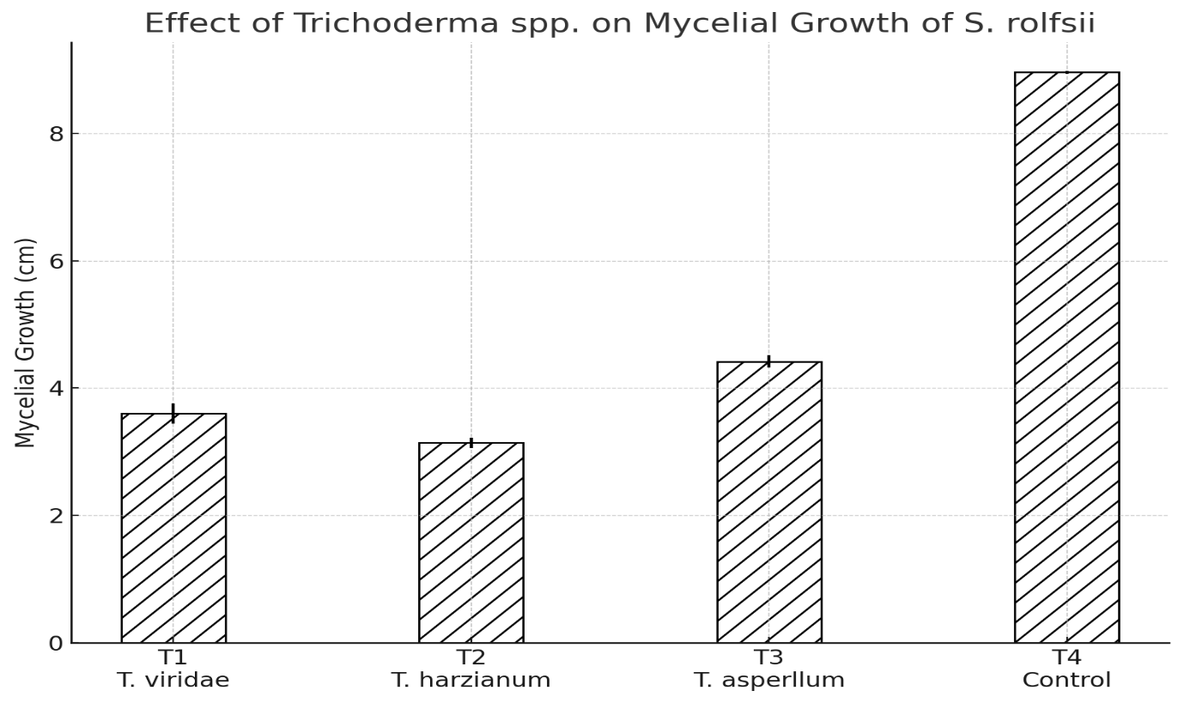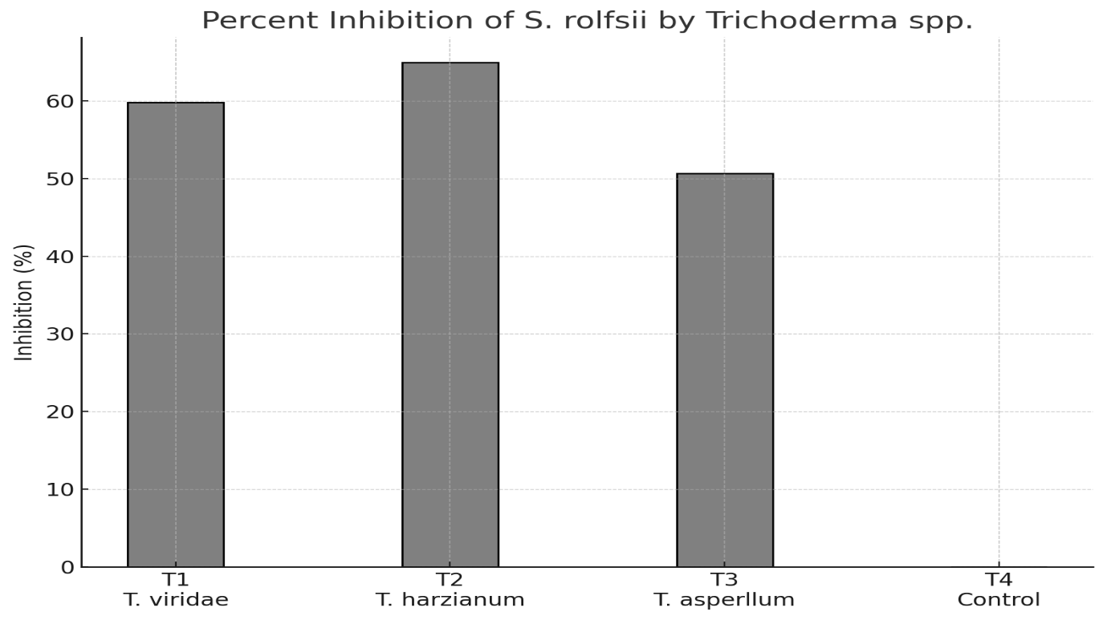

**Graph 1 & 2.** Effect of bioagents (*Trichoderma* spp.) on mycelial growth and inhibition of *Sclerotium rolfsii* in the dual culture method.

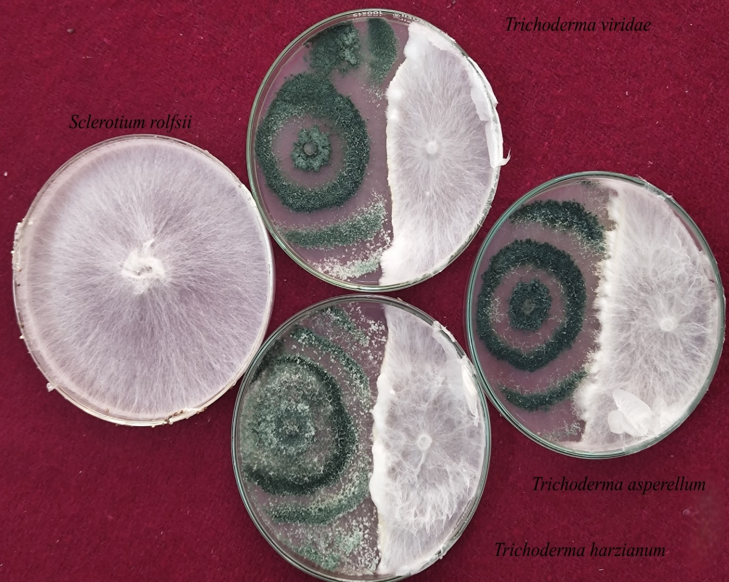

**Figure 1.** Biocontrol efficacy of *Trichoderma spp.* against *Sclerotium rolfsii* in dual culture.

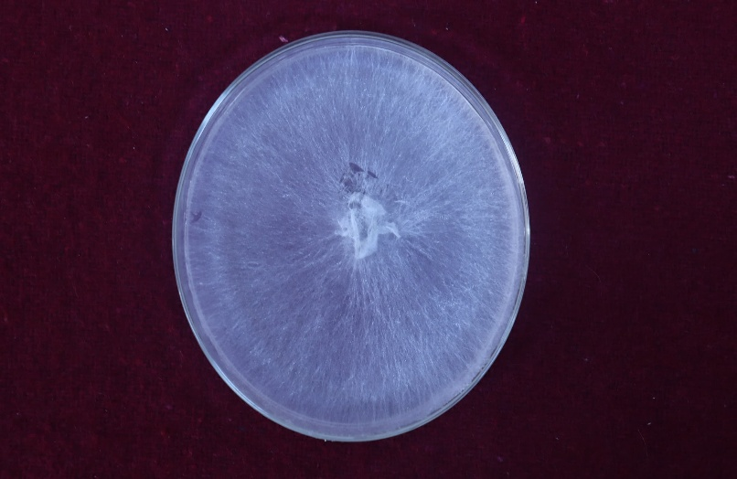 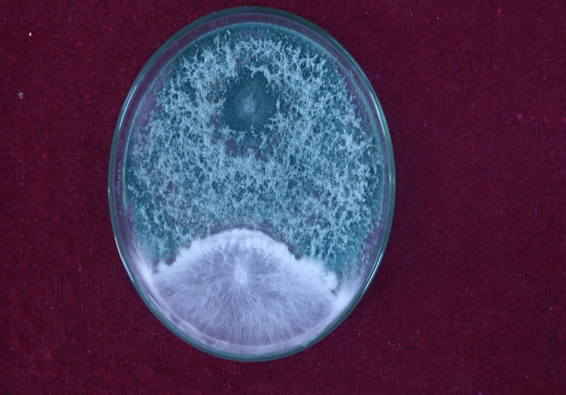 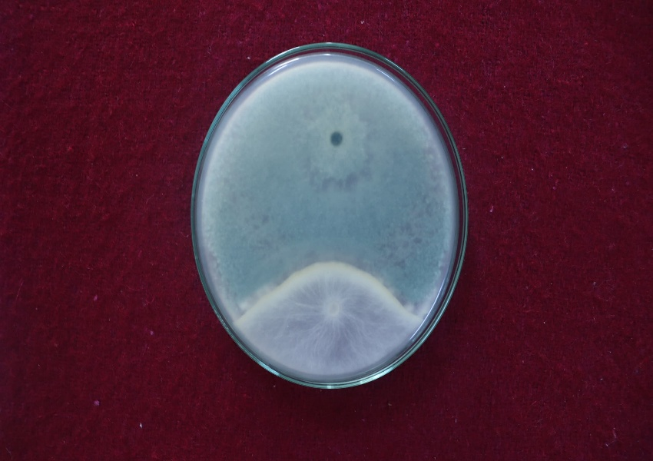

**C**

**B**

**A**

**Figure 2.** Biocontrol efficacy of *Trichoderma harzianum* against *Sclerotium rolfsii*. A – *Sclerotium rolfsii*, B - *T. harzianum* inhibiting the growth of *S. rolfsii –* front view*,* C- *T. harzianum* inhibiting the growth of *S. rolfsii –* back view.

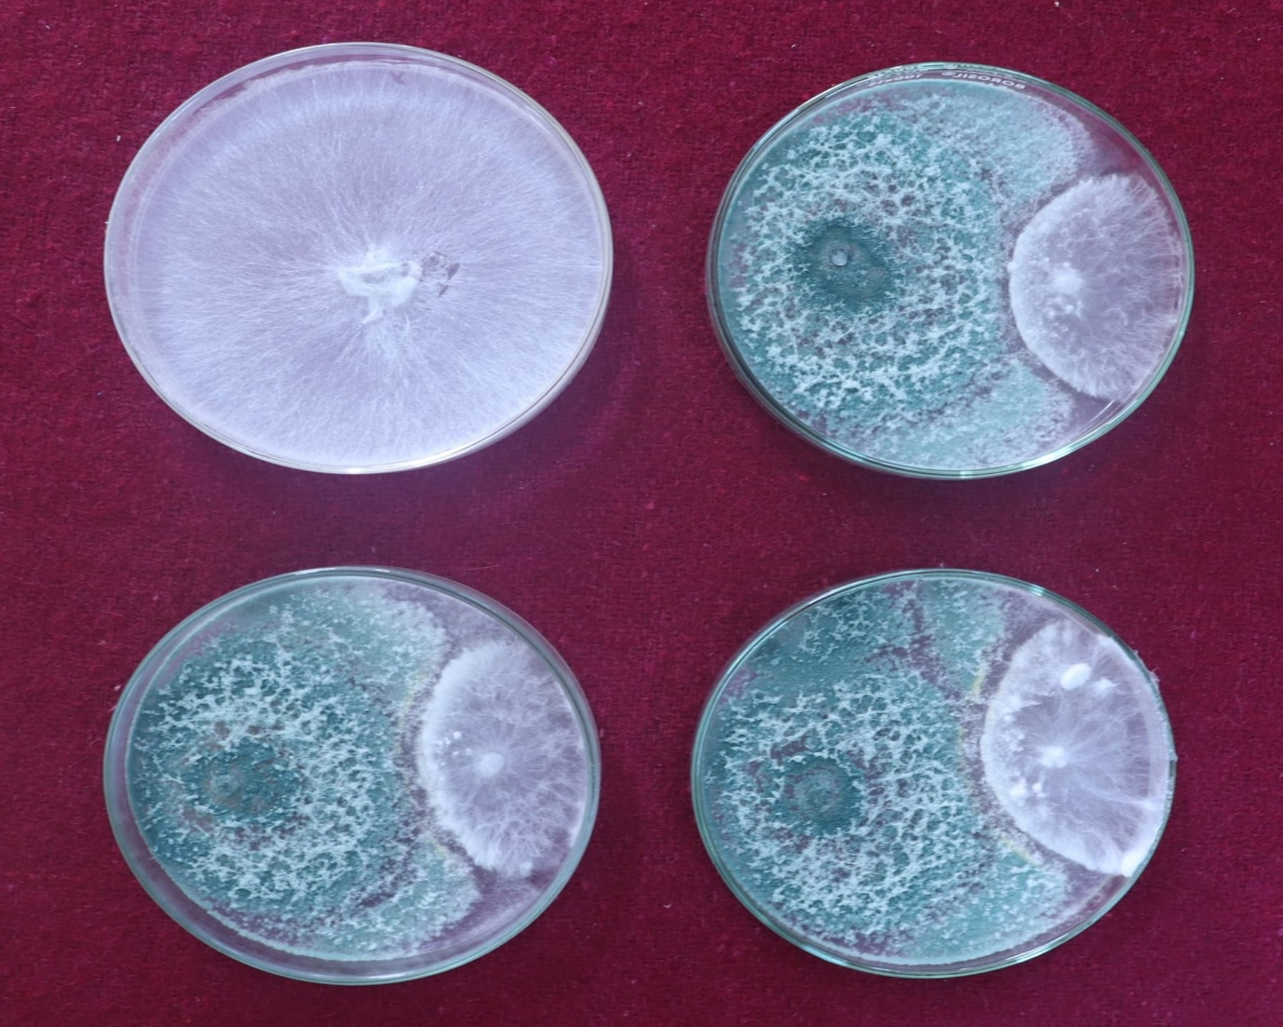

**Figure 3.** *T. harzianum* inhibiting the growth of *S. rolfsii* in dual culture assay.

**3.2. In Vivo Evaluation: Disease Suppression and Growth Promotion**

Encouraged by the laboratory results, a pot culture experiment was conducted to assess the biocontrol potential and growth-promoting effects of the *Trichoderma* spp. on tomato plants under greenhouse conditions.

**3.2.1. Disease Incidence and Suppression:** All *Trichoderma* treatments significantly reduced the incidence of Southern Blight compared to the inoculated control (T2), which showed a disease incidence of 91.67 ± 1.67%. The uninoculated control (T1) showed no disease symptoms. Among individual treatments, *T. harzianum* (T4) exhibited the greatest disease suppression, with a 35.00 ± 2.89% incidence and 61.67 ± 0.32% disease control. *T. viride* (T3) and *T. asperellum* (T5) followed with control efficacies of 57.31% and 43.11%, respectively (Graph 3 & 4).

Dual formulations enhanced effectiveness further. The combination of *T. asperellum* + *T. viride* (T8) was most effective among the dual treatments, showing 20.00 ± 2.89% incidence and 77.96 ± 0.80% control. Other combinations like *T. viride* + *T. harzianum* (T6) and *T. harzianum* + *T. asperellum* (T7) recorded 68.36% and 63.17% disease control, respectively. The triple inoculation treatment (T9: all three species) performed best among biological treatments, with only 13.33 ± 4.41% incidence and 85.93 ± 0.29% control, comparable to the chemical fungicide (T10), which recorded 6.67 ± 1.67% incidence and 92.85 ± 0.17% control. These findings were statistically significant (CD: 8.136 for incidence; 2.153 for control), underscoring the potential of combined *Trichoderma* applications in effective disease suppression.

**3.2.2. Shoot and Root Growth Performance:** Pathogen infection caused marked stunting in tomato plants. The uninoculated control (T1) showed maximum shoot (38.37 ± 0.26 cm) and root length (16.20 ± 0.23 cm), while the infected control (T2) recorded the lowest values (21.90 ± 0.40 cm and 10.63 ± 0.43 cm) (Graph 5) (Fig. 4).

All *Trichoderma* treatments improved plant growth over the infected control. Among single treatments, *T. viride* (T3) resulted in 34.37 ± 0.32 cm shoot and 13.10 ± 0.17 cm root length. *T. asperellum* (T5) showed a root length of 14.23 ± 0.09 cm, suggesting a stronger influence on root development. Dual inoculations were more effective. The T8 treatment (asperellum + viride) produced 36.47 ± 0.18 cm shoots and 14.73 ± 0.09 cm roots. Other dual treatments also showed marked improvements. The best performance was seen in the triple treatment (T9), with 37.67 ± 0.48 cm shoot and 15.50 ± 0.21 cm root lengths—closely approximating the fungicide control (T10), which yielded 37.17 ± 0.54 cm and 15.40 ± 0.15 cm. All differences were statistically significant (CD: 1.014 for shoot, 0.672 for root).

**3.2.3. Biomass Production:** Fresh and dry biomass values mirrored the trends observed in growth measurements. The uninoculated control (T1) showed the highest shoot fresh weight (29.42 ± 0.11 g), root fresh weight (9.15 ± 0.06 g), shoot dry weight (9.48 ± 0.19 g), and root dry weight (2.99 ± 0.07 g). The pathogen-inoculated control (T2) recorded the lowest biomass across all parameters (Graph 6 & 7).

All *Trichoderma* treatments enhanced biomass accumulation. Among individual treatments, *T. harzianum* and *T. asperellum* showed better shoot and root weights than *T. viride*. Combined treatments, especially the triple formulation (T9), significantly improved both fresh and dry weights. T9 produced shoot fresh and dry weights of 27.94 ± 0.20 g and 9.01 ± 0.08 g, and root fresh and dry weights of 8.42 ± 0.05 g and 2.86 ± 0.09 g, respectively—approaching the fungicide treatment values. This emphasizes the dual benefits of *Trichoderma* spp. in disease management and growth stimulation.

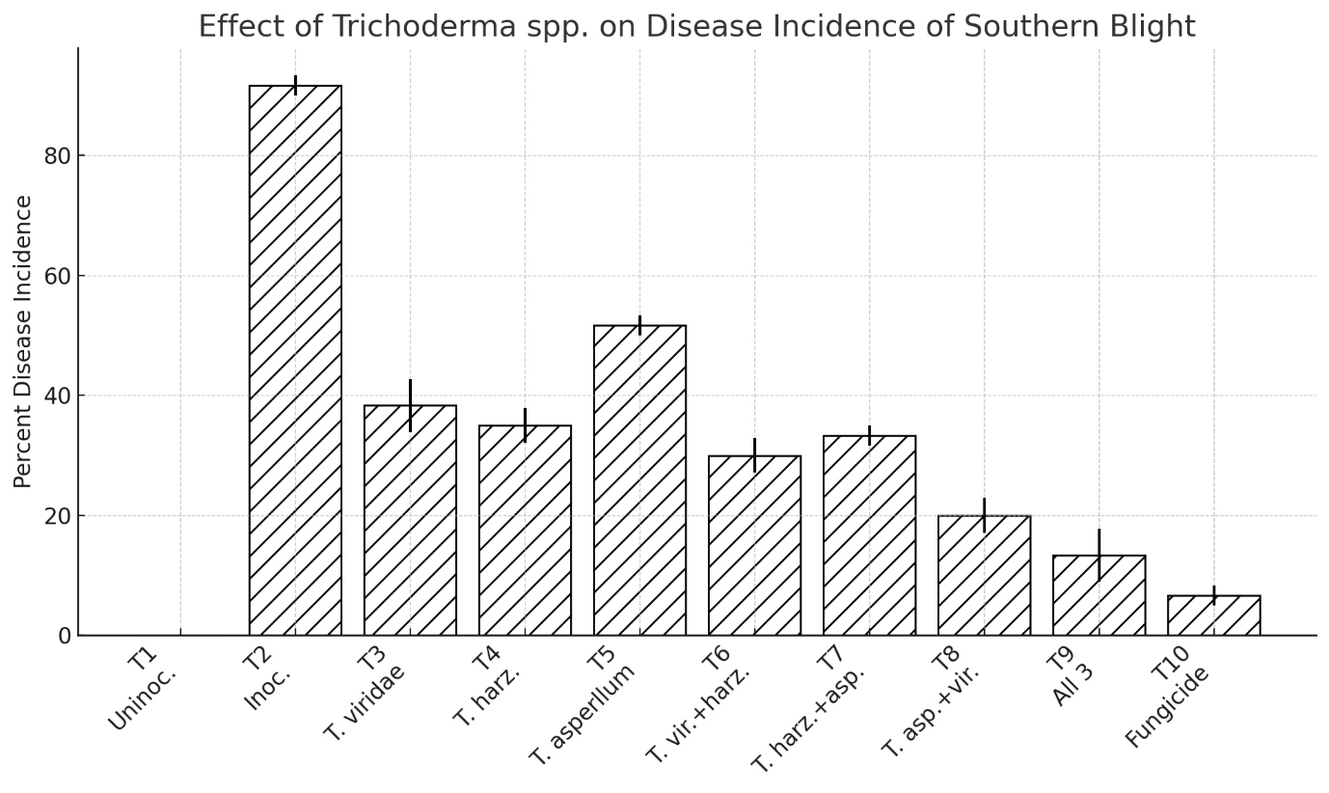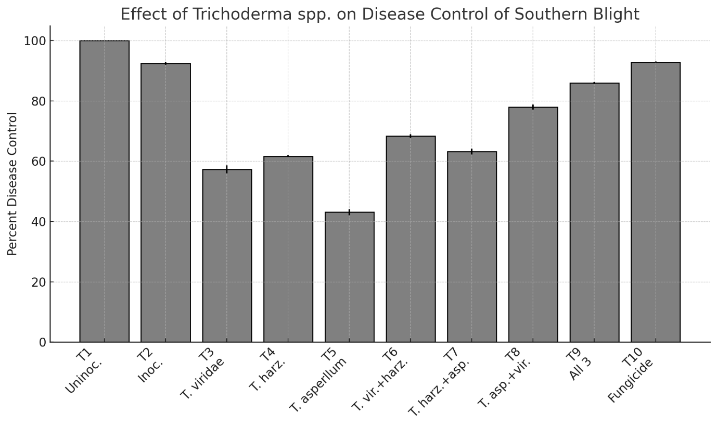

**Graph 3 & 4.** Effect of bioagents (*Trichoderma* spp.) as soil application for managing Southern Blight of tomato caused by *Sclerotium rolfsii*.

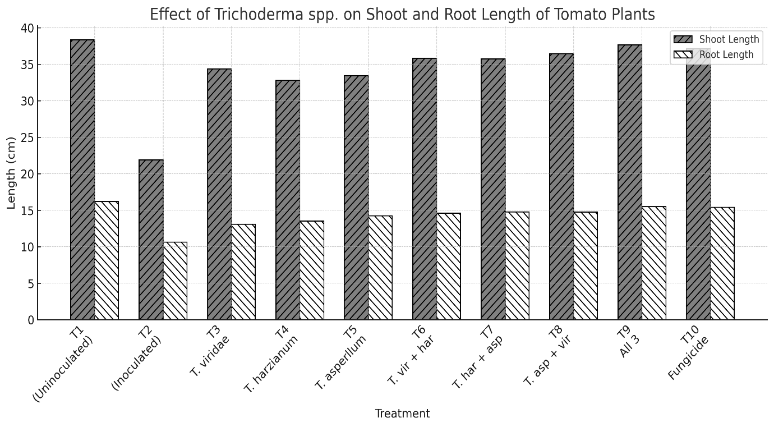

**Graph 5.** Effect of bioagents (*Trichoderma* spp.) on shoot and root length of tomato infected by *Sclerotium rolfsii*.

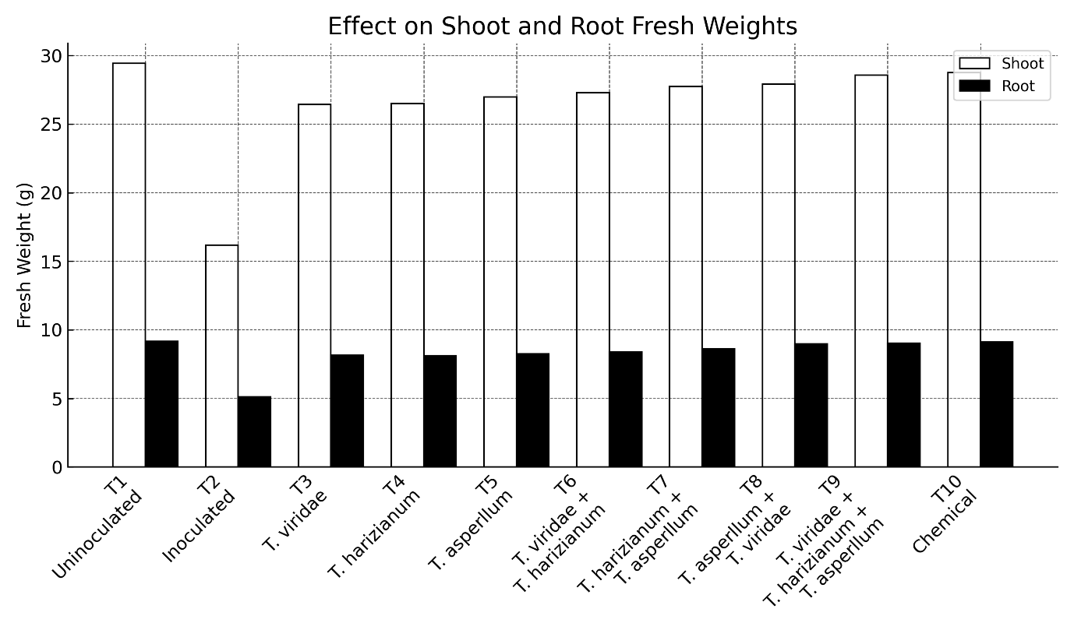

**Graph 6.** Effect of bioagents (*Trichoderma* spp.) on shoot and root fresh weight of tomato infected by *Sclerotium rolfsii*.

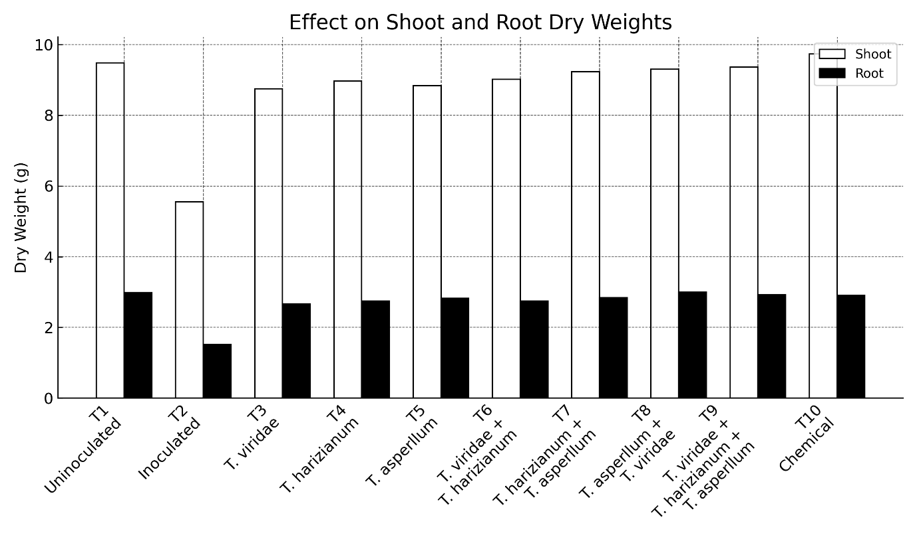

**Graph 7.** Effect of bioagents (*Trichoderma* spp.) on shoot and root dry weight of tomato infected by *Sclerotium rolfsii*.

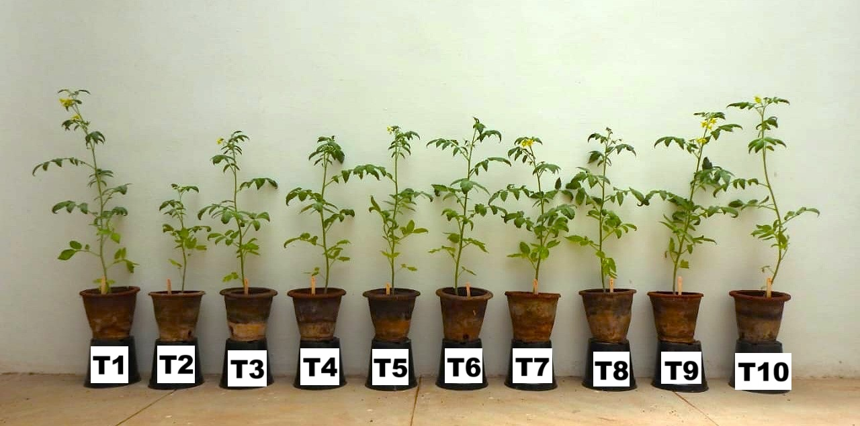

**Figure 4.** Effect of bioagents (*Trichoderma* spp.) on the growth of tomato infected by *Sclerotium rolfsii*.

**4. DISCUSSION**

The study provides compelling evidence supporting the use of *Trichoderma* spp., either alone or in combination, for the effective biological control of *Sclerotium rolfsii* in tomato. In vitro experiments revealed substantial suppression of pathogen growth by *T. harzianum* and *T. viride*, a result consistent with earlier studies such as those by Prajapati *et al*. (2015), who documented similar inhibition in chickpea. The mechanisms involved likely include mycoparasitism, competition, and secretion of lytic enzymes (Sharma *et al*., 2011), paralleling the findings of Dennis and Webster (1971), who first described the mycelial coiling behavior of *Trichoderma*.

Pot experiments further validated the biocontrol potential under soil conditions. Disease reduction and improved plant vigor observed in treatments involving *T. harzianum*, especially in combination with *Pseudomonas fluorescens*, confirm earlier reports by Manjula *et al*. (2004) and Bora *et al*. (2013), who observed synergistic effects between fungal and bacterial antagonists. This combined approach enhances biocontrol efficacy and reinforces plant resistance mechanisms.

Notably, the compatibility between *Trichoderma* spp. and *P. fluorescens* aligns with Jadon *et al*. (2018), who reported superior disease control in groundnut using integrated biocontrol strategies. Our results further support the application of such integrated treatments for tomato stem rot management.

Similar findings were reported by Safari Motlagh *et al*. (2022), who noted improved growth and reduced disease in groundnut with applications of *T. viride*, *A. flavus*, and *P. rubens*. The effectiveness of *P. fluorescens* is attributed to its plant growth-promoting activities such as ISR induction, siderophore production, and phosphate solubilization (Raaijmakers *et al*., 2002).

Studies by Rakholiya and Jadeja (2010), Rasu *et al*. (2013), and Kumar *et al*. (2008) have all confirmed the reliability of seed and soil treatments with *Trichoderma* spp. in managing soilborne pathogens. Our findings extend this evidence to tomato crops, emphasizing the potential of biological agents as viable alternatives to chemical fungicides.

Furthermore, the integration of *Trichoderma* with organic amendments like FYM enhances rhizosphere colonization and longevity of biocontrol action, as reported by Sarita *et al*. (2018). The persistence and adaptability of these agents contribute to their long-term effectiveness, unlike synthetic chemicals which often lead to resistance and environmental concerns (Dupler and Baker, 1984).

The PGPR traits of *P. fluorescens*, such as the production of auxins and lytic enzymes (Chin-A-Woeng *et al*., 2001), further explain the improved growth metrics seen in our study. These multifaceted benefits solidify the case for incorporating such bioagents into integrated pest management (IPM) programs.

**5. CONCLUSION**

In conclusion, the use of *Trichoderma* spp. and *Pseudomonas fluorescens* offers a sustainable, environmentally sound strategy for managing *S. rolfsii* in tomato crops. Future work should focus on optimizing formulations, delivery mechanisms, and evaluating their effectiveness across varied agro-ecological zones to facilitate broader adoption.

**REFERENCES**

1. Aycock, R. (1966). Stem rot, collar rot, and wilt caused by *Sclerotium rolfsii*. *North Carolina Agricultural Experiment Station Technical Bulletin*, 174, 1–33.
2. Dennis, C., & Webster, J. (1971). Antagonistic properties of species groups of *Trichoderma*: I. Production of non-volatile antibiotics. *Transactions of the British Mycological Society*, 57(1), 25–39. <https://doi.org/10.1016/S0007-1536(71)80078-5>
3. Elad, Y., Chet, I., & Boyle, P. (1983). Trichoderma harzianum: A biocontrol agent effective against Sclerotium rolfsii and Rhizoctonia solani. *Phytopathology*, 73(4), 498–501. <https://doi.org/10.1094/Phyto-73-498>
4. Ganesan, S., Subramanian, S., & Manoharan, P. (2007). Biocontrol efficacy of *Trichoderma* spp. against *Sclerotium rolfsii* in groundnut. *Madras Agricultural Journal*, 94(4–6), 161–163.
5. Harman, G. E., Howell, C. R., Viterbo, A., Chet, I., & Lorito, M. (2004). Trichoderma species—Opportunistic, avirulent plant symbionts. *Nature Reviews Microbiology*, 2(1), 43–56. <https://doi.org/10.1038/nrmicro797>
6. Hirte, R. N. (1969). Mass production of inoculum of Sclerotium rolfsii for use in pathogenicity tests. *Phytopathology*, 59, 1894.
7. Kaur, M., Singh, D., & Singh, R. (2019). Biocontrol potential of *Trichoderma* spp. against root rot pathogen *Sclerotium rolfsii* in chickpea. *Journal of Plant Pathology*, 101(2), 455–463. <https://doi.org/10.1007/s42161-019-00248-x>
8. Kumar, R., Sharma, S., & Singh, R. (2018). Challenges in breeding for resistance against *Sclerotium rolfsii* in tomato. *Journal of Horticultural Sciences*, 13(2), 123–129.
9. Mahadevakumar, M., & Janardhana, G. R. (2016). Morphological and molecular characterization of *Sclerotium rolfsii*. *Journal of Agricultural Science*, 8(9), 110–117. <https://doi.org/10.5539/jas.v8n9p110>
10. Mullen, J. M. (2001). Biology and management of *Sclerotium rolfsii*. *Plant Disease*, 85(6), 676–683. <https://doi.org/10.1094/PDIS.2001.85.6.676>
11. Patel, R., Sharma, M., & Singh, A. (2020). Microbial biocontrol agents: Emerging sustainable approaches for plant disease management in India. *Journal of Plant Protection Research*, 60(4), 375–385. <https://doi.org/10.24425/jppr.2020.134576>
12. Prajapati, R., Patel, P., & Patel, R. (2015). Biocontrol potential of *Trichoderma* spp. against root rot pathogens of chickpea. *International Journal of Current Microbiology and Applied Sciences*, 4(6), 47–52.
13. Punja, Z. K. (1985). Diseases of vegetable crops caused by soilborne fungi. *Canadian Journal of Plant Pathology*, 7(2), 147–157. <https://doi.org/10.1080/07060668509501159>
14. Rekha, A., Kavitha, K., & Rajan, S. S. (2012). Trichoderma-mediated induced resistance in plants. *Biotechnology Research International*, 2012, Article ID 263780. <https://doi.org/10.1155/2012/263780>
15. Safari Motlagh, A., Javan-Nikkhah, M., & Ramezani, M. (2022). Biocontrol mechanisms of *Trichoderma* spp. against soilborne pathogens: A review. *Plant Pathology Journal*, 38(1), 1–15. <https://doi.org/10.5423/PPJ.RW.02.2022.0020>
16. Sharma, S., Singh, A., & Singh, N. (2010). Impact of fungicides on soil microorganisms and biocontrol agents: A review. *Agricultural Sciences*, 1(1), 34–39. <https://doi.org/10.4236/as.2010.11005>
17. Singh, D., & Kumar, R. (2015). Challenges in managing fungicide resistance in crop pathogens. *Pesticide Biochemistry and Physiology*, 121, 80–86. <https://doi.org/10.1016/j.pestbp.2014.11.005>
18. Singh, H., Singh, S., & Singh, P. (2010). Biocontrol potential of *Trichoderma* spp. against *Sclerotium rolfsii* in tomato. *Biological Control*, 54(3), 218–223. <https://doi.org/10.1016/j.biocontrol.2010.07.011>
19. Sultana, R., & Hossain, M. (2022). Effectiveness of *Trichoderma* spp. against *Sclerotium rolfsii* causing root rot in vegetable crops. *Journal of Plant Pathology and Microbiology*, 13(1), 1–8. <https://doi.org/10.4172/2157-7471.1000546>
20. Vinale, F., Sivasithamparam, K., Ghisalberti, E. L., Marra, R., Barbetti, M. J., Li, H., Woo, S. L., & Lorito, M. (2008). A novel role for *Trichoderma* secondary metabolites in the interactions with plants. *Physiological and Molecular Plant Pathology*, 72(1-3), 80–86. <https://doi.org/10.1016/j.pmpp.2008.03.001>
21. Yadav, P., & Choudhary, R. (2021). Integrated management of soil-borne diseases in tomato using biocontrol agents and reduced fungicides. *International Journal of Current Microbiology and Applied Sciences*, 10(4), 1631–1638. <https://doi.org/10.20546/ijcmas.2021.1004.193>