***Case report***

**Small Bowel Obstruction Secondary to Chronic Pelvic Fistula: A Case Report**

**Abstract** : Small bowel obstructions caused by inflammatory adhesions without prior surgical history are rare and often linked to chronic infectious processes. Their association with pelvic fistulas, especially anal or vesical, complicates both diagnosis and management. We report the case of a 42-year-old male with no surgical history who developed an acute small bowel obstruction (SBO) caused by an inflammatory ileovesical adhesion associated with a chronic anal fistula. Imaging revealed a closed-loop obstruction and a pre-rectal abscess. Surgical exploration confirmed a purulent intervesico-rectal collection and an obstructive inflammatory band. Cultures identified Escherichia coli. The patient had a favorable postoperative course and was referred for gastroenterological management of the chronic fistula. Inflammatory adhesions complicating chronic pelvic sepsis should be considered in SBO without prior surgery. A multidisciplinary approach is essential for diagnosis and treatment.

**Keywords:** small bowel obstruction, pelvic fistula, inflammatory adhesion, enterovesical adhesion, Escherichia coli, case report

**Introduction** Acute small bowel obstruction (SBO) is a frequent surgical emergency and accounts for up to 20% of hospital admissions for acute abdomen. The most common cause remains postoperative adhesions, responsible for 60% to 75% of cases [1]. Other etiologies include hernias, neoplasms, and inflammatory conditions such as Crohn’s disease. However, in patients without prior abdominal surgery, SBO represents a diagnostic challenge and may result from uncommon causes such as spontaneous adhesions secondary to chronic pelvic inflammation or infection [2].

Chronic pelvic infections—originating from anorectal abscesses, fistulas, or diverticulitis—can lead to localized inflammatory reactions and fibrous adhesions. These adhesions may form between loops of bowel and adjacent pelvic organs, such as the bladder or uterus, resulting in abnormal connections and mechanical obstruction [3,4]. Pelvic fistulas, particularly chronic untreated anal fistulas, may serve as conduits for enteric pathogens like Escherichia coli, which contribute to abscess formation and peritoneal inflammation [5].

While inflammatory enterovesical or ileovesical adhesions are well-described in Crohn’s disease or radiation enteritis, their occurrence in patients without such history is rare. We present a case of SBO caused by an inflammatory ileovesical adhesion in a patient with no prior surgery, likely secondary to a chronic pelvic fistula.

**Case Présentation**

A 42-year-old male with no history of abdominal or pelvic surgery, but with a background of chronic smoking and cannabis use, was previously treated medically for an intervesico-rectal collection two months earlier. He presented with a 3-day history of diffuse abdominal pain, cessation of bowel movements and flatus, and repeated bilious vomiting. He reported fatigue but denied fever.

On examination, the patient was stable. His abdomen was distended and tender, particularly in the right iliac fossa. Rectal examination revealed an external anal fistula at 6 o’clock, with pus and fecal soiling. Laboratory results showed marked leukocytosis (24,700/mm³).

CT scan of the abdomen and pelvis revealed a closed-loop small bowel obstruction with the classic “beak sign,” upstream small bowel dilation up to 56 mm, and a pre-rectal fluid collection measuring 32×27×14 mm, with peripheral contrast enhancement. There were no signs of pneumoperitoneum or bowel wall ischemia.

**Figure 1.** CT scan showing closed-loop small bowel obstruction with “beak sign” and pre-rectal fluid collection :

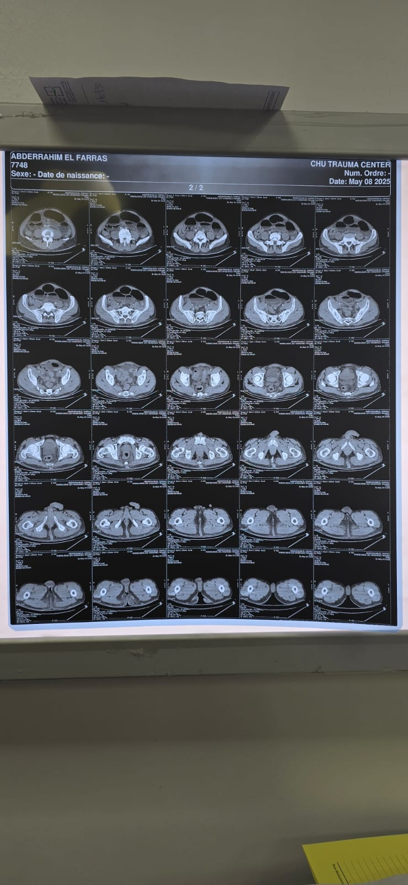

The patient underwent an emergency midline laparotomy. Intraoperative findings included an inflammatory adhesion between the ileum and bladder, located 3.5 meters from the Treitz ligament, multiple dense adhesions between the small intestine, sigmoid colon, and bladder, and a 30 cc purulent intervesico-rectal collection. An external anal fistula was also noted.

**Figure 2.** Intraoperative view showing an ileovesical adhesion with a fibrinous membrane :

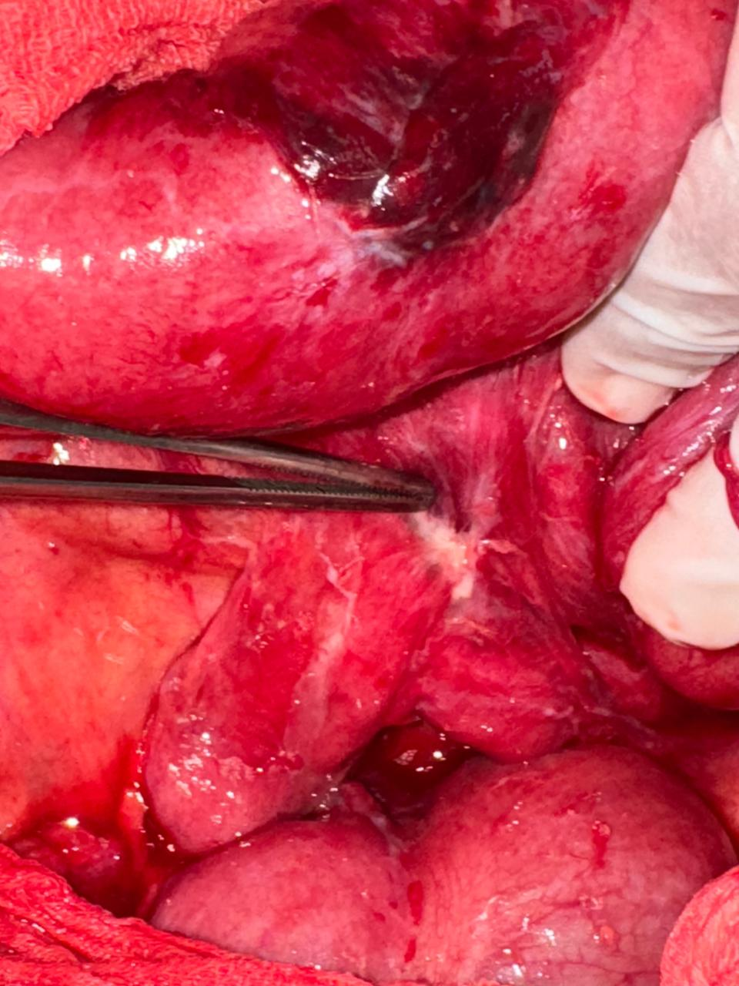

The procedure included adhesiolysis and excision of the fibrous band (biopsied), drainage of the abscess, peritoneal lavage, and placement of pelvic drains. Tests for rectal and vesical leakage were negative. Culture of the purulent fluid grew Escherichia coli sensitive to beta-lactams. The patient’s postoperative course was uncomplicated with return of bowel function by day three. He was referred to gastroenterology for evaluation and treatment of the chronic anal fistula.

**Discussion** Small bowel obstruction in patients without surgical history is uncommon and should raise suspicion for non-adhesive etiologies such as hernias, Crohn’s disease, or inflammatory adhesions. Chronic pelvic infections and fistulas can induce peritoneal inflammation and formation of fibrous bands that entrap bowel loops [3,6,7,8].

In our case, the patient developed an SBO secondary to an ileovesical inflammatory adhesion, with no prior abdominal intervention or known inflammatory bowel disease. The presence of an external anal fistula, pelvic collection, and isolation of E. coli strongly suggest a digestive origin for the pelvic sepsis. The pathophysiological mechanism likely involved chronic contamination of the intervesico-rectal space, inflammation, and secondary adhesion formation.

A multidisciplinary approach including imaging, surgery, and infectious disease or gastroenterological management is essential in such complex cases. Early surgical exploration is warranted when imaging reveals signs of closed-loop obstruction or intra-abdominal abscess, even in the absence of typical surgical risk factors.

**Conclusion** This case illustrates a rare cause of small bowel obstruction due to an inflammatory ileovesical adhesion in a patient with no prior surgery. The condition was likely triggered by chronic pelvic infection from an untreated anal fistula. Identification of E. coli in the abscess supports an enteric origin. Surgical management, including adhesiolysis and drainage, combined with appropriate follow-up for fistula care, is critical to prevent recurrence.

# **Provenance and Peer Review** Not commissioned, externally peer-reviewed.

# **Consent** As per international standard or university standard, patient(s) written consent has been collected and preserved by the author(s).

# **Ethical Approval** As per international standard or university standard, written ethical approval has been collected and preserved by the author(s).

**References**

1. Miller G, Boman J, Shrier I, Gordon PH. Natural history of patients with adhesive small bowel obstruction. Br J Surg. 2000;87(9):1240–1247.
2. O’Connor DB, Winter DC. The role of laparoscopy in the management of acute small-bowel obstruction: a review of over 2,000 cases. Surg Endosc. 2012;26(1):12–17.
3. Steele SR, Kumar R, Feingold DL. Practice parameters for the management of enterocutaneous fistulas. Dis Colon Rectum. 2010;53(5):438–444.
4. Garcia-Aguilar J, Belmonte C, Wong WD, et al. Anal fistula surgery. Dis Colon Rectum. 1996;39(7):723–729.
5. Radwan RW, Hamade A, McGregor C, Hunter IA. Small bowel obstruction due to an enterovesical fistula: a rare presentation. BMJ Case Rep. 2017;2017:bcr-2017-221287.
6. Muneer A, et al. A case of enterovesical fistula presenting with bowel obstruction. Int J Surg Case Rep. 2013;4(1):31–33.
7. Ellis H. The clinical significance of adhesions: focus on intestinal obstruction. Eur J Surg Suppl. 1997;(577):5–9.
8. Beck DE, Roberts PL, Saclarides TJ, Senagore AJ, Stamos MJ, Wexner SD. The ASCRS Textbook of Colon and Rectal Surgery. Springer; 2016.