*Case report*

Acute gastric dilatation with necrosis in a child

**Abstract:-**Acute gastric dilatation with necrosis is a very rare event. We present a case of a 14-year-old boy who presented with acute abdomen. Emergency laparotomy revealed gastric dilatation with fundic and greater-curvature infraction. Greater-curvature gastrectomy was successful and gave satisfactory results.

**Keywords: -** Acute gastric dilatation, Gastric infarction, Greater-curvature or sleeve gastrectomy

# Introduction: -

The incidence of acute gastric dilatation (AGD) is quite rare compared with other gastric pathologies. It is encountered most often as a postoperative complication in abdominal surgery and in multitude of disorders whose pathogenesis is still doubtful. Total or near total gastric necrosis is distinctly rare because of rich blood supply of stomach. We present a case of AGD fundic and greater-curvature necrosis in a young child.

# Case Presentation :-

A 14 –year– old male presented with severe abdominal pain and distension with one episode of vomiting since last 12 hours. There was no history of fever, trauma, surgery, hematemesis, melena or similar episode in the past. No psychiatric disorder was reported. On examination the boy was anxious, afebrile (980 F) with pulse rate of 90/minute and blood pressure of 110/70 mmHg. His height was 142 cm and weight 23 kg. Abdomen was grossly distended and tender with guarding and rigidity. Bowel sounds were absent and there was free fluid in the peritoneal cavity. Rectal examination revealed a boggy swelling anteriorly. Respiratory system and cardiovascular system was normal. His hemoglobin was 13.3 gm%. The leucocyte count was 8800/mm3 with 85% neutrophils. The renal function tests, liver function tests, serum electrolytes were normal. Plain abdominal radiograph revealed massively dilated stomach (Fig.1) and abdominal ultrasound showed free fluid in the peritoneal cavity. A clinical diagnosis of perforation peritonitis with paralytic ileus was made and intravenous fluids, broad spectrum antibiotics were started. Nasogastric tube was passed without difficulty and 200 ml grayish black semisolid material returned. At laparotomy there was AGD with gangrene affecting the fundic and greater curvature of stomach (Fig.2). There was 400ml free fluid in the peritoneal cavity. The greater curvature of stomach was mobilized and greater curvature gastrectomy was performed. The stomach was closed in two layers with 2-0 mersilk. Feeding jejunostomy was performed. Rest of the abdominal viscera was normal. Intra-abdominal drain was kept and abdomen was closed in layers using 1/0 polyglactin violet. Patient received one unit of packed red blood cells and was monitored in intensive care unit. Jejunostomy feeds were started on fourth postoperative day. Patient developed hypoalbuminemia in the postoperative period which was corrected by intravenous 20% human albumin. Skin sutures were removed on 12th postoperative day. The postoperative course was uneventful except he developed small sacral bed sore which healed subsequently. The patient was discharged on 20th postoperative day. The histopathology report was consistent with gangrene of stomach. At six months follow-up patient gained 5kg weight and learned to eat small frequent meals.

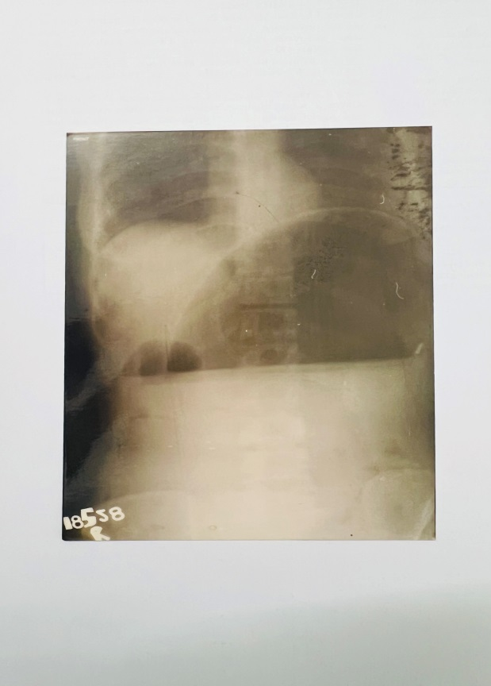

Figure: 1 Plain abdominal radiograph showing massively dilated stomach

# 

# Figure: 2 Intraoperative photograph showing gastric necrosis

# Discussion

Acute gastric dilatation is characterized by a rapid enlargement of stomach and duodenum without actual or organic obstruction. It is often encountered in the postoperative period due to anesthesia and debilitation which cause relaxation of upper esophageal sphincter with aerophagia [1]. In patients with eating disorders such as anorexia and bulimia the stomach undergoes atony and muscular atrophy during starvation so that a sudden ingestion of food overtaxes an already weekend stomach (atonic theory) [2]. In superior mesenteric artery syndrome (SMAS), AGD follows vascular compression of third part of duodenum, between superior mesenteric artery, aorta and vertebral column (mechanical theory). AGD may be a functional entity secondary to regional diseases such as pancreatitis, peptic ulcer, gall bladder disease, appendicitis. It may be noted after minor operative procedure, trauma, or even with the application of a body cast. It may occur in non-surgical conditions such as pneumonia, typhoid fever or tuberculosis. AGD is also reported in patients with low BMI (as in present case), gastric volvulus, spinal conditions, electrolyte disturbance, trauma, and diabetes mellitus [1].

It has been demonstrated that 4 liter is the capacity of stomach before perforation occurs. However, in chronic distension, >15 liter capacity has been described in eating disorders like polyphagia, bulimia. The stomach is very resistant to ischemia due to its rich blood supply and extensive intramuscular anastomosis. Infarction will not occur even if all four major arterial trunks as well as 80% of smaller arterial branches are occluded [2]. Increased intragastric pressure over 20 cm H2O which exceeds venous pressure, results in mucosal necrosis.

Acute massive gastric dilatation (AMGD) represents the extreme form of AGD. When the stomach is extremely distended occupying the abdomen from diaphragm to pelvis and from left to right [2]. In this condition, intragastric pressure usually exceeds 30cm H2O and produce necrosis usually involving greater curvature (present case). Ischemia generally occurs before perforation and mucosal necrosis before full thickness gastric necrosis. Infarction occurs after gross distension of the stomach as cardia and pylorus become occluded and intragastric pressure builds up following muscular contractions. The other causes of gastric infarction include intrathoracic herniation, volvulus, acute necrotizing gastritis, ingestion of caustic materials and vascular compromise [3].

Clinically, emesis is present in more than 90 % of cases of AGD. However, even with full stomach majority of patients are unable to vomit as in present case. This may be due to occlusion of gastroesophageal junction by the distended fundus which angulates the esophagus against the right crus of diaphragm producing one way valve. Diffuse abdominal distension accompanied by pain is common. On physical examination, diffuse tympani on palpation, a splash on percussion, and a distended Douglas pouch may be found in cases without peritonitis. However, guarding and rigidity may mask these signs when obvious gangrene is present.

Trindade E N et al (2008) reported a case of AGD with infarction in a 13-year-old-girl with low BMI 17.9 kg/m2 [4]. Klyuev SA et al [5] reported a case of 13-year-old girl with severe degree of gastric dilatation with necrosis due to simultaneous overeating of bulky food and soft carbonated drinks. In this case atypical resection of necrotic stomach was performed. Joshi PK [6] also described acute gastric necrosis in a 14-year-old child who presented with acute onset abdominal pain and vomiting with features of shock. It was treated with total gastrectomy. Rapid progression of surgical abdomen, hemorrhagic drainage in nasogastric tube and presence of gas in portal vein could be strong indicators of gastric necrosis.

Plain abdominal films may diagnose this condition [2]. In doubtful cases computed tomography may reveal a cause such as SMAS or associated abdominal pathologies. CT scan finding of pneumoperitoneum, gastric pneumatosis and portal venous gas may indicate gastric necrosis [6]. Endoscopy is useful to rule out mechanical causes such as tumor, webs or peptic ulcer. It can also show the general status of gastric mucosa.

First line treatment of AGD consists of nasogastric decompression and fluid resuscitation. A normal size nasogastric tube may prove to be ineffective because of its blockage by semisolid and obstructed gastroesophageal junction. The very large quantity of brownish-black fluid, which may be likened to the storm water of a peat-laden stream is pathognomic.

If conservative measures fail or gastric infarction with or without perforation is suspected, immediate surgical intervention is mandatory. If gastric necrosis or perforation is not recognized and the treatment is delayed, 50-100 % mortality has been reported [7]. The type of surgery depends upon the intra-operative findings surgical decompression, partial or total resection of stomach. In the present case, greater curvature gastrectomy was performed as described in the management of morbid obesity [8]. To our knowledge, this type of surgical procedure has not yet been described in cases of AGD with fundic and greater curvature necrosis.

This report calls attention to AGD with necrosis in a young boy with low BMI without psychiatric illness. Greater curvature gangrene may be treated by sleeve gastrectomy. A high index of suspicion is necessary to diagnose this rare, rapidly progressive and potentially fatal condition.

## DISCLAIMER (ARTIFICIAL INTELLIGENCE)

## There are NO generative AI technologies such as Large Language Models (ChatGPT, COPILOT, etc.) and text-to-image generators have been used during the writing or editing of this manuscript. .

## References

1. Lunca S, Rikkess A, Stanescu A. Acute massive gastric dilatation: Severe ischemia and gastric necrosis without perforation. Rom J. Gastroenterol 2005; **14**: 279-83
2. Saul SH, Dekker A, Watson C G. Acute gastric dilatation with infarction and perforation. Report of fatal outcome in patient with anorexia nervosa. Gut 1981; **22**: 978-83.
3. Turan M, Sen M, Canbay E, Karandayi K, Yildiz E. Gastric necrosis and perforation caused by acute gastric dilataion. Report of a case surgery Today 2003; **33**: 302-4.
4. Trindade EN, Diemen V, Trindade MRM. Acute gastric dilatation and necrosis; a case report. Acta Chir Belg 2008; **108**: 602-3.
5. Klyuev, SA, Goremykin IV, Masevkin, VG et al, Acute gastric dilation with necrosis: Case Report and literature review. Journal of Clinical Trial and Experimental Investigations 2022; **2**: 32-40.
6. Joshi PK. Acute gastric necrosis in a fourteen-year old child: Asian Journal of Medical Sciences, 2013; **4**: 44-8.
7. Bathobakae L, Bashir R, Venero S et al, Acute Gastric Dilatation: A Retrospective Case Series from a Single Institution. Case Rep Gastroenterol 2024; **18**:439-48.
8. Trelles N, Ganger M. Updated review of sleeve gastrectomy. The Open Gastroenterology Journal 2008; **2**:41-9.