Case report

**Fulminant Necrotizing Fasciitis in Infants**

.

ABSTRACT

|  |
| --- |
| **Aims:** To present an infant with necrotizing fasciitis following NSAID administration for cutaneous erythema. We describe the therapeutic management, clinical course, and discuss the potential association between NSAID use and the development of necrotizing fasciitis. **Case presentation:** This case involves an 18-month-old infant with no medical or surgical history who had been treated with non-steroidal anti-inflammatory drugs (NSAIDs) for a truncal erythema. One month after treatment, the child developed fulminant necrotizing fasciitis of the left upper limb, extending to the left flank, accompanied by severe septicemia  **Discussion:** Necrotizing fasciitis is a rare and severe infectious disease. In pediatrics and neonatology, several predisposing factors contribute to the development of necrotizing fasciitis. The evolution of necrotizing fasciitis is extremely rapid, with the appearance of blisters, cutaneous necrosis, and a marked deterioration in the patient's general condition. It constitutes a surgical emergency. The role of non-steroidal anti-inflammatory drugs (NSAIDs) as a risk factor for necrotizing fasciitis has been a subject of controversy.  **Conclusion:** This case clearly illustrates that the spread of the infection beyond the upper limb quickly becomes life-threatening and highlights the importance of radical excisional surgery to eradicate the infection. NSAIDs should be avoided in the management of cutaneous erythema, particularly in children, to mitigate the risk of developing necrotizing fasciitis - a potentially life-threatening condition. |

*Keywords: Necrotizing fasciitis, Non-steroidal anti-inflammatory drugs, Erythema*

**INTRODUCTION :**

Necrotizing fasciitis is a rare and severe infectious disease, not well known among surgeons, and associated with high morbidity and mortality despite significant advancements in resuscitation techniques. It affects the dermis, hypodermis, and fascia.

The initial skin presentation ranges from minimal rash to cellulites.

Early diagnosis and initiation of aggressive surgical and supportive therapy offer best chance for survival.

**CASE PRESENTATION :**

This case involves an 18-month-old infant with no medical or surgical history who had been treated with non-steroidal anti-inflammatory drugs (NSAIDs) for a truncal erythema. One month after treatment, the child developed fulminant necrotizing fasciitis of the left upper limb, extending to the left flank, accompanied by severe septicemia(figure1,2).

Extensive surgical excision of necrotic tissue, combined with medical resuscitation including transfusions and high-calorie, high-protein parenteral nutrition, allowed for eradication of the infection(figure3).

Postoperative intensive care management is essential. Bacterial toxin release following surgical excision may lead to rapid multiorgan failure [1]. A second-look surgery at 24 hours is indispensable.

The residual skin defects were subsequently covered with a meshed split-thickness skin graft(figure4).

The final outcome was satisfactory, with good functional results: normal mobility of the shoulder and elbow, and satisfactory recovery of hand function(figure5).

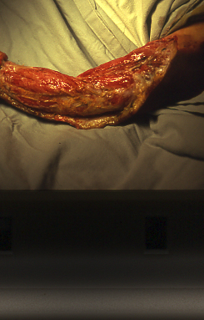 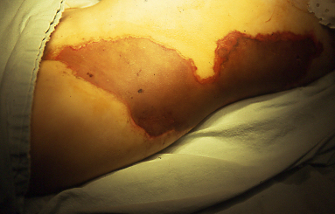

Figure 1,2 : Necrotizing fasciitis of the left upper limb extending to the left flank.

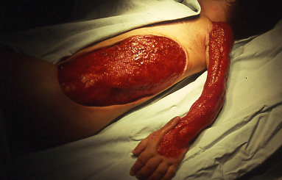

Figure 3 : Extensive surgical excision of necrotic tissue.

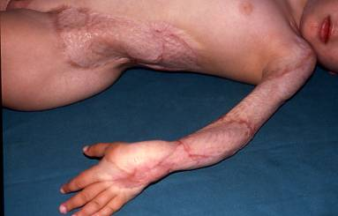

Figure 4 : Expanded split-thickness skin graft.

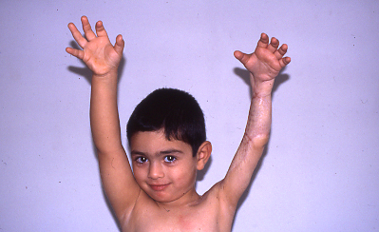

Figure 5 : Final outcome with full range of motion.

**DISCUSSION :**

Necrotizing fasciitis is an extremely rare clinical entity, with approximately 1,000 cases reported annually in the United States[2]. This incidence appears to have increased, possibly as a result of greater awareness of the condition leading to higher reporting rates, increased bacterial virulence, and growing resistance to antimicrobial agents.

In pediatrics and neonatology, several predisposing factors contribute to the development of necrotizing fasciitis, such as varicella lesions, i.m. injections, application of a cream containing menthol to the cervical region, penetrant gluteal trauma, omphalitis, dental abscess and streptococcal toxic shock syndrome[3]. In our case, there were pre-existing skin lesions prior to the development of necrotizing fasciitis, which may be consistent with varicella lesions, thus representing a predisposing factor.

Fever is common, and signs of severe sepsis (shock, tachypnea, and oliguria) are present in nearly half of cases. The most frequently involved pathogen is group A β-hemolytic Streptococcus (GAS), although the infection can also be polymicrobial, involving both aerobic and/or anaerobic organisms.

The evolution of necrotizing fasciitis is extremely rapid, with the appearance of blisters, cutaneous necrosis, and a marked deterioration in the patient's general condition. The extent of subcutaneous necrosis typically exceeds the visibly affected skin area. Necrotizing fasciitis constitutes a surgical emergency. Treatment requires prompt and complete debridement, which may be extensive and, at times, mutilating. Even with appropriate medical and surgical therapy, the mortal ity rate in NF is more than 50%[4].

Complications in survivors include peritonitis, visceral abscesses with consequent peritoneal adhesions, skin grafting and amputations[5].

The role of non-steroidal anti-inflammatory drugs (NSAIDs) as a risk factor for necrotizing fasciitis has been a subject of controversy since the publication in 1966 of three cases of necrotizing fasciitis in adults treated with indomethacin[6].

The publication, in 1995, of a series of 14 pediatric cases of necrotizing fasciitis following chickenpox[7] 35% of which had been exposed to ibuprofen reignited the controversy over the role of NSAIDs in the development of this condition and led the Americans to issue a warning against the use of NSAIDs during chickenpox.

A case-control study [8] compared 19 children hospitalized for necrotizing fasciitis within three weeks following chickenpox with 29 control children, also hospitalized within the same timeframe after chickenpox, but for a soft tissue infection (that was not necrotizing fasciitis). The groups were matched for sex, age, and presence of group A Streptococcus (GAS). The necrotizing fasciitis cases had more frequently received ibuprofen prior to hospitalization than the controls , suggesting that ibuprofen may promote the development of necrotizing fasciitis in children with chickenpox. In most children (whether or not they had fasciitis), ibuprofen was started after the onset of skin infection symptoms, suggesting a promoting rather than triggering role of ibuprofen, which would require a pre-existing skin infection.

Between January 1969 and November 1995, 33 cases of necrotizing fasciitis considered secondary to the use of NSAIDs were reported to the FDA (Food and Drug Administration)[9], one-third of which involved children. The NSAID had been prescribed for varicella (33%), in the postpartum period (18%), or following trauma (18%). The medications involved were diclofenac (48%), ibuprofen (33%), piroxicam (9%), and indomethacin (6%). NSAIDs were administered orally (50%), intramuscularly (21%), rectally (15%), or topically (3%). All patients except one were hospitalized; 80% required surgical debridement, and 6% underwent amputation. The mortality rate was 30%.

For the responsible pathogen, Coagulase-negative Staphylococcus (CONS) infection is the most common bloodstream infection treated in neonatal and pediatric intensive care units and significantly affects patient mortality and morbidity. S. epidermidis is the most common CONS species isolated clinically and investigated for its pathogenicity, virulence, and is a major nosocomial pathogen, even though it is a member of the normal bacterial flora of skin and the mucous membranes[10].

In our patient, this is an 18-month-old infant who was treated with NSAIDs for a skin rash that could be chickenpox, based on the location of the lesions on the trunk and limbs, and who subsequently developed necrotizing fasciitis. Based on these studies, a link can be suggested between the use of NSAIDs for chickenpox and the development of necrotizing fasciitis.

**CONCLUSION :**

It cannot be stated with certainty that NSAIDs promote the development of necrotizing fasciitis, but their use can be discouraged in cases of chickenpox and during any soft tissue infection.

This case clearly illustrates that the spread of the infection beyond the upper limb quickly becomes life-threatening and highlights the importance of radical excisional surgery to eradicate the infection.

In summary, NSAIDs should be avoided in the management of cutaneous erythema, particularly in children, to mitigate the risk of developing necrotizing fasciitis - a potentially life-threatening condition.

**CONSENT :**

All authors declare that ‘written informed consent was obtained from the patient’s next of kin for publication of this case report and accompanying images.

**ETHICAL APPROVAL :**

All authors hereby declare that all experiments have been examined and approved by the appropriate ethics committee and have therefore been performed in accordance with the ethical standards laid down in the 1964 Declaration of Helsinki.

**DISCLAIMER (ARTIFICIAL INTELLIGENCE) :**

Author(s) hereby declare that NO generative AI technologies such as Large Language Models (ChatGPT, COPILOT, etc.) and text-to-image generators have been used during the writing or editing of this manuscript.

**COMPETING INTERESTS DISCLAIMER:**

Authors have declared that they have no known competing financial interests OR non-financial interests OR personal relationships that could have appeared to influence the work reported in this paper.

**REFERENCES :**

1. Pegot A, Aktouf A, Delpierre V, Milliez P-Y, Auquit-Auckbur I. Dermohypodermite nécrosante du tablier abdominal chez l’obèse. À propos de deux cas cliniques révélateurs d’infections profondes abdomino-pelviennes. Ann Chir Plast Esthet 2013;58:248—54.

2. Hakkarainen TW, Kopari NM, Pham TN, Evans HL. Necrotizing soft tissue infections: review and current concepts in treatment, systems of care and outcomes. Curr Probl Surg. 2014;51(8):344–362.

3. Bingo ¨l-Kolog ˘lu M, Yildiz RV, Alper B et al. Necrotizing fasciitis in children: diagnostic and therapeutic aspects. J Pediatr Surg 2007; 42: 192–197.

4. Hsieh WS, Yang PH, Chao HC, Lai JY. Neonatal necro tizing fasciitis: a report of three cases and review of the literature. Pediatrics 1999; 103: 810–816.

5. Samuel M, Freeman NV, Vaishnav A, Sajwany MJ, Nayar MP. Necrotizing fasciitis: a serious complication of omphalitis in neonates. J Pediatr Surg 1994; 29: 1414–1416.

6. Solomon L. Activation of latent infection by indomethacin : a report of three cases. Br Med J 1966 : 1 : 961-2.

7. Brogan TV, Nizet V, Waldhausen JHT, Rubens CE, Clarke WR. Group A streptococcal necrotizing fasciitis complicating primary varicella : a series of fourteen patients. Pediatr Infec Dis J 1995 ; 14 : 588-94.

8. Zerr DM, Alexander ER, Duchin JS, Koutzky LA, Rubens CE. A case-control study of necrotizing fasciitis during primary varicella. Pediatrics 1999 ; 103 : 783-90.

9. Kahn LH, Styrt BA. Necrotizing soft tissue infections reported with NSAIDs. Ann Pharmacother 1997 ; 31 : 1034-9.

10. Venkatesh MP, Placencia F, Weisman LE. Coagulase negative staphylococcal infections in the neonate and child: an update. Semin Pediatr Infect Dis 2006; 17: 120–127.