Case report

Combined De Garengeot and Richter Hernias in a Strangulated Femoral Hernia: A Case Report and Review of the Literature

Abstract :
De Garengeot and Richter hernias are rare types of groin hernias, each with distinct features and clinical challenges. A De Garengeot hernia involves the appendix within a femoral hernia sac, while a Richter hernia involves partial bowel wall herniation, often without obstruction. Both conditions are more common in women due to the higher prevalence of femoral hernias. The simultaneous occurrence of these two hernias is extremely rare, with only one previously reported case. This article presents a unique case involving both hernia types, highlighting diagnostic and surgical considerations.

Introduction

Strangulated groin hernias present a common challenge for emergency and surgical teams worldwide. We report a rare case of a femoral hernia in which surgical exploration revealed the presence of both a loop of small bowel and the vermiform appendix within the hernia sac. The presence of the appendix within a femoral hernia was first described by Rene Jacques Croissant de Garengeot in 1731. In 2005, Akopian and Alexander proposed naming this condition “de Garengeot's hernia”. There have been fewer than 90 reported cases of de Garengeot's hernia in the English literature. The incidence of de Garengeot's hernia is less than 1% of femoral hernias and it occurs predominately in females (13:1 female:male). In 1785, August Gottlieb Richter first comprehensively described a hernia in which only part of the circumference of the bowel is strangulated [8,9].

Case Presentation
A 84-year-old woman with a history of hypertension and no prior abdominal surgeries presented to the emergency department with a strangulated femoral hernia causing intestinal obstruction. The patient's symptoms had been evolving for three days and included constipation, abdominal distention, nausea, and vomiting. She denied experiencing fever or chills.
At presentation, the patient had a temperature of 36.1 °C, heart rate of 72 beats per minute, blood pressure of 140/76 mmHg, respiratory rate of 16 per minute and oxygen saturation of 99% on room air. Her body mass index was 20.2 kg/m2. Clinical examination revealed a distended but soft abdomen without tenderness or guarding. Examination of the groins revealed a strangulated femoral hernia of3 cm.
Laboratory investigations indicated an inflammatory response, with a markedly elevated C-reactive protein level of 168 mg/L, while the white blood cell count remained within normal limits at 8,520/mm³. Electrolyte analysis showed a serum sodium level of 141 mEq/L and potassium at 3.7 mEq/L. Renal function tests revealed a blood urea nitrogen level of 0.58 g/L and a creatinine level of 6.6 mg/L. Diagnostic imaging was not performed, as the diagnosis was made based on clinical findings.
The patient underwent abdominal exploration under general anesthesia. A right inguinal incision was made, revealing incarceration of the anti-mesenteric border of a jejunal loop and the vermiform appendix within the opening of a femoral hernia sac. The vermiform appendix was erythematous and inflamed classified as a class 2A of Garengeot Hernia classification according to Guenther et al (Fig. 1).
An appendectomy was performed without complications. The femoral hernia sac was repositioned to the inguinal position and ligated at its base. Hernia repair was performed using the McVay technique, which involved suturing the transversus abdominis arch and conjoint tendon to Cooper's ligament using 2-0 Silk sutures.
The postoperative course was uneventful, and the patient was discharged home on postoperative day 4.
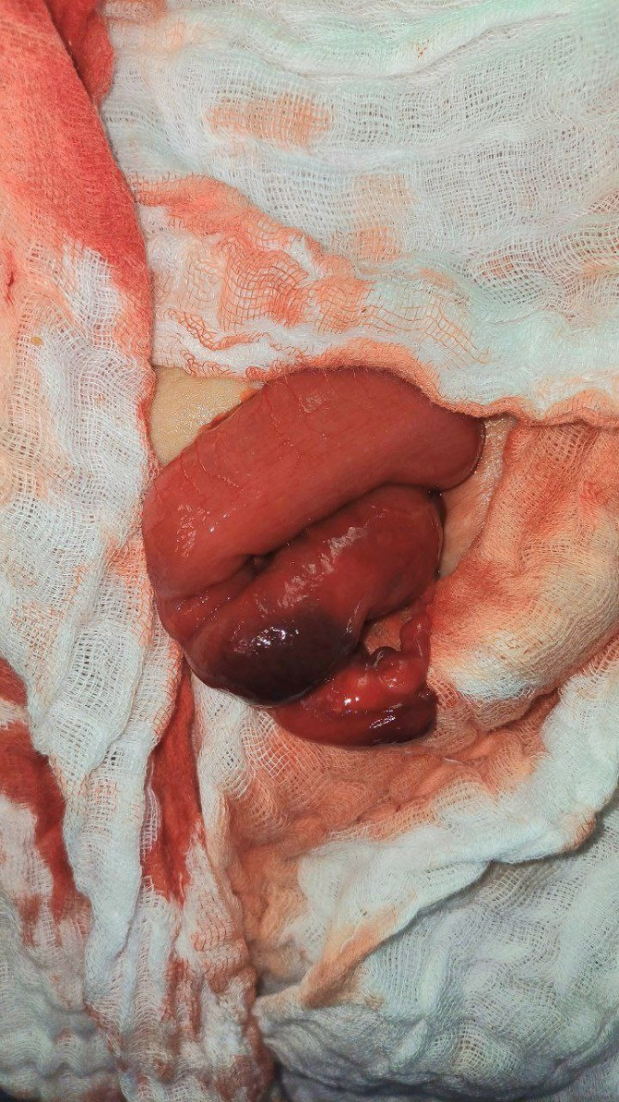
Figure 1 : Per-operative image showing the vermiform appendix and the small bowel

Discussion :

Femoral hernias occur more frequently in women than in men, yet they represent only about 4% of all groin hernias [1]. A rare subtype, known as De Garengeot hernia, was first described by the French surgeon René Jacques Croissant de Garengeot in 1731. This condition involves the presence of the appendix within the femoral hernia sac [2]. It occurs in only 0.5% to 5% of femoral hernia cases. The incidence of appendicitis within a De Garengeot hernia is even lower, ranging from 0.08% to 0.13% [3]. The median age for presentation of a De Garengeot hernia is approximately 55 years. Identified risk factors include pregnancy-related anatomical changes, smoking, chronic cough, constipation, and advancing age.[4]
Two main theories have been proposed to explain this condition. The first suggests that abnormal embryologic rotation leads to atypical attachment of the appendix to the cecum. The second theory posits that a large or mobile cecum may force the appendix into the femoral hernia sac [5].
De Garengeot hernia is most often diagnosed intraoperatively, although there are rare cases where preoperative imaging has revealed the condition [5].
Guenther et al proposed a classification of de Garengeot Hernia based on the appearance of the appendix, the cecum and the small bowel .In a systematic review including 222 case,the most common condition of the appendix was congested inflamed, found in 44.1% of the cases and corresponding to class 2A in the classification system devised (Table 1) [5].

Class | Description
Class 1 | Normal appearing appendix
Class 2  2A  2B | Erythematous, inflamed, or congested appendix  Erythematous, inflamed, or congested appendix  and  Erythema of the cecum or other segment of large or small  intestine
Class 3  3A  3B | Necrosis of the appendix, isolated to the tip  Necrosis of the appendix, involving the entire appendix
Class 4 | Necrosis of the appendix  AND  Necrosis of the cecum or other segment of large or small intestine
Class 5 | Perforated appendix, abscess, or fistula
Table 1 : The classification of De Garengeot hernia according to Guenther et al [5]
The Richter hernia is named after August Gottlich Richter, who first described the condition in 1785. It involves the herniation of only the anti-mesenteric portion of the bowel wall through a fascial defect, rather than the entire circumference of the bowel.[6]
Richter hernias most commonly occur in elderly individuals between 60 and 80 years and account for approximately 10% of all hernias. There is a slightly higher incidence among females, likely due to the higher prevalence of femoral hernias in women. The femoral ring is the most frequent site for Richter hernias, which may explain this gender distribution. The femoral groin is the most common site of occurrence, reported in 36% to 88% of cases.[7]
De Garengeot hernia requires prompt surgical intervention and is considered a surgical emergency. Initial management involves stabilizing the patient with intravenous fluids, antibiotics, and analgesics. Once stabilized, the patient should undergo urgent surgical repair. Due to the rarity of this condition, there is no universally accepted surgical protocol, in our case we preferred the McVay procedure associated to an appendectomy. The use of mesh was deemed inappropriate due to the clinical context.
Postoperative complications include wound infections in 14%–29% of cases. In our case, the patient experienced an uneventful postoperative course without developing any wound infections.[8]
The unique aspect of our case is the coexistence of a Richter hernia and a De Garengeot hernia, a combination that has been reported only once in the literature [8].

Conclusion :
The coexistence of De Garengeot’s and Richter’s hernias is rare and poses a considerable diagnostic challenge. Prompt surgical repair is essential to prevent bowel ischemia
References :
- Coelho, Julio Cezar Uili, et al. "Femoral hernia: uncommon, but associated with potentially severe complications." ABCD. Arquivos Brasileiros de Cirurgia Digestiva (São Paulo) 34 (2021): e1603.
- De Garengeot, René-Jacques Croissant. Traite des operations de chirurgie. Vol. 2. chez Cavelier, 1738.
- Alkhalifa, Ahmed A., et al. "Appendicitis in De Garengeot Hernia: A Rare Presentation." Cureus 16.8 (2024).Kalles V, Mekras a, Mekras D et al. De Garengeot’s hernia: a comprehensive review. Hernia 2013;17:177–82.
- Weir CD, Doan SJ, Lughlin V, et al. Strangulation of the appendix in a femoral hernia sac. Ulster Med J 1994;63:114–5.
- Guenther, T. M., Theodorou, C. M., Grace, N. L., Rinderknecht, T. N., & Wiedeman, J. E. (2020). De Garengeot hernia: a systematic review. Surgical Endoscopy, 35(2), 503–513. doi:10.1007/s00464-020-07934-5
- Richter A. Abhandlung von den Brüchen. Göttingen: Johann Christian Dieterich, 1778.
- Regelsberger-Alvarez, Christina M., and Christopher Pfeifer. "Richter hernia." StatPearls ---[Internet]. StatPearls Publishing, 2023.
- Le, Hau D., et al. "A combined Richter's and de Garengeot's hernia." International Journal of Surgery Case Reports 5.10 (2014): 662-664.
- Whitehead-Clarke, T., Parampalli, U., & Bhardwaj, R. (2015). Incidental De Garengeot’s hernia: A case report of dual pathology to remember. International journal of surgery case reports, 17, 39-41.

