Case report

Appendicular mucocele associated with a rectosigmoid tumor process: A rare case and review of the literature

Abstract:
Appendicular mucocele is a rare lesion of the appendix characterized by the accumulation of mucus in the appendicular lumen, causing dilatation of the appendicular lumen. Its pathogenesis is controversial, and two pathophysiological theories have been developed: an obstructive theory and a neoplastic theory. The obstruction may be: an appendicular endocrine tumor, non-secretory, adenoma or adenocarcinoma of the cecum or appendix, endometriosis, extrinsic compression by nodules of peritoneal carcinosis, specific infections: stercolith, foreign bodies, appendicular volvulus or plication, appendicular diverticulum.
We report the case of a 64-year-old patient with no previous surgical history, followed for a rectosigmoid tumor process, admitted in an emergency setting for neoplastic occlusion.
An abdomino-pelvic CT scan showed circumferential and irregular stenosing parietal thickening of the recto-sigmoid hinge, and cystic distension of the appendix measuring 22mm in diameter, enhanced after injection of contrast medium.
The patient underwent a retrograde appendectomy and an anterior colorectal resection with mechanical anterior colorectal end-to-end anastomosis.
Pathological analysis confirmed the diagnosis of appendiceal mucocele and presence of a few tumour cells within pools of mucin infiltrating the submucosa in the colorectal resection specimen.
The postoperative course was straightforward, and the patient was discharged on the fifth postoperative day.
Key words: Appendicular mucocele, appendicular neoplasia, neoplastic occlusion

Introduction:
Appendicular mucocele, or liquid tumor of the appendicular lumen due to mucus accumulation, is a rare condition worldwide.
Mucinous distension of the appendicular lumen may be tumoral or non-tumoral, benign or malignant in origin [1].
According to the literature, it accounts for 0.15 to 0.6% of appendectomy specimens [2-7]. Clinically, it is asymptomatic in 25 to 30% of cases, and manifests itself as chronic right iliac fossa pain in 70 to 75% of cases [6,7]. Preoperatively, it is essential to recognize an appendicular mucocele, so as to be able to adapt the surgical procedure. Imaging
currently plays an important role in diagnosis, but definitive diagnosis is based on histological study, which must be systematic for all appendectomy specimens. Treatment ranges from simple appendectomy in benign forms to right hemicolectomy for cancer in malignant mucoceles [8].
Appendiceal mucocele poses the dual problem of its possible malignancy and the risk of gelatinous disease of the peritoneum (pseudomyxoma peritoneum) in the event of perforation. We report a case treated in the visceral emergency department at CHU Ibn Rochd in Casablanca. Our aim is to demonstrate the diagnostic difficulties of this condition in our practice.
Patient and observation:
Patient aged 64 years. Past history: followed for a rectosigmoid tumoral process since February 2024 Followed for benign prostatic hypertrophy for 2 years under treatment, chronic smoker at 10PA weaned 25 years ago.
Admitted in emergency on 08 March 2024 for neoplastic occlusion.
Clinical examination revealed no laparotomy scar, very distended and tympanic abdomen, no hepatomegaly, splenomegaly or other palpable masses, hernial orifices free, rectal examination: anal margin healthy, sphincter tone good, prostate enlarged, presence of a circumferential, budding mass located 6cm from anal margin. Examination of lymph nodes: free.The rest of the physical examination was unremarkable.
The blood count showed hyperleukocytosis at 17440 white blood cells per cubic millimeter and anemia at 10.7 grams per deciliter.
An abdomino-pelvic CT scan revealed circumferential, irregular, stenosing parietal thickening of the rectosigmoid hinge, measuring 14mm in maximum thickness and extending over 11.7cm remains 6.5cm from the AM, with infiltration of the surrounding mesenteric fat and mesorectum, the site of micronodules, the two largest measuring 6.2 x6.7mm and 7.8 x8.3mm. She also noted diffuse infiltration of the abdominal fat, with subcentimetric abdominal lymph nodes, and cystic distension of the appendix measuring 22mm in diameter, enhanced after injection of contrast medium and associated with a small peritoneal effusion with no detectable focal lesions (Figure 1).

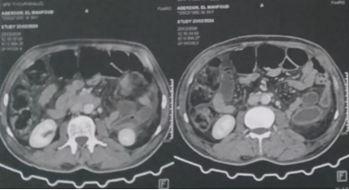
Figure 1: CT image of the appendix
Our patient underwent emergency surgery: a median incision was made, revealing a well-limited oblong cystic mass 20 centimetres long and 6.8 centimetres in diameter, with a healthy base allowing appendectomy without difficulty (Figure 2, Figure 3).

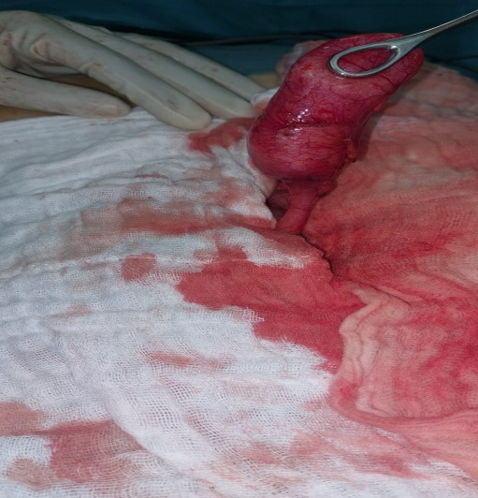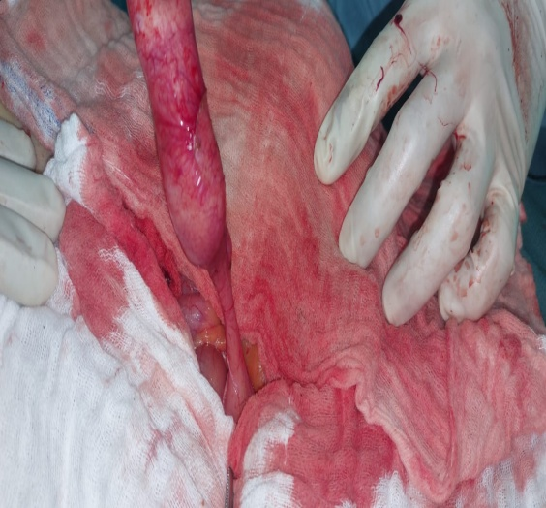
Figure 2: dilated appendix Figure 3: healthy appendicular base

In view of the integrity of the appendiceal mucocele wall and the cleanliness of the abdominal cavity, we took the precaution of excising the cecum at the base of the appendix, while protecting contamination of the peritoneal cavity from any intraluminal secretion.
In addition, an anterior colorectal resection with mechanical anterior colorectal end-to-end anastomosis was performed in the presence of a 10 cm circumferential, irregular, fixed, subperitoneally extensive upper rectum tumour responsible for upstream colonic distension with no bowel distension and no signs of digestive distress.
Anatomopathological analysis of the operative specimen confirmed the diagnosis of appendicular mucocele without malignant cells, of low-grade appendicular neoplasia type, with a swollen appendix with a smooth surface. On section, the wall was congestive, the lumen contained abundant myxoid material, and the cells had no cytonuclear atypia.
Colorectal resection specimen: Presence of a few tumour cells within pools of mucin infiltrating the submucosa without extending beyond it. Absence of lymphatic emboli. Absence of venous emboli. Absence of perineural sheathing. No tumour buds. The resection margins are healthy. No lymph node metastases: ON+/13N.
The postoperative course was straightforward, and the patient was discharged on the fifth postoperative day. She was reviewed at six months; no obvious signs of locoregional recurrence were noted.
Discussion:
Appendiceal mucocele or appendiceal mucosecreting tumor is defined as cystic dilatation of the appendiceal lumen as a result of intraluminal accumulation of translucent, gelatinous, mucinous secretions, which may affect either the entire organ, or a segment most often distal to it. Mucinous distension of the appendicular lumen may be tumoral or non-tumoral, benign or malignant in origin [1,8].
First described by Rokitansky in 1842 and named by Feren in 1876 [9,10], appendicular mucocele is an uncommon condition accounting for 0.15 to 0.6% of appendectomies [2-7,9]. In our setting, appendicular mucocele was confirmed in one out of 874 appendectomies performed in the department over a 5-year period, giving a frequency of 0.001%. Its frequency may be underestimated here, as some appendectomy specimens were not systematically histologically examined.
It is due to dilatation of the appendicular lumen following accumulation of intraluminal mucinous secretions.
It occurs predominantly in adults, with an average age of between 50 and 60 years [4-6, 11, 12]; in our case, the average age was 64. But appendicular mucocele can also affect children; this was the case of Duquenoy [13], who reported this pathology in 5 children aged 4 to 13 suffering from cystic fibrosis. Similarly, Ekert [14], in 1998 in France, reported an appendicular mucocele in a child with cystic fibrosis.
With regard to sex, the patient in our case was male. The sex ratio varies from one series to another, and in the most recent studies [4, 5, 9-11] tends to favour a female predominance. On the other hand, a male predominance was noted by Souei-Mhiri [6], in his study carried out between 1991 and 1998 in Sousse, who found 6 men versus 4 women in a series of 10 cases.
Anatomopathologically, four types of histological lesion can be distinguished (in order of increasing severity) [1, 3, 4, 11, 12].
- Retention cysts correspond to mucus accumulation due to obstruction of the appendicular lumen. In response to obstruction, the mucosa becomes hyperplastic and hypersecretory; progressive degenerative changes occur with the appearance of cuboid cells. The appendicular wall becomes atrophic and may later be replaced by connective tissue.
- Epithelial villous hyperplasia: the appendix is normal or slightly dilated with a thinned mucosa; lesions are limited to the mucosa and arranged in fine papillary structures without atypia or mitosis.
- Mucinous cystadenoma (benign mucinous tumor): the appendix is dilated by mucus and the lumen is lined by unistratified mucosecretory epithelium. Papillary formations may be present
may exist, but the epithelium is usually flat. Certain degrees of dysplasia may be found, associated with atypia or mitosis.
- Mucinous cystadenocarcinoma (malignant tumor) is characterized by a high degree of cellular atypia and mitosis, conjunctival invasion by neoplastic cells and the presence of neoplastic cells in the intraperitoneal mucosal effusion.
Clinically, appendicular mucocele may be completely asymptomatic (in 25 to 30% of cases), and may be discovered incidentally during an ultrasound examination or during laparotomy for another lesion [4, 6 ,7]. Elsewhere, different clinical pictures are found [6, 7, 11]:
- In the majority of cases, acute appendicitis (simple or complicated), generally leading to immediate surgical intervention. In these painful forms, pain may be isolated and evolve in a subacute or chronic mode.
- Pseudotumoral forms: the lesion appears as a mobile or fixed mass in the right iliac fossa, or as an abdominopelvic mass. These forms are more amenable to preoperative diagnosis on the basis of clinical and, above all, radiological evidence.
- Forms complicated by volvulus of the tumour mass, infection that can go as far as suppuration and perforation, or rupture in the peritoneum [6].
In our case, it was clinically suggestive of a rectal syndrome.
Medical imaging based on ultrasonographic and scannographic exploration most often makes it possible to the diagnosis and suggest specific surgical management.
Anatomopathological examination of the surgical specimen is systematically performed to establish a positive diagnosis and to look for signs of malignancy [15]. Ultrasound reveals a cystic mass in the right iliac fossa, with a more or less hypoechoic, giving the so-called “onion skin” image.
The image of a mass with very little echogenicity and posterior enhancement is suggestive of fluid.
This mass contains echogenic layers, in an arc and in the sloping zone, but non-mobile when changing position. This image suggests the preoperative diagnosis of appendicular mucocele [4, 12].
In our case, however, this was not the case. The diagnosis was made incidentally on an AP CT scan.
On CT, it appears as a caecal-based, rounded, well-limited, thin-walled mass with fine parietal calcifications. The wall may be thickened and irregular, with contrast-enhancing nodules, suggesting a cystadenocarcinoma; however, there is no radiological sign to confirm or exclude with certainty the malignancy of the underlying appendicular tumour [1, 16].
Hence the importance of medical imaging and skilled operators in guiding the clinician towards a precise preoperative diagnosis, which in turn determines the management of the case, since rupture of an appendicular mucocele, whatever its stage, into the peritoneal cavity results in a peritoneal pseudomyxoma, also known as “gelatinous disease of the peritoneum”. Its prognosis varies according to whether it is a mucinous adenoma or adenocarcinoma, but peritoneal pseudomyxoma remains a serious condition. For this reason, appendicular mucocele removal during appendectomy must be carried out without any wall invasion [16].
Our patient presents a rather rare association of an appendicular mucocele and a rectosigmoid process; this association has been described by other authors in Italy, Romania and Japan [17, 18, 19, 20].
Conclusion:
In the presence of the discovery or persistence of a right iliac fossa mass or appendicular syndrome, appendicular mucocele deserves to be evoked, although it is rare.
The preoperative diagnosis is possible and important, requiring ultrasound and/or CT scan to alert the surgeon to the risk of rupture during surgery, and to avoid pseudomyxoma of the peritoneum. Systematic histological study of all appendectomy specimens should be the rule.
Management consists of a simple appendectomy in the majority of cases, but a right hemicolectomy should be performed systematically in cases where signs of local malignancy are patent or confirmed by anatomopathological analysis of the surgical specimen.
References:
1. Fairise A, Barbary C, Derelle AL, Tissier S, Granger P, Marchal F
et al. Appendiceal mucocele and pseudomyxoma peritonei. J
Radiol. 2008; 89(6): 751-62. PubMed | Google Scholar
2. Rangarajan M, Palanivelu C, Kavalakat AJ, Parthasarathi R.
Laparoscopic appendectomy for mucocele of the appendix:
report of 8 cases. Indian J Gastroenterol. 2006 ; 25(5): 256-
257. PubMed | Google Scholar
3. Yakan S, Caliskan C, Uguz A, Korkut MA, Çoker A. A
retrospective study on mucocele of the appendix presented
with acute abdomen or acute appendicitis. Hong Kong J Emerg
Med. 2011 ; 18(3) : 144-149. PubMed | Google Scholar
4. Caspi B, Cassif E, Auslender R, Herman A, Hagay Z, Appelman
Z. The onion skin sign: A specific sonographic marker of
appendiceal mucocele. J Ultrasound Med. 2004 ; 23(1):117-21.
PubMed | Google Scholar
5. Lakatos PL, Gyori G, Halasz J, Fuszek P, Papp J, Jaray B et al.
Mucocele of the appendix: An unusual cause of lower
abdominal pain in a patient with ulcerative colitis - a case
report and review of literature. World J Gastroenterol. 2005 ;
11 (3) : 457-459. PubMed | Google Scholar
6. Souei-Mhiri M, Tlili-Graies K, Ben-Cherifa L, Derbel F, Hmissa S,
Dahmen Y et al. Appendicular mucoceles. Study
retrospective report on 10 cases. J Radiol. 2001 ; 82(4): 463-
8. PubMed | Google Scholar

7. Merran S. Muco-secreting tumor of the appendix (mucocele
appendicular). Press Med. 1997; 26 (19) :933. PubMed |
Google Scholar

8. Moujahid M, Ali A, Achour A, Janati MI. Mucocele
appendicular: about ten cases. Journal of African Du
cancer. 2010; 2 (2): 107-111. PubMed | Google Scholar

9. Creuze N, Savoye-Collet C, Lemoine F, Tapon E, Ribeiro C,
Thiebot J. Mucocele on the appendicular meniscus. J Radiol.
2008 ; 89(1 pt.1) :57-9. PubMed | Google Scholar
10. Lopez J, Kandil E, Schwartzman A, Zenman ME. Appendiceal
mucocele: benign or malignant. Surgical Rounds. 2006 ; 29
(11) : 540-544. PubMed | Google Scholar
11. Kouadio LN, Kouadio K, Turquin TH. Appendiceal mucocele: a differential diagnosis to consider.
Med Afr Noire. 2000, 47 (3): 175-176. PubMed | Google Scholar

12. Abdelouafi A, Essodegui F, Ousehal A, Kadiri R. Appendiceal mucoceles: a report of six cases. Annals of Radiology.
1996; 39 (3): 119-125. PubMed | Google Scholar

13. Duquenoy A, Gaussin G, Caillez D, Chevet JB, Guillot M, LeRoux P et al. Appendiceal mucocele: an etiology for chronic abdominal pain in children. International Journal of Pediatrics. 2005; 338:13-18. PubMed |
Google Scholar

14. Ekert P, Mougenot J F, De Lagausie P, Gerardin M, et al.
Recurrent intestinal intussusceptions and appendicular mucocele
in a child with cystic fibrosis. Pediatric Archives.
1998; 5 (4): 400-403. PubMed | Google Scholar

15. Weber G, Teriitehau C, Goudard Y, De Saint-Blancard P,
Minvielle F, Chavihot C et al. Appendicular mucocele. Leaflets
of Radiology. 2009; 49 (1): 40-44. PubMed | Google
Scholar

16. Zanati F. Appendicular mucocele. J Chir. 2007; 144 (7): 146.
PubMed | Google Scholar

17. Vicenzi L, Moser A, Mazzola F, Rizzo S, Bonomo S, Bottura D, Castellini C,
Ballarin A, Tosi D, Rosa G. Appendiceal mucocele associated with colonic neoplasm.
Report of 2 cases and review of the literature Chir Ital. 2001; 53 (3):420-4.

18. A case of appendix mucocele associated with adenocarcinoma of the left colon].
Versaci A, Rossitto M, Giuffré M, Leonello G, Pagano G, Terranova M.G Chir. 1999 Oct;20(10):397-401.
PMID: 10555406 Review. Italian.

19. Appendiceal mucocele associated with rectal cancer Eugen Târcoveanu1, Costel Bradea1,
Felicia Crumpei1, Delia Ciobanu2, Valentin Bejan1, Alin Vasilescu1 1. Clinica 1 Surgery,
"Sf. Spiridon" Emergency Clinical Hospital, "Grigore T. Popa" University of Medicine and Pharmacy Iași 2.
Anatomopathology and Prosectology Service, "Sf. Spiridon" Emergency Clinical Hospital, Iaș J Surgery, an open access journal ISSN: 1584-9341
20. Appendiceal mucocele with concomitant colonic cancer. Report of two cases. Case Reports
Published: February 1996. Volume 39, pages 232–236, (1996)
Toshiyoshi Fujiwara M.D.,Akio Hizuta M.D.,Hiromi Iwagaki M.D.,Tsuyoshi Matsuno M.D., Madoka Hamada M.D., Noriaki Tanaka M.D. & Kunzo Orita M.D.

