Case report
Sigmoid Volvulus Revealing Peritoneal Tuberculosis: A Rare Case Report

Abstract :
The sigmoid volvulus is a rare cause of intestinal occlusion, most cases being found in Asia and Africa. The case we report is of a patient with pulmonary tuberculosis undergoing treatment, who was admitted in our structure for an intestinal occlusion due to sigmoid volvulus, the surgical exploration found the sigmoid volvulus associated to multiple nodules which the anatomopathological biopsies confirmed the diagnostic of peritoneal tuberculosis
The aim of this article is to draw the attention of the medical community to the possibility of this association and the silent spread of tuberculosis infection from one localization to another.

Introduction :

Tuberculosis (TB) remains a worldwide health problem, especially in developing countries, with an estimated 9.0 million cases and 1.5 million deaths globally. Early diagnosis is difficult due to its nonspecific clinical presentation and its resemblance to malignancy or inflammatory bowel diseases. It includes abdominal pain, loss of weight and appetite, vomiting, and fever. Intestinal tuberculosis is a treatable and curable disease by antituberculosis drugs, but surgery is only indicated for complications such as fistula, perforation, stricture, obstruction, or bleeding [8].
The sigmoid volvulus (SV) is a rare pathology due a anatomic disposition of the colon to rotation. Patients most frequently present with abdominal pain, abdominal distention and vomiting, symptoms that may easily be misattributed to a more benign condition. Untreated, SV may progress to colonic ischemia and perforation; as these consequences are potentially life-threatening, clinicians should consider SV in the differential for patients presenting with acute or recurrent episodes of abdominal pain and bowel obstruction [9]. We report here the case of a 52 year old man who was undergoing an antibiotic treatment of his pulmonary tuberculosis treatment.

The case presentation:
We report the case of a 52 years old male who is undergoing an antibiotic treatment for a pulmonary tuberculosis infection. The patient consulted for an abdominal distension and symptoms of an occlusive syndrome that had been evolving over the past three days.
The clinical examination noted a conscient patient with low BMI at 15 kg/m², the abdominal examination found an asymmetric abdominal distension highly tympanic (figure 1) with a normal rectal examination.
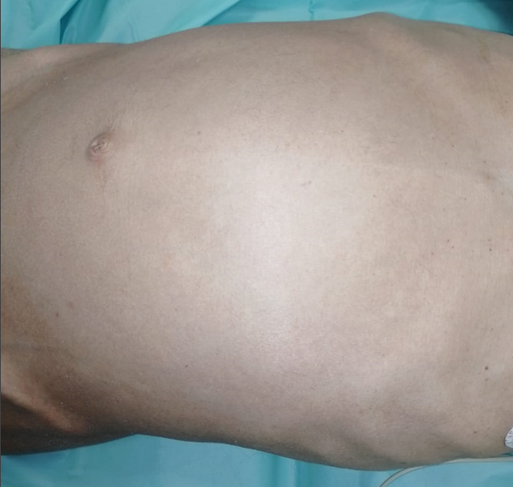
Figure 1 : Asymmetrical abdominal distension
Laboratory tests showed leukocytosis with a white blood cell count of 11,860/mm³ and an elevated C-reactive protein level of 254 mg/L.
Abdominal X-RAY showed an incomplete coffee bean sign (figure 2), a CT scan revealed an aerial colonic distension with whirl sign associated with an important abdominal effusion, suggesting a colic ischemia.
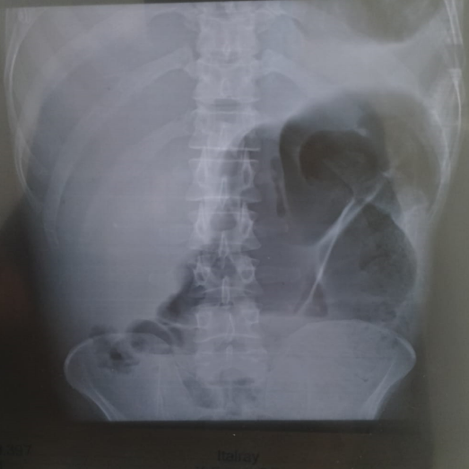
Figure 2 : Abdominal X-RAY showing an incomplete coffee bean sign
Due to the high risk of colonic ischemia endoscopic derotation was not possible. A laparotomy intervention was conducted and the surgical exploration revealed a sigmoid volvulus with a colonic distension and disseminated peritoneal nodules evoking a peritoneal tuberculosis (figure 3).Biopsies were taken, and a sigmoid colectomy was carried out with the creation of a double-barrel colostomy.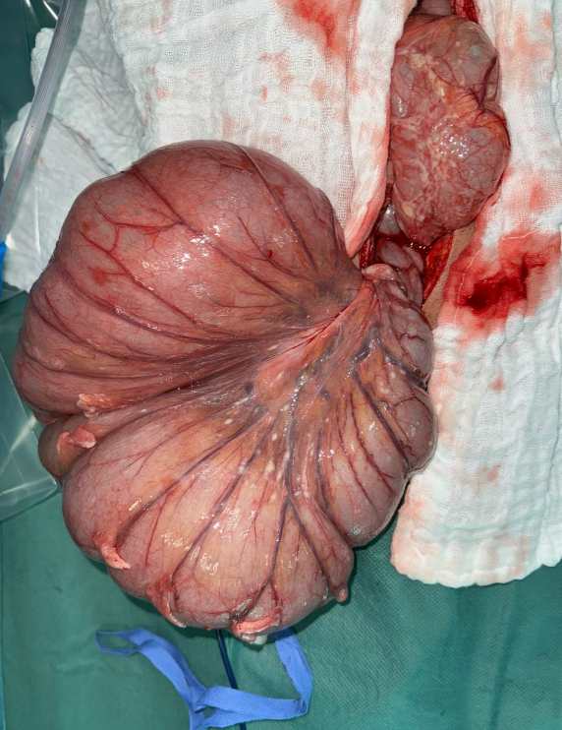
(A)
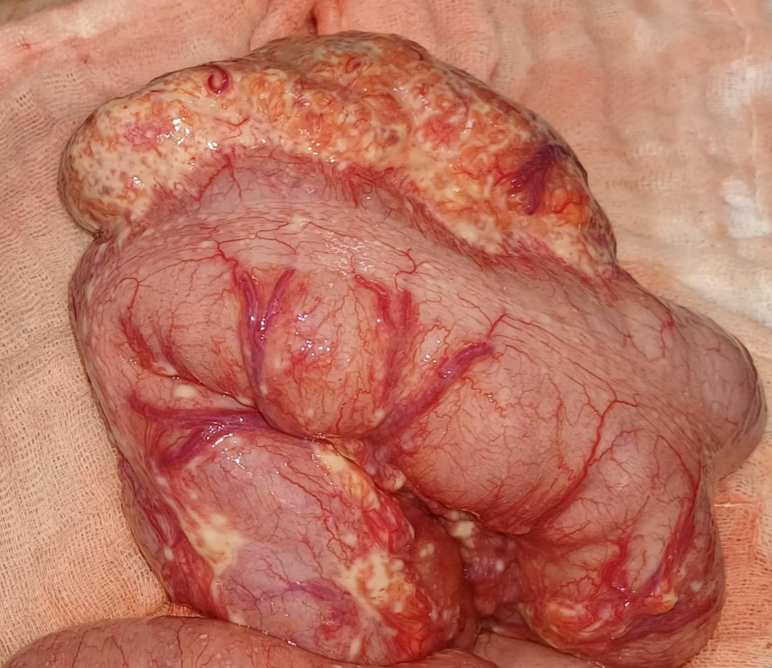
(B)
Figure 3(A,B) : Showing the sigmoid volvulus in his mesenterico-axial form

Discussion :
Sigmoid volvulus is a rare cause of intestinal obstruction, due to the torsion of the colon around his corpse or arround the mesentery, it is responsible of 5% of the occlusion in Europe and North America and between 10 to 40 % in Middle East, Eastern Europe,North America and Africa.It occurs generally on adult men with a ratio men/women of 2:1 to 8:1, and it’s most seen from the 4Th to the 8Th decade. The condition predominantly affects Black males, which may be attributed to a greater tendency for sigmoid colon elongation in this population [1–3].
There are two forms of sigmoid volvulus: the mesentero-axial and the organo-axial types. For reasons that remain unclear, the torsion is counterclockwise in approximately 70% of cases. In sigmoid volvulus, colonic distension increases intraluminal pressure, which compromises capillary perfusion of the bowel wall. This is further aggravated by mechanical compression and axial rotation (“twisting”) of the mesosigmoid vessels. The resulting mucosal ischemia facilitates bacterial translocation, which in turn exacerbates colonic distension and promotes toxic effects. This creates a vicious cycle that can progress to colonic necrosis and ischemia-reperfusion injury [4–5].
The clinical presentation of sigmoid volvulus manifests as an obstructive syndrome, with acute abdominal pain in the left iliac fossa. The clinical examination reveals the classic triad of Von Wahl which includes immobile and asymmetric abdominal distension, tympany, and elastic resistance. Abdominal X-ray and CT scan are crucial in the management of sigmoid volvulus. X-ray may show the coffee bean sign and a pneumoperitoneum in the case of perforation. CT scan demonstrates the whirl sign, the volvulus with distended and collapsed bowel, and signs of peritonitis.
The management of sigmoid volvulus can be categorized into endoscopic and surgical treatments. Endoscopy is used in the absence of peritonitis or perforation and plays a dual role in diagnosing and treating sigmoid volvulus. Surgery is required in approximately 25% of SV cases, either when endoscopic detorsion fails or when bowel necrosis and/or peritonitis are present. Surgical options include sigmoid colectomy with primary anastomosis, a colostomy with delayed anastomosis, or a Hartmann’s procedure.
Peritoneal tuberculosis is the second extra-pulmonary localization of tuberculosis after ganglionnary form, it affects patients between the ages of 35–45 with equal a 1:1 sex-ratio and has a correlation with lower socioeconomic status and promiscuity.[6]
There are three type of mechanism of development of peritoneal tuberculosis : hematogenous infection from active tuberculosis, direct or intraabdominal spread from affected organs such bowel, uterus and rupture of a tuberculous abdominal lymph node, lymphatic through lymph channels from infected abdominal lymph nodes.In our case the patient had a double localization pulmonary and peritoneal [7]
The infection can be silent. clinical features of the infection are wide it manifests by an abdominal distension with or without pain, vomiting, fever, nocturnal sewing and sever weight loss . The main complication is the peritonitis.
Multiple tests are attended to make the diagnostic of peritoneal tuberculosis such as quantiferon dosage in blood ,CA-125 and ADA in ascite fluid have low specificity. In the other hand PCR tuberculosis have a high specificity but a variable sensitivity relative to the tissue, and the gold standard of peritoneal tuberculosis is the surgical exploration with biopsy for anatomopathological and bacteriological confirmation.
The treatment of peritoneal tuberculosis is codified by the WHO which consist on antibacillary treatment during 6 months based on

Conclusion :

Sigmoid volvulus is a rare cause of intestinal obstruction, in our case it revealed a peritoneal spread of a known pulmonary tuberculosis.The association with a peritoneal tuberculosis make our observation unique in the literature ,through our article we detailed the characteristics of each pathology and showed that the two entities have different physiopathology and need different treatment.

Références :
1.KEITA, Sidiki, KEITA, Koniba, SISSOKO, Moussa, et al. Volvulus of the sigmoid colon—Management in the surgery “A” department of the Teaching Hospital of Point G. Surgical Science, 2020, vol. 11, no 12, p. 469-478
2. MADIBA, T. E., ALDOUS, C., et HAFFAJEE, M. R. The morphology of the foetal sigmoid colon in the African population: a possible predisposition to sigmoid volvulus. Colorectal Disease, 2015, vol. 17, no 12, p. 1114-1120.
3.ATAMANALP, Sabri Selcuk, DISCI, Esra, PEKSOZ, Rifat, et al. Management of sigmoid volvulus: a literature review. Ibnosina Journal of Medicine and Biomedical Sciences, 2023
4. Moloney, B.M., Mc Carthy, C.E., Bhayana, R. et al. Sigmoid volvulus—Can CT features predict outcomes and recurrence?. Eur Radiol 35, 897–905 (2025). https://doi.org/10.1007/s00330-024-10979-y
5. Lubrano J, Paquette B, Delabrousse E, Koch S, Mantion G. Volvulus du sigmoïde. EMC - Gastro-entérologie 2012;7(3):1-6 [Article 9-044-A-12].
6. WU, David C., AVERBUKH, Leon D., et WU, George Y. Diagnostic and therapeutic strategies for peritoneal tuberculosis: a review. Journal of clinical and translational hepatology, 2019, vol. 7, no 2, p. 140.
7. Ahmed Khan, Fahmi Yousef. Peritoneal Tuberculosis: Advances and Controversies. Libyan Journal of Medical Sciences 2(1):p 3-7, Jan–Mar 2018. | DOI: 10.4103/LJMS.LJMS_35_17
8. Ait Ali, H., Zeriouh, B., Jabi, R., & Bouziane, M. (2020). Sigmoid Colon Tuberculosis Revealed by a Perforation and Peritonitis. Cureus, 12(12).
9. O'Keefe, L. M., Hu, Y. Y., Thaker, S., & Finck, C. (2016). Sigmoid volvulus: A pediatric case report and review of management. Journal of Pediatric Surgery Case Reports, 7, 4-7.

