Case Report

Recurrent Multifocal Nodular Fibromatosis of the hand Leading to Diagnosis of Neurofibroma: A Case Report

.
ABSTRACT

Aims: Describe the diagnostic evolution of a rare, recurrent soft tissue tumor of the hand, initially diagnosed as nodular fibromatosis and ultimately confirmed as neurofibroma.
Case presentation: A 22-year-old female presented with multiple recurrences of a soft tissue mass in the right index finger over six years. Initial biopsies showed fibromatosis; final diagnosis was neurofibroma confirmed histologically in 2024.
Discussion: Neurofibroma, though benign, may mimic other fibroblastic lesions and can present with delayed diagnosis, especially without immunohistochemical analysis. The pseudo-Tinel’s sign and multifocality should raise early suspicion for nerve sheath tumors.
Conclusion: Recurrent digital fibromatosis must prompt reevaluation, including immunohistochemistry. Early consideration of neurogenic tumors may prevent diagnostic delays and functional morbidity.

Keywords: Nodular fibromatosis; Neurofibroma; Finger tumor; Soft tissue mass; Case report; Hand surgery

1. INTRODUCTION

Soft tissue tumors of the hand are uncommon and can present diagnostic and therapeutic challenges, particularly in young adults. Nodular fibromatosis and neurofibroma, while benign, are rare entities when located in the hand and can mimic other more common conditions(1,2). Recurrent cases necessitate a thorough re-evaluation, especially in the context of multifocal involvement and atypical progression(3,4).

2. case presentation

A 22-year-old right-handed female student presented in December 2018 with a firm, non-inflammatory, slightly painful mass (1 cm) over the dorsal aspect of her right index finger at the level of the distal interphalangeal (DIP) joint. There was no significant past medical or surgical history. Radiographic imaging showed no osseous abnormalities. Ultrasound revealed a hyperechoic lesion, prompting an excisional biopsy. (Figure 1) Histology identified a cicatricial nodule due to tendon rupture, with no malignancy. In June 2019, the patient experienced a recurrence of the mass, now accompanied by signs of complex regional pain syndrome (algodystrophy). (Figure 2) A second biopsy indicated nodular fibromatosis. Despite post-operative orthotic treatment, a mallet finger deformity developed.
In 2020, a third recurrence revealed two additional masses along the index finger's extensor pathway. MRI confirmed multifocal nodular fibromatosis. Surgical excision was performed, again with histopathology suggesting nodular fibromatosis.
By 2022, the patient had developed three new masses along the index finger. Following partial resection, she exhibited joint stiffness and a recurrent mallet finger deformity. Histology was not available.
In 2024, a fourth recurrence involved a 2 cm lesion on the index finger and a 5 cm mass over the dorsal aspect hand with a positive Tinel sign. (Figure 3) Surgical biopsy of seven tissue fragments finally revealed histological features consistent with neurofibroma.
The diagnosis evolved over time through several recurrences. Initial imaging (X-rays and ultrasounds) showed soft tissue masses without bone involvement . MRI in 2020 suggested multifocal nodular fibromatosis. Histopathological findings initially showed cicatricial nodule and fibromatosis , but the final recurrence in 2024 revealed neurofibroma

Each recurrence was managed surgically via excisional biopsies . Surgical challenges included preservation of the extensor tendon system. Rehabilitation was implemented post-operatively, particularly after tendon involvement caused mallet deformity.

Throughout the multiple recurrences, the patient underwent five surgeries. Outcomes included joint stiffness and mallet deformities . (Figure 4) After the final excision in 2024, histopathology confirmed neurofibroma and the recurrence has not reappeared to date.

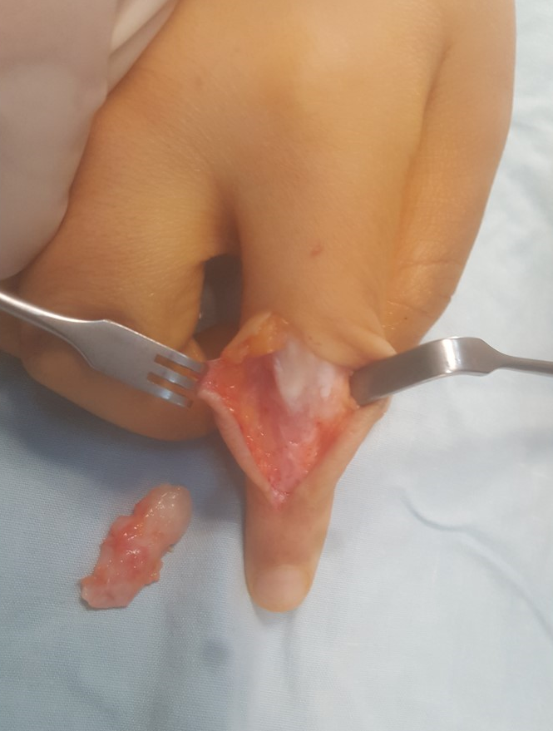

Fig. 1. Intraoperative view : Complete excision of the tumor

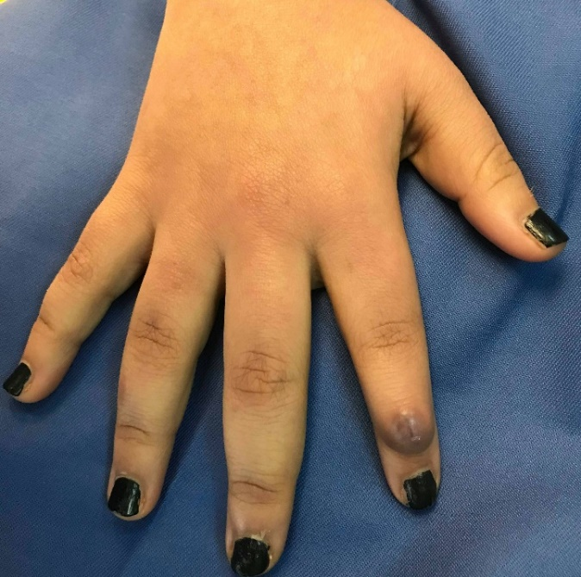

Fig. 2. Clinical appearance at first recurrence : A firm mass

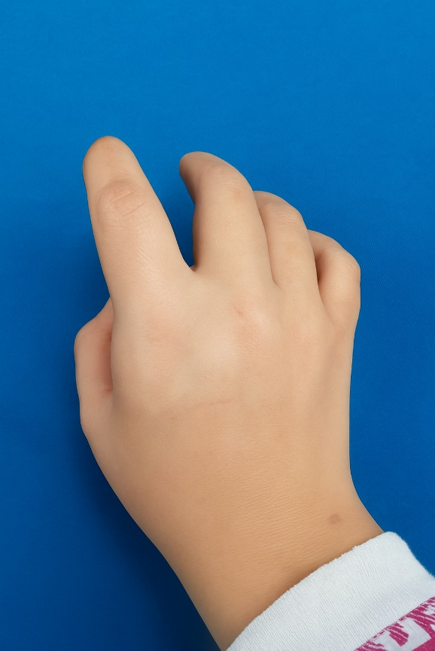

Fig. 3. Clinical appearance in 2024 : A dorsal hand mass and recurrent index finger lesion
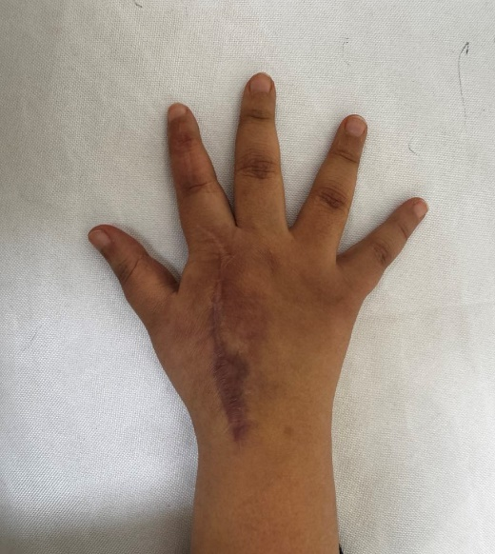

Fig. 4. Six-month postoperative view : Dorsal scar and no recurrence

3. discussion

Soft tissue tumors of the hand present a significant diagnostic challenge due to the wide differential diagnosis and the rarity of certain entities in this anatomical region(1,2). In this case, the progression from an initially benign-appearing lesion to a recurrent, multifocal disease with a final diagnosis of neurofibroma demonstrates the importance of maintaining a broad differential and revisiting initial histological interpretations when faced with atypical recurrence patterns.
Nodular fibromatosis, often considered a localized and benign proliferation of fibroblastic tissue, can mimic other lesions both clinically and histologically(4). Its recurrence is rare but has been documented, particularly when excision is incomplete or when the lesion is deeply adherent to adjacent structures, as was the case here with involvement of the extensor tendon slips. In this patient, the recurrence after the first surgery—combined with increasing size, multifocal presentation, and functional impairment—should have raised suspicion for a more aggressive or misdiagnosed pathology.
Importantly, the diagnosis of neurofibroma—confirmed only after multiple recurrences and extensive histopathological sampling—suggests that the initial biopsies may have been insufficient in scope or depth(3). Neurofibromas, benign peripheral nerve sheath tumors composed of Schwann cells, fibroblasts, and perineurial-like cells, can sometimes present with a misleading histological pattern, especially in the presence of fibrotic or cicatricial changes post-surgery(5). Immunohistochemical analysis, particularly with markers like S100 protein, is critical in differentiating neurofibromas from fibromatosis and other soft tissue tumors(3). The absence of such analyses in earlier stages may explain the delayed definitive diagnosis.
The multifocal nature of the lesions observed in this patient also raises the question of a syndromic association, most notably Neurofibromatosis Type 1 (NF1), although the clinical vignette does not report any additional systemic manifestations or family history suggestive of NF1(6). In sporadic (non-syndromic) neurofibromas, the presentation is usually solitary; multifocal cases, particularly in the hand, are rare and warrant further genetic and dermatologic evaluation.

From a surgical standpoint, the repeated involvement of the extensor system and the development of mallet finger deformities following excisions highlight the balance required between achieving clear margins and preserving tendon integrity(7). Postoperative immobilization and rehabilitation were essential, but the recurrence rate suggests a need for multidisciplinary management, potentially including neurology and oncology input for systemic evaluation(6,8).
Finally, the positive pseudo-Tinel’s sign observed in the final recurrence is an important clinical clue, suggestive of a lesion with neural involvement, which aligns with the eventual diagnosis of neurofibroma(8,9). This physical finding, in the setting of recurrent masses, should prompt earlier consideration of nerve sheath tumors(4,6).
This case emphasizes the importance of a stepwise, evolving diagnostic approach when managing recurrent soft tissue tumors, especially in atypical locations such as the hand(2,8). It also advocates for the early use of MRI and histo-immunohistochemical studies to achieve accurate diagnosis and avoid unnecessary morbidity due to repeated surgeries(3,5). Recent French recommendations also emphasize early genetic counseling and multidisciplinary assessment in suspected NF1 cases(10).

4. Conclusion

This case underscores the necessity for careful long-term monitoring and repeated histopathological assessment in recurrent soft tissue tumors of the hand(2,4). Early consideration of neurogenic tumors such as neurofibroma may improve diagnostic accuracy and patient outcomes(3,6,8).

Consent

Written informed consent was obtained from the patient for publication of this case report and any accompanying images.

Ethical approval

All authors hereby declare that all experiments have been examined and approved by the appropriate ethics committee and have therefore been performed in accordance with the ethical standards laid down in the 1964 Declaration of Helsinki

References

1. Fletcher CDM, et al. WHO Classification of Tumours of Soft Tissue and Bone. 4th ed. IARC Press; 2013
2. Sherman CE, Murray PM. Tumor-Like Conditions of the Hand and Upper Extremity. J Hand Surg. déc 2017;42(12):1009‑17.
3. Rodriguez FJ, Folpe AL, Giannini C, Perry A. Pathology of peripheral nerve sheath tumors: diagnostic overview and update on selected diagnostic problems. Acta Neuropathol (Berl). mars 2012;123(3):295‑319.
4. Weiss SW, Goldblum JR, Folpe AL. Enzinger and Weiss’s Soft Tissue Tumors. Elsevier Health Sciences; 2007. 2815 p.
5. Rosai J. Rosai and Ackerman's Surgical Pathology. 10th ed. Elsevier; 2011.
6. Gupta G, Mammis A, Maniker A. Malignant peripheral nerve sheath tumors. Neurosurg Clin N Am. oct 2008;19(4):533‑43, v.
7. Alla SR, Deal ND, Dempsey IJ. Current concepts: mallet finger. Hand N Y N. juin 2014;9(2):138‑44.
8. Pearl RA, O’Toole G. A case of large sporadic neurofibroma of the hand. J Plast Reconstr Aesthetic Surg JPRAS. juill 2010;63(7):e573-575.
9. Lauri G, Santucci M, Ceruso M, Innocenti M. Recurrent digital fibromatosis of childhood. J Hand Surg. janv 1990;15(1):106‑9.
10. Haute Autorité de Santé. Protocole National de Diagnostic et de Soins (PNDS) Neurofibromatose 1. HAS ; Août 2021

