**Case report**

**Gall stone ileus: An uncommon cause of small bowel obstruction and bowel ischemia**

**Abstract-**

Gall stone ileus is an uncommon cause of small bowel obstruction, which accounts for 1-4% of mechanical small bowel obstruction. Surgery is the mainstay treatment for gall stone ileus. The best surgical approach that includes one-staged versus a two-staged approach and open versus laparoscopic approach, remains controversial. The main aim of emergency surgery is to relieve the intestinal obstruction. We report a case of a 74-year-old female who presented to surgery emergency with a case of gall stone ileus causing small bowel obstruction. In our case, we performed enterotomy with stone extraction alone due to dense adhesion around gall bladder and unstable general condition. Enterotomy with stone extraction alone remains the most common surgical method because of its low incidence of complications.

*Keywords- Gall stone ileus, small bowel obstruction, enterotomy, stone extraction.*

**Introduction-**

Gall stone ileus is an uncommon cause of small bowel obstruction, which accounts for 1-4% of mechanical small bowel obstruction [1,2,3]. Gall stone ileus is a rare complication of chronic cholecystitis. Impaction of large stones within the gallbladder cause pressure necrosis, which leads to the formation of a cholecysto-enteric fistula. Most fistulas involve the duodenum, but fistulas to the stomach and colon have been described [4]. [Thomas Bartholin](https://en.wikipedia.org/wiki/Thomas_Bartholin) [5] in 1654, first described the name "gallstone ileus", is a misnomer because an [ileus](https://en.wikipedia.org/wiki/Ileus) is, by definition, a non-mechanical bowel obstruction (whereas gall stone ileus is a mechanical small bowel obstruction). Bouveret syndrome is a rare variant of gall stone ileus caused by the impaction of large gall stone into the duodenum via cholecysto-duodenal fistula leading to gastric outlet obstruction. Surgery is the mainstay treatment for gall stone ileus. The best surgical approach that includes a one-staged versus two-staged approach and open versus laparoscopic approach remains controversial. We report a case of a 74-year-old female who presented to the surgery emergency with a case of gall stone ileus causing small bowel obstruction.

**Case presentation-**

 A 74 -year-old female presented to the surgery emergency with colicky abdominal pain, bilious vomiting, and abdominal distension for 6 days. The patient was a known case of cholelithiasis for 8 years. Patient had no other comorbidity. Also, there was no history of previous abdominal surgery or intervention. On presentation, she was dehydrated, with tachycardia and hypotension. On examination, all hernial orifices were within normal limits. Moderate abdominal distension was present along with mild tenderness over the right hypochondrium and epigastric region. Laboratory investigations showed leukocytosis(14000/μL), X-ray abdomen erect showed an air-fluid level with dilated bowel loops without the identification of ectopic stones or pneumobilia. Bedside ultrasonography showed cholelithiasis with features of small bowel obstruction. The patient was initially managed conservatively with intravenous fluids and antibiotics with suspicion of partial obstruction. The patient was keptnil per mouth and bowel decompression was facilitated with nasal tube insertion. However, the condition did not improve, and contrast-enhanced computed tomography (CECT) was done on day 3 of admission in view of clinical deterioration. CECT (figure-01) showed features of small bowel obstruction with a large gall stone in distal ileum measuring approximately 4x3 cm. There was air-foci within the gall bladder lumen and a cholecysto-duodenal fistula. The patient was posted for emergency laparotomy. Intra-operatively, there was a large impacted stone seen in terminal ileum 60 cm from the ileocecal junction (figure-02). The whole of small bowel proximal to the stone was dilated and bowel ischemia was present due to excessive enlargement and obstruction (figure-03). The stone was delivered through longitudinal enterotomy and the enterotomy was subsequently closed transversely with silk 3-0 round body. The bowel ischemia reverted (figure-04) once obstruction was relieved by the extraction of stone(figure-05). No further procedure for gallbladder was carried out in view of dense adhesion around gallbladder and unstable general condition. The postoperative course was uneventful and the patient was discharged on the seventh postoperative day. She was followed-up regularly in the surgical clinic.

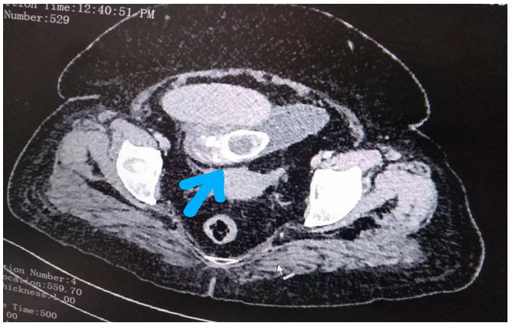

Figure-01: CECT showing ectopic stone in the lumen of small bowel.

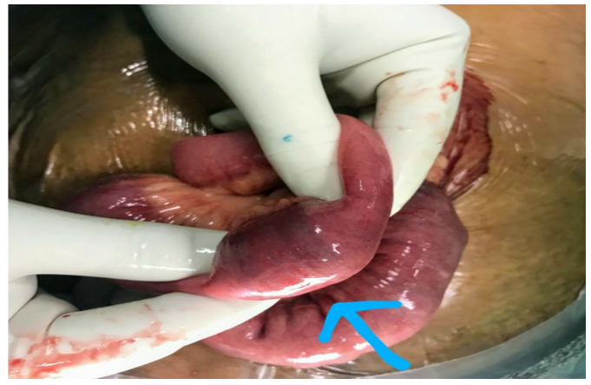

Figure-02: ectopic large stone in the lumen of ileum.

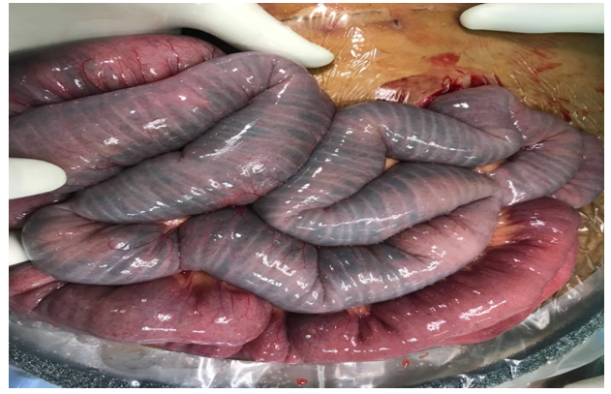

Figure-03: dilated proximal small bowel with bowel ischemia.

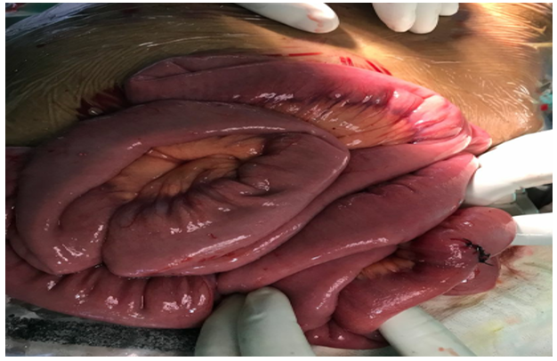

Figure -04: post stone extraction and enterotomy closure, healthy looking small bowel.

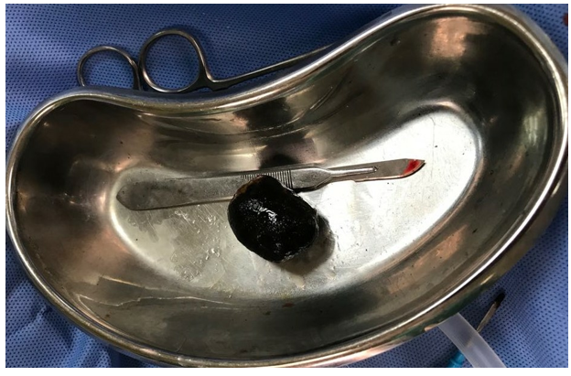

Figure-05: large gall stone of size approximately 4 cm x 3.5 cm x 3 cm.

**Discussion-**

Gall stone ileus is a rare cause of mechanical small bowel obstruction. In this condition gall stone enters the gastrointestinal tract via an acquired cholecysto-enteric fistula and causes mechanical small bowel obstruction. The duodenum is the most common site for fistula [4,6,7]. Most of the patients of gall stone ileus are elderly with multiple comorbidities, thus having higher morbidity and mortality compared to other causes of small bowel obstruction. Gall stone ileus is more common in women, and the ratio of females to males is 3.5 to 1 [8]. Small stones easily pass through the gastrointestinal tract without incidence, but large stones of size ≥ 2-2.5 cm in diameter can impact anywhere in the gastrointestinal tract and cause obstruction [9-12].

Most frequently, stones become impacted in the distal ileum, although they can lodge at other locations also [13]: terminal ileum (most common), proximal ileum, [jejunum](https://radiopaedia.org/articles/jejunum?lang=us), [colon](https://radiopaedia.org/articles/colon?lang=us), and duodenum/stomach- leading to [gastric outlet obstruction](https://radiopaedia.org/articles/gastric-outlet-obstruction?lang=us) ([Bouveret syndrome](https://radiopaedia.org/articles/bouverets-syndrome?lang=us)).

Presentation of gall stone ileus is typically non-specific, and often with intermittent symptoms of nausea, vomiting, pain, and abdominal distension. X-ray abdomen has classical findings of gall stone ileus (Rigler’s triad) [14] which include: (i) pneumobilia; (ii) intestinal obstruction (iii) an ectopic gallstone. CECT has made a diagnosis of gall stone ileus easier with the overall sensitivity, specificity, and accuracy of around 93%, 100%; and 99%, respectively [15]. Surgery is the mainstay treatment for gall stone ileus. The best surgical approach that includes a one-staged versus two-staged approach and open versus laparoscopic approach remains controversial. Management of gall stone ileus is described as follows: (1) enterotomy with stone extraction alone (2) enterotomy, stone extraction, cholecystectomy and fistula closure (3) bowel resection alone and (4) bowel resection with fistula closure [8,16]. The main aim of emergency surgery is to relieve the intestinal obstruction. Enterotomy with stone extraction alone remains the most common surgical method because of its low incidence of complications [8]. In our case, we performed exploratory laparotomy with enterotomy and stone extraction alone due to unstable general condition and dense adhesion around gall bladder. Laparoscopic management of gallstone ileus has also been reported [17,18] but has high conversion rate (53.03%) to laparotomy [8]. Thus, laparoscopic approach for management of dilated bowel and bowel ischemia, still remains challenging. Watanabe Y *et al* [19] reported single-incision laparoscopic surgery (SILS) for gall stone ileus. They concluded that SILS can be an alternative option for the management of gall stone ileus. Shiraishi *et al* [20] also reported transvaginal hybrid NOTES procedure for treatment of gallstone ileus in 63-year-old female. In our experience, even though cases with laparoscopic management have been reported, selection of patient for laparoscopic or open approach should be made on a case by case basis.

**Conclusion-**

Gall stone ileus is an uncommon cause of mechanical small bowel obstruction. Surgery is the mainstay treatment for gall stone ileus. However, the best surgical approach remains controversial. Enterotomy with stone extraction alone remains the most common surgical method because of its low incidence of complications.

**Consent-** Written informed consent was obtained from the patient.

**References-**

[1] Zinkin EB, Brammer WM, Colombo CA. Case of the day. General. Gallstone perforation of the terminal ileum with abscess formation. Radiographics. 1990;10(6):1108-10.

[2] Reisner RM, Cohen JR. Gallstone ileus: a review of 1001 reported cases. Am Surg. 1994;60: 441–46.

[3] Clavien PA, Richon J, Burgan S, Rohner A. Gallstone ileus. Br J Surg. 1990;77: 737-42.

[4] Masanat Y, Massanat Y, Shatnawel A. Gallstone ileus: a review. Mt Sinai J Med. 2006;73: 1132–34.

[5] Porter IH. Thomas Bartholin (1616-80) and Niels Steensen (1638-86). Master and pupil. Med Hist. 1963;7(2):99‐125.

[6] Nakao A, Okamoto Y, Sunami M, Fujita T, Tsuji T. The oldest patient with gallstone ileus: report of a case and review of 176 cases in Japan. Kurume Med J. 2008;55: 29–33.

[7] Ayantunde AA, Agrawal A. Gallstone ileus: diagnosis and management. World J Surg. 2007;31: 1292–1297.

[8] Halabi WJ, Kang CY, Ketana N, Lafaro KJ, Nguyen VQ, Stamos MJ, et al. Surgery for Gallstone Ileus: A Nationwide Comparison of Trends and Outcomes. Ann Surg. 2014;259(2): 329-35.

[9] Kasahara Y, Umemura H, Shiraha S, Kuyama T, Sakata K, Kubota H. Gallstone ileus. Review of 112 patients in the Japanese literature. Am J Surg. 1980;140: 437-40.

[10] Syme RG. Management of gallstone ileus. Can J Surg. 1989;32: 61–64.

[11] Ihara E, Ochiai T, Yamamoto K, Kabemura T, Harada N. A case of gallstone ileus with a

spontaneous evacuation. Am J Gastroenterol. 2002;97: 1259-60.

[12] Al-Obaid O. Gallstone ileus: a forgotten rare cause of intestinal obstruction. Saudi J

Gastroenterol. 2007;13: 39–42.

[13] Singh AK, Shirkhoda A, Lal N et-al. Bouveret's syndrome: appearance on CT and upper gastrointestinal radiography before and after stone obturation. AJR Am J Roentgenol. 2003;181 (3): 828-30.

[14] Rigler LG, Borman CN, Noble JF. Gallstone obstruction: pathogenesis and roentgen manifestations. JAMA. 1941;117: 1753–1759.

[15] Yu CY, Lin CC, Shyu RY et al. Value of CT in the diagnosis and management of gallstone

ileus. World J. Gastroenterol. 2005;11 (14): 2142-47.

[16] Kasahara Y, Umemura H, Shiraha S, Kuyama T, Sakata K, Kubota H. Gallstone ileus.

Review of 112 patients in the Japanese literature. Am J Surg. 1980;140: 437-40.

[17] Franklin ME, Jr, Dorman JP, Schuessler WW. Laparoscopic treatment of gallstone ileus: a case report and review of the literature. J Laparoendosc Surg. 1994; 4:265–272.

[18] Sarli L, Pietra N, Costi R, Gobbi S. Gallstone ileus: laparoscopic-assisted enterolithotomy. J Am Coll Surg. 1998; 186:370–371.

[19] Watanabe Y, Takemoto J, Miyatake E, Kawata J, Ohzono K, Suzuki H et al. [Single-incision laparoscopic surgery for gallstone ileus: An alternative surgical procedure.](https://pubmed.ncbi.nlm.nih.gov/24858981/) Int J Surg Case Rep. 2014;5(7):365-369.

[20] Shiraishi T, Tomizawa N, Andoh T, Arakawa K, Enokida Y, Ozawa N. Transvaginal Hybrid NOTES Procedure for Treatment of Gallstone Ileus. Case Rep Surg. 2016; 2016:9513874.