Case Report

Rare Occurrence of Gastric and Gallbladder Metastasis in Non-Small Cell Lung Carcinoma: A Case Report

.

ABSTRACT

|  |
| --- |
| **Background:** Gastrointestinal metastasis from lung cancer (GMLC), presenting with gastric ulcers, is a rare and complex condition, occurring in 0.5% to 14% of cases. The rarity of GMLC complicates diagnosis as it can mimic benign conditions, leading to potential delays in treatment. Symptoms such as gastrointestinal perforation, hemorrhage, and obstruction may occur, although many patients remain asymptomatic. Diagnostic tools including endoscopy, CT scans, and PET scans are essential for accurate identification. Despite advancements in diagnostics and treatment, the prognosis for patients with GMLC remains poor. This case aims to highlights the clinical challenge of diagnosing GMLC due to its rarity and non-specific symptoms.  **Presentation of Case:** This report describes an 80-year-old female with Stage IVB NSCLC, who developed new abdominal symptoms. A routine surveillance PET scan revealed a new hypermetabolic lesion on stomach and a distended gallbladder. Subsequent esophagogastroduodenoscopy and surgery identified a gastric ulcer and an inflamed gallbladder which were biopsied and removed, respectively. Histopathological examination revealed adenocarcinoma. Immunohistochemical staining (CK7, CK20, TTF1, and Napsin A) confirmed the diagnosis of gastric and gallbladder metastases from primary lung cancer.  **Conclusion:** Heightened clinical awareness and comprehensive diagnostic evaluation are crucial for patients with lung cancer presenting with new gastrointestinal symptoms. Enhanced understanding of the clinical presentation, diagnostic challenges, and management strategies GMLC is essential for improving patient outcomes and guiding future research in this area. |

*Keywords: GMLC, lung cancer, gastric ulcer, cholecystitis, cancer, metastasis*

1. INTRODUCTION

Gastrointestinal metastasis from lung cancer (GMLC) is uncommon, with the stomach and gallbladder being particularly rare sites of spread. While non-small cell lung (NSCLC) frequently metastasizes to the brain, liver, adrenal glands, and bones, gastric metastasis occurs in only 0.5%–14% of cases and gallbladder involvement is even more infrequent, typically reported only in isolated case reports [1-3].Both are often discovered incidentally on imaging or histopathologic evaluation. Immunohistochemical markers such as TTF-1 and Napsin A aid in identifying pulmonary origin.

This report presents a rare case of concurrent gastric and gallbladder metastases from carcinoma NSCLC in an elderly female, emphasizing the importance of diagnostic vigilance and histologic confirmation in patients presenting with gastrointestinal symptoms during lung cancer treatment.

**2. CASE PRESENTATION**

An 80-year-old female with a known diagnosis of Stage IVB NSCLC, harboring EGFR Exon 19 deletion, had prior metastases to bone, liver, and lymph nodes and was receiving Osimertinib therapy.

A routine PET scan revealed a hypermetabolic lesion in the gastric lesser curvature (Figure 1) and a distended gallbladder. Although initially asymptomatic, she subsequently developed intermittent abdominal pain, heartburn, and anorexia two weeks before consultation.

Esophagogastroduodenoscopy revealed a gastric ulcer at the lesser curvature (Figure 2). Subsequent elective laparoscopic cholecystectomy was performed and histopathology of the gastric ulcer and gallbladder demonstrated adenocarcinoma on a background of chronic active gastritis (Figure 3). Immunohistochemistry (CK7, CK20, TTF-1, and Napsin A) was consistent with metastasis from NSCLC.

3. discussion

Gastric and gallbladder metastases originating from NSCLC are exceptionally rare. While the lung commonly metastasizes to organs like the brain, bones, liver, and adrenal glands, gastrointestinal involvement remains an uncommon phenomenon. Among GI organs, the small intestine is most frequently affected, followed by the stomach and, more rarely, the gallbladder [1-3].

The clinical incidence of GMLC remains low, typically under 2%, though autopsy studies report higher rates, up to 11% [1,3,4]. Gallbladder metastasis is even less frequently documented, with only isolated case reports available in the literature. These cases typically arise from adenocarcinomas or large cell carcinomas and often go unnoticed during life due to asymptomatic presentation [5-6].

Gastric metastases often present as ulcers or subepithelial lesions and may mimic benign gastric conditions. In contrast, gallbladder metastases are frequently discovered incidentally during imaging or surgery. They may manifest clinically as acute cholecystitis, biliary colic, or even mimic gallbladder carcinoma, which can complicate accurate diagnosis [5]. For both sites, diagnostic challenges stem from non-specific symptoms or asymptomatic disease, highlighting the need for clinical vigilance in patients with advanced NSCLC presenting with new abdominal symptoms.

Endoscopy is the cornerstone for evaluating suspected gastric involvement, while imaging such as ultrasound, CT, and PET-CT are essential for detecting gallbladder metastasis. Definitive diagnosis relies on histopathological analysis and immunohistochemical profiling. Immunostains such as TTF-1 and Napsin A remain crucial in identifying pulmonary origin, distinguishing metastatic lesions from primary gastric or gallbladder malignancies [7].

In the current case, the gastric lesion was confirmed to be metastatic NSCLC by immunohistochemical positivity for TTF-1 and Napsin A. Although the patient had no gallbladder symptoms, routine imaging in NSCLC patients should include scrutiny of biliary structures, especially in those with abdominal symptoms. Several reports describe NSCLC metastasizing to the gallbladder, discovered post-mortem or during cholecystectomy for presumed primary disease [5-6]. These underscore the need for heightened awareness among clinicians and pathologists.

Treatment of such metastases is largely palliative. Systemic therapy targeting the primary malignancy is the mainstay, although localized interventions may be warranted in cases of bleeding, obstruction, or cholecystitis. Overall prognosis remains guarded, as such metastases signal widespread disease and often occur in the context of multi-organ involvement.

4. Conclusion

Gastric and gallbladder metastases from NSCLC are rare but important diagnostic considerations in advanced lung cancer. While gastric involvement may present with ulcers or mimic primary gastric tumors, gallbladder metastasis may go unnoticed or mimic benign gallbladder disease. Awareness of these atypical metastatic sites, coupled with appropriate diagnostic workup and histopathological confirmation, is vital in guiding effective palliative care. Early recognition of these entities contributes to more accurate staging and improved symptom management in NSCLC patients.

Consent (where ever applicable)

Informed consent for publication could not be obtained as the patient is deceased and no next of kin or legal representative could be identified despite reasonable efforts. The authors have ensured that all potentially identifiable information has been anonymized to protect the patient’s privacy, and the publication of this case report is justified by its educational and scientific value.

Ethical approval (where ever applicable)

Not applicable

References

Yoshimoto A, Kasahara K, Kawashima A. Gastrointestinal metastases from primary lung cancer. *Eur J Cancer.*2006;42:3157–3160.

Hu Y, Feit N, Huang Y, Xu W, Zheng S, Li X. Gastrointestinal metastasis of primary lung cancer: An analysis of 366 cases. Oncol Lett. 2018 Jun;15(6):9766-9776.

Rossi G, Marchioni A, Romagnani E, Bertolini F, Longo L, Cavazza A, Barbieri F. Primary lung cancer presenting with gastrointestinal tract involvement: Clinicopathologic and immunohistochemical features in a series of 18 consecutive cases. *J Thorac Oncol.*2007;2:115–120.

Antler AS, Ough Y, Pitchumoni CS, Davidian M, Thelmo W. Gastrointestinal metastases from malignant tumors of the lung. *Cancer.*1982;49:170–172.Reddy S, Lankala R, Chava SP, Arora A. Gallbladder metastasis from primary lung carcinoma: a case report and review of literature. Case Rep Gastroenterol. 2020;14(1):128–133. doi:10.1159/000505756.Mori M, Adachi Y, Matsushima T, Matsuda H, Mishima Y. Metastatic tumors of the gallbladder: report of four cases and review of the literature. J Surg Oncol. 1991;48(3):151–154. doi:10.1002/jso.2930480311.

Kim MS, Kook EH, Ahn SH, et al. (2010). "Gastric metastasis from pulmonary adenocarcinoma presenting as a subepithelial tumor." Korean J Intern Med.

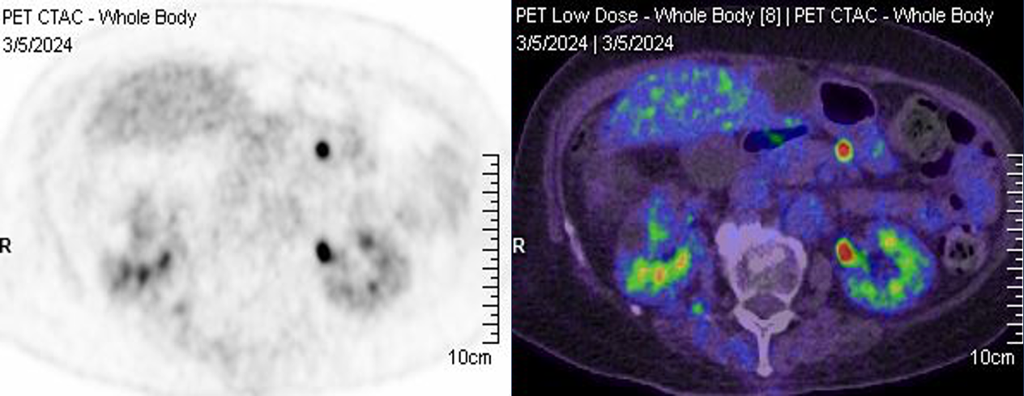

Figure 1.  New, ill-defined hypermetabolic soft tissue lesion at the lesser curvature of the stomach as seen on positron emission tomography (PET) scan.

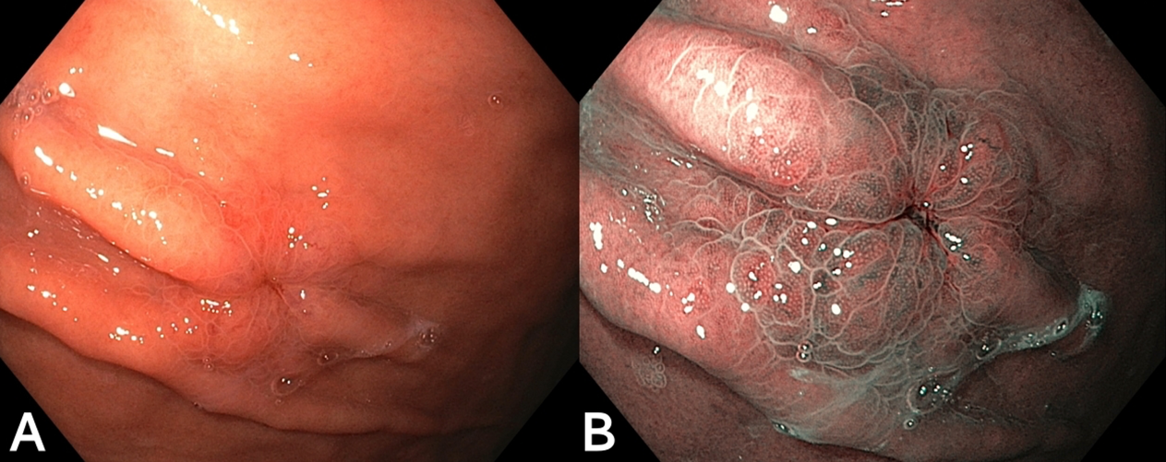

Figure 2. (A) Metastatic gastric ulcer as seen on white light gastroscopy.  (B) Metastatic gastric ulcer as seen on narrow-band imaging (NBI).

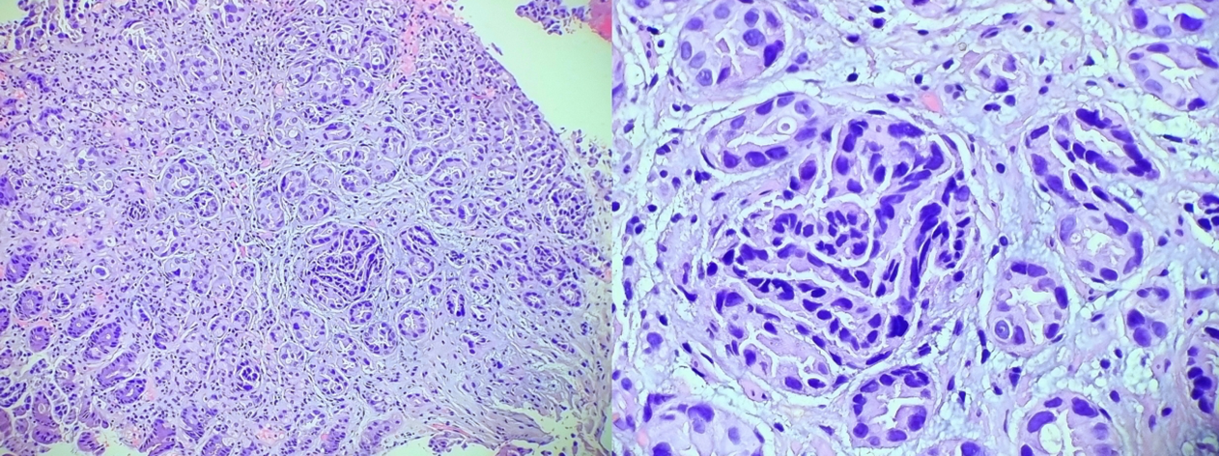

Figure 3. Histopathology showing gastric and gallbladder mucosal tissues infiltrated by well-formed neoplastic glands lined by malignant cells with features of an adenocarcinoma