***Original Research Article***

**Bio-activity of *Ocimum gratissimum* essential oil on *Aedes aegypti* mosquitoes towards Vector control**

**Abstract**

*Aedes aegypti* mosquito is a notorious vector which transmits various diseases in Nigeria especially yellow fever virus. To that regards, the need to control the vector is not only crucial but urgent. Therefore the effect of varying concentrations of *Ocimum gratissimum* leaf-oil extract on *Aedes aegypti* larvae and adults was studied between January 2023 and June 2024. Essential oil from authenticatedfresh samples of *O. gratissimum* leaves were extracted by steam distillation. Bioactive constituents of the oil were analyzed by gas chromatography. The extracted oil taken as 100% concentration was serially diluted to 20%, 10%, 5%, 2.5%, and 1.25% used for larval bioassays and adult repellency tests. Concentrations (20%, 10%, 5%, 2.5%, 1.25% w/w) of oil-based creams were formulated for repellency tests. Plain petroleum jelly and Odomos® (12% DEET) served as negative and positive controls, respectively. *Aedes aegypti* eggs from National Arbovirus and Vector Research Centre Enugu were reared to 4th instar larvae and adults for the study. Log-probit regression produced LC₅₀ and LT₅₀ while two-way ANOVA indicated significant differences (p<0.05) between mortality and repellency regarding concentrations and exposure times. Bioactive components of essential oil included ephedrine, tannin, flavonones, cardiac glycoside, ocimene, and decanal. In-vivo, 1.25% concentration caused 41.3% larval mortality (LC₅₀=2.4%; LT₅₀=7h). Simulated trails with encapsulated essential oils and oil-based creams exhibited comparable effects observed with pure essential oil. There was higher mortality and repellency effects at elevated concentrations. The essential oil of *O. gratissimum* has demonstrated larvicidal and adult repellency properties so that further research is urgently required to develop the oil for sustainable eco-friendly vector control.

**Keywords:** *Ocimum gratissimum*, essential oil, bioactivity, *Aedes aegypti,* vector control

**Introduction:**

The Anopheline and Culicine mosquitoes are incriminated vectors of various pathogenic protozoa and viruses [1]. Each year, mosquito-borne illnesses affect nearly 700 million people and are linked to over 725,000 deaths [2]. While some argue that nearly half of all humans who ever lived died due to mosquito-borne diseases, more conservative estimates suggest that about 5% of the total human population succumbed to such diseases [3]. *Aedes aegypti*, one of the well-researched mosquito species, gained prominence after Walter Reed identified it as a yellow fever vector [4]. Originating in Africa, *Aedes aegypti* is now found across tropical and subtropical regions worldwide [5]. There are over 950 species of *Aedes* mosquitoes [6]. Also known as the yellow fever mosquito, *Aedes aegypti* was the first mosquito species linked to human disease transmission and is known to carry other pathogens, including West Nile virus, Chikungunya, Dengue, and the Zika virus [7] including newly recognized Keystone and Rift Valley fever viruses [8]. By 2050, nearly half (49.13%) of the world's population is projected to be at risk of exposure to arboviruses [9]. The expanding geographic range mosquitoes and the diseases they carry emphasizes the urgent need for a sustainable, universally accepted control strategy. Strategies targeting immature mosquito stages aim to eliminate these stages via chemical or biological larvicides or through habitat modification but control measures for adult mosquitoes often involve methods such as indoor residual spraying (IRS), topical repellents, and insecticide-treated bed nets (ITNs), and effective monitoring of vector control coverage, quality, and durability is essential [10]. Global vector control programs are integral to disease reduction, significant challenges include high insecticide resistance, environmental impacts, rapid urbanization, and climate change [11].

The emergence of insecticide resistance, coupled with the adverse effects of synthetic pesticides on the environment and human health, has necessitated the exploration of bio-control strategies known for being eco-friendly and efficient, have thus gained prominence [12]. Utilizing plant-based insecticides is a promising, sustainable approach. Plant-derived repellents are popular globally due to their safety and effectiveness. Plant volatiles, which have high vapor toxicity, act as insect deterrents by interacting with odorant receptor proteins on specialized sensory neurons in insect antennae and maxillary palps, facilitating olfactory perception [11]. Phytochemicals can be sourced from different parts of plants, such as leaves, fruits, stems, and roots. The extraction process is critical, as it influences the concentration of active compounds [13]. *Ocimum gratissimum*, known as clove basil or African basil, is commonly used in tropical folk medicine [14]. This plant is known for its therapeutic properties. Its essential oils, comprising volatile compounds like aldehydes and terpenes, can be extracted from the plant and are valuable to both pharmaceutical and food industries. Extraction methods vary, including techniques such as steam distillation and maceration [15, 16]. The present study was on Bio-activity of *O. gratissimum* essential oil on *Aedes aegypti* mosquitoes.

**MATERIALS AND METHODS**

**Study location and duration**

The study was done in the Department of Parasitology and Entomology Laboratory, Nnamdi Azikiwe University Awka, Anambra State between January 2023 and June 2024.

**Sources of plant materials**

Fresh *Ocimum gratissimum* leaves were collected from a garden in Achalla, outskirts of Awka. The samples were authenticated in the Department of Botany Herbarium, Nnamdi Azikiwe University.

**Extraction of the essential oil**

The leaves were cleaned and chopped into smaller pieces and weighed in accurate proportion for extraction. The essential oil was extracted using steam distillation method of [17]. Each prepared sample was loaded into 250ml round bottom flask of Clavenger’s distillation apparatus. The distillation column was fixed and the whole setup clamped in a retort stand with the round bottom flask sitting in a heating mantle (Plate 1). Each sample of 100g was distilled in a cycle of 1hr until enough essential oil was obtained for phytochemical analysis. The oil was collected in an airtight 5ml amber bottle and dried in a glass dessicator containing silica gel.

**Phytochemical analysis**

The phytochemical constituents of the essential oils were analyzed using the method of [18]. The analysis of bioactive ingredients was performed on a BUCK M910 Gas chromatography equipped with a flame ionization detector (GC-FID). A RESTEK 15 meter MXT-1 column (15m x 250um x 0.15um) was used. The injector temperature is 280oC with splitless injection of 2ul of sample and a linear velocity of 30cms-1. Helium 5.0 pa was the carrier gas with a flow rate of 40ml/min. The oven operated initially at 200oC was heated to 330oC at a rate of 3oCmin-1 and was kept at this temperature for 5min. The detector was operated at a temperature of 3200C. Bioactive ingredients were determined by the ratio between the area and mass of internal standard and the area of the identified compounds. The concentration of the different bioactive ingredients was expressed in μg/ml and as percentages.

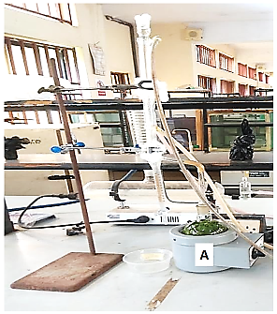

**Plate 1:** *Ocimum gratissimum* leaf samples [A] in Clavenger’s apparatus.

**Formulation of leaf-oil extracts**

Serial dilutions of the oil extract of *O. gratissimum* were prepared in acetone. The extract was taken as 100% concentration and was then diluted serially to 20%, 10%, 5%, 2.5%, 1.25% of the extract (by adding 16 ml of acetone to 4ml of the extract, 18ml of acetone to 2ml of the extract, 19ml of acetone to 1ml of the extract, 19.5mls of acetone to 0.5ml of the extract, 19.75ml of acetone to 0.25ml of the extract) using 20ml syringe respectively yielding 200 µg/ml, 100 µg/ml, 50 µg/ml, 25 µg/ml and 12.5 µg/ml concentrations. Cream formulation was done according to [19] to obtain concentrations of 20%, 10%, 5%, 2.5%, and 1.25% w/w of petroleum jelly based-cream used for repellence tests. A negative control was white petroleum jelly with no trace of essential oil. A proprietary mosquito repellent Odomos® containing 12% DEET was used as the standard positive control.

**Source of *Aedes aegypti* mosquito eggs reared to larvae and adults**

Eggs of *Aedes aegypti* mosquitoes from the National Arbovirus and Vector Research Centre Enugu were reared to the fourth instar larvae and later to adults [20] in the entomology unit of Parasitology and Entomology Department, Nnamdi Azikiwe University, Awka.

**Experimental design**

The study, in a Completely Randomized Design (CRD), involved in-vivo and in-vitro evaluation of efficacy of essential oils extracted from the leaves of *Ocimum gratissimum* on the larvae and adults of *Aedes aegypti* mosquitoes. Five varying concentrations: 20%, 10%, 5%, 2.5%, 1.25% were used for each treatment in triplicates with adequate controls.

**Evaluation of the larvicidal activity of *O. gratissimum* essential oil extracts:**

The procedure employed were those used by [21, 22]. The varying concentrations of the essential oil were obtained from diluting in acetone. Appropriate aliquots 1ml in ml/ml of the essential oil formulations 20%, 10%, 5%, 2.5%, 1.25% (i.e., 200 µg/ml, 100 µg/ml, 50 µg/ml, 25 µg/ml and 12.5 µg/ml) were added in plastic containers containing 200ml of distilled water for the essential oils. Twenty cohorts of fourth instar larvae of *Aedes aegypti* were added in each container accordingly. Each treatment with control was replicated three times. The bioassay was carried out in the laboratory at measured temperature and humidity with a photo period of 12:12 hr. (Light: Dark). Mortality inhibitions of emergence assessments were made after 0, 12, 24, 48 and 72 hr. post-exposure period. Dead larvae and those unable to wriggle (i.e., moribund larvae) were recorded as mortality. Corrected mortality were obtained using Abbott’s formula [23].

Percentage Mortality = $\frac{Number of dead larvae}{Numberof larvae introduced }x100$

**Simulated small scale field trails with larvae**

The larvicidal activity was performed according to the guidelines for laboratory and field testing of mosquito larvicides [24] with minor modifications. In brief, artificial storage containers of water were placed under natural field conditions (Plate 2) and the materials tested against the field-collected larvae of *Aedes aegypti*. The water-filled containers were given at least 24 h for conditioning.

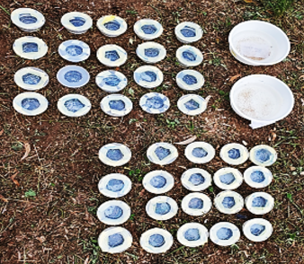.

**Plate 2:** Artificial water containers used for simulated small scale field trails

A batch of 20 field reared larvae of *Aedes aegypti* were released into each container. The larval food (Yale® biscuit) was added, and after 2–3 h of larval acclimation, the containers were then treated with the varying concentrations of the essential oil extract of *O. gratissimum* in a random systematic manner. The containers were covered with nylon mesh screen to prevent other mosquitoes or insects from laying eggs and to protect the water from falling debris. The water level in the containers were sustained and the samples replicated three times for each concentration including three controls. Mosquito larval food were added on alternate days and all containers examined after 12, 24, 48 and 72 hours when live larvae were counted to score post-treatment larval mortality. Also, the survival of larvae, pupae and pupal skins were assessed seven days after treatment, by which time all larvae would have pupated and emerged as adults.

**Evaluation of the adult repellency activity of the essential oil extract**

The standard method used for testing repellency effect was the Arm-in-cage method [25, 26]. The different concentrations were used each for testing repellency activity of the plantoil extracts using synthetic repellent, DEET (*N, N*-diethyl-3-methylbenzamide) as a positive control and acetone as a negative control. The mosquito cage was designed using a wooden structure with open surface covered with netting material, and a small opening at one side of the four corners through which the arm was passed into the net chamber (Plate 3).

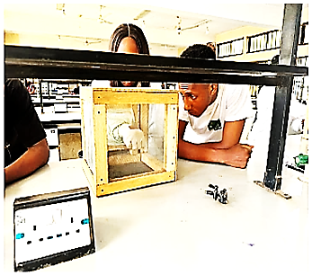  
**Plate 3:** The Arm-in-cage repellency test

The study was conducted indoors to reduce potential confounding variables, such as temperature, wind speed and humidity amongst others. Low population density environment was maintained to reflect more accurately, the typical biting pressures that are encountered indoors. Sixty, specific pathogen free (SPF) 5-7 days old colony bred [20] female *Aedes aegypti* mosquitoes were placed in three cages measuring 50x50x50cm. One cage each for *O. gratissimum* leaf-oil, acetone, and DEET. Three adult immunized volunteers (two males and one female) who did not apply any lotion, perfume, oil or scented soap on the day of the bioassay were recruited for the study. The fore arms of each volunteer from the elbow were washed with unscented soap and rinsed with water, then rinsed with a solution of 70% ethanol in water and dried with a clean towel. 2ml each of the test oil samples and the controls, starting from the lowest concentration were spread evenly over the treatment area (from elbow to the wrists through the tips of the fingers). The treated arm surface was then exposed to the mosquitoes inside the cage (Plate 3). The same caged mosquitoes were used for a particular sample and for a particular volunteer. Sequential exposure to high dosages for 30 minutes were done and timed observations of the reaction of mosquitoes were recorded. After bioassay of each concentration, the hands were washed and allowed to dry naturally for about a period of 20 minutes before dispensing the subsequent concentrations. The number of mosquitoes that landed, probed and knocked down were counted and recorded for each volunteer. Precaution was taken to shake mosquitoes off the arm before they imbibed any blood. However, the abdomen of the mosquitoes was examined for presence of blood meal. The repellency index was calculated according to the formula:

Percentage repellency = $\left[\frac{Ta-Tb}{Ta}\right]x100$, where Ta is the number of mosquitoes in control and Tb, the number of mosquitoes in the treated [26].

**Data analysis**

Mortality data collected were subjected to log-probit regression using Abbott’s formula [23] for determining LC50 and LC90; Two-way analysis of variance (ANOVA) was also performed on the mortality data to determine the level of significance in the effect of both concentration and time at p value of 5%.

**Results**

**Phytochemical composition of *Ocimum gratissimum* essential oil**

The GC-FID phytochemical analysis showed that the essential oil from *Ocimum gratissimum* leaf contain at up to 20 bioactive ingredients (Table 1).

**Table 1:** Phytochemical composition of *Ocimum gratissimum* leaf-oil extract.

|  |  |
| --- | --- |
| S/N. Component | Retention |
| 1. Nonanal | 44.170 |
| 1. Ephedrine | 42.276 |
| 1. Decanal | 39.200 |
| 1. Ribalinidine | 36.876 |
| 1. Sparteine | 34.593 |
| 1. Flavone | 32.996 |
| 1. Flavonones | 29.860 |
| 1. Cardiac Glycoside | 27.536 |
| 1. Thymol | 41.761 |
| 1. Tannin | 25.650 |
| 1. Ammodendrine | 22.730 |
| 1. Aphyllidine | 20.313 |
| 1. Naringenin | 17.966 |
| 1. Octanal | 15.460 |
| 1. Dihydrocytisine | 12.970 |
| 1. Eugenol | 38.638 |
| 1. Terpinene | 10.366 |
| 1. Ocimene | 7.456 |
| 1. Limonene | 6.020 |
| 1. Pinene | 4.116 |
| 1. Thujene | 2.390 |
| 1. Kaempferol | 0.206 |

**Mortality response of *Aedes aegypti* larva exposed to residual application of *Ocimum gratissimum* oil extract at different time intervals**

Mortality response of *Aedes aegypti* larvae exposed to residual application of *O. gratissimum* oil extract at different time intervals (Table 2) showed that at 20% concentration, 100% mortality was recorded compared to 41.3% mortality in 1.25% concentration (p<0.05, p=0.000). The result shows that as concentration increases, mortality of larvae increases. With exposure time, 12hrs application showed a mortality rate of 63.7% while 72hrs of exposure showed a mortality rate of 86.9% (p<0.05, p=0.001), an indication that mortality increases with increase in time of exposure Mortality significantly different among doses (P<0.05).

**Table 2:** Mortality response of *Aedes aegypti* larvae exposed to residual application of *Ocimum gratissimum* oil extract at 12 hourly intervals

|  |  |  |  |  |  |  |
| --- | --- | --- | --- | --- | --- | --- |
| Concentrations | Concentration (%) | 1.25 | 2.5 | 5.0 | 10.0 | 20.0 |
| Log conc. | 0.0969 | 0.3979 | 0.6989 | 1.000 | 1.301 |
| Mortality (%) | 41.3 | 53.6 | 66.3 | 90.9 | 100 |
| Probit | 4.78 | 5.32 | 5.98 | 7.33 | 8.09 |
| Exposure time | Time (h) | 12 | 24 | 48 | 72 |  |
| Log time | 1.0791 | 1.3802 | 1.6812 | 1.8573 |  |
| Mortality (%) | 63.7 | 80.0 | 83.7 | 86.9 |  |
| Probit | 5.29 | 5.80 | 5.94 | 6.08 |  |

Probit against Log of Concentration and log of time of *Aedes aegypti* larvae exposed to residual application of *Ocimum gratissimum* oil extract at 12 hourly intervals is shown in Figure 1. The log-probit regression showed that the LC₅₀ and LC₉₀of *A. aegypti* were 1.75% and 4.92% respectively, and that LT₅₀and LT₉₀of *A. aegypti* were 4.89 hours and 103 hours respectively.

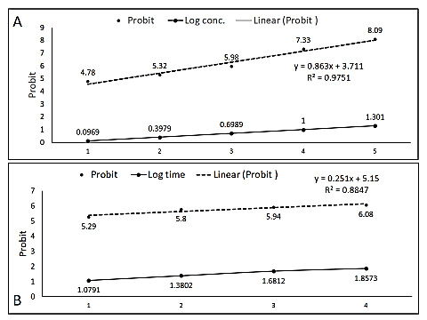

**Figure 1:** Probit against Log of Concentration [A] and log time [B] of *Aedes aegypti* larvae exposed to residual application of *Ocimum gratissimum* oil extract at 12 hourly intervals

**Mortality effect of the encapsulated essential oil of *O. gratissimum* on the larva of *A. aegypti***

The effect of *O. gratissimum* on the larva mortality of *A. aegypti* was dose dependent as shown in Table 3. Mortality increased in accordance with increase in concentration of *O. gratissimum*. The highest mortality of *A. aegypti* was recorded at 20% of *O. gratissimum* while the least was recorded with 1.25% concentration (P<0.05).

**Table 3:** Mortality Effect of the Encapsulated Essential Oil of *Ocimum gratissimum* on the Larva of *Aedes aegypti.*

|  |  |  |  |  |  |  |
| --- | --- | --- | --- | --- | --- | --- |
| Concentrations | Conc (%) | 1.25 | 2.5 | 5.0 | 10.0 | 20.0 |
| Log conc. | 0.0969 | 0.3979 | 0.6989 | 1.000 | 1.301 |
| Mortality (%) | 40.0 | 59.0 | 65.o | 72.0 | 83.0 |
| Probit | 4.75 | 5.23 | 5.39 | 5.58 | 5.95 |
| Exposure time | Time (h) | 12 | 24 | 48 | 72 |  |
| Log time | 1.0791 | 1.3802 | 1.6812 | 1.8573 |  |
| Mortality (%) | 45.35 | 65.99 | 70.67 | 72.67 |  |
| Probit | 4.87 | 5.41 | 5.55 | 5.58 |  |

Figure 2 shows Probit against Log of concentration and time of encapsulated essential oil of *O. gratissimum*. Log-probit regression showed that the LC₅₀and LC₉₀of *A. aegypti* were 1.92% and 3.46% respectively. Mortality was time dependent, and increased in accordance with increase in time of exposure to *O. gratissimum*. The highest mortality of *A. aegypti* was after 72 hours exposure to *O. gratissimum* and the least was recorded at 12 hrs. Mortality of *A. aegypti* was significantly different (P<0.05) at various time of exposure to *O. gratissimum*. The log-probit regression analysis showed that the LT₅₀= 12.69 hours while LT₉₀= 22.84 hours

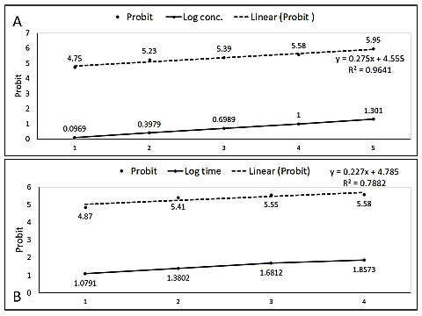

**Figure 2:** Probit against Log concentration of encapsulated essential oil of *Ocimum gratissimum* on the larva of *A. aegypti* [A]andProbit against Log time [B] to show LT₅₀for encapsulated *O. gratissimum.*

**Mortality response of *Aedes aegypti* larvae exposed to theextracts of *O. gratissimum* in a simulated field trial**

The contact toxicity result as shown in Table 4 revealed that there was dose dependent mortality response to *O. gratissimum*. Mortality increased in accordance with increase in concentration of *O. gratissimum*. The highest doses of *O. gratissimum* **(**20%) caused the highest percentage mortalities (85.00%) followed by 10% (78.33%) while least significantly different and in the control (0.00). There was also an increase in mortality with increase in exposure time. At 12-hours, mortality increased from 16% to 30% at 72 hours (P<0.05).

**Table 4:** Mortality response of *Aedes aegypti* larvae exposed to theextracts of *O. gratissimum* in a simulated field trial

|  |  |  |  |  |  |  |
| --- | --- | --- | --- | --- | --- | --- |
| Concentrations | Conc (%) | 1.25 | 2.5 | 5.0 | 10.0 | 20.0 |
|  | Log conc. | 0.0969 | 0.3979 | 0.6989 | 1.000 | 1.301 |
|  | Mortality (%) | 3.33 | 5.00 | 6.67 | 78.33 | 85.00 |
|  | Probit | 3.12 | 3.36 | 3.52 | 5.77 | 6.04 |
| Exposure time | Time (h) | 12 | 24 | 48 | 72 |  |
| Log time | 1.0791 | 1.3802 | 1.6812 | 1.8573 |  |
| Mortality (%) | 16.0 | 21.0 | 24.0 | 30.0 |  |
| Probit | 3.87 | 4.05 | 4.16 | 4.33 |  |

Figure 3 is the Probit against log concentration and log time of larvae exposed to theextracts of *O. gratissimum* in a simulated field trials.Probit against log concentrations and log time of larvae exposed to residual application of encapsulated essential oils *of O. gratissimum* at 12 hourly intervals (LC₅₀=8.546%, LT₅₀= 1295.714 hours).

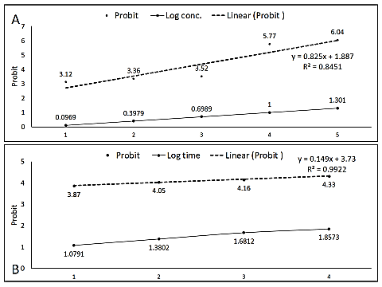

**Figure 3:** Probit against log conc [A] and log time [B] of larvae exposed to theextracts of *Ocimum gratissimum* in a simulated field trial.

**Repellency effect of *Aedes aegypti* adults exposed to varying concentrations of *O. gratissimum* oil extract at 30mins intervals**

Repellency (%) of *Aedes aegypti* adults exposed to varying concentrations of *O. gratissimum* essential oil at 30 minutes intervals is shown in Figure 4. From Figure 4A, it could be seen that repellency was dose-dependent and decreased with reduction in concentration of the plants essential oil. Similarly, Figure 4B revealed that at 0 minute, 30 minutes, 60 minutes, 90 minutes, 120 minutes, 150 minutes and 180 minutes, the percentage repellency recorded 5.4%, 13.3%, 22.0%, 31.3%, 42.0%, 55.4% and 70.7% were respectively. There is significance difference between repellency rate among the different concentrations in relation to exposure time (Pv=0.037; Pv=0.000).

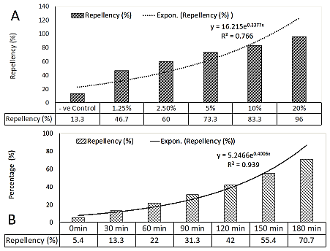

**Figure 4:** Repellency (%) of *Aedes aegypti* adults exposed to varying concentrations of *Ocimum gratissimum* essential oil extract **[A]**  at 30 minutes intervals **[B]**.

**Repellency effect of *Aedes aegypti* adults exposed to varying concentrations of encapsulated *O. gratissimum* oil extract and encapsulated *O. gratissimum* oil-based cream**

Comparative repellency effects of *Aedes aegypti* adults exposed to varying concentrations of encapsulated *O. gratissimum* oil extract and encapsulated *O. gratissimum* oil-based cream are respectively shown in Figure 5**.** It could be observed that repellency effect for encapsulated *O. gratissimum* oil extract was highest (0.71) in the control (+ve) followed by 20% (1.67) while least was in the negative control (P<0.05). Repellency effects of *Aedes aegypti* adults exposed to varying concentrations of encapsulated *O. gratissimum* oil extract (Figure 5A) followed similar trend with encapsulated *O. gratissimum* oil-based cream (Figure 5B). Again, similar trend in the mean repellency effects for exposure time of *Aedes aegypti* adults were observed with encapsulated *O. gratissimum* oil extract (Figure 6A) and the oil-based cream (Figure 6B). Simulated trails with encapsulated essential oils and the oil-based creams exhibited comparable effects observed with pure essential oil. Generally, adult repellency was higher at elevated concentrations consistent with larval mortality results.

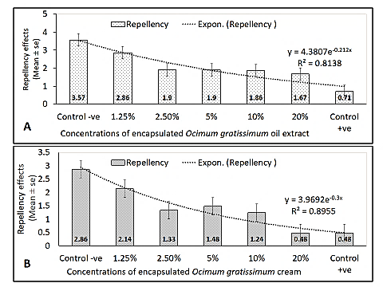

**Figure 5:** Repellency of *Aedes aegypti* adults exposed to varying concentrations of encapsulated *O. gratissimum* oil extract **[A],** and encapsulated *O. gratissimum* oil-based cream **[B].**

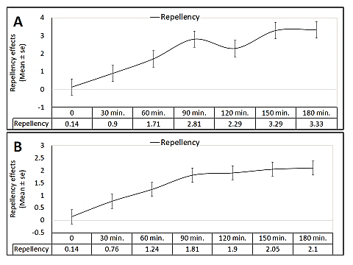**Figure 6:** Repellency of *Aedes aegypti* adults exposed at 30 minutes intervals to varying concentrations of encapsulated *O. gratissimum* oil extract **[A]**, and encapsulated *O. gratissimum* oil-based cream **[B]**.

**Discussion**

The use of plant-derived products against mosquitoes have proved to be an alternative approach to the control of insect vectors since the use of synthetic insecticides have been discouraged because their food and environmental health concerns, toxicity to untargeted organisms and insect vector resurgence rates have made their exploitation undesirable [28]. This study examined the larvicidal and repellent efficacy of *Ocimum gratissimum* essential oil extract against the *Aedes aegypti* mosquito, and showed that the leave oil-extract exhibited good larvicidal and adult repellent activities with varying susceptibility. The plant’s high bio-activity is buttressed by the presence of phytochemicals such as alkaloids, flavonoids, steroids and terpenes (Table 1) which have been reported to show combination effects in terms of mosquito larval mortality [28]. However, *O. gratissimum* has more of alkaloids, steroids, saponins and glycosides than flavonoid, tannins, antraquinones and phenolics (Table 1) in line with Afolabi *et al*. (2007) who reported more alkaloids, saponins, flavonoid and anthraquinones. [29] Demonstrated that the alkaloids, saponins, phenolics and glycosides exhibit larvicidal properties, and this may be responsible for larval mortality recorded in Tables 2, 3 and 4. Also, flavonoids have been reported to play a key role in stress response mechanisms in plants [30] and exhibit larvicidal activity against *Anopheles* mosquitoes. [31, 32] have confirmed that tannins present in plants and vegetables are well known in degrading aquatic habitat and responsible for mortalities in aquatic organisms. Perhaps the mixture of compounds such as flavonoids, tannins, steroids and alkaloids is synergistic in plant’s activity. Larvicidal activity against particular mosquito species may be due to this synergistic effects of phytochemicals in the essential oil.

It was observed that as concentration of oil extract increased, larval mortality increased (Figure 1). Also, larval mortality increased with exposure time (Figures 2 and 3). A mortality above 50% indicates that the *O. gratissimum* extracts exhibited significant mortality rate on the targeted *Aedes aegypti* mosquito larvae. [33] Had showed that toxic effect of the *O. gratissimum* extracts were proportional to concentrations with the highest concentration being the most effective. This is also corroborated by the simulated field trails where the percentage mortality for *Aedes aegypti* larvae increased with increasing concentration of the *O. gratissimum* essential oil extract within 72 hours of exposure (Tables 4). The lethal effect for the larva in this study which was LC₅₀ of 1.75% differed from LC₅₀ of 4.28% reported by Musa *et al*. (2023), and LC₅₀ of 0.093% observed by [27]. Interestingly, [34] reported that *O. gratissimum* has a potential larvicidal activity against *Culex gelidus* and *Culex quinquefasciatus* after 24 h with an LC₅₀ and LC₉₀ values of 21.83 and 66.28 μg/ml respectively. Also, [28] reported that *O. gratissimum* shows larvicidal efficacy against *Aedes albopictus* larvae after 24 h with an LC₅₀ value of 26.10 μg/ml. These activities also indicate the applicability of the oil extract as a potential larvicide, suggesting that the essential oil from *O. gratissimum* leaves and its effective constituents may be explored as a potential natural, more selective, biodegradable and eco-friendly larvicide. *Ocimum gratissimum* had varying degree of repellency against adult *Aedes aegypti*. Repellency was dose-dependent and decreased with reduction in concentration of essential oil. Thus, at the highest concentration of 20%, we observed a repellency of 96% (Figure 4A), indicating that *O. gratissimum* may be highly efficacious in the control of *Aedes* *aegypti*. The encapsulated essential oil of *Ocimum gratissimum* exhibited comparable larvicidal (Figure 2) and repellency (Figure 5) effects to those observed with the pure essential oil (Figure 1) in this study. The larvicidal tests showed higher mortality rates at elevated concentrations, consistent with the repellency results (Figure 6). These findings align with the study by [35], which reported comparable repellent effects between the pure compounds geraniol, (E)-anethole, and farnesol against the greenfly *Myzus. persicae* and their Nano emulsions, whether freshly prepared or stored for six months.

**Conclusion**

The present study reveals that the essential oil of *O. gratissimum* has remarkable larvicidal and repellent properties. Extracts of O. gratissimum is promising in disease-vector mosquito’s management. Further investigations for the mode of the oil constituents’ actions, effects on non-target organisms and field evaluation are required for the development of these bioactive compounds into commercially available value-added products that would give vector control programmes with new products having alternative modes of action from those synthetic chemicals presently available.

**Data availability:** The data used to support the findings of this study are available upon astute request.

**References**

1. Hillary, A., Kim, J. and Johnson, P. (2021). Mosquito ecology and vector-borne diseases: A comprehensive review. *Vector Biology Journal*, 34(1), 15-32. <https://doi.org/10.1016/j.vbj.2021.03.002>
2. Helmer, M. (2023). Global health impacts of mosquito-borne diseases. *International Journal of Tropical Medicine*, 18(2), 101-110. <https://doi.org/10.1038/ijtm.2023.067>.
3. Pomeroy, R. (2019). Mosquito-borne disease and historical impact: Reevaluating claims of human mortality. *Epidemiology Historical Journal*, 5(3), 125-140. <https://doi.org/10.1093/ehj.2019.0456>
4. Walter Reed Biosystematics Unit. (2021). Historical perspectives on the yellow fever mosquito. *Entomological Research Series*, 8(5), 65-72. <https://doi.org/10.1248/ers.2021.005>
5. Zettel, C. and Blanckenhorn, W. (2022). Geographical distribution and climate adaptation of Aedes mosquitoes. *Entomology Today*, 57(3), 207-216. <https://doi.org/10.1016/ento2022.067>
6. Elbers, A.R.W., Meiswinkel, R., van Weezep, E., Kooi, E.A. and van Rijn, P.A. (2015). Culicoides (Diptera: Ceratopogonidae) host preferences and bovine arbovirus surveillance during the 2006 and 2007 bluetongue outbreaks in the Netherlands. *Preventive Veterinary Medicine*, 116(3), 243-254. <https://doi.org/10.1016/j.prevetmed.2014.10.020>
7. VDCI (2023). Vector Disease Control International. *Aedes aegypti* and public health: A review of vector management. *VDCI Research Reports*, 10(2), 112-119. <https://www.vdci.net/publications/aedes-aegypti-2023>
8. WHO (2022). World Health Organization. Vector-borne diseases fact sheet. <https://www.who.int/news-room/fact-sheets/detail/vector-borne-diseases>.
9. Kraemer, M.U.G., Reiner, R.C., Brady, O.J., Messina, J.P., Gilbert, M., Pigott, D.M. and Hay, S.I. (2019). Past and future spread of the arbovirus vectors *Aedes aegypti* and *Aedes* *albopictus*. *Nature Microbiology*, 4(5), 854-863. <https://doi.org/10.1038/s41564-019-0376-y>
10. WHO (2023). World Health Organization. Guidelines for malaria vector control. <https://www.who.int/publications/malaria-vector-control>.
11. Kaura, A., Verma, S. and Khanna, P. (2023). Challenges in modern vector control strategies: Insecticide resistance and environmental impact. *Entomology Research Reviews*, 12(1), 45-57. <https://doi.org/10.1016/j.entresrev.2023.02.006>.
12. Hamed, M. (2022). Biological control strategies for mosquito vectors: Environmental and public health perspectives. *Journal of Medical Entomology*, 59(4), 875-888. <https://doi.org/10.1093/jme/tjac017>.
13. Raveen, R., Paulraj, M. G., and Ignacimuthu, S. (2017). Ovicidal and larvicidal efficacy of plant-based extracts against mosquito vectors. *Insect Biochemistry and Physiology*, 42(1), 18-26. <https://doi.org/10.1002/ibp.2017.025>
14. Priyanka, D., Kaur, H. and Sharma, A. (2018). The pharmacological and therapeutic benefits of *Ocimum gratissimum*. *Journal of Herbal Medicine*, 15(1), 23-34. <https://doi.org/10.1016/j.jhermed.2018.01.005>
15. Ojewumi, M.E., Ojewumi, E.O. and Adekeye, S.A. (2019). Extraction techniques of essential oils from medicinal plants: A review. *Journal of Medicinal Plants Research*, 13(2), 65-77. <https://doi.org/10.5897/JMPR2019.0130>.
16. Ojewumi, M.E., Oluwasegun, I.A. and Oginni, S.O. (2021). The effectiveness of essential oil extraction methods: An updated perspective. *Journal of Applied Science and Technology*, 17(4), 401-409. <https://doi.org/10.1016/j.jast.2021.09.008>
17. Scott, R. M. (2005). Extraction and distillation techniques for essential oils. In Techniques in Organic Extraction. pp. 45-52. University Press.
18. Kelly, R.T. and Nelson, A.J. (2014). Essential oil profiling by gas chromatography-flame ionization detection (GC-FID). *Journal of Analytical Chemistry*, 9(3), 123-130.
19. Govindarajan, M., & Benelli, G. (2017). Facile fabrication of eco-friendly nano-mosquitocides: Biophysical characterization and effectiveness on neglected tropical mosquito vectors. Acta Tropica, 167, 169–178. <https://doi.org/10.1016/j.actatropica.2016.12.029>
20. Onyido, A.E., Ozumba, N.A., Ezike, V.I., Ikpeze. O.O., and Nwankwo, A.C. (2009). A new method of rearing and maintenance of mosquito colony in the laboratory. African *Journal of Biosciences Vector Biology Research*, 2(3), 45–52.
21. Nwankwo, N., Okonkwo, C., and Ezeonu, I. (2012). Evaluating the potential of plant-based products for larval and pupal control in mosquito management. *African Journal of Biotechnology*, 11(10), 2587-2594. <https://doi.org/10.5897/AJB11.2007>.
22. Amakiri, K., Etuk, I. and Obot, J. (2019). Efficacy of botanical insecticides on various developmental stages of mosquitoes. *Journal of Vector Ecology*, 44(1), 67-75. <https://doi.org/10.1111/jvec.2019.44.issue-1>.
23. Abbott, W.A. (1925). A method of computing the effectiveness of an insecticide. *Journal of Economic Entomology*, 18(2), 265-267. <https://doi.org/10.1093/jee/18.2.265a>
24. WHO (2005). World Health Organization. <https://www.who/cds/whopes/gcdpp/2005.13>.
25. WHO (2009). World Health Organization Guidelines for efficacy testing of mosquito repellents for human skin. Geneva: WHO Press. <https://www.who.int/publications-detail/guidelines-for-efficacy-testing-of-mosquito-repellents-for-human-skin>.
26. Lawal, O.A., Ogunwande, I.A. and Olayemi, O.A. (2012). Repellency and larvicidal activities of essential oils from selected Nigerian plants against mosquitoes. *International Journal of Pest Management*, 58(3), 243-249. <https://doi.org/10.1080/09670874.2012.688790>
27. Ileke, K. D., and Olabimi, O. O. (2019). Insecticidal activities of *Chromolaena odorata* and *Vernonia amygdalina* leaf extracts against Anopheles gambiae. *International Journal of Tropical Disease*, 2(1), 1–7.
28. Sumitha, K., Govindarajan, M., Rajeswary, M., and Benelli, G. (2016). Bioefficacy of *Mentha piperita* essential oil against dengue fever mosquito *Aedes aegypti* L. *Environmental Science and Pollution Research*, 23(10), 9570–9577. https://doi.org/10.1007/s11356-016-6181-9
29. Musa, A. K., Ibrahim, H., and Yusuf, A. A. (2023). Larvicidal and adulticidal effects of some Egyptian oils against *Culex pipiens*. *Journal of Arthropod-Borne Diseases*, 17(1), 1–9.
30. Keerti, S., Kumar, A., and Prakash, S. (2018). An online survey of personal mosquito-repellent strategies. *Journal of Vector Borne Diseases*, 55(2), 153–156.
31. Johnson, S. (2011). The use of mosquito repellents at three sites in India with declining malaria transmission: Surveys in the community and clinic. *Journal of Vector Borne Diseases*, 48(3), 138–143.
32. Benelli, G. (2020). Mosquito repellents: An insight into the chronological perspectives and novel discoveries. *Acta Tropica*, 167, 216–230. <https://doi.org/10.1016/j.actatropica.2016.12.031>
33. El-Akhal, F., Lyoussi, B., and Bousta, D. (2016). Evaluation of the repellent effect of essential oils against mosquitoes: A review. *International Journal of Pharmacology and Phytochemical Research*, 8(5), 857–864.
34. Kamaraj, C., Rahuman, A. A., Bagavan, A., Elango, G., Zahir, A. A., Rajakumar, G., & Marimuthu, S. (2010). Evaluation of repellent properties of botanical extracts against Culex tritaeniorhynchus Giles (Diptera: Culicidae). *Parasitology Research*, 107(3), 577–584. https://doi.org/10.1007/s00436-010-1897-8.
35. Pascual-Villalobos, M.J., Muñoz, M., Jacas, J.A. and Urbaneja, A. (2019). Use of Nano emulsions as botanical insecticides against aphids. *Journal of Pest Science,* 92(1), 97–110. <https://doi.org/10.1007/s10340-018-1000-9>.