AI-Enhanced Process Analytical Technology for Real-Time Pharmaceutical Process Monitoring: A Review

ABSTRACT

|  |
| --- |
| In any industrial pharmaceutical process, tiny but unavoidable variations in raw materials and process parameters can lead to variability in the quality of the final product. Process Analytical Technology (PAT) addresses this issue by using sensors to monitor production in real time. However, modern complex manufacturing, particularly for biopharmaceuticals, generates more data than traditional PAT methods can effectively process. Artificial intelligence (AI) complements PAT by adding advanced technologies such as Machine Learning and Deep Learning. This combination allows continuous quality monitoring, early anomaly detection, and adaptive process control. Research demonstrates successful applications of AI-enhanced PAT systems utilizing near-infrared spectroscopy, Raman spectroscopy, and advanced imaging for quality attribute monitoring in both solid dosage forms and biopharmaceutical products. Together, AI and PAT enable a smarter manufacturing approach that enhances drug quality and safety while reducing process variability and production downtime. This integrated approach represents a significant advancement in pharmaceutical production, facilitating the implementation of Quality by Design and continuous manufacturing. |

*Keywords: Process Analytical Technology; Artificial Intelligence; Real-time Monitoring; Quality Control; Quality by Design; Continuous Manufacturing*

1. INTRODUCTION

Variability is unavoidable in pharmaceutical manufacturing. From fluctuations in raw material properties to small changes in equipment performance, numerous sources can introduce fluctuations that eventually impact product quality. Such variability, if not effectively understood and controlled, can lead to deviations, batch failures, or reduced therapeutic efficacy. All these risks cannot be afforded by the pharmaceutical industry in its commitment to ensure patient safety [1,2].

To address these issues, Process Analytical Technology (PAT) has emerged as an essential tool of real-time process understanding and control. By integrating sensors, chemometric models, and feedback systems into manufacturing processes, PAT allows manufacturers to monitor critical process parameters (CPPs) in real time. This proactive approach reduces the reliance on end-product testing and enhances the consistency of pharmaceutical products and the robustness of their manufacturing processes [3,4].

However, with the increasing development, manufacturing processes have become more complex and data-rich, particularly for biotechnology-derived medicines. Thus, the enormous amount of information collected via PAT tools can become increasingly overwhelming [5]. This is where artificial intelligence (AI) becomes helpful. AI algorithms, can analyze patterns, predict trends, and detect subtle variations that may not be detected by traditional statistical approaches [6]. When combined with PAT, AI allows faster responses to deviations and better overall process control [7].

Together, AI and PAT form a synergistic duo, offering the pharmaceutical industry a revolutionary tool to anticipate variability, ensure consistent quality, and accelerate the shift toward continuous manufacturing. This article explains how using AI and PAT together can improve process control and help better manage variability in pharmaceutical production.

2. WHAT IS PROCESS ANALYTICAL TECHNOLOGY (PAT) ?

Process Analytical Technology (PAT) is a framework introduced by the U.S. Food and Drug Administration (FDA) in 2004 to modernize pharmaceutical manufacturing. PAT emphasizes real-time monitoring and control of critical process parameters (CPPs) to ensure product quality [3]. This approach is consistent with the Quality by Design (QbD) principles outlined in ICH Q8 guideline focusing on understanding and controlling variability in manufacturing processes [2]. By integrating advanced analytical tools, PAT aims to shift from traditional end-product testing to continuous quality monitoring, reducing production cycles, minimizing waste, and enhancing efficiency [8].

PAT operates on the principle of real-time measurement and control during manufacturing. It uses three categories of tools (Figure 1):

* Modern Process Analyzers (Sensors): Spectroscopic methods such as Near-Infrared (NIR), Raman, and Terahertz spectroscopy provide non-destructive, in-line measurements of material attributes such as moisture content or active pharmaceutical ingredient (API) concentration. These analyzers allow improved quality via real-time adjustments that prevent batch failures;
* Multivariate Data Acquisition and Analysis: Techniques like Design of Experiments (DoE) and chemometric models such as Partial Least Squares regression optimize processes by identifying interactions between variables;
* Process Control Tools: Feedback loops adjust CPPs dynamically to maintain critical quality attributes (CQAs) within predefined limits [9,10].

Moreover, PAT allows regulatory flexibility by supporting parametric release, hence reducing post-production testing [11].

For example, NIR spectroscopy is widely used for monitoring blend homogeneity in powder mixing, while Raman spectroscopy can detect polymorphic changes in APIs. Terahertz imaging offers new perspectives of solid-state structures without sample preparation [12-14].

PAT represents a paradigm shift in pharmaceutical manufacturing, replacing classic controls on the finished product with, real-time monitoring of critical parameters based on science and data.

. 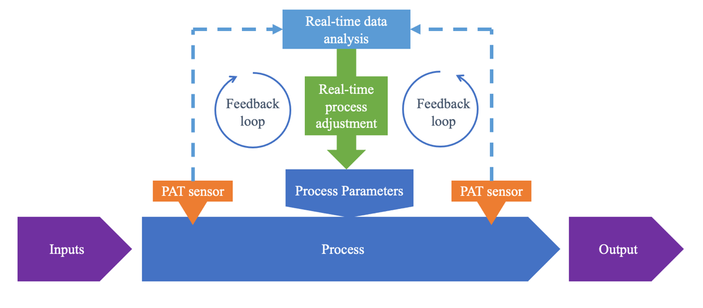

**Figure 1: Real-time monitoring of pharmaceutical processes using PAT**

3. WHAT IS ARTIFICIAL INTELLIGENCE (AI) ?

Artificial Intelligence (AI) is a dynamic field of computer science that allows machines to mimic human cognitive abilities, including learning, reasoning, problem-solving, and creativity. By analyzing large datasets and identifying patterns, AI systems can make predictions, automate complex processes, and generate original outputs (Figure 2).

The main techniques used in AI are:

* **Machine Learning (ML): A process where algorithms learn from data and gradually improve their accuracy without being directly programmed;**
* **Artificial Neural Networks (ANN): A subfield of ML based on algorithmic architectures inspired by the human brain's architecture, capable of executing sophisticated tasks such as diagnostic predictions or financial modeling;**
* **Deep Learning (DL): A subfield of ANN that employs multilayered artificial neural networks to handle complex, high-dimensional data such as images and language [15-17].**

The impact of AI is especially profound in medical sciences. AI is revolutionizing various branches of medicine, particularly those using on visual data. Through the application of deep learning and access to large medical datasets, AI systems can interpret medical images, support diagnostic decisions, and predict disease progression with an accuracy equal or superior to that of clinicians [18]. Artificial intelligence demonstrates strong performance in reading chest X-rays, CT scans, and MRIs. It is also competent in detecting metastases and classifying tumors. In ophthalmology, AI tools have achieved high sensitivity and specificity in screening for diabetic retinopathy, facilitating timely interventions. In dermatology, AI systems can match expert dermatologists in diagnosing skin cancers and distinguishing between benign and malignant lesions. Furthermore, AI is being increasingly integrated into a broad range of medical fields such as anesthesiology, nephrology, diabetology, dentistry, cardiology, and many others [19-23].

In the pharmaceutical domain, AI offers significant opportunities to improve both drug quality and treatment outcomes. In pharmacy practice, AI has been applied to optimize medication management and improve patient care [24,25]. Within the pharmaceutical industry, AI is accelerating a transformative evolution by significantly reducing development time and costs while increasing the success rate of drug discovery pipelines [26,27]. Moreover, AI contributes to improved formulation development, accelerating production processes, and ensuring the quality of manufactured products [28,29]. In pharmacovigilance, machine learning algorithms are employed to detect adverse drug events and reactions more effectively [30]. Even regulatory affairs are benefiting: AI tools can automate a variety of regulatory processes, including administrative tasks, dossier compilation, data extraction, compliance monitoring, auditing, and quality management [31].

.

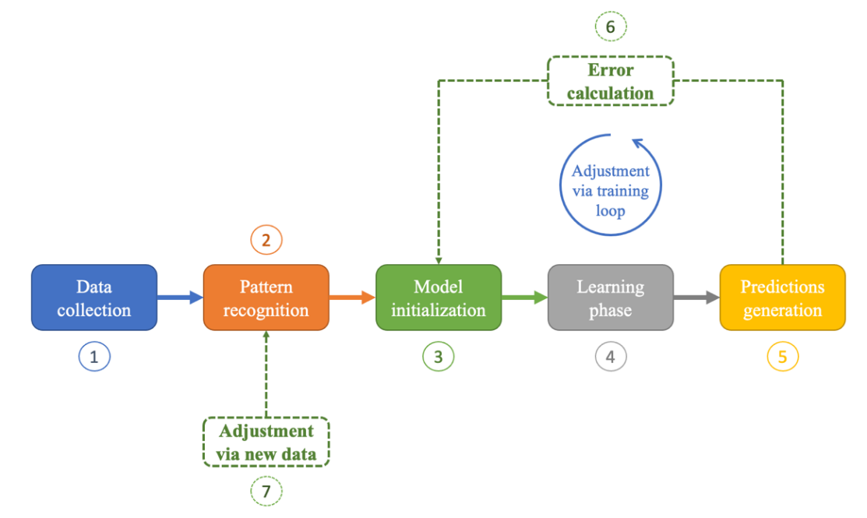

**Figure 2: The Process of Building a Machine Learning Model**

4. HOW CAN AI AND PAT WORKING TOGETHER REDEFINE PROCESS CONTROL?

In this chapter, we present articles exploring the combination of AI and PAT to enhance real-time control of pharmaceutical processes and minimize variability. The peer-reviewed literature indicates that the AI-PAT tandem has been effectively applied in three primary domains: Real-time monitoring of quality attributes, real-time particle size analysis, and visual inspection of freeze-dried pharmaceuticals. These studies are summarized in Table 1 and Figure 3.

4.1. Monitoring of quality attributes:

4.1.1. Solid dosage forms:

Fazekas et al. (Budapest University of Technology and Economics) developed a system combining PAT tools and AI for the control of key attributes in electrospun amorphous solid dispersions. The method utilized Raman and NIR spectroscopy, machine vision, and AI-driven image analysis to monitor drug concentration, morphology, and fiber diameter [32].

Mészáros et al., from the same institution, designed an AI-based surrogate model for real-time dissolution prediction in continuous pharmaceutical manufacturing. Their model, built using NIR spectroscopy-based partial least squares regression and artificial neural networks (ANN), successfully predicted acetylsalicylic acid (ASA) blend uniformity and dissolution. The system demonstrated strong agreement with validation curves, supporting the feasibility of real-time release testing (RTRT) in continuous blending operations [33]. The same research group developed a dual-mode UV/VIS imaging platform for comprehensive tablet quality assessment. This system achieved <5.6% error in API content prediction using UV imaging and <10% error in crushing strength estimation through VIS textural analysis. Additionally, the machine vision approach accurately classified friability and disintegration time and predicted dissolution profile with high precision using ANN with 50 ms acquisition time [34].

Fink et al. introduced an optical coherence tomography (OCT)-based method combined with tree-based machine learning to non-destructively predict the dissolution behavior of uncoated tablets in real time. Their advanced image analysis enabled quantification of microstructural variations imperceptible to the human eye, supporting robust real-time dissolution predictions [35]. The same team later demonstrated OCT’s ability to estimate coating thickness in highly scattering formulations (such as titanium dioxide-based) using unsupervised machine learning, further extending OCT’s utility for at-line and in-line process [36].

Kim et al. implemented machine and deep learning algorithms (Random Forest and ANN) into a tablet press machine (TPM) to detect defects such as capping and low breaking force in real time. The enhanced TPM achieved over 93% prediction accuracy and 99.43% sorting accuracy at commercial scale, validating its potential for non-destructive defect detection [37].

Galata et al. combined NIR spectroscopy, critical material attributes, and process data with ANN modeling to predict dissolution profiles of sustained-release tablets. The inclusion of HPMC particle size, a critical material attribute, resulted in superior predictive performance [38].

Carter et al. employed deep learning to detect distributor plate blockages in fluidized beds. Using passive acoustic emissions captured by piezoelectric microphones and analyzed via ANN, the system robustly classified blockage severity across multiple pellet types [39].

Roggo et al. created a deep learning model to monitor continuous wet granulation lines. By processing seven critical process parameters and eight PAT-derived quality attributes through a three-layer neural network, the system achieved <10% error in key predictions after 2500 training epochs, enabling real-time process control [40].

4.1.2. Biopharmaceuticals:

Nitika et al. developed a Raman spectroscopy-based PAT tool combined with convolutional neural networks (CNN) to monitor charge variants during monoclonal antibody production. Their model precisely quantified acidic, main, and basic variants alongside total protein concentrations, offering a faster and reliable alternative to ion exchange chromatography [41].

Williams et al. demonstrated that an AI-enhanced PAT tool (Ranger, based on refractometry) can model HEK293T cell metabolism, identify pH–metabolism interactions, and enhance metabolic output by 1.8-fold, identifying stress responses and supporting adaptive control [42].

Austerjost et al. introduced a low-cost, machine vision-based foam detection system using CNNs for bioreactors. Their setup allowed both binary detection and detailed classification of foam characteristics [43].

Wang et al. enhanced a Raman-based PAT by integrating KNN models with robotic automation for real-time monitoring of protein aggregates, achieving a 38-second resolution [44]. In another contribution, the same team introduced Butterworth-filter-based preprocessing of Raman spectra and machine learning to predict 16 CQAs in-line, extending the limits of multi-attribute monitoring [45]. They also built an automated platform coupling Raman spectroscopy and robotic liquid handling to monitor eight CQAs during Protein A chromatography. Their method used KNN regression and Butterworth filtering to calibrate with 183 samples in 25 hours, delivering new CQA data every 28 seconds [46].

Shrivastava et al. paired machine learning with LC-FLD for fast N-glycan quantification in monoclonal antibodies, reducing analysis time by 70% and minimizing errors by up to 40% compared to manual integration [47].

Rashedi et al. enhanced Just In Time Learning (JITL) using variational autoencoders (VAE) for Raman spectral analysis, enabling better uncertainty modeling. Their VAE-JITL method outperformed PLS, CNNs, and KNN-JITL for predicting critical process variables across three cell lines [48]. In a related study, they employed deep learning and Raman spectroscopy for continuous glucose control in cell cultures, improving consistency, reducing high mannose levels, and increasing titer yields over traditional bolus feeding [49].

Greenblott et al. applied supervised CNNs and VAEs to detect particle formation during antigen–adjuvant mixing in vaccine production. Flow imaging microscopy enabled differentiation between new particles and background elements [50].

Maruthamuthu et al. trained a CNN on Raman spectra from 12 microbial contaminants and CHO cells, achieving 95–100% classification accuracy. Their approach allowed rapid, non-invasive microbial contamination detection in bioprocessing [51].

4.2. Particle size analysis:

Madarász et al. used a CNN and a rigid endoscope to estimate NaCl particle size, achieving high correlation with laser diffraction results and supporting real-time analysis [52]. Another team from the same university developed a 3D-printed inline imaging device combining fiber-optic endoscopy and high-speed imaging to analyze granule Particle Size Distribution (PSD) (100–2000 µm) in fluidized-bed processes. CNN analysis produced strong agreement with offline image analysis and laser diffraction data [53].

Abdulhussain et al. (McMaster University) enhanced acoustic emissions-based PSD prediction with ANN modeling. By incorporating the Walton–Braun elastoplastic model and retraining on broader datasets, they significantly reduced error and improved real-time prediction of bimodal PSDs [54].

4.3. Visual inspection of freeze-dried biopharmaceuticals:

Hervé et al. applied computer vision and YOLOv7 for automated inspection in continuous freeze-drying. The system outperformed human inspectors in speed and accuracy when identifying particles [55]. Later, the team developed CNN-based models for cosmetic inspection of freeze-dried products, detecting critical defects with perfect precision and recall, and delivering results in less than 50 ms [56].

Korang-Yeboah et al. analyzed the impact of ice nucleation temperature (TIN) on freeze-drying efficiency and product structure. By combining AI-based image analysis with in-line and off-line PAT, they revealed an inverse relationship between TIN and drying efficiency, highlighting the importance of microstructural characterization in optimizing lyophilization [57].

5. Conclusion

The research articles that we reviewed in the present work show undoubtably that the integration of **AI and PAT** represents a transformative leap in pharmaceutical manufacturing, offering unprecedented capabilities to monitor, predict, and control process variability in real time. By using AI’s advanced data analytics such as machine learning (ML), deep learning (DL), and neural networks alongside PAT’s robust sensor technologies such as Raman spectroscopy, NIRS, optical coherence tomography, etc., the pharmaceutical industry can achieve enhanced real-time monitoring, proactive process control, reduction of human error and variability, and regulatory and operational efficiency. Moreover, the synergy of AI and PAT supports **Quality by Design**, **parametric release**, and continuous manufacturing, reducing reliance on end-product testing

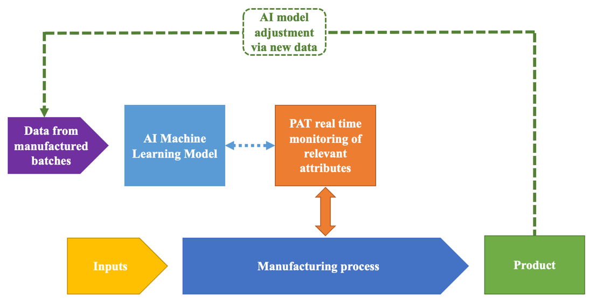

**Figure 3: The use of AI and PAT for real time monitoring of pharmaceutical processes**

**Table 1: Summary of the reviewed articles**

|  |  |  |  |  |
| --- | --- | --- | --- | --- |
| **Authors** | **Type of control** | **PAT type** | **AI type** | **Ref.** |
| Fazekas et al. | Drug concentration, morphology, and fiber diameter of electrospun amorphous solid dispersions. | Raman spectroscopy  NIRS  Machine vision | CNN | 32 |
| Mészáros et al | Blend uniformity and dissolution of acetylsalicylic acid in a continuous blending process. | NIRS | ANN | 33 |
| Mészáros et al | Tablet quality assessment | UV/VIS imaging | ANN | 34 |
| Fink et al. | Dissolution behavior of uncoated tablets | OCT | Tree-based ML | 35 |
| Fink et al. | Coating thickness of tablets | OCT | Unsupervised ML | 36 |
| Kim et al. | Detection of tablet defects | Sensed compression force and speed, and ejection force | RF & ANN | 37 |
| Galata et al. | Dissolution profiles of sustained-release tablets | NIRS | ANN | 38 |
| Carter et al. | Detection of distributor plate blockages in pharmaceutical fluidized beds | Passive acoustic emissions | ANN | 39 |
| Roggo et al. | Monitoring of a wet granulation line | NIRS | ANN | 40 |
| Nitika et al. | Monitoring of charge variants in monoclonal antibody production | Raman spectroscopy | CNN | 41 |
| Williams et al. | Modeling metabolic activity in HEK293T cell cultures | Refractometry | LSTM | 42 |
| Austerjost et al. | Foam sensing system for bioreactors | Visual | CNN | 43 |
| Wang et al. | Monitoring of protein aggregates and fragments during bioprocessing | Raman spectroscopy | ML (KNN) | 44 |
| Wang et al. | 16 critical quality attributes during biopharmaceutical production | Raman spectroscopy | ML | 45 |
| Chen et al. | 8 critical quality attributes (CQAs) during Protein A chromatography. | Raman spectroscopy | ML (KNN) | 46 |
| Shrivastava et al. | N-glycan quantification in mAbs | LC-FLD | ML | 47 |
| Rashedi et al. | Monitoring of biopharmaceutical cell | Raman spectroscopy | VAE-JITL | 48 |
| Rashedi et al. | Continuous glucose control in cell culture | Raman spectroscopy | DL | 49 |
| Greenblott et al. | Particle generation during the mixing of protein antigen–adjuvant vaccine suspensions | Flow imaging microscopy | CNN-VAE | 50 |
| Maruthamuthu et al. | Detection of microbial contamination in pharmaceutical bioprocessing | Raman spectroscopy | DL | 51 |
| Madarász et al. | Particle size measurement | Rigid endoscope | CNN | 52 |
| Péterfi et al. | PSD of pharmaceutical granules | Fiber-optic endoscopy | CNN | 53 |
| Abdulhussain et al. | PSD of pharmaceutical granules | Acoustic emission | ANN | 54 |
| Herve et al. | Visual inspection of freeze-dried products | Machine vision | CNN | 55 |
| Herve et al. | Visual inspection of freeze-dried products | Machine vision | CNN | 56 |
| Korang-Yeboah et al. | Control of ice nucleation temperature | Micro-CT imaging | Image analysis | 57 |

*ANN: Artificial Neural Networks; CNN: Convolutional Neural Networks; DL: Deep Learning; JITL: Just In Time Learning; KNN: k-Nearest Neighbors; LC-FLC: Liquid Chromatography with Fluorometric Detection; LSTM: ; Artificial recurrent neural network architecture long short-term memory; Micro-CT: Micro-Computed Tomography ML: Machine Learning; NIRS: Near Infrared Spectroscopy; OCT: Optical Coherence Tomography; RF: Random Forrest; VAE: variational autoencoders.*

References

1. Nick Hutchinson. Understanding and Controlling Sources of Process Variation: Risks to Achieving Product Critical Quality Attributes [Online]. Retrieved from: <https://www.bioprocessintl.com/bioanalytical-methods/understanding-and-controlling-sources-of-process-variation-risks-to-achieving-product-critical-quality-attributes> (Accessed April 30th, 2025).
2. International conference on harmonisation of technical requirements for registration of pharmaceuticals for human use. (2009). ICH harmonised tripartite guideline pharmaceutical development Q8(R2) [Online]. Retrieved from: <https://database.ich.org/sites/default/files/Q8%28R2%29%20Guideline.pdf> (Accessed April 30th, 2025).
3. U.S. Department of Health and Human Services, Food and Drug Administration. (2004). Guidance for Industry : PAT - A Framework for Innovative Pharmaceutical Development, Manufacturing, and Quality Assurance [Online]. Retrieved from: <https://www.fda.gov/media/71012/download>. (Accesses May 1st 2025).
4. Kim EJ, Kim JH, Kim MS, Jeong SH, Choi DH. Process Analytical Technology Tools for Monitoring Pharmaceutical Unit Operations: A Control Strategy for Continuous Process Verification. Pharmaceutics. 2021 Jun 21;13(6):919. doi: 10.3390/pharmaceutics13060919.
5. Nitika N, Keerthiveena B, Thakur G, Rathore AS. Convolutional Neural Networks Guided Raman Spectroscopy as a Process Analytical Technology (PAT) Tool for Monitoring and Simultaneous Prediction of Monoclonal Antibody Charge Variants. Pharm Res. 2024 Mar;41(3):463-479. doi: 10.1007/s11095-024-03663-9.
6. Topol EJ. High-performance medicine: the convergence of human and artificial intelligence. Nat Med. 2019 Jan;25(1):44-56. doi: 10.1038/s41591-018-0300-7.
7. Puranik A, Dandekar P, Jain R. Exploring the potential of machine learning for more efficient development and production of biopharmaceuticals. Biotechnol Prog. 2022 Nov;38(6):e3291. doi: 10.1002/btpr.3291.
8. Schneidir R. Achieving process understanding—the foundation of strategic PAT programme. Processing in Pharmaceutical manufacturing, 2006 [Online]. Retreieved from: <https://pmc.ncbi.nlm.nih.gov/articles/PMC4245424/#CR2>. (Accesses May 1st 2025).
9. Bakeev KA. Process Analytical Technology*.* Blackwell Publishing Ltd; 2005 (DOI: 10.1002/9780470988459)
10. Process Analytical Technology (PAT): Enhancing Chemical and Pharmaceutical Manufacturing through Critical Parameter Analysis [Online]. Retrieved from: <https://www.mt.com/in/en/home/applications/L1_AutoChem_Applications/L2_PAT.html>. (Accesses May 1st 2025).
11. Hock SC, Constance NX, Wah CL. Toward Higher QA: From Parametric Release of Sterile Parenteral Products to PAT for Other Pharmaceutical Dosage Forms. PDA J Pharm Sci Technol. 2012 Jul-Aug;66(4):371-91. doi: 10.5731/pdajpst.2012.00873.
12. Roggo Y, Martinez L, Peinado A, Matero S. Near infrared spectroscopy for blend uniformity monitoring: An innovative qualitative application based on the coefficient of determination. Journal of Near Infrared Spectroscopy. 2022;30(6):322-336. doi:10.1177/09670335221130430
13. Esmonde-White KA, Cuellar M, Uerpmann C et al. Raman spectroscopy as a process analytical technology for pharmaceutical manufacturing and bioprocessing. Anal Bioanal Chem. 2017; 409:637–649. doi:10.1007/s00216-016-9824-1.
14. Anuschek M, Skelbæk-Pedersen AL, Skibsted E, Kvistgaard Vilhelmsen T, Axel Zeitler J, Rantanen J. THz-TDS as a PAT tool for monitoring blend homogeneity in pharmaceutical manufacturing of solid oral dosage forms: A proof-of-concept study. Int J Pharm. 2024 Sep 5;662:124534. doi: 10.1016/j.ijpharm.2024.124534.
15. What is AI (Artificial Intelligence)? [Online]. Retrieved from: <https://www.mckinsey.com/featured-insights/mckinsey-explainers/what-is-ai>. (Accesses May 1st 2025).
16. What is Artificial Intelligence ? Definition, Uses, and Types [Online]. Retrieved from: <https://www.coursera.org/articles/what-is-artificial-intelligence>. (Accesses May 1st 2025).
17. Deep Learning vs. Machine Learning: A Beginner’s Guide [Online]. Retrieved from: https://www.coursera.org/articles/ai-vs-deep-learning-vs-machine-learning-beginners-guide. (Accesses May 1st 2025).
18. Kulkarni S, Seneviratne N, Baig MS, Khan AHA. Artificial Intelligence in Medicine: Where Are We Now? Acad Radiol. 2020 Jan;27(1):62-70. doi: 10.1016/j.acra.2019.10.001.
19. Hashimoto DA, Witkowski E, Gao L, Meireles O, Rosman G. Artificial Intelligence in Anesthesiology: Current Techniques, Clinical Applications, and Limitations. Anesthesiology. 2020 Feb;132(2):379-394. doi: 10.1097/ALN.0000000000002960.
20. Niel O, Bastard P. Artificial Intelligence in Nephrology: Core Concepts, Clinical Applications, and Perspectives. Am J Kidney Dis. 2019 Dec;74(6):803-810. doi: 10.1053/j.ajkd.2019.05.020.
21. Khodve GB, Banerjee S. Artificial Intelligence in Efficient Diabetes Care. Curr Diabetes Rev. 2023;19(9):e050922208561. doi: 10.2174/1573399819666220905163940
22. Siddiqui TA, Sukhia RH, Ghandhi D. Artificial intelligence in dentistry, orthodontics and Orthognathic surgery: A literature review. J Pak Med Assoc. 2022 Feb;72(Suppl 1)(2):S91-S96. doi: 10.47391/JPMA.AKU-18.
23. Ranka S, Reddy M, Noheria A. Artificial intelligence in cardiovascular medicine. Curr Opin Cardiol. 2021 Jan;36(1):26-35. doi: 10.1097/HCO.0000000000000812.
24. Chalasani SH, Syed J, Ramesh M, Patil V, Pramod Kumar TM. Artificial intelligence in the field of pharmacy practice: A literature review. Explor Res Clin Soc Pharm. 2023 Oct 21;12:100346. doi: 10.1016/j.rcsop.2023.100346.
25. Raza MA, Aziz S, Noreen M, Saeed A, Anjum I, Ahmed M, Raza SM. Artificial Intelligence (AI) in Pharmacy: An Overview of Innovations. Innov Pharm. 2022 Dec 12;13(2):10.24926/iip.v13i2.4839. doi: 10.24926/iip.v13i2.4839.
26. Chan HCS, Shan H, Dahoun T, Vogel H, Yuan S. Advancing Drug Discovery via Artificial Intelligence. Trends Pharmacol Sci. 2019 Aug;40(8):592-604. doi: 10.1016/j.tips.2019.06.004. Epub 2019 Jul 15. Erratum in: Trends Pharmacol Sci. 2019 Oct;40(10):801. doi: 10.1016/j.tips.2019.07.013
27. Zhong F, Xing J, Li X, Liu X, Fu Z, Xiong Z, Lu D, Wu X, Zhao J, Tan X, Li F, Luo X, Li Z, Chen K, Zheng M, Jiang H. Artificial intelligence in drug design. Sci China Life Sci. 2018 Oct;61(10):1191-1204. doi: 10.1007/s11427-018-9342-2.
28. Huanbutta K, Burapapadh K, Kraisit P, Sriamornsak P, Ganokratanaa T, Suwanpitak K, Sangnim T. Artificial intelligence-driven pharmaceutical industry: A paradigm shift in drug discovery, formulation development, manufacturing, quality control, and post-market surveillance. Eur J Pharm Sci. 2024 Dec 1;203:106938. doi: 10.1016/j.ejps.2024.106938.
29. Gupta S. Artificial Intelligence and Pharmaceutical Production. PDA J Pharm Sci Technol. 2023 May-Jun;77(3):145. doi: 10.5731/pdajpst.2023.001423. PMID: 37290966.
30. Salas M, Petracek J, Yalamanchili P, Aimer O, Kasthuril D, Dhingra S, Junaid T, Bostic T. The Use of Artificial Intelligence in Pharmacovigilance : A Systematic Review of the Literature. Pharmaceut Med. 2022 Oct;36(5):295-306. doi: 10.1007/s40290-022-00441-z.
31. Patil RS, Kulkarni SB, Gaikwad VL. Artificial intelligence in pharmaceutical regulatory affairs. Drug Discov Today. 2023 Sep;28(9):103700. doi: 10.1016/j.drudis.2023.103700.
32. Fazekas B, Péterfi O, Galata DL, Nagy ZK, Hirsch E. Process analytical technology based quality assurance of API concentration and fiber diameter of electrospun amorphous solid dispersions. Eur J Pharm Biopharm. 2024 Nov;204:114529. doi: 10.1016/j.ejpb.2024.114529.
33. Mészáros LA, Gyürkés M, Varga E, Tacsi K, Honti B, Borbás E, Farkas A, Nagy ZK, Nagy B. Real-time release testing of in vitro dissolution and blend uniformity in a continuous powder blending process by NIR spectroscopy and machine vision. Eur J Pharm Biopharm. 2024 Aug;201:114368. doi: 10.1016/j.ejpb.2024.114368.
34. Mészáros LA, Madarász L, Ficzere M, Bicsár R, Farkas A, Nagy ZK. UV/VIS-imaging of white caffeine tablets for prediction of CQAs: API content, crushing strength, friability, disintegration time and dissolution profile. Int J Pharm. 2024 Sep 30;663:124565. doi: 10.1016/j.ijpharm.2024.124565.
35. Fink E, Celikovic S, Rehrl J, Sacher S, Afonso Urich JA, Khinast J. Prediction of dissolution performance of uncoated solid oral dosage forms via optical coherence tomography. Eur J Pharm Biopharm. 2023 Aug;189:281-290. doi: 10.1016/j.ejpb.2023.07.003.
36. Fink E, Gartshein E, Khinast JG. Extending the Use of Optical Coherence Tomography to Scattering Coatings Containing Pigments. J Pharm Sci. 2024 Jun;113(6):1580-1585. doi: 10.1016/j.xphs.2024.01.008.
37. Kim SH, Han SH. Development of an Intelligent Tablet Press Machine for the In-Line Detection of Defective Tablets Using Machine Learning and Deep Learning Models. Pharmaceutics. 2025 Mar 24;17(4):406. doi: 10.3390/pharmaceutics17040406.
38. Galata DL, Könyves Z, Nagy B, Novák M, Mészáros LA, Szabó E, Farkas A, Marosi G, Nagy ZK. Real-time release testing of dissolution based on surrogate models developed by machine learning algorithms using NIR spectra, compression force and particle size distribution as input data. Int J Pharm. 2021 Mar 15;597:120338. doi: 10.1016/j.ijpharm.2021.120338.
39. Carter A, Briens L. An application of deep learning to detect process upset during pharmaceutical manufacturing using passive acoustic emissions. Int J Pharm. 2018 Dec 1;552(1-2):235-240. doi: 10.1016/j.ijpharm.2018.08.052.
40. Roggo Y, Jelsch M, Heger P, Ensslin S, Krumme M. Deep learning for continuous manufacturing of pharmaceutical solid dosage form. Eur J Pharm Biopharm. 2020 Aug;153:95-105. doi: 10.1016/j.ejpb.2020.06.002.
41. Nitika N, Keerthiveena B, Thakur G, Rathore AS. Convolutional Neural Networks Guided Raman Spectroscopy as a Process Analytical Technology (PAT) Tool for Monitoring and Simultaneous Prediction of Monoclonal Antibody Charge Variants. Pharm Res. 2024 Mar;41(3):463-479. doi: 10.1007/s11095-024-03663-9.
42. Williams T, Kalinka K, Sanches R, Blanchard-Emmerson G, Watts S, Davies L, Knevelman C, McCloskey L, Jones P, Mitrophanous K, Miskin J, Dikicioglu D. Machine learning and metabolic modelling assisted implementation of a novel process analytical technology in cell and gene therapy manufacturing. Sci Rep. 2023 Jan 16;13(1):834. doi: 10.1038/s41598-023-27998-2.
43. Austerjost J, Söldner R, Edlund C, Trygg J, Pollard D, Sjögren R. A Machine Vision Approach for Bioreactor Foam Sensing. SLAS Technol. 2021 Aug;26(4):408-414. doi: 10.1177/24726303211008861.
44. Wang J, Chen J, Studts J, Wang G. In-line product quality monitoring during biopharmaceutical manufacturing using computational Raman spectroscopy. MAbs. 2023 Jan-Dec;15(1):2220149. doi: 10.1080/19420862.2023.2220149.
45. Wang J, Chen J, Studts J, Wang G. Simultaneous prediction of 16 quality attributes during protein A chromatography using machine learning based Raman spectroscopy models. Biotechnol Bioeng. 2024 May;121(5):1729-1738. doi: 10.1002/bit.28679.
46. Chen J, Wang J, Hess R, Wang G, Studts J, Franzreb M. Application of Raman spectroscopy during pharmaceutical process development for determination of critical quality attributes in Protein A chromatography. J Chromatogr A. 2024 Mar 15;1718:464721. doi: 10.1016/j.chroma.2024.464721.
47. Shrivastava A, Nikita S, Rathore AS. Machine learning tool as an enabler for rapid quantification of monoclonal antibodies N-glycans using fluorescence detector. Int J Biol Macromol. 2024 Jun;271(Pt 2):132694. doi: 10.1016/j.ijbiomac.2024.132694.
48. Rashedi M, Khodabandehlou H, Wang T, Demers M, Tulsyan A, Garvin C, Undey C. Integration of just-in-time learning with variational autoencoder for cell culture process monitoring based on Raman spectroscopy. Biotechnol Bioeng. 2024 Jul;121(7):2205-2224. doi: 10.1002/bit.28713.
49. Rashedi M, Demers M, Khodabandehlou H, Wang T, Garvin C, Rianna S. Continuous glucose feedback control using Raman spectroscopy and deep learning models for biopharmaceutical processes. Biotechnol Prog. 2025 Apr 2:e70020. doi: 10.1002/btpr.70020.
50. Greenblott DN, Wood CV, Zhang J, Viza N, Chintala R, Calderon CP, Randolph TW. Supervised and unsupervised machine learning approaches for monitoring subvisible particles within an aluminum-salt adjuvanted vaccine formulation. Biotechnol Bioeng. 2024 May;121(5):1626-1641. doi: 10.1002/bit.28671.
51. Maruthamuthu MK, Raffiee AH, De Oliveira DM, Ardekani AM, Verma MS. Raman spectra-based deep learning: A tool to identify microbial contamination. Microbiologyopen. 2020 Nov;9(11):e1122. doi: 10.1002/mbo3.1122.
52. Madarász L, Mészáros LA, Köte Á, Farkas A, Nagy ZK. AI-based analysis of in-line process endoscope images for real-time particle size measurement in a continuous pharmaceutical milling process. Int J Pharm. 2023 Jun 25;641:123060. doi: 10.1016/j.ijpharm.2023.123060.
53. Péterfi O, Madarász L, Ficzere M, Lestyán-Goda K, Záhonyi P, Erdei G, Sipos E, Nagy ZK, Galata DL. In-line particle size measurement during granule fluidization using convolutional neural network-aided process imaging. Eur J Pharm Sci. 2023 Oct 1;189:106563. doi: 10.1016/j.ejps.2023.106563.
54. Abdulhussain HA, Thompson MR. Considering inelasticity in the real-time monitoring of particle size for twin-screw granulation via acoustic emissions. Int J Pharm. 2023 May 25;639:122949. doi: 10.1016/j.ijpharm.2023.122949.
55. Herve Q, Ipek N, Verwaeren J, De Beer T. Automated particle inspection of continuously freeze-dried products using computer vision. Int J Pharm. 2024 Oct 25;664:124629. doi: 10.1016/j.ijpharm.2024.124629.
56. Herve Q, Ipek N, Verwaeren J, De Beer T. A deep learning approach to perform defect classification of freeze-dried product. Int J Pharm. 2025 Feb 10;670:125127. doi: 10.1016/j.ijpharm.2024.125127.
57. Korang-Yeboah M, Ako-Adounvo AM, Hengst L, Dong X, Zhang S, Ma L, Connor TO, Ashraf M. Root Cause Analysis of An Inverse Relationship Between The Ice Nucleation Temperature, Process Efficiency And Quality of A Lyophilized Product. J Pharm Sci. 2023 Dec;112(12):3035-3044. doi: 10.1016/j.xphs.2023.08.019.