Original Research Article
Effects of Polyethylene Terephthalate Microplastics on CA 15-3 Breast Cancer Marker, TNF-α and Breast Tissues of Chronically Exposed Female Albino Rats

.
ABSTRACT

Breast cancer remains the leading cause of cancer-related deaths among women, with approximately 670,000 deaths globally. Emerging studies have linked exposure to various substances, including microplastics, to organ damage and cancer development. Polyethylene terephthalate (PET), a common plastic in Nigeria, can degrade into microplastics, posing potential health risks.
Aim: This study evaluated the effects of chronic exposure to PET-derived microplastics on CA 15-3 breast cancer marker, Tumor Necrosis Factor-alpha (TNF-α), and breast tissues in female albino rats.
Methodology: Thirty-five female albino rats weighing 150–170g were used for the study. The rats were acclimatized for 14 days and randomly divided into five groups with 7 rats in each group. PET pellets were crushed to microplastics, dissolved in water and filtered before use. Group 2, 3, and 4 rats received 40mg/kg, 80mg/kg, and 120mg/kg PET-microplastics respectively, administered orally using gavage tubes for 90 days. Group 5 rats were given water exposed to sunlight between 10 am to 4pm daily in PET1 containers for 30 days, while Group 1 served as the negative control with standard food and water. After treatment, blood samples were collected to assess CA 15-3 and TNF-α using ELISA method, and breast tissues were also collected for histological examination. Statistical analysis was performed using GraphPad Prism (Version 9.0.0), with significance set at P≤0.05.

Results: Results obtained showed significantly elevated TNF-α levels in PET-treated groups compared to controls (p<0.001). However, no significant difference in TNF-α was observed in rats that consumed sunlight-exposed water and control rats. CA 15-3 levels showed no significant difference between PET-exposed and control groups (P=0.077). Histological analysis revealed fibrocystic changes in the breast tissues of PET-exposed rats.
Conclusion: These findings suggests that chronic exposure to PET microplastics induced inflammatory responses and histological breast tissue alterations, highlighting the potential health risks associated with prolonged PET exposure.

Keywords: Breast cancer, Inflammation, Polyethylene Terephthalate (PET), Microplastics

1. INTRODUCTION
Breast cancer which is an abnormal uncontrolled growth of cells in the breast tissue is currently the 5th cause of cancer-related deaths with an estimated 2.3 million new cases worldwide (Sung et al., 2021). In 2022, there were 2.3 million women diagnosed with breast cancer and 670 000 deaths globally (WHO, 2024). It is most common in developed countries but rapidly rises in developing countries (Sun et al., 2022). Breast cancer rates vary due to genetic manipulations, lifestyle factors, and early detection and treatment access, making understanding risk factors and etiology crucial for prevention, early detection and treatment. Recently, different natural and chemical substances including microplastics have been implicated in causing damage to organs of the body including inflammatory response and cancer (Yee et al., 2021; Park et al., 2023; Li et al., 2024).
Microplastics are plastic particles with a diameter less than 5 mm and in recent years, there has been a global recognition of the potential damage and threat it poses to the environment and human health (Priya et al., 2022; Ziani et al., 2023). With a tremendous increase in the worldwide use of plastics (Li et al., 2023), recently, microplastic particles have been classified a new environmental pollutant due to their increased toxicity as a result of high production and extremely low natural biodegradation in the ecosystem (Prata, 2018; Li et al., 2023). There are also increasing reports of microplastics in drinking water and food products (Schymanski et al., 2018) which can enter the human body from the environment or through food (Deng et al., 2017; Schwabl et al., 2019).

Major commercial plastics polymers in the market include polypropylene (PP), polyethylene (PE), polyethylene terephthalate (PET), polystyrene (PS), and polyvinyl chloride (PVC) (Sharma et al., 2023). Polyethylene terephthalate (PET) is a widely used plastic polymer especially in Nigeria, particularly favored for its robustness, clarity, and food safety, making it a popular choice for beverage bottles, food packaging, and synthetic fibers (Dhaka et al., 2022). Over time and through physical wear, exposure to UV light, and other environmental stressors, PET products can degrade and fragment into smaller pieces (microplastics) which can persist in the environment, contributing significantly to pollution and human toxicity (De Vos et al., 2021). Also, it has been reported that these plastics when used in food packaging and bottling of water and foods, microplastics have the tendency of leaching into foods serving as a potential source of its toxicity affecting human health and contributing to various responses and diseases in the body which may include inflammatory response and cancer (Campanale et al., 2020). Due to the adverse effects of microplastics, various international organizations have banned its use especially phthalates in various household products such as toys and childcare articles in concentration above 0.1% (The Danish EPA, 2013; The REACH Regulation, 2019).
As these Microplastics (MPs) pose significant environmental and health concerns, the long-term effects of MPs on human health and chronic diseases including cancer are currently unknown or not extensively studied in this part of the world (Rahman et al., 2021). Few studies have shown that the ingestion of MPs can cause an inflammatory response and can damage the gut, cause organ damage, and affect reproduction and metabolism (Li et al., 2024). Also, Campanale et al. (2020) reported that MPs introduced through skin contact can cause skin damage due to local inflammation and cellular toxicity. Further, most plastic products have been known to release estrogenic chemicals or endocrine-disrupting chemicals (EDCs) and exposure to EDCs and estrogenic chemicals released by most plastics may cause hormonal imbalances as well as increasing the risk of cancer including breast cancer (Rodgers et al., 2018; Kannan and Vimalkumar, 2021). Park et al. (2023) in their study on Polypropylene microplastics found that moderate amounts of PPMPs significantly accelerated the cell cycle of cancer cells and enhanced the secretion of interleukin 6 (IL-6) in the human breast cancer cell lines, MDA-MB-231 and MCF-7, stating that chronic exposure to PPMPs may increase the risk of cancer progression and metastasis.
Currently, there is a dearth of literature on the risks of particularly PET MPs relating to inflammatory response and cancer development or metabolic diseases especially in Nigeria where breast cancer remains one of the most common cancers, affecting millions of people with rising incidence rates. This highlights the urgent need for research into all potential risk factors, including environmental pollutants like microplastics, hence the need of this study. This study was therefore conducted to evaluate the effects of chronic exposure to polyethylene terephthalate (PET) microplastics on CA 15-3 breast cancer marker, Tumour necrosis factor -α (TNF -α) and breast tissues of female albino rats. Understanding the effects of these particles on human health, particularly in relation to inflammatory response and breast cancer is crucial for assessing potential risks, effective diagnosis and prevention as well as implementing appropriate regulatory measures to improve health and outcomes.

2. material and methods

2.1 Materials
Female albino rats used in this study were obtained from University of Port Harcourt Teaching Hospital and transported in well-ventilated wired cage to the Animal House at the Department of Animal and Environmental Biology, Rivers State University, Port Harcourt. Polyethylene terephthalate (PET, PETE), (C₁₀H₈O₄) _{n}, (CAS Number 25038-59-9), pellets used in this study were obtained from a Petrochemical Industry in Port Harcourt, Rivers State. Rat specific cancer marker CA 15-3 ELISA kits (Cat. No E1139Ra) was obtained from Bioassay Technology Laboratory, Jiaxing, Zhejiang Province, China. Rat specific TNF-α (Tumour Necrosis Factor Alpha) ELISA Kit (Catalog No: E-EL-R2856) was obtained from Elabscience Bioinovation Inc. Other equipment used include: MindRay MR-96A Microplate Reader, NewLife Bucket centrifuge (Model: 800D), digital weighing balance, tissue embedder (LEICA EG 1160), rotatory microtome (LEICA RM 2125 RTS). All chemicals, stains and reagents used for all analysis were of good quality and analytical grade.

2.2 Experimental Animals
Thirty-five (35) female albino rats weighing approximately 150g – 170g were used for the study. The animals were obtained from University of Port Harcourt Teaching Hospital and transported in well-ventilated wired cage to the Animal House at the Department of Animal and Environmental Biology, Rivers State University, Port Harcourt. The rats were acclimatized for 14 days prior to the initiation of the research and were permitted access to standard laboratory feed and uncontaminated drinking water ad libitum. The rats were placed in well-ventilated cage in a temperature-maintained (28 ± 2 °C) and humidity-regulated (47 ± 2%) location, with a typical 12:12 light-dark photocycle. The animal experiments and handling were in consonant with the National Research Council's Guide for the Care and Use of Laboratory Animals Health (National Research Council, 2011), and the ARRIVE (Animal Research: Reporting of In Vivo Experiments) guidelines (Percie du Sert, 2020).

2.3 Preparation of Polyethylene terephthalate (PET)
Polyethylene terephthalate (PET, PETE), (C₁₀H₈O₄) _{n}, (CAS Number 25038-59-9) pellets used in this study were obtained from a Petrochemical Industry in Port Harcourt, Rivers State, Nigeria. Pellets were crushed thoroughly using a mechanical grinder to obtain tiny particles (microplastics). Then, the powder from the crushed PET was weighed using a digital weighing balance (Model: TS500), mixed with water and allowed to stay for 24 hours after which it was filtered using a micropore sieve before use.

2.4 Dose Determination and Pilot Study
Pilot study was carried out to determine the LD₅₀ of polyethylene terephthalate (PET) microplastic administered orally after allowing 14 days of acclimatization using the Lorke’s method of pilot toxicity testing as described by Chinedu et al. (2013). A total of 12 rats weighing approximately 150g – 170g were used for the pilot study. The rats were classified into 6 groups labelled 1, 2, 3, 4, 5, and 6, with groups 1 – 3 consisting of 3 rats each and groups 4 – 6 having 1 rat each and were treated with 20mg/kg, 50mg/kg, 80mg/kg, 100mg/kg, 115mg/kg and 130mg/kg PET microplastic respectively. After 24 hours, the rats were observed for signs of PET toxicity such as change in feeding behaviour, micturition, restlessness, pupil constriction, and convulsion. The LD₅₀ of the PET administered orally was obtained using Lorke’s formula:
LD₅₀ = √ (D₀ × D₁₀₀)
Where:
D₀ = Highest dose that gave no mortality
D₁₀₀ = Lowest dose that produced mortality

2.5 Experimental Design
After allowing fourteen (14) days for adaptation to the new environment (acclimatization), the rats for the study were randomly assigned into five (5) groups labelled group 1 to 5 with seven (7) rats in each group as shown on table.1.

Table 1: Experimental Design
Groups | Treatment
1 (Negative Control) | Food and water only
2 (Low Dose Group) | 40mg/kg PET microplastics + Food and Water
3 (Medium Dose Group) | 80mg/kg PET microplastics + Food and Water
4 (High Dose Group) | 120mg/kg PET microplastics + Food and Water
5 (Food and water exposed to sunlight in PET containers) | Food + water exposed to sunlight between 10am to 4pm daily for 90 days in PET 1 containers

The PET microplastic treatment was done daily, administered orally using gavage tube for 90 days.

2.6 Blood and Tissue Sample Collection and Preparation
At the end of the 90 days treatment for the respective groups, the animals in all groups were anaesthetized using chloroform after which a cardiac puncture was performed. Then, 5ml of blood samples were collected aseptically into plain sample bottles and allowed to clot. The clotted sample were spun using a centrifuge (NewLife bucket centrifuge, Model: 800D) at 4000rpm for 5minutes. The serum was collected into another plain bottle and properly labelled for analysis of breast cancer marker CA 15-3, and TNF α. Breast tissues were also collected from rats in all groups to determine the histological changes in the breast tissue after exposure to PET microplastics.

2.7 Estimation of CA 15-3 Tumour Marker
Rat specific cancer marker CA 15-3 ELISA kits (Cat. No E1139Ra) from Bioassay Technology Laboratory, Jiaxing, Zhejiang Province, China was used to measure the concentration of rat carbohydrate antigen CA 15-3 present in the samples using ELISA method according to the manufacturer’s instruction/procedure as described by Bioassay Technology Laboratory, (2024). Analysis was performed using MindRay MR-96A Microplate Reader.

2.8 Estimation of Rat Tumour Necrosis Factor Alpha
Rat specific TNF-α (Tumour Necrosis Factor Alpha) ELISA Kit (Catalog No: E-EL-R2856) from Elabscience Bioinovation Inc. was used to measure the concentration of Tumour Necrosis Factor Alpha in the samples according to the manufacturer’s instruction/procedure as described by Elabscience Bioinovation Inc., (2024). Analysis was performed using MindRay MR-96A Microplate Reader.

2.9 Histological Analysis
Breast tissue was prepared for histological examination using the procedure as described by Kiernan, (2001) which involves fixing the breast tissue in 10% neutral buffered formalin, dehydrating in increasing grades of alcohol (70%, 85%, 90%, 100% and 100%) for two (2) hours each and clearing in two changes of xylene for 30 minutes each. The tissue was embedded in paraffin wax in a tissue embedder (LEICA EG 1160) and trimmed using a rotatory microtome (LEICA RM 2125 RTS) and sectioned at 3um. The sectioned tissues were attached to slides and subsequently dewaxed in xylene and stained in Haematoxylin and Eosin (H&E) using the method as described by Avwioro, (2014) for general tissue architecture. The stained slides were examined under the light microscope at ×100 magnification and photomicrographs were taken.

2.10 Statistical Analysis
Data obtained from evaluation of parameters was presented as mean ± SD. Analysis was computed using GraphPad Prism Software Version 9.0.0 (121), San Diego, CA. Statistical comparison between groups was done using one-way ANOVA while Tukey’s multiple comparison (post hoc tests) was used to obtain specific significant differences among the various groups. Differences were considered significant at P≤0.05.

3. results and discussion

3.1 Results

3.1.1 Pilot Toxicity Study for Determination of D₀, D₁₀₀ and LD₅₀ of Rats Treated Orally with PET Microplastics
Results obtained from pilot toxicity study as presented on table 2 revealed that the Highest Dose that caused no death (D₀) of PET microplastics administered orally was15mg/kg, the Minimum Dose that caused death (D₁₀₀) was 130mg/kg, while the lethal dose 50 (LD₅₀) was 122.27mg/kg.

Table 2: Pilot Toxicity Study for Determination of D₀, D₁₀₀ and LD₅₀ of Rats Treated Orally with PET Microplastics
Groups | Dose  (mg/kg) | Number of rats | Number of Death | Number Alive
1 | 20 | 3 | 0 | 3
2 | 50 | 3 | 0 | 3
3 | 80 | 3 | 0 | 3
4 | 100 | 1 | 0 | 1
*5 | 115 | 1 | 0 | 1
**6 | 130 | 1 | 1 | 0
KEY
*Highest Dose that caused no death = 115mg/kg (D₀)
**Minimum Dose that caused death = 130mg/kg (D₁₀₀)
- = √( D₀ × D₁₀₀) (Lorke’s Formula).

Therefore: = $\sqrt{(115 ×130)}$ = $\sqrt{14950}$
= 122.27mg/kg
Thus, the mean lethal dose (LD₅₀) = 122.27mg/kg

3.1.2 Mean ± SD of Levels of Ca 15-3 and TNF α in the Rats According to Groups
The results of the mean values of Ca 15-3 and TNF α as shown on table 3. revealed no significant difference in the mean levels of breast cancer marker Ca 15-3 in rats exposed to polyethylene terephthalate (PET) microplastics and the control rats (P=0.077). The mean levels of TNF-α in the rats exposed to PET were significantly higher than the levels in control group (P<0.001). However, the levels of both TNF-α and Ca 15-3 in the rats fed with water in PET bottles exposed to sunlight do not differ significantly from the control rats.

Table 3. Mean ± SD of Levels of Ca 15-3, IL 1β and TNF α in the Rats According to Groups
Groups | Ca 15-3 (uIU/ml) | TNF α (pg/ml)
1 | 16.83 ± 2.84 | 26.60 ± 2.84ª
2 | 18.03 ± 1.54 | 61.52 ± 4.69^{b}
3 | 18.17 ± 2.42 | 80.36 ± 6.19^{c}
4 | 19.07 ± 0.59 | 84.93 ± 3.75^{c}
5 | 15.90 ± 2.18 | 51.88 ± 2.84^{d}
p- value | 0.0772 | <0.0001
F -value | 2.354 | 145.0
Inference | NS | S
NB. Post Hoc Analysis (Tukey’s Test): Values with different superscripts within a column indicate significant differences between groups when compared. Values with the same superscript on each column do not differ significantly from each other.

Key: NS- Not Significant; S – Significant; Ca 15-3 – Cancer Antigen 15-3; TNF α – Tumour Necrotic Factor α

3.1.2 Histological Analysis

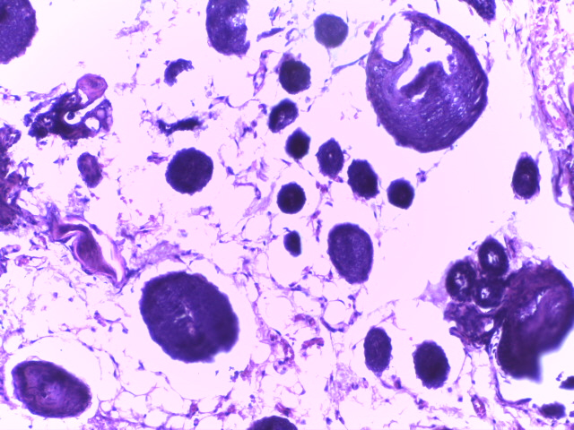 | 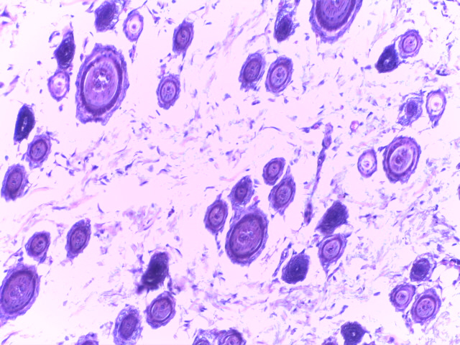
A B
Plate 1: Histo-architecture of the Breast Tissues of Control (A) and Group 2 (B) Rats.
(A) Control group showing normal tissue architecture with unremarkable breast ducts (blue) and lobules (red). (B) Group 2, showing unremarkable breast ducts (blue) and lobules (red) also implying a normal tissue architecture. H & E ×100.

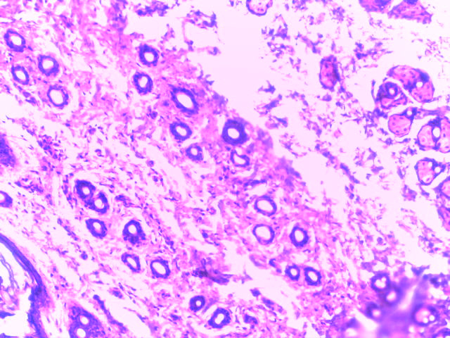
A C
Plate 2: Histo-architecture of the Breast Tissues of Control (A) and Group 3 (C) Rats.
(A) Control group showing normal tissue architecture with unremarkable breast ducts (blue) and lobules (red). (C) Group 3, showing preserved breast lobules (blue) with ducts containing pinkish luminal secretion. The stroma shows increased fibrosis (black). This is suggestive of fibrocystic changes. H & E ×100.

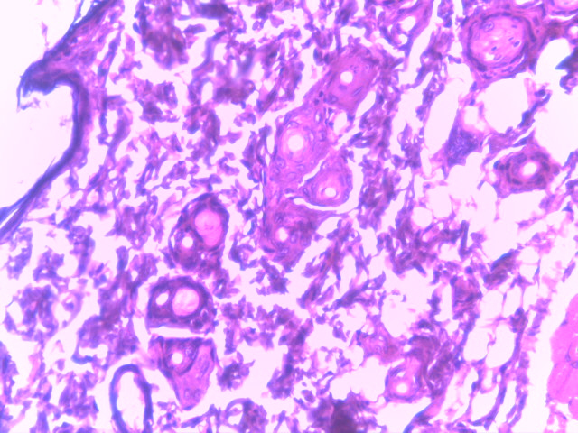
A D
Plate 3: Histo-architecture of the Breast Tissues of Control (A) and Group 4 (D) Rats.
(A) Control group showing normal tissue architecture with unremarkable breast ducts (blue) and lobules (red). (D) Group 4, showing breast ducts (blue) with pinkish luminal secretion suggestive of fibrocystic changes. H & E ×100.

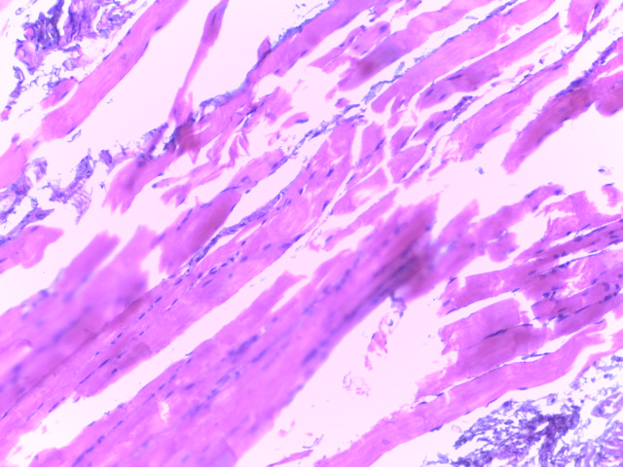
A E
Plate 4: Histo-architecture of the Breast Tissues of Control (A) and Group 5 (E) Rats.
(A) Control group showing normal tissue architecture with unremarkable breast ducts (blue) and lobules (red). (E) Group 5, showing unremarkable skeletal muscle (red) and fibrous tissue (blue)

3.2 Discussion
This study investigated the effects of chronic exposure to polyethylene terephthalate (PET) microplastics on CA 15-3 breast cancer marker, Tumour necrosis factor -α (TNF -α) and breast tissues of female albino rats.
From this study, as presented on table 3., there was no significant difference in the mean levels of breast cancer marker Ca 15-3 in rats exposed to polyethylene terephthalate (PET) microplastics and the control rats (P=0.077). The absence of a statistically significant difference in Ca 15-3 levels in this study suggests that PET microplastic exposure have no effect on this marker. Ca 15-3, a soluble fragment of Mucin 1 (MUC1), is a well-established biomarker for breast cancer and is commonly used to monitor disease progression and treatment response (Duffy et al., 2010). Alternatively, the lack of a significant difference may indicate that any potential carcinogenic effects of PET microplastics are still in the early stages, influencing underlying pathways that have not yet resulted in elevated Ca 15-3, which is primarily associated with later disease progression.
While no study has directly assessed Ca 15-3 in relation to PET microplastic exposure, previous research has demonstrated that exposure to different types of microplastics have a significant alteration/influence on breast cancer cell lines (Park et al., 2023; Schnee et al., 2024) which differs from the Ca 15-3 result from this study. Park et al., (2023), in their study found that polypropylene microplastics (PPMPs) significantly accelerated the cell cycle in breast cancer cell lines which does not directly agree with the breast cancer marker result in this study. The reason for this discrepancy may be that while we examined the effects of PET microplastics on serum marker (Ca 15-3) in this study, Park et al., (2023) examined effects of polypropylene microplastics on breast cancer cells which suggests that different types of microplastics may have varying biological effects depending on their composition, exposure route, and target system. Similarly, Schnee et al., (2024) observed absorption of microplastic particles in breast cancer cells exposed to polystyrene (PS) particles, suggesting that different plastics can differentially affect cancer cell behavior. Their study focused on cellular responses, including cancer cell absorption and accumulation of microplastics, while our study evaluated systemic biochemical changes in vivo which may also account for difference in the result between the studies.

This study also found a significant increase in the levels of inflammatory cytokines TNF-α (P<0.001) following PET microplastic exposure (table 3.). Since TNF-α are key mediators of chronic inflammation and tumorigenesis (Hanahan & Weinberg, 2011), its significant elevation suggests that PET microplastics induce a persistent inflammatory response, which is a well-recognized driver of various disease conditions and cancer development. Chronic inflammation can lead to oxidative stress, DNA damage, and immune evasion, all of which contribute to pathological conditions including carcinogenesis (Prüst et al., 2020). The activation of inflammatory pathways may result from PET microplastics triggering macrophage activation and immune cell recruitment. Studies have shown that microplastic exposure can lead to inflammatory cytokine production in various tissues, exacerbating systemic inflammation, various disease progression and increasing cancer susceptibility (Deng et al., 2017).
This study’s findings are consistent with that of Campanale et al., (2020), who reported that inhaled microplastics trigger inflammation and increase cytokine levels. Similarly, Deng et al., (2021) found that microplastic leachates upregulate pro-inflammatory pathways, leading to chronic inflammation and increased cancer risk. Moreover, Park et al. (2023) observed enhanced IL-6 secretion in breast cancer cells exposed to polypropylene microplastics, reinforcing the link between plastic exposure and inflammatory cytokine production. The increased levels of TNF-α in this study suggest that while PET microplastics may not directly elevate Ca 15-3 levels, they may promote an inflammatory microenvironment conducive to disease development including breast tissue alterations and cancer progression.
Histological results of breast tissues also support these biochemical findings. Sections of breast tissue from control (Plate 1A) rats and Group 2 rats (Plate.1B) that received very low dose PET microplastics showed unremarkable breast ducts and lobules, indicating normal tissue architecture with no significant pathological changes. However, Group 3 (Plate.2 C) and Group 4 (Plate 3 D), which were exposed to higher PET doses, exhibited notable histopathological alterations, including ducts containing pinkish luminal secretion and increased stromal fibrosis, suggestive of fibrocystic changes. Fibrocystic changes are benign but indicate chronic tissue stress, potentially linked to endocrine disruption and inflammation (Malherbe et al., 2023). Hence, these fibrocystic changes observed in this study may be because of inflammatory response triggered by PET exposure. The significant increase in TNF-α in this study aligns with the histological findings, suggesting that PET microplastics contribute to a pro-inflammatory microenvironment that may predispose breast tissue to alterations. Group 5 (Plate 4 E), which received water stored in PET bottles exposed to sunlight, showed no significant histopathological abnormalities, with unremarkable skeletal muscle and fibrous tissue. The absence of fibrocystic changes in Group 5 indicates that PET microplastics may not have leached in this case to cause a detectable change in the parameters studied as well as breast tissue histological characterization.
- CONCLUSION
The findings from this study revealed that chronic exposure to polyethylene terephthalate (PET) microplastics significantly increases the levels of TNF-α. Histological findings revealed fibrocystic breast changes in PET-exposed groups, suggesting potential long-term risks associated with PET microplastic exposure. The increased inflammatory cytokines observed in this study highlight PET microplastics as contributors to a pro-inflammatory microenvironment, which may predispose breast tissue to pathological alterations, hormone related disorders including breast cancer risks. These findings highlight the potential health risks associated with prolonged PET microplastic exposure.

Consent

It is not applicable.

Ethical approval (where ever applicable)

The National Research Council's Guide for the Care and Use of Laboratory Animals Health (National Research Council, 2011) and the ARRIVE (Animal Research: Reporting of In Vivo Experiments) guidelines (Percie du Sert, 2020) were followed in this research.

DISCLAIMER (ARTIFICIAL INTELLIGENCE)
Author(s) hereby declares that this manuscript is solely the result of author’s original research. No generative AI technologies such as large language models (ChatGPT, Copilot, etc.) and text-to-image generators have been used during writing of this manuscript.

References

Avwioro, O.G. (2014). Histochemistry& tissue pathology: principles & technique (3rd ed.). Claverianum Press Ltd, Nigeria.
Bioassay Technology Laboratory (2024). Rat Carbohydrate Antigen CA 15-3 ELISA kits (Cat. No E1139Ra) Retrieved from https://www.bt-laboratory.com/
Campanale, C., Massarelli, C., Savino, I., Locaputo, V. & Uricchio, V. F. (2020). A Detailed Review Study on Potential Effects of Microplastics and Additives of Concern on Human Health. International journal of environmental research and public health, 17(4), 1212. https://doi.org/10.3390/ijerph17041212
De Vos, L., Van de Voorde, B., Van Daele, L., Dubruel, P., & Van Vlierberghe, S. (2021). Poly (alkylene terephthalate) s: From current developments in synthetic strategies towards applications. European Polymer Journal, 161, 110840. https://doi.org/10.1016/j.eurpolymj.2021.110840
Deng, P., Tan, M., Zhou, W., Chen, C., Xi, Y., Gao, P., Ma, Q., Liang, Y., Chen, M., Tian, L., Xie, J., Liu, M., Luo, Y., Li, Y., Zhang, L., Wang, L., Zeng, Y., Pi, H., Yu, Z., & Zhou, Z. (2021). Bisphenol A promotes breast cancer cell proliferation by driving miR-381- 3p-PTTG1-dependent cell cycle progression. Chemosphere, 268, 129221. https://doi.org/10.1016/j.chemosphere.2020.129221
Deng, Y., Zhang, Y., Lemos, B., & Ren, H. (2017). Tissue accumulation of microplastics in mice and biomarker responses suggest widespread health risks of exposure. Scientific reports, 7, 46687. https://doi.org/10.1038/srep46687
Dhaka, V., Singh, S., Anil, A. G., Sunil Kumar Naik, T. S., Garg, S., Samuel, J., Kumar, M., Ramamurthy, P. C., & Singh, J. (2022). Occurrence, toxicity and remediation of polyethylene terephthalate plastics. A review. Environmental chemistry letters, 20(3), 1777–1800. https://doi.org/10.1007/s10311-021-01384-8
Duffy, M. J., Evoy, D., & McDermott, E. W. (2010). CA 15-3: uses and limitation as a biomarker for breast cancer. Clinica chimica acta; international journal of clinical chemistry, 411(23-24), 1869–1874. https://doi.org/10.1016/j.cca.2010.08.039
Elabscience Bioinovation Inc. (2024). Rat TNF-α(Tumor Necrosis Factor Alpha) ELISA Kit (E- EL-R2856) Retrieved from https://www.elabscience.com/p/rat-tnf-tumor-necrosis- factor-alpha-elisa-kit--e-el-r2856
Hanahan, D., & Weinberg, R. A. (2011). Hallmarks of cancer: the next generation. Cell, 144(5), 646–674. https://doi.org/10.1016/j.cell.2011.02.013
Kannan, K., & Vimalkumar, K. (2021). A Review of Human Exposure to Microplastics and Insights Into Microplastics as Obesogens. Frontiers in endocrinology, 12, 724989. https://doi.org/10.3389/fendo.2021.724989
Kiernan, J. A. (2001). Histological & histological methods: theory & practice. Butter-worth, oxford.
Li, T., Bian, B., Ji, R., Zhu, X., Wo, X., Song, Q., Li, Z., Wang, F., & Jia, Y. (2024). Polyethylene Terephthalate Microplastic Exposure Induced Reproductive Toxicity Through Oxidative Stress and p38 Signaling Pathway Activation in Male Mice. Toxics, 12(11), 779. https://doi.org/10.3390/toxics12110779
Li, Y., Chen, L., Zhou, N., Chen, Y., Ling, Z. & Xiang, P. (2024). Microplastics in the human body: A comprehensive review of exposure, distribution, migration mechanisms, and toxicity. The Science of the total environment, 946, 174215. https://doi.org/10.1016/j.scitotenv.2024.174215
Li, Y., Tao, L., Wang, Q., Wang, F., Li, G., & Song, M. (2023). Potential Health Impact of Microplastics: A Review of Environmental Distribution, Human Exposure, and Toxic Effects. Environment & health (Washington, D.C.), 1(4), 249–257. https://doi.org/10.1021/envhealth.3c00052
Malherbe, K., Khan, M., & Fatima, S. (2023). Fibrocystic Breast Disease. In StatPearls. StatPearls Publishing.
National Research Council. (2011). Guide for the Care and Use of Laboratory Animals: Eighth Edition. Washington, DC: The National Academies Press. https://doi.org/10.17226/12910.
Park, J. H., Hong, S., Kim, O. H., Kim, C. H., Kim, J., Kim, J. W., Hong, S., & Lee, H. J. (2023). Polypropylene microplastics promote metastatic features in human breast cancer. Scientific reports, 13(1), 6252. https://doi.org/10.1038/s41598-023-33393-8
Percie du Sert, N., Hurst, V., Ahluwalia, A., Alam, S., Avey, M. T., Baker, M., ... & Würbel, H. (2020). The ARRIVE guidelines 2.0: Updated guidelines for reporting animal research. Journal of Cerebral Blood Flow & Metabolism, 40(9), 1769-1777. https://doi.org/10.1111/bph.15193
Prata J. C. (2018). Airborne microplastics: Consequences to human health? Environmental pollution (Barking, Essex: 1987), 234, 115–126. https://doi.org/10.1016/j.envpol.2017.11.043
Priya, A. K., Jalil, A. A., Dutta, K., Rajendran, S., Vasseghian, Y., Qin, J., & Soto-Moscoso, M. (2022). Microplastics in the environment: Recent developments in characteristic, occurrence, identification and ecological risk. Chemosphere, 298, 134161. https://doi.org/10.1016/j.chemosphere.2022.134161
Prüst, M., Meijer, J., & Westerink, R. H. S. (2020). The plastic brain: neurotoxicity of micro- and nanoplastics. Particle and fibre toxicology, 17(1), 24. https://doi.org/10.1186/s12989-020-00358-y
Rahman, A., Sarkar, A., Yadav, O. P., Achari, G., & Slobodnik, J. (2021). Potential human health risks due to environmental exposure to nano- and microplastics and knowledge gaps: A scoping review. The Science of the total environment, 757, 143872. https://doi.org/10.1016/j.scitotenv.2020.143872
Rodgers, K. M., Udesky, J. O., Rudel, R. A., & Brody, J. G. (2018). Environmental chemicals and breast cancer: An updated review of epidemiological literature informed by biological mechanisms. Environmental research, 160, 152–182. https://doi.org/10.1016/j.envres.2017.08.045
Schnee, M., Sieler, M., Dörnen, J., & Dittmar, T. (2024). Effects of polystyrene nano- and microplastics on human breast epithelial cells and human breast cancer cells. Heliyon, 10(20), e38686. https://doi.org/10.1016/j.heliyon.2024.e38686
Schwabl, P., Köppel, S., Königshofer, P., Bucsics, T., Trauner, M., Reiberger, T., & Liebmann, B. (2019). Detection of Various Microplastics in Human Stool: A Prospective Case Series. Annals of internal medicine, 171(7), 453–457. https://doi.org/10.7326/M19- 0618
Schymanski, D., Goldbeck, C., Humpf, H. U., & Fürst, P. (2018). Analysis of microplastics in water by micro-Raman spectroscopy: Release of plastic particles from different packaging into mineral water. Water research, 129, 154–162. https://doi.org/10.1016/j.watres.2017.11.011
Sharma, S., Sharma, V., & Chatterjee, S. (2023). Contribution of plastic and microplastic to global climate change and their conjoining impacts on the environment - A review. The Science of the total environment, 875, 162627. https://doi.org/10.1016/j.scitotenv.2023.162627
Sun, H., Dai, J., Chen, M., Chen, Q., Xie, Q., Zhang, W., Li, G., & Yan, M. (2022). miR-139- 5p Was Identified as Biomarker of Different Molecular Subtypes of Breast Carcinoma. Frontiers in oncology, 12, 857714. https://doi.org/10.3389/fonc.2022.857714
Sung, H., Ferlay, J., Siegel, R. L., Laversanne, M., Soerjomataram, I., Jemal, A., & Bray, F. (2021). Global Cancer Statistics 2020: GLOBOCAN Estimates of Incidence and Mortality Worldwide for 36 Cancers in 185 Countries. CA: a cancer journal for clinicians, 71(3), 209–249. https://doi.org/10.3322/caac.21660
The Danish Environmental Protection Agency (Danish EPA) (2013). Phthalates Strategy. Copenhagen, Denmark: The Danish EPA. Retrieved from https://www2.mst.dk/Udgiv/publications/2013/06/978-87-93026-22-3.pdf Retrieved January, 2025.
The REACH Regulation (Regulation (EC) No 1907/2006) on Registration (2006). Evaluation and Authorisation and Restriction of Chemicals. Retrieved from https://osha.europa.eu/it/legislation/directives/regulation-ec-no-1907-2006-of-the- european-parliament-and-of-the-council
World Health Organization. (2024). Breast cancer. Retrieved from https://www.who.int/news- room/fact-sheets/detail/breast-cancer Retrieved January, 2025.
Yee, M. S., Hii, L. W., Looi, C. K., Lim, W. M., Wong, S. F., Kok, Y. Y., Tan, B. K., Wong, C. Y., & Leong, C. O. (2021). Impact of Microplastics and Nanoplastics on Human Health. Nanomaterials (Basel, Switzerland), 11(2), 496. https://doi.org/10.3390/nano11020496
Ziani, K., Ioniță-Mîndrican, C. B., Mititelu, M., Neacșu, S. M., Negrei, C., Moroșan, E., Drăgănescu, D., & Preda, O. T. (2023). Microplastics: A Real Global Threat for Environment and Food Safety: A State of the Art Review. Nutrients, 15(3), 617. https://doi.org/10.3390/nu15030617

