**Factors associated with the occurrence of pertussis in children in Guinea: a case-control study**

**abstract**

**Introduction :** In January 2023, cases of pertussis occurred in Guinea in the health districts of Lelouma and Lola. The aim of this study was to estimate the effect of potential risk factors on the occurrence of pertussis in children who had contact with a confirmed pertussis patient in Guinea during the epidemic from 1st January to 31 May 2023.

**Material and methods :** We conducted a matched case-control study using data from linear lists of children. We used conditional logistic regression to estimate the effect of our variables of interest on the occurrence of pertussis.

**Results :** We included 204 cases and 408 controls. The use of the same cup for drinking (ORa 3.22; 95% CI 2.00 - 5.18) and the promiscuity of children in the household (ORa 4.31; 95% CI 2.52 - 7.39) increased the risk of whooping cough, while full vaccination had a protective effect (ORa 0.38; 95% CI 0.21 - 0.70). There was no significant association between partial vaccination and the occurrence of pertussis.

**Conclusion :** These results underline the importance of preventive measures, such as improving hygiene practices and promoting full vaccination, in reducing the incidence of pertussis in children.

**Key words:** Pertussis ; Children ; Associated factors ; Guinea

1. INTRODUCTION

Pertussis, caused by Bordetella pertussis, is an acute respiratory infection characterised by a paroxysmal cough and high contagiousness. [1] The typical incubation period is 7 to 10 days, but it can last up to 21 days. [2] It progresses through three phases: catarrhal, paroxysmal and convalescent.[3] It is a cyclical endemic disease, with peaks of activity every 2 to 5 years. [4] Diagnosis is based on PCR tests on nasopharyngeal secretions, [5] and although antibiotics, particularly azithromycin, limit transmission, they have no significant effect on the clinical course. [6,7]

The World Health Organisation (WHO) estimates that there are between 20 and 40 million cases and around 300,000 deaths from pertussis each year, mainly in low- and middle-income countries (LMICs).[8] Resurgences have been observed in the United States, (48,000 cases in 2012), [9] in France, it remains the leading cause of bacterial mortality in infants, [10] and in Africa, the extent of the disease is increasingly serious due to persistent surveillance and vaccination challenges.[11] In Morocco, a resurgence was observed in 2012 despite vaccination coverage exceeding 95%. [12]

Previously controlled by systematic vaccination with whole-cell diphtheria-tetanus-pertussis vaccine (DTPw), pertussis has been on the rise again in recent years as a result of variations in vaccination strategies and inadequate vaccination coverage. [8,13,14]

In Guinea, cases of pertussis emerged in January 2023 in a context of low vaccination coverage, [15] drawing the attention of the national and international communities to this disease. The aim of this study was to estimate the effect of potential risk factors on the occurrence of pertussis, in particular promiscuity and the sharing of cups, which have rarely been studied, in order to guide health policy

1. MATERIAL AND METHODS
   1. Type and period of study

This was a retrospective matched case-control study of pertussis in children residing in health districts where there were cases of pertussis during the epidemic from 1st January to 31 May 2023 in Guinea.

* 1. Study framework

The Republic of Guinea is located in West Africa, between 7° and 12° north latitude and 8° and 15° west longitude. It comprises 8 administrative regions and 38 health districts.

Since 2017, the DHIS2 surveillance system has been deployed in all of Guinea's health districts. The public and private health facilities involved in surveillance have been trained and equipped to collect data in DHIS2. A network of super-users at regional (SUR) and prefectural (SUP) level was set up to monitor data collection and analyse surveillance data in the system. The data was collected on tablets using a customised form, then synchronised via an internet connection. All these activities were carried out under the leadership of the National Health Security Agency.

Our analysis focused on data from the health districts of Lelouma and Lola, following cases of whooping cough in Guinea from 1st January, date of confirmation of the first case, to 31 May 2023, date of the end of the disease.

* 1. Population
     1. Target population :

The study targeted all children resident in Guinea.

* + 1. Source population :

This study focused on children living in health districts where there had been cases of whooping cough from 1st January to 31 May 2023.

* + 1. Selection criteria :

All children who had contact with a confirmed case of pertussis in health districts where there were cases of pertussis meeting our inclusion criteria during the study period.

Inclusion criteria

We included in this study all contact children aged 0 to 15 extracted from the database according to the following criteria

* **The cases :** the case population included all contact children who developed pertussis, confirmed either by isolation of B. pertussis by culture, detection of B. pertussis DNA by polymerase chain reaction (PCR), or a direct epidemiological link with a confirmed case, associated with a suggestive clinical presentation.
* **Controls :** controls were selected from children who had been in contact with a pertussis patient, had been monitored during the quarantine period and had not developed the disease.

Non-inclusion criteria

The study did not include children whose information was incomplete or could not be used.

* 1. Data sources

For each case, we extracted socio-demographic factors, potential risk factors, clinical data, management data and outcome data from the DHIS2

For the controls, linear data on socio-demographic factors and potential risk factors for pertussis were extracted from the DHIS2 surveillance system of National Health Security Agency.

* 1. Sampling strategy

For the extraction we proceeded as follows :

* **Cases :** we carried out an exhaustive extraction of all cases. Each case was matched to two controls on the basis of sex, age (±5 years) and origin.
* **Controls :** controls were randomly selected according to the matching criteria (gender, age and origin).
  1. Definition of variables
     1. Dependent variable :

**Occurrence of pertussis** : represented the classification of the child according to whether he or she was a case (sick) or a control (not sick)

* + 1. Matching variables :

**Age** : was expressed in completed years, a matching variable relaxed to plus or minus 5 years to find children in the same locality. We used it as a potential confounding factor to better control for potential bias due to age differences between matched children.

**Gender** : represents the gender to which you belong (Female, Male)

**Provenance :** refers to the child's place of residence (Name of village)

* + 1. Variables

**Geographical health distance** : expressed the distance of the child's location from the health centre (around 10km ; between 10 and 15km, over 15km).

**Road condition** : expressed the condition of the road linking the patient's locality to the health centre. It was classified into three categories: accessible (tarmac road in good condition), degraded (road partially tarmac or in poor condition) and inaccessible (road not tarmac or severely damaged).

**Educational level of mothers of children:** represented the mother's level of education, classified into three categories based on the mothers' verbal statement:

**None:** the mother had received no formal education.

**Primary:** The mother had completed primary education.

**Secondary:** The mother had completed secondary education.

**Parents' monthly income: e**xpressing the monthly amount earned by the household, households were classified into three income categories: below 200 euros, between 200 and 300 euros, and above 300 euros. However, due to the low numbers in this last category, the two highest classes were merged into greater than or equal to 200 euros.

* + 1. Clinical data

**Case outcome:** expressed the final status of the case (alive, dead).

**Date of death:** expressed the day, month and year of the case's death.

* + 1. Potential associated factors

**Use of the same cup for drinking :** expressed the situation where people used the same container to draw water from canaries (traditional containers) for drinking during the last 21 days before being recorded as contacts (Yes, No), reported by verbal declaration of the children's parents.

**Promiscuity of children in the household**: thiswas defined as the sharing of the same living and sleeping space by more than two children in the same household, during a reference period of 21 days prior to recording as a contact. The variable was binary, indicating either the presence (Yes) or absence (No) of this situation of shared living and sleeping space among the children in the household. It was obtained by parental declaration.

**Vaccination against whooping cough:** expressed whether the child had received vaccination against whooping cough before being declared a contact. Complete vaccination against pertussis is defined in Guinea as a three-dose vaccination with a first dose at 06 weeks (1.5 months), a second dose at 10 weeks (2.5 months) and a third dose at 14 weeks (3.5 months). The variable was defined as no vaccination received (none), one or two vaccinations received (partial) or all three vaccinations received (complete). It was collected by reviewing vaccination records.

* 1. Data management and analysis
     1. Data management

The data was extracted from the DHIS2 surveillance system of the National Health Security Agency in Excel format and then analysed using R software version 4.3.1

* + 1. Managing missing data

No missing data were identified in this study.

* + 1. Data analysis

The characteristics of the population were described in the form of a table showing total data and stratified according to disease status

Quantitative variables were compared between cases and controls using the Wilcoxon signed ranks test. Qualitative variables were analysed using the McNemar test; when its conditions of application were not met, Fisher's exact test was used.

To calculate the attack rate and case-fatality rate of pertussis in the health districts of Lelouma and Lola for the population as a whole for the epidemic from 1st January to 31 May 2023 in children, we proceeded as follows:

$Attack rate=\frac{Number of cases during the same period}{Total number of children during the study period}$*100 (1)

$Lethality=\frac{Number of cases of death from the disease}{Total number of cases}$ (2)

To estimate the effect of potential risk factors for pertussis, we constructed conditional logistic regression models on three main determinants: (i) the common use of the same cup for drinking, (ii) the promiscuity of children in the household and (iii) vaccination against pertussis. Each factor was tested in a model adjusted for the socio-demographic characteristics identified as confounders. The identification of the adjustment variables was guided by the directed acyclic diagrams (DAGs) approach.

The conditional logistic model was used for the analysis because the dependent variable was binary and the data were matched. The model was implemented using the clogit function in the survival package of R software.

The model formula was as follows.

$logit\left(P\left(Yi=1|Xi\right)\right)=β0+ β1Xi1+…+ βnXin$ (3)

*Yi* was the dependent variable (occurrence of pertussis disease)

*Xi*1: was the independent variable

*Xin*: were the potential confounding factors

Interpretation of coefficients

1. **For a binary explanatory variable (Xp):**

* The coefficient βp gave the log odds ratio (OR). The estimator exp(βp) was used to compare individuals who had characteristic Xp with those who did not. An OR greater than 1 indicated a risk, while an OR less than 1 indicated a protective effect.
* The intercept β0 represented the log odds of the event studied when all explanatory variables were equal to zero.

1. **For a quantitative variable (Xp) :**

* The coefficient βp gave the log odds ratio for a one-unit increase in Xp.
* The estimator exp(βp) showed the increase or decrease in risk associated with an additional unit of Xp.

1. **For a factorial variable with more than two modalities:**

* The coefficients of the indicator variables showed the effect of each modality relative to the reference category. The estimator exp(*βni*) was the odds ratio for modality i compared to the reference category.

**Note:** If the other explanatory variables ... *Xin* were non-zero, they would add their respective contributions to the log-score of the occurrence of the event.

In all analyses, we used an alpha risk (or risk of the first kind) of 0.05

1. RESULTS

From 1st January to 31 May 2023, 1,327 contact children were recorded, from which we extracted all 204 cases to which we matched 408 randomly selected controls (two controls for one case) (***Figure 1*)**.

Children without contact

**187807**

Non-sick children not selected

**715**

**Source population**

189134

**Children contacts**

1327

**No Sick**

**408**

**Sick**

**204**

**Figure 1:** Flow chart of children in health districts with pertussis in Guinea from 1st January to 31 May 2023

In our population, we observed an attack rate of 0.11 cases per 100 children, and a case-fatality rate of 0.98 deaths per 100 cases

Among the 612 participants, 265 children used the same cup for drinking, 232 children lived in crowded conditions in the household, 336 children had not received any vaccination, 90 children had received partial vaccination and 186 children had received full vaccination (***Table 1*).**

**Table 1.** Comparison of the characteristics of children according to the occurrence of pertussis in Guinea from 1st January to 31 May 2023.

| **Features** | **Total, N=612**  n (%) | **Sick**, N = 204  n (%) | **Not ill**, N = 408  n (%) | | **p-value**2 |
| --- | --- | --- | --- | --- | --- |
| Age (Year) 1 |  | 4.0 (2.0, 7.0) | 4.0 (3.0, 8.0) | | <0.001 |
| Health district |  |  |  | | >0.9 |
| Lelouma | 420 (69%) | 140 (69%) | 280 (69%) | |  |
| Lola | 192 (31%) | 64 (31%) | 128 (31%) | |  |
| Geographical health distance |  |  |  | | >0.9 |
| More than 15km | 246 (40%) | 82 (40%) | 164 (40%) | |  |
| Around 10km | 186 (30%) | 62 (30%) | 124 (30%) | |  |
| Between 10 and 15km | 180 (30%) | 60 (29%) | 120 (29%) | |  |
| Road conditions |  |  |  | | >0.9 |
| Accessible | 114 (18%) | 38 (19%) | 76 (19%) | |  |
| Gradient | 225 (37%) | 75 (37%) | 150 (37%) | |  |
| Inaccessible | 273 (45%) | 91 (45%) | 182 (45%) | |  |
| Mothers' level of education |  |  |  | | <0.001 |
| No | 243 (40%) | 119 (58%) | 124 (30%) | |  |
| Primary | 203 (33%) | 50 (25%) | 153 (38%) | |  |
| Secondary | 166 (27%) | 35 (17%) | 131 (32%) | |  |
| Parents' monthly income |  |  |  | | <0.001 |
| Between 200 euros and more | 354 (58%) | 66 (32%) | 288 (71%) | |  |
| Less than 200 euros | 258 (42%) | 138 (68%) | 120 (29%) | |  |
| Promiscuity of children in the household |  |  |  | | <0.001 |
| No | 380 (62%) | 80 (39%) | 300 (74%) | |  |
| Yes | 232 (38%) | 124 (61%) | 108 (26%) | |  |
| Use of the same cup for drinks |  |  |  | | <0.001 |
| No | 347 (57%) | 68 (33%) | 279 (68%) | |  |
| Yes | 265 (43%) | 136 (67%) | 129 (32%) | |  |
| Whooping cough vaccination |  |  |  | | <0.001 |
| No | 336 (55%) | 128 (63%) | 208 (51%) | |  |
| Partial | 90 (15%) | 46 (23%) | 44 (11%) | |  |
| Complete | 186 (30%) | 30 (15%) | 156 (38%) | |  |
| **1Median (IQR)** | | | | |
| **2Wilcoxon signed rank test; McNemar test; Fisher's exact test** | | | | |

We adjusted the model by identifying potential confounding factors, including age, mothers' level of education and parents' monthly income (***Figure 2)***.

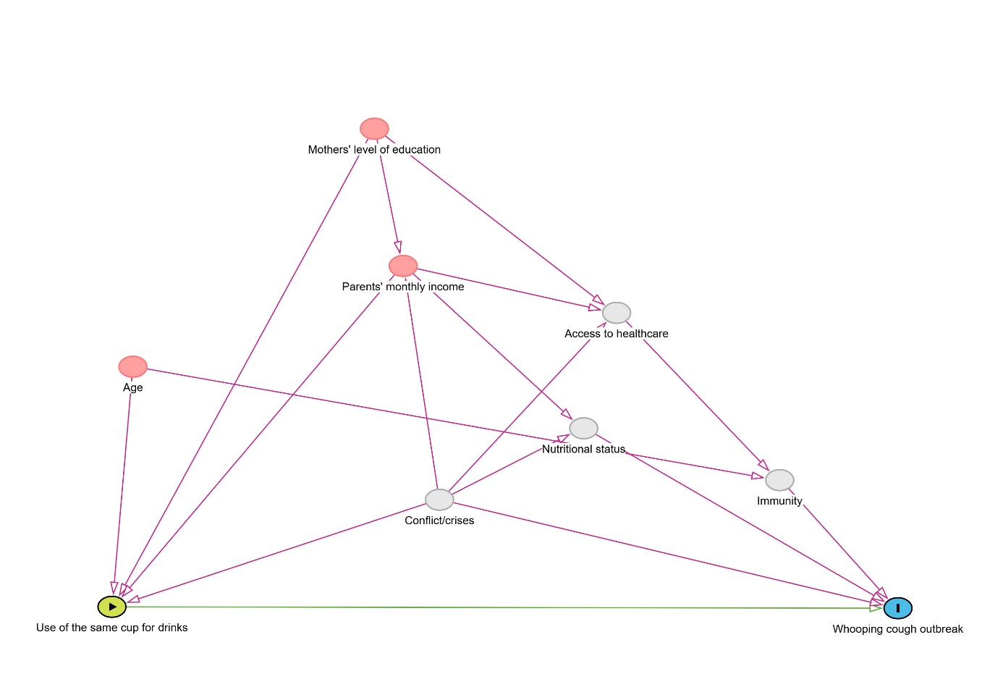

**Figure 2**: DAG to identify confounding factors between the onset of whooping cough and the use of the same drinking cup among children in Guinea from 1st January to 31 May 2023.

The use of the same cup for drinking remained significantly associated with the occurrence of pertussis, with an adjusted Odds Ratio (ORa) of 3.22 (95% CI: 2.00-5.18, p < 0.001) (***Table 2***).

***Table 2*.** Adjusted model for estimating the effect of using the same cup for drinking on the occurrence of pertussis in children in Guinea from 1st January to 31 May 2023

| **Features** | **ORa**1 | **95% CI**1 | **p-value** |
| --- | --- | --- | --- |
| Use of the same cup for drinks |  |  | <0.001 |
| No | - | - |  |
| Yes | 3.22 | 2.00, 5.18 |  |
| Parents' monthly income |  |  | <0.001 |
| Between 200 euros and more | - | - |  |
| Less than 200 euros | 3.95 | 2.32, 6.73 |  |
| Mothers' level of education |  |  | 0.4 |
| No | - | - |  |
| Primary | 0.89 | 0.50, 1.60 |  |
| Secondary | 0.65 | 0.34, 1.22 |  |
| Age | 0.42 | 0.33, 0.53 | <0.001 |
| 1ORa = Adjusted Odds Ratio, CI = Confidence Interval | | | |

After controlling for parents' monthly income, mothers' level of education and age (***Figure 3***),

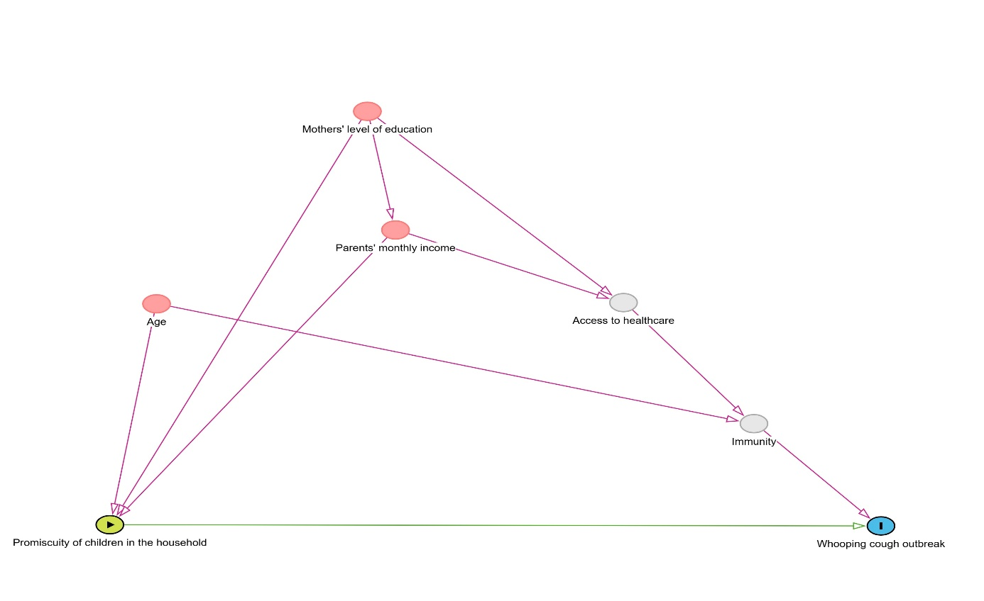

**Figure 3:** DAG for identifying potential confounding factors between the occurrence of whooping cough and the Promiscuity of children in the household in Guinea from 1st January to 31 May 2023

The promiscuity of children in the household remained significantly associated with the occurrence of pertussis, with an adjusted odds ratio (ORa) of 4.31 (95% CI: 2.52-7.39, p < 0.001) (***Table 3***).

**Table 3.** Adjusted model for estimating the effect of promiscuity of children in the household on the occurrence of pertussis in children in Guinea from 1st January to 31 May 2023.

| **Features** | **ORa**1 | **95% CI**1 | **p-value** |
| --- | --- | --- | --- |
| Promiscuity of children in the household |  |  | <0.001 |
| No | - | - |  |
| Yes | 4.31 | 2.52, 7.39 |  |
| Parents' monthly income |  |  | <0.001 |
| Between 200 euros and more | - | - |  |
| Less than 200 euros | 3.55 | 2.11, 5.97 |  |
| Mothers' level of education |  |  | 0.12 |
| No | - | - |  |
| Primary | 0.67 | 0.37, 1.20 |  |
| Secondary | 0.52 | 0.28, 0.99 |  |
| Age | 0.42 | 0.33, 0.53 | <0.001 |
| 1ORa = Adjusted Odds Ratio, CI = Confidence Interval | | | |

After adjustment (***Figure 4***),

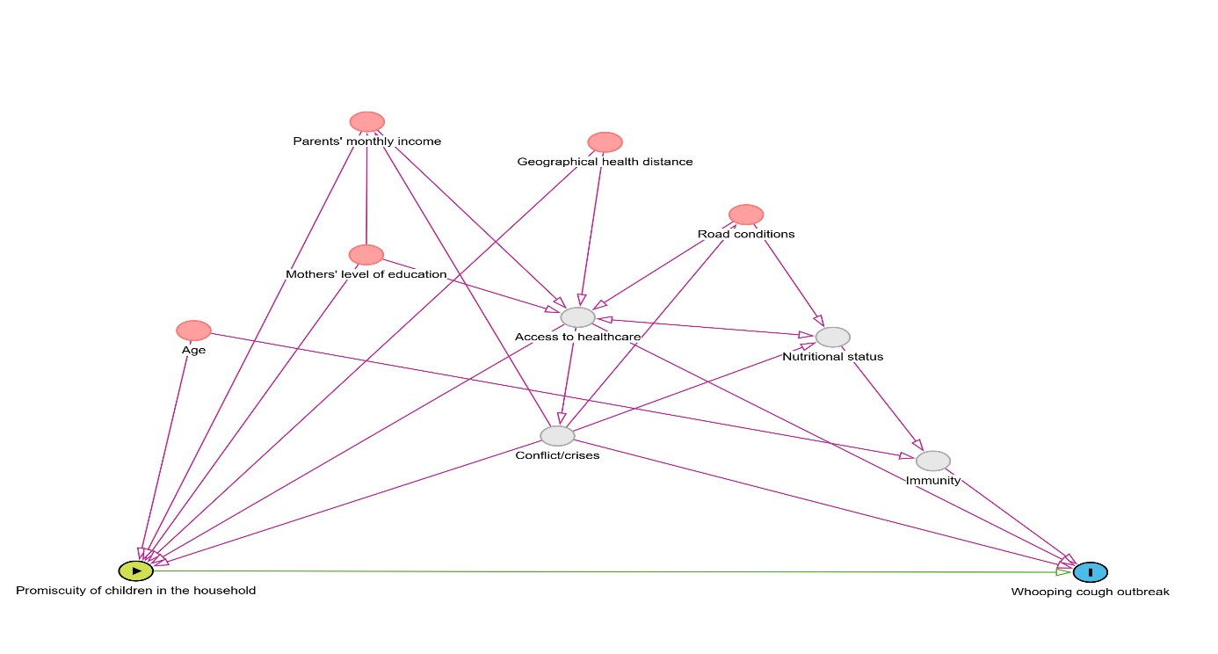

**Figure 4:** DAG for identifying potential confounding factors between the occurrence of pertussis and vaccination against pertussis in children in Guinea from 1st January to 31 May 2023.

Vaccination remained significantly associated with the occurrence of pertussis (p < 0.001); partial vaccination against pertussis showed no statistically significant association with the risk of disease occurrence compared with no vaccination (adjusted OR = 1.69, 95% CI: 0.84-3.40), while full vaccination remained significantly associated with a reduced risk of pertussis compared with no vaccination (adjusted OR = 0.38, 95% CI: 0.21-0.70). (***Table 4***)

**Table 4.** Adjusted model for estimating the effect of vaccination on the occurrence of pertussis in children in Guinea from 1st January to 31 May 2023.

| **Features** | **ORa**1 | **95% CI**1 | **p-value** |
| --- | --- | --- | --- |
| Whooping cough vaccination |  |  | <0.001 |
| No | - | - |  |
| Partial | 1.69 | 0.84, 3.40 |  |
| Complete | 0.38 | 0.21, 0.70 |  |
| Mothers' level of education |  |  | 0.4 |
| No | - | - |  |
| Primary | 0.75 | 0.42, 1.34 |  |
| Secondary | 0.64 | 0.34, 1.22 |  |
| Age | 0.41 | 0.32, 0.51 | <0.001 |
| Parents' monthly income |  |  | <0.001 |
| Between 200 euros and more | - | - |  |
| Less than 200 euros | 3.96 | 2.34, 6.71 |  |
| 1ORa = Adjusted Odds Ratio, CI = Confidence Interval | | | |

1. DISCUSSION

Since the middle of the 20th century, the development of analytical studies using the individual as the unit of analysis has made it possible to identify individual risk factors and has led to the initiation of preventive measures. [16] In this case-control study conducted from 1 January to 31 May 2023 in Guinea, we observed that certain factors were associated with an increased risk of whooping cough among children who had had contact with a confirmed case. The results show that the use of the same cup for drinking and the promiscuity of children in the household were important risk factors for the occurrence of pertussis. These results are consistent with those reported in several other studies, although some of the factors identified have not been widely studied in the literature.

Using the same cup for drinking increased the risk of contracting pertussis, with an adjusted Odds Ratio of 3.22 (95% CI: 2.00-5.18). Although this practice is common in many households, it may facilitate the occurrence of pertussis through saliva left on the cups, a transmission factor that is often underestimated. To our knowledge, no study to date has established such a specific association, which makes our finding particularly relevant to understanding the dynamics of pertussis occurrence in households.

The promiscuity of children in the household was also associated with the risk of whooping cough. The adjusted OR of 4.31 (95% CI: 2.52-7.39) indicates that children living in conditions of high promiscuity have a greater risk of being exposed to pertussis. This result reflects the socio-cultural situation in Guinea, where several children often share the same living and sleeping areas. These conditions encourage the spread of respiratory diseases, particularly airborne diseases such as whooping cough.

Age had been used as a matching variable but, because of the relaxed matching to plus or minus 5 years to find children in the same locality, we had also considered it as a potential confounding factor. According to our results, its effect was associated with a significant reduction in the risk of whooping cough. Our results corroborate with a study conducted in the paediatrics department of Beijing's Ditan Hospital, which showed that younger children were at greater risk of developing pertussis. [17] This association in our study could be explained by several factors. Firstly, older children were more likely to have completed their immunisation schedule, thereby increasing their protection against the disease. Secondly, they may have been exposed to previous infections that would have induced partial natural immunity. In addition, because of their lifestyle and dependence on adult care, younger children are often in close contact with potential sources of infection, particularly within the household.

Our results suggest that full vaccination against pertussis was associated with a significant reduction in the risk of contracting pertussis, with an adjusted OR of 0.38 (95% CI: 0.21 - 0.70). Kalthan and his allies also made the same finding, showing that full vaccination exerted a significant protective effect, with an odds ratio of 0.3 (95% CI: 0.2 - 0.6). [18] This suggests that full vaccination is necessary to ensure optimal protection against pertussis. This association of complete vaccination in our study could be explained by the fact that complete vaccination generally succeeds in inducing sterilising immunity against the pathogen; this immunity reduces the infectious load in the population and thus limits transmission of the disease. [19] This result highlights the need to step up vaccination campaigns in order to achieve higher rates of complete vaccination coverage. However, partial vaccination did not show a significant association with a reduced risk of whooping cough. This result differs from that of a previous study conducted in South Africa, which reported that children vaccinated at least once (5%, 32/692) were less likely to contract pertussis than unvaccinated children (10%, 24/230) (p = 0.0001)[20]. It is crucial to consider other contextual and research factors when interpreting this result with caution. Variations in vaccination regimens, time between doses, and individual immune responses may influence the perceived efficacy of partial vaccination. It is also possible that the protection offered by partial vaccination may not be sufficient to prevent infection in certain contexts, which could create a false sense of security and encourage risky behaviour. It is therefore important to continue research to better understand the conditions in which partial vaccination could be beneficial, while stepping up efforts to achieve full vaccination rates.

The attack rate reported in our study was 0.11%, whereas Mitiku AD and allies reported a rate of 0.02%, [21] and Kalthan and allies found an attack rate of 0.3%.[18] This high rate in our study could be attributed, on the one hand, to low vaccination coverage in the country due to malfunctions in the Expanded Programme on Immunisation (EPI), and on the other hand, to resource limitations in a precarious socio-economic context such as poverty and lack of hygiene.

The case-fatality rate observed in our study was 0.98%, which is lower than that reported by Mitiku AD et al, who showed a case-fatality rate of 3.3% ; [21]  and that reported by Shi et al, who reported a case-fatality rate of 9%. [22] This low case fatality in our study may be explained by the fact that our study focused on a population of children who had direct contact with confirmed cases of pertussis; targeted exposure to the disease in a closely monitored group may have allowed early detection and prompt management, thereby reducing the risk of death. As several previous studies have emphasised, early detection and prompt treatment play a decisive role in controlling epidemics. [23]

However, our study has some limitations. Firstly, the age matching of children, although essential, may have introduced confounding bias. Furthermore, as the study was limited to specific districts of Guinea, extrapolation of our results to the Guinean population as a whole requires caution. It is possible that other unmeasured factors, such as hygiene behaviour, population density or variations in the quality of healthcare, may have influenced the results.

1. CONCLUSION

This study showed a significant association between the use of the same drinking cup, the promiscuity of children in the household, and the occurrence of pertussis. Our results suggest that these factors increase the risk of contracting the disease, while full vaccination appears to significantly reduce this risk. Although the attack rate is high, the observed case-fatality rate remains low, underlining the importance of prompt management.

These results underline the need to step up efforts to improve vaccination coverage, ensuring that all children receive the necessary doses to ensure complete protection. In addition, targeted awareness campaigns are essential to encourage stricter hygiene practices, in particular by reducing behaviour conducive to transmission, such as sharing drinking cups.

Finally, further studies, including other confounding factors potentially not observed in our study, are needed to confirm these associations and deepen our understanding of the effects of partial vaccination.

### CONSENT

It is not applicable.

ADMINISTRATIVE PROCEDURES

A request for authorisation to use case and control data in the DHIS2 was submitted to the management of the National Health Security Agency for approval, and authorisation was obtained. The work was carried out on an unrestricted database.

**ETHICAL APPROVAL**

The study protocol was approved by the approval committee of the Faculty of Health Sciences and Techniques at the Gamal Abdel Nasser University in Conakry.

Children's anonymity and confidentiality were respected.

**DISCLAIMER (ARTIFICIAL INTELLIGENCE)**

Generative AI technologies such as large language models (ChatGPT, COPILOT, etc.) and text-image generators were not used in the writing of this manuscript.

**REFERENCES**

1. Liu C, Yang L, Cheng Y, Xu H, Xu F. Risk factors associated with death in infants <120 days old with severe pertussis: a case-control study. BMC Infect Dis. 16 Nov 2020;20[1]:852.

2. Daniels HL, Sabella C. Bordetella pertussis (Pertussis). Pediatrics In Review. May 1, 2018;39[5]:247-57.

3. Semeeh O, Getachew B, Taofik Y, Surajudeen L, Hassan A, Nagudale B. An epidemiological investigation of the 2019 suspected pertussis outbreak in northwestern Nigeria. SAGE Open Med. 2021;9:20503121211008344.

4. Baron S, Haeghebaert S, Lévy-Bruhl D, Laurent E, Guiso N. Epidemiology of pertussis in France. Médecine et Maladies Infectieuses. 1 March 2001;31:12-9.

5. Rodgers L, Martin SW, Cohn A, Budd J, Marcon M, Terranella A, et al. Epidemiologic and Laboratory Features of a Large Outbreak of Pertussis-Like Illnesses Associated With Cocirculating Bordetella holmesii and Bordetella pertussis-Ohio, 2010-2011. Clinical Infectious Diseases. 1 Feb 2013;56[3]:322-31.

6. Wood N, McIntyre P. Pertussis: review of epidemiology, diagnosis, management and prevention. Paediatr Respir Rev. Sept 2008;9[3]:201-11; quiz 211-2.

7. Kline JM, Smith EA, Zavala A. Pertussis: Common Questions and Answers. Am Fam Physician. 1 August 2021;104[2]:186-92.

8. Macina D, Evans KE. Bordetella pertussis in School-Age Children, Adolescents, and Adults: A Systematic Review of Epidemiology, Burden, and Mortality in Africa. Infect Dis Ther. Sept 2021;10[3]:1097-113.

9. Skoff TH, Blain AE, Watt J, Scherzinger K, McMahon M, Zansky SM, et al. Impact of the US Maternal Tetanus, Diphtheria, and Acellular Pertussis Vaccination Program on Preventing Pertussis in Infants <2 Months of Age: A Case-Control Evaluation. Clin Infect Dis. 29 Nov 2017;65[12]:1977-83.

10. Nagalo K. Newborn whooping cough in Africa. Archives of Pediatrics. 1 Jul 2009;16[7]:1028-32.

11. Yeshanew AG, Lankir D, Wondimu J, Solomon S. Pertussis outbreak investigation in Northwest Ethiopia: A community based study. PLoS One. 2022;17[2]:e0263708.

12. Slaoui B, Saidi H, Kamal M, Kafty K, Nourlil J, Diawara I, et al. Epidemiological profile of infant pertussis in Casablanca from 2012 to 2019. The Pan African Medical Journal [Internet]. 29 Dec 2023 [cited 7 Feb 2025];46[124]. Available from: https://www.panafrican-med-journal.com//content/article/46/124/full

13. Zouari A, Smaoui H, Brun D, Njamkepo E, Sghaier S, Zouari E, et al. Prevalence of Bordetella pertussis and Bordetella parapertussis infections in Tunisian hospitalized infants: results of a 4-year prospective study. Diagn Microbiol Infect Dis. Apr 2012;72[4]:303-17.

14. Katfy K, Guiso N, Diawara I, Zerouali K, Slaoui B, Jouhadi Z, et al. Epidemiology of pertussis in Casablanca (Morocco): contribution of conventional and molecular diagnostic tools. BMC Infect Dis. 16 May 2017;17[1]:348.

15. National Statistics Institute. Demographic and Health Survey. Guinea, Conakry: Ministry of Planning and Economic Development; 2018 pp. 181–221. Report No.: EDS V.

16. Bizouarn P. Eco-epidemiology - Towards an epidemiology of complexity. Med Sci (Paris). 1 May 2016;32[5]:500-5.

17. Wang C, Zhang H, Zhang Y, Xu L, Miao M, Yang H, et al. Analysis of clinical characteristics of severe pertussis in infants and children: a retrospective study. BMC Pediatrics. 5 Feb 2021;21[1]:65.

18. Kalthan E, Lakei-Abdon C, Wol-Wol P, Pamatika CM, Belizaire MR. Case study of a 2022 pertussis epidemic in the Baoro sub-prefecture (Central African Republic). Infect Dis Now. 30 August 2023;104778.

19. Althouse BM, Scarpino SV. Asymptomatic transmission and the resurgence of Bordetella pertussis. BMC Medicine. 24 June 2015;13[1]:146.

20. du Plessis NM, Ntshoe G, Reubenson G, Kularatne R, Blumberg L, Thomas J, et al. Risk factors for pertussis among hospitalized children in a high HIV prevalence setting, South Africa. Int J Infect Dis. March 2018;68:54-60.

21. Mitiku AD, Argaw MD, Desta BF, Tsegaye ZT, Atsa AA, Tefera BB, et al. Pertussis outbreak in southern Ethiopia: challenges of detection, management, and response. BMC Public Health. 11 August 2020;20[1]:1223.

22. Shi T, Wang L, Du S, Fan H, Yu M, Ding T, et al. Mortality risk factors among hospitalized children with severe pertussis. BMC Infectious Diseases. 12 Oct 2021;21[1]:1057.

23. Cohen S, Black A, Ross A, Mandel ED. Updated treatment and prevention guidelines for pertussis. JAAPA. Jan 2014;27[1]:19.