Original Research Article
Floristic inventory of Meghalithic Site Hirebenkal, Koppal District, Karnataka.

.
ABSTRACT

An intensive field surveys has been carried out in megalithic sites of Koppal district from 2020 to 2023 and collected total 122 plant species belongs to 107 genera 45 family plant species. Dominant families are Fabaceae with 18 species (16.21%) followed by Apocynaceae 10 (9%) & Amaranthaceae 9 (8.1%) followed by Malvaceae with 7 species (6.3%) and Asteraceae 5 (4.5%). Among habit herb stands first with 63 species (56.75%) followed by shrub 43 (38.73%), tree 10 (9%), and climber 5 (4.5%). Perennials are more with 91 species (81.98%) than Annual were 29 (26.12%). Meghalithic site, Hirebenkal located near to Hampi, is the ‘vally of Dead’, “Mouryara gudda”, one of the seven wonder of Karnataka & selected for obtaining UNESCO World Heritage status from India for 2025. A hill is the ‘treasure of medicinal plants’ is under threat by anthropogenic activities, hence there is a urge to protect and conserve highly medicinal plant species of the site hence the current study.

Keywords: Wonder of Karnataka, Medicinal plants, Meghalithic dolmens, Conservation, IUCN status.

1. INTRODUCTION

Biodiversity is the foundation of life on Earth and global ecosystems can become unstable if biodiversity is destroyed (Baert et al., 2018; Nicholson et al., 2021). The Conference of the Parties to the Convention on Biological Diversity (CBD) in 2002, adopted, through Decision VI/9, the Global Strategy for Plant Conservation (GSPC), adopted the voluntary complementary actions related to plant conservation. Since the onset of the 21st century, the effects of climate change mainly driven by human activities on biodiversity loss have significantly increased (Wu et al., 2020). Climate change will certainly cause a loss of biodiversity (Girardin et al., 2021; Kariuki et al., 2022; Shin et al., 2022). Habitat encroachment and fragmentation are primarily driven by human activities such as agriculture expansion, urbanization, logging, and infrastructure development. These actions replace, divide, and degrade natural habitats, leading to a significant decrease in available living space for various species (Prudhomme et al., 2020).
An astonishing site on the banks of River Tungabhadra is covered with thorny bushes, slippery boulders, and uneven trails. It covers village, viz., Hirebenkal, Chikbenkal the site contains around 400 funerary monuments. In the area around the large town site of Kadebakele, more than sixty hectares in extent overall, associated with the Iron Age & Early Historic include a wide range of megaliths or mortuary monuments that vary greatly in scale, form, and placement. In this paper we enumerate the floristic data of megalithic sites of Koppal district. which can gives a elides importance for plants diversity conservation along with historical sites. The present study area comprises Dry deciduous scrub & thorny forest according to classification given by Champion HG, Seth SK 1966)

2. material and methods

Study area:
The South Indian Iron Age- megalithic period sites dates back to 800 BCE to 200 BCE, one among seven wonders of Karnataka, Hirebenakal Dolmens, “Moryar Gudda” is situated in the Koppal district of Kalyana Karnataka region in Karnataka, the largest necropolis among 2000-old megalithic sites present in South India, various different structures of prehistoric manmade megalithic funerary monuments carved in stone can be observed here Kathleen D. Morrison et al. (2016) (Fig. 1).
Survey, Collection, and Identification:
Field surveys were carried out during 2020 to 2023 to study the floristic diversity of the megalithic site. Twigs with inflorescence were collected, pressed, dried and poisoned with 0.2 % Mercuric Chloride solution, herbarium was prepared by following the standard herbarium method suggested by Jain, S.K. and R. R. Rao (1977). Plant species were identified using Flora of Madras by Gamble (1918-35), flora of Eastern Karnataka by Singh, N.P. and Roa, M.A. (1988), flora of Hassan district by Saldanha, C.J. Nicolson, D.H. (1976), flora of Karnataka by Saldanha CJ. (1984-1996). and plants names are checked for their synonyms IPNI & POWO.
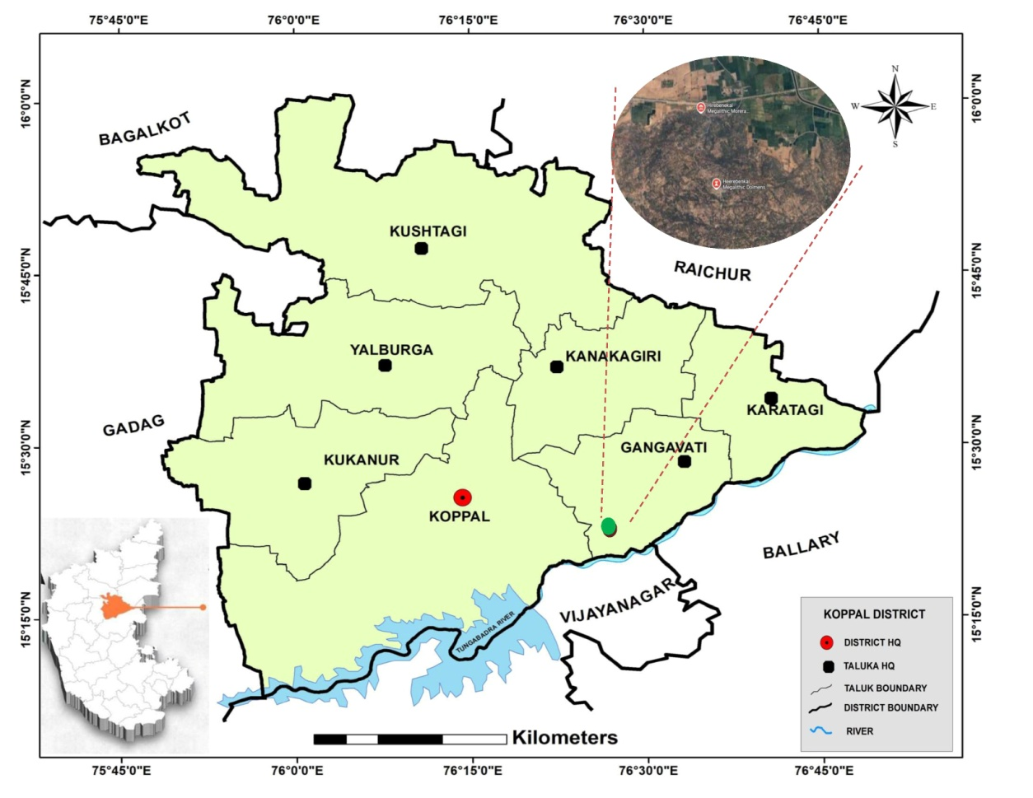
Figure 1. A. Map of Megalithic site, Hirebenakal, Koppal
3. Result and discussion:
The megalithic region comprising predominantly thorny and hardwood species. The comprehensive and unified account on vegetation of this region includes documentation total 122 plant species belongs to 107 genera 45 family of plant species.
Among the collected plant species dominant are Fabaceae with 18 species (16.21%) followed by Apocynaceae 10 (9%) & Amaranthaceae 9 (8.1%) followed by Malvaceae with 7 species (6.3%) and Asteraceae 5 (4.5%) (Fig. 2). Among habit herb stands first with 63 species (56.75%) followed by shrub 43 (38.73%), tree 10 (9%), and climber 5 (4.5%) (Fig. 3). Perennials are more with 91 species (81.98%) than Annual 29 ( 26.12%) (Fig. 4).
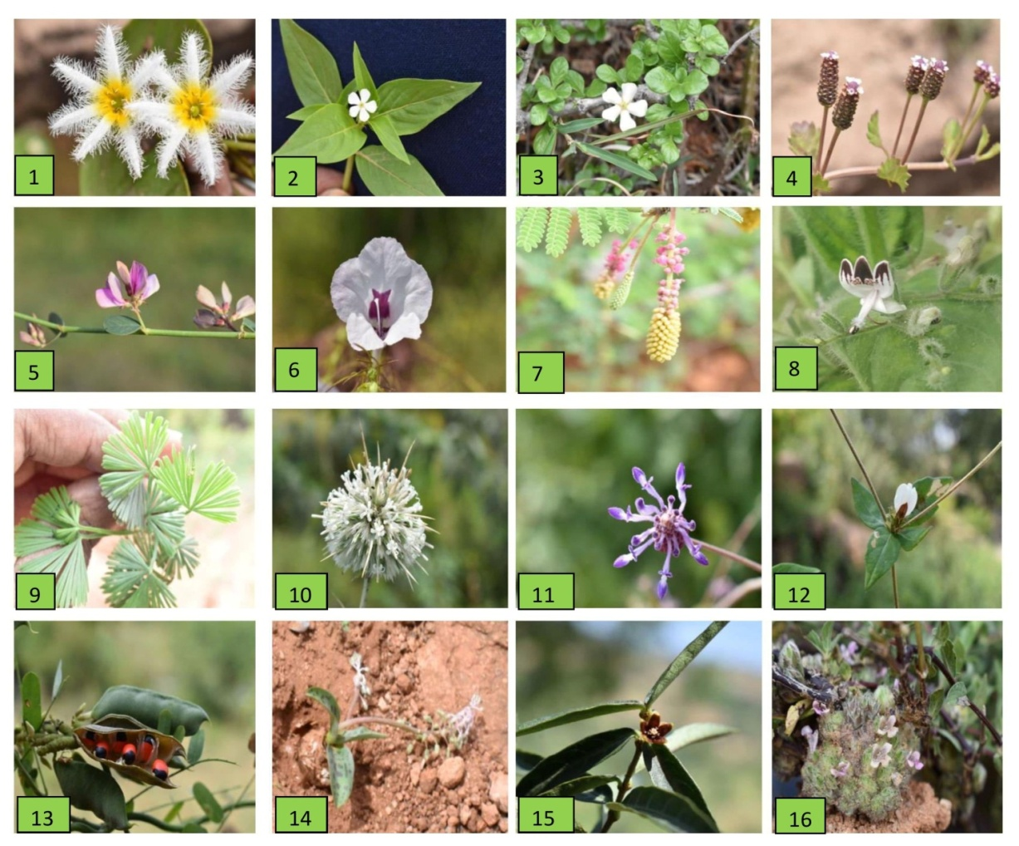
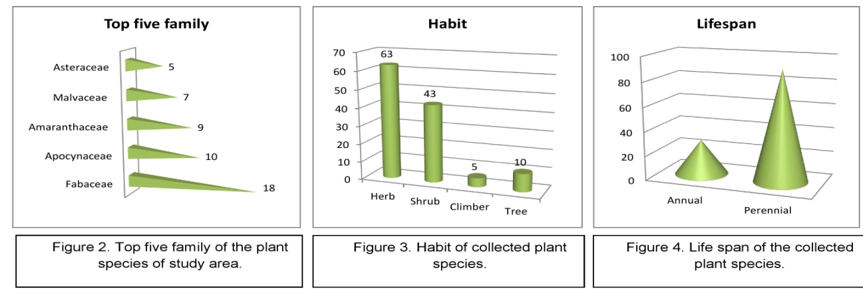
Pteridophytes like Selaginella bryopteris (L.) Baker. A treasure of medicinal properties is present abundantly in the area. Actiniopteris radiata usually found under stone crevices, aquatic plants like Nymphoides indica (L.) Kuntze., Pistia stratiotis L., and Typha domingensis pers. were abundant in pond near large number of stone buildings at the peak of Morera gudda, which are creating botanical interest about this sites (Fig. 5).
1. Nymphoides indica (L.) Kuntze 2. Catharanthus pusillus (Murray) G.Don
3. Catunaregum spinosa (Thunb.) Tirveng. 4. Phyla nodiflora (L.) Greene
5. Taverniera cuneifolia (Roth) Arn. 6. Parasopubia delphiniifolia (L.)
7. Dichrostachys cinerea (L.) Wight & Arn. 8. Andrographis echioides (L.) Nees
9. Actiniopteris radiate (Sw.) Link. 10. Echinops echinatus Roxb.
11. Anisochilous carnosus (L.f.) Wall. ex Benth. 12. Blepharis maderaspatensis (L.) B.Heyne ex Roth 13. Abrus precatorius L. 14. Ledebouria revulata (L. f.) Jassop.
15. Hemidesmus indica R.Br. 16. Lepidogathis cristata Willd.

Figure. 5. Glimps of floristic diversity of Megalithic sites, Koppal District, Karnataka.

Table 1. Enumeration of Flora of Megalithic sites, Koppal District, Karnataka.
SL. No. | Scientific name | Family | IUCN  status | Habit | Life  span | Uses
1 | Abrus precatorius L. | Fabaceae | LC | S | p | Treats digestive disorders, jewellery making
2 | Achyranthes aspera L. | Amaranthaceae | NA | H | P | Anti- inflammatory, anti-oxidant, wound healing
3 | Aerva javanica Juss. | Amaranthaceae | NA | H | P | Anti- inflammatory, fodder, ornamental
4 | Aeschynomene indica L. | Fabaceae | LC | H | P | Phyto-remediation, green manure
5 | Albizia amara (Roxb.) B. Boivin | Fabaceae | NA | T | P | Anti -inflammatory, fodder, wood , gum
6 | Alternanthera sessilis (L.) DC. | Amaranthaceae | LC | H | P | Anti -inflammatory, anti- microbial, anti-diabitic
7 | Alternanthera pungens Kunth | Amaranthaceae | LC | H | P | To treat flatulence, nausea, vomiting, cough,
8 | Alysicarpus monilifer (L.) DC. | Fabaceae | LC | H | P | Forage and fodder, Cover crop, manure
9 | Alysicarpus vaginalis (L.) DC. | Fabaceae | NA | H | P | Forage and fodder, green manure
10 | Amaranthus caudatus L. | Amaranthaceae | NA | H | A | Leaves edible, anti-microbial
11 | Amaranthus viridis L. | Amaranthaceae | NA | H | A | Wound healing
12 | Andrographis echioides (L.) Nees | Acanthaceae | NA | H | P | Anti -inflammatory, anti- microbial, anti-pyretic
13 | Anisochilous carnosus (L.f.) Wall. | Lamiaceae | NA | H | A | Skin diseases, Gastric ulcers, Stomach ache
14 | Antigonon leptopus Hook. & Arn. | Polygonaceae | NA | C | P | Ornamental, crafts and decorations
15 | Aristolochia bracteolata Lam. | Aristolochiaceae | NA | H | P | Anthelminitic, anti-pyretic, laxative, antidote
16 | Aristolochia indica L. | Aristolochiaceae | NA | H | P | Anti-microbial, anti-inflammatory
17 | Asparagus officinalis L. | Asparagaceae | DD | H | P | Culinary uses, medicinal and ornamental
18 | Azima tetracantha Lam. | Salvadoraceae | LC | S | P | Rhueutism arthritis, oral health, insect repellent
19 | Barleria prionitis L. | Acanthaceae | NA | H | P | Anti- inflammatory, anti-oxidant, wound healing
20 | Bauhinia racemosa Lam. | Fabaceae | LC | S | P | Fodder, manure, used in bidi making
21 | Bidens frondosa L. | Asteraceae | LC | H | P | Ornamental, anti-inflammatory
22 | Blepharis maderaspatensis (L.) B.Heyne ex Roth | Acanthaceae | NA | H | P | Anti- inflammatory, anti-oxidant, wound healing
23 | Cadaba fruticosa (L.) Druce | Capparaceae | NA | S | A | Treats fever, asthma leaves edible, natural dye
24 | Calotropis gigantea (L.) Dryand | Apocynaceae | NA | S | P | Treats elephantiasis, toothache, tumor
25 | Calotropis procera (L.) W.T.Aiton | Apocynaceae | NA | S | P | Antidote for snake bite
26 | Canavalia rosea (Sw.)DC. | Fabaceae | LC | H | A | Ornamental, fixes nitrogen, seeds are edible
27 | Canthium coromandelicum (Burm.f.) Alston | Rubiaceae | NA | S | P | Treats fever, dysentery, diarrhea, respiratory disorders, wood
28 | Capparis spinosa Linnaeus | Capparaceae | NA | S | P | Buds used as spice, extracts used in skin care
29 | Capparis divaricata Lam. | Capparaceae | NA | S | P | Flower buds used as spices, medicinal
30 | Cardiospermum halicacabum L. | Sapindaceae | LC | H | P | Treats skin conditions, insect bites
31 | Carissa caranda L. | Apocynaceae | LC | S | A | Ornamental plant, treats diarrhea, hedge plant
32 | Carissa spinarum L. | Apocynaceae | LC | S | P | Treats cold, fever, digestive issues
33 | Cassia fistula L. | Fabaceae | LC | T | P | Ornamental, treats constipation, anti-microbial
34 | Catharanthus pusillus (Murray) G.Don | Apocynaceae | NA | H | A | To treat cancer and diabetes, root paste is used in septic wounds
35 | Catunaregum spinosa (Thunb.) Tirveng. | Rubiaceae | NA | S | P | to treat gastrointestinal and hepatic problems
36 | Celosia argentea L. | Amaranthaceae | LC | H | P | Ornamental plant, edible, cover crop, anti-fungal
37 | Chloroxylon swietenia DC. | Rutaceae | VU | T | P | Timber used as furniture, oils in perfumery
38 | Cissus quadrangularis L. | Vitaceae | NA | S | P | Promotes bone health, heals fractures
39 | Cleome viscosa L. | Cleomaceae | NA | H | P | Anti-inflammatory, anti-microbial, digestive aid
40 | Coccinia grandis (L.) voigt | Cucurbitaceae | NA | V | P | Treats bronchitis, asthma, jaundice, fruit edible
41 | Coldenia procumbens L. | Boraginaceae | LC | H | A | Anti-inflammatory, anti-microbial, digestive aid
42 | Combretum latifolium blume | Combretaceae | NA | S | P | Treats cough, sore throats, used as fuel wood,
43 | Corchorus aestuans L. | Malvaceae | NA | S | P | Leaves edible, durable fiber, medicinal
44 | Cressa cretica L. | Convolvulaceae | LC | S | P | Treats respiratory ailments, wound healing
45 | Cryptostegia grandiflora Roxb. Ex R.Br | Apocynaceae | NA | V | P | Ornamental, strong and durable fiber
46 | Cuscuta reflexa Roxb. | Convolvulaceae | LC | S | P | Protects liver, promotes hair growth, anti-cancer
47 | Cyanthillium cinereum(L.) H.Rob. | Asteraceae | NA | S | P | Anti-inflammatory, anti-pyretic, treats respiratory issues
48 | Cymbopogon citratus (DC.) Stapf | Poaceae | NA | H | P | Culinary uses, insect repellent
49 | Cynanchum sarcomedium Meve &Liede | Apocynaceae | NA | S | P | Anti-parasitic, horticulture use
50 | Cynodon dactylon L.Pers. | Poaceae | NA | H | P | Fodder
51 | Dalbergia lanceolaria L.f. | Fabaceae | LC | S | A | Anti-diarrheal, astringent, seed oil used for rheumatism
52 | Datura metel L. | Solanaceae | NA | S | P | Treats epilepsy, skin disorders, fever and heart diseases
53 | Dichrostachys cinerea Wight et Arn. | Fabaceae | LC | S | P | Treats sore eyes, rheumatism, anti-inflammatory
54 | Dicliptera paniculata (Forssk.) I.Darbysh. | Acanthaceae | NA | H | P | Treats cancer, anti-bacterial, snake poison
55 | Dodonaea viscosa Jacq. | Sapindaceae | LC | S | P | Treats gouts, fractures, snake bites, hemorrhoids
56 | Echinops echinatus Roxb. | Asteraceae | NA | H | P | Stimulant, antipyretic ,anti-fungal
57 | Euphorbia antiquorum L. | Euphorbiaceae | LC | S | P | Anti-inflammation, anti-arthritis, wound healing
58 | Euphorbia hirta L. | Euphorbiaceae | NA | H | A | Teeth ache, antiasthmatic, anticancer
59 | Euphorbia tirucalli L. | Euphorbiaceae | LC | S | A | Whooping cough, gonorrhea, asthma, leprosy
60 | Evolvulus alsinoides (L,) L. | Convolvulaceae | NA | H | P | Treats neurodegenerative, wound healing
61 | Ficus religiosa L. | Moraceae | NA | S | P | Fruits treats fever, bark treats snake bites
62 | Gomphrena serrata L. | Amaranthaceae | NA | S | P | Used against bronchial asthma, diarrhea, piles
63 | Grewia villosa Willd. | Malvaceae | LC | S | P | Fodder, fruits edible
64 | Holoptelea integrifolia (Roxb.) Planch. | Ulmaceae | LC | T | A | Treats leprosy, rickets, scabies and ring worm
65 | Hemidesmus indica R.Br. | Apocynaceae | NA | C | P | Treats Digestive issues, Skin diseases, Urinary diseases,
66 | Ipomoea triloba L. | Convolvulaceae | LC | H | P | Treats headache, stomachache, anti-bacterial and anti-cancer
67 | Ixora pavetta Andrews | Rubiaceae | LC | S | P | Treats fever, skin conditions, Ornamental plant
68 | Lagascea mollis Cav. | Asteraceae | NA | H | A | Used for hemorrhages, bleeding, snake bites
69 | Lantana camara L. | Verbenaceae | NA | S | P | Anti-tumor, anti-hypersensitive, treats chicken pox
70 | Ledebouria revulata (L. f.) Jassop. | Liliaceae | NA | H | A | Anti-Poison, Anti-rheumatic agents, Cardio tonic
71 | Lepidogathis cristataWilld. | Acanthaceae | NA | S | P | snake bites, wounds, skin diseases.
72 | Mesophaerum suaveolens (L.) Kuntze | Lamiaceae | NA | H | P | Treats fever and cancer
73 | Mollugo verticillata L. | Mollunginaceae | NA | H | P | Immunomodulator, anti-fungal
74 | Morinda tinctoria Roxb. | Rubiaceae | LC | S | A | Treats gastropathy, stomach ulcers
75 | Neltuma juliflora (Sw.) Raf. | Fabaceae | LC | S | P | Pods are edible, treats asthma, dysentery, flowers treat miscarriage
76 | Nymphoides indica (L.) Kuntze | Menyanthaceae | LC | H | P | Ornamental
77 | Opuntia dilleni (Ker Gawl.) Hawl. | Cactaceae | NA | S | P | Fruits edible, treats burns, liver problems
78 | Ouret lanata (L.) Kuntze | Amaranthaceae | NA | H | P | Anti- inflammatory, anti-oxidant, wound healing
79 | Parasopubia delphiniifolia (L.) H.-P.Hofm. & Eb.Fisch. | Orobanchaceae | NA | H | P | Treats wounds, cuts, malaria, urinary problems, headache
80 | Passiflora foetida L. | Passifloraceae | NA | C | P | Anti-inflammatory, anti-bacterial, anti-diarrheal
81 | Pavonia zeylanica (L.) Cav. | Malvaceae | NA | H | P | Treats hemorrhage, inflammation, fever, giddiness
82 | Phyla nodiflora (L.) Greene | Verbenaceae | LC | H | P | Fodder, treats liver disorders, nourishing agent
83 | Phyllanthus maderaspatensis Forssk. | Phyllanthaceae | LC | H | P | Treats kidney & urinary diseases
84 | Phyllanthus reticulatus Poir. | Phyllanthaceae | LC | H | P | Anti-inflammatory, anti-bacterial, anti-diarrheal
85 | Physalis minima L. | Solanaceae | VU | H | P | Anti-cancer, ethno medicine, anti-pyretic
86 | Pistia stratiotes L. | Araceae | LC | H | P | To treat leprosy, ulcers, piles,
87 | Plumbago zeylanica L. | Plumbaginaceae | NA | H | P | Anti-antherogenic, cardio tonic, nueroprotective
88 | Polycarpaea corymbosa (L.) Lam. | Caryophyllaceae | NA | H | A | Anti-diabetic, treats fever and jaundice
89 | Priva cordifolia (L.f.) Druce | Verbenaceae | NA | H | P | Treats wounds, migranes, dermatitis, insect bites
90 | Pupalia lappacea (L.) Juss. | Amaranthaceae | LC | H | P | Treats wounds, bone fracture, malaria
91 | Rhynchospora minima L.DC. | Fabaceae | LC | H | A | Anti-inflammatory, anti-bacterial, anti-diarrheal
92 | Schouwia purpurea (Forssk.) Schweinf. | Brassicaceae | NA | H | A | Anti-inflammatory, anticancer
93 | Senna alexandrina Mill. | Fabaceae | LC | S | P | To treat blood cancer, constipation relief
94 | Senna occidentalis (L.) Link | Fabaceae | LC | S | A | Treats fever, hepatitis
95 | Senna uniflora (Mill.) H.S.Irwin & Barneby | Fabaceae | LC | S | P | Organic fertilizer, treats constipation
96 | Sesamum indicum L. | Pedaliaceae | NA | H | P | Anti-oxidant, cholesterol reduction
97 | Sida acuta Burm.f. | Malvaceae | NA | H | A | Treats neurological disorders, abnormal vaginal discharge
98 | Sida cordifolia L. | Malvaceae | NA | H | P | Treats bronchial asthma, cold, flu, chills
99 | Solanum torvum Sw. | Solanaceae | NA | S | A | Treats fever, wounds, reproductive problems
100 | Solanum virginianum L. | Solanaceae | NA | S | P | Treats epilepsy, headache, migraine, hair fall
101 | Strychnos potatorum L.f. | Loganiaceae | NA | S | P | Treats gonorrhea, leucorrhea, dysentery
102 | Striga asiatica (L.) Kuntze | Orobanchaceae | NA | S | P | Anti-androgenic, anti-bacterial, anti-fungal
103 | Striga densiflora (Benth.) Benth. | Orobanchaceae | NA | H | A | Treats malaria, stomach issues, natural pesticide
104 | Striga gesnerioides (Willd.) Vatke | Orobanchaceae | NA | H | P | Traditional medicine
105 | Taverniera cuneifolia (Roth) Arn. | Fabaceae | NA | S | P | Blood purifier, anti-inflammatory, antiulcer,
106 | Tinospora cordifolia (Willd.) Hook.f. & Thomson | Menispermaceae | NA | C | P | used to make beverages like nannari sharbat
107 | Trianthema portulacastrum L. | Aizoceae | NA | H | A | Analgesic, stomachic, laxative
108 | Tribulus terrestris L. | Zygophyllaceae | LC | H | A | Treats chest pain, heart problems, dizziness
109 | Trichodesma indicum (L.)Sm. | Boriginaceae | NA | H | P | Cure arthritis, fever, skin diseases
110 | Tridax procumbens L. | Asteraceae | NA | H | A | Treats bronchial, liver problems
111 | Typha domingensis pers. | Typhaceae | LC | H | A | Reduces bacterial contamination of water
112 | Urena lobata L. | Malvaceae | LC | H | P | Treats headache, stomachache, gastritis
113 | Vachellia leucophloea (Roxb.) Maslin, Seigler and Ebinger | Fabaceae | LC | T | P | Ornamental, timber, fiber, dye
114 | Vincetoxicum indicum var.indicum | Apocynaceae | NA | H | P | Treats bronchial asthma, allergies, dermatitis
115 | Vigna trilobata (L.) Verdc. | Fabaceae | NA | H | P | Treats arthritis, fever, cough, dysentery, urinogenital disorders
116 | Waltheria indica L. | Malvaceae | LC | H | A | Treats cough, dysentery, bladder disorder
117 | Wrightia tinctoria (Roxb.) R. BR. | Apocynaceae | LC | T | A | Anticancer, wound healing, fights cholesterol
118 | Ximenia americana L. | Olacaceae | LC | T | P | Treats lung abscess, muscle cramp, wounds
119 | Ziziphus oenoplia (L.)Mill. | Rhamnaceae | NA | T | P | Anti-ulcer, anti-plasmodia, anti-cancer, nausea
120 | Ziziphus xylopyrus (Retz.)willd. | Rhamnaceae | NA | T | P | Treats diabetes, obesity, snake bite, insomnia
121 | Zygophyllum indicum (Burm.f.) christenh. and Byng | Zygophyllaceae | NA | S | P | Anti- inflammatory, anti-oxidant, wound healing
122 | Selaginella bryopteris (L.) Baker | Selaginellaceae | NA | H | P | Relief from heat stroke, dysuria, irregular menstruation, and jaundice
* Note: Habit: H-Herb, S-Shrub, T-Tree, C-Climber. Internation Union for Conservation of Nature (IUCN) status: VU- Vulnerable, LC- Least Concerned, DD-Data Deficient. Growth from: C-Cultivated, W-Wild. Life span: A-Annual and P-Perennial.

5. CONCLUSION
Vegetation of Meghalithic site is crusial to study ethno-archeology, as it is the largest necropolis among 2000-old megalithic sites located Hirebenkal located near to Hampi, South India, is the ‘vally of Dead’ and the “Mouryara gudda”, one of the seven wonder of Karnataka & one of selected site from India to obtain UNESCO World Heritage status during 2025. A hill is the ‘treasure of medicinal plants’ is now under threat by anthropogenic activities, hence there is a urge to protect and conserve highly medicinal plant species from the site hence the current study.

DISCLAIMER (ARTIFICIAL INTELLIGENCE)
Author(s) hereby declare that No AI generative technologies used during to prepare this manuscript.

COMPETING INTERESTS DISCLAIMER:
Authors have declared that they have no known competing financial interests OR non-financial interests OR personal relationships that could have appeared to influence the work reported in this paper.

References

- Fisher, D.B. & Wang, N. 1993. A kinetic and autoradiographic analysis of [14C] sucrose import by developing wheat grains. Plant Physiology, 101: 391-398.
- Champion, H.G. & Seth, S.K. 1968. A Revised Survey of Forest Types of India, Government of India Press, New Delhi.
- Kathleen D. Morrison, Mark T. Lycett, and Mudit Trivedi. 2016. Megaliths and memory- excavations at Kadebakele & megaliths of Northen Karnataka. 239-252.
- Gamble. J.S. 1918-35. Flora of the Presidency of Madras. Adlard and Son Ltd. W.c., London Vol.II-III.
- International Plant Name Index 2012. Published on the Internet http://www.ipni.org.
- Jain, S.K. and R. R. Rao. 1977. A handbook of Field and Herbarium Methods, Today & Tomorrow’s Printers & Publishers, New Delhi.
- https://powo.science.kew.org/
- Saldanha CJ, Nicolson DH. 1976. Flora of Hassan District. Karnataka India. Amerind Publishing Co. Pvt. Ltd,
- Saldanha CJ. 1984-1996. Flora of Karnataka, Oxford and IBH Publishing Co., New Delhi, I- II.
- Sanjappa, M. & Sringeshwara, A. N. (2019). Flora of Karnataka. Gymnosperms & Angiosperms. Karnataka Biodiversity Board.
- Seetharam, Y.N. Kotresha, K. and Uplankar, S.B. 2000. Flora of Gulbarga District. Registrar, Gulbarga University, Gulbarga, India.
- Seetharam, Y. N., Kotresha, K., Haleshi, C., Vijay, D. & Rajanna, L. (2018). Flora of Bidar District, Karnataka. VrikshaVijnan Pvt. Ltd. Bangalore. Karnataka
- Singh, N.P. and Roa, M.A. 1988. Flora of Eastern Karnataka. Mittal publication. New Delhi, India. 336.
- Sharma, B. D., Singh, N. P., Raghavan, R. S. & Deshapande, U. R. (1984). .Flora of Karnataka analysis. Botanical Survey of India. Calcutta.

