Beyond Dye and Medicine: Reviving Indigofera tinctoria L. Cultivation for Water Sustainability, Fodder Resilience, and Economic Opportunity in Iran

.
ABSTRACT

Drought as an inevitable phenomenon occurs frequently in hot and dry regions, and Iran is not in a good condition in terms of water supply from a geographical and climatic point of view, and according to the investigations carried out in the coming years with drought and We will face more water shortage crisis than in previous years. The cultivation and processing of plants has long been of interest to the people of the world, especially Iranians in all parts of the country, many plants have miraculous properties and applications that are of interest to the world. Perhaps it can be said seriously that it is one of the neglected plants located in Iran due to its potential for cultivation and processing as well as the many uses of the indigo plant, which can be considered in order to increase sustainability in agricultural ecosystems and the appropriate planting pattern in the region. be placed A plant that has many medicinal properties and its characteristic and unique feature is the production of indigo dye, which is widely used in the clothing dyeing industry as well as the production of cosmetics and hygiene products, and by developing the cultivation of this product by experts in the field of agriculture, it can be the basis for entering He considered various methods for planting and processing this product with the prospects of domestic and export consumption. In addition to being used as a medicine in traditional medicine, the indigo plant is also planted to produce natural dyes. According to international researches, it has the ability to be introduced and used as a tasty fodder plant. In this research, which was carried out by sampling from library sources, while introducing this valuable plant, it will be investigated the various aspects and applications of this plant in the pharmaceutical, industrial and fodder sectors.

Keywords: Medicinal plant, folding, palatable, vegetable color, protein
Contributions, Consent (where applicable), Ethical approval (where applicable), and References plus figures and/or tables.)

1. INTRODUCTION

Indigo (Indigofera tinctoria L.) is a spring and summer plant whose leaves are harvested in 2 to 4 weeks per year, and its planting period in Iran is from late September to mid-December, and it is a product for domestic and export consumption. Indigo is a plant that is one, two, or several years old, and the blue substance called indigo is obtained from its leaves, and indigo leaves are used to cool blood heat, treat measles, typhoid, and influenza. The country of Iran is one of the potential areas for the production of medicinal plants, including indigo, in the southern (western and eastern) and central parts of Iran. The indigo plant belongs to the Papilionaceae family. Indigo is a bushy plant, 1 to 2 meters high and covered with fine silver hairs, its leaves are composed of individual combs, and each leaf usually contains 9-13 small, thin, membranous, light green leaflets. The length of the leaves relates to the branch, its flowers are pink in color and appear next to the leaves and on a peduncle 5 to 15 cm long. Its fruit is a legume, which contains 8 to 12 seeds. . Indigo seed has a very hard shell. The weight of 1000 seeds is 4 to 7 grams and the seeds are brown in color. Nile has a straight and very long main root, which penetrates to a depth of 2.5 meters in the soil. In general, the root system of Nile is extensive. Like other plants of the leguminous family, indigo has the ability to coexist with rhizobium (Rhizobium Indigofera) and fix nitrogen (Khoshnam et al.;2019). Considering the recent droughts, planting medicinal, industrial and fodder plants such as the indigo plant, in addition to saving water, and economically because of its medicinal, cosmetic, industrial and fodder properties, is also affordable. It is economical and the cultivation of this plant will create a lot of jobs through the planting and processing of this plant.
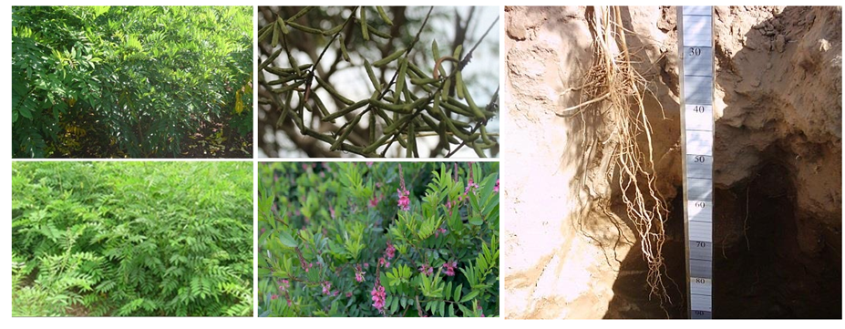Fig1: Growth stages and parts of the indigo plant

2. Distribution of Nile in the world and Iran
The origin of this plant is East Asia (Sarhadi et al. 2014), but today it is also found in Southeast and parts of central Europe, and apparently this plant has been cultivated in Europe since the Stone Age. The presence of the main long root enables the plant to resist drought. This plant is distributed almost throughout tropical and subtropical regions of Africa, Asia and America. Large areas of the Netherlands are covered by indigo cultivation. In some regions, including America, its growth is in the form of cars. This plant also grows in Pakistan, Sri Lanka, Indonesia, Saudi Arabia, Egypt, India, hot and humid areas of Africa and Syria (Mozzafari et al. 2012). Nile has a long history of cultivation in the cities of Jiroft and Kahnouj as well as Iranshahr and Bam cities in Iran (Hamdani, 1989). Indigo came to Iran in the 6th century AD (Olfati, 1995; Strobel and Gröger, 1989). In some sources, it is mentioned that indigo was cultivated in Kerman province (during the Sassanid period) and Khuzestan province (during the Qajar rule period). (Mozzafari et al. 2000). Currently, indigo cultivation in Iran and Kerman province is one of the most important summer crops in this region (Aeen, 2005). Also, this plant grows wild in the mountainous areas of Khash, Nehbandan, Iranshahr, Zabul, Mirjaveh, Fahraj and Regan. The cultivated area of indigo in Jiroft and Kahnouj ,region was 520 hectares in the 2006 crop year with an average yield of 2500 kg per hectare (statistics of the Ministry of Agricultural Jihad of Iran, 2007) and decreased to 131 hectares in 2011 (statistics of the Ministry of Agricultural Jihad of Iran, 2012). Therefore, this plant is considered as a forgotten plant. Indigo is cultivated in small plots of less than 0.5 hectares and along with other crops and the number of beneficiaries reaches about 500 people. Cultivation of this plant is mainly done by small owners. The replacement of artificial colors with natural colors is one of the main reasons for the forgetting of various colored agricultural and horticultural products (Zargaran Khouzani et al., 2018).

3. Ecophysiological characteristics of the Nile
Indigo is a tropical plant and the most suitable climate for it is warm and humid weather. The indigo plant shows better adaptation up to 1250 meters above sea level. Nile prefers sunny weather. Areas that have a high cloudiness during the growth period of the plant are not suitable for indigo. The average optimum temperature for the growth and development of indigo is 30 degrees Celsius. The minimum soil temperature for its germination is 18 to 20 degrees Celsius. For optimal growth and development, indigo requires at least a 120-day period free from cold and frost. The temperature below zero destroys the plant at any stage. Nile is resistant to drought stress due to its extensive and deep root system. The drought resistance of Nile has been proven in numerous tests (Ansouri et al. 2015). Aien et al. (2011) showed in Jiroft that mild drought stress (irrigation at the stage of 75% of field capacity) had no significant effect on the amount of dry leaves (economic performance) of Nile. Also, the effect of moderate drought stress (irrigation at the stage of 50% of the field capacity) on the total (biological) yield of the plant was not significant. Indigo is a low-expectation plant that grows well in weak and grade 2 and 3 soils and produces an acceptable crop. In general, indigo can be planted in any soil, but soils with medium and deep texture and with proper drainage are more favorable for indigo. Indigo does not tolerate waterlogged conditions and the plant reacts quickly in waterlogged conditions In the early stages of growth, it is relatively sensitive to soil and water salinity, but if the plant is established, it can tolerate moderate salinity (Zargaran Khouzani., 2022).

4. Nile farming
Due to the fact that indigo seeds have a hard shell, it seems that the embryo has dormancy due to the impenetrability of the shell, so it is necessary to pre-treat the seed with appropriate methods to make the shell permeable and break the seed dormancy in order to increase the germination percentage. Be In the tropical regions of southern Iran, where there is usually no temperature limit in spring, the suitable planting date is the second half of April to May. If the goal is to produce seeds, it is better to plant in June. In cases where planting is done alternately with wheat and barley, it is recommended to do protective planting immediately after harvesting wheat and barley, but in the cold temperate regions of the country, the planting date should be set in such a way that the soil temperature is at least 18 degrees Celsius, and on the other hand, the final stages of plant growth should not be exposed to cold. In the southeast of Iran, indigo is mainly cultivated after wheat or kitchen garden plants. The most suitable crop rotation for Nile as a summer crop is rotation with cereals (wheat and barley). The advantages of this rotation are the absence of common diseases, pests and weeds. Meanwhile, their root systems are different. Indigo is propagated through seeds. Farmers use about 25 kg of seeds per hectare in flat planting and broadcast planting. But it can be cultivated with a rapeseed machine in rows, in which case the amount of seed used will be about 6 kilograms. In linear cultivation, row spacing of 35 to 50 cm and plant spacing of 10 cm are recommended. The seeds grow green 4-5 days after planting in the right conditions of temperature and humidity. In the hot areas of the south of the country, after planting indigo, depending on the texture of the soil, at least 2 irrigations with a time interval of 3 to 4 days are necessary for the field to turn completely green. After the plant is fully established (the stage when the plants are about 10 cm high), the watering cycle can be increased to once every 10 to 14 days. In soils with high water holding capacity, the irrigation cycle can be considered more. Nile is sensitive to flooding conditions. Therefore, the irrigation method should be implemented and adjusted so that water does not stay at the feet of the bushes for a long time. As a result, the Kirti irrigation method is not suitable at all and it is better to use Faroese method. Of course, the drip irrigation system (band type) is very desirable and recommended. In general, indigo needs more water during the budding and greening stage as well as the flowering stage (if the purpose of planting is to produce seeds) (Aien et al., 2011, quoted by Zargaran Khouzani et al., 2018).
The initial growth of indigo is slow and slow, so weeds can cause great damage to the crop at the beginning of the plant's growth and development period. In order to control weeds and reduce damage in indigo cultivation, the following are recommended: The use of Pursuit herbicide (imazethapyr 10%) at the rate of 1.75 liters per hectare in combination with Focus herbicide (Cycloxydim Herbicide 10%) at the rate of 2 liters per hectare is also useful for controlling Nile weeds. Indigo is resistant to pests and no pest problem has been reported for it so far. One of the most important diseases of indigo can be mentioned Fusarium wilt disease during greening and early growth. The symptoms of this disease are wilting, falling leaves and finally the complete death of the plant. The diseased plants are easily removed from the soil and signs of decay and browning can be seen in the root and crown area. The cause of this disease is the fungus Fusarium solani (Khorramdel et al., 2015).If the goal is to harvest one stage per year, or if the climatic conditions do not allow harvesting more than one stage, then one-stage harvesting is done at the stage of full flowering, when the plant has achieved its maximum vegetative growth, and the bushes are harvested. . In the hot areas of the south of the country, if the farm is well managed, the possibility of 2 to 3 stages of harvest (in the form of fodder up to 5 stages of harvest) (Herdiawan & Krisnan, 2014); There is. The first stage of harvesting should be done before the beginning of flowering and when the height of the plant is about 50 to 70 cm. The important point in multi-stage harvesting is the cutting height; the bushes must be harvested at least from a height of 10 centimeters. After the first stage of harvesting, proper feeding and watering should be done; Subsequent harvests should be done after the plants reach a height of at least 50 cm. After each harvesting stage, the harvested foliage is sorted and dried in the sun. After drying, the stems and woody parts of the plant are separated and the leaves are packed. The economic yield for color extraction is mainly its dry leaves. The production potential of dried indigo leaves is about 5 tons of dried leaves per hectare per harvesting stage. Fields that are planted specifically for seed production are usually cultivated later and at the end of June so that the flowering and podding of the plant does not face the intense heat of summer. In some areas, the first stage of field harvesting is for leaves and the second stage of harvesting is devoted to seed production. The harvest date of the seed fields is late November. The average production of indigo seeds in southeast Iran is about 800-900 kg per hectare (Ansouri et al., 2015).

5. Industrial applications of indigo
A substance called Indigo is extracted from the indigo leaf, which is very important in the industry. Indigo is used for dyeing cloth and similar objects. Indigo color has a very high stability. Indigo has different colored materials, the most important of which is indigo, tin or Indigo pure. Indigo has other color substances such as Indi Rubin or Indigo red, as well as Indi renin or Indi humane or indigo brown. Indigo also contains other substances such as gluten indigo and 3-6% of minerals (Jahan et al. 2014).
Indigo tin (pure blue indigo) has the formula C16H10N2O2. Indigo is planted to produce natural indigo dye. Indigo is a very beautiful azure blue color material that has been known to mankind for centuries and is used for dyeing silk, cotton, and woolen fabrics (Figure 2) and also for painting and making calico pale blue (Kavimani, et al. .2001).
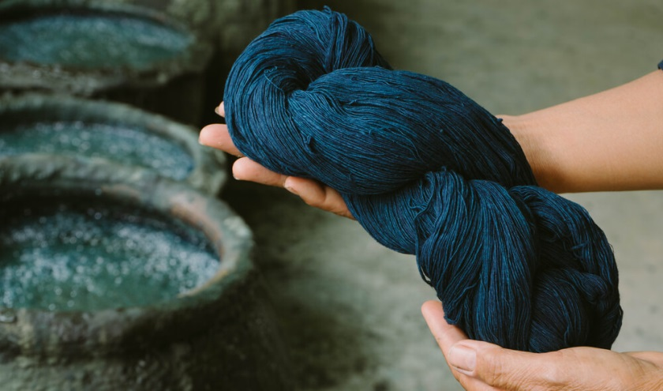
Fig 2: Natural fibers dyed with dye extracted from the indigo plant

5.1. Carbon quantum dot synthesis from indigo plant
One of the main challenges of making an electrochemical sensor is the selection and preparation of suitable modifying materials for the electrodes. So far, many studies have been conducted to modify electrodes using nanostructures in order to improve the performance of sensors. Meanwhile, carbon Nano materials have been widely used due to their high sensitivity, selectivity and stability. Among others, we can mention carbon quantum dots, quantum graphene dots, and Nano composites of carbon nanotubes and carbon Nano fibers. Considering the importance of using carbon materials to modify the electrode surface and the features mentioned for carbon quantum dot, it is possible to prepare carbon quantum dot using indigo plant and hydrothermal method. Carbon quantum dots are prepared by methods such as IR and UV. Materials synthesized from the indigo plant can be used to modify the electrode surface in energy storage, Drug delivery, Catalyst and Sensor applications.(Figure 3).( Daei Naseri et al., 2022)
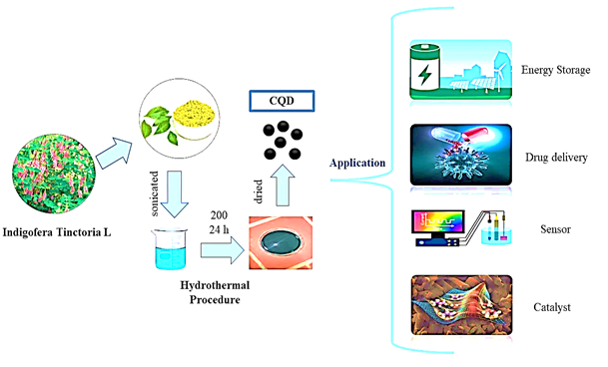Fig3: Schematic of applications of quantum dot carbon prepared from indigo plant
6. The use of indigo in traditional medicine and its uses
The indigo plant is widely used in traditional medicine. In Iran, in the southeastern regions, the decoction of the leaves of this plant is used to treat foot pain and headache. Also, in these areas, crushed indigo leaves are used to treat burning and cracked feet. In Cameroon, the branches of the Nile plant are used as toothbrushes (Zargaran Khouzani., 2022). The root and stem of indigo have a bitter taste and laxative, expectorant and anti-helminthes effects and strengthen hair. All parts of this plant have an anti-inflammatory effect and are used to treat chronic bronchitis, asthma (especially in children), hemorrhoids, insect bites and poisonous reptiles, wound treatment and skin disorders. The juice obtained from the plant is also used to treat epilepsy and nervous disorders; it is used as an ointment to treat skin diseases and hemorrhoids. Also, the leaf extract of this plant is used to treat burns and wounds of domestic animals such as cows and horses (Bangar & Saralaya. 2008). In India, its root paste is used to heal wounds. Also, the infusion of the root of this plant is used in India as an antidote against snake bites and to treat scorpion and insect bites. The use of indigo seeds can be useful to prevent watery eyes and also to absorb eye water at the beginning of cataracts. Its leaves and roots are recommended for the treatment of epilepsy and diabetes. Its dry powder is used in the treatment of asthma. The consumption of its leaves has been recommended to eliminate hepatotoxicity and as an anti-inflammatory (Nadkarni 1998). The extract of this plant is known to be effective in treating shortness of breath, whooping cough and heart palpitations (Bangar and Saralaya. 2008). Methanolic extract of the organs of this plant prevents the growth of AIDS virus (Kavimani et al. 2001).
7. Fodder use of indigo plant
Acquiring new sources of fodder in order to optimize the efficiency of water and soil resources to meet the food needs of the country's livestock population is considered one of the priorities of the agricultural sector (Fazayli, 2009). Although fodder is one of the main sources of feed in livestock nutrition, the nutritional value of a significant number of them is still not well known. On the other hand, the nutrition of ruminants should be based on wood materials and other foods that do not compete with human food as much as possible. This is while fodder constitutes more than 90% of the world's livestock feed and indirectly provides a significant part of the human population's food. Fodder products have a higher efficiency in terms of biomass production, and due to their use in direct animal grazing, they can reduce the cost of harvest and maintenance. On the other hand, over many years, environmental and climatic challenges such as greenhouse effects, long-term droughts, desertification, and floods have repeatedly increased, which has caused several socio-economic crises. is (Ma et al. 2011); In addition, the volume of surface and underground water has decreased due to the increase in consumption in the agricultural, domestic and industrial sectors, so promising fodder products with less water need should be given more attention (Barba de la Rosa et al. , 2009). Iran is located in an arid and semi-arid region, and drought and salinity stresses in it cause a decrease in crops. Therefore, it is inevitable to use species tolerant to environmental stress in areas that are in low water and salinity conditions. Hay and corn are the best fodder for livestock. While their cultivation requires abundant and quality water as well as suitable soil. With climate change, increasing heat and limited water resources, the production of fodder with high water consumption is no longer justified and it is necessary to move towards the use of fodder with higher water efficiency or tolerance to drought and salinity, which have higher dry matter production efficiency. Per cubic meter of water consumption or it is possible to produce them with low quality water (Azerbaijani et al., 2021).
In the field of livestock feed, the indigo plant can be used as a good source of protein for livestock, considering that it is a member of the legume family. The indigo plant is one of the vertically growing plants; It has many branches and leaves, and due to its deep roots, it has a good ability to acquire water and nutrients. Currently, indigo is widely cultivated in Southeast Asia, especially in Indonesia, due to its good quality to become a fodder (Simanihuruk. & Sirait, 2009) (Figure 4).
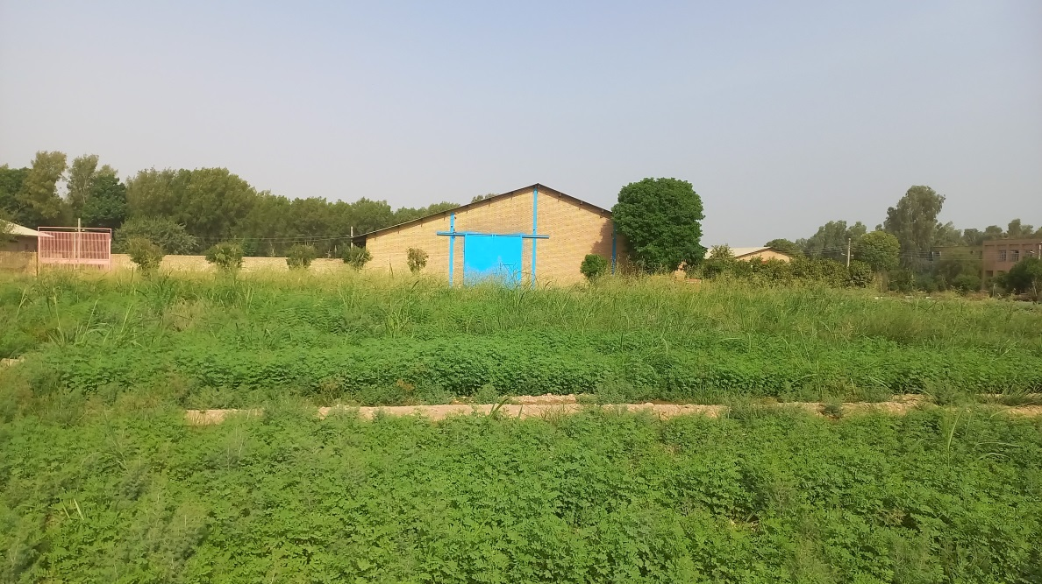
Fig 4: A view of the indigo farm in Shoushtar city - Khuzestan province - Iran in the harvesting stage

7-1 Fodder advantage of indigo plant compared to other fodder plants
- The indigo plant is very suitable for use as an alternative fodder in the dry season due to its resistance to drought.
- The forage productivity of the indigo plant is very high.
- It contains high protein and therefore it is useful and practical for fattening cows and goats [sheep] and increasing the milk production of dairy cows and goats [sheep].
- Nile fodder has a high digestibility so that a small part of the nutrients in the fodder is excreted by the animal.
- The mineral content is ideal for livestock needs and can contribute to the optimal growth of livestock.
- Indigo has very few anti-nutrients, the tannin content of this plant is only between 0.6 ppm and 1.4 ppm.
- The palatability of indigo fodder is high and cattle prefer indigo fodder (Tarigan, Andi & Ginting, 2011).
7.2 Indigo plant in the diet of goats
Protein materials are among the high requirements, especially for goats that have high production. For example, goats that is in the early stages of growth or in their lactation period. By consuming more indigo in their diet, while increasing their growth, daily weight and milk production, they approach their potential, however, using indigo as a pure feed in goat nutrition is not recommended and other types of feed are needed. should be included in the diet of goats along with indigo fodder like grasses.
With the use of indigo fodder in the diet of goats and the closeness of the actual production to the potential in Indonesia, this plant has a special place to make the production of milk and fattening goats more efficient. The best combination of indigo plants for growing goats is 50% grass and 50% indigo (Simanihuruk. & Sirait, 2009). Based on the researches, the composition of the ration can lead to an average weight gain of 44 grams/head/day; While compared to the control goats that were given grass only, weight gain was only 37 g/head/day, which indicated a difference of about 7 g/head/day in goats fed with indigo fodder. In other words, indigo can provide a daily weight gain of about 18% more than goats that only feed on grasses. In another study, goats fed with indigo plant in their diet gained an average of 52 grams/head/day, while goats that were fed only with grasses, the weight gain of each head was only 28 grams per day (Tarigan , Andi & Ginting, 2011).. Dairy goats usually always use concentrate. This concentrate can increase milk production due to its excellent nutritional content. In general, the ration composition for dairy goats is 60% grass and 40% concentrate. Indirectly, Nile feed can also be considered as a substitute for concentrate. Sanen goats (Figure 5-b) with Nile ration can have an average of 660 ml/head/day compared to the consumption of concentrate ration which is only 539 ml/head/day. While the average milk production of Jamunapari Goat (Figure 5-a), with indigo plant ration, is 762 ml/head/day and its average production with concentrate feed ration is only 379 ml/head/day (Titis Anugraheni, 2011).

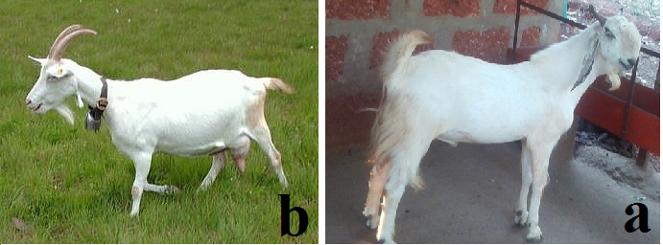
Fig 5: a. Indian Jamunapari goat b. Goat of the Saanen breed
These data are taken in milking conditions outside the peak of production, so that indigo is added to the diet in the form of dry fodder at the rate of 4% of dry matter per goat weight. The nutritional content of dried indigo fodder is different from its fresh fodder. You can see the nutritional content comparison in Table 1:
Table 1: Nutritional content of dry and wet indigo plant fodder
Nutritional content | Nile dry fodder | Fresh (fresher)  Nile fodder
dry matter percentage | 88.11 | 21.97
Ash percentage | 6.41 | 6.14
Protein percentage | 25.66 | 24.17
Fiber percentage | 14 | 15.25
Fat percentage | 2.9 | 6.15
The percentage of Beta N | 39.14
The percentage of total digestible energy (TDN) | 75.47

The percentage of dry matter in the dry indigo fodder is higher than that of its wet fodder, because before making the dry indigo fodder pellets, the indigo leaves are first dried to reduce the amount of water. The amount of dry matter from pellets is almost 4 times that of fresh (wetter) Nile fodder (Titis Anugraheni, 2011).
7.3 Indigo plant in cattle diet
According to the research conducted on the food ration of cows, the use of 60% of indigo in the ration can increase the daily weight gain of the cow by 39%; In this study, the ration used was complete fodder, elephant grass. Then, 60% of the elephant grass plant in the complete diet was replaced with indigo, (40% of the elephant grass diet and 60% of the indigo diet). Of course, this also depends on the type or breed of cattle. In this study, the ongole cattle breed (Figure 6-b) showed a good reaction to this diet, the weight change in Simmental cows (Figure 6-a) and limousine cattle (Figure 6-c), very little was observed. To calculate the appropriate amount of dry indigo fodder in the diet of cows according to the diversity of the breed, it is enough to change the ration gradually and use the indigo plant based on the highest efficiency in feeding the cattle of the desired breed (Nurhayu, & Pasambe, 2016).
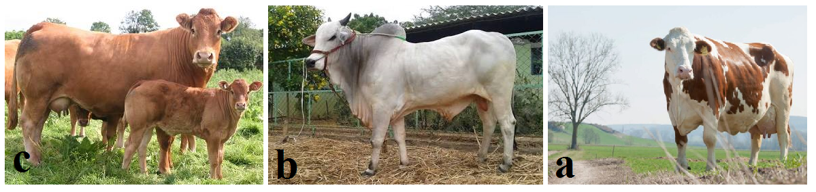Fig 6. a. Simmental cattle, b. ongole breed cattle, c. limousine cattle
7.4 Advantages of indigo plants as fodder
There are several types of plants in the Fabaceae family that are similar in quality to indigo, which are good sources of protein for goats and cattle.
1. Indigo has better nutritional quality: its crude protein value is high and its fiber and nutrients are low.
2. Tolerance of weak soils: Nile can grow well in grade 2 and 3, acidic and alkaline soils with low water content.
3. More growth and fodder production: Indigo plant can produce up to 33 tons per hectare per year of fresh fodder (Herdiawan & Krisnan, 2014).
8. Conclusion
Although the cultivated area of indigo in Iran is very small, but considering its various uses, it seems that the revival of the cultivation of this product can be fruitful in creating employment and diversity in cultivation patterns in the direction of sustainability in agriculture in different regions of Iran. Therefore, knowing the needs of the neglected medicinal and industrial plant of indigo and the role of management factors in the production of this plant can, on the one hand, increase and improve the livelihood of the producers of this product from the withdrawal of foreign exchange for the preparation of chemical dyes, some medicinal items and also a part It will greatly reduce the need for fodder. Also, due to the lack of cultivation of this plant and its lack of historical background, there is a significant lack of information regarding the cultivation of this plant and the production of indigo. Considering the demand for natural dyes, medicinal products and fodder, increasing the development of indigo cultivation in line with the improvement of the indigo plant can be considered as an alternative in the crop rotations of different regions. Revival of ecological capacities, quantitative and qualitative improvement of medicinal, industrial and fodder indigo plant as it is planted and cultivated in ecological conditions appropriate to its habitat, in addition to being placed in crop rotations that can lead to better stability of agricultural ecosystems. With its Eco physiological characteristics, it will be fruitful in the direction of using the natural capacities and preserving the country's water resources. Considering the existing characteristics and potential, such as tolerance to drought stress and suitable dry and wet fodder performance, palatability and richness Nutrients for livestock feeding based on international researches of indigo plant (Indigofera tinctoria L.) with a history of long-term planting in the southern and central regions of Iran, the ability to be placed in crop rotations and use as a palatable fodder plant for livestock has light and heavy in the country. In this research, an attempt was made to address the different aspects of this valuable plant, taking into account that so far no scientific and practical research has been done in the country regarding the placement of this plant in the field of fodder plants, and generally its medicinal and industrial status, of course Again, it is limited, it demands that the activists in the country's livestock production field pay special attention to this valuable plant in order to better manage their livestock's rations and increase productivity in the production of livestock products, because droughts always occur, and The lack of animal feed due to the decrease in the production of fodder plants, which leads to an increase in the cost of providing the necessities of livestock farms and animal farms, and the unaffordability of supplying imported fodder, the need to pay attention to a plant such as indigo, can reduce these problems to some extent and in paying attention to all medicinal, industrial and fodder aspects of the Nile will be a solution to combat drought and develop sustainable agriculture.

9. Reference

Azarbaijani, Alireza; Tarabi, Massoud; Aghashahi, Alireza; 2021., Application of summer fodder plants in animal nutrition, National Animal Science Research Institute. Office of Knowledge Network and Extension Media, Agricultural Research, Education and Extension Organization. Deputy of Agricultural Education and Promotion. Publication of agricultural education.(in Persia)
Anonymous, 2007, statistics and information of the Ministry of Agriculture, crop year 2006, statistics and information center of the Ministry of Agriculture, Tehran. (in Persia)
Anonymous, 2013, statistics and information of the Ministry of Agriculture, crop year 2012, statistics and information center of the Ministry of Agriculture, Tehran. (in Persia)
Ansouri Ali, Shahqoli Hassan, Makarian Hassan, Qolipour Manouchehr. 2015. Investigating the effect of planting date on the growth and performance of the Shahrood plant (Indigofera tinctoria L) in Shahrood conditions. Agricultural research in Iran. (in Persia)
Bangar, V.A., and Saralaya, M.G. 2008. Anti-hyperglycaemic activity of ethanol extract and chloroform extract of Indigofera tinctoria leaves in streptozotocin induced diabetic mice (Family Papilionaceae). Research Journal of Pharmaceutical, Biological and Chemical Sciences, 2(1): 445-455.
Barba de la Rosa, A.P., Fomsgaard, I.S. Laursen, B., Mortensen, A.G., Olvera-Martinez, L., Silva-Sanchez, C., Mendoza-Herrera, A., Gonzalez-Castaneda, J. and De Leon-Rodriguez, A. 2009. Amaranth (Amaranthus hypochondriacus( as aalternative crop for sustainable food production: Phenolic acidand ﬂavonoids with potential impact on its nutraceutical qualityJournal of Cereal Science, 49:117–121
Daei Naseri S M A, Ghasemi. S, Mousavi F, Zargaran Khouzani, M. R. Fotouki F. Green synthesis of carbon quantum dots from Indigo plant. 7th Zeolite Conference of Iranian Chemical Society, Chemistry & Chemical Engineering Research Center of Iran. 2022. 30 & 31 Aug.
Fadaeli, H. 1388. Introduction of Amaranthus as a new fodder source. Animal Science Research Quarterly, 10:53-64. (in Persia)
Hamdani, R F, 1989, Athar wa Ahiyya (Persian text on the art of agriculture); by Sotoudeh, Manouchehr and Afshar, Iraj, Institute of Islamic Studies, University of Tehran - McGill University: Tehran University. (in Persia)
Herdiawan, Iwan and Krisnan R. 2014. Productivity and Utilization of Indigofera zollingeriana Tree Legume Plants on Dry Land. Bogor Animal Research Institute. WARTAZOA Vol. 24 No. 2 years. p. 75-82.
Jahan, S., Sarwar, A.G., Hossain, M., Fakir,M. 2014. Floral morphology and seed yield in two Indigofera spp. As affected by shoot Clipping. Journal of the Bangladesh Agricultural University, 11: 61-66.
Kavimani, S., Jaykar, B., De Clercq, E., Pannecouque, C., Witvrouw, M., and De Clercq, E. 2001. Studies on anti-HIV activity of Indigofera tinctoria. Hamdard Medicus, 43(1): 5-7.
Khorramdel S, Rizvani Moghadam P, Houshmand M, Banhangi F, 2015. The effect of manure levels and plant density on the yield and components of grain yield, leaf yield and indigo vesme. Plant production research (agricultural sciences and natural resources). (in Persia)
Khoshnam Z, Amirinejad M, Aien A, Parsasamtalaq Bahareh. 2019. Evaluation of the intercropping system of Indigofera tinctoria L and Hibiscus sabdariffa L on yield, biodiversity and weed population changes. Production and processing of agricultural and garden products; 10 (2): 109-121. (in Persia)
Mozzafari, F., Ghorbanli, S., Babai, M., and Farzami, A. 2000. The effect of water stress on the seed oil of Nigella sativa L. Journal of Essential Oil Research, 12: 36-31.
Mozzafari, F., Ghorbanli, S., Babai, M., and Farzami. 2012. Identification of medicinal and aromatic plants in Iran. National Network of Medicinal Plants Research and Technology Publications
Nadkarni, K.M. 1998. Indian Medicinal Plants and Drugs-with their Medicinal Properties and
Nurhayu, A. and Daniel Pasambe. Indigofera as Forage Substitution in Beef Cattle Feed in Bulukumba Regency, South Sulawesi. 2016. South Sulawesi Agricultural Technology Assessment Office. National Seminar on Animal Husbandry 2, Faculty of Animal Science, Hasanuddin University Makassar, August 25.
Olfati, Hadi. 1995, History of Agriculture and Animal Husbandry in Iran, Volume I, Amir Kabir Publishing House, Tehran, page 711.
Sarhadi, H., Afsharmanesh, G.R., and Mokhtari, Z., 2014. Effect of drought Stress on some morphological traits and seed yield of indigo (Indigofera Tinctoria L.) under different levels of nitrogen. International Journal of Science 3: 2319-5037.
Simanihuruk, K. And J. Sirait. 2009.Utilization of Indigofera sp. Legume tree. As Boerka Goat Basal Feed Growth Phase. North Sumatra Goat Cut Research Station. National Seminar on Animal Husbandry and Veterinary Technology.
Strobel, J., and Gröger, D. 1989. Uber das Vorkommen von Indigovorstufen in Isatis-species. Biochem Physiology Pflanzen, 114: 321–327.
Tarigan, Andi and S. P. Ginting. 2011.Effect of the level of administration of Indigofera sp. Against Feed Consumption and Digestion and Increase in Life Weight of Goats Given Brachiaria ruziziensis Grass. North Sumatra Goat Cut Research Station. JITV Vol. 16 No1 Th.: 25-32.
Titis Anugraheni P. A. 2011. Utilization of Indigofera sp. Pellet. In the Etawah and Saanen Peranakan Dairy Sheep at Bangun Karso Farm Farm. Department of Nutrition and Feed Technology, Faculty of Animal Husbandry, Bogor Agricultural University.Uses. Asiatic Publishing House New Delhi. 451 pp.
Wahyuni Lubis, Sri. 2018. The Effect of Indigofera zollingeriana Leaf Flour Use in the Ration on Ration Consumption, Protein Consumption, Hen-day and the weight of Broiler Eggs. Thesis. Department of Animal Husbandry, University of Lampung.
Zargaran Khouzani, M. R and Gharineh, M.H ; Khodayi Joghan, A ; Shojaei, A, 2018, investigation of the forgotten industrial-medicinal plant Indigofera tinctoria.L and the importance of its revival in the sustainability of agricultural ecosystems in Iran, 7th National Research Conference Applications in agricultural sciences, healthy food from farm to table, Tehran(in Persia).
Zargaran Khouzani, M. R. (2022). Assessing Indigofera tinctoria L. as a forgotten medicinal-industrial plant and the importance of its revitalization for the sustainability of Iran's agricultural ecosystems. Central Asian Journal of Environmental Science and Technology Innovation, 3(2), 32-39. doi: 10.22034/CAJESTI.2022.02.01

