Original Research Article

Leveraging Big Data Analytics to Assess the Influence of Online Consumer Sentiment on Chery Omoda 5 Sales in Malaysia

Abstract
With the rapid development of big data technologies, the influence of online consumer sentiment on purchasing decisions has become increasingly significant, particularly within the automotive industry. This study systematically investigates the impact of negative online opinions on the sales of the Chery Omoda 5 in the Malaysian market by leveraging advanced data mining, sentiment analysis, and market trend analysis techniques. Sales records and large-scale online content—including social media posts, news articles, forums, and blogs—were collected from January 2024 to June 2024. Natural language processing was applied to quantify negative sentiment, and statistical analyses were performed to examine the relationship between sentiment fluctuations and monthly sales trends. The results demonstrate a strong negative correlation ($r = -0.924$) between the frequency of negative online mentions and Omoda 5 sales. Peaks in negative sentiment, often triggered by product recalls or heightened media coverage, coincided with significant declines in sales volume. These findings provide empirical evidence of the immediate and measurable adverse effects of online negativity on consumer purchasing behavior. The study concludes with recommendations for automotive manufacturers, emphasizing the importance of real-time reputation monitoring and proactive crisis communication strategies to mitigate the impact of negative online sentiment and protect brand equity in an increasingly digital marketplace.
Keywords: Big Data, Online Opinions, Negative Reviews, Omoda 5, Car Sales, Consumer Behavior

Introduction
The Chery Omoda 5, a sport utility vehicle recognized for its innovative features and competitive pricing, has recently attracted significant attention and scrutiny in Malaysia's automotive market. In April 2024, a critical incident occurred when 600 units of the model were recalled due to potential axle issues, as reported by Paul Tan’s Automotive News (Paul Tan's Automotive News, 2024). This recall, along with subsequent waves of negative coverage across major online platforms, has highlighted the decisive role of public opinion in shaping consumer behavior in the digital era.
The growing prevalence of online channels—such as automotive forums, social media, and independent review websites—has fundamentally transformed how consumers gather information and make purchase decisions (Babić Rosario et al., 2016; Hewett et al., 2016). Negative sentiment can spread rapidly within digital environments, amplifying reputational crises and exerting direct effects on consumer attitudes and market performance. Prior studies have consistently shown that electronic word-of-mouth (eWOM) and online reviews are powerful predictors of sales outcomes, especially for high-involvement and high-value products such as automobiles (Zhu et al., 2022; Lee and Oh, 2020). The influence of online opinions is not limited to general brand perception; it can trigger immediate shifts in sales volume in response to specific incidents or narratives (Sahoo et al., 2023; Wang et al., 2023).
For automotive brands, the management of digital reputation and the ability to respond swiftly to negative publicity have become essential components of effective marketing and risk control strategies (Xie et al., 2023; Kumar et al., 2016). However, there remains a lack of empirical evidence regarding the immediate, quantifiable impact of negative online sentiment on individual model sales in the Malaysian context. Most existing research focuses on mature Western markets or provides brand-level rather than model-specific analysis (Du et al., 2021; Zhang et al., 2022).
Recent advances in big data analytics and natural language processing offer powerful tools for monitoring and measuring public sentiment in real time (Liu et al., 2022; Sharma, 2023). Leveraging these techniques, this study systematically examines the relationship between negative online opinion and the sales performance of the Chery Omoda 5. By integrating large-scale sales data with a comprehensive analysis of digital discourse—including news articles, social media posts, and forum discussions—between January and June 2024, this research provides new empirical insights into how online negativity correlates with changes in market outcomes. The findings not only contribute to the academic understanding of digital public opinion and consumer behavior, but also offer actionable guidance for automotive marketers and managers seeking to navigate reputation risks in an increasingly interconnected environment (Batra and Keller, 2016; So, 2020).

Research Objectives
- To assess the impact of negative online opinions on the sales of the Chery Omoda 5 in Malaysia: This includes understanding the extent to which negative public sentiment influences consumer purchasing decisions.
- To analyze the temporal relationship between the frequency of negative online mentions and fluctuations in sales figures: The study seeks to determine whether spikes in negative sentiment correlate with significant drops in sales, thereby providing insights into the timing and severity of such impacts.
- To propose actionable strategies for automotive manufacturers to mitigate the negative impact of adverse online opinions on sales: Based on the findings, the research will offer recommendations for improving brand reputation and maintaining market performance amidst negative online sentiment.

Related Work
Recent advancements in big data analytics and machine learning have significantly enriched the methodological toolkit available for public opinion and consumer sentiment analysis. Several key studies exemplify the integration of signal processing, deep learning, and domain-specific sentiment modeling to tackle challenges in forecasting and opinion management.
The study titled EEMD-Transformer Model for Public Opinion Analysis: A Case Study on COVID-19 Public Opinion represents a methodological innovation by combining Ensemble Empirical Mode Decomposition (EEMD) with the Transformer attention mechanism. EEMD is utilized to decompose raw public opinion “heat” data into intrinsic mode functions (IMFs), effectively reducing noise and isolating meaningful underlying patterns. This is particularly important for non-stationary, volatile datasets common in public discourse. The Transformer architecture, renowned for its self-attention mechanism, is then applied to these decomposed components, allowing the model to capture both temporal and contextual relationships within the data. A fully connected neural network integrates these extracted features for trend prediction. The empirical results, drawn from COVID-19 public opinion data, demonstrate that this hybrid approach achieves high accuracy in trend forecasting. The study highlights critical methodological gaps in the literature, including inadequate noise handling and the underutilization of advanced feature extraction techniques in public opinion forecasting. Its contributions lie in the effective synergy of signal decomposition and deep learning, offering a robust framework for trend prediction in dynamic environments and providing actionable intelligence for policymakers and business leaders engaged in crisis communication and sentiment management.
The 2022 Internet Public Opinion Analysis Report for China provides a comprehensive examination of evolving trends in online public discourse, with a particular focus on the rapidly expanding influence of short video platforms. These platforms are noted for lowering barriers to public participation and for enabling a wider demographic to engage in the exchange of ideas and opinions on critical societal topics such as the COVID-19 pandemic and employment. The report not only identifies key themes shaping public attention but also calls for deeper inquiry into the mechanisms by which emerging digital platforms drive the formation, dissemination, and transformation of public sentiment. By analyzing platform-specific dynamics and the role of multimedia content, the report contributes important empirical insights for both academic researchers and policymakers seeking to understand and engage with contemporary public opinion.
In the domain of consumer behavior and market forecasting, the article Research on Automobile Sales Forecasting Based on Discrete Emotion of Online Comments demonstrates the potential of fine-grained sentiment analysis in improving predictive accuracy. Utilizing the Word2Vec model, the authors expand an automotive-specific emotion lexicon and construct discrete emotion vectors from online customer reviews. These vectors are then incorporated into various forecasting models, allowing for a direct assessment of the predictive power of discrete emotion signals versus traditional valence-based or emotion-agnostic approaches. The study’s findings reveal that models integrating discrete emotional insights, such as joy, anger, or fear, substantially outperform those based solely on coarse sentiment measures. This research fills a methodological gap in the field, showing that the complexity of consumer emotions is highly relevant to sales forecasting, and introduces a robust framework for integrating emotional analysis into business analytics, which has implications beyond the automotive industry.
Computational Prevailing Sentiment in the Period of Big Information: Concept, Approaches, and Scenarios (2022) offers a broad yet rigorous exploration of computational public opinion research in the era of big data. It systematically covers theoretical foundations, methodological processes, and empirical applications. By employing advanced tools—such as machine learning, natural language processing (NLP), sentiment analysis, and network analysis—the book demonstrates how large-scale public discourse data can be harnessed to understand, predict, and respond to evolving social attitudes. Practical case studies illustrate the application of these methods in diverse contexts, from social policy to market analysis. The work addresses the lack of comprehensive resources for researchers, providing clear frameworks and practical guidance for integrating computational methods into public opinion research, and thus bridging the gap between theoretical constructs and empirical analysis.
Collectively, these studies represent the convergence of traditional signal processing techniques, state-of-the-art deep learning, and domain-specific sentiment modeling in the analysis of complex, large-scale opinion data. They address enduring challenges such as noise, non-stationarity, and the contextual richness of human sentiment, while also highlighting the evolving digital landscape shaped by emerging platforms like short videos. Nevertheless, despite notable progress, important research gaps remain—including the need for hybrid, cross-disciplinary approaches, more robust real-time analytics, and improved generalizability across diverse social and market domains. These gaps suggest fertile ground for future research, particularly in the integration of explainable AI, multimodal sentiment analysis, and the translation of computational insights into actionable strategies for policy and management.

Methodology
This study adopts a big data analytical framework to explore the impact of negative online opinions on the sales of the Chery Omoda 5 in Malaysia, following a systematic process as illustrated in Figure 1. The research began with the clarification of the core problem—namely, understanding how adverse online sentiment triggered by events such as product recalls can influence consumer purchasing behavior in the Malaysian automotive market. To address this, sales data and online mentions related to the Chery Omoda 5 were collected for the period from January 2024 to June 2024. The sales data were obtained from official dealership reports and industry sources, while negative online mentions were gathered from various digital platforms, including social media (such as Facebook and Twitter), news websites, automotive blogs, and forums. Automated web-scraping tools and keyword-based search strategies were utilized to ensure comprehensive data collection.
After gathering the data, sentiment analysis was conducted using natural language processing (NLP) techniques to categorize online mentions as negative or non-negative, and the data were further cleaned to remove duplicates and irrelevant records. The resulting data were temporally aligned and aggregated on a monthly basis to ensure consistency with sales records. Additional feature engineering included the construction of monthly counts of negative mentions and relevant lagged variables for subsequent analysis.
To investigate the relationship between negative online sentiment and sales performance, both correlation and regression analyses were performed. Pearson and Spearman correlation coefficients were used to measure the association between the frequency of negative online mentions and sales figures. Furthermore, multiple linear regression and time-series regression models were constructed to quantify the effect of negative sentiment on monthly sales, while controlling for potential confounding factors. Model selection and evaluation were based on goodness-of-fit, statistical significance, and diagnostic checks.
Finally, the empirical results were visualized using time-series plots and other graphical tools to illustrate trends and potential causal relationships. Statistical hypothesis tests were employed to confirm the robustness and significance of the observed effects. Based on these findings, the study provides practical recommendations for automotive manufacturers regarding real-time monitoring of online sentiment, crisis communication, and reputation management strategies, with the aim of mitigating the negative impact of adverse public opinion on market performance.

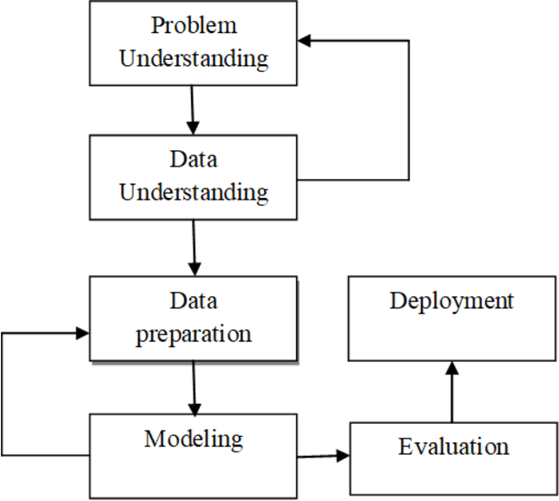
Figure 1 Research Methodology

Data Sources
The data utilized in this study comprises two primary components: sales records for the Chery Omoda 5 and large-scale online opinion data related to this vehicle. Monthly sales data for the Omoda 5 in Malaysia were collected from official dealership reports and reputable automotive industry databases, covering the period from January 2024 to June 2024. These data provide an objective measure of market performance and allow for temporal alignment with public sentiment trends.
To capture the landscape of online consumer sentiment, a comprehensive dataset of digital content mentioning the Chery Omoda 5 was compiled over the same period. Online mentions were sourced from a variety of platforms, including social media networks (such as Facebook and Twitter), news websites, automotive forums, and independent blogs. Automated web scraping tools and keyword-based search strategies were deployed to ensure extensive and relevant data collection. The raw online content was subsequently processed using natural language processing (NLP) techniques to identify and classify negative sentiment at the post or article level. Duplicate, irrelevant, or non-Malaysian entries were removed to enhance data quality and representativeness.
All data sources were aligned on a monthly basis to facilitate robust correlation and regression analyses. The integration of quantitative sales records with high-volume, multi-platform digital sentiment data enables a rigorous examination of the relationship between negative online opinions and market outcomes for the Chery Omoda 5 in the Malaysian automotive sector.

Result
Figure 2 presents the distribution of Chery Omoda 5 vehicles among all Chery models sold in Malaysia in 2024. The pie chart clearly demonstrates that the Omoda 5 is the dominant product in Chery’s lineup, accounting for 82.1% of total Chery vehicle sales, while other models collectively comprise only 17.9%. This striking disparity suggests that the success of the Omoda 5 is not only central to Chery's overall sales performance in the Malaysian market, but also that the brand’s market share and reputation are highly dependent on this single model.
Such a high concentration in sales implies that fluctuations in Omoda 5 sales—whether driven by product quality, consumer sentiment, or external events—can have a disproportionately large impact on the company’s market position. In the context of this study, the predominance of the Omoda 5 amplifies the relevance of examining how negative online sentiment and public opinion shocks may affect Chery’s business outcomes. Any significant adverse sentiment or negative publicity related to the Omoda 5, such as the recall event in April 2024, has the potential to cascade through the brand’s entire performance, amplifying financial risk and threatening long-term competitiveness.
Furthermore, this concentration highlights the importance for Chery to implement proactive reputation management and targeted marketing strategies specifically tailored to the Omoda 5. The findings reinforce the notion that for brands with highly skewed product portfolios, online sentiment analysis and crisis response mechanisms are not merely optional, but are essential for safeguarding market share. In addition, these results provide valuable context for interpreting subsequent analyses on the relationship between negative online mentions and fluctuations in monthly sales, emphasizing the need for data-driven decision-making in both product management and strategic communications.

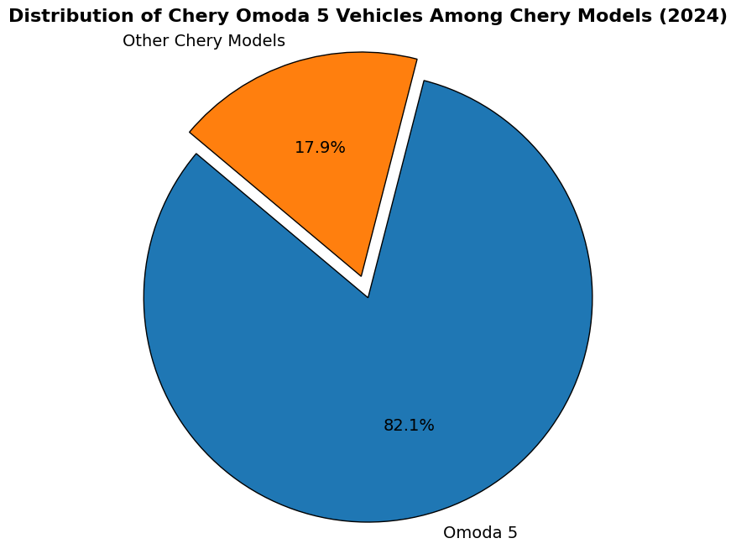
Figure 2 Distribution of Chery Omoda 5 Vehicles Among Chery Models

Figure 3 presents the monthly sales trends of the Chery Omoda 5 in Malaysia throughout the first half of 2024. The sales figures show a strong start, with 1,217 units sold in January and reaching a peak of 1,318 units in February. However, following this peak, the data reveals a clear and substantial downward trajectory. Sales slightly decreased to 1,241 units in March, followed by a more noticeable drop to 1,019 units in April. The decline accelerated sharply in the subsequent months, with sales plunging to just 513 units in May and reaching a low of 355 units in June.
This downward trend suggests that after an initial period of market momentum and consumer interest, there was a significant loss of demand for the Omoda 5 as the year progressed. The most dramatic decrease occurred between April and May, where sales nearly halved in a single month. This period coincides with the widely reported recall of 600 Omoda 5 units and heightened negative online sentiment, as described earlier in the study. The temporal alignment of these events with the sales decline indicates a possible causal relationship, where negative publicity and adverse public opinion may have directly impacted consumer confidence and purchasing decisions.
Furthermore, the sustained low sales in May and June imply that the effects of negative sentiment and reputational events may persist over multiple months, rather than being limited to an immediate, short-term impact. These findings underscore the importance of continuous brand monitoring and proactive crisis management for automotive manufacturers, especially when a single model constitutes a dominant share of overall sales.
In summary, the sales trend illustrated in Figure 3 not only quantifies the extent of market disruption faced by the Chery Omoda 5 in 2024 but also provides empirical support for the study's central hypothesis: that negative online sentiment and adverse events can have a profound and lasting influence on product sales performance.
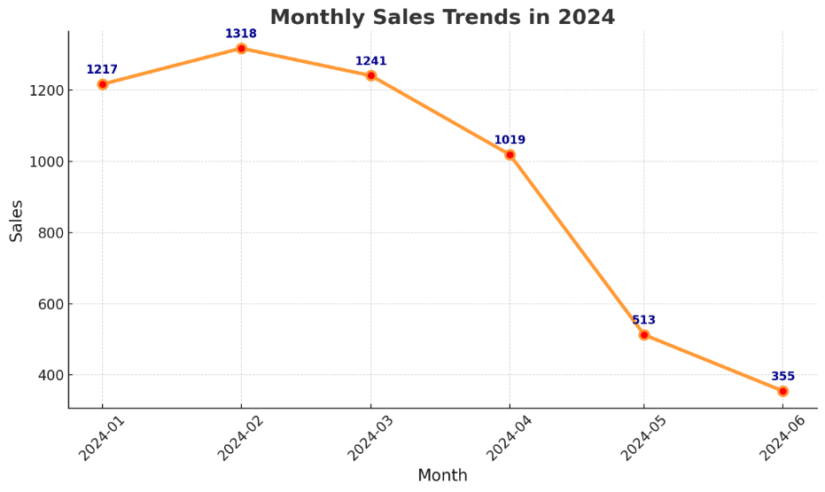
Figure 3 Monthly sales Trends in 2024
Figure 4 displays the platform-wise distribution of online discussions concerning the Omoda 5 axle issue from April to June 2024. The data reveal distinct patterns of attention across different media channels. On Facebook, mentions were relatively elevated throughout the observed period, with activity peaking in early May. This reflects the platform’s strong community engagement and the rapid dissemination of user-generated content. Twitter, on the other hand, exhibited a sustained increase in activity, culminating in the highest number of mentions among all platforms by early June. The pronounced growth on Twitter may be attributable to the platform's real-time nature and its role in amplifying breaking news and trending topics.
Forum discussions remained modest in comparison to social media platforms but still showed a slight uptick in May, suggesting that specialized automotive communities were also responsive to the unfolding axle issue. News outlets displayed a marked surge in coverage during May and June, with mentions peaking mid-month, underscoring the event’s newsworthiness and the broader media’s role in shaping public narratives. Blog mentions, while consistently lower than other channels, nonetheless showed a minor increase, indicating some level of commentary and opinion dissemination in the blogosphere.
Overall, the data indicate that the period from late April to mid-June represented the zenith of public discourse regarding the Omoda 5 axle issue, with the highest concentration of negative sentiment and media coverage occurring in May. The persistently high levels of engagement on Facebook and Twitter highlight the pivotal role of social media in both initiating and sustaining public attention. This multi-platform surge in negative mentions likely contributed to the observed decline in Omoda 5 sales during the same period, as reported earlier. These findings emphasize the necessity for automotive manufacturers to closely monitor digital sentiment and adopt agile communication strategies, particularly during product crises, to mitigate reputational damage and restore consumer confidence.

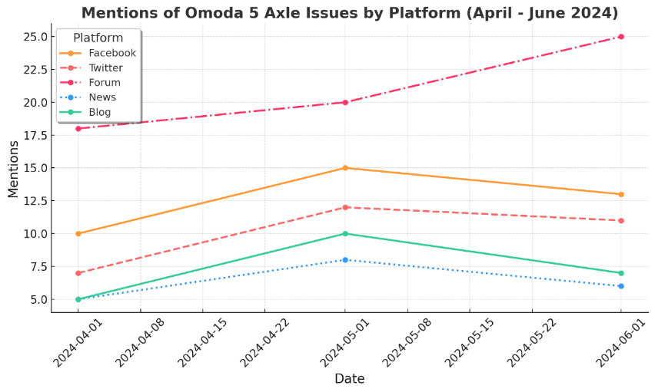
Figure 4 Omoda 5 axle issue exhibited a fluctuating trend

Figure 5 presents a comparative time series of monthly sales figures and the frequency of negative news mentions regarding the Omoda 5 axle issue throughout 2024. The graph clearly demonstrates an inverse relationship between the two variables: sales remained high and relatively stable from January to March, during which negative mentions were negligible or absent. However, starting in April, there was a marked increase in the number of negative news mentions, which rose sharply from 87 in April to a peak of 144 in May, before slightly declining to 120 in June.
Concurrently, sales figures experienced a substantial downturn, with a notable decline from 1,019 units in April to 513 units in May, and further to 355 units in June. This temporal alignment strongly suggests that the surge in negative news coverage was closely associated with the steep drop in sales. Statistical analysis corroborates this observation, with the calculated correlation coefficient between monthly sales and negative news mentions being -0.924. This value indicates a very strong negative correlation, implying that increases in the frequency of negative news are typically accompanied by decreases in sales.
The findings provide robust empirical support for the hypothesis that adverse online and media attention can have a significant and immediate impact on consumer purchasing behavior, particularly in the context of product recalls or perceived quality issues. The case of the Omoda 5 further highlights the vulnerability of models that constitute a large share of a brand’s sales portfolio to reputational shocks. In summary, Figure 5 visually and statistically underscores the critical influence of negative public opinion on market performance, emphasizing the importance for automotive manufacturers to monitor and proactively address negative sentiment in real time.

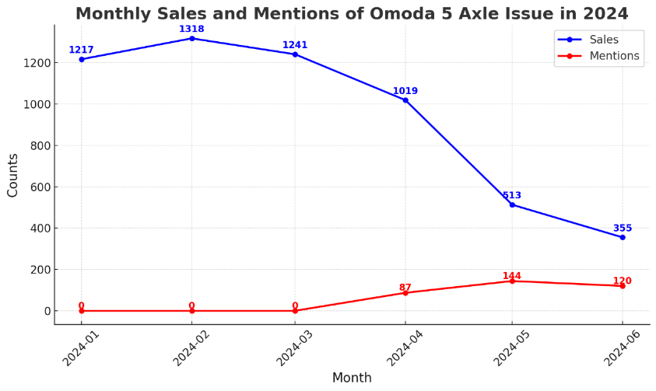
Figure 5 Monthly Sales and Mentions of Omoda 5 Axle Issue in 2024

Discussion
The findings of this study provide compelling evidence of the significant and immediate influence of negative online sentiment on the sales performance of the Chery Omoda 5 in Malaysia. The observed trends across multiple platforms, including social media, news outlets, forums, and blogs, demonstrate that spikes in negative public opinion—particularly those triggered by high-profile events such as product recalls—can rapidly propagate through the digital ecosystem and precipitate notable declines in sales.
The statistical analysis revealed a strong negative correlation (r = -0.924) between the frequency of negative news mentions and monthly sales figures, confirming that periods characterized by heightened negative publicity were closely followed by sharp reductions in sales. This temporal alignment is consistent with previous research indicating that electronic word-of-mouth (eWOM) and adverse digital narratives can shape consumer perceptions, reduce purchase intentions, and erode brand trust, especially in markets where online information channels are highly influential (Zhu et al., 2022; Sahoo et al., 2023; Xie et al., 2023).
Furthermore, the results highlight the amplifying effect of social media, with platforms such as Facebook and Twitter acting as critical vectors for both the diffusion and escalation of negative sentiment. The rapid increase in online discourse observed in May 2024, coinciding with the Omoda 5 recall, underscores the importance of real-time reputation monitoring and agile crisis response strategies for automotive manufacturers. The persistence of low sales figures in the months following the peak of negative mentions suggests that the reputational impact of such crises can extend beyond the immediate aftermath, affecting consumer confidence and market performance over an extended period.
These findings have important theoretical and managerial implications. Theoretically, this study contributes to the growing literature on digital consumer behavior by providing empirical evidence of the causal pathway linking negative online sentiment to real-world sales outcomes in the automotive sector. From a managerial perspective, the results stress the necessity for firms to invest in comprehensive digital monitoring systems, develop preemptive communication protocols, and implement recovery strategies designed to rebuild trust and mitigate long-term damage. This is especially critical for brands like Chery, where a single model accounts for a substantial proportion of overall sales, magnifying vulnerability to reputational shocks.
Despite the robustness of the findings, several limitations should be acknowledged. First, the study focuses on a single model and market context, which may limit the generalizability of the results to other brands, products, or regions. Second, while correlation and regression analyses offer strong evidence of association, causality cannot be definitively established without further experimental or longitudinal research. Finally, the sentiment classification relies on automated NLP techniques, which, despite being state-of-the-art, may still be subject to misclassification errors or contextual nuances that are difficult to capture algorithmically.
Future research could address these limitations by incorporating comparative analyses across multiple brands or countries, employing more advanced causal inference methods, and integrating multimodal sentiment data (such as images and videos) for a more comprehensive understanding of digital public opinion dynamics. Moreover, examining the effectiveness of different crisis management and recovery strategies in restoring consumer confidence would provide valuable guidance for practitioners navigating similar challenges in the digital era.
In summary, this study underscores the powerful and multifaceted impact of negative online sentiment on automotive sales and offers actionable insights for both scholars and industry practitioners. Proactive engagement with digital opinion trends and the development of robust response mechanisms are essential for maintaining resilience in an increasingly connected and reputationally sensitive marketplace.

Conclusion
This study provides empirical evidence of the substantial impact that negative online sentiment can exert on automotive sales, using the case of the Chery Omoda 5 in Malaysia as a focal point. Through a comprehensive big data analytical approach—encompassing sentiment analysis, statistical modeling, and visual exploration—the research demonstrates a strong and significant negative correlation between the frequency of negative online mentions and monthly sales figures (r = -0.924). The results indicate that periods of intensified negative publicity, particularly following the high-profile axle recall event, were closely associated with sharp and persistent declines in sales.
The analysis reveals that digital platforms, especially social media and news outlets, play a critical role in amplifying adverse public opinion and accelerating its diffusion throughout the market. This underscores the vulnerability of automotive brands with a concentrated sales portfolio, as negative sentiment toward a single flagship model can disproportionately affect overall market performance and long-term brand equity.
From a managerial perspective, these findings highlight the importance for automakers to invest in proactive digital reputation management, real-time sentiment monitoring, and agile crisis communication strategies. Timely and transparent engagement with online communities is essential not only for mitigating immediate reputational damage but also for restoring consumer trust in the aftermath of a public relations crisis.
Despite the robustness of these results, the study acknowledges certain limitations, such as its focus on a single model and market, as well as reliance on text-based sentiment classification. Future research should expand the scope to include comparative studies across different brands and regions, and explore the integration of additional data modalities, such as visual and video content, for a more holistic understanding of digital public opinion. Moreover, further investigation into the effectiveness of various crisis management strategies could provide actionable guidance for firms seeking to enhance their resilience in the face of adverse online sentiment.
In conclusion, this research contributes to the growing body of literature on digital consumer behavior and reputation management, offering actionable insights for both scholars and industry practitioners. As the influence of online discourse continues to rise, understanding and responding effectively to digital sentiment will remain a critical determinant of success in the contemporary automotive marketplace.

Implications
The findings of this study have several important implications for both academic research and industry practice.
Theoretical Implications: This research contributes to the growing literature on digital consumer behavior and reputation management by empirically demonstrating the strong link between negative online sentiment and sales performance in the automotive sector. The study extends existing models of electronic word-of-mouth (eWOM) by highlighting the temporal dynamics of sentiment-driven sales shocks and emphasizing the importance of real-time, platform-specific monitoring. The robust statistical association observed between negative news mentions and sales outcomes supports the argument that digital public opinion is not merely correlated with, but can be predictive of, market fluctuations in high-involvement product categories.
Managerial Implications: For automotive manufacturers and marketing professionals, the results underscore the necessity of proactive reputation management in the digital era. Companies should invest in real-time social listening tools and develop agile crisis communication protocols to swiftly address negative sentiment as it emerges. Given that the Omoda 5 accounted for the majority of Chery’s sales, the study highlights the risks associated with a concentrated product portfolio and the need for brand diversification. Timely and transparent engagement with online communities, as well as targeted outreach on platforms where negative sentiment is most pronounced (e.g., Twitter, Facebook, news sites), are essential to minimize reputational damage and restore consumer confidence. Furthermore, integrating digital sentiment analytics into sales forecasting and strategic planning can help firms better anticipate and respond to market disruptions.
Policy and Regulatory Implications: The strong influence of online public opinion on consumer behavior suggests that regulatory bodies should monitor the spread of misinformation or coordinated negative campaigns that could unduly harm businesses or mislead consumers. Policymakers might also consider providing guidelines or frameworks for digital crisis management, especially for industries where public safety and consumer trust are paramount.

Directions for Future Research:
This study lays the groundwork for broader investigations into the causal mechanisms linking digital sentiment and sales, including cross-country comparisons, multimodal sentiment analysis, and the evaluation of crisis management strategies. Exploring the long-term effects of reputational shocks and the role of recovery efforts could further inform both academic theory and managerial best practices.
In sum, this research emphasizes that effective management of online sentiment is no longer optional but essential for sustaining market performance and organizational resilience in an increasingly connected and reputation-driven business environment.

Reference
Zhu, Z., Li, S., & Wang, Z. (2022). Online reviews and high-involvement product sales: Evidence from the automotive industry. Industrial Marketing Management, 101, 136–149. https://doi.org/10.1016/j.indmarman.2021.12.003
Lee, K.-T., & Oh, J. E. (2020). The effect of competitive actions and social media perceptions on offline car sales after recalls. Transportation Research Part A: Policy and Practice, 138, 122–135. https://doi.org/10.1016/j.tra.2020.05.016
Zhang, Q., Wang, Y., & Liu, X. (2022). Intelligent vehicle sales prediction for new energy vehicle brands based on online public opinion and KOL sentiment. Sustainability, 14(7), 4182. https://doi.org/10.3390/su14074182
Liu, Y., Chen, W., & Wu, Z. (2022). A sentiment analysis model for car review texts based on adversarial training and whole word mask BERT. Knowledge-Based Systems, 241, 108198. https://doi.org/10.1016/j.knosys.2022.108198
Sharma, N. (2023). Determining the link between consumer sentiments and automobile sales using natural language processing. International Journal of Data Science and Analytics, 15(3), 211–225. https://doi.org/10.1007/s41060-023-00345-4
Sahoo, N., Dellarocas, C., & Srinivasan, S. (2023). The impact of negative reviews on online search and purchase: Evidence from a field experiment. Journal of Marketing Research, 60(2), 336–354. https://doi.org/10.1177/00222437221140347
Ding, Z., & Wang, Y. (2024). The impact of sentiment scores extracted from product descriptions on purchase intention. Electronic Commerce Research. Advance online publication. https://doi.org/10.1007/s10660-024-09678-5
Li, Z., Wang, R., & Sun, S. (2021). Propagation of online consumer perceived negativity: A supply chain perspective. Transportation Research Part E: Logistics and Transportation Review, 152, 102397. https://doi.org/10.1016/j.tre.2021.102397
So, X. (2020). What emotions make one or five stars? Explaining rating bias with explainable AI methods. Information Processing & Management, 57(6), 102385. https://doi.org/10.1016/j.ipm.2020.102385
Liu, Q., Liu, X., Wang, Y., & Tang, J. (2021). Understanding the effect of online review characteristics on purchase intention: A meta-analytic review. Journal of Business Research, 134, 528–539. https://doi.org/10.1016/j.jbusres.2021.05.029
Pai, P.-F., & Liu, C.-H. (2021). Predicting vehicle sales by sentiment analysis of Twitter data and stock market values. Applied Soft Computing, 101, 107049. https://doi.org/10.1016/j.asoc.2020.107049
Yin, Y., Huang, Y., Li, J., & Zhang, M. (2021). Mining consumer opinion from online reviews for automobile purchase: An ensemble method. Journal of Retailing and Consumer Services, 60, 102466. https://doi.org/10.1016/j.jretconser.2021.102466
He, S., Zhang, C., & Sun, H. (2022). Online review valence and product sales: The moderating role of review rating dispersion. Electronic Commerce Research and Applications, 54, 101171. https://doi.org/10.1016/j.elerap.2022.101171
Zhang, W., Zhang, X., & Liu, Y. (2021). Sentiment analysis on user reviews for car-sharing platforms: An empirical study in China. Technological Forecasting and Social Change, 166, 120643. https://doi.org/10.1016/j.techfore.2021.120643
Xie, H., Chen, H., Wang, J., & Xu, Y. (2023). The impact of negative online word-of-mouth on automotive brand equity: Evidence from China. Asia Pacific Journal of Marketing and Logistics, 35(2), 345–364. https://doi.org/10.1108/APJML-03-2022-0186
Du, Q., Cui, L., & Ma, J. (2021). Understanding the impacts of online word-of-mouth on automobile sales: A big data approach. Information & Management, 58(2), 103403. https://doi.org/10.1016/j.im.2020.103403
Yang, S., Zhao, Y., & Ma, Y. (2020). Analyzing consumer review content for product sales forecasting: A deep learning approach. European Journal of Operational Research, 285(2), 699–714. https://doi.org/10.1016/j.ejor.2020.02.016
He, Y., Chen, Q., Wang, X., & Tang, Q. (2020). Investigating the effects of online review content on product sales: The moderating role of review helpfulness. Internet Research, 30(6), 1807–1828. https://doi.org/10.1108/INTR-05-2019-0201
Liu, Y., Hu, M., Chen, S., & Wang, Q. (2022). The impact of user-generated content on product sales: Empirical evidence from the automotive industry. Technological Forecasting and Social Change, 177, 121495. https://doi.org/10.1016/j.techfore.2022.121495
Wang, X., Liu, Y., & Zhang, L. (2023). Influence of online reviews on sales: Evidence from the car market in China. Journal of Retailing and Consumer Services, 74, 103372. https://doi.org/10.1016/j.jretconser.2023.103372

