IOS-Based Travel Planning Application Using Agile Methodology

.

ABSTRACT

|  |
| --- |
| **Aims:** This research focuses on the development of an iOS-based application for a travel planning application called Find Your Way using Agile Methodology  **Study design:** This research uses Agile methodology which focuses on user needs, and there are 6 phases, namely planning, design, development, testing, deployment, review and repeated 2 iterations.  **Place and Duration of Study:** The study was conducted in Indonesia over a period of five months, from December 2024 to April 2025.  **Methodology:** This study will involve 4 informants with an age range of 18-35 years who are used as samples to find user functional needs. Interview data will be processed into user functional needs data in the planning phase and will produce user needs and application use case diagrams. Then the study continues with the development of application design in the design phase. The results of the application design will be implemented in the form of codes using iOS-based swift in the development phase. The results of the implementation will be tested using blackbox and whitebox testing. After that, the application will be deployed in the app store in the form of testflight. The application will be reviewed by 30 respondents with an age range of 18-25 using the UAT questionnaire in the review phase. Then the application will be launched on the app store in the launch phase. The 6 phases will be repeated 2 times to ensure the application is in accordance with user needs  **Results:** This research resulted in the Find Your Way application, a travel planning application based on the functional needs of users. There are five main needs identified, ranging from destination information, location and route recommendations, to storage and map display settings. The application was developed using the MVVM Clean Architecture architecture with three main layers: presentation, domain, and data. Testing was carried out using the blackbox and whitebox methods, as well as reviews using the User Acceptance Test (UAT) on 30 respondents aged 18–25 years with a final result of 97.33%. The deployment process was carried out using CI/CD via Xcode Cloud.  **Conclusion:** Find Your Way was successfully implemented optimally with functional test results (blackbox), program logic test (whitebox), and a final UAT score of 97.33% from 30 respondents aged 18–25 years. These results indicate that the application is able to meet the functional needs of users according to development objectives. |

*Keywords: Find Your Way, Particle Swarm Optimization, Agile Methodology, Optimal Route, Navigation Application, UAT*

1. INTRODUCTION

Generation Z, the generation born between the mid-1990s and early 2010s, is a generation that has a high curiosity and a great adventurous spirit and has a hobby, one of which is traveling. Traveling activities are not only used as a means of entertainment, but also as a way to seek new experiences, explore cultures, and enrich personal insights. For many Gen Z, traveling is an important part of lifestyle and self-expression (Medcom, 2017).

Interest in traveling among Gen Z also shows an increasing trend. As many as 76% of Gen Z admitted to being more interested in traveling than before. This figure reflects a significant increase in their interest in traveling activities. In terms of motivation, as many as 63% of Gen Z stated that the main reason they went on vacation was for "healing" or to relieve stress, emphasizing that vacations are no longer considered mere entertainment, but rather as an emotional need to maintain mental health (Sabri, 2025).

However, the desire for adventure is often hampered by financial constraints. Generation Z is known as the generation that pays the most attention to their expenses, including in terms of vacations. This is due to their relatively young age, so they do not yet have a large fixed income and do not have significant responsibilities. Therefore, in planning a trip, Gen Z tends to look for efficient solutions in terms of cost, especially in choosing a destination, to the travel route (Medcom, 2017).

Based on the results of interviews with 4 Gen Z people, several obstacles were found that they experienced in planning a trip. One of the most crucial obstacles is related to the time and distance between tourist destinations. They said that often the time and distance of the trip did not match the plan that had been made, so they were forced to reduce or even cancel visits to several previously planned tourist destinations. In addition, they also had difficulty in choosing a tourist destination, especially when looking for destinations that were around their area. This makes the travel planning process less efficient and tends to take longer.

In response to these problems, the Find Your Way Application was designed as an innovative solution to answer the functional needs of the user. This application aims to help tourists recommend optimal tourist routes along with providing time estimates and recommendations for nearby tourist attractions based on the categories desired by tourists so that tourists have a variety of tourist choices.

2. methodology

The Find Your Way application development method uses the SDLC (Software Development Life Cycle) approach by implementing the Agile methodology. The Agile methodology is the framework adopted to ensure smoothness and flexibility in the development of this system. The Agile methodology offers an iterative and collaborative approach, allowing developers to respond to changing needs and ensure the quality of the resulting software (Abrahamsson et al., 2017). The Agile methodology will be carried out 2 iterations with the first iteration focusing on developing applications according to user functional needs and the second iteration focusing on developing applications based on user feedback. The agile methodology flow diagram can be seen in Fig. 1

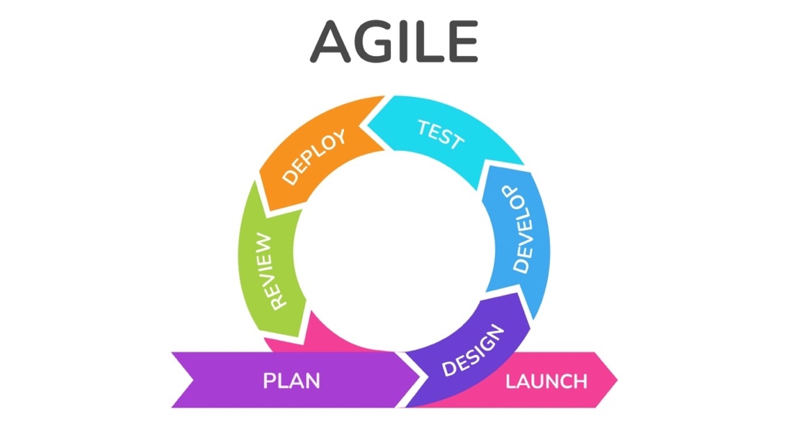

**Fig. 1 Agile Methodology Flow Diagram On Each Iteration**

**2.1 Planning**

The Planning stage in Agile Methodology is the initial stage that aims to summarize user needs and prepare a system development plan in several future iterations (Shankarmani et al., 2012). In the development of the Find Your Way application, 2 iterations will be used.

In the first iteration, an interview process will be conducted with 4 sources aged 18 - 25 years to obtain the functional needs of users from the application. The questions asked can be seen in table 1

**Table 1 Stage 1 Interview Question**

|  |  |
| --- | --- |
| **Code** | **Question** |
| Q1 | How do you plan your travel itinerary? |
| Q2 | Is it important for you to know the shortest route on your trip? |
| Q3 | Do you take into account travel time between destinations when planning your travel? |
| Q4 | Is it important for you to know the amount of time you can spend at each tourist spot? |
| Q5 | Have you ever been confused in determining a tourist destination? |
| Q6 | If yes, what factors do you usually consider in determining tourist destination recommendations? |
| Q7 | Have you ever used a travel planning app before? |
| Q8 | If yes, what do you think about the application? |

While in the second iteration, user needs will be defined based on previous feedback obtained at the review on stage 2

**2.2 Design**

At the design stage, the interface design of the Find Your Way application uses the iOS Design System, namely the iOS UI Kit which is officially provided by Apple. The selection of this Design System aims to adjust to the characteristics and standards of the iOS user environment, thus providing a consistent, intuitive user experience that is in accordance with platform design principles (Inc, 2025). The design process begins with the creation of a wireframe or low fidelity design as an initial framework that describes the structure and navigation flow of the application. Furthermore, the design is further developed into a high fidelity design with more detailed and realistic visual and interactive elements, as a reference in the user interface implementation stage in the application development process (Abrahamsson et al., 2017).

**2.3 Development**

At the development stage, the application design implementation process will be carried out in the form of codes (Abrahamsson et al., 2017). This implementation process will focus on developing iOS applications using Swift and several tech stacks that can be seen in Table 2

**Table 2 Tech Stack Application**

|  |  |
| --- | --- |
| **Type** | **Name** |
| Framework | iOS Native Development |
| Platform | iOS |
| Databases | Swift Data |
| Packages | Google Maps iOS SDK, Google Maps Place iOS SDK, Google Maps Navigation API, SwiftUI, UIKit, SwiftData, Combine, and Foundation |
| Architecture Patter | MVVM (Model-View-View Model) |
| Design Pattern | Repository Pattern, Delegates Pattern, and Dependency Injection |
| VCS | Git (Local) and Github (Remote) |
| Design | Figma |
| Tools | XCode, Simulator, and iOS SDK |
| CI/CD | XCode Cloud |
| Deployment | App Store Connect |

**2.4 Testing**

At the testing stage, testing is carried out by combining two main approaches, namely blackbox testing and whitebox testing, to ensure that the functionality and logic of the application run as expected. In blackbox testing, the Equivalence Partitioning technique is used which aims to group input into equivalent classes, so that each class can represent a series of relevant test conditions. This is done to test the application's response to various input variations without knowing the internal structure of the code (Wijaya & Astuti, 2021). Meanwhile, in whitebox testing, the Basis Path Testing method is used which aims to evaluate the logic path in the program code as a whole. The use of this basis path allows developers to identify and test each independent path in the program, so that they can ensure that the entire algorithm logic, including the PSO implementation, works correctly and efficiently (Londjo, 2021).

**2.5 Deploy**

At the deployment stage, the process of implementing the Find Your Way application into the production environment is carried out by utilizing the CI/CD (Continuous Integration/Continuous Deployment) service provided by Xcode Cloud. The use of Xcode Cloud enables automation in the build, testing, and distribution processes of applications to test devices and the App Store. With this CI/CD integration, every change to the source code sent to the repository will be immediately tested and built automatically, minimizing the risk of manual errors and accelerating the application release cycle. In addition, Xcode Cloud also supports efficient team collaboration by providing real-time build reports and test results, which helps developers to immediately detect and fix bugs before the application is launched to the public (Inc, 2025).

**2.6 Review**

The Find Your Way application review process involves the UAT (User Acceptance Testing) distribution stage to 30 respondents aged 18 - 25 years. This stage is carried out 2 times, namely when the application implementation for user needs iteration 1 is complete and when the application implementation for user needs iteration 2 is complete. This process will provide results and feedback from users to the application that can be implemented in the next iteration. The UAT questions can be seen in table 3

**Table 3 UAT Question**

|  |  |
| --- | --- |
| **Code** | **Question** |
| Q1 | Is the application user interface (UI) of this application easy to understand and user friendly? |
| Q2 | Did you find that the application was responsive to user input and performed its tasks smoothly without any hiccups or errors? |
| Q3 | Did you find it easy and did you experience few technical difficulties while using this application? |
| Q4 | Do you find the optimal route determination feature of this app easy to use? |
| Q5 | Are the nearby tourist recommendations on the app relevant and helpful in finding interesting tourist destinations? |
| Q6 | Do you feel that this application is reliable in providing travel recommendations and information related to travel routes? |

**2.7 Launch**

At the launch stage, the Find Your Way application is released to the public through Apple's official platform, namely App Store Connect. Through this service, applications that have been developed and tested are then packaged and sent for review by Apple. App Store Connect allows the development team to manage application metadata, such as descriptions, icons, screenshots, and application categories. After the application passes the Apple review process and is declared to meet all the provisions of the App Store Guidelines, the Find Your Way application is officially launched to the public through the App Store, so that it can be downloaded and used by iOS device users (Inc, 2025).

3. results and discussion

**3.1 Planning**

Determination of user functional needs was conducted by interviewing 4 people with an age range of 18-25 years. The summary of the interview results can be seen in table 1

**Table 4 Summary of User Functional Needs Interview Results**

|  |  |  |
| --- | --- | --- |
| **Codes** | **Question** | **Summary Result** |
| Q1 | How do you plan your travel itinerary? | Generally, the resource person will search for the tourist destinations they want to visit first, either through social media, destination wishlists, or suggestions from friends/family. Then, some resource persons will plan the trip either by determining the location or travel time from each destination. |
| Q2 | Is it important for you to know the shortest route on your trip? | All sources answered that it was important because it could save time and several sources also said that the shortest route could save travel costs, especially fuel costs. |
| Q3 | Do you take into account travel time between destinations when planning your travel? | All sources took into account travel time between destinations, because according to several sources, travel time between destinations is needed to find out how long it will take us to travel or arrive at our destination, and one source said that he wanted to visit... |
| Q4 | Is it important for you to know the amount of time you can spend at each tourist spot? | All sources answered that it was important because it was used to find out the duration of the tour and estimate how many places could be visited in one day. In addition, one source argued that travel time could also be used as a reference in knowing when the source would continue the tour to the next tourist destination. |
| Q5 | Have you ever been confused in determining a tourist destination? | All sources answered that they had felt confused in determining tourist destinations. |
| Q6 | If yes, what factors do you usually consider in determining tourist destination recommendations? | All sources answered that the location of the destination and type (restaurant, mall, zoo, etc.) were the main references for determining tourist destinations. Several sources also argued that the price and photos of the destination were also references in choosing a destination. |
| Q7 | Have you ever used a travel planning app before? | All of the interviewees answered that they had never used a travel planning application, but several interviewees said that they tended to use assistive applications such as Google Maps and social media such as TikTok and Instagram, to help plan routes and provide recommendations for places. |
| Q8 | If yes, what do you think about the application? | Several sources said that the Google Maps application is very useful in finding locations, routes and travel times from destinations you want to visit, and the Social Media application is used to provide recommendations for tourist destinations. |

Based on the interview results in Table 1, users still plan their travel manually by considering the location and travel time between destinations based on Q1. They consider the importance of determining the shortest route because it can save time and money based on Q2, and always consider the travel time and duration of visits to each tourist spot based on Q3 and Q4. This shows the need for a system that can recommend optimal travel routes based on distance and time.

In Q5 and Q6, all respondents admitted that they had been confused about choosing a destination and considering the location and type of tourist spot. This indicates the need for a system that recommends destinations according to user preferences, especially the type of tourism and the closest distance.

In addition, from Q7 and Q8, it is known that users have never used a special travel planning application, but rely on Google Maps and social media. Therefore, the application needed must be able to help with travel planning while providing complete information such as types of tourism, locations, prices, and images.

In addition, at the review stage in iteration 1, there was some feedback from users based on the UAT results in iteration 1. The UAT results stated that users wanted to be able to save routes that had been inputted into the application so that they could be used later. In addition, there was also feedback where users also wanted to be able to see several other types of maps according to user needs such as satellite and terrain maps. This feedback will be processed into user needs to be implemented in the application.

The conclusion of functional requirements is described in Table 5

**Table 5 User Functional Requirements**

|  |  |
| --- | --- |
| **Codes** | **User Functional Requirement** |
| KF-01 | Users need a system that can be used to view tourist destination information and plan travel practically in the same application. |
| KF-02 | Users need a system that can recommend tourist destinations according to their wishes based on the closest distance. |
| KF-03 | Users need a system that can recommend travel routes from several destinations based on the shortest distance, estimated travel time between locations, and the duration of time spent at each destination. |
| KF-04 | Users need a system that allows them to save the inputted travel routes so that they can be accessed and reused at a later date. |
| KF-05 | Users need a system that allows them to change the type of map display according to their preferences, such as standard, satellite, or terrain maps. |

Based on the user's needs, a use case diagram of the application can be prepared as in Figure 2.

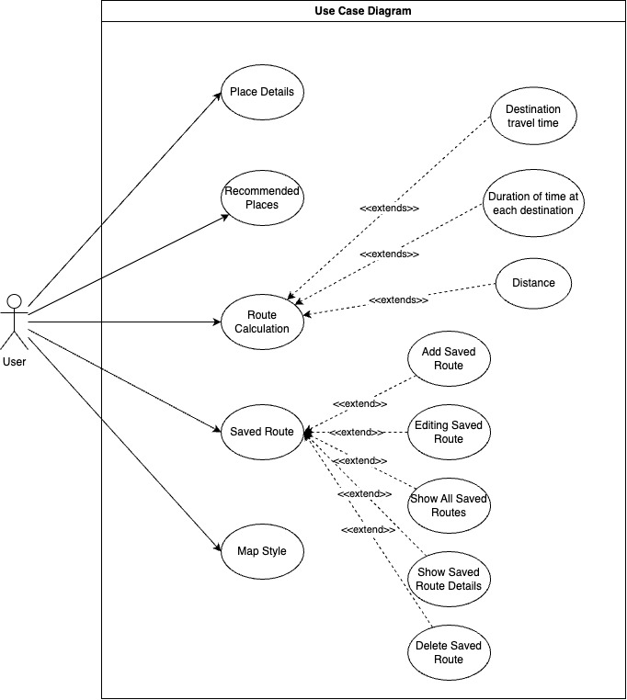

**Fig. 2 Use Case Diagram**

In the use case diagram in Figure 2, there is 1 actor, namely the user of the Find Your Way application and it has 5 main features based on the user's functional needs, namely recommendations for nearby tourist attractions based on categories entered by the user which refer to KF-01, detailed tourist information which refers to KF-02, route calculations from several tourist destinations which refer to KF-03, saved route features which refer to KF-04, and map style features which refer to KF-05.

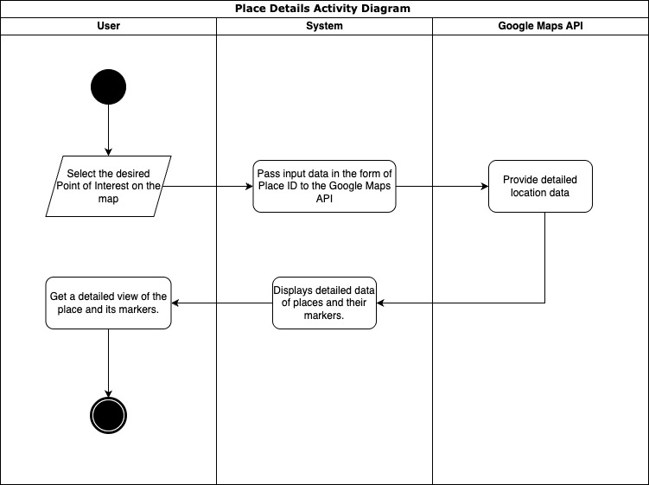

**Fig. 3 Place Details Activity Diagram**

The Place Detail Activity Diagram at Figure 3 illustrates the flow when a user wants to view details of a place or Point of Interest (POI) in the application. The process begins when the user opens the interactive map view and explores the available POIs. After selecting a POI by tapping on an icon or marker, the system retrieves the PlaceID, a unique identifier from Google Maps, and sends it to the Google Maps API to request details of the place. The API responds in JSON format containing information such as the place name, full address, operating hours, ratings, number of reviews, and photos (if any). This data is then parsed and displayed in an easy-to-read interface. The POI marker is also displayed back on the map as visual context for the user.

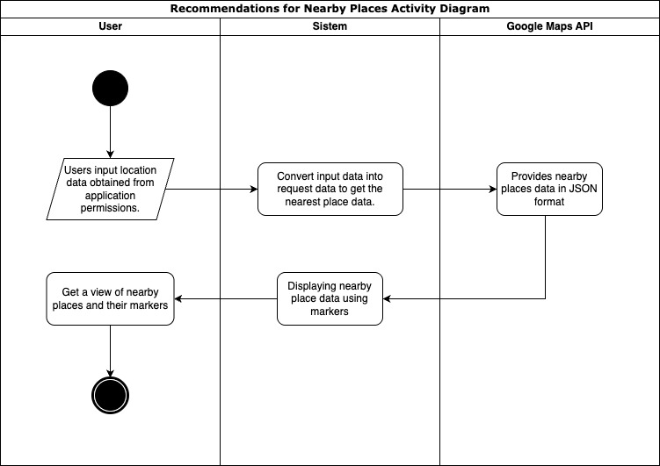

**Fig. 4 Recommendations for Nearby Place Activity Diagram**

Based on the Activity Diagram in Figure 4, the process of finding the nearest place begins when the user grants location access permission to the application. After obtaining the user's location through the permission given, the system will convert the location data into a format suitable for sending as a request to the Google Maps API. This request aims to obtain information about the nearest places from the user's current position. Next, the Google Maps API will respond by returning data in JSON format containing a list of the nearest places along with their details. The system then processes the data and displays it to the user via a map display by adding markers to each nearest location found. With this display, users can easily see and select places that are relevant to their needs directly from the application map.

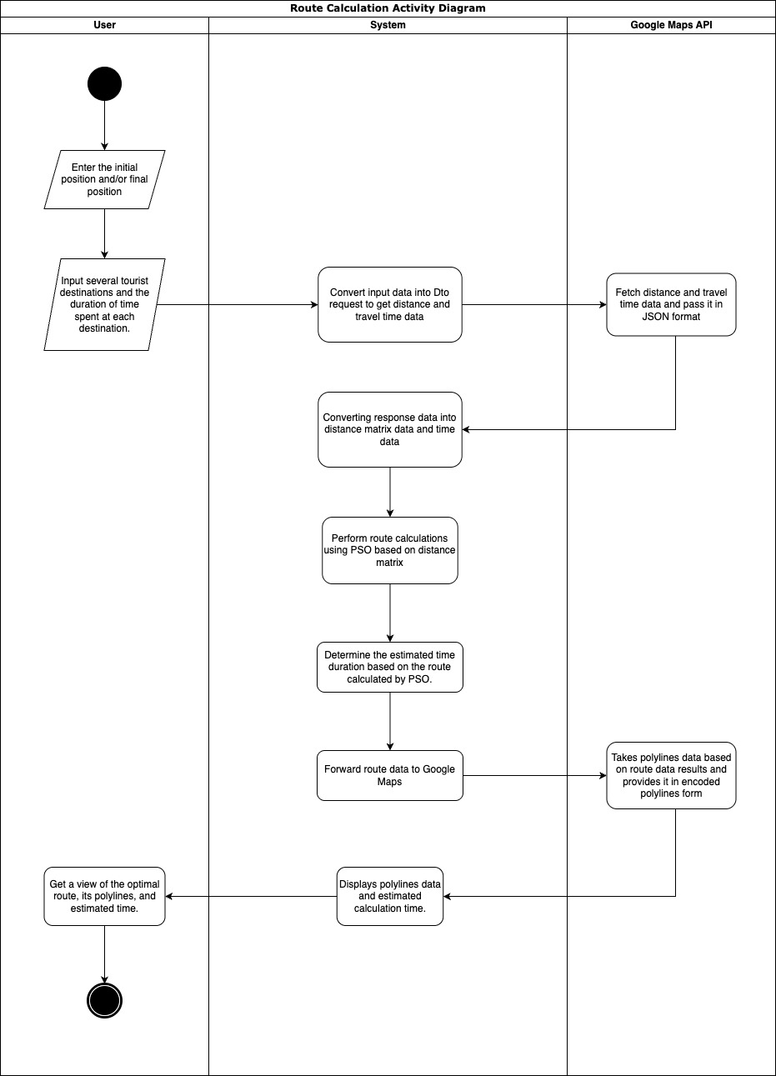

**Fig. 5 Route Calculation Activity Diagram**

The Activity Diagram in Figure 5 explains the workflow of the travel route calculation feature in the system. The process begins when the user accesses this feature and enters data such as starting point, destination point, list of tourist destinations, and estimated duration of visit at each location. After the input is complete, the system forms a request to the Google Maps API to obtain distance information and estimated travel time between destinations. The API will respond in JSON format containing distance and travel time matrix data, which is then parsed by the system. Distance data is used in the route optimization process using the Particle Swarm Optimization (PSO) algorithm to determine the most efficient visit sequence. Meanwhile, travel time and visit duration data are used to calculate the estimated total travel time. Finally, the calculation results are displayed as a route visualization in the form of polylines on the map, depicting the complete travel path from start to finish.

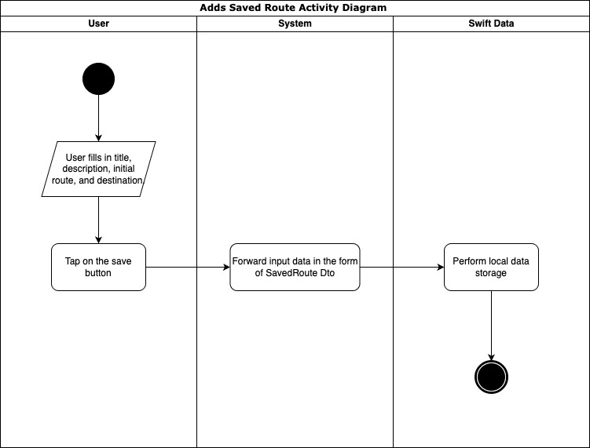

**Fig. 6 Saved Route Activity Diagram**

In Figure 6, the user is asked to fill in all the required data before saving the route, such as title, description, initial position, destination, duration time at each destination, and/or final position of the route to be saved. After all the information is filled in completely, the user will press the "Save" button to start the saving process. Next, the data that has been input will be processed by the system and sent to local storage using Swift Data, which acts as a data persistence medium in the application. By using this approach, the system ensures that the data entered by the user is stored securely

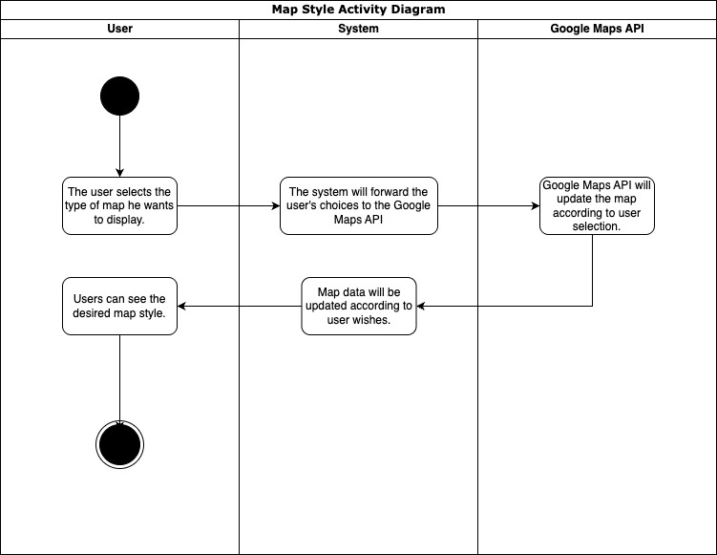

**Fig. 7 Map Style Activity Diagram**

Based on the Activity Diagram in Figure 7, the map style change process begins when the user selects the desired map type through the application interface. This choice can be various types of maps such as standard maps, satellite, or terrain available in the settings options. After the user makes a selection, the system will capture the input and forward it as a request to the Google Maps API. Google Maps API then processes the request by changing the map style according to the user's choice. After the map style change is complete, the API will send map update data back to the system. The system then displays the map with the new style in real-time on the application screen, so that users can immediately see the map display that has been adjusted to their preferences. This process ensures responsive interaction and a more personalized user experience in using the application. In addition, the system also saves the map style preferences selected by the user so that they can be applied automatically for subsequent use. Thus, users do not need to reset every time they open the application, thus providing convenience and comfort in long-term use. This feature also increases application efficiency by reducing the burden of repetitive data processing.

**3.2 Design**

For the application design, it can be seen in Figure 8, where the application design focuses on a single view application to make it easier for users to navigate. Users will always have full access to the map and some features will be tucked away using modal sheets, so that users can focus on the map utility.

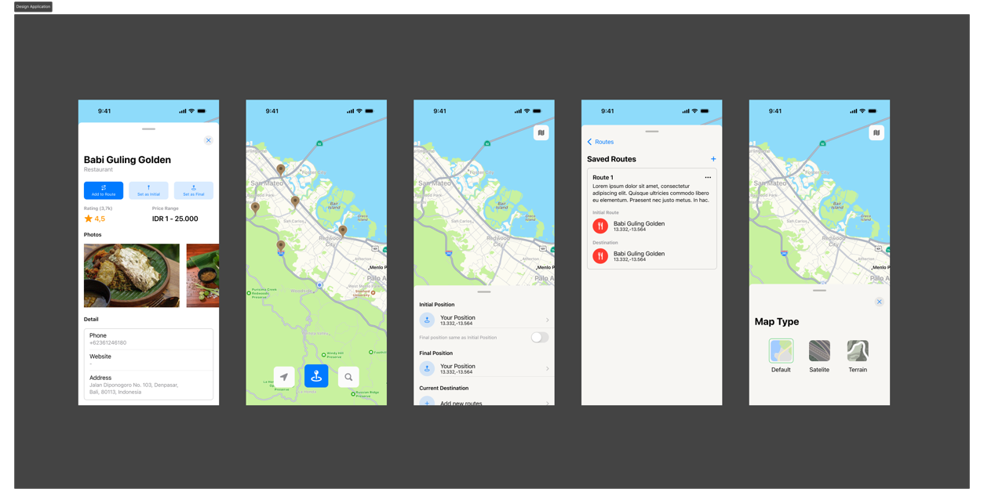

**Fig. 8 Design Application**

**3.3 Development**

Application development stage, using MVVM Clean Architecture architecture which is divided into 3 main folders, namely presentation, domain, and data. The presentation folder is used to store view related code such as screen, viewModel, event, and widgets. The domain folder is used to store protocol files such as repository protocol, actual model, and also application business logic. And data is used to store files related to data providers such as Dto, repository implementation, and data providers. The architecture flow application can be seen on Fig. 9 and for the implementation can be seen on Fig. 10

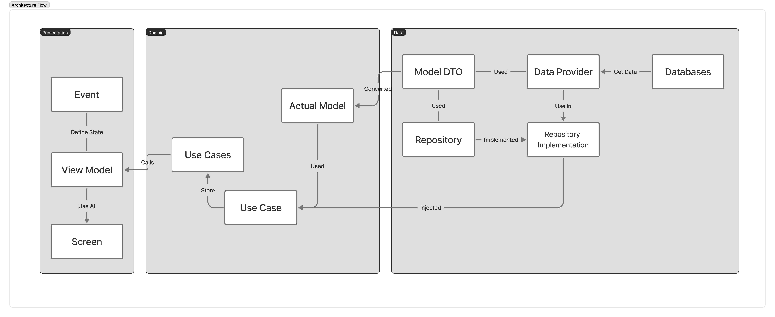

**Fig. 9 Architecture Flow Application**

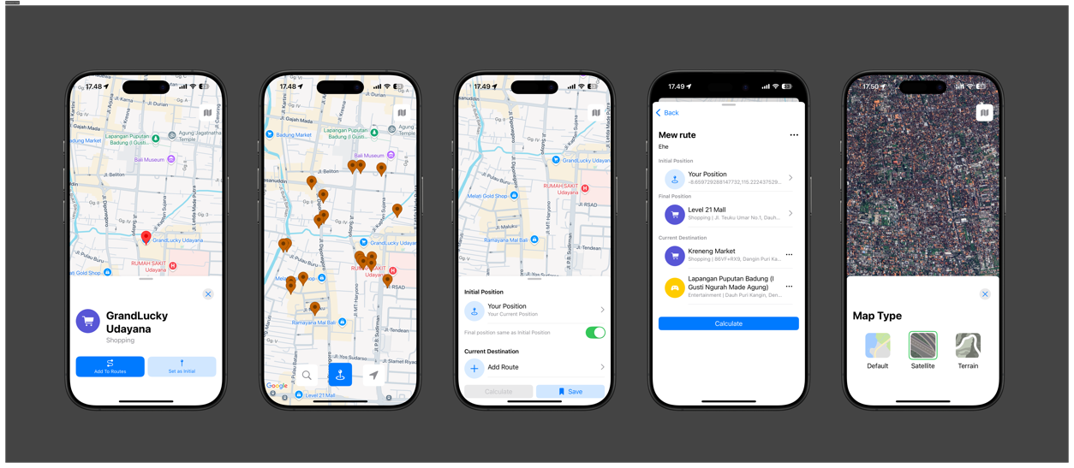

**Fig. 10 Application Implementation**

**3.4 Testing**

The implemented Find Your Way application was tested using blackbox and whitebox testing to test the application's functionality. Blackbox testing of the application can be seen in Table 6 -10 which focuses on providing validation based on the input and output provided to the application. The results of blackbox testing show that all test scenarios provided are acceptable as they should be and meet the application's functionality.

**Table 6 Result Detail Place Test**

|  |  |  |  |  |
| --- | --- | --- | --- | --- |
| **Code** | **Test Case** | **Expected Result** | **Actual Result** | **Summary** |
| T1 | User clicks on one of the Points of Interest | Markers and detail modals will appear and display data from that point. | Markers and detail modals appear as expected. | Accepted |
| T2 | While the marker and detail modal are still visible, the user clicks any point on the map. | The marker will disappear and the detail modal will close. | The marker disappears and the detail modal closes. | Accepted |
| T3 | While the marker and modal details are still visible, the user closes the modal. | The marker will disappear and the detail modal will close. | The marker disappears and the detail modal closes as expected. | Accepted |

**Table 7 Search Nearby Test Result**

|  |  |  |  |  |
| --- | --- | --- | --- | --- |
| **Code** | **Test Case** | **Expected Result** | **Actual Result** | **Summary** |
| T1 | User clicks search and looks for the nearest search category. | A marker will appear and the location will appear on the map. | The marker appears and the location appears on the map as expected. | Accepted |
| T2 | User clicks on Point of Interest marker | The recommendation marker will disappear and the detail modal will appear. | The recommendation marker is gone and the detail modal appears as expected. | Accepted |

**Table 8 Calculate Route Test Result**

|  |  |  |  |  |
| --- | --- | --- | --- | --- |
| **Code** | **Test Case** | **Expected Result** | **Actual Result** | **Summary** |
| Q1 | The user adds the destination, initial position, and/or final position and clicks the calculate button. | Route calculation and time estimate will be visible and the result modal will appear. | Route calculation and time estimation are visible and the result modal will appear. | Accepted |
| Q2 | User did not add any destination and did not add any final position at all. | The calculate button will be disabled | Calculation button disabled as expected | Accepted |

**Table 9 Saved Route Test Result**

|  |  |  |  |  |
| --- | --- | --- | --- | --- |
| **Code** | **Test Case** | **Expected Result** | **Actual Result** | **Summary** |
| T1 | The user fills in the title, description, initial position, and destination and clicks save. | The route will be saved and displayed in the SavedRoute modal. | The route is saved and appears in the SavedRoute modal as expected. | Accepted |
| T2 | User did not fill in any of the fields | The capital will be closed and a pop up will appear if all the mandatory fields are filled in. | The capital is closed and a pop up appears if all the mandatory fields are filled in as expected. | Accepted |

**Table 10 Map Style Test Result**

|  |  |  |  |  |
| --- | --- | --- | --- | --- |
| **Code** | **Test Case** | **Expected Result** | **Actual Result** | **Summary** |
| T1 | User selects the type of map desired | Maps will be changed to user's choice | Maps are changed to user's choice as expected | Accepted |

Meanwhile, the results of whitebox testing carried out using the basis path technique are presented in Table 11, and show that all logical paths in the program have been tested and produce appropriate output. Based on the results of both types of testing, it can be concluded that the route recommendation feature functions well and has met the acceptance criteria.

**Table 11 White Box Test Result**

|  |  |  |  |  |  |
| --- | --- | --- | --- | --- | --- |
| **Region** | **Condition** | **Input** | **Expected Output** | **Actual Output** | **Summary** |
| 1. | No iteration (⁠maxIter = 0⁠) | w: 1.0, c1: 1.0, c2: 1.0, numParticles: 2, maxIter: 0, distanceMatrix: [[0, 10], [10, 0]] | [0, 1, 0] | [0, 1, 0] | Accepted |
| 2. | All conditions are false | w: 0.0, c1: 0.0, c2: 0.0, numParticles: 2, maxIter: 1, distanceMatrix: [[0, 10, 20], [10, 0, 5], [20, 5, 0]] | [0, 1, 0] | [0, 1, 0] | Accepted |
| 3. | Only pbest update | w: 0.5, c1: 2.0, c2: 0.0, numParticles: 2, maxIter: 1, distanceMatrix: [[0, 1, 5], [1, 0, 1], [5, 1, 0]] | [0, 1, 0] | [0, 1, 0] | Accepted |
| 4. | Only gbest update | w: 0.5, c1: 0.0, c2: 2.0, numParticles: 2, maxIter: 1, distanceMatrix: [[0, 4, 3], [4, 0, 2], [3, 2, 0]] | [0, 1, 2, 0] | [0, 1, 2, 0] | Accepted |
| 5. | pbest and gbest update | w: 0.5, c1: 2.0, c2: 2.0, numParticles: 2, maxIter: 1, distanceMatrix: [[0, 1, 3, 4], [1, 0, 1, 2], [3, 1, 0, 1], [4, 2, 1, 0]] | [0, 1, 2, 3, 0] | [0, 1, 2, 3, 0] | Accepted |
| 6. | Iteration > 1 with combination of conditions | w: 0.5, c1: 2.0, c2: 2.0, numParticles: 3, maxIter: 5, distanceMatrix: [[0, 2, 9, 10], [2, 0, 6, 4], [9, 6, 0, 3], [10, 4, 3, 0]] | [0, 1, 3, 2, 0] | [0, 1, 3, 2, 0] | Accepted |

**3.5 Deploy**

The application deployment process is carried out by utilizing the TestFlight feature available in the App Store Connect. TestFlight functions as an application distribution platform in the testing phase, allowing developers to send application builds to test users before the application is officially launched to the public. In this way, feedback from user testing can be collected to improve and refine the application before the final release.

In this process, the application build is created and deployed automatically using the CI/CD pipeline integrated with Xcode Cloud, as shown in Figure 6. The use of Xcode Cloud enables automation in building, testing, and distributing applications more efficiently and consistently. This ensures that any code changes can be immediately tested by the team and user testers through TestFlight, so that the development and testing process runs faster and more structured.

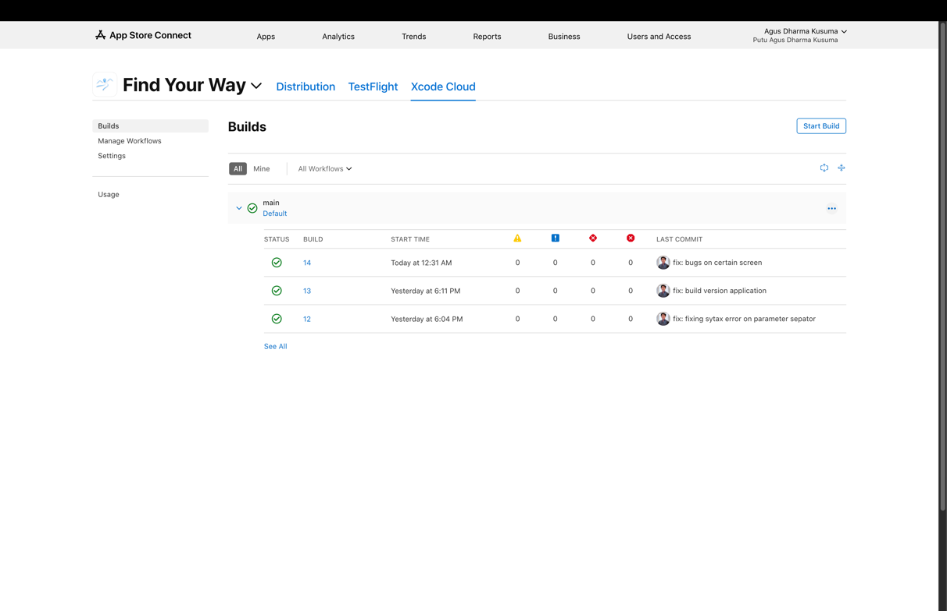

**Fig. 11 XCode Cloud CI/CD**

**3.6 Review**

Based on the lastest results of the User Acceptance Test (UAT) at Table 12, that conducted on 30 respondents aged 18–25 years, the final score was 97.33%. This score indicates that the majority of respondents feel that the Find Your Way application has met their needs in planning a practical and efficient travel trip. Achieving this value is a strong indicator that the developed system is able to provide a user experience that is in accordance with the expectations and functional needs that have been identified at the planning stage. Thus, it can be concluded that this application has succeeded in answering user problems.

**Table 12 UAT Result**

|  |  |  |  |  |
| --- | --- | --- | --- | --- |
| **Question** | **Variable** | **Bobot** | **Respondents Total** | **Actual Score** |
| Is the application user interface (UI) of this application easy to understand and user friendly? | Strongly Agree | 5 | 23 | 115 |
| Agree | 4 | 7 | 28 |
| Netral | 3 | 0 | 0 |
| Disagree Less | 2 | 0 | 0 |
| Disagree | 1 | 0 | 0 |
| **Total** | | | **30** | **143** |
| Did you find that the application was responsive to user input and performed its tasks smoothly without any hiccups or errors? | Strongly Agree | 5 | 26 | 130 |
| Agree | 4 | 4 | 16 |
| Netral | 3 | 0 | 0 |
| Disagree Less | 2 | 0 | 0 |
| Disagree | 1 | 0 | 0 |
| **Total** | | | **30** | **146** |
| Did you find it easy and did you experience few technical difficulties while using this application? | Strongly Agree | 5 | 25 | 125 |
| Agree | 4 | 5 | 20 |
| Netral | 3 | 0 | 0 |
| Disagree Less | 2 | 0 | 0 |
| Disagree | 1 | 0 | 0 |
| **Total** | | | **30** | **145** |
| Do you find the optimal route determination feature of this app easy to use? | Strongly Agree | 5 | 26 | 130 |
| Agree | 4 | 4 | 16 |
| Netral | 3 | 0 | 0 |
| Disagree Less | 2 | 0 | 0 |
| Disagree | 1 | 0 | 0 |
| **Total** | | | **30** | **146** |
| Are the nearby tourist recommendations on the app relevant and helpful in finding interesting tourist destinations? | Strongly Agree | 5 | 27 | 135 |
| Agree | 4 | 3 | 12 |
| Netral | 3 | 0 | 0 |
| Disagree Less | 2 | 0 | 0 |
| Disagree | 1 | 0 | 0 |
| **Total** | | | **30** | **147** |
| Do you feel that this application is reliable in providing travel recommendations and information related to travel routes? | Strongly Agree | 5 | 29 | 145 |
| Agree | 4 | 1 | 4 |
| Netral | 3 | 0 | 0 |
| Disagree Less | 2 | 0 | 0 |
| Disagree | 1 | 0 | 0 |
| **Total** | | | **30** | **149** |
| **% Total Score** | | | | **97,33%** |

**3.7 Launch**

After that the application can be published on the App Store platform. The application that has been developed will be reviewed again by Apple and if it is still lacking, Apple will provide feedback on the application and if it is safe, the application can be directly accessed to the public. The application can be downloaded in <https://apps.apple.com/id/app/find-your-way/id6744858864>

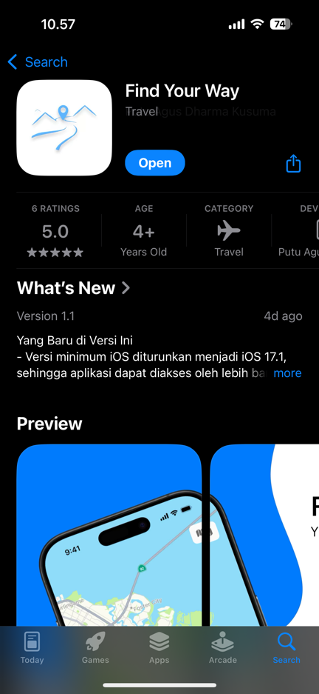

**Fig. 12 App Store Launch Application**

4. Conclusion

Based on the results of testing and evaluation, it can be concluded that the Find Your Way application has been successfully implemented optimally. This feature not only passed the functional test through the blackbox method and the program logic test through the whitebox method, but also obtained a final UAT score of 97.33% from 30 respondents aged 18–25 years. These results indicate that the Find Your Way application is able to meet the functional needs of users in accordance with the purpose of its implementation.

References

Abrahamsson, P., Salo, O., Ronkainen, J., & Warsta, J. (2017). *Agile Software Development Methods: Review and Analysis* (Version 1). arXiv. https://doi.org/10.48550/ARXIV.1709.08439

Inc, A. (2025). Apple Developer. Apple Developer. https://developer.apple.com/

Londjo, M. F. (2021). IMPLEMENTATION OF WHITE BOX TESTING WITH PATH-BASED TECHNIQUE IN LOGIN FORM TESTING. Jurnal Siliwangi Seri Sains dan Teknologi, 7(2), Article 2. https://doi.org/10.37058/jssainstek.v7i2.4086

Medcom, id. (2017, October 6). This is the Difference in Travel Preferences for Each Generation. medcom.id. https://www.medcom.id/rona/wisata-kuliner/3NOEl4yk-ini-perbedaan-preferensi-travelling-tiap-generasi

Rusydi Umar & Prasetyo Hari Prabowo. (2016). Mobile-Based Travel Search and Booking with Google Maps API. Annual Research Seminar: Computer Science and Information and Communications Technology 2016, Indonesia.

Sabri, H. A. (2025). 30+ Statistics and Travel Trends of Gen Z [2025 Update]—Businesstourism. https://bisniswisata.co.id/30-statistik-dan-tren-perjalanan-gen-z-pembaruan-2025/

Shankarmani, R., Pawar, R., S. Mantha, S., & Babu, V. (2012). Agile Methodology Adoption: Benefits and Constraints. International Journal of Computer Applications, 58(15), 31–37. https://doi.org/10.5120/9361-3698

Wijaya, Y. D., & Astuti, M. W. (2021). BLACKBOX TESTING OF EMPLOYEE PERFORMANCE ASSESSMENT INFORMATION SYSTEM PT INKA (PERSERO) BASED ON EQUIVALENCE PARTITIONS. Digital Journal of Information Technology, 4(1), Article 1. https://doi.org/10.32502/digital.v4i1.3163