### Hybrid CNN-Haralick Framework for Foot and Mouth Disease Classification in Cattle

### *Abstract*

### ***Foot and Mouth Disease (FMD) poses a major challenge to livestock health, resulting in notable economic losses and threatening food security.*** *This study introduces a hybrid classification model that combines Convolutional Neural Network (CNN) for spatial feature extraction with texture analysis using Haralick features. Evaluated on a curated dataset of FMD-infected and healthy cattle images, the hybrid model demonstrated a notable improvement over other existing pure deep learning and CNN models, achieving an overall classification accuracy of 94%. Generally, the framework exhibited a balanced f1-score, precision and recall across all classes, addressing challenges such as overlapping patterns and class imbalance. By leveraging complementary spatial and texture-based features, the approach enhances diagnostic accuracy, offering a novel approach for FMD classification. This research underscores the value of hybrid models in advancing veterinary diagnostics and lays the groundwork for broader applications in livestock disease monitoring systems.*

***Keywords****: Machine Learning, Convolutional Neural Network, Haralick Features, Hybrid Classification framework, Foot and Mouth Disease, Livestock Health.*

# INTRODUCTION

Foot and Mouth Disease (FMD) is a highly contagious viral illness that affects cloven-hooved animals, causing substantial economic losses globally (Awada, 2021). The disease has significant implications for livestock health, particularly in cattle, sheep, and goats. Wildlife species, including deer and antelope, are also susceptible, with some, such as African buffalo, serving as asymptomatic carriers (Awada, 2021).

The economic and environmental costs of FMD outbreak far outweigh the preventive expenses associated with early detection and response mechanisms. Effective surveillance not only mitigates the adverse impacts of an outbreak but also bolsters a nation's reputation as a reliable trading partner (Awada, 2021). Timely and accurate diagnostic measures are therefore vital in minimizing the social and economic repercussions of FMD.

Traditional diagnostic practices, including visual inspections by veterinarians are time-consuming, subjective, and prone to error. Farmers often rely on rudimentary remedies, such as burning neem leaves or disinfecting farms, before seeking veterinary assistance (Tikarya et al., 2023). However, advances in Artificial Intelligence (AI) and Machine Learning (ML) have introduced transformative tools for veterinary science, enabling automated cattle recognition, disease detection, behavior analysis, and health monitoring (Mate et al., 2024).

According to Ahmad et al. (2024) Convolutional Neural Networks (CNNs) are widely used in these domains for extracting spatial features indicative of disease symptoms, such as lesions and discoloration. However, CNNs alone may face challenges when diseases share overlapping visual characteristics. To address these limitations, texture-based analyses provide an additional layer of diagnostic accuracy by examining pixel intensity relationships. Features such as contrast, entropy, and correlation, derived from Gray-Level Co-Occurrence Matrices (GLCM) can reveal subtle variations in disease-specific patterns that spatial analysis may miss (Haralick et al., 1973; Sutton et al., 2018).

This study proposes a hybrid framework that combines the spatial feature extraction capabilities of CNNs with Haralick-based texture analysis to improve FMD classification in cattle. The dual-input architecture processes raw image data through a CNN pathway and normalized Haralick features through a secondary pathway, with their outputs concatenated in fully connected layers for final predictions. This approach addresses challenges such as overlapping symptoms with other diseases (e.g., Foot and Mouth Disease, Lumpy Skin Disease etc) and imbalanced datasets using class weighting and data augmentation techniques.

Evaluated on a curated dataset of FMD-infected and healthy cattle, the proposed framework demonstrated superior diagnostic precision compared to traditional CNN models. By integrating spatial and texture features, this hybrid model enhances disease detection capabilities while offering scalability for automated livestock health monitoring. This study contributes to the development of reliable tools for improving animal health, economic stability, and food security on a global scale. The rest of this Paper is organized as follows: Section 2 contains the literature review while Section 3 contains the methodology. Results are analyzed and discussed in Section 4 while Section 5 concludes the paper.

# LITERATURE REVIEW

* 1. **Applications of Texture Analysis in Disease Detection**

Choi et al. (2022) proposed a novel approach for classifying the health status of calves into normal and abnormal categories using a combination of GLCM features and CNNs. The dataset comprised 177 images of healthy calves and 130 images of unhealthy calves. Six texture attributes—energy, correlation, contrast, homogeneity, dissimilarity and entropy were extracted via GLCM and subsequently integrated into the CNN for classification. The model achieved an impressive classification accuracy of 91.3%, alongside precision, recall, and F1-score values of 89.8%, 89.1%, and 89.4%, respectively.

Shinde et al. (2024) proposed an automated cattle disease detection framework leveraging CNNs, specifically the VGG16 architecture. The study addressed the critical need for timely and objective diagnosis of common cattle diseases, including FMD, Infectious Bovine Keratoconjunctivitis (IBK), and Lumpy Skin Disease (LSD). The VGG16 model, pre-trained on ImageNet, was fine-tuned for cattle disease classification, enabling it to extract disease-relevant features effectively. This transfer learning approach achieved a test accuracy of 88.14%, demonstrating its potential for practical application in livestock health systems.

Genemo et al. (2023) proposed an innovative framework for detecting and classifying LSD in cattle, leveraging a combination of deep learning based segmentation and classification techniques. The methodology employed a 10-layer CNN to extract deep spatial features and segment disease-affected regions, followed by an Extreme Learning Machine (ELM) for classification. The framework was validated on the Cattle’s LSD dataset, comprising 1,100 images of lumpy and non-lumpy skin disease cases, divided into training (800), testing (200), and validation (100) subsets. Various metrics were used to evaluate the framework's performance, including an overall classification accuracy of 90.12%, sensitivity of 89.98%, specificity of 94.7%, and a precision of 94.68%. To optimize feature representation, the study incorporated techniques such as local color-controlled histogram intensity values (LCcHIV) to enhance contrast in affected regions, and a meta-heuristic feature selection strategy to reduce computational overhead and irrelevant feature inclusion.

Khan et al. (2023) proposed a hybrid deep learning model combining VGG-19 and DenseNet121 for animal breed classification. The methodology involved preprocessing the Animal-10 dataset using steps like edge detection, normalization, and image resizing. Data augmentation techniques, such as horizontal flipping, were applied to increase the diversity of the dataset. The integration of VGG-19 and DenseNet121 allowed the model to leverage hierarchical features from both networks, enhancing its ability to differentiate between seven animal classes (butterfly, cat, cow, dog, elephant, spider, and squirrel). The model achieved a training accuracy of 96.43% and a validation accuracy of 91%, outperforming existing models like InceptionV3, ResNet-50, MobileNet, and VGG-16 in accuracy and loss metrics. It demonstrated significant improvements in image-based species classification

Tito et al. (2024) explored predictive modeling for FMD outbreaks using ML algorithms, focusing on attribute correlations and risk factor analysis. The study utilized a dataset of 266 bovine sera samples collected from Ethiopia's East Wollega zone and applied five ML models: Naïve Bayes, Multilayer Perceptron (MLP), Sequential Minimal Optimization (SMO), AdaBoostM1, and REP Tree. Performance metrics such as accuracy, Kappa statistic, precision, recall, F1-score, and Matthews Correlation Coefficient (MCC) were evaluated, with the MLP model demonstrating the highest overall performance. Specifically, MLP achieved an accuracy of 82.21%, a precision of 88.2%, and the highest MCC of 0.753.

Permana et al. (2024) developed a CNN-based cattle disease classification system targeting three prevalent conditions in the Semin District: Bovine Ephemeral Fever (BEF), Mastitis, and Scabies. The dataset used consisted of 864 training images and 216 validation images sourced from the Semin Veterinary Health Center. The system employed a CNN architecture with Conv2D layers, ReLU activation, and MaxPooling for feature extraction, followed by fully connected layers for classification. The model achieved a testing accuracy of 93.06% with a loss of 0.4430. The study also demonstrated the system's practical application through a mobile app, which provided classification predictions with accuracies of 80%, 97%, and 81% for BEF, Mastitis, and Scabies, respectively.

* 1. **Hybrid Models Integrating Spatial and Texture Features**

Heikal et al. (2024) proposed an approach to enhance the differentiation task between benign and malignant Breast Tumors (BT) using histopathology images from the BreakHis dataset. Both feature extraction and classification tasks are employed by a Custom CNN. The experimental results show that the proposed approach using the Custom CNN model exhibits better performance with an accuracy of 84% than applying the same approach using other pretrained models, including MobileNetV3, EfficientNetB0, VGG16, and ResNet50V2, that present relatively lower accuracies, ranging from 74 to 82%; these four models are used as both feature extractors and classifiers. To increase the accuracy and other performance metrics, Grey Wolf Optimization (GWO), and Modified Gorilla Troops Optimization (MGTO) metaheuristic optimizers are applied to each model separately for hyperparameter tuning. In this case, the experimental results showed that the Custom CNN model, refined with MGTO optimization which is a texture feature, reaches an exceptional accuracy of 93.13% in just 10 iterations, outperforming the other state of the art methods.

Guo et al. (2024) proposed a novel unsupervised breast cancer image classification model based on multiscale texture analysis and a dynamic learning strategy for mammograms. First, a GLCM and Tamura Coarseness are used to transfer images to multiscale texture feature vectors. Then, an unsupervised dynamic learning mechanism is used to classify these vectors. In the simulation experiments with a resolution of 40 pixels, the accuracy, precision, F1-score and AUC of the proposed method reached 91.5%, 92.7%, 91.3%, and 91.5%, respectively.

There has been a low turnout of research on developing hybrid models which integrate texture based models alongside spatial models for the detection and classification of FMD. Though there have been standalone CNN and texture based models which have explored and introduced different approaches to classifying and detecting cattle diseases. We even have hybrid approaches in other domains.

This study aims to integrate the statistical gray-level invariant Haralick features into a classification framework, utilizing classifiers such as deep learning convolutional neural models. This approach seeks to enhance the performance and accuracy of texture-based image analysis across diverse imaging conditions.

# METHODOLOGY

This section outlines the research design, dataset collection and preprocessing, Haralick feature extraction with specified GLCM features, data splitting, model architecture, and the compilation and training strategies employed in developing a hybrid deep learning model for detecting FMD in cattle while ensuring reproducible and valid results..

## 3.1. Research Design

The study adopts a quantitative methodology to design and evaluate a hybrid classification model that combines Convolutional Neural Networks (CNNs) with Haralick texture features. The primary objective is to classify cattle health conditions (healthy vs. diseased) using image-based diagnostics. The integration of Haralick texture features enhances the spatial features extracted by CNNs, enabling the model to detect subtle texture-based variations. A comparative analysis was conducted between the hybrid model and baseline models to assess improvements in classification performance, including accuracy and precision.

**3.2. Dataset Collection and Preprocessing**

The dataset for this research is sourced from Osborn University’s FMD Cattle Dataset (2024), which contains images of cattle muzzles, mouths, tongues, hooves, and feet in healthy and diseased states. To ensure uniform input dimensions for the neural network, all images were resized to 224×224 pixels, and pixel values were normalized to the range [0, 1] to facilitate efficient training by standardizing the input scale. Images and their corresponding labels were converted to arrays for seamless integration into the machine learning pipeline. To further enhance the model's ability to generalize, data augmentation was incorporated during preprocessing. Transformations such as rotation, width/height shifting, shear transformations, zooming, and horizontal flipping were applied to artificially expand the training dataset. These augmentations ensured that the model was exposed to a variety of orientations and perspectives, enhancing robustness without altering the core disease-relevant features..

### 3.3. Haralick Feature Extraction

To capture disease-relevant texture features, the Gray-Level Co-occurrence Matrix (GLCM) was employed to compute Haralick features. Each image was converted to grayscale to focus on intensity-based patterns, simplifying the extraction process. The GLCM was calculated using a distance of 1 pixel across four directional angles (0°, 45°, 90°, and 135°) to comprehensively analyze pixel relationships in multiple orientations. Haralick features such as contrast, homogeneity, energy, and correlation were extracted, providing detailed statistical representations of texture that complement the spatial features extracted by the CNN.

**3.3.1. GLCM Features**

Contrast: Generally, an association among pixels, its neighbors, causing it to escalate.

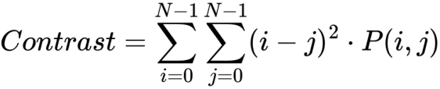

(1)

**Energy: Energy yields the total of squared components inside the GLCM with an esteem of to**

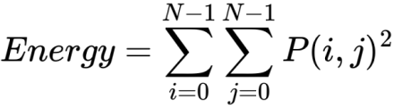

(2)

Correlation: It diverts a degree of how close neighbors all of a pixel are associated to ought the total picture.

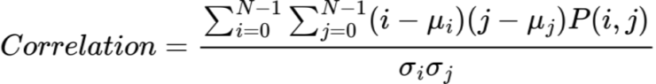

(3)

Homogeneity: it indicates uniformity. As the GLCM elements gradually move away from the diagonal, the number of Homogeneity increases geometrically.

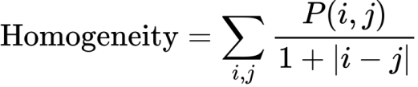

(4)

)

### Where:

P(i,j) is the probability value at position (i,j) in the GLCM.

N is the number of gray levels in the image.

C:/Users/Hp/AppData/Local/Temp/wps.Rqxftqwps is row i and column j.

wps is the standard deviations of row i and column j.

### 3.4. Data Splitting and Augmentation

### The dataset was divided into training (70%), validation (15%), and testing (15%) subsets using stratified sampling to ensure balanced class representation. This systematic splitting approach minimized the risk of class imbalance adversely affecting the model's performance.

### 3.5. Model Architecture

The proposed hybrid model integrates spatial and texture features, accepting two inputs: CNN-extracted spatial features and Haralick texture features. The CNN component comprises three convolutional layers with ReLU activation, each followed by Batch Normalization and MaxPooling, with Global Average Pooling applied to reduce dimensionality. Haralick features, after standardization, were passed through Batch Normalization layers. The spatial and texture features were concatenated and fed into a fully connected dense layer with 128 units and ReLU activation, followed by Dropout regularization to mitigate overfitting. The final output layer utilized a softmax activation function for classification into disease categories. Figure 1 illustrates the architecture of the hybrid model.

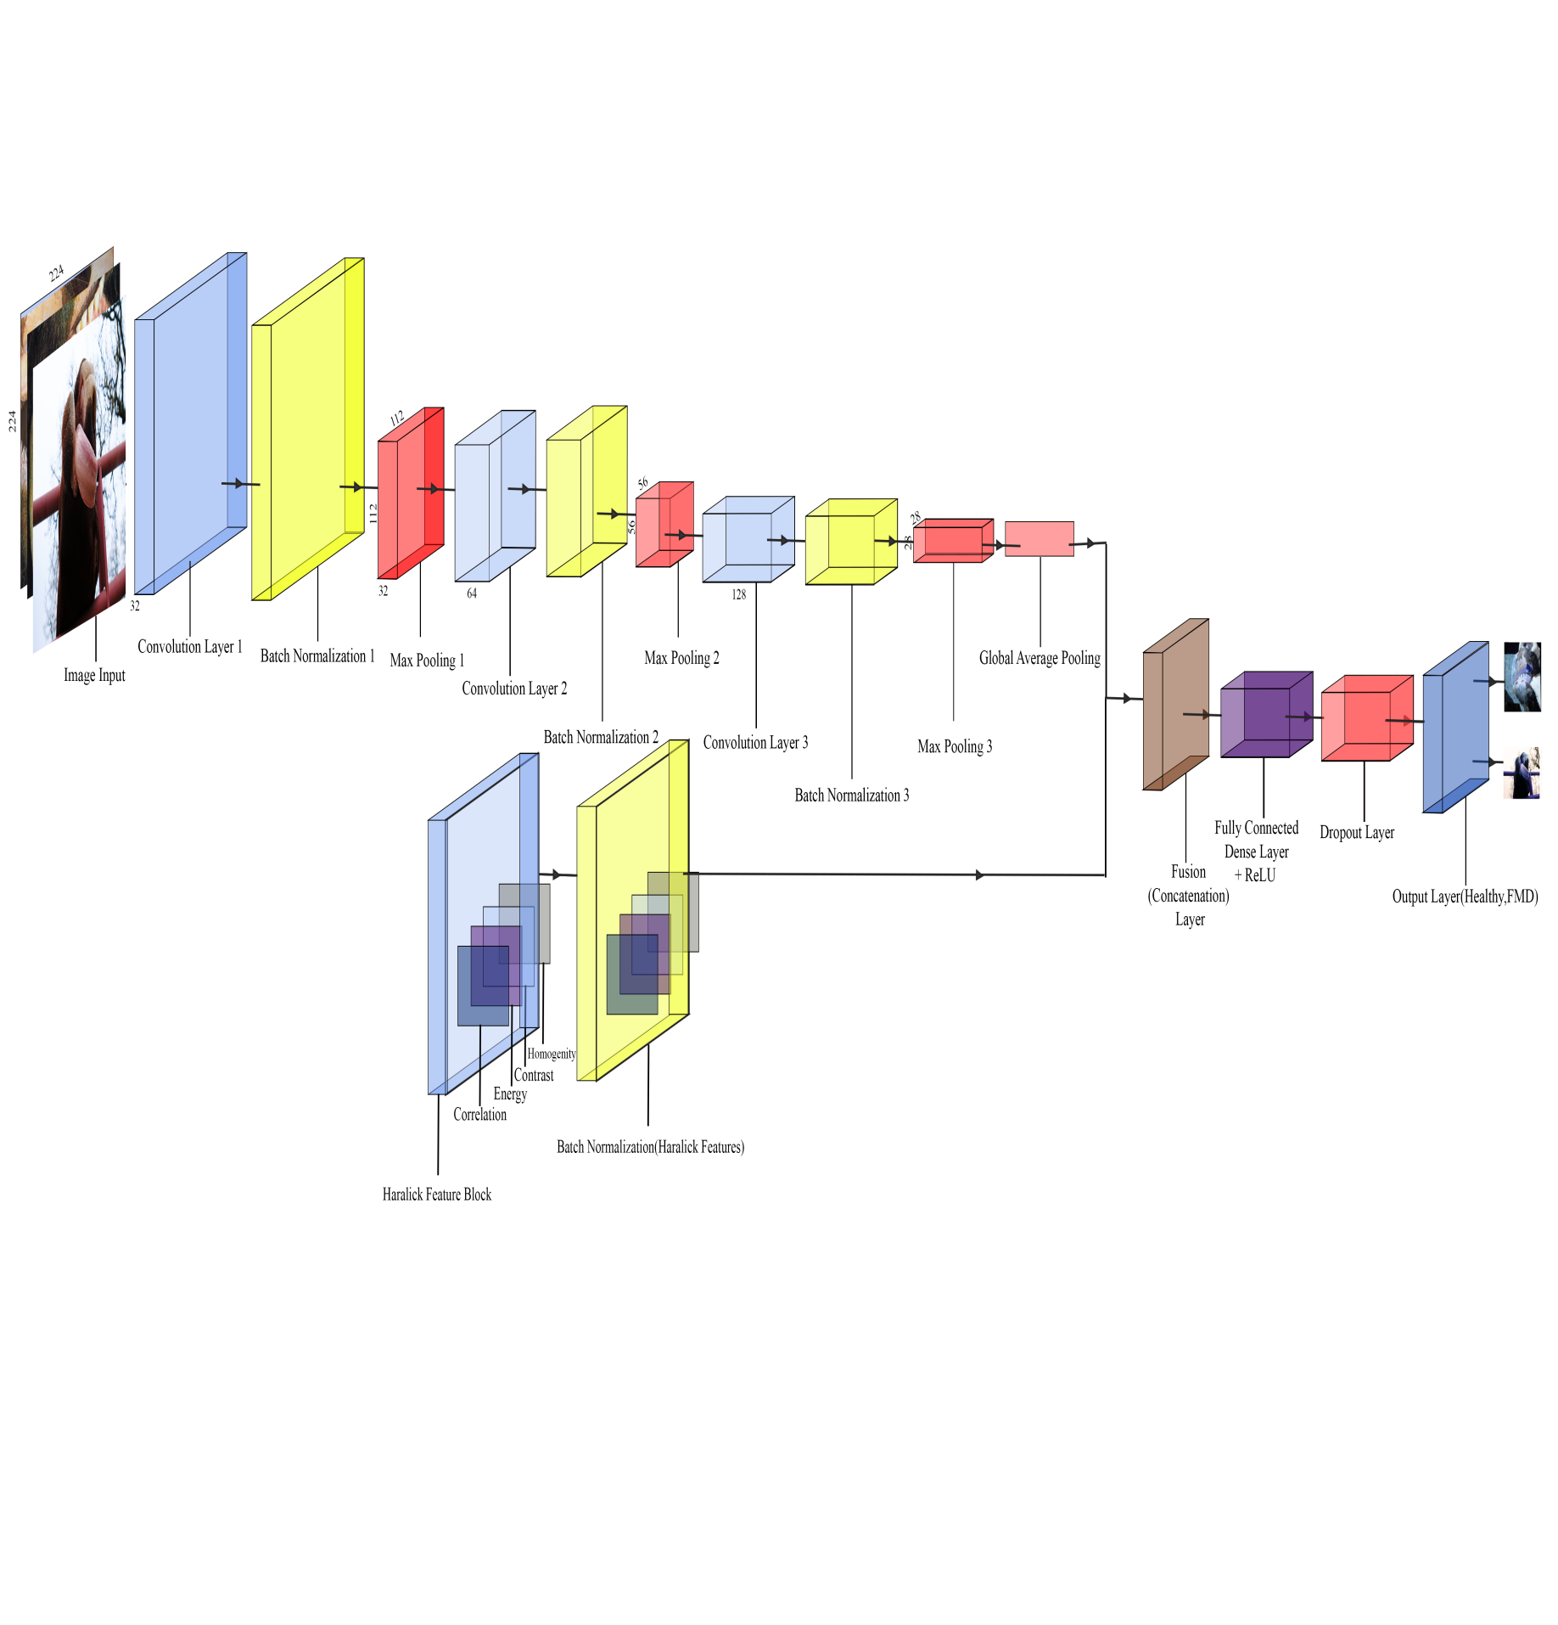

**Figure 3: CNN-HARALICK Architecture**

### 3.6 Model Compilation and Training

The model was compiled using the Adam optimizer, chosen for its adaptability in handling sparse gradients, with an initial learning rate of 1e-2. The categorical cross-entropy loss function was employed to quantify discrepancies between predicted and actual class probabilities, enabling effective back propagation. To mitigate the influence of class imbalance, class weights were introduced to ensure that underrepresented classes contributed equitably to the loss function.

To further enhance training efficiency, callbacks were incorporated. EarlyStopping monitored the validation loss, halting training after 10 consecutive epochs of no improvement to prevent overfitting and reduce computation time. Additionally, ReduceLROnPlateau dynamically adjusted the learning rate when the validation loss plateaued, fine-tuning the model's parameters for optimal performance. The training process spanned 40 epochs with a batch size of 32, balancing computational efficiency with robust gradient updates.

By combining CNNs' ability to extract spatial features with Haralick texture features' representation of fine texture details, the hybrid model achieves improved classification accuracy, addressing the limitations of single-modality approaches. Data preprocessing steps, including normalization and augmentation, ensured that the input data was robust and prepared for efficient model training.

### 3.7 Performance Metrics

The model's effectiveness was evaluated using the following metrics:

1. **Accuracy**:  
   The ratio of correctly classified samples to the total number of samples in the evaluation datasets:

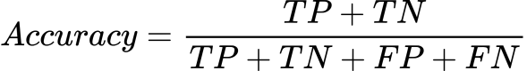​

(5)

1. **Recall (Sensitivity)**:  
   The ratio of correctly classified positive samples to all samples assigned to the positive class:

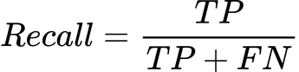

(6)

1. **Precision**:  
   The ratio of correctly classified samples to all samples assigned to that class:

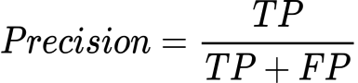

(7)

1. **F1-Score**:  
   The harmonic mean of precision and recall, penalizing extreme values of either metric

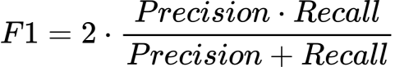

(8)

Where:

FP stands for False Positive

TP stands for True Positive

TN stands for True Negative

FN stands for False Negative

# RESULTS AND DISCUSSION

The performance of the hybrid CNN-Haralick model using a range of metrics, including accuracy, precision, recall, F1-score, and a comparative analysis with benchmark models, was evaluated.

**4.1. Model Performance Metrics**

This section summarizes the classification report for the hybrid CNN-Haralick model. The classification report presented in Figure 2 and Table 1 gives an evaluation of the models predictive ability for the diseased and healthy classes which includes the overall accuracy, f1-score, precision and recall highlighted in section 3 on the validation dataset

.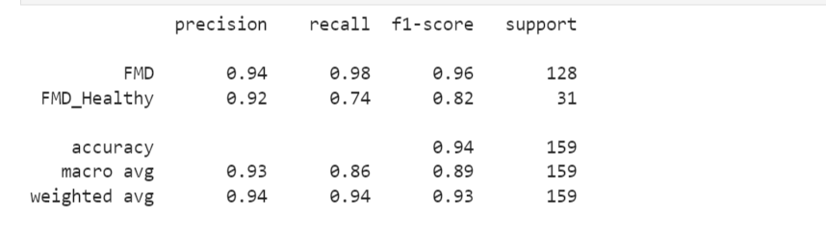

**Figure 2:** Screenshot of Classification Report of the Hybrid CNN-Haralick Model

**Table 1:** Classification Report for the Hybrid CNN-Haralick Model

|  |  |  |  |  |
| --- | --- | --- | --- | --- |
| **Class/**  **Metrics** | **Precision** | **Recall** | **F1-score** | **Support** |
| FMD | 94% | 98% | 96% | 128 |
| Healthy | 92% | 74% | 82% | 31 |
| Macro Avg | 93% | 86% | 89% | 159 |
| Weighted Avg | 94% | 94% | 93% | 159 |

The Weighted Avg Recall of 94% demonstrates the model's balanced performance across classes, despite the inherent imbalance in the dataset.

**4.2. Confusion Matrix**

Figure 3 below shows the confusion matrix, which provides a detailed breakdown of predictions against actual labels. The matrix illustrates that the model performed exceptionally well in classifying FMD, with near-perfect predictions.

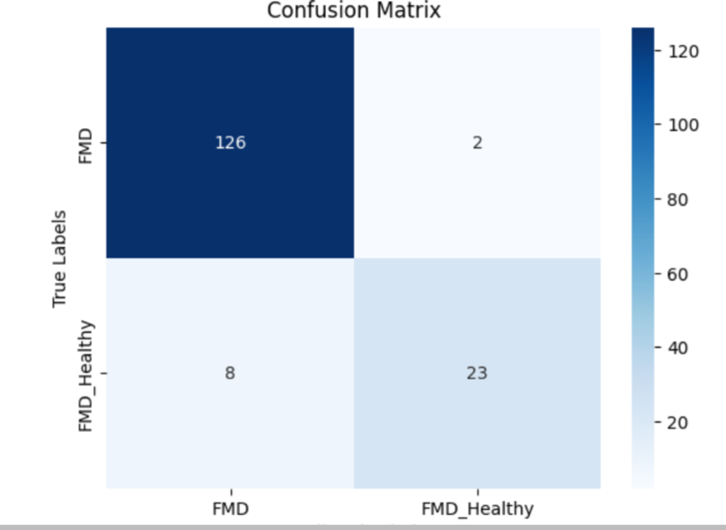

**Figure 3:** Confusion Matrix Visualization

**4.3. Comparison with Benchmark Models**

The hybrid CNN-Haralick model was compared against two benchmark models: a stand-alone CNN and a traditional GLCM-based approach. As shown in Table 2, the hybrid model outperformed both benchmarks in all evaluated metrics, particularly in recall and F1-score for the minority class (healthy cattle).

**Table 2:** Comparison of Proposed Hybrid CNN-Haralick Model with Benchmark Models

|  |  |  |  |  |
| --- | --- | --- | --- | --- |
| **Methodology** | **Accuracy** | **Precision** | **Recall** | **F1-Score** |
| Naive-Bayes | 81.39% | 82.0% | 81.4% | 81.3% |
| Traditional GLCM | 91% | 89% | 89% | 89% |
| **Hybrid CNN-Haralick** | **94%** | **93%** | **86%** | **89%** |

**4.5 Feature Importance Analysis**

The contribution of Haralick texture features to the model's performance was evaluated. The top contributing GLCM properties are shown in Figure 4 and Table 3 below.

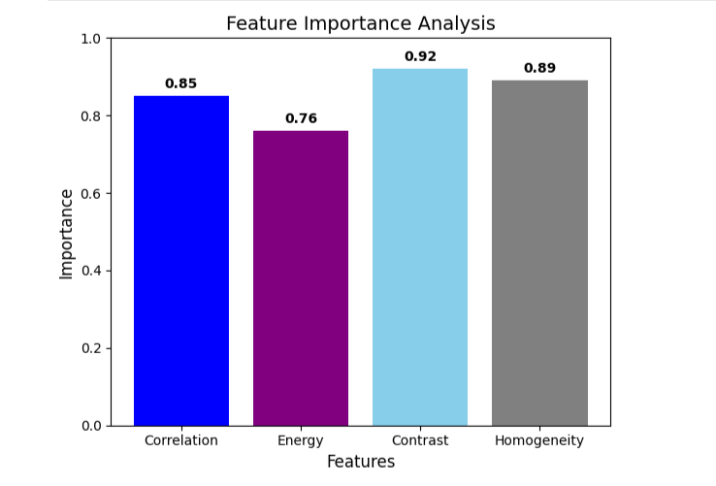**Figure 4: Feature Importance Bar Plot**

**Table 3:** Feature Importance Analysis

|  |  |
| --- | --- |
| **Feature** | **Importance** |
| Correlation | 0.85 |
| Energy | 0.76 |
| Contrast | 0.92 |
| Homogeneity | 0.89 |

Energy: Identification of repetitive patterns allowed for clearer separation between healthy and diseased textures.Contrast, which measures the intensity difference between neighboring pixels, proved essential in identifying disease-specific patterns. In FMD-infected cattle, contrast values were higher due to the presence of lesions and irregular textures. These variations enabled the model to detect rough or eroded patches on diseased areas, significantly boosting its ability to distinguish between healthy and diseased samples.

Correlation, a feature that quantifies the linear dependency between pixel pairs, contributed to the accurate classification of healthy cattle. Healthy samples often exhibit smooth and consistent textures, reflected in higher correlation values. By emphasizing these uniform patterns, the model was better equipped to reduce false positives in the healthy class, improving its overall recall.

Homogeneity, which captures the closeness of pixel intensity distributions, was particularly useful in detecting uniform regions in healthy cattle. This feature helped the model differentiate smooth, undisturbed textures from the coarse textures associated with FMD. By leveraging homogeneity, the hybrid model demonstrated superior performance in distinguishing healthy samples, even in cases with mild discoloration.

Energy, a measure of texture uniformity, contributed significantly to identifying strong, repetitive patterns in the dataset. This feature proved advantageous in separating healthy textures from the uneven patterns typical of disease. The presence of energy as a key texture property allowed the model to focus on identifying areas of consistent pixel intensity in both healthy and diseased samples.

**4.5.1. Comparative Advantage over Other Approaches**

In comparison to stand-alone CNNs, which excel at spatial feature extraction, the inclusion of Haralick features addressed the limitations of classifying subtle texture variations. For instance, lesions that appear similar in shape but differ in texture were better identified when the hybrid model incorporated Haralick features. This synergy between spatial and texture analysis provided a robust mechanism for capturing disease-specific patterns.

Similarly, while traditional GLCM-based models are effective in analyzing texture, they lack the ability to extract spatial features. By integrating Haralick features with CNNs, the hybrid model bridged this gap, delivering superior classification performance. The ability to simultaneously analyze texture and spatial features significantly reduced false negatives in the healthy cattle class. Table 4 shows the comparison of the proposed hybrid model with other state of the art models used in classification of animal diseases.

**Table 4:** Comparison of Proposed Model with other State of the Art Models

|  |  |  |  |  |
| --- | --- | --- | --- | --- |
| **Author(s)** | **Methodology** | **Scope** | **Accuracy** | **Precision** |
| Choi et al. (2022) | *GLCM and Artificial Neural*  *Networks* | *Classification of Livestock Disease* | *91.3%* | 89.8% |
| Genomo (2023) | *Extreme Learning Machine (ELM)* | *Detecting high-risk Area for Lumpy Skin Disease in Cattle* | *90.12%* | *90.19%* |
| Shinde et al. (2024) | *VGG16 Architecture.* | *Developed a system that classify common cattle disease.* | *88.14%.* |  |
| Yashu et al. (2024) | *Synergizing CNN and Random Forest* | *Idenntification of Cattle Diseases* | *91.56%* | range from 88.12% to 97.57% |
| Permana et al. (2024) | *CNN* | *Classification of Cattle Diseases in Semin District* | *93.06%* | 93% |
| Tito et al. (2024) | *Naïve Bayes, MLP,*  *SMO, AdaBoostM1, REP Tree* | *Deciphering Foot and Mouth Disease Predictive Modeling* | 81.39% 82.20% 86.04% 83.72% 83.72% | 82.0%  88.2%  89.0%  86.5%  87.7% |
| Khan et al. (2023) | *VGG-19 and*  *DenseNet121* | *Animal Breed Classification and Prediction* | *91%* |  |
| **Own Study (2025)** | ***CNN-Haralick Framework*** | ***Classification of Cattle Disease*** | ***94%.*** | **93%** |

**5. CONCLUSION**

The hybrid CNN-Haralick model demonstrates robust performance in classifying FMD and healthy cattle, particularly in addressing class imbalance through effective feature analysis. By integrating texture-based Haralick features with spatial-feature extraction, the model bridges the gap between subtle texture variations and spatial information, delivering superior classification performance with overall Accuracy of 94%, F1-score of 89%, Precision value of 93% and Recall of 86%.

**5.1. Future Works and Recommendations**

The hybrid model effectively combines spatial and texture feature analysis, offering a balanced approach that surpasses the limitations of stand-alone CNNs and traditional GLCM-based models. This advancement addresses class imbalance and subtle texture variations, making it a valuable contribution to the field of cattle disease classification.

To further improve the model's generalizability, future work should focus on expanding the dataset by incorporating images from diverse cattle breeds, environmental conditions, and disease stages. Including images of early-stage symptoms and varying disease severities can help the model capture subtle differences, leading to better detection accuracy across a broader range of scenarios. Additionally, sourcing data from multiple regions can ensure the model's applicability to real-world conditions and global agricultural needs.

While this study relied on image-based diagnostics, integrating additional modalities, such as clinical data (e.g., temperature, heart rate) or behavioral metrics (e.g., feeding patterns, movement analysis), could enhance the system’s predictive power. Multi-modal approaches would allow the model to identify disease indicators that are not visually apparent, leading to a more comprehensive diagnostic tool for livestock health management.

# References

Ahmad, M., Usama, M., Mazzara, M., & Distefano, S. (2025). WaveMamba: Spatial-Spectral Wavelet Mamba for Hyperspectral Image Classification. *IEEE Geoscience and Remote Sensing Letters*, *22*, 1–5. https://doi.org/10.1109/lgrs.2024.3506034

Awada, L., Lambergeon, N., Morales, R., Mur, L., Tizzani, P., Melens, P., & Caceres, P. (2021). *OIE • 12, rue de Prony • 88 SG/2 Current Animal Health Situation Worldwide: Analysis of Events and Trends*.

Choi, D.-O., Huan, M., & Kang, Y.-J. (2022). Classification of Livestock Diseases Using GLCM and Artificial Neural Networks. *International Journal of Internet, Broadcasting and Communication*, *14*, 173–180. https://doi.org/10.7236/IJIBC.2022.14.4.173

GENEMO, M. (2022). Detecting High-risk Area for Lumpy Skin Disease in Cattle Using Deep Learning Feature. *Advances in Artificial Intelligence Research*. https://doi.org/10.54569/aair.1164731

Guo, J., Yuan, H., Shi, B., Zheng, X., Zhang, Z., Li, H., & Sato, Y. (2024). A novel breast cancer image classification model based on multiscale texture feature analysis and dynamic learning. *Scientific Reports*, *14*(1), 7216. https://doi.org/10.1038/s41598-024-57891-5

Haralick, R. M., Shanmugam, K., & Dinstein, I. (1973). Textural Features for Image Classification. *IEEE Transactions on Systems, Man, and Cybernetics*, *SMC-3*(6), 610–621. https://doi.org/10.1109/tsmc.1973.4309314

Heikal, A., El-Ghamry, A., Elmougy, S., & Rashad, M. Z. (2024). Fine tuning deep learning models for breast tumor classification. *Scientific Reports*, *14*(1). https://doi.org/10.1038/s41598-024-60245-w

Khan, S. S., Doohan, N. V., Gupta, M., Jaffari, S., Chourasia, A., Joshi, K., & Panchal, B. (2023). Hybrid Deep Learning Approach for Enhanced Animal Breed Classification and Prediction. *Traitement Du Signal*, *40*(5), 2087–2099. https://doi.org/10.18280/ts.400526

Kobar, E., Akbar, N., & Muqorobin Muqorobin. (2024). Classification of Cattle Diseases in Semin District Using Convolutional Neural Network (CNN). *International Journal of Computer and Information System (IJCIS)*, *5*(2), 125–131. https://doi.org/10.29040/ijcis.v5i2.172

Mate, S., Somani, V., & Prashant Dahiwale. (2024). Applications of Machine Learning to Address Complex Problems in Livestock. *IEEE XPLORE*, 1–5. https://doi.org/10.1109/inocon60754.2024.10511471

Neethirajan, S. (2020). The role of sensors, big data and machine learning in modern animal farming. *Sensing and Bio-Sensing Research*, *29*, 100367. https://doi.org/10.1016/j.sbsr.2020.100367

Shinde, S., Himpalnerkar, A., Shendurkar, S., Deshmane, S., & Jadhav, S. (2024). Cattle Disease Detection using VGG16 CNN Architecture. *2024 15th International Conference on Computing Communication and Networking Technologies (ICCCNT)*, 1–6. https://doi.org/10.1109/icccnt61001.2024.10724717

Tikarya, K., Jain, Y. V., & Dhiraj Bhise. (2023). A Review: Cattle Breed and Skin Disease Identification Using Deep Learning. *2022 International Conference on Computing, Communication, and Intelligent Systems (ICCCIS)*, 835–842. https://doi.org/10.1109/icccis60361.2023.10425776

Tito, M. H., Jannat, M. H. E., Afrose, M., Ahmed, S. M. J., Maruf, S. M., Hossain, Md. A., Samani, S., Mira, R. J., Saha, B., Jihad, A. I., & Das, T. K. (2024). Deciphering Foot and Mouth Disease Predictive Modeling: Uncovering Attribute Correlations and Risk Factors with Advanced Machine Learning. *Veterinary Sciences: Research and Reviews*. https://doi.org/10.17582/journal.vsrr/2024/10.2.58.71