**DEVELOPMENT AND IMPLEMENTATION OF MACHINE LEARNING SYSTEMS FOR PREDICTING CONSUMER BEHAVIOR**

**Abstract.** The development and implementation of machine learning systems for predicting consumer behavior is a crucial stage in the digital transformation of business. Machine learning offers unique opportunities for analyzing large volumes of data and identifying hidden patterns, significantly enhancing the decision-making process in marketing. The use of algorithms such as neural networks, decision trees, and clustering methods allows businesses to predict future consumer preferences and create personalized offers. This, in turn, increases customer loyalty and the effectiveness of marketing campaigns. The article discusses key approaches to applying machine learning in the context of consumer behavior analysis, along with examples of successful implementation of these technologies in business practices. The high accuracy of predictions helps optimize supply chains and reduce operational risks, making machine learning a key element of modern marketing.

**Keywords:** machine learning, behavior prediction, consumer demand, neural networks, marketing, personalization, big data.

**INTRODUCTION**

The development of digital technologies and the widespread use of big data have led to increased interest in methods for analyzing consumer behavior [9]. Companies seeking to strengthen their positions in competitive markets are increasingly turning to machine learning to improve the accuracy of demand forecasting and optimize business processes [10,11]. The implementation of such systems enables companies to interact more effectively with consumers by offering personalized products and services based on a deep analysis of their preferences [12,13].

The relevance of this study is driven by the need for businesses to adapt to rapidly changing consumer preferences and market behavior. In the context of globalization and the growing volume of data, traditional analysis methods have become insufficient for identifying hidden patterns and predicting customer behavior. The application of machine learning allows the automation of data processing, significantly reducing the time required for analytical operations and minimizing the likelihood of errors. This makes machine learning systems an indispensable tool for modern businesses.

The purpose of this work is to examine the theoretical and practical aspects of developing and implementing machine learning systems for predicting consumer behavior.

**1. THEORETICAL FOUNDATIONS OF MACHINE LEARNING AND CONSUMER BEHAVIOR PREDICTION**

Currently, machine learning plays a key role in processing vast amounts of data, which are continuously growing. It enables computers to automatically perform complex tasks and make predictions with minimal human involvement. This significantly saves time and reduces the likelihood of errors. With machine learning, hidden patterns can be uncovered, and data can be analyzed more accurately over time, improving outcomes.

There are two main types of machine learning: supervised and unsupervised learning. In supervised learning, the model is trained on pre-labeled data, where each element has a correct answer. These approaches are often used for classification and regression tasks, where a prediction needs to be made based on known data.

For example, predicting housing prices in the market based on its characteristics is an example of supervised learning. In this case, the program learns from data on location, area, and housing prices to later predict the price of a new apartment.

Unsupervised learning, on the other hand, is used when the answers to the tasks are unknown. One example is data clustering, where objects are grouped based on similar characteristics. This can be useful in tasks where people need to be categorized by clothing size based on their height and weight [1].

Machine learning covers a wide range of tasks, each requiring specific approaches and methods. The main categories of tasks are presented in Table 1.

Table 1. Tasks solved by machine learning [1]

|  |  |
| --- | --- |
| **Task name** | **Task description** |
| Regression task | The process of forecasting quantitative data, where the result is a numerical value. This may include predicting real estate prices based on its characteristics, estimating future sales in a store, or predicting product ratings based on its properties. |
| Classification task | Determining an answer from a finite set of categories based on input data. An example includes identifying whether a person or an animal is depicted in a photo, or detecting the presence of a disease in a patient. |
| Clustering task | Grouping objects based on their similarities. For instance, bank customers can be grouped by income level, or celestial objects can be classified by type. |
| Dimensionality reduction task | Reducing the number of variables to simplify data analysis and visualization. This approach can be used to compress data with minimal information loss. |
| Anomaly detection task | Identifying rare and atypical cases in data that may indicate errors or abnormal situations. An example is detecting fraudulent transactions with credit cards. |

The main machine learning algorithms are reflected in Table 2.

Table 2. Basic machine learning algorithms [1]

|  |  |
| --- | --- |
| **Machine learning algorithm name** | **Algorithm description** |
| Decision tree | This method allows decisions to be made based on a series of binary questions ("yes" or "no"). This approach simplifies the selection of the optimal solution by sequentially excluding incorrect options. |
| Naive Bayes classification | A method based on Bayes' theorem is used to classify objects using probabilistic estimates. It is applied for spam filtering, text classification, and other tasks where fast and accurate data analysis is important. |
| Least squares method | A statistical method that minimizes errors in predicting values using regression. It is used, for example, to determine the optimal line passing through a set of data points. |
| Logistic regression | A method used to analyze dependencies between a categorical variable and multiple independent factors. It is actively applied in credit scoring, evaluating the success of marketing campaigns, and predicting the probability of events. |
| Support vector machine (SVM) | An algorithm used to classify objects by constructing a hyperplane that separates them into classes. It is commonly used for data analysis in classification and regression tasks. |
| Ensemble method | An approach where multiple models are combined to achieve more accurate results than one model alone. Methods such as boosting and bagging use this approach to improve forecasting. |
| Clustering | The process of dividing data into groups based on their similarity. This is a useful tool for analyzing large datasets in biology, sociology, and information technology. |
| Principal component analysis (PCA) | A statistical method used to reduce data dimensionality for visualization and simplification of analysis. |
| Singular value decomposition (SVD) | A mathematical method used to decompose matrices, facilitating the processing of large datasets. |
| Independent component analysis (ICA) | A method that identifies hidden dependencies in data. It is used in various fields such as astronomy, medicine, and financial analysis to detect hidden patterns. |

Each of these machine learning methods has its own unique advantages and areas of application, enabling the effective solving of a wide range of tasks in science and business [2].

When it comes to predicting consumer demand for products, this process plays a crucial role in developing modern technologies, improving customer interactions, and maintaining stable business operations. High forecasting accuracy helps reduce potential risks and costs, as well as optimize inventory management and planning processes. It also improves the product assortment that is most in demand by consumers.

The quality of the forecast directly depends on the chosen model and data structure. In cases where the demand mechanism is either too complex or not well understood, such as in retail sales, simple statistical methods are often used. Widely applied classical methods include ARIMA models, exponential smoothing (particularly Holt-Winters), and the less common Theta method.

With the advancement of machine learning technologies, forecasting methods have become more diverse. Algorithms such as random forests and recurrent neural networks have demonstrated high efficiency when sufficient data is available. However, selecting the most appropriate model remains uncertain until practical experiments are conducted, requiring the testing of several approaches to identify the optimal solution.

For the practical implementation of sales forecasting methods, a dataset provided as part of the "Store Item Demand Forecasting Challenge" on the Kaggle platform was used. This dataset contains information on item sales in several stores over a five-year period, providing an opportunity to test various time series analysis approaches. The competition's task is to forecast sales for 50 items in 10 stores over a three-month period.

The data is presented in several tables: "train.csv" contains training data, "test.csv" holds the test data, and "sample_submission.csv" serves as an example for submitting results. Important columns include the sale date, store and item identifiers, and the number of units sold.

|  |
| --- |
| import pandas as pd  from sklearn.model_selection import train_test_split  from sklearn.linear_model import LinearRegression  from sklearn.metrics import mean_squared_error  # 1. Loading data  train_df = pd.read_csv('train.csv')  test_df = pd.read_csv('test.csv')  sample_submission_df = pd.read_csv('sample_submission.csv')  # 2. Data preprocessing  # Converting date to year and month  train_df['date'] = pd.to_datetime(train_df['date'])  train_df['year'] = train_df['date'].dt.year  train_df['month'] = train_df['date'].dt.month  test_df['date'] = pd.to_datetime(test_df['date'])  test_df['year'] = test_df['date'].dt.year  test_df['month'] = test_df['date'].dt.month  # Selecting features and target variable  features = ['store_id', 'item_id', 'year', 'month']  X = train_df[features]  y = train_df['sales']  # 3. Model training  X_train, X_val, y_train, y_val = train_test_split(X, y, test_size=0.2, random_state=42)  model = LinearRegression()  model.fit(X_train, y_train)  # 4. Model evaluation  y_pred = model.predict(X_val)  print('MSE:', mean_squared_error(y_val, y_pred))  # 5. Predictions on test data  X_test = test_df[features]  test_df['sales'] = model.predict(X_test)  # 6. Creating submission file  submission_df = test_df[['id', 'sales']]  submission_df.to_csv('submission.csv', index=False) |

For time series visualization, the decomposition method was used, which allows separating the data into trend, seasonality, and random noise components. This approach revealed that product sales exhibit pronounced seasonal fluctuations: low demand is observed at the beginning and end of the year, while sales increase during the summer. The rising trend indicates non-stationary data, which requires special processing during modeling.

Various models were tested for time series forecasting: autoregression, gradient boosting models, and deep neural networks such as multilayer perceptrons and long short-term memory networks (LSTM). Metrics such as mean squared error, mean absolute error, and the coefficient of determination were used to evaluate the performance of each model.

Experiments showed that the ARIMAX model was the most accurate among autoregressive models. However, its drawback is the need to create a separate model for each item and store, complicating the scaling process. Among machine learning models, the CatBoost model produced the best results, demonstrating high forecasting accuracy without requiring significant training time. The LSTM model also showed good results, especially when working with time series, but required more resources for training.

Thus, the use of a combination of machine learning models and deep learning methods ensures high forecast accuracy and allows adaptation to different data conditions. The results obtained can be useful for solving similar tasks in demand management and inventory optimization [3].

**2. DEVELOPMENT, INTEGRATION, AND EXAMPLES OF MACHINE LEARNING MODELS FOR PREDICTING CONSUMER BEHAVIOR**

Special attention in modern marketing practices is given to the use of artificial intelligence and other advanced technologies that allow for more accurate market forecasts and efficient management of marketing processes. These technologies enhance the collection of consumer data and demand analysis, significantly improving the quality of marketing research.

The main direction of improving marketing strategies today is closely tied to the active use of digital tools. These tools allow companies to significantly enhance customer interaction, making processes more flexible and personalized. More organizations are transitioning to the online environment, where digital solutions are becoming a crucial component in shaping competitive strategies.

Digital technologies enable companies to collect and analyze more customer data, greatly expanding the possibilities for segmenting target audiences and increasing the effectiveness of marketing campaigns. It is important to note that successful marketing strategies in modern conditions increasingly rely on the use of personalized advertising tools, such as content marketing, social media, and mobile apps with built-in loyalty programs.

With the rapid development of artificial intelligence technologies, businesses are starting to implement such solutions to increase the efficiency of their processes. One of the key advantages of neural networks and AI is the automation of routine tasks, which not only reduces costs but also improves the quality of services provided. Neural networks, based on machine learning algorithms, allow companies to better understand their customers' needs and tailor offerings to their preferences.

The impact of artificial intelligence on marketing can be seen in the improvement of customer experience, product personalization, and the automation of marketing campaigns. Innovations such as virtual assistants and chatbots are becoming an integral part of customer interaction, enabling companies to respond promptly to requests and provide more accurate recommendations.

Artificial intelligence has already established itself as a powerful tool in the field of marketing and business analytics. It not only improves the accuracy of consumer demand forecasts but also helps organizations optimize their processes, enhancing their competitiveness [4]. Next, Figure 1 describes the elements of developing and integrating machine learning models to predict consumer behavior.

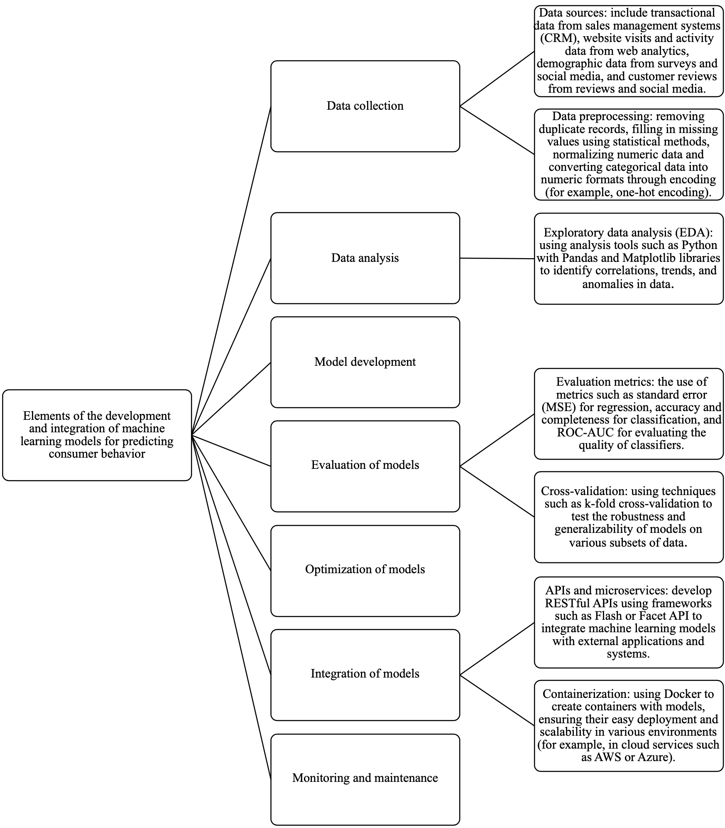

Fig.1. Elements of the development and integration of machine learning models for predicting consumer behavior

Modern marketing strategies increasingly rely on big data analysis to predict future customer behavior. In this regard, many companies are actively investing in technologies that enable them to efficiently process these data and monitor user interactions on social media. Below are the key advantages of big data analysis in the context of social media marketing (Table 3).

Table 3. Key advantages of big data analysis in the context of social media marketing [5]

|  |  |
| --- | --- |
| **Advantage name** | **Description** |
| Multichannel data | With the help of AI tools, companies can analyze data from various sources, such as social media and platforms like Google or Facebook. This allows them to gather information about user behavior in the online environment, including interactions with mobile apps, desktop devices, and cloud services. |
| Real-time analysis | Social media provides instant access to user data, including likes, comments, views, and ad clicks. This approach gives marketers the most accurate and up-to-date understanding of market demand and customer preferences. |
| Personalized offers | By leveraging machine learning, companies can refine their target customer profiles. This enables them to consider personal preferences, interests, and user activity on social media to create more precise marketing offers. |
| Behavior prediction | Predictive analytics based on big data not only helps identify current trends but also predicts future customer preferences. This fosters the development of personalized offer strategies, which are especially relevant as user interests and behavior change. |
| Data protection | Ensuring user data security on social media remains a critical task. Companies working with big data must implement modern data protection methods, including biometric authentication and controlling data sharing with third parties. |
| Campaign effectiveness | Big data analysis helps marketers track ROI dynamics and assess the success of advertising campaigns on social media. This allows them to identify the most in-demand products and services and understand how users respond to ads on different platforms. |
| Price optimization | Market data analysis helps companies set optimal prices for products and services, taking into account demand, competition, and the economic situation. Interactive methods such as A/B testing and online surveys help better understand how much consumers are willing to pay for specific goods. |

The large volume and diversity of information require the use of modern analytical methods, as traditional approaches are insufficient to handle such data size and complexity. Big data-driven forecasting allows businesses to make more informed decisions based on up-to-date and historical user data [5].

In marketing, machine learning is gaining special importance as it enables the automation of customer data analysis, prediction of consumer behavior, and improvement of promotion strategies. Marketers face massive amounts of information daily, including data on consumers, products, and advertising campaigns. The application of machine learning algorithms significantly eases the processing of such data by revealing hidden patterns that might go unnoticed during manual analysis.

With machine learning, companies can develop personalized advertising offers tailored to each customer. This approach increases the likelihood of positive interaction with the target audience, enhances user satisfaction, and strengthens brand loyalty. It is worth noting that implementing machine learning algorithms provides businesses with significant competitive advantages, allowing them to analyze data more deeply and respond more quickly to changes in consumer behavior.

Among the machine learning methods used in marketing are neural networks, decision trees, and classification and clustering methods. Neural networks, for example, are widely used for analyzing texts on social media, customer reviews, and news to determine sentiments and identify consumer preferences. Moreover, such systems are successfully applied to develop recommendation engines that suggest products and services to users based on their previous interactions with the platform.

Decision trees serve as a tool for visualizing decision-making processes, helping marketers segment audiences and predict customer behavior. Classification methods allow users to be assigned to specific categories, which simplifies the development of personalized offers and advertising campaigns.

Companies like Amazon and Netflix are already actively using machine learning to enhance customer interactions. Amazon, by analyzing user purchases and actions, creates personalized recommendations that drive sales and improve the user experience. Netflix, in turn, applies algorithms to create content recommendations, taking into account each user's preferences, which helps increase engagement and customer retention.

On the other hand, machine learning in marketing faces several challenges. Algorithms require large volumes of high-quality data, and a lack of such data can distort results. Additionally, interpreting complex models is often challenging for marketers, which can complicate the decision-making process. Ethical aspects related to personalized advertising and data use also need attention, as excessive personalization may provoke negative reactions from consumers [6].

Companies like Google and Facebook are actively developing deep learning-based tools, contributing to the further integration of AI into business processes. Google offers cloud services for launching deep learning projects, while Facebook is developing highly accurate facial recognition applications, such as DeepFace. This provides marketers with new tools to enhance customer interaction efficiency. The use of AI in areas such as supply chain management, production, and marketing is predicted to generate global revenues ranging from $1.4 to $2.6 trillion. The ability to predict consumer behavior with high accuracy is becoming an integral part of future marketing strategies, and deep learning is already significantly transforming approaches to product and service promotion [7].

Machine learning allows identifying hidden patterns, trends, due to which companies are able to develop effective, personalized marketing strategies, as demonstrated by the below examples. In China, following the tradition of gift-giving during the Chinese New Year, Coca-Cola created unique bottles with symbols that could be combined to form festive greetings. In predominantly Muslim countries, during Ramadan, the brand regularly launches advertising campaigns emphasizing the importance of family and community values.

In Europe, Nike focuses on football, promoting products specifically designed for fans of the sport, while in the U.S., the company concentrates on basketball products.

In Asia, IKEA adapts its products by reducing the size of its furniture to better fit living spaces in countries with limited space, such as Hong Kong and Japan. In Saudi Arabia, the company altered its product catalog by removing images of women to align with local norms [8]. The use of machine learning systems allows brands to accurately analyze and predict consumer preferences and behavior in different markets.

Thus, the integration of machine learning systems into marketing activities contributes to a deep understanding and satisfaction of consumer needs, ensuring sustainable growth and development of brands in the international arena.

**CONCLUSION**

Machine learning offers significant opportunities for predicting consumer behavior and enhancing marketing strategies. The application of neural networks, decision trees, and clustering methods allows companies to more accurately forecast customer preferences and provide personalized solutions, which greatly increases customer satisfaction and loyalty. The use of artificial intelligence technologies and big data analysis is becoming a key factor in market competitiveness. The main findings of the study emphasize that the integration of machine learning systems enables businesses to manage inventory more efficiently, reduce risks, and adapt to changes in demand.

**COMPETING INTERESTS DISCLAIMER:**

Authors have declared that they have no known competing financial interests OR non-financial interests OR personal relationships that could have appeared to influence the work reported in this paper.

**REFERENCES**

1. Safronov I. D. Theoretical foundations in the machine learning model //Bulletin of Science. – 2023. – T. 1. – №. 6 (63). – Pp. 1050-1053.
2. Cherbu O. et al. Introduction to machine learning in Python: fundamentals and practice //Abordări inter/transdisciplinare în predarea ştiinţelor reale,(concept STEAM). – 2023. – pp. 260-271.
3. Pilipenko A. Yu. Forecasting demand for goods by means of machine learning //StudNet. – 2022. – Vol. 5. – No. 2. – pp. 1278-1291.
4. Toloknova A. A. The influence of artificial intelligence on behavioral targeting in digital marketing: analysis of machine learning methods for predicting and modifying consumer behavior //BBK 1 N 34. – p. 1806.
5. Chaudhary K. et al. Machine learning-based mathematical modeling for prediction of social media consumer behavior using big data analytics //Journal of Big Data. – 2021. – Vol. 8. – No. 1. – p. 73.
6. Polishchuk O. A., Martynicheva A.D., Egorov P. D. Machine learning as a modern approach to data analysis //Izvestiya Yugo-Zapadnogo gosudarstvennogo universiteta. Series: Economics. Sociology. Management. – 2022. – Vol. 12. – No. 2. – pp. 64-73.
7. Predicting consumer behavior using AI. [Electronic resource] Access mode: https://vc.ru/u/704101-vitalii-minyailo/292307-prognozirovanie-povedeniya-potrebitelei-s-pomoshyu-ii (accessed 06.09.2024).
8. The study of consumer behavior through data analysis. [Electronic resource] Access mode: https://habr.com/ru/companies/otus/articles/777332 / (accessed 06.09.2024).
9. Theodorakopoulos, L., & Theodoropoulou, A. (2024). Leveraging big data analytics for understanding consumer behavior in digital marketing: A systematic review. *Human Behavior and Emerging Technologies*, *2024*(1), 3641502.
10. Vasilopoulos, C., Theodorakopoulos, L., & Giotopoulos, K. (2023). Big data and consumer behavior: The power and pitfalls of analytics in the digital age. *Technium Soc. Sci. J.*, *45*, 469.
11. Shao, J., Feng, Y., & Liu, Z. (2024). The Impact of Big Data-Driven Strategies on Sustainable Consumer Behaviour in E-Commerce: A Green Economy Perspective. *Sustainability*, *16*(24), 10960.
12. Yangzom, T., & Ahuja, L. (2023, July). Uses of big data to understand consumers’ buying behavior. In *2023 4th International Conference on Electronics and Sustainable Communication Systems (ICESC)* (pp. 819-823). IEEE.
13. Ernest, A., Adonachor, J. A., Arthur, L. A. K., Bernard, W.-A., Acquah, A. O., & Essah, R. (2024). Use of Big Data Analytics to Understand Consumer Behavior . *Asian Journal of Research in Computer Science*, *17*(12), 185–200.