Fasting and Post-Prandial Effect of Moringa Stem Extract on Glucose and Fasting Lipids on Healthy Subjects in Rivers State

ABSTACT
Moringa plant is an ancient medicinal plant introduced to Africa from India. Empirical studies using albino rats reveal how goodMoringa leaves are in combating hyperlipideamia and hyperglycaemia and it is widely researched using its leaves, but limited work is done on the stem. The study was done to evaluate the effectiveness of moringa stem on glucose and lipids of healthy subjects. The extract was prepared from the stem of Moringa plantand given to healthy subjects on fasting upon blood collection, food was given and blood samples collected again to compare its effect on glucose levels after the subjects have been fed.A pilot study was carried out to determine a safe dose to be administered. One hundred and eighteen (118) healthy subjects participated in this study from Umueze Afara Community in Etche and Rumuepirikom community in Obio-Akpor with ages ranging from 18-80 years.The subjects were divided into three groups (A, B & C). Group A were given 400ml(6.8g) of Moringa stem extract, Group B, 300ml (5.1g) of Moringastem extract and group C, 200ml (3.4g) of the stem extract. Fasting plasma glucose and lipids were estimated quantitatively using the glucose oxidase method and enzymatic method. Data was generated using Graph pad Prism 6.1 and Microsoft Excel. Mean, standard deviation, correlation coefficient, standard error of mean was calculated and comparison of the fasting and 2hrs postprandial of glucose and lipids were calculated using students t-test and results were considered significant at p < 0.05 for the subjects. Mean standard deviation in group A (400ml of moringa extract) for fasting blood sugarwasnot significant after two hours of administration.TC, TC and HDL were also observed to have a non-significant value, whereas LDL had a significant reduction after two hours at p < 0.05. In group B,(300ml of moringa extract) there was no significant reduction in FBS after two hours, but a significant reduction is seen in lipids parameters after two hrs of administration of the extract. In group C (200ml of moringa extract) there was no significant reduction in FBS, TC, TG and LDL after two hours of administration. HDL was observed to be significantly reduced after two hours of administration at p > 0.05. Moringa stem extract does not have any significant effect on glucose levels as claimed by the populace but we observed a significant reduction in lipids levels at 300ml of extract administration.

Keywords: Moringa stem extract, Post-prandial, Glucose, Lipids, Fasting.

- INTRODUCTION
Moringa is cultivated in the tropics and subtropical regions and is referred to by many names such as horseradish tree, drumstick tree, Ben oil tree, miracle tree and Mother’s best friend (Gao et al., 2020). It was introduced to Africa from India at the turn of the twentieth century where it has been used as a health supplement (Gandji et al., 2017). By virtue of its high nutritional as well as ethnomedical values, it has gained profound interest both in nutritional and medicinal research. Research shows that its leaves, stems, flowers, seeds, pods (fruit), back and roots of this plant are uniquely harvested and utilized. The leaves contain a higher percentage of nutrients and phytochemicals (Penalveret al., 2022). It contains a phenolic content of 181.3–200mg/100g catechin equivalents whereas the stem contains lesser but similar phenolic components (71.9–134.4mg/100g) catechin equivalents as the leaves which makes its research of interest as so much work has been carried outusing its leaves. Its main phytochemical compounds include 4-hydroxymellein, vanillin, β-sitosterone, octacosanoic acid, and β-sitosterol (Penalveret al., 2022).
Phytochemical analysis reveals that its leaves are extremely rich in potassium, calcium, phosphorus, iron, vitamin A, C, and D, essential amino acid magnesium, antioxidants, and B-carotene (El-Sherbiny et al., 2024). Moringa stem contains protein at 9.56-12.77% dry weight, fatty acid content of 1.98-2.00% dry weight, ash content of 6.65-8.41% and calcium content of 6.65-8.41% dry weight respectively. It also contains 71.9–134.4mg/100g catechin equivalents (phenolic content) (Shih et al., 2011)
Cardiovascular disease, a marker of diabetics, is the leading cause of death in developed countries over the last ten decades and developing countries are seriously experiencing this epidemic. Coronary artery disease which is a type of cardiovascular disease causes over four million deaths in European countries and over 1.9 million deaths in western society despite major advances in its prevention, detection and treatment(European Heart Network, 2012). The prevalence of diabetics in Europe is high and has increased rapidly over the last ten years by more than 50% in many countries. In the Sub-Saharan Africa, coronary heart disease is also the greatest cause of death and is on the rise particularly in Nigeria because of factors such as diet and lifestyle (Ogah et al.,2023).
About four billion people (representing 80% of world’s population) living in this developed world mostly rely on herbal medicinal products (Aware et al., 2022) this herbal medicine is often received as a balance to healing. WHO tradition medicine strategy reports a complementary and alternative medicine (CAM) use prevalence rate of Belgium 31%, China 40%, Colombia 40%,USA 42%, Australia 48%, France 49%, India 65%, Chile 71% and Canada 70% (WHO, 2002).
Over the years, the use of herbal medicinal products and supplements for the treatment of various diseases has increased tremendously in our health care setting (WHO, 2005). This may be due to their believed natural origin and less side effects as compared to complementary medicine such as insulin and oral hypoglycemic agents (Chaachouay et al., 2023). There is enormous search for an ideal treatment of diabetics hence the use of natural plants. People with diabetics take so many different drugs which are synthetically produced, and enormous side effect accompanies the use of these synthetic drugs (Reuter, 2011). This has led to various recent research using different herbs even without a good knowledge of their proper functioning and constituent. Studies have revealed that, almost all parts of the plant are considered to possess medicinal properties and used in the treatment and management of disorders such as diabetes, hyperlipidemia, ascites, rheumatism, and venomous bites, some cardiovascular diseases and so on (Hossain et al, 2021). However, paucity of research has been done using the stem, therefore, the need for this work.
- MATERIALS AND METHODS

  - Stem Collection
Fresh Stems were harvested from Amukele farm in Odiokwu, Ahoada, Rivers State.

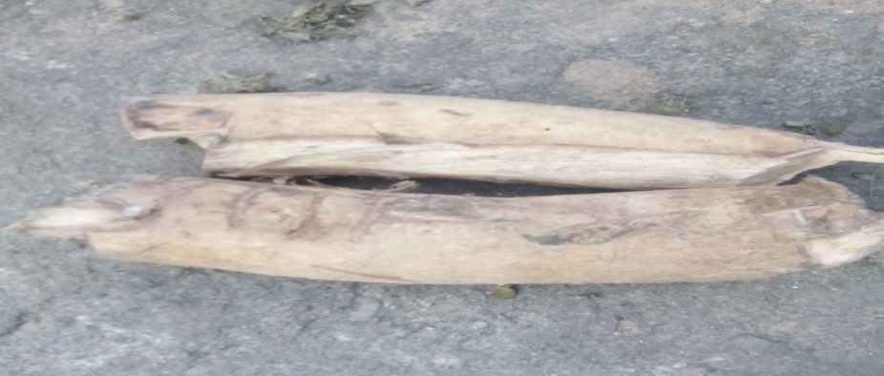
Figure 1: Moringa oleifera stem collected from Amukele farm in Odiokwu, Ahoada, Rivers State.

2.2 Extract Preparation
Moringa stem extract was prepared using the tender stem called the shoot. Its outer layer is poisonous, so it’s peeled off. Next layer is stem bark, and this was scraped off too. They were weighed and washed thoroughly in clean water and soaked. 20kg of Moringa shoot was dissolved in 20 liters of water, soaked for 3 days to allow for fermentation. It was then harvested, distilled by boiling to 100^{oc} in a salad master pot, allowed to cool for about four hours. Thereafter the extract was filtered with Whatman’s No 1 filter paper and then stored in a bottle in the refrigerator.
2.3 Pilot Study
A pilot study was conducted among 10 people before the actual study. The pilot study was carried out using 50ml (6.85g dried weight), 100ml (1.7g dried weight) 150ml (2.55 dried weights) and 200ml (3.4g dried weight) respectively on healthy subjects. This was based upon a previous study by Adedapo et al., 2004 of the acute toxicity study performed using the single dose of orally administered 2g/kg of methanolic extract of Moringa leaves extract which showed no signs of toxicity in rats. Results realized from these gave room for necessary adjustments to be made.
2.4 Experimental Design
A total of 118 healthy subjects participated in this study from Umueze Afara Community in Etche and Rumuepirikom community in Obio-Akpor with ages ranging 18-80 years. Female subjects were 48(40.7%) while 70(59.3%) were males. Their mean body mass index and ages were was 23.97, and 42.67 respectively.
The subjects were classified into 3 groups as outlined:
Group A: Thirty-four (34) subjects of which 10 were females and 24 males with a mean age of 43.09 and a mean BMI of 23.98±3.7kg/m². 400ml (6.8g) of Moringa stem extract was administered.
Group B: Forty-three (43) subjects, 21 females and 22 males with a mean age of 42.26 and a mean body mass index of 21.63 ± 3.86.300ml (5.1g) of Moringa extract was administered.
Group C: Forty-one(41) subjects, 17 females and 24 males with a mean age of 42.66 and a mean body mass index of 23.26 ± 2.91. 200ml (3.4g) of the extract was administered.

Their fasting sample was collected, measured amount of stipulated quantity of the extract were administered and measured portion of a diet was then given to each subject. Two hours later, their blood samples were collected again.
2.5 Sample Collection and Preparation
Approximately 5 mL of blood were collected into fluoride oxalate bottles and lithium heparin respectively. Sample collection spanned between 9am to 12pm on each stipulated day. The samples collected were carefully labeled, arranged, centrifuged and preserved for usage. Sample in fluoride oxalate was used for the estimation of glucose while lithium heparin sample was separated and stored for the analysis of fasting lipid profile.

2.6 Statistical Analysis
Data values generated were analyzed using GraphPad Prism version 8.0.2 and Microsoft Excel.
Mean, and standard deviation were calculated and comparison of the fasting and 2hrs postprandial effect of glucose and lipid levels were made using students t-test and results were considered significant at p < 0.05.

- RESULTS

  - Results of Fasting Glucose and Lipid parameters
Figure 2 shows the fasting and 2 hours parameters of Moringa stem extract administered at 400ml. The results indicated non-significant differences between the fasting and 2hrs post-prandial values in glucose, triglyceride, TC, and HDL. However, LDL indicated significantly higher values in the fasting state compared to that f the 2 hours post-prandial state. In addition, Figure 3, showed the fasting and 2 hours parameters of Moringa stem extract administered at 300ml. The result obtained also indicated non-significant differences in the fasting and 2hrs postprandial levels of glucose. However, significantly lower values of lipid parameters were seen in the 2 hours post-prandial state. Finally, when administered at 200ml (Figure 4), the results obtained indicate indicated a significantly lower values of HDL in the 2 hours Post-Prandial State. However, all other parameters considered were not significantly different.
BOX AND WISKER PLOTS
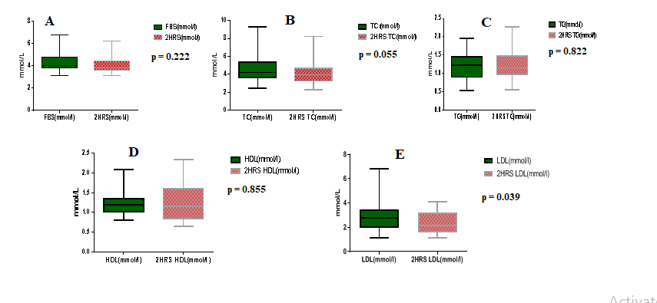
Fig 2: Box and Wisker plot showing values of Glucose (Plot A), TC (Plot B), TG (plot C), HDL (plot D), and LDL (plot E) of Fasting and 2 hours Post-Prandial states in Subjects treated with 400ml of Moringa stem extract.

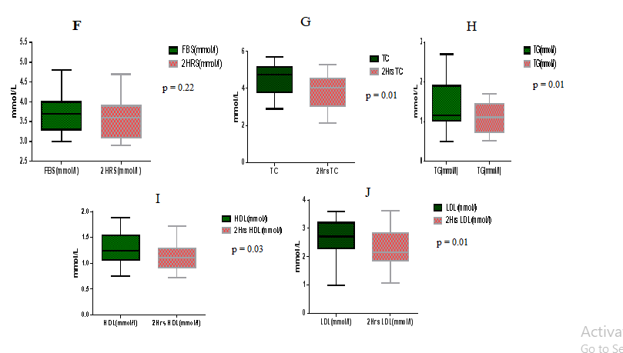
Fig 3: Box and Wisker plot showing values of Glucose (Plot F), TC (Plot G), TG (Plot H), HDL (Plot I), and LDL (Plot J) of Fasting and 2-hours Post-Prandial states in Subjects treated with 300ml of Moringa stem extract.

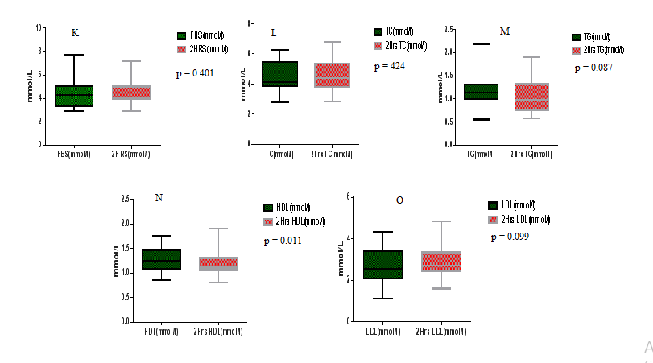
Fig 4: Box and Wisker plot showing values of Glucose (Plot K), TC (Plot L), TG (Plot M), HDL (Plot N), and LDL (Plot O) of Fasting and 2-hours Post-Prandial states in subjects treated with 200ml of Moringa stem extract.

- DISCUSSION

The results from the fasting blood sugar comparison to the 2-hour postprandial level after the intake of 400 ml of Moringa stem extract showed an insignificant reduction, as healthy subjects can regulate blood glucose. Therefore, there are no noticeable health issues compared to diabetic patients. This is similar to results obtained after 2 hours of taking 300 ml and 200 ml of the stem extract. Moringa stem extract does not have a reducing effect on the glucose level of healthy subjects after 2 hours. Similar results were seen in studies conducted by Adeolu et al., (2020), Mariayebu et al., (2014), and Ghasi et al., (2013), which used Moringa leaves on Wistar rats. Villarruel-López et al., (2025) also demonstrated that the leaf extract had a significant impact on diabetic rats but not on the control rats. This is also observed in a study by Michael & Howell (2012), which used Moringa leaves on both diabetic and healthy human subjects.
A non-significant reduction in fasting cholesterol levels was observed after administering 400 ml of the stem extract when compared with its 2-hour postprandial value. However, a significant reduction was noted after two hours of taking 300 ml, while a non-significant reduction was seen with 200 ml of Moringa extract. The ability of Moringa extract to reduce cholesterol in group B plays a significant role in lowering arterial cholesterol, thereby reducing the risk of cardiovascular disease. Its ability to reduce cholesterol in group B and not in group C may be attributed to inadequate phytochemical constituents in group C containing 3.4g of the extract.

This finding is similar to the work done by Ijeoma et al., (2013), in which different doses of Moringa leaves extract were administered to rats. In her study, the lowest concentration of extract resulted in a significant reduction. Mona et al., (2013), Tete et al., (2013), and Souvarah et al., (2014) also reported similar reductions in total cholesterol using Moringa leaves on rats. Onwe et al., (2015) used Moringa leaf extracts and its stem and discovered a reduction in lipid levels, especially in the group administered stem extracts.
A non-significant increase in triglyceride levels was observed in groups A and C after 2 hours of administration of the extract. However, a significant reduction was noted in group B (300 ml) at p < 0.05, which can be attributed to an adequate phytochemical constituent in 300 ml (5.1 g) of Moringa extract. Triglycerides are fats found in foods such as meat, dairy products, and cooking oil. The body synthesizes its own triglycerides, and the excess intake of fatty foods has been on the rise in the 21st century, becoming a leading cause of obesity, diabetes, atherosclerosis, and related diseases (Koskinen et al., 2020). Moringa stem contains sitosterol and β-sitosterol, which help reduce lipids (López-Salazar et al., 2019). Its inability to reduce triglycerides in 200 ml may be attributed to its lower phenolic content and the fact that triglycerides are also produced by body cells, in addition to being derived from food. Studies by Akinlolu et al., (2017), using Moringa oleifera extracts, discovered dose-dependent non-significant higher mean levels of total cholesterol and triglycerides in the sera of rats administered 250 g, 500 g, and 750 g compared to the control group. This is similar to the increase observed after two hours of administration in this study. The findings of Jain et al., (2000), Mona et al., (2013), and Ijeoma et al., (2013) are consistent with the reduction seen in group B after the administration of 300 ml.
The significant reduction in high-density lipoprotein cholesterol (HDL-C) levels in groups B and C after taking 300 ml and 200 ml of the extract can be attributed to the low phenolic content of 71.9–134.4 mg/100 g in the stem. With this low phenolic content, it only increased HDL-C insignificantly in group A after administering 400 ml of Moringa stem extract. At 400 ml, it can be said to have a protective effect on the arteries. The findings in groups B and C contrast with the work of Jain et al., (2010) and Ijeoma et al., (2013), where HDL cholesterol, "the good cholesterol," increased significantly after administering different doses of Moringa leaves extract to various groups of Wistar rats. This is similar to what we see in group A after administering 400 ml of the extract. Therefore, high-density lipoprotein increases only upon administration of the highest dose (400 ml), which is a positive sign for anti-atherosclerosis.
Additionally, the significant reduction in low-density lipoprotein (LDL) only in group B may reflect inadequate phenolic content in the other groups administered 400 ml and 200 ml, respectively. This finding aligns with previous studies by Jain et al., (2010), Mona et al., (2013), and Ijeoma et al., (2013), all using Moringa leaves on rats, and discovered a reduction in LDL-C across all groups. Ajayi et al. (2020) used Moringa seed extract for six weeks on Wistar rats fed with a high-fat diet and found a reducing effect on all groups compared to the control group. This could be attributed to a lower phenolic content in the stem compared to that in the leaves and seeds (Shin et al., 2011). Increased low-density lipoprotein, "bad cholesterol," is a predisposing factor for the development of atherosclerosis. LDL-C, termed "bad cholesterol," carries cholesterol from the liver to the cells. The accumulation of cholesterol in cells over time can lead to the development of cardiovascular disease, even in the absence of risk factors such as diabetes. LDL-C is the prime index of cardiovascular disease (Duncan et al., 2019).

- CONCLUSION
Compared to the leaves and seeds of Moringa, its stem contains lower phenolic content, which is reflected in its effects on glucose and lipid levels. From this study, Moringa stem extract does not have a reducing effect on plasma glucose in healthy subjects compared to the leaf extract, but it does have a significant effect on lipids.

REFERENCES
Adeolu, A. A., Iyanuoluwa, O. O., Olufunke, O. F., Blessing, S. O., Ademola, A. O., Abayomi, O., Temidayo, O. O., Momoh, A. Y. & Oluwafemi O. O. (2020).The lyophilized aqueous leaf extract of Moringa oleifera blunts streptozocin-induced diabetes in rats through upregulation of GLUT 4 signaling pathway and anti-oxidant effect. Scientific African, 10, 2468-2276
Ajayi, T.O. 1., Moody, J.O.1., Odumuwagun, O.J.1. &Olugbuyiro, J.A.O. (2020). Potential of Moringa oleifera Lam Seed Extract and Isolated Constituents In Wistar Rats. Afr. J. Biomed. Res, 23, 77- 85
Akinlolu, A. A., Bayode, Elizabeth, O., Ghazali, K. O. & Ameen, M. O. (2017). The effects of Moringa Oleifera on lipid profile status, heart histology, and liver histochemistry in adult Wistar rats. ChrisMed Journal of Health and Research, 4(2), 104-109.
Aware, C. B., Patil, D. N., Suryawanshi, S. S., Mali, P. R., Rane, M. R. & Gurav, R. G. (2022). Natural bioactive products as promising therapeutics: A review of natural product-based drug development. S Afr J Bot, 151, 512-528.
Chaachouay, N., Azeroual, A. & Zidane, L. (2023). Ethnobotany, Ethnopharmacology, and Traditional Uses of Medicinal and Aromatic Plants. In Ethnobotany and Ethnopharmacology of Medicinal and Aromatic Plants; CRC Press: Boca Raton, FL, USA,; ISBN 978-1-00-328421-5.
Duncan, M. S., Vasan, R. S. & Xanthakis, V. (2019). Trajectories of blood lipid concentrations over the adult life course and risk of cardiovascular disease and all-cause mortality: observations from the Framingham Study Over 35 Years. J. Am. Heart Assoc, 8, Article e011433
El;Sherbiny, G. M., Alluqmani, A.J., Elsehemy, I. A. (2024). Antibacterial, antioxidant, cytotoxicity and phytochemical screnning of Moringa oleifera leaves. Sci Rep, 14, 30485.
European Heart Network and European Society of Cardiology. (2012). ISBN 978-2-9537898-1-2.
Gandji, K., Chadare, F. J., Idohou, V. K., Salako, A. E., Assogbadjo, R. L. &Glele K. (2018). Status and Utilization of Moringa oleifera lam: a review. Afric. Crop Sci Journal, 26, 137.
Gao Q., Sha Z., Tang S. & Li Z. (2020). Research Progress of Chemical Constituents and Pharmacological Effects of Moringa Oleifera. Herald of Medicine, 39(3), 350-359.
Ghasi, S., Nwobodo, E. & Ofili, J.O. (2000). Hypocholesterolemic Effects of Crude Extract of Leaf of Moringa Oleifera Lam. In High Fat Diet Fed Wistar Rats. Journal of Ethnopharmacology, 69, 21-25.
Hossain, F., Mostofa, M. G. & Alam, A. K. (2021). Traditional uses and pharmacological activities of the genus leea and its phytochemicals: A review. Heliyon,10, 7(2):e06222.
Ijeoma, O., Eliasm, A. & Deo, O.(2014). Lipid Lowering and Appetite Suppressive Effect of Leaves of Moringa Oleiferalam in Rats. British Journal of Pharmacology and Toxicology, 5(3), 103 – 108.
Jain, P.J., Patil, S.D., Haswani, N.G., Girase, M.V. & Surana, S J. (2010). Hypolipidemic Activity of Moringa Oleifera Lam., Moringaceae, on High Fat Diet-Induced Hyperlipidemia in Albino Rats. Braizilian Journal of Pharmacology, 20, 969–973.
Koskinen, J.S., Kytö, V., Juonala, M., Viikari, J.S.A., Nevalainen, J., Kähönen, M., Lehtimäki, T., Hutri-Kähönen, N., Laitinen, T. & Tossavainen, P. (2020). Childhood Risk Factors and Carotid Atherosclerotic Plaque in Adulthood: The Cardiovascular Risk in Young Finns Study. Atherosclerosis, 293, 18–25.
López-Salazar, H., Camacho-Díaz, B. H., Ávila-Reyes, S.V., Pérez-García, M. D., Cortazar, M.G., Ocampo, M.L.A. & Jiménez-Aparicio, A. R. (2019). Identification and Quantification of β-Sitosterol β-d-Glucoside of an Ethanolic Extract Obtained by Microwave-Assisted Extraction from Agave angustifolia Haw. Molecules, 24:3926.]
Meraiyebu, A., Ogunlrole, E., Izuchukwu, N. & Stephanie, A. (2014). Effects of Aqueous Extract of MoringaOleifera Seeds on Alloxan Induced Hyperglycemia Basic Science of Medicine. Journal of Medicine, 3(3), 37 – 42.
Micheal, P. & Howell, H. O. (2012). Comparative Effects of Moringa Oleiferalam. Tea on Normal and Hyperperglycemia Patients. Health Internatinal Journal, 23(5), 411 – 418.
Mona, S. H. (2013). Effect of Moringa Oleifera on Serum Lipids. Journal of Applied Sciences Research, 9(8), 5, 89-98.
Mona, S. H. (2013). Effect of Moringa Oleifera on Serum Lipids. Journal of Applied Sciences Research, 9(8), 5, 89-98.
Ogah, O. S., Orimolade, O. A.& Jinadu, T. O. (2023). Cardiovascular Diseases in Nigeria: Current Status, Threats, and Opportunities. AHA Scientific Journal, 148, 19.
Onwe, P.E., Folawiyo, M. A., Anyigor-Ogah, C. S., Uche, J. E., Balogun, M. E., Umahi, G., Besong, E. E., Okorocha A. E. & Afoke A.O. (2015). Extracts of Moringa oleifera a sure bet for Hyperlipidemia management. Journal of Pharmacy and Biological Sciences, 10 (5), 28-32.
Peñalver, R., Lorenzo, M.J., Zamora, L M., Ros, G. & Nieto, G. (2022). Nutritional and Antioxidant Properties of Moringa oleifera Leaves in Functional Foods.Foods, 11(8), 1107; https://doi.org/10.3390/foods11081107.
Shih, M.C., Green, A. & Bryan, E. (2011). Effect of Different Parts (Leaf, Stem and Stalk) and Seasons (Summer and Winter) on the Chemical Compositions and Antioxidant Activity of Moringa Oleifera. International Journal of Molecular Science, 3(1), 761 – 768.
Souravh, B.1., Guru, S. S., &Ramica, S. (2014). Antiobesity and Hypolipidemic Activity of MoringaOleifera Leaves against High Fat Diet-Induced Obesity in Rats. Journal of Nutritional Biochemistry, 15, 130–141
Tete, B., Green, A. & Newman, A. (2013). The Influence of Moringa Oliefera on Lipids and Glucose in Malnourished Patients. Journal of Applied Bioassay, 5(2), 56 – 73.
Villarruel-López, A., López-de la Mora, D.A. & Vázquez-Paulino, O.D. (2018). Effect of Moringa oleifera consumption on diabetic rats. BMC Complement Alternative Medcine, 18, 127 https://doi.org/10.1186/s12906-018-2180-2.
World Health Organisation (WHO). (2005). National Policy on Traditonal Medicine and Regulation of Herbal Medicines. Retrieved from www.who.int/medicinesdoc/en/d/Js7916e/10.html on 3rd March, 2016
World Health Organization (WHO). (2002). Traditional Medicine Strategy, 2002 - 2005.www.who.int/medicinesdoc/en/d/Js2297eon 12th January, 2016

