Original Research Article
Study of Haemato-Biochemical Alterations Of Canine Monocytic Ehrlichiosis (CME) In Seropositive Dogs Of Kathmandu Valley

ABSTRACT
Aims: A cross-sectional study was conducted to study diagnostic importance of haemato-biochemical alterations of Canine Monocytic Ehrlichiosis (CME) in seropositive dogs.
Place and duration of study: A sampling from case reports of 88 dogs of different hospitals and clinics of Kathmandu valley was conducted from June to October, 2024 with tested positive via rapid antibody kit was done for estimation of haemato-biochemical alterations and its associated risk factors.
Results: The incidence of E. canis was found to be highest in mixed breed (35.23%) followed by German shepherd (12.50 %), Spitz (15.91%), Golden retriever (6.82%), Mongrel (5.68%), Labrador (4.55%), Lhasa apso (4.55%), Cocker, Tibetan mastiff and Local (3.41%), and least infected breed were found to be Pug and Husky. Female dogs were more predisposed to E. canis than male dogs (35%). The highest incidence of E. canis was seen in monsoon (62.50%), followed by spring season (30.68%) and the least incidence in autumn. The mean and range of seropositive dogs were 6.52±3.96 and 0.5 to 17 years respectively. Young (43.16%) and middle (44.32%) age group were more predisposed than old age. In addition, significant low PCV, TEC, Hb, albumin, thrombocytes, and significant increase in ALP, total serum bilirubin, direct bilirubin, BUN, Creatinine and leukocyte indicate that haemato-biochemical test can play a significant role in accurate diagnosis of E. canis. The mean value of neutrophil, lymphocyte, monocyte, eosinophil, basophil, ALT, total protein and random blood glucose was found to be within normal range but with significant p- value of <0.05.
Conclusion: This study showed mark alterations in haemato-biochemcial parameters of E. canis in seropositive dogs in comparison to apparently healthy dogs.

Keywords: E. canis, haemato-biochemical alterations, incidence, seropositive dogs.

1. INTRODUCTION
Canine monocytic ehrlichiosis (CME) is a multisystemic tick-borne disease (Harrus and Waner, 2013). Gram negative obligate intracellular rickettsia and E. canis is the etiological agent, while Rhipicephalus sanguineus is the transmission vector (Aziz et al., 2022). Ehrlichia species viz, Ehrlichia canis, E. ewingii, and E.chaffeens infect dogs, humans and other mammals through tick bites (McDade, 1990; Schudel et al., 2024). Recurrent thrombocytopenia, anaemia, pancytopenia, glomerulonephritis, renal failure, keratitis, fever, anorexia, depression, lymphoadenopathy, ocular discharge, pallor of mucous membrane and hemorrhagic tendencies are the clinical signs of E. canis (Chawla et al., 2020). The spectrum of tick-borne diseases (TBDs) affecting animals and humans has increased in recent years; many important zoonotic TBDs, such as anaplasmosis, babesiosis, ehrlichiosis, and Lyme borreliosis are increasingly gaining more attention from physicians and veterinarians (Dantas-Torres et al., 2012, Fuente et al., 2023).
Continuous increasing of canine population in different areas of Nepal is evident. In Kathmandu valley, an estimated 22,500 stray dogs live inside the Ring Road of the Valley (WSPA, 2012).There are 60.66 %, 36.28 % and 3.06 % male, female and puppies in Pokhara valley in Nepal, respectively (Acharya and Dhakal, 2015). Vector borne diseases are highly prevalent in stray dogs of Nepal with 27.14% overall prevalence for Ehrlichia canis and a total of 81.43% of dogs were positive for at least one of the vector-borne pathogens (VBP) tested (Díaz et al., 2020). The prevalence of CME is found to be 26.76 % and 11.85 % in pet dogs of Lalitpur district and Kathmandu valley, respectively. (Sah, 2019). The change in ecosystem, global warming and increased trend of movement throughout world has given favorable environment for adaptation and thriving of tick vector responsible for transmission of E. canis. The increasing incidence of ehrlichiosis with indifferent clinical symptoms like fever, anorexia, distended abdomen, pale mucous membrane, lethargy and uncontrolled bleeding tendencies indulges veterinary practitioner and health workers to do more study on reliable and inexpensive diagnosis of E. canis.
However, it is suggested that the platelet counts may be a good and inexpensive screening test for canine monocytic ehrlichiosis, and that the magnitude of thrombocytopenia may increase the reliability of diagnosis(Bulla et al., 2004).The molecular methods of diagnosis are not readily available and expensive while cytological detection of morula of E. canis is difficult and not accurate due to possibility of false positive. Only few studies have been done in study of hematobiochemical alterations of dog with canine ehrlichiosis in Kathmandu valley.

Objectives
- To compare haemato-biochemical parameters of E. canispositive and apparently healthy dogs.
- To calculate incidence of E. canisvia rapid test kit.
- To study associated risk factors of E. canis.

2. MATERIALS AND METHODS

2.1 Study area
Study was conducted in Kathmandu valley (Fig 1). Samples were collected from different hospitals and clinics.
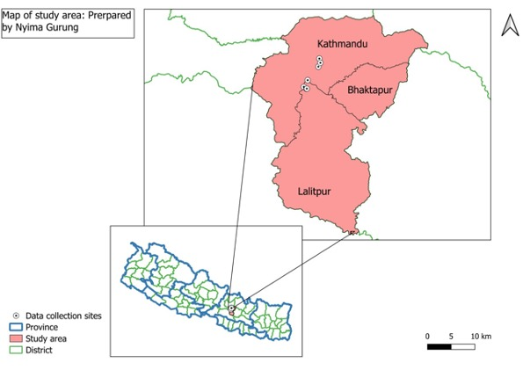
Fig 1: Map of study area

2.2 Study Duration and procedure
A cross-sectional study was conducted from June to October, 2024 with Purposive sampling of the secondary blood report of infected dogs tested positive via rapid antibody test kit from different hospitals and clinic such as Animal Medical Center(AMC), Central Referral Veterinary Hospital(CRVH), Advanced Pet Hospital, Lifeline Veterinary Hospital, Jibachha Veterinary Hospital, Patan Veterinary Clinic were done.

2.3 Interpretation of result of rapid test kit
The presence of both C band and T band, no matter how faint the T band appears,only clear C band appearsandno colored band appears in C zone, no matter whether T band appears are treated as positive, negative and invalid, respectively (Fig 2).
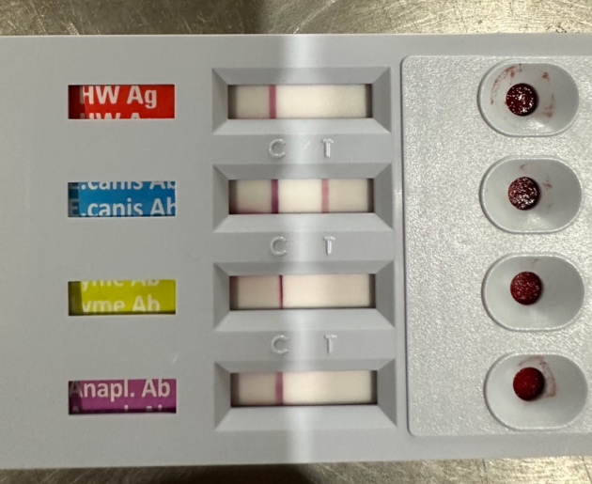
Fig 2: Rapid antibody test kit showing positive result

2.4 Sensitivity and specificity of rapid test kit
- The Antigen Rapid E. canisAb Test Kit is a chromatographic immunoassay for the qualitative detection of Ehrlichiacanis antibodies in canine whole blood, serum, or plasma.
- Working principle:Sandwich lateral flow immune-chromatographic assay.
- Sensitivity:97.6 % vs. Immunofluorescence Assay(IFA).
- Specificity:99.0 % vs. IFA

2.5 Statistical analysis
The data was entered and graphical representation was done in Ms-excel 2010. the data was analyzed via Statistical Package for Social Science (SPSS) version 25.0 and Ms-excel 2010 using unpaired t-test. p-value less than 0.05 was considered significant at confidence interval of 95%.

3. RESULTS AND DISCUSSION
3.1 Incidence of E. canis according to breed
The incidence of E. canis was found to be highest in mixed breed (35.23%) followed by German shepherd (12.50 %), Spitz (15.91%), Golden retriever (6.82%), Mongrel (5.68%), Labrador and Lhasa apso (4.55%), Cocker and Tibetan mastiff (3.41%), and least infected breed were found to be Pug and Husky (2.27 %) shown in (fig 3). We found greater variation in incidence of E. canis which may be due to significant association between breeds (Harrus et al.,1997).The higher predisposition of German shepherd was in agreement with (Harrus et al. 1997). This might be due to low cell mediated immune response in these breeds as cell mediated plays important role in mitigating Ehrlichiosis (Nyindo et al.,1980).

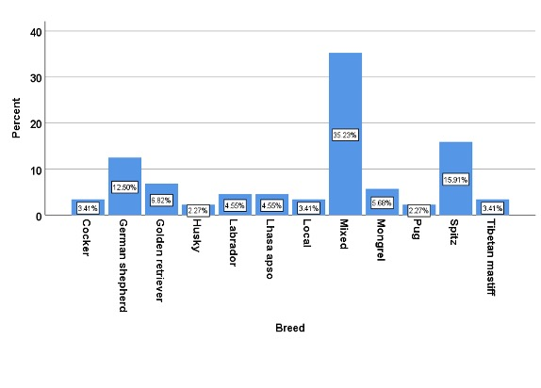
Fig 3: Bar graph showing incidence of E. canis according to breed
3.2 Incidence of E. canis according to season
The highest 62.50 % incidence of E. canis was seen in monsoon followed by 30.68 % in spring and 12.50 % incidence in autumn season (Fig 4). The result was similar to that of Harrus et al., (1997); Kottadamane et al., (2017) and Singh et al. (2021).The higher incidence of E. canis might be due to seasonal activity of brown dog tick during monsoon season (Soulsby, 2012).

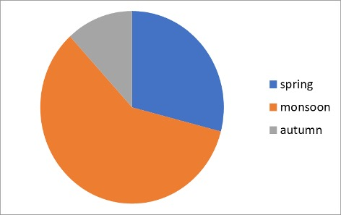
Fig 4: Pie- chart showing incidence of E. canis according to season
3.3 Incidence of E. canis according to sex
According to my finding 65 % Female dogs were affected to E. caniswhereas, 35% male dogsaffected to E. canis(Fig 5). Female were more vulnerable to E. canis than that of male (fig 5) similar to that of Bhadesiya and Ravalet al. (2015).
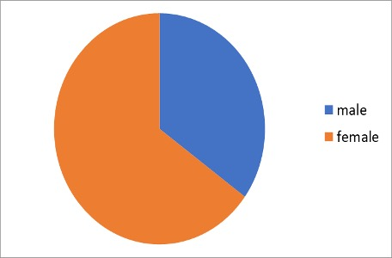
Fig 5: Pie- chart showing incidence of E. canisaccording to sex

3.4 Incidence of E. canis according to age
Old age (more than 10 years) was less vulnerable than the young (0–5 years) and middle (6–10 years) age groups with 12.50%, 43.16% and 44.32 %. respectively. Young and middle age group of dogs were more predisposed to E. canis than old dog similar to finding of Bhadesiya and Raval, (2015) whereas Harrus et al. (1997) and Bhattaet al. (2017) found E. canis in all age groups.

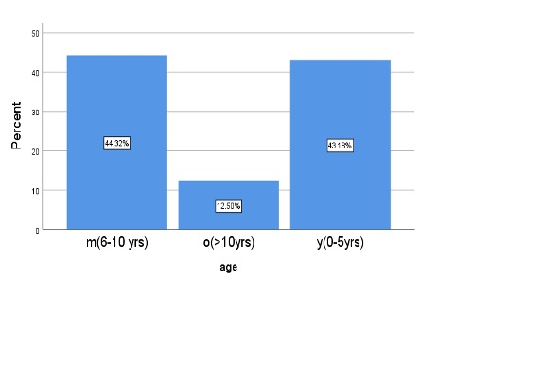
Fig 6: showing incidence of E. canis according to age
3.5 Haemato-biochemical parameters of E. Canis seropositive dogs
We Observed mark alteration in Haemato-biochemical parameters in seropositive dogs in compare to healthy one (Fig 7). Percent of PCV was significantly decreased (31.22±8.62). Haemoglobin (g/dl) was found to be 10.54±2.86 , Total erythrocyte count(10¹²/L) was 4.35±1.46, Thrombocyte count(K/μL) was 191.48±87.38, Total leukocyte count(10⁹/L) was significantly increased (18.13±11.93). Neutrophil(%), Lymphocyte(%), Monocyte(%), Eosinophil(%) and Basophil(%) was observed to be 76.21±13.86, 18.48±9.83, 2.18±7.02, 1.75±1.61 and 0.54±1.10 respectively (Table 1). Hemoglobin, Packed Cell Volume(PCV) & Total erythrocyte count were found to be decreased similar to findings of Kottadamane et al. (2017), Sah, (2019), Singhet al. (2021), ,Bhadesiya and Raval, (2015), Baiet al.(2017) and Ratnalikaret al. (2022). The change is due to secondary immune mediated anemia as per Blackwell’s five-minute veterinary consult: Canine and Feline, 7th Edition, 2021.Because of bone marrow suppression (Harrus et al., 1997) and secondary immune mediated thrombocytopenia (Blackwell’s five-minute veterinary consult: Canine and Feline, 7th edition, 2021), thrombocyte count was also found to be decreased in E. canis seropositive dogs, similar to findings of Gyawaliet al. (2023), Kottadamaneet al. (2017), Sah. (2019), Singhet al. (2021), BhadesiyaandRaval, (2015), Baiet al. (2017),Roopaliet al. (2018),,Parasharet al. (2016) and Yadavet al. (2017). In addition, significant low PCV, TEC, Hb, albumin, thrombocytes, calcium and significant increase in ALP, total serum bilirubin, direct bilirubin, BUN, creatinine and leukocytes indicates that haemogram can play a significant role in accurate diagnosis of E. canis when used along with other tools of diagnosis (Table 1).
The mean value of neutrophil, lymphocyte, monocyte, eosinophil and total protein was found to be within normal range (Fig 8) but with significant p- value(<0.05).

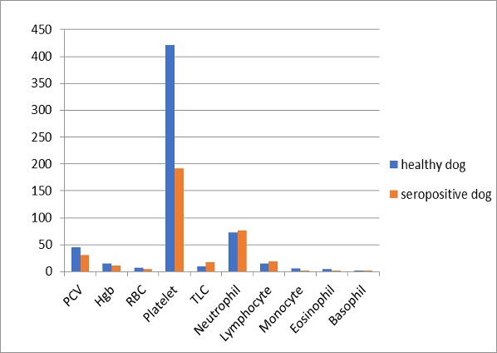
Fig7: Haematological alterations in seropositive dogs
Table 1: Haematological alternations in healthy and seropositive dogs
Hematological parameter | Reference range (Merck Veterinary Manual, 2016) | Healthy dog (Mean±S.D) | E. canisseropositive dogs (Mean±S.D) | p-value
 |  | 45.22±5.96 | 31.22±8.62 | P<0.05
  Packed cell volume(%)
  35-57
Haemoglobin (g/dl) | 11,9-18.9 | 15.27±1.92 | 10.54±2.86 | P<0.05
Total erythrocyte count(10¹²/L) | 4.95-7.87 |  |  | P<0.05
  6.47±0.86
  4.35±1.46
 | 211-621 | 421.30±127.99 | 191.48±87.38 | P<0.05
  Thrombocyte count(K/μL)
Total leukocyte count(10⁹/L) | 5.0-14.1 | 9.60±2.63 | 18.13±11.93 | P<0.05
Neutrophil(%) | 58-85 | 72.69±7.85 | 76.21±13.86 | P<0.05
 | 8-21 | 14.40±3.81 | 18.48±9.83 | P<0.05
  Lymphocyte(%)
Monocyte(%) | 2-10 | 5.80±2.35 | 2.18±7.02 | P<0.05
Eosinophil(%) | 0-9 | 4.64±2.56 | 1.75±1.61 | P<0.05
Basophil(%) | 0-1 | 0.48±0.28 | 0.54±1.10 | P>0.05
*significantp-value (0.05) at 95% confidence interval
3.6 Serum biochemistry of healthy and E. Canis dog
Various alteration were observed in biochemistry profile of seropositive dogs in our study when compared to healthy one(Fig 8) ALP (U/L) was significantly increased (208.88±250.66), total serum bilirubin (mg/dL) was significantly increased (0.32±0.60) whereas, serum albumin (g/dL), was significantly decreased (2.37±0.79). In contrast to serum albumin, BUN and creatinine were found to be significantly increased with the value of 54.09±70.90 (dL) and 2.24±3.29 (dL) respectively. Calcium (dL) was found significantly decreased with the value of 5.34±2.61 (Table 2). ALP was significantly increased due to portal and acinar hepatitis (Table 2) caused by infiltration of inflammatory cells (Harrus et al., 1997) similar to results of Singhet al. (2021), Ratnalikaret al. (2022), Bai et al. (2017),Kottadamaneet al. (2017), Harruset al.(1997).Likewise, total serum bilirubin was signigicantly increased similar to findings of Singhet al. (2021) and Baiet al. (2017). Corresponding to findings of Kottadamaneet al.(2017), Singhet al. (2021), Harruset al. (1996), Harruset al. (1997), Gyawaliet al. (2023), Ratnalikaret al. (2022), Yadavet al. (2017) serum albumin, in E. canisseropositve dogs, was significantly decrease because of myriad of causes like anorexia, decrease in protein uptake, blood loss and vasculitis (Harrus et al., 1996).In contrast to serum albumin, BUN and creatinine were found to be significantly increase, as a result of glomerulonephritis due to deposition of anti-canine IgG and IgM antibodies (Harrus et al., 1997) and chronic nephritis due to infiltration of inflammatory cells(Harruset al., 1997) respectively, similar to results of Singhet al. (2021), Harruset al. (1997), Ratnalikaret al. (2022), Roopaliet al. (2018) andKottadamaneet al., (2017), Harruset al., (1997), Bhadesiya andRaval, (2015), Ratnalikaret al. (2022), Roopaliet al. (2018). Due to hypoalbuminemia, causing reduction of protein bound calcium (Blackwell’s fiveminute veterinary consult, 2021) in E.canis seropositive dogs, calcium was significantly decrease resulting finding alike to Parasharet al. (2016). It may suggest that despite statistical significance, the observed difference mightn’t be clinically relevant .

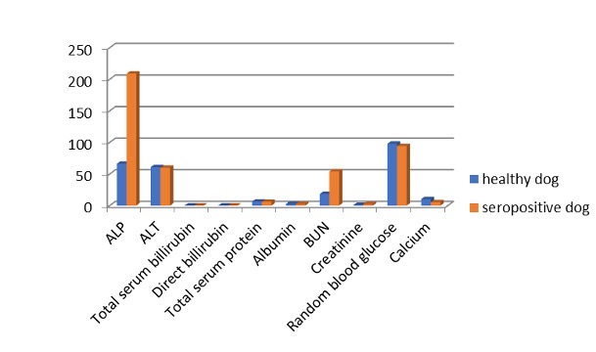
Fig 8: Serum biochemistry of healthy and E. canis dog
Table 2: Statistical analysis of biochemical alternations of seropositive dogs
Biochemical parameters | Reference value (Merck Veterinary Manual, 2016) | Healthy dog (MeanS.D) | E. canisseropositive dog (Mean±S.D) | p-value
ALP(U/L) |  | 66.33±31.51 | 208.88±250.66 | P<0.05
  1-114
ALT(U/L) | 10-109 | 60.98±30.85 | 60.11±63.88 | P>0.05
Total serum bilirubin (mg/dL) | 0-0.3 | 0.15±0.11 | 0.32±0.60 | P<0.05
Direct billirubin (mg/dL) | 0-0.1 | 0.16±0.09 | 0.18±0.32 | P>0.05
Total protein(g/dL) | 5.4-7.5 | 6.41±1.49 | 5.97±0.60 | P<0.05
Albumin (g/dL) | 2.3-3.1 | 2.69±0.24 | 2.37±0.79 | P<0.05
Blood urea nitrogen(mg/dL) | 8-28 | 18.32±5.86 | 54.09±70.90 | P<0.05
Creatinine(mg/dL) | 0.5-1.7 | 1.10±0.35 | 2.24±3.29 | P<0.05
Calcium(mg/dL) | 9.1-11.7 | 10.35±0.75 | 5.34±2.61 | P<0.05
*Significant (p-value <0.05) at 95% confidence interval

Conflict of interest: Authors have no conflict of interest in this study.

Data set generated during research: All data was collected from different hospitals and clinics such as Animal Medical Center(AMC), Central Referral VeterinaryHospital(CRVH), Advanced Pet Hospital, Lifeline Veterinary Hospital, Jibachha Veterinary Hospital, Patan Veterinary Clinic

REFERENCES

Acharya M and Dhakal S, 2015. Survey on street dog population in Pokhara valley on Nepal. Bangladesh J Vet Med, 13 (1): 65-70, DOI:10.3329/bjvm.v13i1.23722
Aziz MU, Hussain S, Song B,Ghauri HN, Zeb Jet al., 2023. Ehrlichiosis in Dogs: A Comprehensive Review about the Pathogen and Its Vectors with Emphasis on South and East Asian Countries. Vet Sci, 10(1):21.
Bai L, Goel P, Jhambh R, Kumar P and Joshi V.G, 2017. Molecular prevalence and haemato-biochemical profile of canine monocytic ehrlichiosis in dogs in and around Hisar, Haryana, India. J Parasitol Dis, 41:647–654. doi: 10.1007/s12639-016-0860-8.
Bhatta T, Acharya N, Prasad K and Thapa B, 2017. Prevalence of Blood Parasites in Hyperthermic Dogs of Kathmandu Valley, Nepal. Asian JAnim Vet Advances, 13(1); 67–72.
BullaC, Takahira RK, Aaujo JP, Trinca LA, Lopes RS etal., 2004. The relationship between the degree of thrombocytopenia and infection with Ehrlichiacanis in an endemic area. Vet Res, 35(1):141-146. doi: 10.1051/vetres:2003038.
de Castro MB, Machado RZ, de Aquino LP, Alessi AC, Costa MT, 2004. Experimental acute canine monocytic ehrlichiosis: clinicopathological and immunopathological findings.Vet Parasitol,19(1):73-86. doi: 10.1016/j.vetpar.2003.10.012.
DantasTF, Chomel BB and Otranto D, 2012. Ticks and tick-borne diseases: a One Health perspective. Trends Parasitol, 28(10); 437-446.
DíazRD, Agulla B, Piya B, FernándezRN, Villaescusa Aet al., 2020. Stray dogs in Nepal have high prevalence of vector-borne pathogens: A molecular survey. Parasites Vectors, 13(1):174. doi: 10.1186/s13071-020-04057-7.
FuentedLJ, Estrada-PA, Rafael M, Almazán C, Bermúdez Set al., 2023. Perception of Ticks and Tick-Borne Diseases Worldwide. Pathogens, 19;12(10):1258.
GyawaliCN, Gupta MP, Singh S and Poudyal RP, 2023. Study of Ehrlichiacanis in febrile dogs of Kathmandu valley of Nepal. Int J Vet Sci Anim Husbandry, 8(5): 227-235.
Harrus S, Kass PH, Klement E and Waner T, 1997. Canine monocytic ehrlichiosis: A retrospective study of 100 cases, and an epidemiological investigation of prognostic indicators for the disease. Vet Record, 141(14): 360–363.
Harrus S, Waner T, Avidar Y, Bogin E, Peh H and Bark H, 1996. Serum protein alterations in canine ehrlichiosis. Vet Parasitol, 66(3-4);241-9.
ChawlaH,Katoch A, Sharma D, Wadhwa DR and Sharma A, 2020.Diagnosis and therapeutic management of ehrlichiosis Induced chronic kidney disease in dogs.VetPract, 21(1): 71-75.
Kottadamane MR, Dhaliwal PS, Singla LD, Bansal BK and Uppal SK, 2017. Clinical and hematobiochemical response in canine monocytic ehrlichiosis seropositive dogs of Punjab. Vet World, 10(2):255-261.
McDade JE, 1990. Ehrlichiosis--a disease of animals and humans. J Infect Dis, 161(4):609-17. doi: 10.1093/infdis/161.4.609.
Nyindo M, HuxsollDL, Ristic M, Kakoma I, Brown JL, Carson CA and Stephenson EH, 1980. Cell-mediated and humoral immune responses of German Shepherd Dogs and Beagles to experimental infection with Ehrlichiacanis. Am J Vet Res., 41(2):250-4. PMID: 6989300.
Parashar R, Sudan V, Jaiswal AK, Srivastava A and Shanker D, 2016. Evaluation of clinical, biochemical and haematological markers in natural infection of canine monocytic ehrlichiosis. J Parasit Dis., 40(4):1351-1354. doi: 10.1007/s12639-015-0688-7.
Ratnalikar VM, Kumar VVVA, Nagaraj P and Kumar BA, 2022. Clinical findings and hemato biochemical alterations in dogs affected with Ehrlichiacanis.Pharma Innovation J, 11(9): 820–824.
Roopali B, Roy M, and Roy S, 2018. Clinico, Haemato-Biochemical Changes and Therapeutic Management of Canine Babesiosis. Int J Current Microbiol Applied Sci, 7(08), 1384–1388. doi: https://doi.org/10.20546/ijcmas.2018.708.158
Harrus S andWaner T, 2013. Canine Monocytic Ehrlichiosis - From Pathology to Clinical Manifestations. Israel J Vet Med,68(1): 12-18.
Sah JK, 2019. Prevalence and associated risk factor of Ehrlichiacanis in attenting clinical cases of pet dogs in different clinics and hospitals of Lalitpur district. Unpublished MSc. thesis, Tribhuvan University, Kathmandu, Nepal.
Schudel S, Gygax L, Kositz C, Kuenzli E and Neumayr A, 2024. Human granulocytotropic anaplasmosis-A systematic review and analysis of the literature. PLoSNegl Trop Dis, 18(8):e0012313. doi: 10.1371/journal.pntd.0012313.
Soulsby EJ, 2012. Helminths, arthropods, and protozoa of domesticated animals (7th ed.). Baillière Tindall, London, Affiliated East-West Press Private Limited.
WSPA, 2012. Street Dog Population Survey Kathmandu.https://animalnepal.files.wordpress. com/2013/09/dog-survey-kathmanduvalley-2012.pdf
Yadav J, Bihani DK, Ahuja A, Chahar A, Kashyap SK et al., 2017. Haemato-biochemical and therapeutic evaluation of canine monocytic ehrlichiosis. Vet Pract, 18(2):237-240.

