**Testicular hypoplasia and associated scrotal variations in sahel goats: an abattoir survey**

**Abstract**

Breeding soundness in bucks is dependent on how healthy the animal. Sahelian bucks are the predominant breed of goats found in northeastern part of Nigeria. Factors that influence the occurrence of testicular hypoplasia are malnutrition, hormonal imbalance and trauma. 200 Sahel bucks presented for slaughter at Maiduguri central abattoir were assessed for this study. Body condition score, scrotal circumference and scrotal length and shapes were evaluated. Gross examination of the testicles was carried out and those with variation in sizes and shape were identified and further examined after flaying. Scrotal bifida was obtained in this study presenting a prevalence of 0.5%. Both unilateral and bilateral hypoplasia were identified grossly by this study with a prevalence of 3% and 1.5% respectively. Those with gross hypoplasia were collected for histopathological examination. Hematoxylin and eosin-stained sections revealed absence of spermatogenic activities. Scrotal bifida has no effect on reproductive performance in bucks. Testicular hypoplasia is still prevalent among Sahel bucks and there is a need to further study the detailed causes to boost small ruminant production in the area.

**Keywords**: Sahel bucks, Testes, Hypoplasia, bilateral, unilateral, scrotal bifida, reproduction

**Introduction**

Sahel goats are breeds of goats found mostly in the central and northern part of Borno state Nigeria, where the prevailing weather are semi-arid to arid. They are identified by their appearance, having long legs, short fur and their coats are primarily colored in plain white, black, or brown, or in patches or spots of a combination of these colors (Igbokwe, 2011). Male reproductive performance relies on an intact testicle. Several factor such as malnutrition, hormonal imbalance and trauma impairs the testicular growth there by causing abnormalities such as hypoplasia and atrophy of one or both testicles. Pathology of the testicular tissue among Sahel bucks have previously been report in Maiduguri (Igbokwe, 2009, Mshelbwala, 2010, Abba, 2014) and in other breeds and species around the world (Bousmaha, 2012), however this study is carried out in order to determine the current status and provide an up to date knowledge of testicular hypoplasia in the study area.

**Materials and Methods**

**Ethical statement:** Invasive procedure was not performed on the animals. The ethics committee has confirmed that no ethical approval is required since the bucks were presented for slaughter at the abattoir.

**Study area**: The study was conducted at Maiduguri central abattoir located in Maiduguri, Borno State, Northeastern Nigeria.

**Study animals**: Two Hundred (200) apparently healthy male Sahel goats in good body condition weighing 10–25 kg, presented for slaughter at the metropolitan abattoir, were selected by stratified quota sampling to capture those with various Scrotal sizes from small to large sizes, and those with testicular hypoplasia were used for the study. Scrotal length (SL) and circumference (SC) were estimated using measuring tape and the readings taken. Gross examination of the testes was done prior to slaughter by palpation. Those with evidence of testicular abnormalities were further examined after slaughter and flaying. Abnormal testes were collected and fixed in 10% formalin for histopathology. Testicular tissues were processed according to the standard laboratory methods and stained with hematoxylin and eosin.

**Statistical analysis**

Data obtained from this study for scrotal length and scrotal circumference are expressed as means ± standard deviation.

**Results**

**Mean Body Weight, Scrotal Circumference and Scrotal Length**

Table 1 shows the mean body weight of bucks examined for testicular hypoplasia during the period of this studies is 17.4±3.4 kg, while mean of the scrotal circumference is 20.3±2.8 cm and the scrotal length is 12.4±1.9 cm respectively.

Table 1 Mean body weight, scrotal circumference and scrotal length.

N=200

|  |  |
| --- | --- |
| Variables | Mean ± SD |
| Body Weight(kg) | 17.4±3.4 |
| Scrotal circumference(cm) | 20.3±2.8 |
| Scrotal Length(cm) | 12.4±1.9 |

**Types of testicular hypoplasia in bucks slaughtered in Maiduguri, Nigeria.**

Types of testicular hypoplasia observed during this study is shown in Table 2. Out of the 200 Sahel bucks examined during this study, 6 had Unilateral testicular hypoplasia representing a prevalence of 3% and 3 had bilateral testicular hypoplasia represented 1.5%. The overall prevalence of testicular hypoplasia is 4.5%.

Table 2: Types of testicular hypoplasia in bucks slaughtered in Maiduguri, Nigeria (n = 200).

|  |  |  |  |
| --- | --- | --- | --- |
| Type of hypoplasia | Number observed | Prevalence (%) |  |
| Unilateral  Bilateral | 6  3 | 3  1.5 |  |
| Total | 9 | 4.5 |  |

**Scrotal Bifurcation in bucks**

Scrotal bifida was identified in one (1) buck representing a prevalence of 0.5% in the population is presented in figure 4b.

**Gross examination of the testicular tissue**

The gross examination of testicular was done prior to slaughter by palpation. Unilateral testicular hypoplasia is presented in Figure 1a-c while bilateral testicular hypoplasia is presented in Figure 2a&b. While those identified with gross variation in testicular size were further examined after flaying Figure 3a-d.

**Histopathological Examination**

Section of testicular tissue with gross hypoplasia stained with hematoxylin and eosin were examined using light microscope and lesions identified (Figure 5)

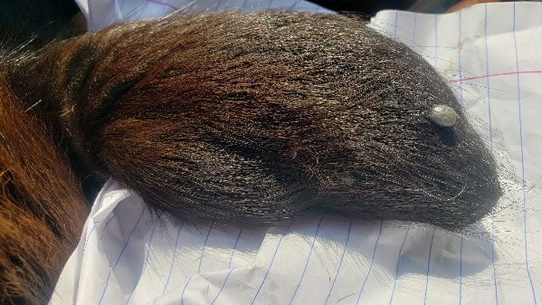 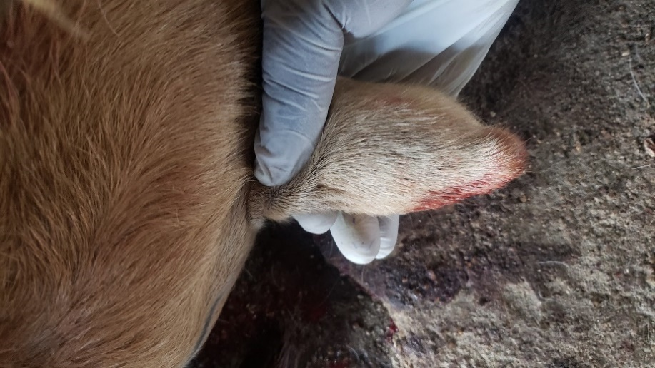 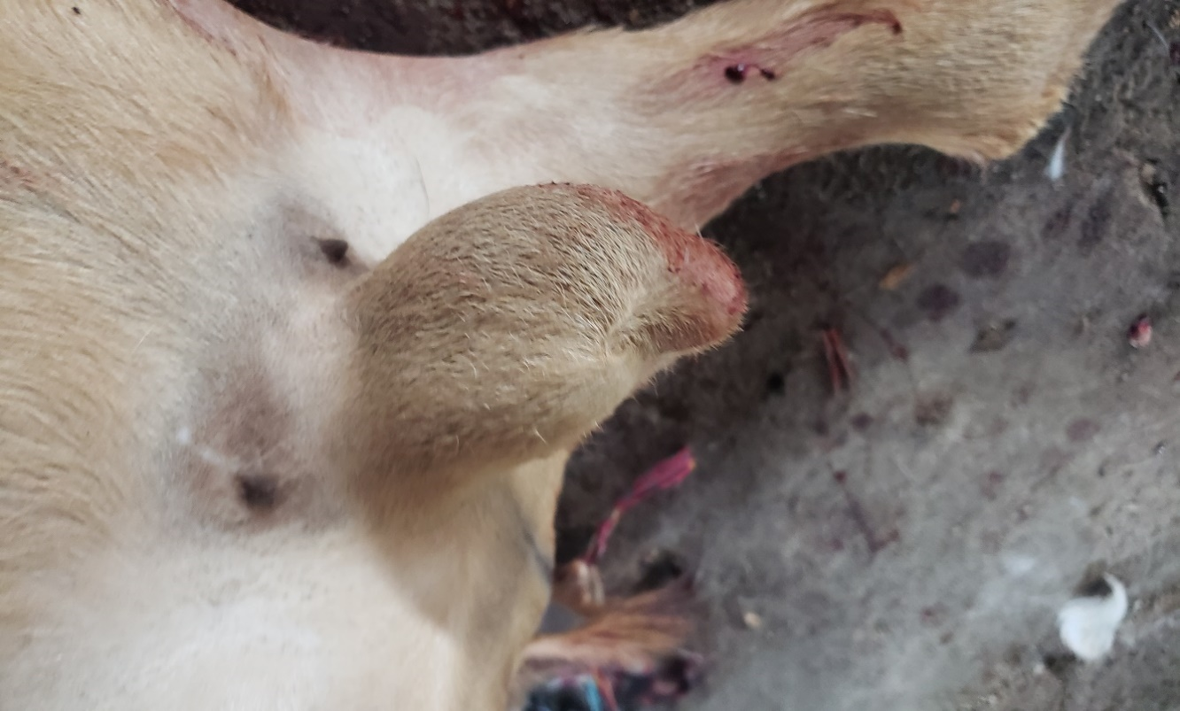

c

b

a

**Figure 1a,b &c.** Grosspresentation ofunilateral testicular hypoplasia. Red arrows showed hypoplastic testicles while arrow heads showed normal testicle.

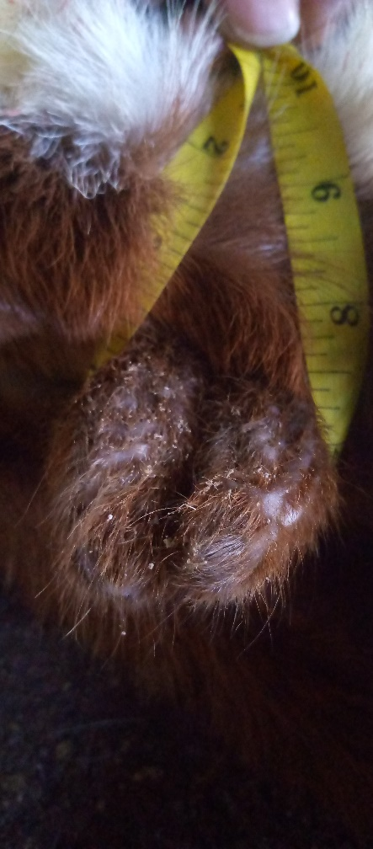 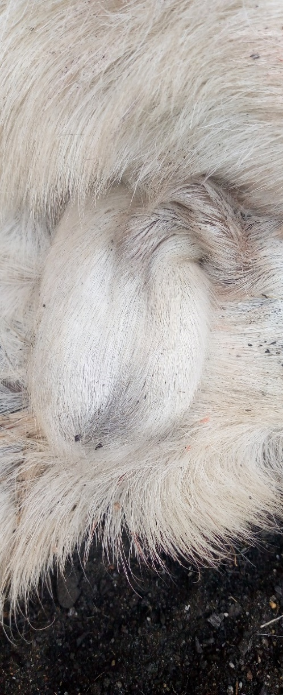

b

a

**Figure 2a&b** Gross presentation of bilateral testicular hypoplasia (Red arrows)

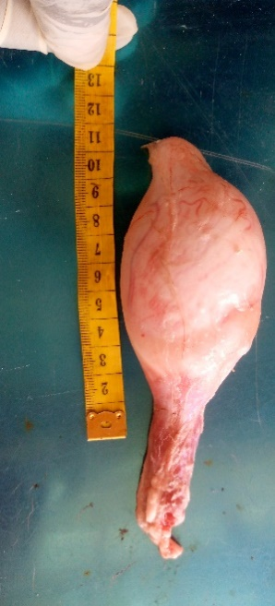 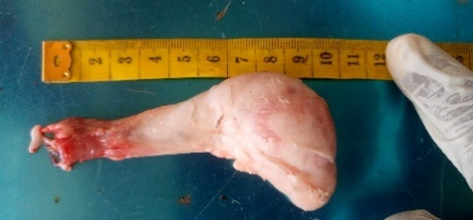 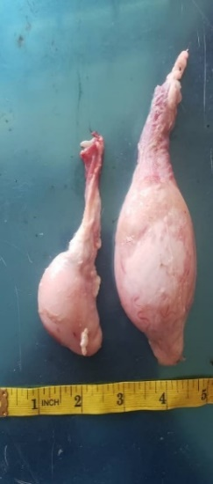 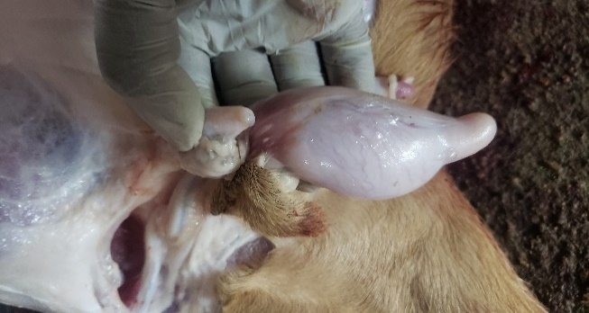

a

d

c

b

**Fig 3 (a).** Full-size testis **(b).** Shows smaller testis of a buck with unilateral

Hypoplasia **(c & d)**. Shows unilateral hypoplasia (red arrow) and full-sized testis (arrow head).

|  |  |
| --- | --- |
|   **Figure 3a**. Normal Scrotal shape in sahel buck having one scrotal sac. |   **Figure3b.** Scrotal bifida: note the gap between the left and the right testicle (arrow) |

**Histopathological evaluation of testicular hypoplasia**

Histopathogical section of the testicular tissue stained with Hematoxylin and Eosin are presented in Figure 4 and 5. Figure 4a&b shows normal testicular tissue with active spermatogenesis characterized by the presence of spermatogonia and spermatozoa while figure 5a&b shows the hypoplastic testicular tissue with few spermatogonia, sloughing and detachment of the seminiferous tubules from the basement membrane.

|  |  |
| --- | --- |
| Fig 4a Normal Testes showing seminiferous tubules (arrows) H&E x40 | Fig 4b Normal Testes showing spermatogenic activities in the seminiferous tubules (arrows) H&E x100 |
| Fig 5a Hypoplastic Testes showing seminiferous tubules (arrows) H&E x40 | Fig 5b Hypoplastic Testes showing seminiferous tubules with no spermatogenic activity (arrows) H&E x100 |

**Discussions**

Reproductive performance in bucks is dependable on how healthy the testes is. Decreased spermatogenic activity is obtained if one or both testicles are impaired. In this study the mean body condition score obtained was 17.4 ± 3.4 kg and this findings showed an increased body condition score in comparison with the reports of Abba and Igbokwe 2015, and also the reports of Abba et al., 2021 who reported a body condition score of 14.0 ± 1.1 and 15.12 ± 1.1 cm respectively. Scrotal circumference (SC) and scrotal length obtained was 20.3 ± 2.8 and 12.4 ± 1.9 cm respectively. It is closely related with the reports of Amare and Kefelegn (2017) who reported a SC of 20.8 ± 1.94cm in bucks from Ethiopia. These findings differ with the report of Abba et al., 2021 who reported 17.95± 1.2 and 11.39 ± 1.1 cm for scrotal circumference and scrotal length respectively. Increase values obtained in this study for the scrotal circumference and scrotal length could be due to an increased body condition score obtained in this study in comparison with that of Abba et al., 2021. The reproductive performance of a buck is largely dependent on the body weight and condition and this in its self is affected by the nutritional status of the animal (Mekasha, 2007). This study presented both unilateral and bilateral hypoplasia in Sahel bucks with a prevalence of 3% and 1.5% respectively. Abba et al., (2014) presented a prevalence of 15.1% for testicular abnormalities in Sahel bucks. This study however obtained a lower overall prevalence of 4.5% possibly due to improved nutrition, since testicular hypoplasia have been reported to have a hereditary cause with malnutrition during pregnancy, chromosomes abnormalities and inbreeding been suggested (Adeyeye, 2022). Grossly hypoplastic testes are smaller than normal. In unilateral hypoplasia one testicle is smaller than the other while in bilateral hypoplasia both testicles are smaller in size. Scrotal bifurcation is found to be present in Sahel bucks by this study with a prevalence of 0.5%. even though it has been reported not to have a significant effect in reproduction (Singh, 2019). Histopathological in this study hypoplastic testicle has decrease to no spermatogenic activity with sloughing of the seminiferous tubules from the basement membrane and this finding agrees with the reports of Mshelbwala and Igbokwe (2010) who reported no spermatogenic activity in atrophic testicle in Sahel buck. Adeyeye et al., (2022) also reported a decrease to no spermatogenic activities in rams with unilateral testicular hypoplasia. Abba et al (2014) also had a similar report in Sahel bucks. Bucks with hypoplastic testes tends to have decreased testosterone level and hence decrease libido which if left unchecked can lead to infertility.

In conclusion testicular hypoplasia is still prevalent in Sahel bucks. However, unilateral hypoplasia tends to be higher than bilateral hypoplasia. Hypoplastic testes tend to have decrease to no spermatogenic activities and this tends to affect the breeding quality of the buck leading to unnecessary culling of the animal. In order to boost production in a Sahel bucks more studies should be carried out to ascertain the causes of testicular abnormalities in the area.

**Conflict of Interest**

We do not have any conflict of interest to declare.

**Data availability statement**

All data generated and/or analyzed during this study are available on request.

# References

Abba, A. M. (2021). Pelvic and Testicular Biometry of Sahel Goats in Maiduguri, Nigeria. *Sahel J. Vet. Sci. , 18*(1), 1-5.

Abba, Y. S. (2014). Pathological Conditions Associated with the Male Reproductive Tract of the Sahel Bucks. *Vet Med Int.*, 406-431. doi:10.1155/2014/406431

Adeyeye, A. O. (2022). Testicular abnormalities of rams in two slaughter houses in Sokoto, Nigeria. *Sokoto journal of veterinary sciences, 20*(4), 248-254.

Amare, E. G. (2017). Body Weight and Scrotal-Testicular Biometry in Three Indigenous Breeds of Bucks in Arid and Semiarid Agroecologies, Ethiopia. *Journal of Veterinary Medicine*, 9 pages. doi:doi.org/10.1155/2017/5276106

Bousmaha, F. a. (2012). Comparative and Pathological Study of the Testis and Epididymis in Rams, Bucks and Bulls of Algeria. *Asian Journal of Animal and Veterinary Advances, 7*(10), 950-959. doi:10.3923/ajava.2012.950.959

Igbokwe, I. G. (2009). Unilateral cryptorchidism in nigerian sahel bucks. *International Journal of Morphology, 27*(3), 805–810.

Igbokwe, I. O. (2011). Bilateral testicular hypoplasia among mature Sahel bucks in Nigeria. *Turkish Journal of Veterinary & Animal Sciences, 35*(2), 111-115. doi:doi.org/10.3906/ vet-0909-108

Mekasha, Y. T.-M. (2007). Sperm morphological attributes in indigenous male goats raised under extensive husbandry in Ethiopia,. *Animal Reproduction,, 4*(1-2), 15-22.

Mshelbwala F. M., I. I. (2010). Severe bilateral testicular atrophy among Sahel goats in Maiduguri, Nigeria. *Sahel Journal of Veterinary Science., 9*, 17–20.

Mshelbwala, F. a. (2010). Severe bilateral testicular atrophy among sahel goats in Maiduguri, Nigeria. *Sahel Journal of Veterinary Sciences., 1*(9), 17-20.

Singh, M. K. (2019). Effect of scrotal bifurcation on breeding soundness traits in Beetal bucks during summer season. *Tropical Animal Health & Production,, 51*(6), 1585.