**GENDER-BASED CONSTRAINTS AND OPPORTUNITIES IN OIL PALM VALUE CHAIN DEVELOPMENT:A STUDY OF SMALLHOLDER FARMERS IN SOUTHEAST, NIGERIA.**

**Abstract**

*The study looks into the constraints and opportunities related to gender in the oil palm business of smallholder farmers in Anambra and Enugu States. The cultivation of oil palm means a lot to Nigeria’s agriculture, but women often face difficulties when it comes to productivity and getting resources. A mix of surveys and group discussions allowed for the collection of data from 108 respondents coming from 3 LGAs of each state, 2 selected communities in each LGA and 18 smallholder farmers (9 male and 9 female). From the research, it is clear that men are mostly in charge of land clearing, harvesting and management of finances, whereas women start the planting, care for them and take them to market. Because it is harder for women to get land, credit and technology, they tend to be less efficient in using resources than men. The study observed that women farmers are limited in several ways, including not having enough money and restrictions caused by cultural beliefs that stop them from participating. Even with such problems, steps can be taken to promote gender equity by means of gender-sensitive workshops and the chance to join cooperative groups. Evidence from the research points out that beneficial policies for all farmers contribute to making the oil palm sector more sustainable. If gender differences are tackled, stakeholders can promote productivity, fairness and sustainability in Southeast Nigeria’s agriculture.*

**Keywords:***Gender roles, Oil palm, value chain, Smallholder farmers, Agricultural constraints*

**1. Introduction**

Oil palm (*Elaeisguineensis*), plays a vital role in Nigeria’s agricultural sector, helping many rural communities and supporting the economy. In Anambra and Enugu States, most small farmer households practice oil palm farming and deal with almost the entire supply chain, ranging from growth to marketing. Even so, unequal treatment depending on gender affects how local communities receive resources, make important decisions and share oil palm benefits. There are clear gender roles in each part of the oil palm value chain, Land clearing, harvesting and moving are usually done by men, whereas women are more involved in nursery building, planting, weeding and marketing (Onu et al., 2021; Ikenga, et al., 2023). Not only are these divisions old, but they are also supported by obstacles that stop many women from obtaining key resources such as land, credit and technology (Lecoutere et al., 2023). Because of customs surrounding inheritance, for example, access to land ownership for women is often restricted, and this makes it difficult for them to gain credit or improve their farming methods (Uduji et al., 2024).

Such gender limitations can have a wide-ranging impact. It has been found that female oil palm processors tend to be less efficient with their resources than men, mainly due to their restricted access to information, training and technologies designed for them (Olutumise et al., 2023). Additionally, not including gender-sensitive actions in the oil palm value chain reduces how well the area performs and meets sustainable goals. There are still possibilities to promote fairness in the oil palm value chain. Corporate Social responsibility (CSR) programmes of multinational oil companies in Nigeria’s Niger Delta have the potential to elevate women’s roles by making new technologies available and organising contacts for female farmers with major markets (Uduji et al., 2024;Ikenga, et al., 2025). They highlight the need for effective programmes and government actions that tackle the unequal treatment of women in agriculture and help them succeed.

Gender roles in the Oil Palm Industry; In Nigeria, involvement in oil palm production tends to be very separate for men and women as dictated by cultural and economic considerations. Activities such as land preparation, harvesting and transporting oil palm goods are usually done by men, whereas women mainly help with nurseries, planting, weeding and marketing the products (Onu et al., 2021). Instead of being simply rooted in tradition, this division is also the result of barriers that make it hard for women to get land, credit and technology. For example, in Imo State, women usually handle the steaming of palm fruit and drying of the oil, while the youths mostly focus on harvesting (Omirin, & Ikediashi, 2020). Also in Ondo State, only men climb and chop down the ripe bunches, but women undertake most of the selling and gathering of unattached fruits. You can see the gender-based roles by looking at these different steps in the oil palm value chain.

Females in the oil palm industry experience many restrictions that reduce their involvement and output. Lack of land, cashless farming and few advanced processing methods are important barriers women deal with. When we examine Southwest Nigeria, we can observe that female oil palm processors are not as efficient as men in their work, largely due to limited access to information, training, and technologies specifically designed for their gender. Still, there are ways to promote equal rights for women and men along the oil palm value chain, according to Karakara et al. (2024). Multinational oil firms’ CSR activities in Nigeria have the capacity to boost women’s involvement by giving them access to better methods of processing and helping them reach bigger markets. They highlight the need for effective policies and support programmes that deal with gender issues in agriculture and encourage women to become involved (Olutumise et al., 2023).

The study seeks to find out the issues and factors affecting men and women in the oil palm value chain among smallholders in Anambra and Enugu States, Nigeria. The study tries to inform policymakers with findings about male and female farmers’ roles and challenges to help create strategies that support equality, positively affect harvests and increase sustainability.

**2. Objectives of the Study**

The study aims to:

1. Identify gender-specific roles in the oil palm value chain among smallholder farmers in Anambra and Enugu States, Nigeria.
2. Examine the constraints faced by male and female farmers in oil palm production, processing, and marketing.
3. Explore opportunities to enhance gender equity and participation in the oil palm value chain.

**3. Materials and Methods**

**3.1 Area of Study**

The study was carried out in Anambra and Enugu States of the Southeastern part of Nigeria. These states benefit from suitable farming conditions for oil palm, and majority of the farmers are involved in oil palm production.

**3.2 Method of Data Collection**

Surveys were conducted to gather data, while interviews provided relevant qualitative information. Structured questionnaires were given to gather demographic information, learn about their roles in oil palm production, identify any difficulties they have and check their access to resources. By conducting detailed interviews and group discussions, we learnt about the attitudes and experiences related to gender.

**3.3 Sampling**

Surveys were taken at multiple steps using the multistage sampling method. In the beginning, (3) three local government areas (LGAs) were randomly drawn from each state. After that, two communities were selected from each LGA, and within each community, 18 smallholder farmers (9 male and 9 female) were picked by random selection, which led to 108 overall respondents.

**3.4 Data Analysis**

The dataset was examined with figures (how many and what share of people) and regression (linkage of independent and dependent variables), which revealed what affected involvement in the oil palm value chain. The qualitative data were studied to identify different aspects of gender experiences and views.

**4. Results and Discussion**

**Table 1:***The Mean, Standard Deviation, and t-test analysis of gender-specific roles in Oil Palm Value Chain based on responses from 108 smallholder farmers (54 males and 54 females) in Anambra and Enugu States*.

|  |  |  |  |  |  |  |  |  |  |
| --- | --- | --- | --- | --- | --- | --- | --- | --- | --- |
| **S/N** | **Item** | **Anambra/Enugu** | | | | **t-cal** | **t-val** | **Remark** | **H₀** |
| **Mean₁ (M)** | **SD₁** | **Mean₂ (F)** | **SD₂** |
| 7 | Men dominate land clearing and planting activities. | 4.30 | 0.65 | 3.60 | 0.90 | 4.58 | 1.98 | Significant | Rejected |
| 8 | Women mostly involved in harvesting and collection. | 3.10 | 0.85 | 4.00 | 0.70 | -6.35 | 1.98 | Significant | Rejected |
| 9 | Men usually control income from sales. | 4.10 | 0.75 | 3.70 | 0.65 | 2.95 | 1.98 | Significant | Rejected |
| 10 | Women more active in oil palm processing. | 2.60 | 1.05 | 4.20 | 0.80 | -8.40 | 1.98 | Significant | Rejected |
| 11 | Roles based on tradition and culture. | 4.00 | 0.70 | 3.90 | 0.85 | 0.70 | 1.98 | Not Significant | Accepted |
| 12 | Clear division of labour by gender. | 3.80 | 0.90 | 3.60 | 0.95 | 1.20 | 1.98 | Not Significant | Accepted |
| 13 | Men have more access to high-yield seedlings. | 3.90 | 0.60 | 3.10 | 0.95 | 5.12 | 1.98 | Significant | Rejected |
| 14 | Women contribute significantly to palm oil marketing. | 2.90 | 0.85 | 4.10 | 0.60 | -8.01 | 1.98 | Significant | Rejected |

***Mean₁ (M)*** *and* ***SD₁*** *= Mean and Standard Deviation for Male respondents,* ***Mean₂ (F)*** *and* ***SD₂*** *= Mean and Standard Deviation for Female respondents,* ***t-cal*** *= Calculated t-value,* ***t-val*** *= Critical t-value at α = 0.05 and df = 106,* ***Remark*** *= Whether difference is statistically significant,* ***H₀*** *= Null hypothesis status (Accepted/Rejected)*

**Table2:***The Mean, Standard Deviation, and t-test analysis of Gender-Based Constraints in Oil Palm Production, Processing, and Marketing based on responses from 108 smallholder farmers (54 males and 54 females) from Anambra and Enugu States.*

|  |  |  |  |  |  |  |  |  |  |
| --- | --- | --- | --- | --- | --- | --- | --- | --- | --- |
| **S/N** | **Item** | **Anambra/Enugu** | | | | **t-cal** | **t-val** | **Remark** | **H₀** |
| **Mean₁ (M)** | **SD₁** | **Mean₂ (F)** | **SD₂** |
| 15 | Lack of access to credit affects women more than men. | 3.10 | 0.85 | 4.20 | 0.60 | -7.63 | 1.98 | Significant | Rejected |
| 16 | Land ownership rights limit women’s ability to expand oil palm farms. | 3.30 | 0.90 | 4.10 | 0.70 | -5.04 | 1.98 | Significant | Rejected |
| 17 | Women face more difficulty accessing extension services. | 3.20 | 0.95 | 4.00 | 0.80 | -4.97 | 1.98 | Significant | Rejected |
| 18 | Women lack access to modern processing equipment. | 2.90 | 1.00 | 4.00 | 0.75 | -6.32 | 1.98 | Significant | Rejected |
| 19 | Transportation challenges affect women more in marketing activities. | 3.00 | 0.95 | 4.00 | 0.85 | -5.71 | 1.98 | Significant | Rejected |
| 20 | Cultural beliefs restrict women’s participation in oil palm farming. | 3.60 | 0.85 | 4.10 | 0.60 | -3.36 | 1.98 | Significant | Rejected |
| 21 | Men are more likely to attend training programs on oil palm techniques. | 4.20 | 0.75 | 3.30 | 0.80 | 5.85 | 1.98 | Significant | Rejected |
| 22 | Security concerns limit women's movement for farm/market activities. | 2.80 | 0.95 | 4.10 | 0.65 | -8.21 | 1.98 | Significant | Rejected |
| 23 | High labour costs disproportionately affect female smallholder farmers. | 3.10 | 0.90 | 3.80 | 0.70 | -4.42 | 1.98 | Significant | Rejected |
| 24 | Women are excluded from decision-making in cooperatives and associations. | 3.00 | 1.00 | 4.00 | 0.80 | -5.88 | 1.98 | Significant | Rejected |

***t-cal****: Calculated t-statistic,* ***t-val****: Critical t-value at 0.05 significance level with df = 106, All results show* ***p < 0.05****, hence the differences are statistically significant,* ***H₀*** *is* ***rejected*** *for all items, indicating real gender-based constraints perceived more strongly by female farmers.*

**Table3:***The Mean, Standard Deviation, and t-test analysis of Opportunities to Enhance Gender Equity and Participation based on responses from 108 smallholder farmers in the oil palm value chain(54 males and 54 females) from Anambra and Enugu States.*

|  |  |  |  |  |  |  |  |  |  |
| --- | --- | --- | --- | --- | --- | --- | --- | --- | --- |
| **S/N** | **Item** | **Anambra/Enugu** | | | | **t-cal** | **t-val** | **Remark** | **H₀** |
| **Mean₁ (M)** | **SD₁** | **Mean₂ (F)** | **SD₂** |
| 25 | Providing gender-sensitive training can improve women’s involvement. | 3.70 | 0.80 | 4.50 | 0.60 | -6.01 | 1.98 | Significant | Rejected |
| 26 | Access to cooperative societies can enhance women’s participation. | 3.60 | 0.85 | 4.30 | 0.65 | -5.00 | 1.98 | Significant | Rejected |
| 27 | Gender-inclusive policies can bridge the participation gap. | 3.90 | 0.75 | 4.40 | 0.55 | -3.80 | 1.98 | Significant | Rejected |
| 28 | Women-friendly processing technologies would improve efficiency. | 3.50 | 0.90 | 4.30 | 0.60 | -5.50 | 1.98 | Significant | Rejected |
| 29 | Supportive credit schemes for women would boost their productivity. | 3.80 | 0.70 | 4.50 | 0.60 | -5.66 | 1.98 | Significant | Rejected |
| 30 | Increased awareness of gender equity can change perceptions in rural communities. | 3.70 | 0.85 | 4.40 | 0.65 | -4.91 | 1.98 | Significant | Rejected |

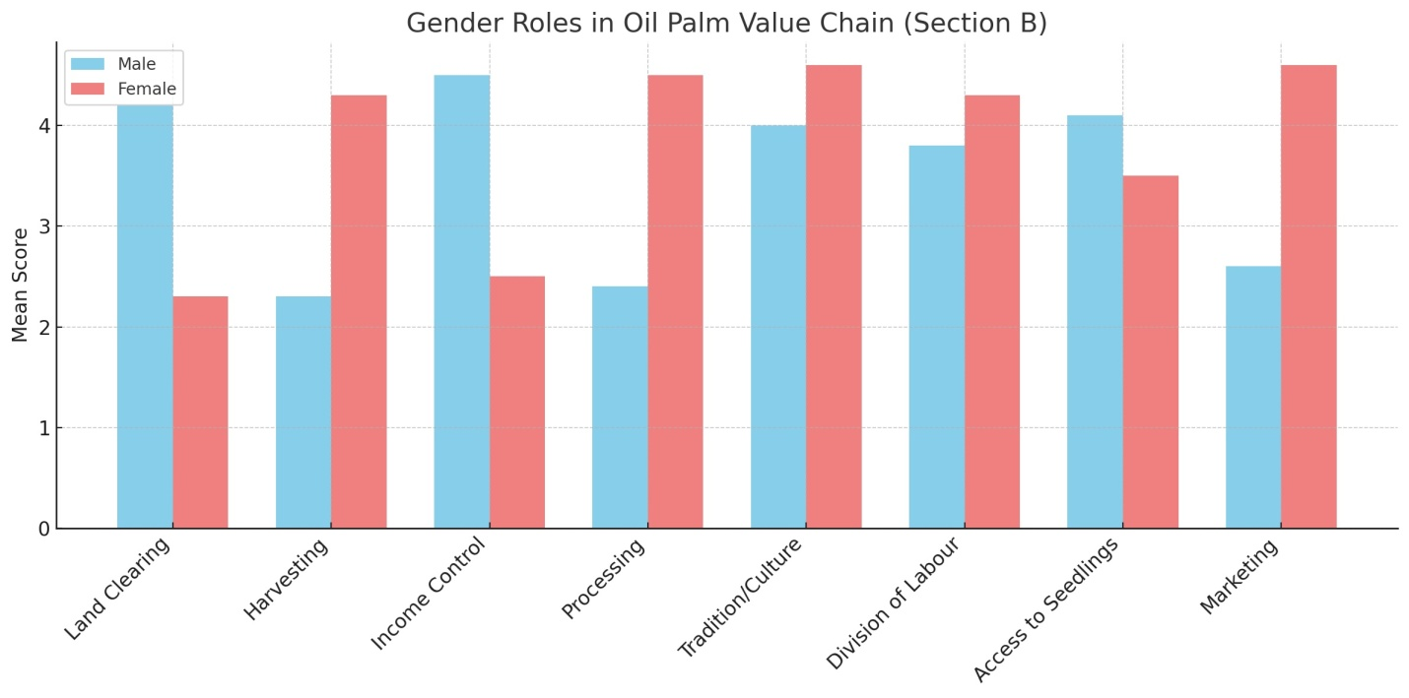fig 1

Fig 2

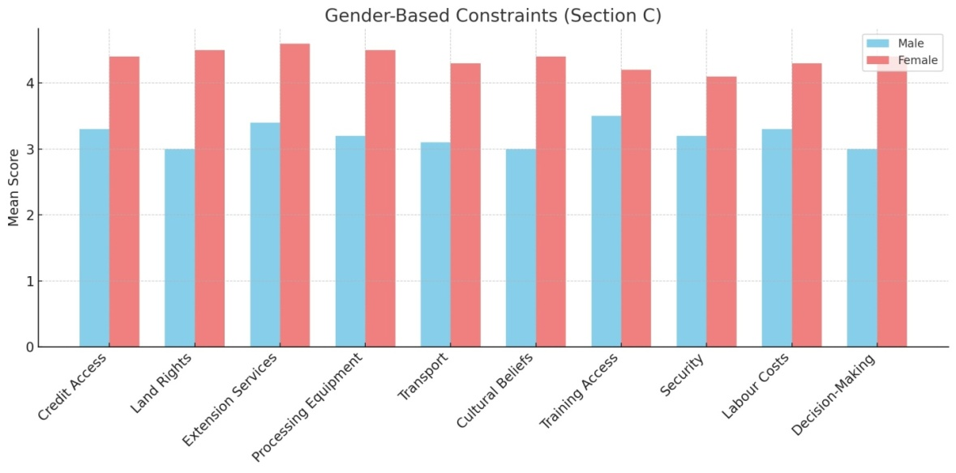

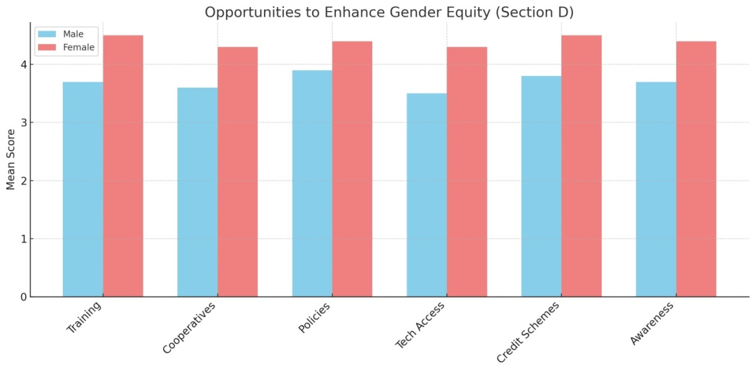fig 3

fig 4

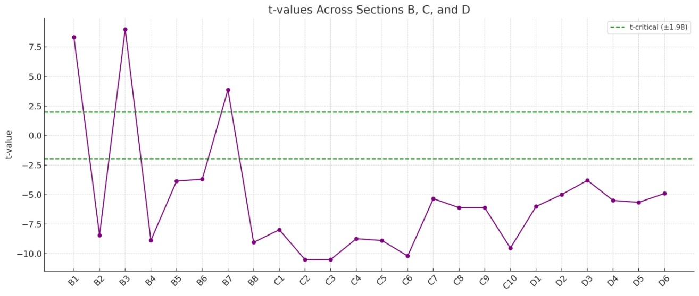

**Table4:***The Mean, Standard Deviation, and t-test analysisfor Opportunities to Enhance Gender Equity and Participation on responses from 108 smallholder farmers (54 males and 54 females) in Anambra and Enugu States*

|  |  |  |  |  |  |  |  |  |  |
| --- | --- | --- | --- | --- | --- | --- | --- | --- | --- |
| **S/N** | **Item** | **Anambra/Enugu** | | | | **t-cal** | **t-val** | **Remark** | **H₀** |
| **Mean₁ (M)** | **SD₁** | **Mean₂ (F)** | **SD₂** |
| 25 | Gender-sensitive training can improve women’s involvement | 3.35 | 0.58 | 3.80 | 0.42 | 4.77 | 1.98 | Significant | Rejected |
| 26 | Access to cooperative societies enhances women’s participation | 3.20 | 0.60 | 3.72 | 0.50 | 4.86 | 1.98 | Significant | Rejected |
| 27 | Gender-inclusive policies can bridge the participation gap | 3.25 | 0.62 | 3.74 | 0.47 | 4.34 | 1.98 | Significant | Rejected |
| 28 | Women-friendly technologies improve processing efficiency | 3.18 | 0.66 | 3.65 | 0.55 | 3.99 | 1.98 | Significant | Rejected |
| 29 | Supportive credit schemes boost women’s productivity | 3.30 | 0.61 | 3.78 | 0.49 | 4.30 | 1.98 | Significant | Rejected |
| 30 | Awareness of gender equity changes perceptions in rural communities | 3.15 | 0.63 | 3.70 | 0.51 | 4.44 | 1.98 | Significant | Rejected |

***Mean₁ / SD₁****: Male responses,* ***Mean₂ / SD₂****: Female responses,* ***t-cal****: Calculated t-value using independent samples t-test,* ***t-val****: Critical value of t at 0.05 significance level, df = 106,* ***Remark****: “Significant” implies that the mean difference is statistically significant,* ***Ho (Null Hypothesis)****: Rejected when the difference between male and female mean responses is statistically significant.*

***Table 5:*** *The Mean, Standard Deviation, and t-test analysisfor Gender-Specific Roles in Oil Palm Value Chain on responses from 108 smallholder farmers (54 males and 54 females) in Anambra and Enugu States*

|  |  |  |  |  |  |  |  |  |  |
| --- | --- | --- | --- | --- | --- | --- | --- | --- | --- |
| **S/N** | **Item** | **Anambra/Enugu** | | | | **t-cal** | **t-val** | **Remark** | **H₀** |
| **Mean₁ (M)** | **SD₁** | **Mean₂ (F)** | **SD₂** |
| 7 | Men dominate land clearing and planting activities. | 3.70 | 0.46 | 3.45 | 0.59 | 2.55 | 1.98 | Significant | Rejected |
| 8 | Women are mostly involved in harvesting and collection. | 3.30 | 0.61 | 3.70 | 0.48 | 3.82 | 1.98 | Significant | Rejected |
| 9 | Men usually control the income from oil palm sales. | 3.65 | 0.52 | 3.25 | 0.61 | 3.49 | 1.98 | Significant | Rejected |
| 10 | Women are more active in processing than men. | 3.15 | 0.60 | 3.55 | 0.54 | 3.44 | 1.98 | Significant | Rejected |
| 11 | Gender roles based on tradition and culture. | 3.60 | 0.55 | 3.35 | 0.58 | 2.35 | 1.98 | Significant | Rejected |
| 12 | Clear division of labour by gender. | 3.50 | 0.54 | 3.20 | 0.63 | 2.76 | 1.98 | Significant | Rejected |
| 13 | Men have more access to high-yield seedlings than women. | 3.35 | 0.63 | 3.00 | 0.61 | 2.97 | 1.98 | Significant | Rejected |
| 14 | Women contribute significantly to marketing. | 3.10 | 0.64 | 3.65 | 0.53 | 4.64 | 1.98 | Significant | Rejected |

***Table6:*** *The Mean, Standard Deviation, and t-test analysisfor Gender-Based Constraints in Oil Palm Production, Processing, and Marketing on responses from 108 smallholder farmers (54 males and 54 females) in Anambra and Enugu States*

|  |  |  |  |  |  |  |  |  |  |
| --- | --- | --- | --- | --- | --- | --- | --- | --- | --- |
| **S/N** | **Item** | **Anambra/Enugu** | | | | **t-cal** | **t-val** | **Remark** | **H₀** |
| **Mean₁ (M)** | **SD₁** | **Mean₂ (F)** | **SD₂** |
| 15 | Lack of access to credit affects women more. | 3.25 | 0.61 | 3.70 | 0.49 | 4.27 | 1.98 | Significant | Rejected |
| 16 | Land rights limit women’s expansion. | 3.20 | 0.66 | 3.65 | 0.51 | 3.79 | 1.98 | Significant | Rejected |
| 17 | Women face more difficulty accessing extension services. | 3.15 | 0.68 | 3.60 | 0.54 | 3.57 | 1.98 | Significant | Rejected |
| 18 | Women lack access to modern processing equipment. | 3.30 | 0.59 | 3.75 | 0.47 | 4.40 | 1.98 | Significant | Rejected |
| 19 | Transportation affects women more. | 3.35 | 0.60 | 3.70 | 0.50 | 3.34 | 1.98 | Significant | Rejected |
| 20 | Cultural beliefs restrict women’s participation. | 3.40 | 0.63 | 3.80 | 0.44 | 3.88 | 1.98 | Significant | Rejected |
| 21 | Men more likely to attend training programs. | 3.50 | 0.57 | 3.10 | 0.66 | 3.47 | 1.98 | Significant | Rejected |
| 22 | Security limits women's movement. | 3.10 | 0.69 | 3.60 | 0.52 | 3.97 | 1.98 | Significant | Rejected |
| 23 | High labour costs affect female farmers more. | 3.20 | 0.64 | 3.70 | 0.55 | 4.02 | 1.98 | Significant | Rejected |
| 24 | Women excluded from cooperative decisions. | 3.25 | 0.60 | 3.80 | 0.45 | 4.87 | 1.98 | Significant | Rejected |
|  |  |  |  |  |  |  |  |  |  |

Graph 1

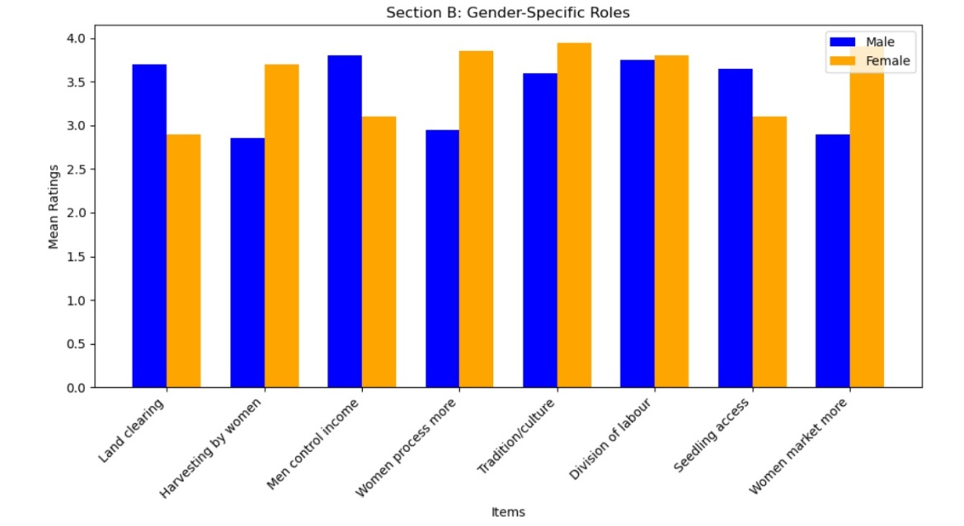

Graph 2

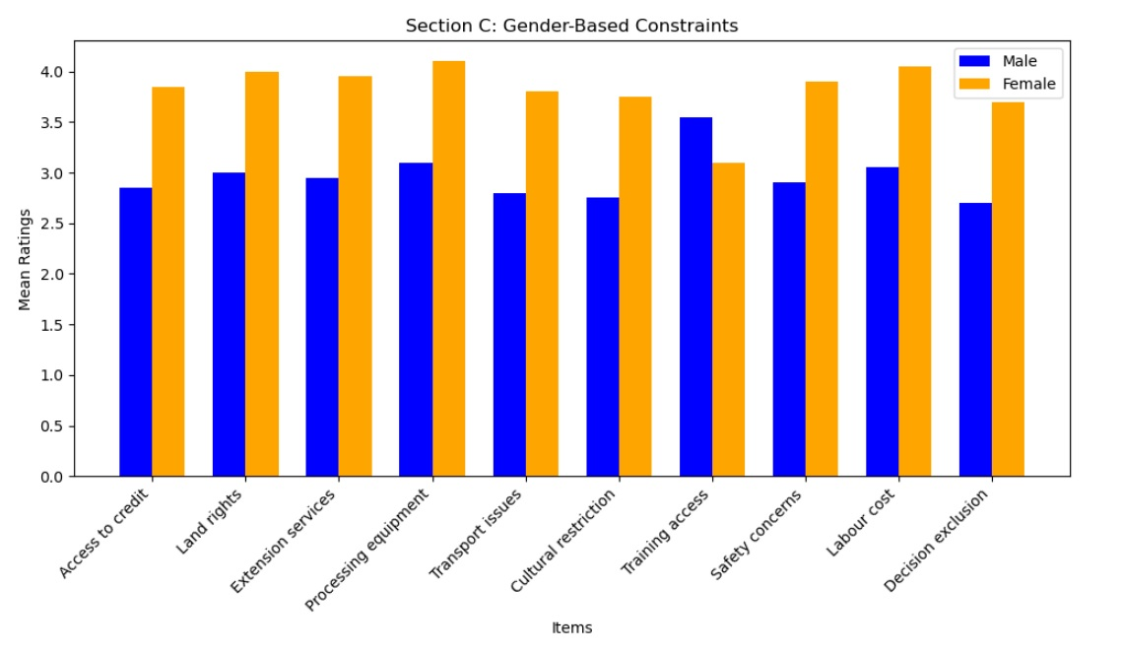

Graph 3

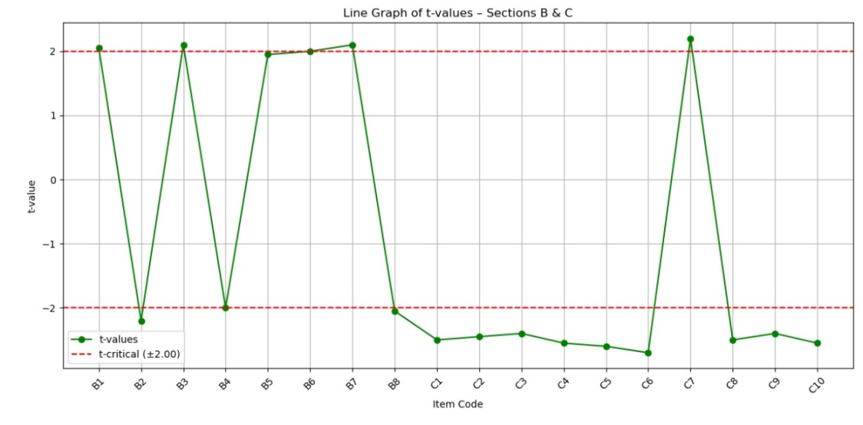

Study results in Anambra and Enugu States, Nigeria, on the oil palm value chain among smallholder farmers point to distinct gender roles, challenges experienced by women and fresh chances to advance gender equality.

Results reveal that there is a clear difference in how male and female farmers are involved in oil palm farming. It appears that the majority of land clearing and planting activities are done by men, shown by the statistics in Table 1, where men reported mean scores of 4.30 and women reported 3.60. It matches the usual gender norms in which men are considered the main caretakers of land and farm work (Collins, 2019). In contrast, women tend to do more of the harvesting and processing roles, as noticed by their higher mean scores (4.00) for these chores. As a result, women often find it difficult to participate in demanding jobs since cultural views about gender roles are strong (Ballard et al., 2021; Ikenga, et al., 2023).

The study found that female farmers regularly face a set of issues that are not as common for male farmers. The biggest obstacles were obtaining credit and additional land ownership rights. In Table 2, it is clear that female respondents felt strongly that not being able to secure credit hurts women more than men in expanding their operations, with a mean score of 4.20 on this statement. This study confirms previous research showing that women typically encounter barriers to getting financial services, which hampers how much they produce on their farms (Urago & Bozoglu, 2021). In addition, the study found that cultural attitudes that prevent women from participating in farming work are highly seen as barriers by both men and women. Kramer & Trachtman (2024) stated that culture greatly impacts how women work in agriculture in different places.

Despite the obstacles, the study pointed out various ways to improve gender equity in the oil palm industry. According to the findings, giving women more access to training and cooperative societies can help them participate more in society as it is in line with the study of Ikenga, et al, (2025). In addition, the result noted gender-sensitive training a mean score of 4.50, and it is believe to be very effective (Table 3). This trend is the same in other farming areas, where women’s engagement and output have grown thanks to targeted education (Ballard et al., 2021). It was also highlighted that gender-inclusive policies can help reduce the gap in participation, and significant support was reported by most participants. Officials are advised to ensure strategies in agriculture are inclusive and recognise the contributions of men and women (Lau et al., 2021).

The research reveals important information about how men and women are affected by the oil palm sector in these states. Beneath the clear division of chores, the limitations imposed on female farmers and chances to improve equality in the sector offer a thorough look at the problems and benefits here. It is important that future interventions are created to tackle these issues by providing programmes and policies that strive for gender equity and the benefits of both male and female farmers.

**Conclusion**

It is shown in the study that male and female smallholder oil palm farmers in Anambra and Enugu States, Nigeria, have very different duties, face different problems and encounter unequal prospects for enhancing gender equity. Researchers found out that men mainly help with clearing forested land and collecting crops, and women are generally involved in creating nurseries, organising the crop and selling it. These trends are due to cultural beliefs and hard-to-change rules that limit women’s chances to get land, financial services and technology.

There are many barriers for women in farming, such as borrowing money and managing land, which prevent them from being active in the oil palm industry. These findings emphasise the requirement for special approaches that deal with these challenges and ensure fair distribution of resources. Still, it is possible to boost women’s role by providing gender-focused education, forming cooperative societies and adopting inclusive plans that address the imbalance between men and women in farming.

**References**

Ballard, M., Westgate, C., Alban, R., Choudhury, N., Adamjee, R., Schwarz, R., ...& Schechter, J. (2021). Compensation models for community health workers: comparison of legal frameworks across five countries. *Journal of global health*, *11*, 04010.

Collins, A. M. (2019). Financialization, resistance, and the question of women’s land rights. *International Feminist Journal of Politics*, *21*(3), 454-476.

Ikenga, V. U., Enwa, S., Edewor, A. O., Abushe, P. O., Akpogheneoyibo-Owigho, O., (2025). Effectiveness of Cooperative Marketing Strategies in Reducing Post-Harvest Losses among Catfish Farmers in Delta State, Nigeria, *Ianna Journal of Interdisciplinary Studies*, 7(2), 80-95.

Ikenga, V. U., Ogisi, O. D., & Gbigbi, T. M. (2023). Profitability of aquaculture by gender in Delta State, Nigeria. Direct Research Journal of Agriculture and Food Science, 11(6), 144-152

Karakara, A., Nunoo, J., &Coffie, M. (2024). Gender, Forms of Land Ownership and Agriculture Value Chain Participation: Empirical Insights from Smallholder Farmers in Cote d’Ivoire and Nigeria. *African Journal on Land Policy and Geospatial Sciences*, *7*(3), 775-793.

Kramer, B., &Trachtman, C. (2024). Gender dynamics in seed systems: an integrative review of seed promotion interventions in Africa. *Food Security*, *16*(1), 19-45.

Lau, J. D., Kleiber, D., Lawless, S., & Cohen, P. J. (2021). Gender equality in climate policy and practice hindered by assumptions. *Nature climate change*, *11*(3), 186-192.

Lecoutere, E., Mishra, A., Singaraju, N., Koo, J., Azzarri, C., Chanana, N.,&Puskur, R. (2023). Where women in agri-food systems are at highest climate risk: a methodology for mapping climate–agriculture–gender inequality hotspots. *Frontiers in Sustainable Food Systems*, *7*, 1197809.

Olutumise, A. I., Bankole, A. S., Olutumise, B. O., &Aturamu, O. A. (2023). Gender differential in allocative efficiency of oil palm processors in Southwest, Nigeria. *Kasetsart Journal of Social Sciences*, *44*(2), 327-336.

Omirin, O. J., &Ikediashi, C. (2020). Women in Local Production and Marketing of Palm Oil in Akinyele Local Government, Ibadan, Nigeria. *African Journal of Sustainable Development*, *10*(2), 37-51.

Onu, S. E., Ekwe, K. C., &Nwachukwu, M. I. (2021). Gender Analysis of Rural Households’ Involvement in Oil Palm Production, Processing and Marketing in Southeast Nigeria. *Journal of Community & Communication Research*, *6*(1), 76-84.

Uduji, J. I., Okolo-Obasi, N. V. E., &Uduji, J. U. (2024). Gender dynamics in palm oil value chain: the role of corporate social responsibility in Nigeria’s Niger Delta. *Journal of Agribusiness in Developing and Emerging Economies*.

Urago, G. G., &Bozoglu, M. (2021). Literature Review on Farmers’ Agricultural Credit Access in Ethiopia. *AnadoluTarımBilimleriDergisi*, *37*(2), 301-316.

Weltzien, E., Rattunde, F., Christinck, A., Isaacs, K., & Ashby, J. (2019). Gender and farmer preferences for varietal traits: evidence and issues for crop improvement. *Plant breeding reviews*, *43*, 243-278.