Effect of Pre-anthesis Melatonin Priming on Plant Growth, Yield, and Grain Quality in Wheat under Post-anthesis Salt Stress

ABSTRACT
The present study was performed at the Farm of the Department of Laboratory, China. To evaluate the effects of pre-anthesis melatonin priming in alleviating the negative impact of post-anthesis salt stress on plant growth, yield, and quality of two winter wheat (Triticum aestivum L..), Yangmai 16 from China and Imam from Sudan. Pre-anthesis wheat plants at nine-leaf-stage were separately primed with 500 μM of melatonin and after post-anthesis consequently exposed to 100 and 300 mM of NaCl. Five concentrations were used: CT: Control; S1: 100 mM NaCl only; S2: 300 mM NaCl only; S1+M: 100 mM NaCl +melatonin, S2+M: 300 mM NaCl + melatonin. The treatments were arranged in a Randomized Complete Block Design (RCBD) with four replications. Parameters measured under study were analyzed statistically using SPSS (SPSS Inc, Chicago, IL). Significantly different means of the measured data separated at the 0.05 probability level using Duncan’s Multiple Range Test (DMRT). The results demonstrated that post-anthesis salt stress lead to significant decrease in plant height, flag leaf area, fresh and dry weight of shoot and root, relative water (RWC), while the post-anthesis melatonin priming alleviated these decline. Also, post-anthesis salt stress decreased chlorophyll, indole acetic acid (IAA), gas exchange and Chlorophyll fluorescence parameters contents, antioxidant activities, yield and yield components’ characters , protein and starch concentration, Ca⁺² and K⁺ contents but pre-anthesis with 500 μM of melatonin priming improved these parameters. We also found that post-anthesis salt- stressed plants had elevated reactive oxygen species (ROS) malondialdehyde (MDA), hydrogen peroxide (H₂O₂) contents, superoxide (O₂₋), sodium (Na⁺) contents, where pre- anthesis primed with melatonin lowered these parameters. Then, pre- anthesis priming with 500 μM of melatonin expected to be a best alternative to mitigate the negative effects of post-anthesis salts stress at plant growth yield and yield components and grain quality in wheat.

Keywords: pre-anthesis melatonin priming, antioxidant enzymes, reactive oxygen species, wheat (Triticum aestivum L.), post-anthesis salt stress

1. Introduction
Soil salinity is a serious environmental risk for several countries across the globe. Global agricultural productivity is decreasing as a result of this process (Al-jughaif and Alobaidy, 2024). It affects about 7% of the planet’s land area. A high proportion of cultivated land is influenced by salt stress; 23% of cultivated land is salty, and 20% of irrigated area has secondary salinization (Singh et al., 2015; Sidra et al., 2024). Salinity causes osmotic stress, imbalance of ionic, and oxidative injure to plants, reduces plant ability to absorb water and nutrients from the soil, inhibits germination of seed, growth, and development, lead to the stunting of plant growth and leaves wilting, and, finally, causes a decline in crop production (Ismail et al., 2017) The ionic toxicity induced by high contents of Na+ and Cl− damages cells balance, raises the extent of membrane lipid harm, and reduce photosynthesis (Hoa et al.,2021) also leading to physiological drought by decreasing the osmotic potential of soil solution’s (Khan et al., 2019). Salinity stress prevents plants to take up water from the soil, leading to a decline in cellular water, which influence cell expansion and lead to accumulation of a high levels of reactive oxygen species (ROS), which influences normal plant growth (Khan et al., 2018). Plants have developed potential antioxidant enzymatic defense systems to battle oxidative stress and enhance their tolerance to salty conditions. The enzymatic system consist of catalase (CAT), guaiacol peroxidase (POD), superoxide dismutase (SOD), ascorbate peroxidase (APX),( Shen et al., 2021).
Melatonin (MT, N-acetyl-5-methoxytryptamine) is an essential hormone of plant. In 1995, the melatonin was discovered in the plant kingdom (Dubbels et al. 1995) and now documented as a ubiquitous biomolecule synthesized in all kingdoms, from prokaryotes to eukaryotes, from animals to plants (Arnao and Hernandez-Ruiz 2014). Confirmations specify that melatonin is a plant master regulator that enhances plant growth (Park et al. 2021; Yu et al. 2021) and yield of crop (Zahedi et al. 2020). Furthermore, melatonin plays significant function in plant stress tolerance (Shafi et al. 2021). earlier studies mentioned that melatonin works in plant by regulating, activity of antioxidant enzymes, molecules of scavenging ROS, and stabilizing biological membranes (Debnath et al. 2019; Zhang et al. 2021).Exogenous application of melatonin stimulates salt stress tolerance via improving photosynthetic efficiency, metabolism of nitrogen, uptake of ion, and antioxidant defense system (Talaat andShawky 2022). There are also information that exogenous of melatonin improves crop salt tolerance by enhancing redox homeostasis, transcription factors, and plant hormones (Chen et al. 2021).
Wheat (Triticum aestivum L.) is most important cereal crop in several parts of the world recognized as the “king of cereals.” As a strategic crop, wheat is important for the global economy, production, food supply, and nutrition (Bashir et al., 2023; Sidra et al., 2024). It is one of the main species widely cultivated, providing food for over one-third of the world’s population. However, saline soils in arid and semi-arid areas of the world restrict food production (Kalsoom and Ahmed, 2023).

2. MATERIALS AND METHODS
2.1 Experimental design
The experiment was carried out at the Farm of the Department of Laboratory, China. Two winter wheat varieties (Yangmai 16) from China and (Imam) from Sudan, were grown in plastic pots (22cm in height and 25cm in diameter) filled with 7.5 kg of clay soil. The soil contained 13.1 g kg−1 organic matter, 1.1g kg−1 total N, 72.4 mg kg−1 available N, 41.9 mg kg−1 Olsen-P, 146.2 mg kg−1 available K. In order to meet the nutrient demands of the plants, 0.9 g N, 0.36 g P₂O₅, and 0.9 g K₂O per pot were homogenously mixed into the soil before filling the pots; and another 0.3 g N per pot was applied with irrigation water at the jointing stage. Water was supplied sufficiently throughout the experiment to avoid the occurrence of drought stress. Before anthesis (at the nine-leaf stages), the plants were divided into two batches, one batch of the plants was non-primed with melatonin as (Control) and others batch of plants primed with 500 μM of melatonin. 7 days after anthesis (DAA) five treatments were established: (I) Control (CT), (II) 100 mM of NaCl (S1), (III) 300 mM of NaCl (S2), (IV) 100 mM of NaCl + 500 μM of melatonin (S1+M), (V) 300 mM of NaCl +500 μM melatonin (S2+M). The experiment was arranged in a randomized complete block design, with four replicates for each treatment. Namely, at least four pots for each treatment were used for each harvest or each measurement. At 90 days after sowing (DAS), plant samples were taken to study some growth parameters as plant height (cm), flag leaf area (cm²), fresh and dry weight of shoot and root (mg), photosynthetic pigments of leaves, relative water content (RWC).Yield and its components as spikes number/pot, spikes length (cm), grains number/ spike, grains weight/spike (g), grains yield/(g/ pot⁻¹) , 1000 grains weight (g), biological yield/(g/pot⁻¹) and harvest index (%) as well as nutritive value of the yielded grains as protein %, starch%, amylose % , amylopectin%, sodium, potassium and calcium percentages
2.2 Characters Measured
2.2.1 Plant height (cm)
Plant height was measured as an average height of five plants per plot at the taken from the soil surface to the tip of the flag leaf.
2.2.2 Flag leaf area (cm²)
Was measured by the following formula:
0.83 x leaf Length x leaf width
2.2.3 Relative water content (RWC)
Was measured in the first fully expanded leaf (from the top) using the method of .
RWC (%) = Fresh weight - Dry weight x 100
Turgid weight - Dry weight
2.2.4 Chlorophyll concentration
Chlorophyll a, chlorophyll b concentrations were estimated using the method of
2.2.5 Measurements of IAA contents
Indole acetic acid (IAA) in the wheat plant leaves were determined followed the method described by .
2.2.6 Measurement of reactive oxygen species (ROS)
Malonaldehyde (MDA) content, Hydrogen peroxide (H₂O₂) and superoxide (O₂) in wheat leave were determined using our previous method.
2.2.7 Assay of antioxidants enzymes
The activities of antioxidant enzymes, namely catalase (CAT), superoxide dismutase (SOD), peroxidase (POD) were assayed following the methods of .
2.2.8 Gas Exchange Parameters
“After post-anthesis of salt stress treatment, the latest fully expanded leaf were used for the gas exchange measurements fallowing the method of (Wang et al., 2011). The LI-6400 system (LI-COR Biosciences, Lincoln, NE, USA) was utilized to calculate photosynthesis rates (PN), stomatal conductance (Gs), transpiration rate (Tr) and intercellular CO2 concentration (Ci) from 8 a.m. to 11 a.m. Four leaves were taken as replicates from each treatment.
2.2.9 Chlorophyll Fluorescence
After post-anthesis of salt stress treatments set, the plants were dark modified for at least 20 min prior to calculating leaf chlorophyll fluorescence in the latest fully expanded leaf (PAM chlorophyll fluorometer, M-series, Heinz Walz, Effeltrich, Germany). The actual PSII photochemical efficiency (ΦPSII), maximum photochemical efficiency (Fv/Fm), photochemical quenching (qP), and non-photochemical quenching of chlorophyll fluorescence (NPQ) were calculated. Four biological replicates (leaves from various plants in different pots) were used.
2.2.10 Protein isolation and quantification
Protein is analyzed as nitrogen on a Leco TruSpec carbon–nitrogen analyzer according to method of .
2.2.11 Starch analysis
The isolation procedure of starch was done according to the method of .
Measurements of amylose and amylopectin contents in wheat grains were determined as described by .
2.2.12 Mineral content
The minerals content of the wheat grain (Na⁺, K⁺ , and Ca⁺²) were determined according to method of
2.3. Statistical analysis
In this study, all data were shown as the mean values ± SD (standard deviations). At least
Four independent replicates were conducted for each experiment. Data were analyzed by the one-way ANOVA using SPSS (SPSS Inc., Chicago, IL). Significantly different means of the measured data were separated at the 0.05 probability level by the Duncan’s
Multiple Range Test. Different letters above the columns of tables and figures indicated to be statistically significant at the 0.05 level among treatments.
3. RESULTS
3.1 Effect of pre-anthesis melatonin priming on growth parameters under post-anthesis salt stress
All the measured growth parameters (plant height, flag leaf area, fresh and dry weights of shoot and root) as well as relative water content (RWC) decreased as a result of application of the two salinity levels compare to control plants in the two varieties (Table 1). These decreases were significantly improved with pre-anthesis melatonin treatment, but, melatonin effect on plants stressed by salt was highest in Yangmai 16 compared to Imam, , it was noted that pre-anthesis melatonin concentrations (500 μM) increased all examined growth parameters under 100 mM and 300 mM of post-anthesis salt stress. These results indicated that exogenous melatonin treatment could promote growth of wheat plants exposed to salinity.
3.2 Effect of pre-anthesis melatonin priming on photosynthetic pigments under post-anthesis salt stress
The two post-anthesis applied salinity levels (S1 and S2) caused a decrease in all components of photosynthetic pigments (chlorophylls a, b ) and consequently chlorophyll a+b as well as chl a/ b ratio relative to the control plants (Fig.1). Meanwhile, pre-anthesis plants with 500 μM of melatonin caused significant increases in all components of photosynthetic pigments relative to the salt stress. It is imperative to mention that the enhancement effect of 500 mM melatonin on photosynthetic pigments was more pronounced in Yangmai 16 compared to Imam.
3.3 Effect of pre-anthesis melatonin priming on IAA content under post-anthesis salt stress
Two post-anthesis applied salinity levels (S1 and S2) caused significant decreases in indole acetic acid contents relative to the control plant in the two varieties compared to the control plants (Fig.2). On the other hand, pre-anthesis wheat plants with 500 μM of melatonin caused significant increases in IAA as compared with post-anthesis salt-stressed plants in the two wheat varieties (Fig.2).

Table 1. Effect of pre-anthesis melatonin priming on growth parameters of wheat plants grown under post-anthesis salt stress.
 |  |  |  | Fresh weight (mg plant⁻¹) |  | Dry weight (mg plant⁻¹) |  | RWC (%)
variety | Treatments | Plant height (cm) | Flag leaf area (cm²) | Shoot | Root | Shoot | Root
Yangmai16 | CT | 70.33±2.10a | 48.27±0.33a | 39.22±0.62a | 8.67±0.23a | 13.86±0.50a | 2.87±0.16a | 78.36±0.71a
 | S1 | 59.71±2.01d | 29.03±0.63d | 29.81±0.50d | 3.86±0.19d | 7.35±0.27d | 1.98±0.02c | 67.55±1.40d
 | S2 | 55.25±2.35e | 27.45±0.88e | 25.19±0.66e | 3.15±0.17d | 5.64±0.17e | 1.24±0.10d | 64.50±0.94e
 | S1+M | 68.36±0.49b | 43.60±0.67b | 36.44±0.75b | 7.78±0.25b | 10.31±0.33b | 2.43±0.16b | 75.46±0.78b
 | S2+M | 66.28±1.67c | 41.87±0.53c | 35.08±0.59c | 5.80±0.38c | 8.60±0.46c | 2.31±0.17b | 70.67±1.81c
Imam | CT | 66.22±2.18a | 45.03±0.74a | 38.08±0.90a | 8.08±0.06a | 11.07±0.40a | 2.43±0.19a | 76.48±0.94a
 | S1 | 53.26±2.16d | 27.97±0.53d | 28.47±0.42d | 4.57±0.11d | 6.23±0.35d | 1.35±0.05c | 65.42±1.04d
 | S2 | 51.59±0.89e | 24.90±0.49e | 23.39±0.53e | 2.96±0.22e | 4.31±0.16e | 1.08±0.03d | 63.62±0.91e
 | S1+M | 64.39±0.96b | 43.58±0.36b | 35.15±0.82b | 6.69±0.18b | 8.89±0.21b | 2.23±0.11a | 73.54±1.01b
 | S2+M | 60.32±1.64c | 41.99±0.22c | 32.70±0.57c | 5.91±0.15c | 7.68±0.15c | 1.91±0.08b | 68.37±0.69c
Different small letters in the same column refer to significant difference between treatments at P < 0.05 level

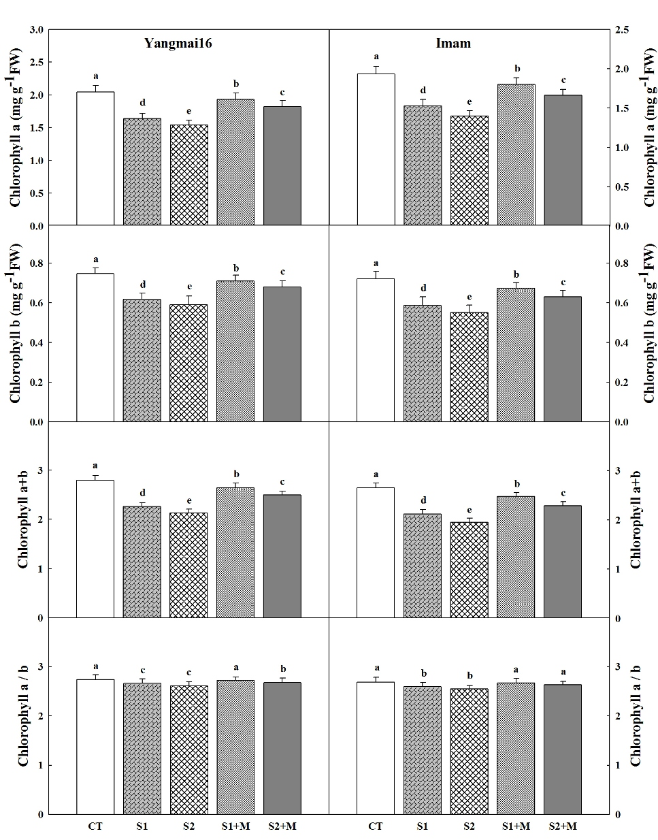
Fig.1 Effect of pre-anthesis melatonin priming on contents of chlorophyll a, b, chlorophyll (a+b) and chl a/b ratio of wheat under post-anthesis salt stress. Data are means ±SD (n=3). Different small letters indicate significant difference between treatments at P < 0.0
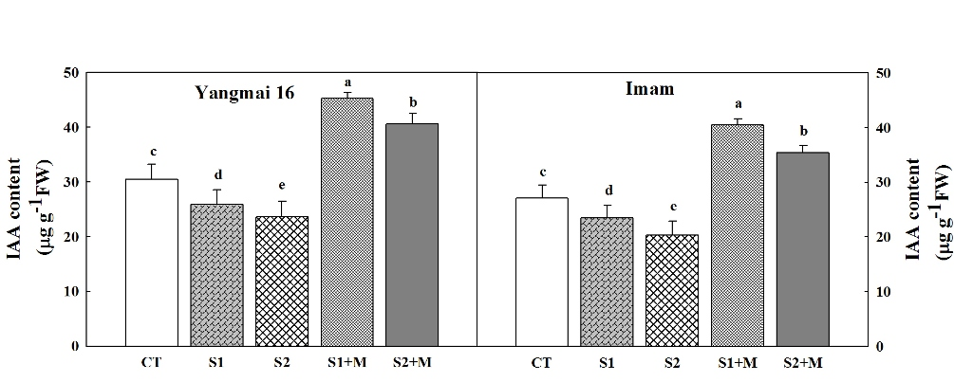
Fig.2 Effect of pre-anthesis melatonin priming on indole acetic acid content of wheat under post-anthesis salt stress. Data are means ±SD (n=3). Different small letters indicate significant difference between treatments at P < 0.05.

3.4 Effect of pre-anthesis melatonin priming on gas exchange under post-anthesis salt stress
Post-anthesis salt stress treatments (S1 and S2) decreased net photosynthetic rate (Pn), transpiration rate (Tr) and stomatal conductance (gs), but increased intercellular CO₂ concentration (Ci) of the wheat varieties leaves when compared to the control plant (Fig. 3). However, pre-anthesis melatonin priming plants significantly increased the net photosynthetic rate (Pn), transpiration rate (Tr) and stomatal conductance (gs), but decreased intercellular CO₂ concentration (Ci) when compared to salt- stressed plants, these parameters where more in the Yangmai 16 compared to Imam, these findings suggested that pre-anthesis melatonin priming played a positive role in protecting wheat plants photosynthetic apparatus against post-anthesis salt stress.

3.5 Effect of pre-anthesis melatonin priming on chlorophyll fluorescence under post-anthesis salt stress
As shown in (Fig.4) post-anthesis salt stress (S1 and S2), decreased the actual photosynthetic efficiency (ФPSII), photochemical quenching (qP), maximum photochemical efficiency (Fv/Fm), but increased the non-photochemical quenching (NPQ) compared to the control plants. Mean while, pre-anthesis melatonin priming caused significant increases in photosynthetic efficiency (ФPSII), photochemical quenching (qP), maximum photochemical efficiency (Fv/Fm), but decreased the non-photochemical quenching (NPQ).These above mentioned parameters where more in Yangmai when compared to Imam variety.
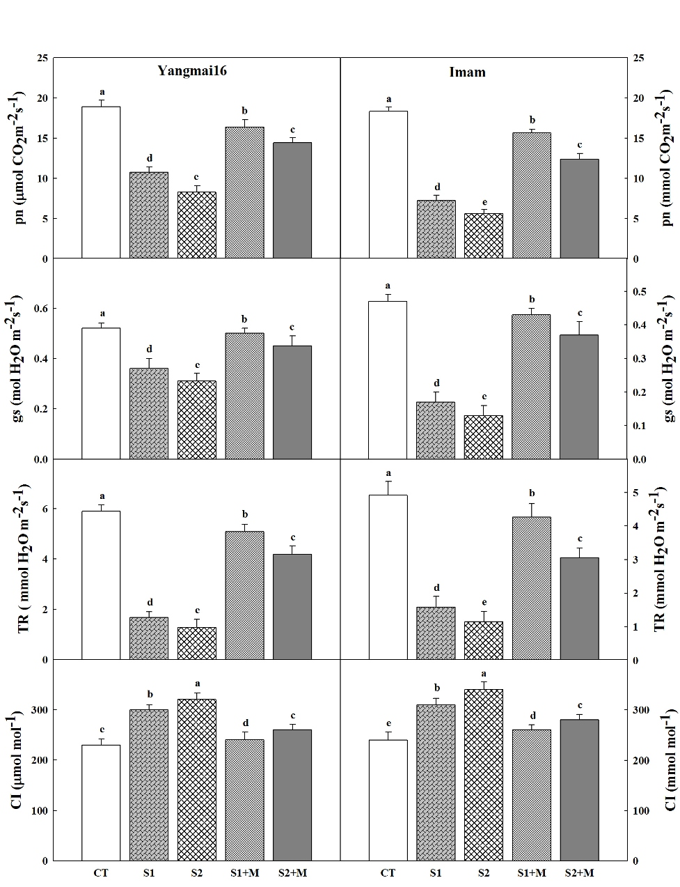
Fig.3 Effect of pre-anthesis melatonin priming on changes in contents of net photosynthetic rate (P_{n}), stomatal conductance (G_{s}), transpiration rate (Tr) and intercellular CO₂ concentration (Ci) in top leaf of wheat under post-anthesis salt stress. Data are means ±SD (n=3). Different small letters indicate significant difference between treatments at P < 0.05
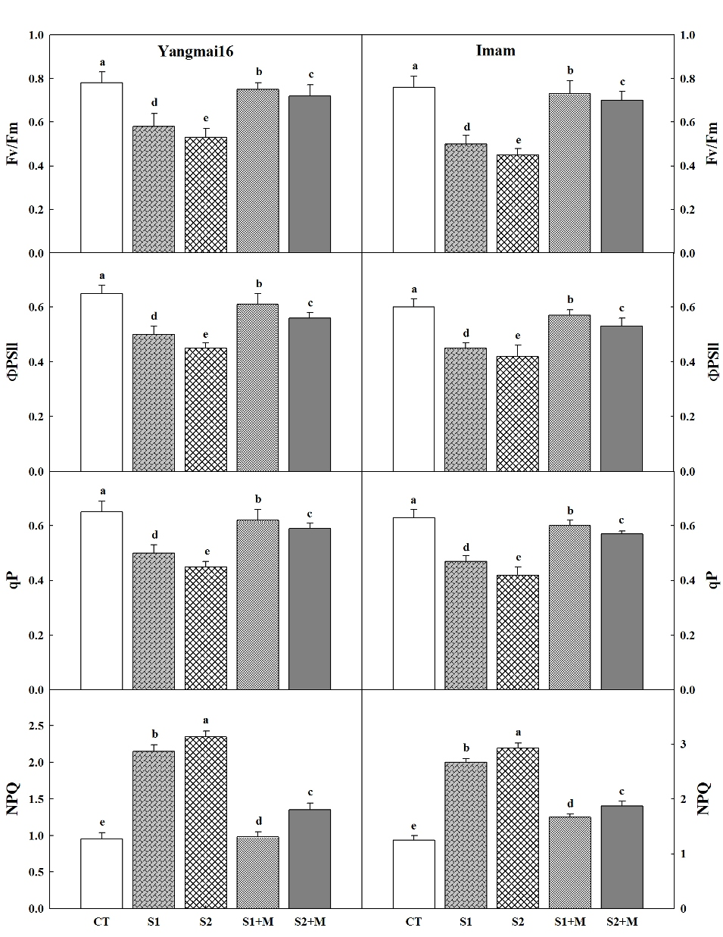
Fig. 4 Effect of pre-anthesis melatonin priming on changes in maximum photochemical efficiency (Fv/Fm), actual photosynthetic efficiency (Φpsll), photochemical quenching (q^{p}), and non- photochemical quenching (NPQ) in top leaf of wheat under post-anthesis salt stress. Data are means ±SD (n=3). Different small letters indicate significant difference between treatments at P < 0.05
3.6 Effect of pre-anthesis melatonin priming on reactive oxygen species (ROS) under post-anthesis salt stress
As important indicators of oxidative damage under environmental stresses, H₂O₂, O₂˙¯, MDA were measured. MDA, O2˙¯ and H₂O₂ levels of the post-anthesis leaves were increased under salt stress in the two varieties relative to the control plants (Fig. 5). However, the pre-anthesis priming of 500 μM melatonin remarkably alleviated these levels compared to salt-stressed plants. These facts confirmed that exogenous melatonin might alleviate salt stress-induced ROS accumulation and the subsequent oxidative damage in wheat plants
3.7 Effect of pre-anthesis melatonin priming on antioxidant enzymes activities under post-anthesis salt stress
Post-anthesis salt stress reduced the activity of CAT, SOD and POD of wheat leaves compared to the control in the two wheat varieties. In addition, pre-anthesis melatonin-treatment effectively improved the activities of three antioxidant enzymes compared to the salt stress plants (Fig.6).the activities of above mentioned enzymes were higher in the Yangmai 16 when compared by Imam. These results showed that melatonin might have essential effects on antioxidant enzymes activities which could be involved in alleviating salt stress-induced oxidative damage in wheat.
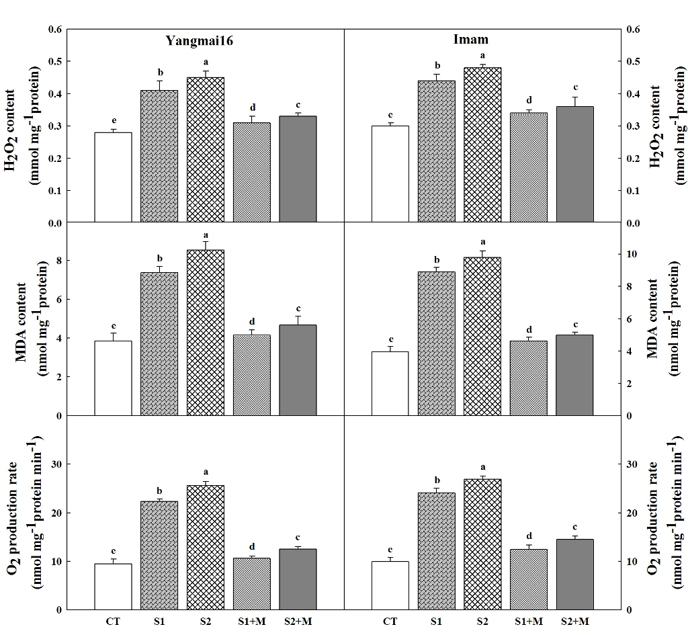
Fig.5 Effect of pre-anthesis melatonin priming on changes in content of H₂O_{2,} MDA and O₂⁻ production rate of wheat plants under post-anthesis salt stress. Data are means ±SD (n=3). Different small letters indicate significant difference between treatments at P < 0.05.
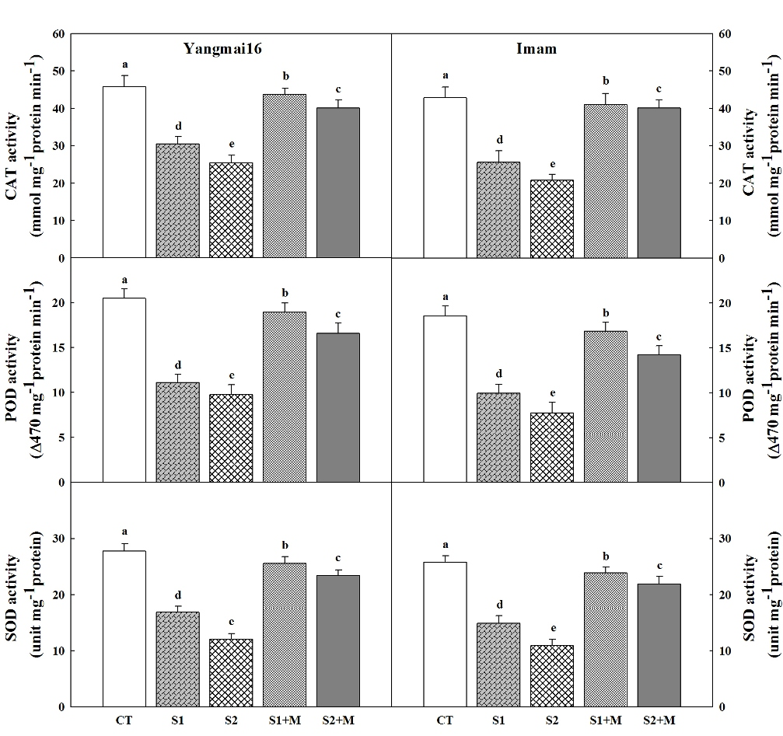
Fig.6 Effect of pre-anthesis melatonin priming on changes in activities of CAT, POD and SOD of wheat plants under post-anthesis salt stress. Data are means ±SD (n=3). Different small letters indicate significant difference between treatments at P < 0.05.

3.8 Effect of pre-anthesis melatonin priming on yield and yield components under post-anthesis salt stress
At harvest, spikes number/pot, spikes length (cm) , grains number/ spikes, grains weight/spikes (g), grains yield (g/ pot), 1000 grains weight (g) , biological yield (g/ pot) and harvest index of wheat plant varieties were decreased under salt stress as compared to the control plants (Table 2). On the other hand, 500 μM of melatonin caused significant increases in all the components of wheat varieties yield and yield components relative to salt stress. These facts indicated that exogenous melatonin alleviate salt stress-induced to the wheat plants yield.
3.9 Effect of pre-anthesis melatonin priming on protein percentage in yielded grains under post-anthesis salt stress
Table 3 shows that post-anthesis salt stress caused significant decreases in total protein contents of grains of wheat plant compared with control plant. These decreases were gradually with increased salinity level from 100 mM NaCl to 300 mM NaCl. In the meantime, 500 μM of melatonin treatment caused significant increases in protein contents of the yielded grains of wheat plant compared with their corresponding salt stress. A higher concentration of the grain yield protein was in Yangmai 16 and the lower concentration obtained in the Imam (Table 3).
3.10 Effect of pre-anthesis melatonin priming on starch characteristics under post-anthesis salt stress
At maturity, the total starch content in the grain was significantly lowered by both S1. S2 of salt stress treatment relative to the CT plants in the two wheat varieties (Table 3). Additionally, melatonin-treatment effectively improved the starch content in yielded grain of wheat varieties. The amylose and amylopectin contents were significantly decreased by post-anthesis salt stress compared to the control plant; on the other hand, melatonin treatment remarkably increased amylose and amylopectin contents resulting in increased amylopectin/amylose ratio in the two wheat varieties.

Table 2. Effects of pre-anthesis melatonin priming on grain yield and yield components in wheat under post-anthesis salt stress during grain filling.
variety | Treatments | Spikes No/pot | Spike length (cm) | Grains No/spike | Grains weight/spike (g) | Grain yield/(g pot-1) | 1000 grain weight (g) | Biological yield (g pot-1) | Harvest index (%)
Yangmai16 | CT | 20.34±0.07a | 17.12±0.34a | 28.67±0.45a | 2.94±0.05a | 25.89±0.68a | 42.04±1.28a | 74.15±1.17a | 34.91±1.12a
 | S1 | 18.69±0.25 | 7.13±0.36d | 21.78±0.56d | 1.73±0.02d | 18.45±0.69d | 32.76±1.09d | 63.76±1.22d | 28.62±0.87d
 | S2 | 18.19±0.02b | 6.77±0.56e | 20.98±0.69e | 1.44±0.05d | 15.67±0.68e | 30.12±1.15e | 60.01±1.56e | 26.11±1.05e
 | S1+M | 20.27±0.04a | 15.91±0.41b | 26.43±0.45b | 2.69±0.01b | 23.16±1.16b | 39.14±1.23b | 72.18±1.38b | 32.08±0.31b
 | S2+M | 20.24±0.06a | 13.78±0.40c | 24.45±0.76c | 2.08±0.06c | 20.88±0.65c | 36.70±1.05c | 67.82±0.89c | 30.79±0.75c
Imam | CT | 20.24±0.10a | 15.16±0.23a | 26.88±0.30a | 2.61±0.06a | 24.29±1.13a | 39.18±1.43a | 71.55±1.52a | 33.98±1.15a
 | S1 | 18.13±0.02c | 6.45±0.50d | 18.84±0.82d | 1.68±0.04c | 15.01±0.71d | 30.75±1.58d | 56.12±1.06d | 26.74±0.80d
 | S2 | 17.74±0.06d | 5.84±0.33e | 17.91±0.64e | 1.35±0.01c | 13.59±1.70e | 27.26±0.96e | 53.72±1.12e | 25.30±0.94e
 | S1+M | 19.62±0.15b | 13.81±0.53b | 25.87±0.54b | 2.49±0.06a | 20.61±1.22b | 36.72±1.14b | 66.72±1.44b | 30.89±0.57b
 | S2+M | 19.22±0.04b | 11.77±0.51c | 23.69±0.43c | 2.00±0.04b | 18.41±0.76c | 34.63±1.47c | 64.63±1.31c | 28.49±0.89c
Different small letters in the same column refer to significant difference between treatments at P < 0.05 level

3.11 Effect of pre-anthesis melatonin priming on mineral contents under post-anthesis salt stress
As shown in (Table 4). The two post-anthesis applied salinity levels ( 100 mM NaCl and 300 mM NaCl) caused significant and gradual increases in Na⁺ content accompanied by significant and gradual decreases in Ca⁺² and K⁺ percentages of yielded grains as well as ratios of K⁺/Na⁺ and Ca⁺²/Na⁺ comparative to the control plants in the two wheat varieties. In meantime pre-anthesis of 500 μM of melatonin caused significant decreases in post- anthesis Na⁺ percentages compared by increases in the percentages of K⁺ and Ca⁺² as well as ratios of K⁺/Na⁺ and Ca⁺²/Na⁺ relative to salt-stressed plants (Table 4).

Table 3. Effects of pre-anthesis melatonin priming on contents of protein, starch, amylose, amylopectin and amylopectin /amylose ratio in mature wheat grain under post-anthesis salt stress.
Variety | Treatments | Protein content (%) | Starch content (%) | Amylose content (%) | Amylopectin content (%) | Amylopectin/Amylose ratio
Yangmai16 | CT | 14.10±0.80a | 65.15±1.39a | 20.63±1.43a | 47.59±1.93a | 2.31±0.039a
 | S1 | 10.70±0.41d | 57.76±2.15d | 16.11±1.46d | 40.33±2.03d | 2.50±0.026a
 | S2 | 9.14±1.06e | 55.02±1.16e | 15.17±1.36e | 39.61±2.24e | 2.61±0.032a
 | S1+M | 13.90±0.35b | 63.65±2.32b | 18.66±1.25b | 45.21±1.89b | 2.42±0.030a
 | S2+M | 12.03±0.46c | 61.67±2.61c | 17.33±1.47c | 44.20±2.26c | 2.55±0.036a
Imam | CT | 13.84±1.02a | 62.47±1.67a | 18.88±0.39a | 45.31±1.08a | 2.40±0.099b
 | S1 | 9.52±0.32c | 55.45±1.04d | 14.70±1.22d | 39.33±1.59d | 2.68±0.098b
 | S2 | 7.14±0.16d | 53.41±1.83e | 12.15±0.89e | 38.56±1.83e | 3.17±0.119a
 | S1+M | 13.20±0.42a | 60.71±1.87b | 17.65±0.97b | 44.48±1.63b | 2.52±0.019b
 | S2+M | 11.21±0.39b | 59.02±2.29c | 16.50±0.89c | 42.88±1.44c | 2.60±0.018b
Different small letters in the same column refer to significant difference between treatments at P < 0.05 level

4. DISCUSSION
The objective of this study was to test the hypothesis that pre-anthesis melatonin priming may improve post-anthesis salt stress tolerance of wheat plants. To achieve this goal, we examined the performances of plant growth, the yield and yield components, antioxidant enzyme activities, and the expression of photosynthesis pigments, mineral contents of wheat plants subjected to the post-anthesis salt stress regimes. We found that pre-anthesis melatonin priming could significantly alleviate the damage of post-anthesis salt stress to wheat plants, and thus improved salt tolerance during grain setting and filling stages
It is well known that salt stress clearly inhibits plant growth and consequence in the reduce of crop yield (Saddiq et al., 2021; Seleiman, et al., 2022). As higher plants, they have developed different strategies to response to various environmental stresses. Melatonin, as a kind of new plant growth regulator, is consideration to be involved in various biotic and a biotic stress responses (. In the present study, the enhancement effect of melatonin on growth parameters of wheat plants under salt stress was investigated (Table 1). Previous studies have showed that melatonin might play an important regulatory role in plant growth and development . In this study, the growth of wheat was markedly inhibited when exposed to salt stress; nevertheless the inhibition of growth was clearly relieved by melatonin treatment. Melatonin affects plant growth by effecting on growth regulation and ion homeostasis. It has been known that a biotic stress generally causes the reduce in leaf water status and the augment in osmotic regulators . In agreement with these results, we observed that salt stress led to a decrease in RWC. However, melatonin priming alleviated the decrease in leaf water status, indicating that melatonin might enhance the water absorbing or holding capacity (Table 1).
many studies have showed that melatonin may reduce the decline of the photosynthetic pigments under different environmental stresses . These results were additional confirmed by our data (Fig.1). Under salt stress condition, the application of exogenous melatonin demonstrated higher level of photosynthetic pigments than the salt stressed plants. This practical decrease in pigments may be attributed not only to an improved degradation but also to an inhibited synthesis of chlorophylls due to salinity. It is well-known that sodium ions could interact with the negatively charged plasma membrane, which would lead to depolarization of the transmembrane potential and changes of H+-ATPase activity, and subsequently disrupt the uptake of some cations, such as Mg²⁺, impacting chlorophyll biosynthesis.

Table 4. Effects of pre-anthesis melatonin priming on contents of Na⁺, K⁺, Ca⁺², and K⁺/Na⁺, Ca⁺²/Na⁺ ratio in mature wheat grain under post-anthesis salt stress.
Variety | Treatments | Na⁺ content (mg g-1DW) | K⁺ content (mg g-1DW) | Ca⁺² content (mg g-1DW) | K⁺/Na⁺ ratio | Ca⁺²/Na⁺ ratio
Yangmai16 | CT | 1.33±0.033c | 3.41±0.03a | 1.47±0.022a | 2.57±0.21a | 1.11±0.10a
 | S11 | 2.21±0.035a | 2.73±0.02b | 0.98±0.045b | 1.23±0.17c | 0.44±0.07d
 | S2 | 2.51±0.027a | 2.42±0.05b | 0.89±0.032c | 0.97±0.15d | 0.35±0.08e
 | S1+M | 1.69±0.022b | 3.29±0.03a | 1.41±0.020a | 1.95±0.05b | 0.84±0.04b
 | S2+M | 1.81±0.032b | 3.18±0.02a | 1.24±0.021a | 1.76±0.19b | 0.68±0.11c
Imam | CT | 1.21±0.030c | 3.30±0.038a | 1.33±0.018a | 2.72±0.23a | 1.10±0.12a
 | S1 | 2.09±0.055a | 2.62±0.023b | 0.87±0.020b | 1.25±0.16d | 0.42±0.06d
 | S2 | 2.39±0.012a | 2.27±0.025b | 0.78±0.037b | 0.95±0.19e | 0.33±0.08e
 | S1+M | 1.57±0.033b | 3.18±0.022a | 1.28±0.010a | 2.02±0.15b | 0.82±0.05b
 | S2+M | 1.69±0.022b | 3.07±0.027a | 1.12±0.047a | 1.81±0.22c | 0.66±0.38c
Different small letters in the same column refer to significant difference between treatments at P < 0.05 level

Data obtained in Fig (2) confirmed that IAA were significantly reduced in wheat leaves with increasing levels of post-anthesis salt stress (S1 and S2) when compared with those of the control (CT) plants. IAA as a phytohormone regulate the protective responses of plants against both biotic and a biotic stresses by means of synergistic or antagonistic actions with other hormones as GA3, BA and ABA referred to as signaling cross talk . Conversely, exogenous application of 500μM of melatonin caused considerable enhances in IAA as compared with salt-stressed plants. The promotive effect of melatonin on IAA concentrations were established on various plant species .
Photosynthesis is the most important process influenced by salt stress and can lead to drops in crop yield (Ismaeil et al., 2022) “In our study, we found that salt stress significant decreased in the photosynthesis rate of both wheat varieties when compared with control plants. However, melatonin priming significantly (P < 0.05) increased the photosynthetic rate of wheat plants (Fig. 3), suggesting that melatonin primed plants demonstrates a higher ability to protect photosynthetic activity in response to a later salt stress quite than the establishment of a changed state. Our result also showed that stomatal conductance was reduced under salt stress, but after the application of .melatonin seems to alleviate a biotic stress-induced inhibition partially by increasing the photosynthetic efficiency of plants. Similar data were also obtained in a study of cold-stressed wheat seedlings . In the present study of wheat varieties, melatonin increased the photosynthetic rate Pn and maintained higher stomatal conductance gs, transpiration rate Tr. Parameters of chlorophyll fluorescence are important indictors for photon conversion and electron transition processes in Photosystem II (PSII) of leaves and are very sensitive to a biotic stress (Sayed, 2003). Moreover, the maximal photochemistry efficiency (Fv/Fm) and the actual photochemistry efficiency (ФPSII), photochemical quenching qP of PSII were clearly depressed by salt stress, but non- photochemical quenching NPQ increased, at the same time; the melatonin priming effectively alleviates the negative effect of salt on Fv/Fm, ФPSI, and qP (Fig.4), similar results was also obtained by (Ismaeil et al., 2024)
Several publications have demonstrated that melatonin alleviates ROS production caused by a biotic stress (. Constantly, our study suggested that salt stress increased ROS in wheat leaves; however the application of exogenous melatonin alleviated ROS accumulation (Fig. 5). MDA was consideration to be important indicators of oxidative injure impacting the membrane’s integrity . In the present study, lower levels of MDA were observed in melatonin-treated plants under salt stress condition, which was inconsistent with the reduce of ROS creation, additional indicating that melatonin may protect cell membranes against oxidative damage caused by salt stress . However, our study also demonstrated that a lower rate of cell death was found in melatonin-treated plants under salt stress condition, demonstrating that melatonin might alleviate cell death by reduce ROS accumulation under salt stresses in wheat plants (Fig 5).
To reduce the effect of ROS, plants have evolved various antioxidant systems to prevent accumulation of ROS (Ismaeil et al., 2024). In plants, melatonin has also been suggested to be a essential antioxidant that can scavenge oxygen free radicals efficiently. Several studies have showed that application of melatonin can enhance some antioxidant enzyme (such as POD, SOD, and APX) activities under a biotic stress condition in plants (. Constantly, we confirmed that melatonin application improved the activities of CAT, SOD, and POD antioxidant enzymes in wheat plants under salt stress (Fig. 6). In the present study, the high activities of CAT, SOD and POD, under salt stress in the wheat leaves presence of melatonin could principally be due to the synergistic effects of the combination of salt stress and exogenous of melatonin.
Different levels of post-anthesis salt stress caused marked reduces in yield and yield components (Table 2). Increasing post-anthesis salt stress levels decreased yield and yield components of wheat plants in comparison with control plants. In agreement with our results, those funded on faba bean plant. These decreases may be due to the decreases in plant growth, photosynthetic pigments and disturbance in the nutrient balance. Conversely pre-anthesis priming wheat plant with the melatonin alleviates the harmful effect of salt stress on yield and yield components (Table 2). These obtained data are in accordance with . Melatonin treatment allowing plants to maintain a vigorous root system and enhanced photosynthetic activity so can alleviate growth inhibition and increased crop yield.
Concerning to the nutritional values of the wheat yielded grains, different levels of post-anthesis of salt stress caused significant decreases in crude protein contents compared to the control plants (Table. 3). As the photosynthetic pigments of wheat leaves decreased under salt stress ,thus may led to photo-assimilate decrease mainly reduction in protein content , and this might be due to the inhibitory effect of salt stress on chlorophyll synthesis .In the meantime, melatonin enhancement effect on photosynthetic pigments (Fig 1) might led to the increases in protein contents (Table.3) .
Starch in the endosperm of wheat plant is the main form of carbon reserves and comprises 60% to 75% of the final dry weight of the wheat grain . Therefore, biosynthesis and accumulation of starch in grain is also a key process determining grain yield and quality in wheat.. Our results in (Table 3) obviously showed that post-anthesis salt stress can decreased starch contents relative to the control plants, reduction in starch accumulation caused by post-anthesis salt stress could be associated with the decrease of the soluble starch synthase enzyme activities, which may have led to a reduced conversion of sucrose into starch and accordingly stored in the grain ., but pre-anthesis of melatonin priming improved the starch content. The main components of wheat starch granules are amylose and amylopectin. , reported that the amylose content was higher in large granules, whereas others have found that similar amylose contents exist in both small and large granules . The results (Table 3) in present study, was to determine the effect of pre-anthesis of melatonin priming on amylose and amylopectin content, and amylose: amylopectin ratio in wheat grain at post-anthesis stage under salt stress. Under salt stress (S1, S2) at post-anthesis amylopectin and amylase content stage, amylopectin to amylose ratio in the wheat grains significantly declined, compared to control plant, whereas, pre-anthesis melatonin treatment (500 μM) was advantage not only to biosynthesis and increases of starch but also to the regulation of starch composition such as amylopectin to amylose ratio during grain configuration. On the other hand, further studies are needed in order to interpret the underlying mechanisms that how the pre-anthesis melatonin priming acclimation is caused to sustain the grain yield and quality in wheat plants exposed to subsequent post-anthesis salt stress.
The reduction in K⁺ and Ca²⁺ were accompanied by increases in Na⁺ grain of wheat plant under the effect of salt stress (Table 4), this conclusion agrees with those reported by ,who revealed that plants exposed to NaCl resulting in high amounts of Na⁺, while the uptake of K⁺ and Ca²⁺ is radically decreased. K⁺/Na⁺ ratio in plants under salt stress conditions is considered as one of the important selection criteria for salt tolerance . It was demonstrated that when faba bean plants take up high amounts of Na⁺, where the uptake of K⁺ and Ca²⁺ is significantly reduced in leaves and this decreases affect on the mineral contents of seeds lead to reduction of K⁺ and Ca²⁺ contents . However, melatonin priming treatments improved K ⁺ and Ca²⁺ content of wheat plant grains (Table 4). These enhancement effects might be due to that, melatonin may contribute to the maintenance of ion homeostasis through the control of the expression of ion channel genes under salt stress .

5. CONCLUSIONS
The present study clearly established that post-anthesis salt stress harmfully influenced the growth of wheat plants, while pre-anthesis treatment with 500 μM of melatonin efficiently alleviated negative causes on wheat plants. Moreover, it was revealed that under post-anthesis salt stress pre-anthesis exogenous of melatonin performed better in terms of relative water content (RWC), chlorophyll content, and indole acetic acid. In addition, pre-anthesis priming with 500 μM of melatonin promoted wheat plant development under post-anthesis salinity stress through enhancing leaf gas exchange and chlorophyll fluorescence and better preservation of ion balance between K+ , Ca⁺² and Na+, and promote enhanced photosynthesis of leaf and mitigated the oxidative damage through improving antioxidant enzymes activities to reduce ROS production. Also pre-anthesis melatonin application increased the yield and yield components of wheat plants under post-anthesis salt stress and improved grain quality through enhancing protein and starch of grain. Subsequently melatonin recommended as prospective amendments of pre-anthesis priming used for enhancement of post-anthesis salt stress throughout plant growth, yield, and quality in wheat.

DISCLAIMER (ARTIFICIAL INTELLIGENCE)
Author(s) hereby declare that NO generative AI technologies suchas Large Language Models (ChatGPT, COPILOT, etc.) and text-to-image generators have been used during the writing or editing of this manuscript.

REFERENCES
Al-jughaif, A., Alobaidy, B. S. J. (2024): Response to some tolerance standards of salinity stress to adapt the seeds of wheat varieties with salty water and growth regulators. – Sciences 22: 331-342.
Arnao M, Hernandez-Ruiz J (2014) Melatonin: plant growth regulator and/or biostimulator during stress? Trends Plant Sci 19:789– 797. https:// doi. org/ 10. 1016/j. tplan ts. 2014. 07. 006
Aşık, B. B., M. A. Turan, et al. (2009). "Uptake of wheat (Triticum durun cv. Salihli) under conditions of salinity." Asian Journal of Crop Science 1(2): 87-95.
Bashir, I., Ramza, M., Mustafa, F. (2023): Characterization of wheat genotypes for sustainable production in the face of changing climatic conditions. – Journal of Biological and Agricultural Advancements 1: 9-14.
Bikson, M., P. Grossman, et al. (2016). "Safety of transcranial direct current stimulation: evidence based update 2016." Brain stimulation 9(5): 641-661.
Bikson, M., P. Grossman, et al. (2016). "Safety of transcranial direct current stimulation: evidence based update 2016." Brain stimulation 9(5): 641-661.
Bryan, G. L., M. L. Norman, et al. (2014). "Enzo: An adaptive mesh refinement code for astrophysics." The Astrophysical Journal Supplement Series 211(2): 19.
Chen Y, Li R, Ge J, Liu J, Wang W, Xu M, Zhang R, Hussain S, Wei H, Dai Q (2021) Exogenous melatonin confers enhanced salinity tolerance in rice by blocking the ROS burst and improving Na+/ K+ homeostasis. Environ Exp Bot 189:104530. https:// doi. org/ 10. 1016/j. envex pbot. 2021. 104530
Chen, Y. E., J. J. Mao, et al. (2018). "Exogenous melatonin enhances salt stress tolerance in maize seedlings by improving antioxidant and photosynthetic capacity." Physiologia plantarum 164(3): 349-363.
Dai, K., T. Peng, et al. (2009). "Photocatalytic hydrogen generation using a nanocomposite of multi-walled carbon nanotubes and TiO2 nanoparticles under visible light irradiation." Nanotechnology 20(12): 125603.
Dawood, M. G. and M. E. El-Awadi (2015). "Alleviation of salinity stress on Vicia faba L. plants via seed priming with melatonin." Acta Biológica Colombiana 20(2): 223-235.
Dawood, M. G. and M. S. Sadak (2014). "Physiological role of glycinebetaine in alleviating the deleterious effects of drought stress on canola plants (Brassica napus L.)." Middle East J. Agric. Res 3(4): 943-954.
Debnath B, Islam W, Li M, Sun Y, Lu X, Mitra S, Hussain M, Liu S, Qiu D (2019) Melatonin mediates enhancement of stress tolerance in plants. Int J Mol Sci 20:1040. https:// doi. org/ 10. 3390/ ijms2 00510 40
Dietze, S., H. Q. Yu, et al. (2012). Linked Education: interlinking educational Resources and the Web of Data. Proceedings of the 27th annual ACM symposium on applied computing.
Dubbels R, Reiter RJ, Klenke E, Goebel A, Schnakenberg E, Ehlers C et al (1995) Melatonin in edible plants identified by radioimmunoassay and by high performance liquid chromatographymass spectrometry. J Pineal Res 18:28–31. https:// doi. org/ 10. 1111/j. 1600- 079X. 1995. tb001 36.x
El-Bassiouny, H. and M. S. Sadak (2015). "Impact of foliar application of ascorbic acid and α-tocopherol on antioxidant activity and some biochemical aspects of flax cultivars under salinity stress." Acta Biológica Colombiana 20(2): 209-222.
Hao, S.; Wang, Y.; Yan, Y.; Liu, Y.; Wang, J.; Chen, S. A review on plant responses to salt stress and their mechanisms of salt resistance. Horticulturae 2021, 7, 132. [CrossRef]
Hurkman, W. J., K. F. McCue, et al. (2003). "Effect of temperature on expression of genes encoding enzymes for starch biosynthesis in developing wheat endosperm." Plant Science 164(5): 873-881.
Hurkman, W. J., K. F. McCue, et al. (2003). "Effect of temperature on expression of genes encoding enzymes for starch biosynthesis in developing wheat endosperm." Plant Science 164(5): 873-881.
Ismaeil FM, Salah Eldeen E. Ahmed, Abderhim A. Jabereldar, Ahmed M. El Naim, Elshiekh A. Ibrahim and Entisar Elilah B. Mohammed Ahmed (2022). Effects and Mechanisms of Melatonin Priming on Seedlings Establishment of two Wheat Cultivars under Salt Stress. Asian Basic and Applied Research Journal 6(3): 29-41
Ismaeil FM, Ahmed SEE, Jabereldar AA, El-Naim AM, Ahmed EEBM. Alleviation of salt stress on seed germination and seedling growth in wheat by seed priming with melatonin. Discovery Agriculture 2024; 10: e8da1557 doi:
Ismail, A.M.; Horie, T. Genomics, physiology, and molecular breeding approaches for improving salt tolerance. Annu. Rev. Plant Biol. 2017, 68, 405–434. [CrossRef]
Janas, K. M. and M. M. Posmyk (2013). "Melatonin, an underestimated natural substance with great potential for agricultural application." Acta Physiologiae Plantarum 35(12): 3285-3292.
Ji, H., H. Wang, et al. (2003). "Observations of the failed eruption of a filament." The Astrophysical Journal Letters 595(2): L135.
Kalsoom, R., Ahmed, H. (2023): Evaluating salt-tolerant wheat genotypes in seedlings exposed to diverse salinity stress levels. – Journal of Biological and Agricultural Advancements 1: 21-28.
Ke, W., G. Fang, et al. (2015). "Low-temperature solution-processed tin oxide as an alternative electron transporting layer for efficient perovskite solar cells." Journal of the American Chemical Society 137(21): 6730-6733.
Kena, G., S. Aud, et al. (2014). "The condition of education 2014. NCES 2014-083."
Khan N, Bano A, Babar MDA. The stimulatory effects of plant growth promoting rhizobacteria and plant growth regulators on wheat physiology grown in sandy soil. Arch Microbiol. 2019 Aug; 201(6):769-785. doi: 10.1007/s00203-019- 01644-w. Epub 2019 Mar 6. PMID: 30843087.
Li, X., L. Bing, et al. (2018). "Transformation networks for target-oriented sentiment classification." arXiv preprint arXiv:1805.01086.
Luo, Y. and M. W. Peng (1999). "Learning to compete in a transition economy: Experience, environment, and performance." Journal of international business studies 30(2): 269-295.
Moran, R. (1982). "Formulae for determination of chlorophyllous pigments extracted with n,n-dimethylformamide." Plant physiology 69(6): 1376-1381.
Park H-S, Kazerooni EA, Kang S-M, Al-Sadi AM, Lee I-J (2021) Melatonin enhances the tolerance and recovery mechanisms in brassica juncea (L.) Czern. under saline conditions. Front Plant Sci 12:593717. https:// doi. org/ 10. 3389/ fpls. 2021. 593717
rhizobacteria and plant growth regulators on wheat physiology grown in sandy soil. Arch. Microbiol. 2019, 201, 769–785. [CrossRef]
Ritchie, M. E., B. Phipson, et al. (2015). "limma powers differential expression analyses for RNA-sequencing and microarray studies." Nucleic acids research 43(7): e47-e47.
Sadak, M. S. (2016). "Mitigation of salinity adverse effects of on wheat by grain priming with melatonin." International Journal of ChemTech Research 9(2): 85-97.
Sadak, M. S., A. El-Monem, et al. (2012). "Physiological response of sunflower (Helianthus annuus L.) to exogenous arginine and putrescine treatments under salinity stress." Journal of Applied Sciences Research(October): 4943-4957.
Saddiq, M. S., Iqbal, S., Hafeez, M. B., Ibrahim, A. M., Raza, A., Fatima, E. M., et al. (2021). Effect of salinity stress on physiological changes in winter and spring wheat. Agronomy 11, 1193. doi: 10.3390/agronomy11061193.
Sayed, O. (2003). "Chlorophyll fluorescence as a tool in cereal crop research." Photosynthetica 41(3): 321-330.
Seleiman, M. F., Aslam, M. T., Alhammad, B. A., Hassan, M. U., Maqbool, R., Chattha, M. U., et al. (2022). Salinity stress in wheat: effects, mechanisms and management strategies. Phyton 91, 667–694. doi: 10.32604/phyton.2022.017365.
Sh Sadak, M., M. T. Abdelhamid, et al. (2015). "Effect of foliar application of aminoacids on plant yield and some physiological parameters in bean plants irrigated with seawater." Acta Biológica Colombiana 20(1): 141-152.
Shafi A, Singh AK, Zahoor I (2021) Melatonin: role in abiotic stress resistance and tolerance. In: Aftab T., Hakeem K.R. (eds.) Plant growth regulators. Springer Cham. pp 239–273. https:// doi. org/ 10. 1007/ 978-3- 030- 61153-8_ 12
Shen W, Liu D, Zhang H, Zhu W, He H, Li G, Liu J (2021) Overexpression of β- cyanoalanine synthase of Prunus persica increases salt tolerance by modulating ROS metabolism and ion homeostasis.
Sidra, Y., Usama, S. M., Muhammad, S. (2024): Assessment of phenological and physiological traits in wheat under normal and delayed sowing conditions. – Journal of Biological and Agricultural Advancements 2: 1-10.
Sidra, Y., Usama, S. M., Muhammad, S. (2024): Assessment of phenological and physiological traits in wheat under normal and delayed sowing conditions. – Journal of Biological and Agricultural Advancements 2: 1-10.
Singh, S., Sengar, R., Kulshreshtha, N., Datta, D., Tomar, R., Rao, V., Garg, D., Ojha, A. (2015): Assessment of multiple tolerance indices for salinity stress in bread wheat (Triticum aestivum L.). – Journal of Agricultural Science 7: 49.
Talaat NB, Shawky BT (2022) Synergistic effects of salicylic acid and melatonin on modulating ion homeostasis in salt-stressed wheat (Triticum aestivum L.) plants by enhancing root H+- pump activity. Plants 11:416. https:// doi. org/ 10. 3390/ plant s1103 0416
Tan W, Liu J, Dai T, Jing Q, Cao W, Jiang D. Alterations in photosynthesis and antioxidant enzyme activity in winter wheat subjected to post-anthesis water- logging. Photosynthetica 2008; 46:21-27. doi: 10.1007/s11099-008-0005-0
Wang X, Cai J, Jiang D, Liu F, Dai T, Cao W. Pre-anthesis high-temperature acclimation alleviates damage to the flag leaf caused by post-anthesis heat stress in wheat. J Plant Physiol 2011; 168(6):585-593. doi: 10.1016/j.jplph.2010.09.016
Wei, Y., P. J. McGrath, et al. (2015). "Mental health literacy measures evaluating knowledge, attitudes and help-seeking: a scoping review." BMC psychiatry 15(1): 1-20.
Yamasaki, S. and L. R. Dillenburg (1999). "Measurements of leaf relative water content in Araucaria angustifolia." Revista Brasilleira de fisiologia vegetal 11(2): 69-75.
Yu R, Zuo T, Diao P, Fu J, Fan Y, Wang Y, Zhao Q, Ma X, Lu W, Li A, Wang R, Yan F, Pu L, Niu Y, Wuriyanghan H (2021) Melatonin enhances seed germination and seedling growth of Medicago sativa under salinity via a putative melatonin receptor MsPMTR1. Front Plant Sci 12:702875. https:// doi. org/ 10. 3389/ fpls. 2021. 702875
Zahedi SM, Hosseini MS, Abadia J, Marjani M (2020) Melatonin foliar sprays elicit salinity stress tolerance and enhance fruit yield and quality in strawberry (Fragaria . ananassa Duch.). Plant Physiol Biochem 149:313–323. https:// doi. org/ 10. 1016/j. plaphy. 2020. 02. 021
Zhang Y, Fan Y, Rui C, Zhang H, Xu N, Dai M, Chen X, Lu X, Wang D, Wang J, Wang J, Wang Q, Wang S, Chen C, Guo L, Zhao L, Ye W (2021) Melatonin improves cotton salt tolerance by regulating ROS scavenging system and Ca2+ signal transduction. Front Plant Sci 12:693690. https:// doi. org/ 10. 3389/ fpls. 2021. 693690
Zhao, C.-X., M.-R. He, et al. (2009). "Effects of different water availability at post-anthesis stage on grain nutrition and quality in strong-gluten winter wheat." Comptes rendus biologies 332(8): 759-764.

