Design, and Simulation of a Captive Grid-tied Solar Photovoltaic System for a Daytime Peak Load, Based on an Institution Profile- Case Study of Maasai Mara University

.

ABSTRACT

|  |
| --- |
| **Aims:** To develop an optimal electricity consumption profile for Maasai Mara University based on 90 days actual consumption data. To design and simulate captive grid interactive solar photovoltaic system for Maasai Mara University based on (I) above.  **Study design:** The system was designed and simulated using PV*Sol software to determine monthly energy production.  **Place and Duration of Study:** A captive grid-tied solar PV system for the rooftop of the kitchen square at Maasai Mara University, for the daytime peak load that occurs usually between 10:00 AM and 2:00 PM.  **Methodology:** Maasai Mara University consumption load data was collected using a data logging system by the use of a special meter, acuvim ii meter. Initial system sizing was performed using the PV Sizing Agent tool. A 141-KW panel system was sized. A detailed 3D model was designed utilizing 203 Jinko JKM629N-66HL-5-BDV photovoltaic panels, each with a rated power of 695W Silicon Monocrystalline panels and a total of 14 SMA inverters were strategically chosen, with different models selected to match the specific characteristics of each PV array.  **Results:** Analysis of the university’s energy consumption profile revealed a Peak Load Value, 102KW peak demand. The simulated PV system is projected to generate 249,576.20 kWh of electricity in a year, of this 78.1% is directly consumed on-site, fulfilling 50.07% of the university's appliance load, demonstrating the potential for significant peak load reduction within institutional settings.  **Conclusion:** A financial analysis of the designed system was done, the financial analysis obtained a net present value of Ksh.8.058988704×107 for the solar PV system with an Internal Rate of Return (IRR) of 26.735% and a payback period of 4 years. This study highlights the feasibility of cost-effective, sustainable solar energy solutions for universities. |

*Keywords: {PV*Sol, data logging system, captive grid interactive solar photovoltaic system, Silicon Monocrystalline panels, peak load value, peak demand }*

1. INTRODUCTION

Energy has been one of the main factors driving human activities for years. For the past centuries, fossil fuels such as coal, natural gas, and petroleum products did dominate the market for primary energy sources(*FactSheet_Fossil_Fuel_Externalities_2021*, 2021). However, a significant change is happening, with renewable energy sources like solar photovoltaic (PV) systems rapidly becoming more important (Haque & Zaheeruddin, 2013). Globally, countries like China, the US, India, Japan, and numerous European countries are leaders in solar PV installations.It is recorded that the energy use of solar PV systems has increased a lot in recent years(International Energy Agency, 2022). In the 4-year period, this rate has increased from 9.5% to 13.4% in OECD countries, from 5.1% to 8.1% in non-OECD countries, from 17.2% to 19% in EU countries, and from 6.9% to 10.2% in the (Yolcan, 2023).

Kenya is also shifting to a mix of different energy sources. During the review period, as of June 2024, Kenya's EPRA report, 13,684.63 GWh of electrical energy was generated as compared to 13,289.63 GWh of electrical energy that was generated in the year ended June 2023. This represents an increase of 2.98%. Geothermal energy remained the leading source of electrical power in the country, generating 41.7% of the total electrical energy produced for the year ending June 2024. Hydro energy contributed 24.7% of the total electrical energy generated. Wind energy’s share of the generation mix decreased to 13.1%. Electricity imports rose accounting for 8.8% of total energy. Thermal generation declined to 8.2% of the total energy generated in the year ending June 2024 (*EPRA Energy and Petroleum Statistics Report FY 2023-2024*, 2024)**.**

Kenya has a great potential for harnessing solar energy but only 3.5% of Kenya’s electrical energy is obtained through solar photovoltaic projects(Kariuki & Sato, 2018). Moreover, solar energy has several advantages compared to other renewable energy sources.

The growing need for electricity around the world puts a lot of pressure on power grids, leading to higher costs. This is a big issue for places like universities, where energy use is high during the day when the power grid is also busiest. High energy use during peak times often leads to extra charges or surcharges, making energy bills even more expensive. To handle these challenges, it’s important to use load management strategies and renewable energy sources, like solar photovoltaic (PV) systems(Abbood et al., 2017). Different researchers have examined the role of PV systems in reducing peak demand, focusing on their design, economic viability, and contribution to energy independence and effective energy management within institutional settings. For example(Ouammi, 2021) used a solar PV-based microgrid in an institutional building and successfully lowered energy use during peak hours. (Shafeey & Harb, 2018)also found that solar farms in Jordan are a good solution for reducing peak demand.

(Abbood et al., 2017) stated that load management can save energy and ensure efficient electricity use. Demand-Side Management (DSM) is also important for controlling energy use by adjusting how and when electricity is used. (Dharani et al., 2021) studied DSM techniques like load shifting and peak clipping at an educational building at Alagappa Chettiar Government College of Engineering and Technology (ACGCET), showing how these methods can lower energy use. Pricing strategies, such as critical peak pricing (CPP), can also help manage energy demand. (Aghaei & Alizadeh, 2013) explored how CPP and load control can shape demand and lower costs by charging higher prices during peak times. These surcharges on high peaks encourage consumers to reduce or shift their electricity use when demand is highest.

Combining solar PV with other technologies can make peak load reduction even more effective. (Mahmud et al., 2018) proposed a system that uses PV units, electric vehicles, and battery storage to optimize energy use in residential networks, showing that multiple technologies working together can reduce peak loads more efficiently. (Moshövel et al., 2015)found that batteries can increase energy self-use and reduce the strain on the grid from PV power. (Nematirad et al., 2024) also explained that batteries help deal with the limits of PV systems, especially during early mornings and late evenings when solar power is low. (Ouammi, 2021) explored how microgrids in smart buildings can reduce peak loads by using EVs and other flexible energy sources.

The financial benefits of using solar PV systems are a major reason for their popularity (Nematirad et al., 2024). Key economic parameters, such as Net Present Value (NPV) and Payback Period, are fundamental in determining the profitability and investment return of PV systems (Bernal-Agustın & Dufo-Lopez, 2006). The Net Present Value (NPV) is used to evaluate the profitability of a PV system by discounting future cash flows, while the payback period calculates the time required to recover the initial investment(Bernal-Agustın & Dufo-Lopez, 2006). The Internal Rate of Return (IRR) serves as a key indicator of investment attractiveness. (Cucchiella et al., 2015) Studies show that solar PV systems can save a lot of money over time. Additionally, the Levelized Cost of Energy (LCOE) is a crucial metric for evaluating the lifetime cost of electricity generated by PV systems. Government incentive policies play a significant role in enhancing the economic attractiveness of PV investments by reducing initial costs and ensuring stable returns(Spertino et al., 2013). Electricity tariffs, net metering(Tudisca et al., 2013), and self-consumption rates also impact the economic benefits, with higher tariffs and increased self-consumption leading to greater savings (Rodrigues et al., 2016) The efficiency and performance of PV systems, as well as installation costs, are critical determinants of economic viability. Progressive price decreases of components for PV installations have occurred, according their learning curve: every doubling of the volume implies approximately a cost reduction of 20%(Spertino et al., 2013).

Although many institutions already have existing structures where mounting can be done and of course there is no need for transmission related costs(Hassan et al., 2023) there is still limited research on the design and simulation of captive grid-tied solar PV systems specifically for daytime peak load management in institutional settings. Most studies, such as (Mahmud et al., 2018) and (Ouammi, 2021) emphasize residential networks, smart buildings, or microgrids integrated with electric vehicles, overlooking the unique needs of institutions. The high-power bills are mainly due to power demand surcharge(El Gohary et al., 2023) which can be easily avoided by a grid- tied solar power installation(Baig & Jahanzaib, 2022).

This study addresses this gap by focusing on the design and simulation of a captive grid-tied solar PV system for managing daytime peak load in an institutional setting, using Maasai Mara University, located in Kenya at coordinates 1.08750° S and 35.87710° E. This study optimizes the system to meet the unique energy demands of Maasai Mara University based on its load profile, analyzes the economic and operational benefits, including peak load reduction and cost savings and also evaluate the effectiveness of a captive grid-tied setup in enhancing energy independence and reliability.

2. methodology

# 2.1 Electrical data collection

To determine the university's energy consumption patterns, an Acuvim ii series data logger was installed at the main distribution panel at the main power house system at the university. Figure 4 illustrates the connection of the Acuvim meter, showing the wiring, terminals, and communication ports. The meter was connected to the university’s main electricity incoming three-phase power point, and it was configured to record data every minute for a period of three months (on session) to monitor real-time load behavior. The meter was then connected to the mobile phone via Wi-Fi, using the Acuvim II app. After pairing the meter with the app, real-time data was retrieved directly from the meter. The app displayed parameters such as voltage, current, active power, and energy consumption. This provided a detailed dataset for analysis, allowing for insights into energy consumption behavior, peak demand periods, and potential energy savings through solar PV integration. Once the real-time data was collected through the mobile app, it was stored within the app's internal database. The data was then exported in Excel format, which was easily opened on a computer for further processing and analysis.

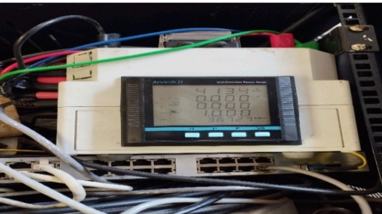

**Figure 1: Acuvim ii series data logger.**

# 2.2 Data Conversion

The raw one-minute data was processed into 30-minute average values. This was done by averaging all data points within each 30-minute interval across all weekdays, all Saturdays, and all Sundays in the 30-day data collection period. This resulted in three average daily profiles: one for weekdays, one for Saturdays, and one for Sundays, each with 30-minute interval. Processed data was then visualized. A time series graph was created, with the x-axis representing the half-hour intervals, and the y-axis representing the corresponding average value for power. This allowed for a clear visualization of daily energy consumption patterns. This data was then used to generate energy consumption profiles, assess the impact of peak load pricing, and in the sizing of the captive solar PV system.

# 2.3 Solar PV sizing

The energy consumption profile visualized in the previous paragraph, was used to determine the peak load demand. Using the excel based PV sizing tool developed by SUN-farming company. Here, the peak load demand, and optimal PV system size were determined. The flow diagram in figure 2 illustrates the steps that were taken in estimating the optimal PV system size. The sized PV system's capacity was then used to estimate the annual energy production. This estimation ensured that the proposed system could adequately meet the university's daytime energy needs without generating excess power that would be fed back into the grid

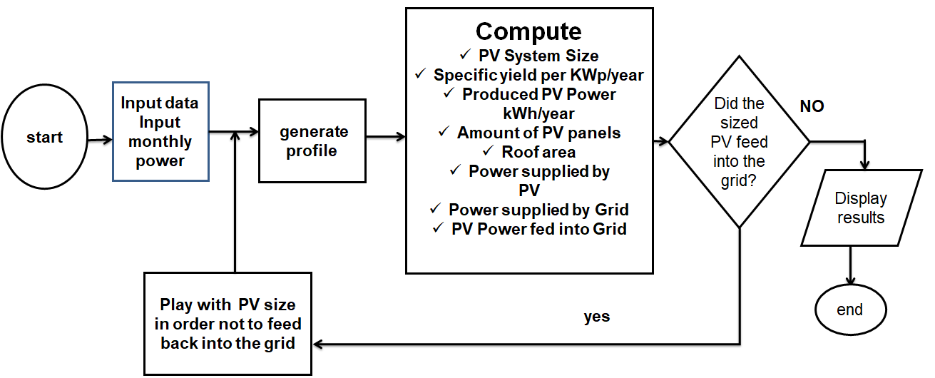

**Figure 2: Flow chart of PV sizing steps**

# 2.4 PV system design and simulation

Figure 3 is an outline of different steps that were taken in performing a PV system design and simulation in PV*Sol.

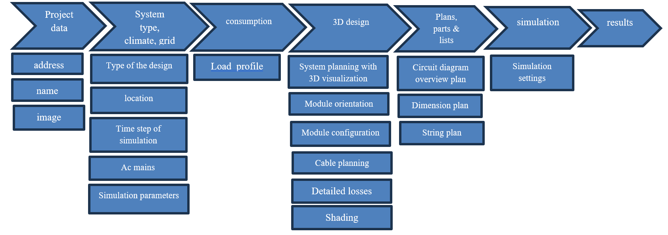

**Figure 3: Project design steps in PV*Sol software.**

# 2.4.1 Project data, system type, climate and grid

# 2.4.1.1 Location and Meteorological data

To model the proposed grid-connected PV system at Maasai Mara University, PV*Sol software was utilized. Within the project design section of the software, site-specific parameters were defined. This included entering the geographical location of Maasai Mara University in Narok as 01°05'35.0"S latitude and 35°51'28.0"E longitude. Also meteorological data, including solar irradiance of 2287Kwh/m2, annual average temperature of 25.9 degrees Celsius was obtained from meteonorm. The area selected for installation of PV panels is the Kitchen Square buildings due to the large spaces available on the rooftops and also is free from nearby shading due to trees or other taller buildings, as seen in figure 4, therefore panels will receive maximum sunlight throughout the day, ensuring optimal performance and energy output.

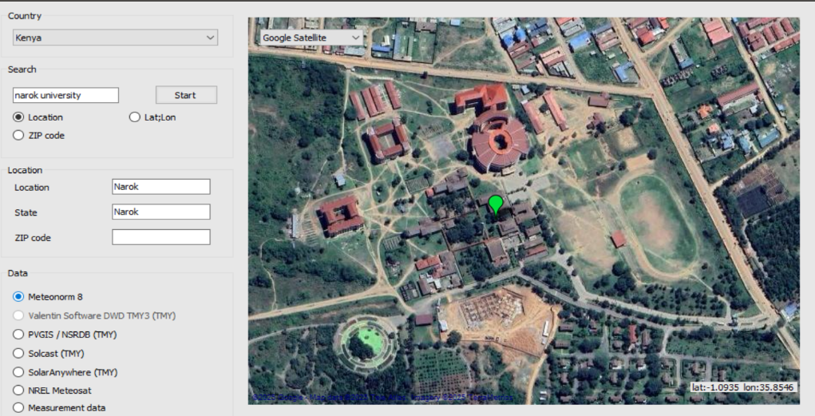

**Figure 4: Data creation for new location on PV*Sol software.**

Figure 5 is a 3D grid-connected PV system design with electrical appliances which was selected to accurately reflect the project's requirements. These specific parameters were chosen to ensure that the simulation accurately reflected the environmental conditions and system configuration at Maasai Mara University, enabling a realistic evaluation of the proposed PV system's performance.

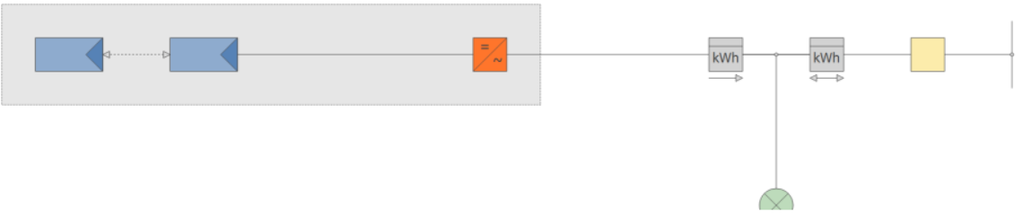

**Figure 5: Diagram of a grid-connected PV system with appliances.**

# 2.4.1.2 Time step of simulation

Figure 6 shows the initial setup parameters in PV*SOL for a 3D, grid-connected photovoltaic system simulation in Narok, Kenya, using 20 years of climate data. A one-minute time step was chosen in PV*Sol to ensure accurate and detailed simulation results. This high-resolution setting allowed for a more precise simulation of the PV system's performance, capturing variations in solar radiation and temperature throughout the day.

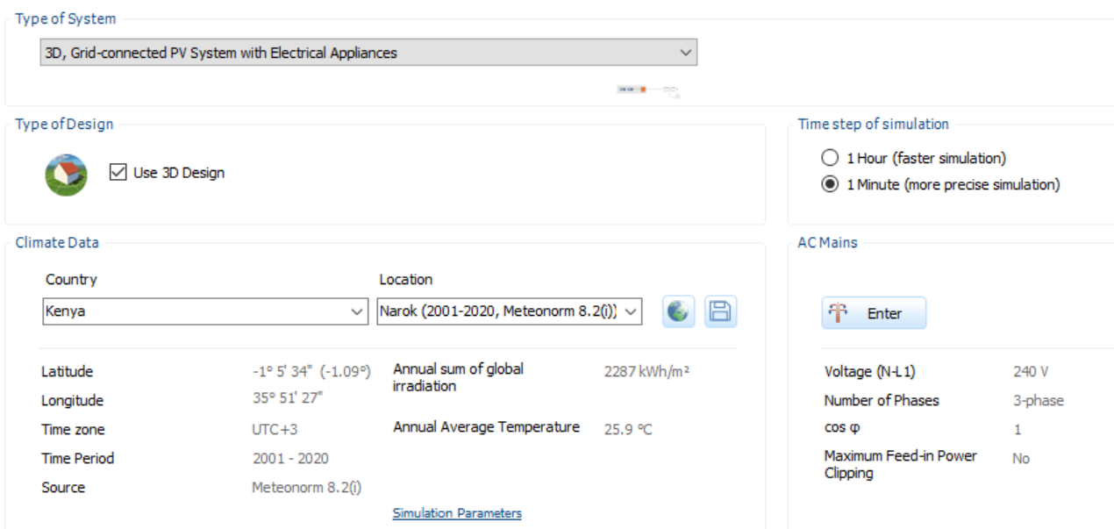

**Figure 6: System type, climate and grid.**

# 2.4.2 3D-design of the Captive PV system

A 3D model, which offers an in-depth visualization of the installation site and its key features of the PV system installation site at Maasai Mara University was designed first. Then the Google satellite imagery was used to create a new map section, for accurate mapping, due to its high-resolution imagery that enables precise identification of the installation area. The selected area was the rooftop of the kitchen square buildings, with a total surface area of 637 M2 as shown in figure 7.

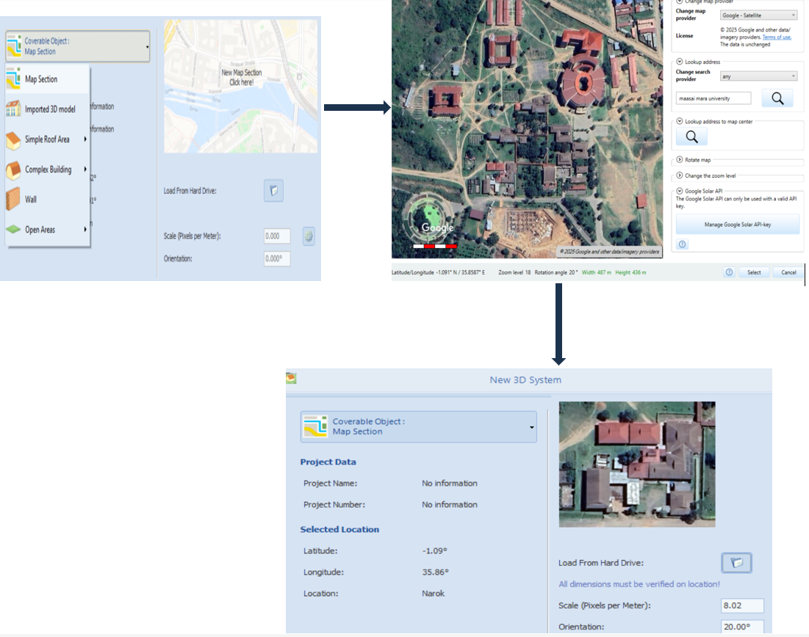

**Figure 7: map selection.**

# 2.4.3 Module and inverter selection

# 2.4.3.1 Selecting module

The module selected was Jinko panels model JKM695N-66HL5-V of Silicon Monocrystalline cell type having 132-cell count. This model was chosen based on factors such as efficiency and output power. I/V characteristics at STC are recorded in the table 1.

The electrical performance and temperature dependence of Jinko panel model JKM695N-66HL5-V are depicted in figure 12 and 13. They provided information about the module's performance under varying irradiance levels, as seen in the Power-Voltage (P-V) curve diagram 8. Also, The Current-Voltage (I-V) curves for the module is as shown in Figure 9. These were important for designing the system's performance under the varying irradiance conditions experienced in Narok, Kenya. These were subsequently used in the PV*Sol simulation to predict the system's energy output.

**Table 1: Panel characteristics.**

|  |  |
| --- | --- |
| I/V characteristics at STC |  |
| MPP Voltage | 40.29 v |
| MPP Current | 17.25A |
| Open Circuit Voltage | 48.24V |
| Short Circuit Current | 18.33A |
| Nominal output | 695W |
| Fill Factor | 78.6% |
| efficiency | 22.37% |

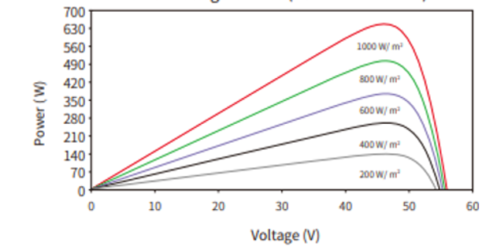

**Figure 8: Electrical performance.**

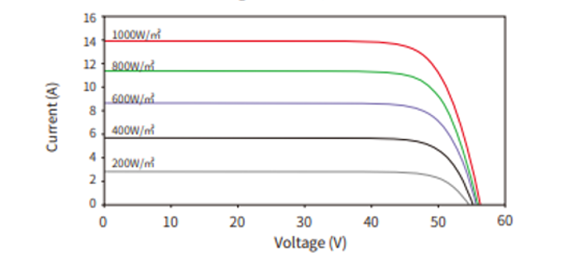

**Figure 9: Temperature dependance.**

During the system sizing, a PV system with a capacity of 141KWp was sized. To accommodate standard module sizes, the final array size was adjusted to 141.09 KWp. This system had a total of 203 Jinko JKM629N-66HL-5-BDV of Silicon Monocrystalline photovoltaic panels, each with a rated power of 695W and a dimension of 1.134M by 2.465M as seen in figure 10. These panels were distributed across 12 coverable roof surfaces on 8 different buildings at the kitchen square, utilizing a total rooftop area of 637 m².

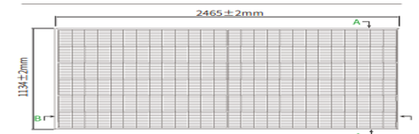

**Figure 10: Panel dimension.**

The diverse orientations of these roof surfaces, facing north, south, east, and west, were incorporated into the PV*Sol simulation. This allowed for accurate modeling of the system's performance, considering varying angles of solar incidence throughout the day and year as shown in figure 11.

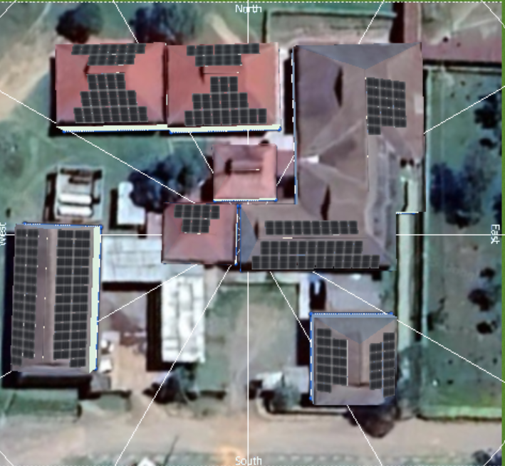

**Figure 11: Photovoltaic panels mounted on the kitchen square buildings.**

# 2.4.3.2 Inverter selection

Inverter selection was an important and necessary step in the PV system design process, considering factors such as system size, cost, flexibility, and compatibility with the 132-cell modules used. A total of 14 SMA inverters were strategically chosen, with different models selected to match the specific characteristics of each PV array. Four Sunny Boy 6.0-1SP-US40 (208V) inverters and one Sunny Boy 5.0-1SP-US40 (208V) inverter, along with one Sunny Boy 6.0-1AV-41 inverter, were selected for their appropriate capacity and single-phase connection, simplifying integration with the building's electrical system. For larger roof surfaces, three Sunny Trippower X15 inverters and four STP 8.0-3AV-40 inverters were chosen due to their higher capacity and suitability for handling a greater number of panels.

Figure 12 depicts the approach that was used for matching inverter capacity and features to the specific needs of each subarray for building 8. The approach was applied for all the 12 roof surfaces in the kitchen.

. 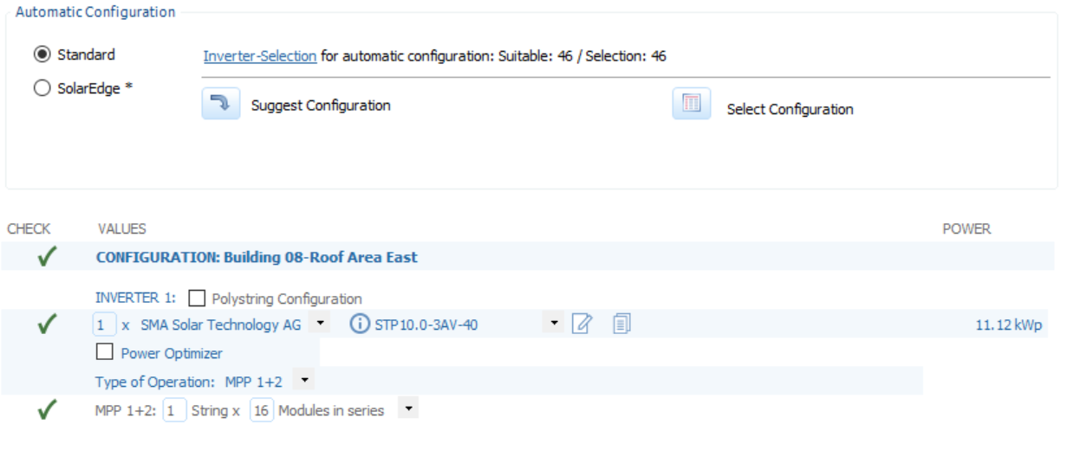

**Figure 12: Automatic configuration for building 8-roof Area East.**

The SMA inverter visualization is shown in figure 14. Its efficiency curve shown in Figure 13 were crucial for accurately modeling the system's performance and estimating its energy. Production

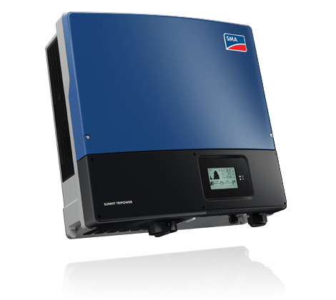

**Figure 13: Inverter from SMA Solar Technology.**

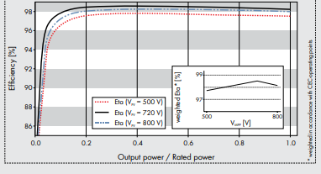

**Figure 14: Efficiency Curve Graph (Source: SMA solar).**

Table 2 details the specifications for the photovoltaic system installations in this study. Showing various buildings at kitchen area in Maasai Mara university. It outlines the building number, roof orientation, PV array size using Jinko Solar panels, the quantity of arrays, and the specific inverter models and quantities from SMA Solar Technology AG. Notably, the table shows variations in array size and orientation based on each building's characteristics.

**Table 2: Photovoltaic System Design Specifications for kitchen square buildings.**

|  |  |  |  |  |
| --- | --- | --- | --- | --- |
| **Building No.** | **Orientation** | **PV array size (KWp)-JINKO SOLAR** | **Quantity of Arrays** | **Inverter model and quantity (SMA solar technology AG** |
| **1** | 359oN  179oS | **9.04**  **12.51** | 13  18 | STP8.0-3AV-40  2-Sunny Boy 6.0-ISP-US40(208) |
| 2 | 358oN  178oS | 9.04  12.51 | 13  18 | 2-Sunny Boy 6.0-ISP-US40(208) |
| 3 | 92oE  272oW | 20.15  20.15 | 29  29 | Sunny Tripower X15 |
| 4 | 90oE  270oW | 8.34  8.34 | 12  12 | STP8.0-3AV-40 |
| 5 | 2oN | 5.56 | 8 | 2-Sunny Boy 6.0-ISP-US40(208) |
| 6 | 360oN  180oS | 6.96  17.38 | 10  25 | 2-Sunny Boy 6.0-ISP-US40(208)  Sunny Tripower X15 |
| 7 | 88oE | 10.43 | 15 | STP8.0-3AV-40 |
|  |  |  |  |  |

After inverter selection, a shading analysis was conducted in PV*Sol software. This analysis was done to identify the potential areas of energy loss which led to module layout adjustments accordingly in order to mitigate shading-induced performance reductions. Finally, Cable selection was appropriately done within the PV*Sol software for all the 8 roofs, the software recommended cables with suitable cross-sectional areas and voltage ratings to handle the expected current and minimize power losses due to resistance. Figure 19 shows an example of this planning for one roof section at Maasai Mara University, depicting the routing and connection of cables between the PV modules and the inverter.

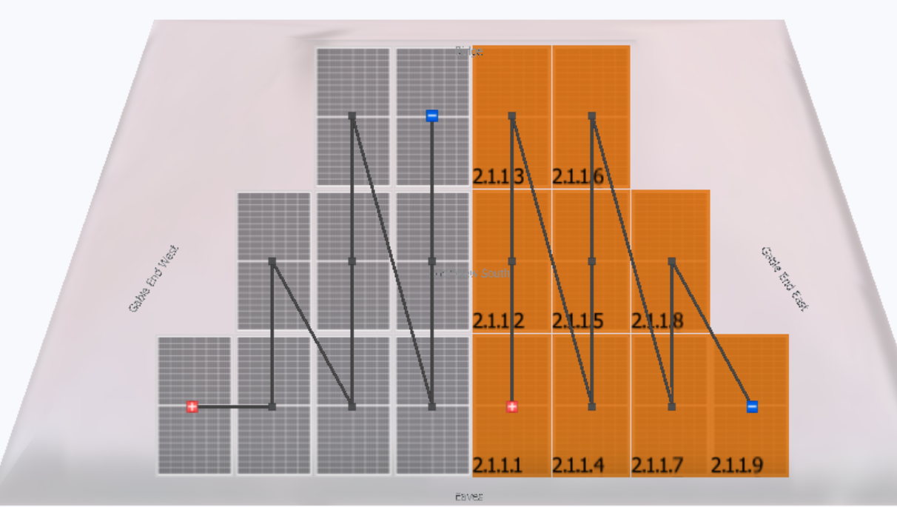

**Figure 15: Building 1 cable plan diagram.**

3. results and discussion

# 3.1 Energy consumption profile

Figure 16, represents the average daily power consumption profile for Maasai Mara University during March 2023. The different lines represent the average consumption on weekdays, Saturdays and Sundays. The weekday power consumption profile shows a distinct peak during the day between 7:30 am and 5:00 pm, this peak suggests that the institution has high level of activities during day time hours, likely due to regular operational activities such as classes, administrative work and use of facilities. The power consumption peak around midday, reaching the highest peak of 102KWh, this reflects heavy use of electricity during institutional working hours. The power consumption peak at noon is likely due to a combination of factors. Academic activities, such as classes and labs, are often at their peak around midday. Additionally, the midday heat in Narok might lead to increased use of air conditioning. Administrative offices and kitchen operations could also contribute to higher energy demand at noon. After 5:00 pm the consumption decreases, which might be attributed to the reduction of institutional activities. Beyond this time, most of the offices are closed and most of power consuming devices are turned off, hence low electricity consumption. For Sunday and Saturday, the consumption profile is generally lower than the weekday, with no distinct peaks, indicating limited weekend operations.

From the graph, the institution experiences its highest demand during the daytime on weekdays, which fortunately coincides with the sunshine hours (9.00 am to 3.00 pm) of Narok region. This observation implies that, the peak load demand can be shaved off by integrating captive grid-connected PV system to the university’s power system to compliment the power from KPLC. The system therefore was sized primarily based on the weekday profile for it to handle the peak loads during working hours, which is between 9:00am and 3:00pm, when solar generation is also at its highest. This ensures that a significant portion of institution power demand is met by solar energy during its operational hours

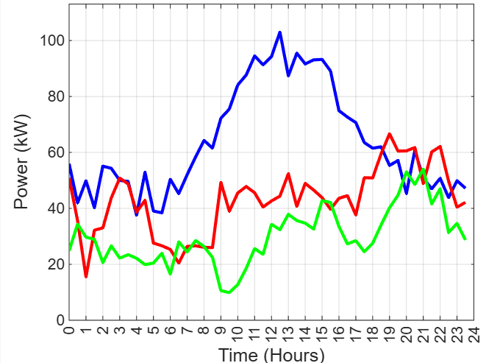



**Figure 16: Average daily power consumption profile for March, 2023.**

# 3.2 Captive Solar PV system sizing

Based on collected data, the university's total electricity consumption for March was 50,072kWh. To significantly reduce the university's electricity costs by offsetting a large portion of their energy needs, through peak load shaving, a 141 KWp solar PV system was designed. The system was sized using an 8-hour profile, focusing on peak demand periods, this is to maximize self-consumption and avoid feeding excess power back into the grid. This 141 KWp system is projected to generate 262,679 kWh of electricity annually, translating to a specific yield of 1,863 kWh/KWp per year, which indicates efficient performance for each kilowatt of installed capacity.

Figure 17 illustrates the university's daily electricity consumption profile, comparing scenarios with and without the 141 KWp solar PV system. The original grid demand, represented by the blue line, clearly exhibits a peak consumption period between 10:00 AM and 4:00 PM, reaching approximately 102 kW. This peak demand drives a significant portion of the university's electricity costs due to demand charges. The 141 KWp PV system, sized to align with this peak demand, generates power as shown by the orange line. The close correlation between the PV system's output and the university's peak demand is evident, demonstrating the system's effectiveness in shaving the peak load. Consequently, the grid demand with the PV system in operation (dotted blue line) is substantially reduced during these critical hours. The 141 KWp capacity was determined by analyzing the university's load profile and focusing on the 8-hour window between 10:00 AM and 6:00 PM, encompassing both peak sunshine hours and the university's core operating hours. This 8-hour focus ensures maximum solar energy capture and optimal alignment with the university's highest energy needs, enabling the PV system to effectively mitigate peak demand by directly addressing the problem of exceeding the 185 kVA authorized load as seen in the KPLC bills. This reduction in peak demand translates to significant potential cost savings, minimizing or eliminating the demand charges that previously constituted a substantial portion of the university's electricity bill.

The system was designed in a way that it does not feed significant power into the grid, as all electricity generated is to be consumed on-site. Whenever the solar PV generation exceeds the consumers’ power demand of the daytime, the end users are advised to do load shifting-this is where activities that are done at night hours which are not fixed can be shifted towards the day so as to maximize the usage of power generated by PV system.

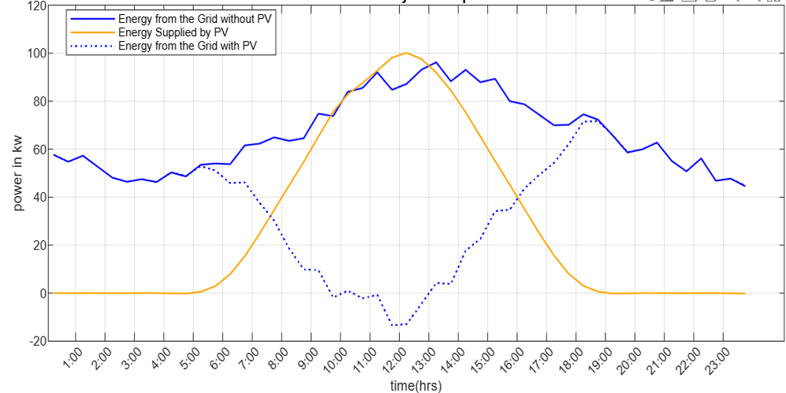

**Figure 17: Maasai Mara University’s daily electricity consumption profile.**

# 3.3 Design and simulation results

The annual energy bill profile in figure 18 was used for the PV*Sol simulation. PV*Sol's import capabilities were best at using the monthly electricity from the university's bills. This monthly bill data, encompassing all months, allowed for a comprehensive assessment of the PV system's performance across the entire year. Although the March data informed the sizing process, the annual consumption profile form the bill data was essential for PV*Sol to accurately simulate annual energy production, self-consumption, and financial implications, considering seasonal variations and providing a holistic view of the system's long-term performance

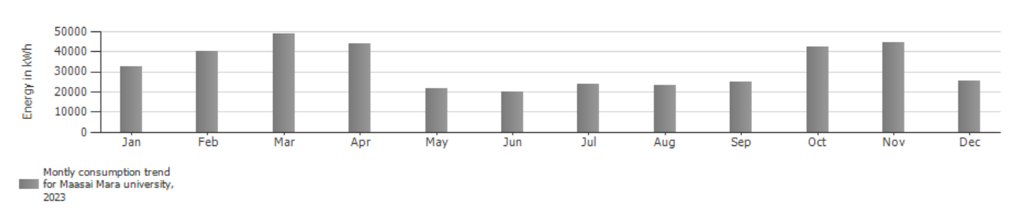

**Figure 18: Maasai Mara University annual consumption profile for 2023 source (KPLC bill)**

Figure 19 provides further details into the overall system efficiency by displaying the Performance Ratio (PR) for the inverters over a full year. The consistently maintained PR values, ranging between 80% and 100%, clearly demonstrate the stable and efficient operation of both the inverters and the captive PV system. This narrow range of fluctuation indicates reliable performance and suggests minimal energy losses due to factors such as shading, soiling, or equipment malfunctions. The absence of any significant drops PR values shows the reliability of the system and confirms that it is performing as expected.

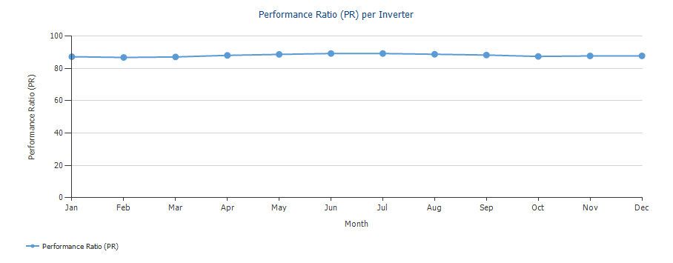

**Figure 19: performance ratio per inverter.**

# 3.4 System Design layout

Figure 20 illustrates the final design of our solar PV system for Maasai Mara University, with solar panels strategically placed across the rooftop area of the kitchen buildings. The panels are distributed across 12 coverable roof surfaces on 8 different roof buildings at the kitchen square, utilizing a total rooftop area of 637 m² with different orientation of these roof surfaces facing; north, south, east, and west. Only roofs in good condition were selected, while those in poor condition were excluded to ensure safety, durability of solar panels. Roofs in poor condition were excluded to prevent structural risks, as the added weight and pressure of the PV panels could further weaken compromised surfaces. To maximize energy generation, inter-panel spacing was prioritized to minimize inter-row shading hence ensuring optimal sunlight exposure throughout the day. A fixed tilt angle of 10 degrees was chosen, a value close to the latitude of our location to balance energy generation across seasons. However, it's important to note that the simulated annual generation of 249,576KWh is slightly lower than the initially expected 262,679KWh. This difference was likely due to two main factors: (1) Complex Roof Orientations: The kitchen buildings at Maasai Mara University have a variety of roof orientations. Ideally, for maximum solar energy generation throughout the year in the Southern Hemisphere, roofs should face true North. However, due to the existing building constraints and varying roof orientations, some panels may not face true North, potentially reducing overall energy capture, and (2) Fixed Tilt Angle: We used a fixed tilt angle of 10 degrees for all panels. While this is a reasonable average for the latitude of 1°05'35.0"S, it may not be the optimal angle for maximizing energy generation throughout the year. The ideal tilt angle for solar panels changes with the seasons to capture the most sunlight. A fixed angle might lead to less efficient energy capture during certain periods, especially during the winter months when the sun's path is lower in the sky.

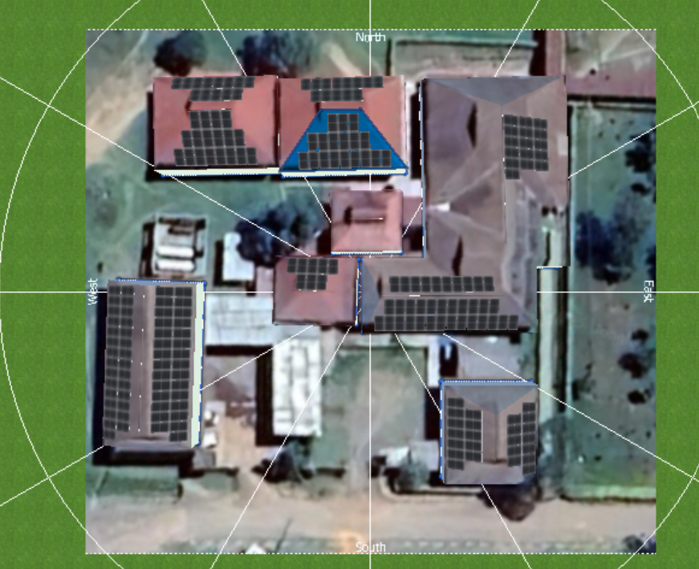

**Figure 20: Solar Panel Distribution at Mara University Kitchen Buildings.**

Figure 21 presents various solar panel string layouts across different rooftop sections. Each numbered diagram represents a unique wiring configuration, based on roof orientation and panel distribution. The color-coded lines indicate different electrical connections between panels, ensuring effective power output while considering factors like inverter placement, and structural constraints.

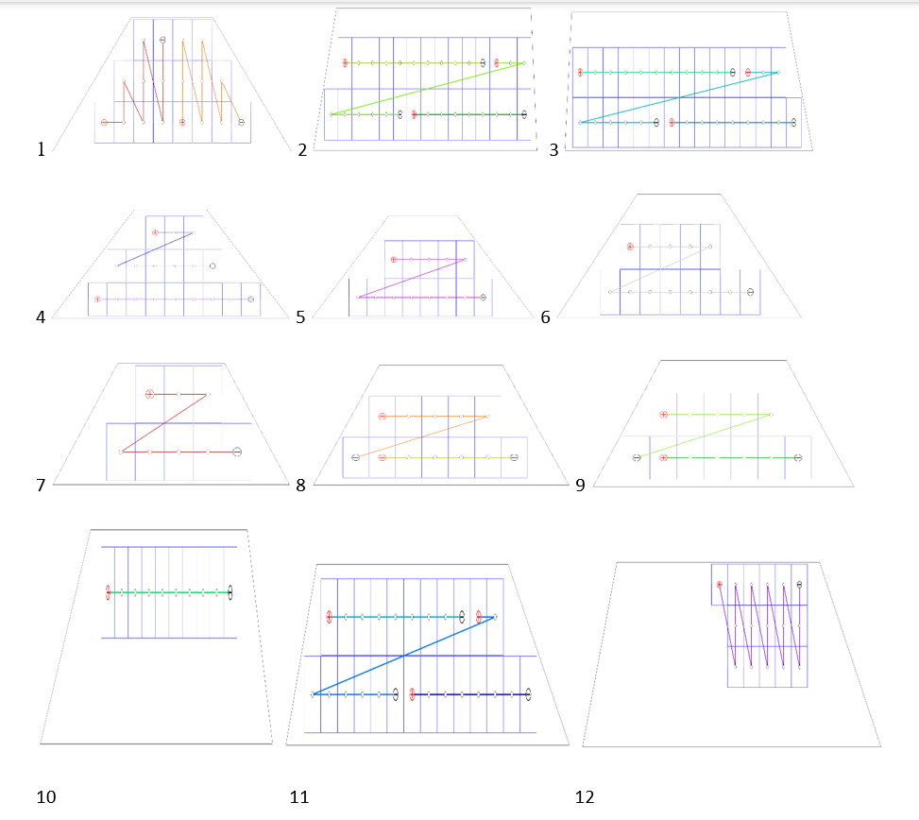

**Figure 21: String layout.**

Figure 22 shows a string diagram that groups solar panels into multiple series-connected strings, which are then combined in parallel to optimize energy generation. Each string consists of a set number of panels wired together to maintain the required voltage and current levels for efficient inverter operation, the inverter then converts the DC power into usable AC power for the electrical system.

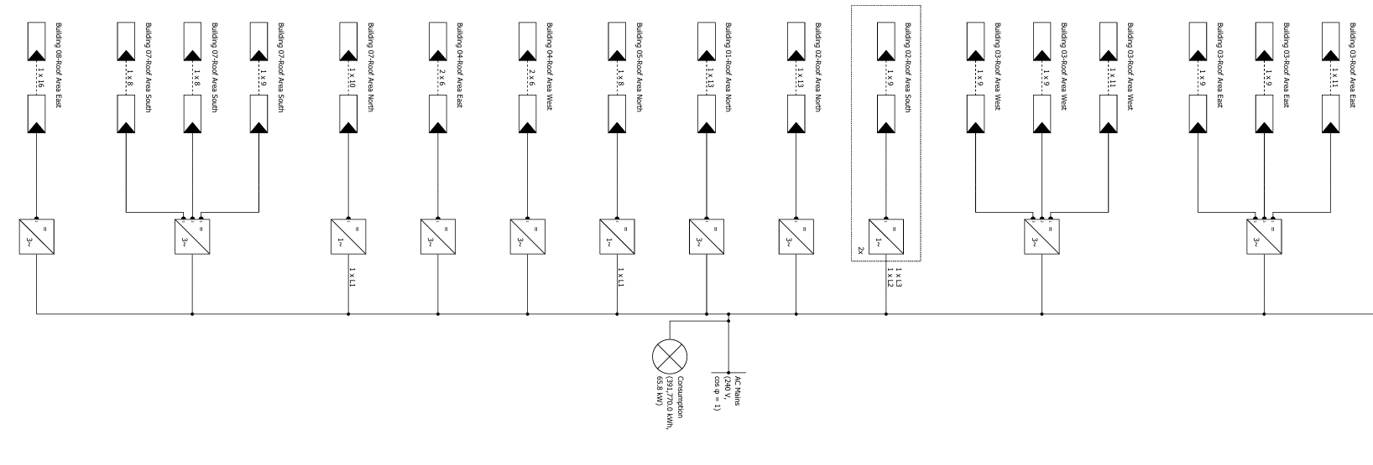

**Figure 22: Circuit diagram**

Figure 23 illustrates the projected degradation of the Jinko JKM695N-66HL5-BDV PV modules over a 29-year period. The graph shows a gradual and relatively consistent reduction in power output, reaching approximately 80% of the initial rated power after 29 years. This is consistent with the manufacturer's warranty that guarantied at least 80% output after 25 years. The PV*SOL simulation incorporates this degradation profile to provide a more accurate estimate of the system's long-term energy production and financial performance. While the system’s output will reduce energy generation over time, the modules' projected performance remains within acceptable limits and was main factor considered in their selection for this project.

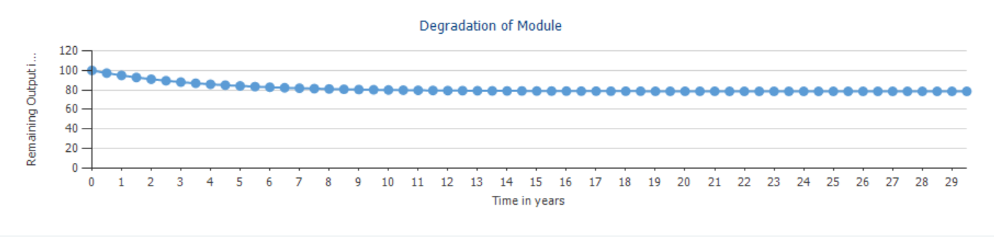

**Figure 23: Module degradation.**

# 3.5 Annual Energy Balance

The 141.09 KWp solar PV system designed, plays a crucial role in meeting the university's energy demands. The system is projected to generate 249,576.20 kWh of electricity, with an additional 259 kWh attributed to inverter standby consumption, totaling 249,835.20 kWh in generated energy. Of this, 195,195 kWh (78.1%) which will be directly consumed on-site as seen in figure 24, fulfilling a substantial portion of the university's appliance load of 391,773 kWh energy annually. The solar PV system appears slightly oversized because it was sized based on the highest monthly energy demand rather than the average consumption throughout the year. As a result, 78% of the generated energy (195,195 kWh) will be directly consumed on-site, while the remaining energy may exceed immediate demand during lower-consumption months.

This sizing approach was necessary to ensure that the system could meet the university’s peak load requirements and avoid shortages during the most energy-intensive periods. Universities experience fluctuating energy demands, influenced by factors such as student activities, research operations, and seasonal variations in facility usage. Additionally, energy needs are expected to grow over time with increasing student enrollment, new buildings, and expanded technological infrastructure. By designing the system around peak demand, we prevent under-sizing, which could lead to power deficits and greater reliance on grid electricity in the future. Also this excess solar energy generated amounting to 54,676 kWh can be used through strategic load shifting to ensure maximum on-site utilization. By adjusting energy consumption patterns to align with peak solar generation hours, the university can maximize the use of its self-generated clean energy, potentially minimizing grid reliance even further and achieving greater cost savings.

This sized PV electricity energy translates to a solar fraction of 50.07%, effectively covering half of the university's total energy needs and significantly reducing reliance on the grid as in figure 25. The system was captively designed to prioritize peak load management, explaining why it does not fulfill 100% of the university's energy requirements. Whilst the peak periods of electricity consumption during the day were effectively substituted by the sized PV system, the university still required 196,340 KWh from the grid to meet its full energy requirements, particularly during night hours and periods of lower solar irradiance. Figure 26 shows the graph that depicts the coverage of consumption.

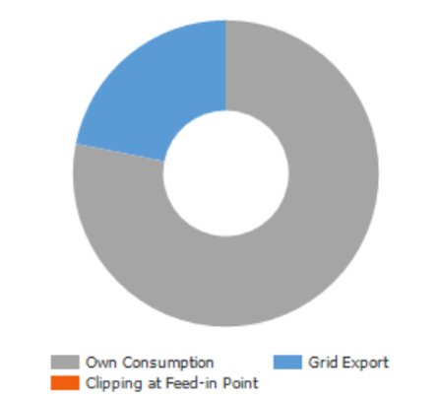

**Figure 24: PV generator Energy (AC).**

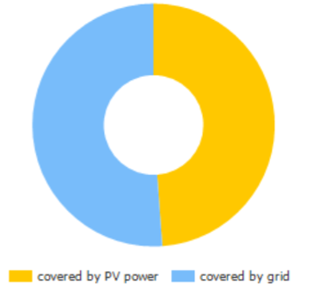

**Figure 25: Total consumption.**

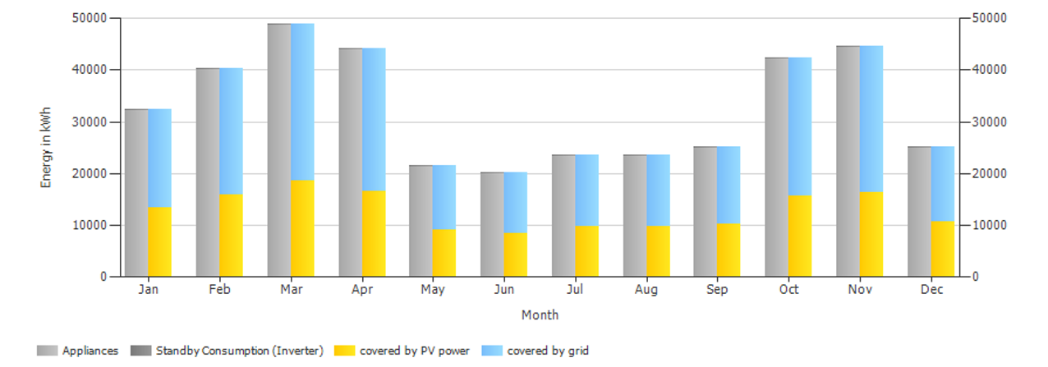

**Figure 26: Coverage of consumption.**

The system is further projected to achieve a specific annual yield of 1,768 kWh/KWp and a performance ratio of 87.47%, demonstrating efficient and acceptable energy conversion. This clean energy generation resulted in the avoidance of 117,301 kg of CO2 emissions, highlighting the system's significant contribution to environmental sustainability.

Figure 27 presents the cumulative total energy generation for the 141.09 KWp PV system designed for Maasai Mara University in Narok, Kenya. The graph compares monthly system’s generation with the university's appliance consumption for the whole year. The yellow bars show the monthly solar energy production and the gray bars represent the corresponding appliance consumption, the key feature is the downward-trending line representing the cumulative energy balance. This line, starting at zero in January, tracks the accumulated difference between generated and consumed energy throughout the year, culminating in a net deficit of 115,815 KWh/yr by December. This negative balance indicates that the PV system, in its current configuration, does not meet the university's total annual energy needs. However, it's crucial to consider that this system was captively designed for peak load shaving, not total energy independence. Therefore, the university will still depend on grid electricity in order to supply the deficit power.

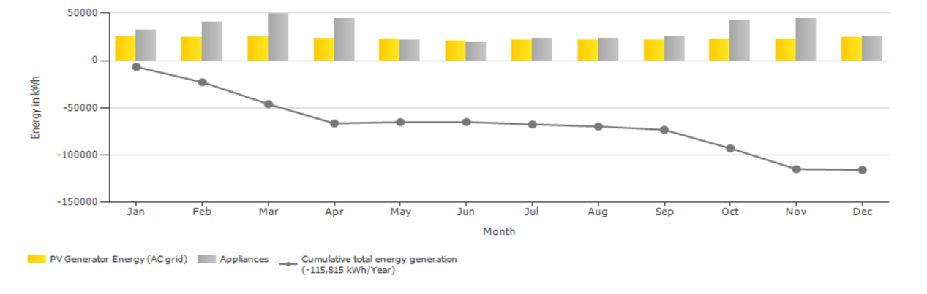

**Figure 27: cumulative total energy generation.**

4. Conclusion

A comprehensive financial analysis, incorporating key metrics such as Net Present Value of Ksh. 8.058988704 x 107, Benefit-Cost Ratio of 5.40%, Internal Rate of Return 26.735%, and payback period of 4 years. These results demonstrate a strong return on investment and substantial long-term cost savings for the university. Beyond the economic benefits, the system contributes significantly to environmental sustainability by avoiding 117,301 kg of CO2 emissions annually.

**COMPETING INTERESTS DISCLAIMER:**

Authors have declared that they have no known competing financial interests OR non-financial interests OR personal relationships that could have appeared to influence the work reported in this paper.

# References.

Abbood, A. A., Salih, M. A., & Muslim, H. N. (2017). Management of electricity peak load for residential sector in Baghdad city by using solar generation. *International Journal of Energy and Environment*, *8*(1).

Aghaei, J., & Alizadeh, M. (2013). Critical peak pricing with load control demand response program in unit commitment problem. *IET Generation, Transmission & Distribution*, *7*(7), 681–690. https://doi.org/10.1049/iet-gtd.2012.0739

Baig, M. Z., & Jahanzaib, M. (2022). Risk Assessment of Sustainable Renewable Energy Resources on CPEC Route. *International Journal of Academe and Industry Research*, *3*(1), 1–25. https://doi.org/10.53378/352855

Bernal-Agustın, J. L., & Dufo-Lopez, R. (2006). Economical and environmental analysis of grid connected photovoltaic systems in Spain. *Renewable Energy*.

Cucchiella, F., D’Adamo, I., & Lenny Koh, S. C. (2015). Environmental and economic analysis of building integrated photovoltaic systems in Italian regions. *Journal of Cleaner Production*, *98*, 241–252. https://doi.org/10.1016/j.jclepro.2013.10.043

Dharani, R., Balasubramonian, M., Babu, T. S., & Nastasi, B. (2021). Load Shifting and Peak Clipping for Reducing Energy Consumption in an Indian University Campus. *Energies*, *14*(3), 558. https://doi.org/10.3390/en14030558

El Gohary, F., Stikvoort, B., & Bartusch, C. (2023). Evaluating demand charges as instruments for managing peak-demand. *Renewable and Sustainable Energy Reviews*, *188*, 113876. https://doi.org/10.1016/j.rser.2023.113876

*EPRA Energy and Petroleum Statistics Report FY 2023-2024*. (2024). https://www.epra.go.ke/sites/default/files/2024-10/EPRA Energy and Petroleum Statistics Report FY 2023-2024_2.pdf

*FactSheet_Fossil_Fuel_Externalities_2021*. (2021). https://www.eesi.org/files/FactSheet_Fossil_Fuel_Externalities_2021.pdf

Haque, A., & Zaheeruddin. (2013). Research on solar photovoltaic (PV) energy conversion system: An overview. *IET Conference Publications*, *2013*(CP646), 605–611. https://doi.org/10.1049/cp.2013.2653

Hassan, Q., Algburi, S., Sameen, A. Z., Salman, H. M., & Jaszczur, M. (2023). A review of hybrid renewable energy systems: Solar and wind-powered solutions: Challenges, opportunities, and policy implications. *Results in Engineering*, *20*, 101621.

International Energy Agency. (2022). *Special Report on Solar PV Global Supply Chains*. https://doi.org/10.1787/9e8b0121-en

Kariuki, B. W., & Sato, T. (2018). Interannual and spatial variability of solar radiation energy potential in Kenya using Meteosat satellite. *Renewable Energy*, *116*, 88–96. https://doi.org/10.1016/j.renene.2017.09.069

Mahmud, K., Hossain, M. J., & Town, G. E. (2018). Peak-Load Reduction by Coordinated Response of Photovoltaics, Battery Storage, and Electric Vehicles. *IEEE Access*, *6*, 29353–29365. https://doi.org/10.1109/ACCESS.2018.2837144

Moshövel, J., Kairies, K.-P., Magnor, D., Leuthold, M., Bost, M., Gährs, S., Szczechowicz, E., Cramer, M., & Sauer, D. U. (2015). Analysis of the maximal possible grid relief from PV-peak-power impacts by using storage systems for increased self-consumption. *Applied Energy*, *137*, 567–575. https://doi.org/10.1016/j.apenergy.2014.07.021

Nematirad, R., Pahwa, A., & Natarajan, B. (2024). A Novel Statistical Framework for Optimal Sizing of Grid-Connected Photovoltaic–Battery Systems for Peak Demand Reduction to Flatten Daily Load Profiles. *Solar*, *4*(1), 179–208. https://doi.org/10.3390/solar4010008

Ouammi, A. (2021). Peak load reduction with a solar PV-based smart microgrid and vehicle-to-building (V2B) concept. *Sustainable Energy Technologies and Assessments*, *44*, 101027. https://doi.org/10.1016/j.seta.2021.101027

Rodrigues, S., Torabikalaki, R., Faria, F., Cafôfo, N., Chen, X., Ivaki, A. R., Mata-Lima, H., & Morgado-Dias, F. (2016). Economic feasibility analysis of small scale PV systems in different countries. *Solar Energy*, *131*, 81–95. https://doi.org/10.1016/j.solener.2016.02.019

Shafeey, M. A., & Harb, A. M. (2018). Photovoltaic as a promising solution for peak demands and energy cost reduction in Jordan. *2018 9th International Renewable Energy Congress (IREC)*, 1–4. https://doi.org/10.1109/IREC.2018.8362570

Spertino, F., Di Leo, P., & Cocina, V. (2013). Economic analysis of investment in the rooftop photovoltaic systems: A long-term research in the two main markets. *Renewable and Sustainable Energy Reviews*, *28*, 531–540. https://doi.org/10.1016/j.rser.2013.08.024

Tudisca, S., Di Trapani, A. M., Sgroi, F., Testa, R., & Squatrito, R. (2013). Economic analysis of PV systems on buildings in Sicilian farms. *Renewable and Sustainable Energy Reviews*, *28*, 691–701. https://doi.org/10.1016/j.rser.2013.08.035

Yolcan, O. O. (2023). World energy outlook and state of renewable energy: 10-Year evaluation. *Innovation and Green Development*, *2*(4), 100070. https://doi.org/10.1016/j.igd.2023.100070