**Case report**

**Dyggve-Melchior-Clausen Syndrome: A Case Report**

**ABSTRACT**

Dyggve-Melchior-Clausen syndrome (DMC) is a rare autosomal recessive skeletal dysplasia caused by mutations in the *DYM* gene, characterized by disproportionate short stature, intellectual disability, and specific radiographic anomalies. It is often misdiagnosed due to clinical similarities with Morquio syndrome and other skeletal dysplasias. This report presents a four-year-old female from a consanguineous union, evaluated for global developmental delay and growth retardation. Clinical findings included coarse facies, thoracic scoliosis, and short extremities. Radiographs revealed characteristic features such as platyspondyly and irregular iliac crests. Genetic analysis identified a homozygous pathogenic variant in the *DYM* gene, confirming the diagnosis. Differential diagnosis with mucopolysaccharidoses and Smith-McCort dysplasia was discussed. The importance of early diagnosis through clinical, radiological, and genetic correlation is emphasized to provide anticipatory care and genetic counseling. Although no curative treatment exists, a multidisciplinary approach can improve quality of life and functional outcomes. This case reinforces the diagnostic value of molecular genetics in rare dysplasias.

**KEYWORDS:** Dyggve-Melchior-Clausen syndrome, spondyloepimetaphyseal dysplasia, skeletal dysplasia, rare genetic disorder

**INTRODUCTION**

Dyggve-Melchior-Clausen syndrome (DMC) is a rare, autosomal recessive spondyloepimetaphyseal dysplasia first identified in 1962, associated with mutations in the *DYM* gene located on chromosome 18q21.1 [1]. The syndrome results in impaired endochondral ossification and manifests with disproportionate short stature, intellectual disability, skeletal abnormalities, and distinctive radiological features [2–4]. DMC has a prevalence estimated at less than 1 in 1,000,000 live births, with consanguinity often increasing its occurrence [5]. Affected individuals commonly present with coarse facial features, progressive kyphoscoliosis, joint stiffness, and short limbs [6]. Due to phenotypic overlap with other skeletal disorders, particularly Morquio syndrome (mucopolysaccharidosis type IV), early diagnosis can be challenging [7–9]. The hallmark radiological findings such as platyspondyly and lace-like iliac crests assist in narrowing the diagnosis, which can be confirmed through molecular testing [10]. We report a pediatric case of DMC, highlighting diagnostic pitfalls, the utility of genetic sequencing, and the importance of a multidisciplinary approach to management and genetic counseling in affected families.

**CASE REPORT**

A four-year-old girl was referred for evaluation of growth retardation and developmental delay. She was the second child of a first-degree consanguineous marriage, born full term via spontaneous vaginal delivery, with a birth weight of 3 kg. Her perinatal course was unremarkable. The family history was notable for two previous miscarriages.

On clinical examination, the child exhibited global developmental delay, especially in language and cognition. She had a short stature (height 88 cm; below -3 SD), low weight (12 kg; approximately -2 SD), and microcephaly. Distinct facial dysmorphism included a broad forehead, flat nasal bridge, midface hypoplasia, and coarse features (Figure 1).

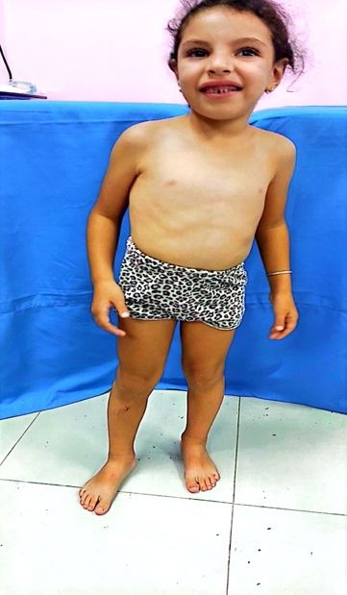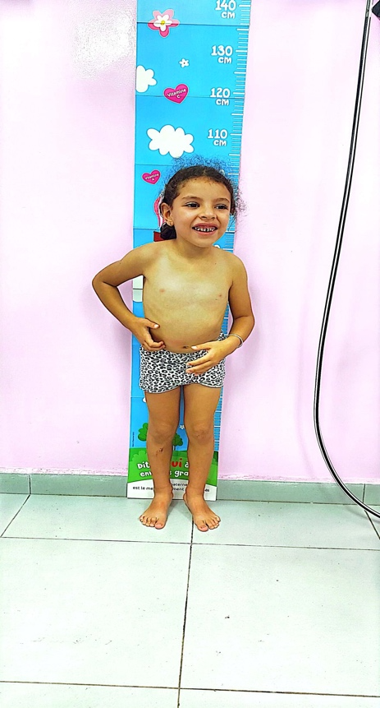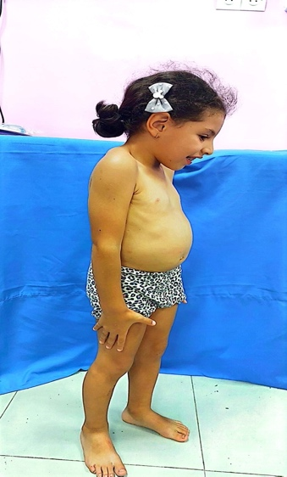

Figure 1- Distinct facial dysmorphism

Musculoskeletal anomalies included short limbs, wide wrists and ankles, and severe thoracic scoliosis. Neurological examination showed no focal deficits. There was no evidence of hepatosplenomegaly, corneal clouding, or valvular heart defects.

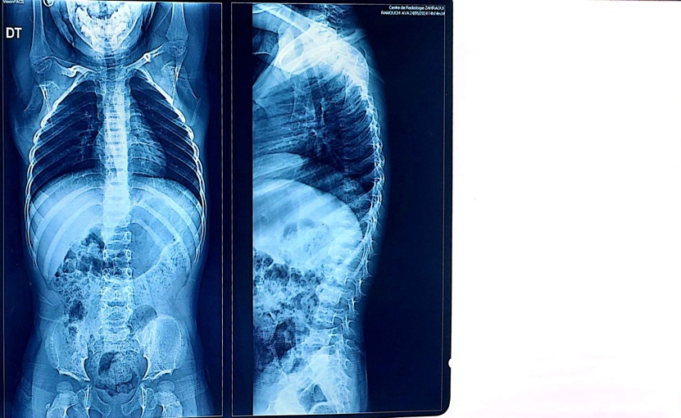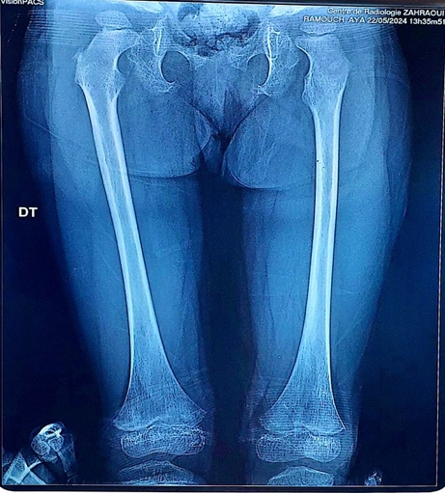

Figure 2: Radiographic features showing platyspondyly and irregular vertebral endplates.

Laboratory evaluations, including thyroid function, cortisol, and growth hormone levels, were within normal limits. Urinary glycosaminoglycan (GAG) levels were normal, excluding mucopolysaccharidoses. Cytogenetic analysis revealed a normal 46,XX karyotype.

A comprehensive skeletal survey demonstrated platyspondyly with anterior beaking, flared iliac wings with lace-like iliac crests, and femoral neck widening—hallmark signs of DMC. Brain MRI revealed mild cortical and subcortical atrophy with slight ventricular enlargement, but no parenchymal lesions.

Genetic testing via whole-exome sequencing confirmed a homozygous pathogenic variant in exon [number to be inserted] of the *DYM* gene, establishing the diagnosis of Dyggve-Melchior-Clausen syndrome. The diagnosis was explained to the family, who received genetic counseling. Sanger sequencing and prenatal testing were offered for future pregnancies.

The child was enrolled in neurodevelopmental and physical therapy programs. Orthopedic referral was made for monitoring of scoliosis and joint mobility. A multidisciplinary care plan involving pediatrics, orthopedics, neurology, and genetics was initiated.

**DISCUSSION**

Dyggve-Melchior-Clausen syndrome (DMC) represents a rare form of spondyloepimetaphyseal dysplasia, attributable to biallelic mutations in the *DYM* gene [1,2]. The encoded protein, dymeclin, is involved in Golgi apparatus function and plays a pivotal role in skeletal and neuronal development [3]. Dymeclin dysfunction disrupts endochondral ossification and intracellular trafficking, explaining the combined skeletal and neurological manifestations of DMC [4].

The classic phenotype includes disproportionate short stature, intellectual disability, and dysostosis multiplex with specific features like platyspondyly, flared iliac crests, and metaphyseal irregularities [5,6]. In the present case, these signs, along with normal urinary GAG levels, helped differentiate DMC from Morquio syndrome (MPS IV), which is characterized by GAG accumulation, corneal clouding, and cardiac involvement [7–9].

Smith-McCort dysplasia (SMC), a phenotypic mimic caused by similar mutations in the *DYM* gene, must also be considered. However, unlike DMC, SMC typically lacks intellectual impairment, serving as a key discriminating feature [10,11]. Thus, careful neurological assessment is essential in distinguishing the two.

Radiographic evaluation remains a cornerstone in the diagnostic pathway. The characteristic “lace-like” iliac crest and beaked vertebral bodies provide strong diagnostic clues, as seen in our patient [12,13]. Definitive diagnosis relies on genetic testing, particularly whole-exome sequencing, which identifies pathogenic variants in *DYM*, enabling appropriate counseling and future family planning [14].

Currently, treatment for DMC is symptomatic and supportive. Orthopedic intervention may be necessary for severe scoliosis, hip dysplasia, or joint deformities [15,16]. Early physiotherapy and speech/language therapy improve functional outcomes, while educational interventions address cognitive deficits [17]. Multidisciplinary collaboration optimizes care delivery.

Emerging research into gene therapies and pharmacological chaperones targeting Golgi-related disorders could potentially transform DMC management, although such interventions remain experimental [18–20]. Understanding the broader implications of Golgi dysfunction may yield novel therapeutic approaches for skeletal dysplasias and neurodevelopmental syndromes.

In conclusion, this case illustrates the importance of clinical suspicion, thorough radiological evaluation, and confirmatory genetic testing in diagnosing DMC. Early multidisciplinary intervention and genetic counseling are essential to improving the prognosis and quality of life for affected individuals and their families.

**CONCLUSION**

Dyggve-Melchior-Clausen syndrome is a rare but clinically recognizable skeletal dysplasia. Diagnosis requires an integrated approach of clinical, radiographic, and genetic evaluations. Differentiation from phenotypically similar disorders such as Morquio syndrome and Smith-McCort dysplasia is crucial to avoid mismanagement. Although no curative treatments exist, early supportive interventions and orthopedic management significantly enhance patient outcomes. Genetic counseling is vital for affected families, especially in consanguineous populations. Advances in molecular research may open new therapeutic possibilities in the future. This case underscores the diagnostic value of whole-exome sequencing and the necessity of a multidisciplinary approach in managing rare genetic skeletal disorders.

### ****REFERENCES****

1. El Ghouzzi V, Dagoneau N, Kinning E, et al. Mutations in Dymeclin are responsible for Dyggve-Melchior-Clausen syndrome. Nat Genet. 2003;31(2):128–134. doi:10.1038/ng892
2. Krakow D, Rimoin DL. The skeletal dysplasias. Genet Med. 2010;12(6):327–341. doi:10.1097/GIM.0b013e3181daae9c
3. D’Angelo G, Polishchuk E, Di Tullio G, et al. Golgi function and dysfunction in human disease. Cell Mol Life Sci. 2017;74(14):2289–2307. doi:10.1007/s00018-017-2471-8
4. Leroy JG. Genetic disorders of proteoglycan degradation. Birth Defects Orig Artic Ser. 1977;13(3B):205–225.
5. Tüysüz B, Ungür S, Bober E. Differential diagnosis of mucopolysaccharidoses: a practical approach for pediatricians. Turk Pediatri Ars. 2017;52(4):219–225. doi:10.5152/TurkPediatriArs.2017.5910
6. Spranger J, Langer LO Jr, Wiedemann HR. The pseudo-Morquio syndrome (Dyggve-Melchior-Clausen). Radiology. 1971;99(1):191–198. doi:10.1148/99.1.191
7. Montaño AM, Tomatsu S, Gottesman GS, et al. Mucopolysaccharidoses. In: Pagon RA, Adam MP, Ardinger HH, et al., editors. GeneReviews® [Internet]. 2007. PMID: 20301441
8. Ehtesham N, Park K, Jabs EW, et al. Smith-McCort dysplasia and Dyggve-Melchior-Clausen syndrome are allelic disorders. Am J Med Genet A. 2013;161A(7):1796–802. doi:10.1002/ajmg.a.35980
9. Southgate L, Machado RD, Snape KM, et al. Dyggve-Melchior-Clausen syndrome caused by compound heterozygous mutations in DYM. Clin Genet. 2010;78(3):293–296. doi:10.1111/j.1399-0004.2010.01387.x
10. Cormier-Daire V. Dysmorphic syndromes with short stature. Best Pract Res Clin Endocrinol Metab. 2011;25(1):143–153. doi:10.1016/j.beem.2010.09.003
11. Unger S, Bonafé L, Superti-Furga A. Multiple epiphyseal dysplasia: clinical and radiographic features, differential diagnosis and molecular basis. Best Pract Res Clin Rheumatol. 2008;22(1):19–32. doi:10.1016/j.berh.2007.11.001
12. Hall CM. International nosology and classification of constitutional disorders of bone (2001). Am J Med Genet. 2002;113(1):65–77. doi:10.1002/ajmg.1075
13. Maroteaux P, Le Merrer M. The spectrum of osteochondrodysplasias. Best Pract Res Clin Rheumatol. 2008;22(2):355–375. doi:10.1016/j.berh.2007.12.003
14. Bonafe L, Cormier-Daire V, Hall C, et al. Nosology and classification of genetic skeletal disorders: 2015 revision. Am J Med Genet A. 2015;167A(12):2869–2892. doi:10.1002/ajmg.a.37365
15. Kaczmarski M, Młynarski W, Niedzielski K. Orthopaedic management in Dyggve-Melchior-Clausen syndrome. Ortop Traumatol Rehabil. 2013;15(6):565–571. PMID: 24344989
16. Aglan MS, Temtamy SA, El Ruby M, et al. Phenotypic and radiological spectrum of Dyggve-Melchior-Clausen syndrome and Smith-McCort dysplasia in Egyptian patients. Osteoporos Int. 2009;20(6):937–948. doi:10.1007/s00198-008-0762-5
17. Lemyre E, Rauch F, Huber C, et al. Clinical and radiographic manifestations of Dyggve-Melchior-Clausen syndrome: report of three cases and review of the literature. Eur J Pediatr. 2001;160(11):705–710. doi:10.1007/s004310100813
18. Sztalryd C, El Ghouzzi V, Munnich A, et al. Molecular basis and diagnostic challenges in genetic skeletal dysplasias. Pediatr Endocrinol Rev. 2004;2(2):237–245. PMID: 16444197
19. Bui C, Dudding T, Thompson EM. A review of gene therapy clinical trials for inherited skeletal disorders. Mol Genet Genomic Med. 2021;9(2):e1584. doi:10.1002/mgg3.1584
20. Nilsson O, Baron J. Fundamental limits on longitudinal bone growth: growth plate senescence and epiphyseal fusion. Trends Endocrinol Metab. 2004;15(8):370–374. doi:10.1016/j.tem.2004.08.002