Conjoined twins at the Mother-Child University Hospital Jeanne Ebori Foundation in Libreville: About 2 cases

Abstract :
Conjoined twins (Siamese twins) are among the major complications of twin pregnancy. We report two cases of conjoined twins discovered incidentally at birth. Observation 1: Female conjoined craniopagus twins born by cesarean section indicated for hemorrhagic placenta previa.
Observation 2:Omphalopagus conjoined twins, female, born at term and vaginally.
Conclusion :Antenatal diagnosis is essential for better care.
Keywords: fetal malformation, conjoined twins, antenatal diagnosis, Libreville

Introduction
Siamese twins are the result of an incomplete division of the embryonic disc that occurs beyond 13 days after fertilization [1,2]. It is a rare congenital malformation that attracts special attention whenever it is discovered. Its prevalence varies from 1 in 50,000 to 1/100,000 with a female predominance [3]. It is a malformation accessible to antenatal diagnosis by ultrasound from the first trimester of pregnancy. Antenatal diagnosis allows for appropriate monitoring, for making an appropriate obstetric decision and finally for planning the most appropriate management. Conjoined twins represent one of the rare congenital anomalies and constitute one of the greatest challenges in pediatric surgery [4]. We report two (2) cases of conjoined twins in Libreville followed at the CHU Mère-Enfant Fondation Jeanne Ebori (CHUME-FJE), a reference hospital dedicated to the care of mothers, newborns and children. The objective of this work was to show the importance of pregnancy monitoring and obstetric ultrasound in antenatal screening for congenital malformations.
Case presentation :
Observation 1: these are premature female newborns, born at 30 weeks in a private facility by cesarean section indicated in view of a hemorrhagic placenta previa. They were admitted at 72 hours of life for the management of conjoined twins. The block weighed 2060g. Other anthropometric parameters (height and head circumference) not mentioned.They were born with poor adaptation to extra-uterine life with an Apgar score of 5 at the 1st minute and 8 at the 5th minute after resuscitation measures such as drying, stimulation. The mother was 41 years old, with no particular medical history and a gyneco-obstetric history of Gestation 8 Parity 2 Abortion 2, alive 5. The parents were of Gabonese nationality with no notion of consanguinity. No toxic intake was noted during the pregnancy. The pregnancy was accepted and monitored by a midwife. She benefited from five prenatal contacts. The biological assessment (retroviral serology, hepatitis B, syphilis, toxoplasmosis and rubella) was negative. On the morphological level, an obstetric ultrasound revealed an evolving singleton pregnancy with good cardiac activity. The clinical examination on admission revealed a fusion-type malformation at the level of the cranial vault, left temporal face, one of which looked forward and the other backward. A stable hemodynamic state with an oxygen saturation of 98% for (D1) and 97% for (D2) in room air, a normal heart rate at 156 beats per minute (D1) and 160 beats per minute (D2), a recoloration time of less than 3 seconds with a cutaneous-mucosal subicterus. Archaic reflexes were present but weak. The pulmonary and cardiac examination was unremarkable. No other visible malformation was found.
The biological assessment (blood count, C-reactive protein, renal assessment, liver assessment and blood sugar) was unremarkable. Moderate hyponatremia was found at 132.79 mmol/L for (D1) and 133 mmol/L (D2). Hyperbilirubinemia had prompted the initiation of conventional phototherapy. The block was blood group O positive. A brain computed tomography (CT) scan showed a fused posterior fossa and an absence of a 4th ventricle. A brain magnetic resonance imaging (MRI) scan revealed a single posterior fossa. Cardiac ultrasound could not be performed. At the end of the clinical and morphological assessment, we concluded that they were conjoined craniopagus twins (figure 1)

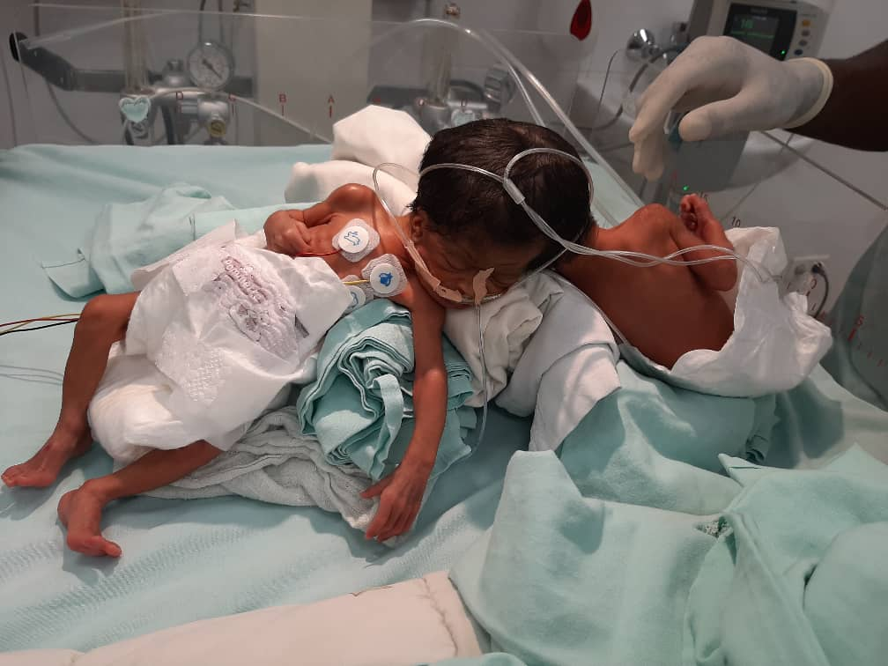
Figure 1: Conjoined craniopagus twins
The care consisted of hospitalization in the intensive care unit with open incubator, cardiorespiratory monitoring, orogastric tube and umbilical venous catheter placement, age-appropriate fluid and carbohydrate intake, essential newborn care and probabilistic dual antibiotic therapy (ceftazidime 35mg/kg/8h and gentamicin 5mg/kg/24h). Close monitoring with psychological follow-up for the parents. The evolution was marked by the occurrence of an unrecovered cardiorespiratory arrest at H48 of hospitalization on (D1) then on (D2).

Observation 2: newborns, female, born vaginally at 39 weeks. They were admitted at H6 of life for the management of conjoined twins. The block weighed 5900g. (J1) was born in good adaptation to extra-uterine life (Apgar score of 7 at the 1st minute and 10 at the 5th minute) with a height of 45cm and a head circumference of 34cm. (J2) was born in a state of apparent death (Apgar score of 3/10 at the 1st minute and 7/10 at the 10th minute) after a well-conducted resuscitation with a height of 41cm and a head circumference of 33.5cm. The mother was 33 years old, with no particular medical or surgical history and an obstetric history of G4P2E2AV1. The father was 35 years old. The parents were of Nigerian nationality. There was no evidence of toxic intake during the pregnancy or of consanguinity among the parents. The pregnancy was accepted and monitored by a midwife. She had benefited from five prenatal contacts. The biological assessment (retroviral serology, hepatitis B, syphilis, toxoplasmosis and rubella) was negative. Morphologically, she had not had any obstetric ultrasounds. No intercurrent pathologies were noted. She had received iron and folic acid supplementation.
Clinical examination on admission revealed conjoined twins fused abdominally (Figure 2). The newborns were wide awake. (J1) was tonic with effective and vigorous sucking and (J2) was hypotonic with absent sucking. Other archaic reflexes were difficult to assess. Detailed anatomical analysis showed twins each with a single head, a distinct rib cage with visible and normal ribs, two hearts with normal cardiac activity, two normal cervico-dorso-lumbo-sacral spines and two normal upper and lower limbs. They had a common abdominal wall with a single umbilical cord with four vessels (Figure 3) and a large umbilicus with a ruptured omphalocele (Figure 4).

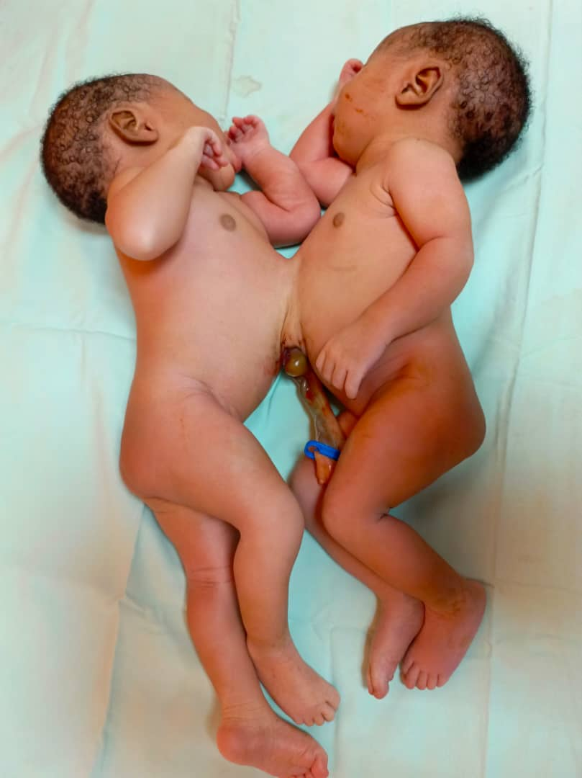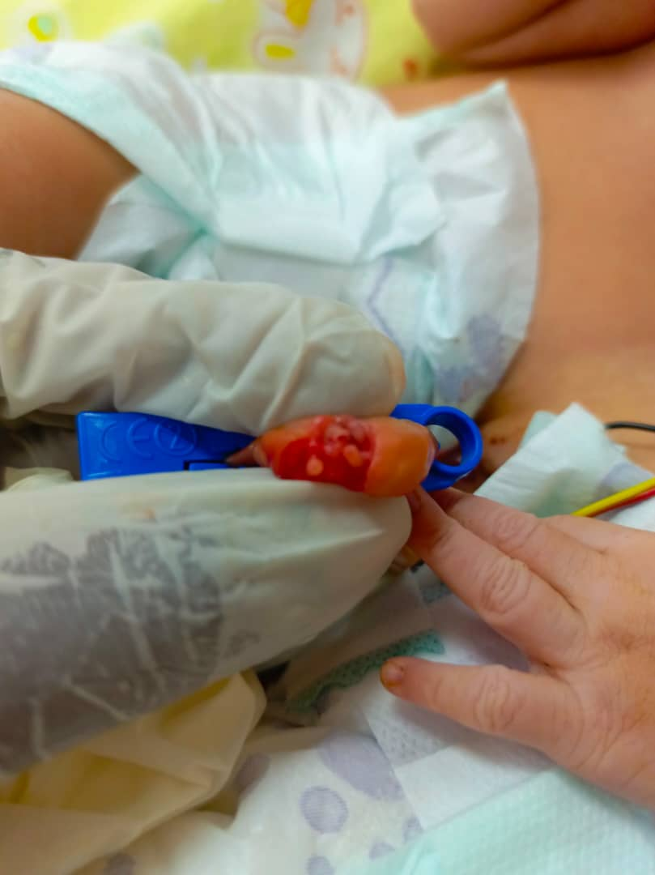

Figure 2:Siamese twins omphalopagus Figure 3: 4 umbilical vessels

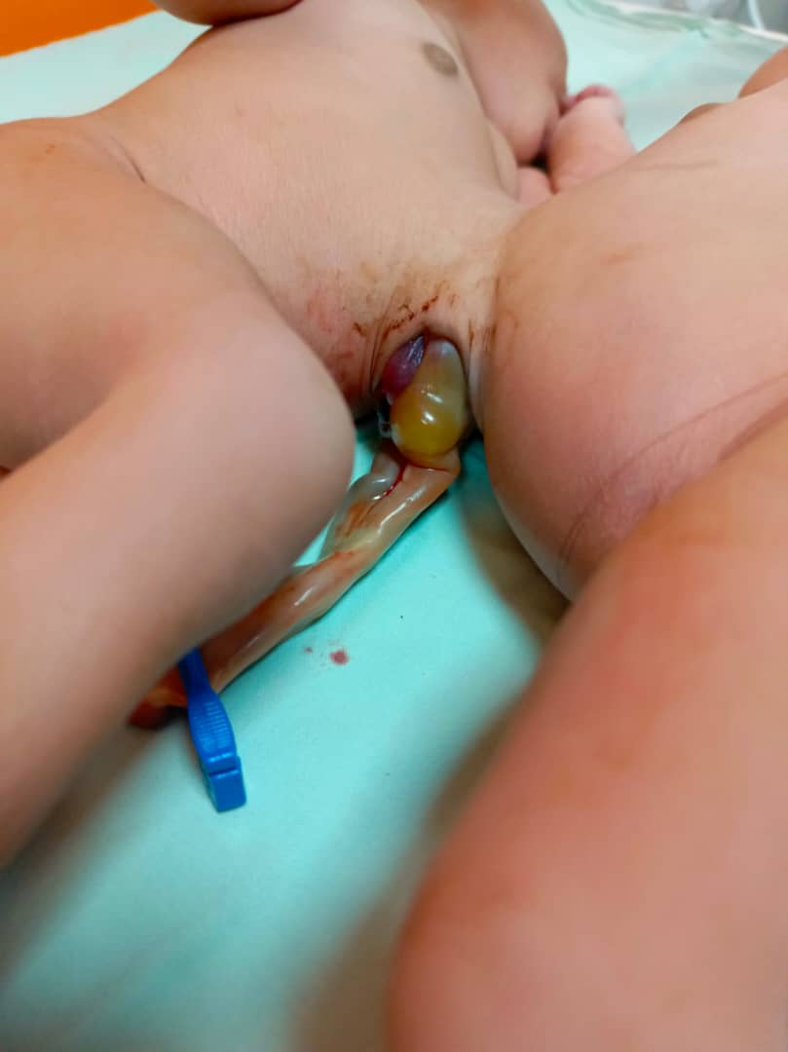

Figure 4:Omphalopagus conjoined twins with ruptured omphalocele

Biology showed normochromic microcytic anemia at 12.7 g/dl (D1) and 13.5 g/dl (D2) at 13.5 g/dl, hepatic cytolysis in both with ASAT: 50 IU/L, ALAT: 24 IU/L (D1) and ASAT: 59 IU/L ALAT: 45 IU/L (D2), a positive infectious assessment with procalcitonin (PCT) at 19.8 ng/ml for (D1) and 24.98 ng/ml for (D2). An unremarkable renal, glycemic, metabolic and terrain assessment.
Morphologically, the Body-scan of (J1) and (J2) found a communication through the liver with extension of the left liver of J1 into the abdominal cavity of J2 and a communication at the umbilical level with J2, a meningeal hemorrhage and cerebral edema. The thoraco-abdomino-pelvic CT angiography found a bilobed gallbladder for J2, a liver of J2 connected to the distal arteriovenous structures of the left liver of J1 and poor visualization of the gallbladder. The thoraco-abdomino-pelvic MRI (J2) revealed a common liver with poor visualization of the inferior vena cava of J2 and without particularity for J1 (Figure 5).

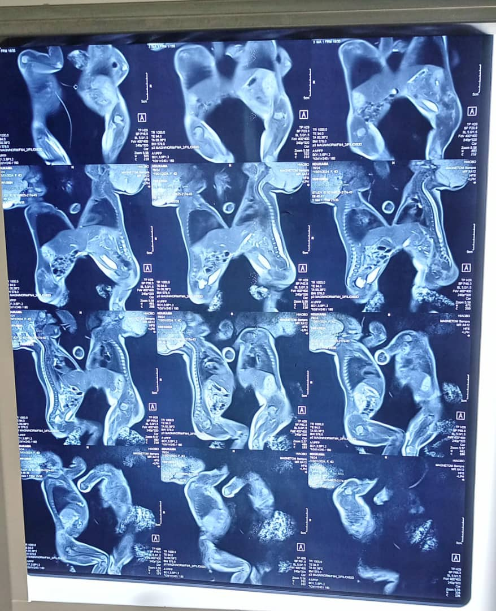
Figure 5:Common liver between D1 and D2
The initial treatment consisted of hospitalization in the intensive care unit, placement in a warming crib, placement of a peripheral venous line and orogastric tubes, essential care of the newborn, fluid and carbohydrate intake, probabilistic dual antibiotic therapy (ceftazidime 35 mg/kg/8 hours and gentamicin 5 mg/kg/24 hours), antiparasitic (metronidazole 10 mg/kg/day intravenously) for 7 days, antimycotic (fluconazole 10 mg/kg/day) for 21 days IV then oral relay. The evolution during hospitalization was favorable. A transfer was made at 1 month of life at the request of the parents to Nigeria for continued care in a specialized structure with the technicality and surgical expertise for this type of malformation.
Discussion:
Siamese twins represent an exceptional malformation in obstetrics occurring once in 50,000 to 60,000 births, with 60% perinatal mortality [5]. In our case, they were craniopagus and omphalopagus twins. A case of thoracopagus male conjoined twins was published in Gabon in 2022 and in Morocco in 2021 [6,7]. A case of craniopagus conjoined twins was described in Ivory Coast in 2007 [8]. This demonstrates the extremely rare nature of this malformation. The female sex is dominant in 70 to 75% of cases according to literature data [3]. This result is consistent with our observation. The pathogenesis of conjoined twins is unclear. The mechanism of conjoined twin formation is based on two explanatory theories. The theory of secondary and partial fusion of the two initially separated monozygotic embryonic discs, but this theory is rejected in favor of the incomplete and late fission of an embryonic disc [9,10]. It should be noted that there is no associated chromosomal abnormality. Race, heredity, parity and consanguinity would not intervene in the process.
In our observation, the first difficulty encountered was the lack of pregnancy monitoring and obstetric ultrasound, which can be explained by the difficult access to ultrasound in our countries with low medical density, as well as the cost of this examination, which is not always within the reach of our less well-off populations. Antenatal diagnosis of conjoined twins is based on ultrasound [10]. The first ultrasound examination was performed by Wilson in 1976 at 35 weeks of amenorrhea [11]. Antenatal diagnosis will be done earlier and earlier thereafter. Indeed, ultrasound should be done in the first trimester of pregnancy (12-14 weeks of amenorrhea) by vaginal route. Early diagnosis is essential for the purposes of medical termination of pregnancy. It is easy in the second trimester of pregnancy (22 weeks of amenorrhea) due to good development of the morphology and fetal adnexa. At this time, it is easy to precisely locate the area of ​​attachment, analyze duplicated structures and look for other associated malformations, particularly cardiac [10]. Other imaging techniques, namely MRI, uterine content and karyotype, are useless for diagnosis but can provide additional information for prognostic purposes.
The survival of conjoined twins depends on the type of union (shared organs) and other associated anomalies. Currently, only a few pediatric surgical teams are able to consider surgery to separate conjoined twins, provided that there is no severe malformation association. According to Romero, 39% of conjoined twins are stillborn and 34% die within hours of birth [12]. The real problem with this pathology is the separation of the twins, which is not always possible (49 to 62%) [13,14], not always easy and of uncertain prognosis even with experienced teams [13,14]. Very few teams perform these procedures, the best postoperative results of which are observed in thoraco-omphalopagus with separate hearts [13,14]. Few have the surgical expertise of craniopagus twins, with a perioperative risk of death of 50% [15]. Despite these technical problems, it is a major, very expensive surgery, which raises ethical issues due to the need to sacrifice one child to the detriment of the other [13, 14]. Complex ethical questions also arise when the separation involves the unequal sharing of limbs and organs, or when the separation results in the death of one of the conjoined twins. The separation could not be done in our context because our technical platform did not allow it and our teams were not sufficiently trained, equipped and prepared despite the multiple multidisciplinary consultations. The steps for a possible transfer to a specialized department were successful for the second observation.
Conclusion
Current technology helps in early diagnosis and opens new perspectives on the future of conjoined twins. It represents a real diagnostic and especially therapeutic challenge. The aim of our case was to draw the attention of obstetricians-gynecologists to this rare anomaly, to specify the importance of ultrasound as an essential diagnostic tool to set up an effective management strategy in order to avoid any surprise that could compromise the vital prognosis of newborns and their mothers.

references:
1-Herkiloglu D, Baksu B, Pekin O. Early septal diagnosis of thoraco-omphalopagus twins at ten weeks of gestation by ultrasound. Turk J Obstet Gynecol. 2016;13:106-8.
2-Alkhateeb M, Mashaqbeh M, Magableh S, Rafiq H, Quteiba N, Abdelkheleg A. Early Prenatal Diagnosis of thoracopagus twins by ultrasound. Acta Informed Med. 2015;23:60-2.
3-Mishra N, Rohilla M. Thoraco-omphalopagus conjoined twins: a case report and literature review. Gynacol Obstet Case Report. 2015;1:3.
4-Bousselamti Amal. Siamese twins about 8 cases with literature review. [Medical thesis]. Rabat: Mohammed-V University Rabat; 2016.
5- Durier M, Vervaet H, Gabriel. Twin pregnancy. Anatomoclinical study and management. EMC (Elsevier Masson SAS, Paris). Elsevier Masson; 2010:5-030-A-10.
6- Lembet Mikolo A, Minko J, Kuissi Kamgaing E, Nkole Aboughe M, Mekame Meye A, Mabery Grodet A et al. Thoracopian conjoined twins: a case report from Libreville and review of the literature. PAMJ Case Report. 2022;1-9.
7- Rhaidouni Mohamed Adnane, Barick.A, Chaara H, Fdili Alaoui FZ, Jayi S, Melhouf My A. Antenatal diagnosis of conjoined twins (about a case and review of the literature). IJAHMR 2022.65-9.
8-Konan Blé R, Seni K, Adjoussou S, Quenum G, Akaffou E, Koné M. Craniopagus conjoined twins: management difficulties in the African environment. Obstetrics and Gynecology and Fertility. 2008;36:56-9
9-Mathew RP, Francis S, Basti RS, Suresh HB, Rajarathnam A, Cunha PD et al. Conjoined twins - role of imaging and recent advances. J Ultrasound. 2017;17(71):259-266.
10-Benchiba I, Saoud MK, Mamouni N, Errarhay S, Bouchikhi C, Abdelaziz B. Full-term diagnosis of conjoined twins. Pan Afr Med J. 2020; 56-9.
11- Wilson RL, Cetrulo CL, Shaub MS. The prepartum diagnosis of conjoined twins by the use of diagnostic ultrasound. Am J Obstet Gynecol. 1976;126(6):737.
12- Romero R, Pilu G, Jeanty P, Ghidini A, Hobbins JC. Prenatal diagnosis of congenital anomalies. Norwalk, CT: Appleton and Lange; 1988.
13-Al Rabeeah A. Conjoined twins – past, present and future. J Pediatr Surg. 2006;41(5):1000–4.
14-Rode H, Fieggen AG, Brown RA, Cywes S, Davies MR, Hewitson JP, et al. Four decades of conjoined twin at -Red Cross Children's Hospital: lessons learned. S Afr Med J. 2006; 96(9 pt. 2):931-40.
15-Campbell S. Separation of craniopagus twins: the Brisbane experience. Childs Nerv System 2004; 20(8–9):60

