Numerical Evaluation and Optimization of an Indirect Forced-Convection Solar Tunnel Dryer Using Computational Fluid Dynamics (CFD)

Abstract
The quality of dried agri-food products depends on the uniformity of their moisture content at the end of the drying process. Controlling parameters such as temperature, air velocity, and relative humidity within the dryer is essential to ensure optimal drying. This study presents the design of a tunnel-type indirect solar dryer intended for drying agri-food products. A numerical simulation using Computational Fluid Dynamics (CFD) was performed to analyze the airflow and temperature distribution inside the dryer. To validate the numerical model, an experimental study was carried out. Geometric adjustments were then applied to the CFD model to optimize the thermal performance of the dryer and improve the efficiency of the drying process.
Keywords: Indirect solar tunnel dryer, airflow, air temperature, numerical simulation, CFD.
1. Introduction
Since the oil crisis of the 1980s, solar drying technology has attracted considerable interest among researchers, mainly as a response to the energy demands associated with the preservation of fruits and vegetables [1]. This method, the subject of numerous scientific studies, remains one of the most actively researched fields today—particularly in developing countries where simple and low-cost technologies are still widely used [2]. Solar dryers, commonly employed in the agri-food industry, are valued for their simple design, low installation costs, and ease of use in various environments [3]. Several types of dryers have been studied in the scientific literature, each evaluated based on its physical characteristics, thermal performance, and the quality of the dried products [4]. Within the drying chamber, hot air flows from the inlet to the outlet, resulting in faster drying of products located near the inlet compared to those further away. The dehydration rate is directly influenced by the temperature and velocity of the drying air [5][6]. Therefore, achieving a uniform airflow distribution inside the dryer is crucial for ensuring optimal efficiency and homogeneous drying of the products [7]. To better understand the airflow and temperature distribution, Computational Fluid Dynamics (CFD) was employed to analyze a tunnel-type solar dryer. Geometric modifications were then applied to the CFD model in order to optimize the thermal performance of the drying process.
2. Materials and Methods
2.1 Dryer Description
The studied dryer is an indirect solar tunnel dryer with forced convection (see Figure 1). It consists of a parallelepipedal steel sheet frame with a thickness of 1 mm, painted black to enhance solar radiation absorption. The dryer measures 210 cm in length and 45 cm in width. On one of the lateral sides (along the width), a fan is installed to force air circulation inside the dryer. On the opposite side, an air exhaust vent is located. One of the longitudinal lateral faces is equipped with three doors, allowing access to the different compartments of the dryer. Inside, each compartment is fitted with drying trays measuring 490 cm² in surface area, and each compartment can accommodate up to six trays, spaced 10 cm apart.
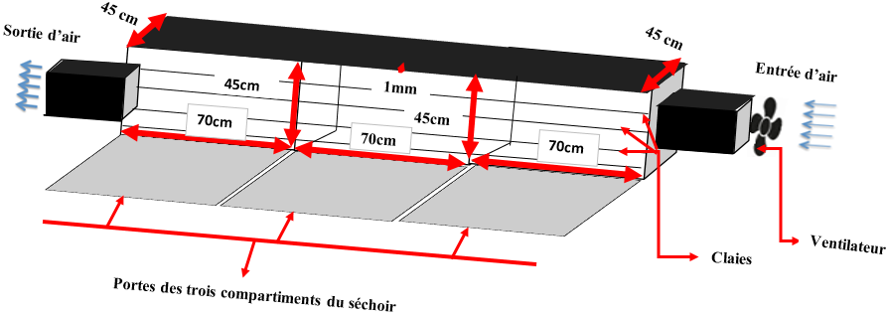
Figure 1: Schematic representation of the dryer
2.3 CFD Numerical Model
Computational Fluid Dynamics (CFD) is widely used to predict air velocity and temperature within drying chambers [8]. It significantly reduces the time required for experimental work, which can often be tedious and challenging. Solving a problem using the CFD method can be structured into the following three main steps [9]:

- Problem setup: This involves defining the geometry, generating a mesh to discretize the computational domain, and selecting appropriate physical models and numerical methods;
- Numerical resolution: The problem is solved through the execution of a computational program;
- Post-processing of results: First, the consistency of the results is verified, then they are analyzed in order to provide answers to the initial research questions.
2.3.1 Model Geometry
Figure 2 shows the geometric configuration of the model built using the FEATool Multiphysics environment. The geometric parameters are presented in Table 1.


Figure 2: Geometric configuration of the model
Table 1: Geometric parameters of the model
Air inlet size (m) | 0.25
Air outlet size (m) | 0.25
Drying chamber length (m) | 2.1
Drying chamber width (m) | 0.45
Distance between the air inlet and the top of the drying chamber (m) | 0.1
Distance between the air inlet and the bottom of the drying chamber (m) | 0.1

2.3.2 Mesh Used
Figure 3 shows the mesh topology and node distribution. The mesh parameters for the generated model are presented in the following Table 2.
Table 2: Mesh parameters of the generated model
Number of grid points | 2940
Number of grid cells | 5593
Minimum cell area | 1.1011x10⁻⁰⁴
Average cell area | 1.7075 x10⁻⁰⁴
Maximum cell area | 2.4540 x10⁻⁰⁴
Minimum cell quality | 0.8175
Average cell quality | 0.9970

2.3.3 Governing Equations of the Numerical Model
The equations governing the numerical model for the distribution of airflow and temperature are inspired by existing models in the scientific literature. These equations are derived from the fundamental laws of mass and energy conservation. They are based on the Navier–Stokes equation and heat transfer equations.
Navier–Stokes Equation Used in the Model.
$$ρ_{f}\left(u^{,}+\left(u.∇\right)u\right)=-∇p+∇.\left(μ\left(∇u+{∇u}^{T}\right)\right)+F_{X}.∇u (1)$$
With the following parameters:
$ρ_{f}$ : air density
$u$ : air velocity
$u^{,}$ : rate of change of velocity with respect to time
$p$ : air pressure
$μ$ : kinematic viscosity of air
$F_{X}$: external forces
Heat Transfer Equation Used in the Model
$$ρ_{p}C_{p}T^{'}+∇.\left(-k∇T\right)=Q-ρC_{p}u∇T (2)$$
With the following parameters:
$ρ_{p}$ : density of the dryer wall
$C_{p}$ : specific heat capacity of the sheet metal
$T$ : temperature
$T^{'}$ : rate of change of temperature with respect to time
$k$ : thermal conductivity
$Q$ : heat quantity
Boundary Conditions
For the airflow distribution within the system, the velocity coefficient of the incoming airflow is conditioned by the following relationship [10].
$$U_{in}=\frac{4*u_{max}*(y*\left(h-y\right))}{h^{2}}, 0≤y≤h (3)$$

With:
$U_{in}$: velocity coefficient of the incoming airflow into the system
$u_{max}$: maximum air velocity at the inlet of the drying chamber
$h$ : height of the air inlet opening into the drying chamber
The pressure of the airflow from the outlet to the interior of the system is assumed to be zero. The other sides of the system are considered as slip-free walls.
For temperature diffusion inside the system, we have set the temperature values at the inlet of the dryer walls.

2.4 Experimental Approach
In order to validate the model simulated using Computational Fluid Dynamics (CFD), we conducted experimental tests with temperature and wind speed sensors, as illustrated in Figure 4 and Photo 1.
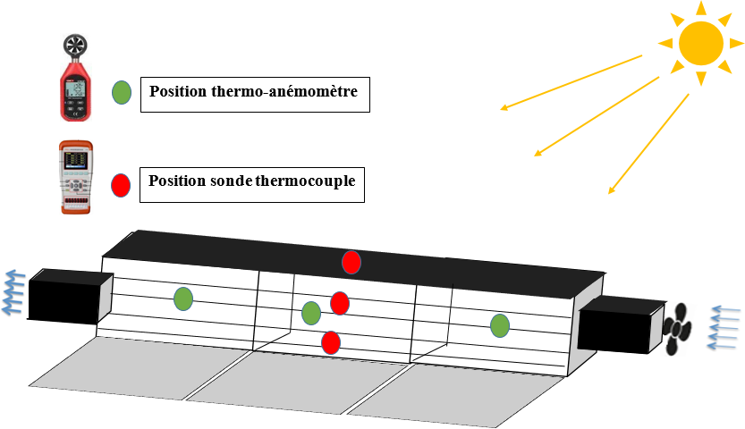
Figure 3: Schematic representation of the setup
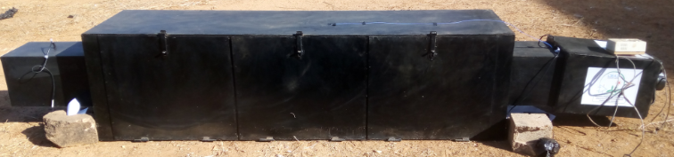
Figure 4: Photo of the setup
2.4.1 Equipment Used
The main equipment used for our experimental tests includes:
- Temperature probes of the thermocouple type, coupled with a data acquisition system (JINKO-JK804), to monitor the temperature changes of the product, the walls, and the ambient air in the dryer.
- A thermo-anemometer of the UNI-T UT363 BT type, used to monitor the airflow velocity at various locations within the dryer.

Result And Discussion
3.1 Airflow Distribution
Figures 5 (a), (b), and (c) present the airflow velocity distribution profile inside the drying chamber. In (a), (b), and (c), we have the inlet velocities of 1 m/s, 2 m/s, and 3 m/s, respectively.

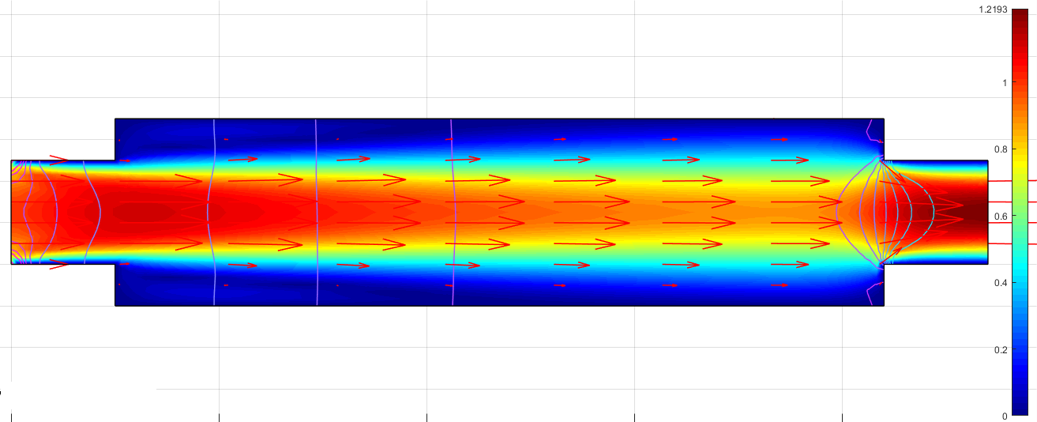
(a)
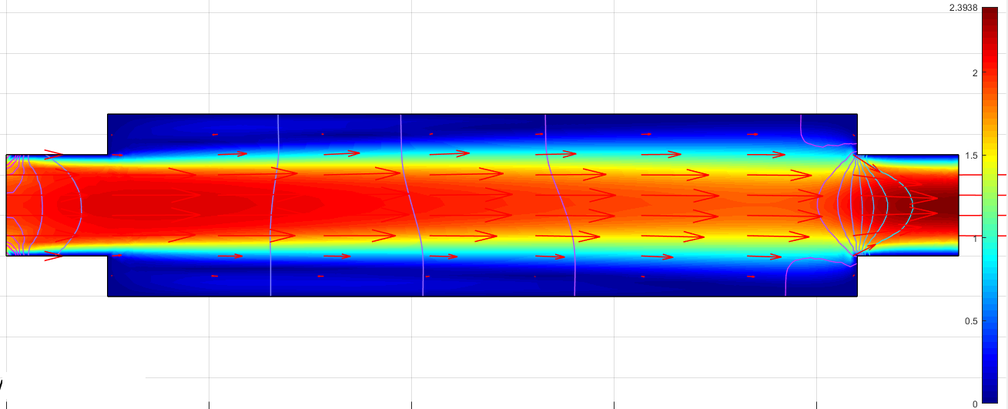
(b)
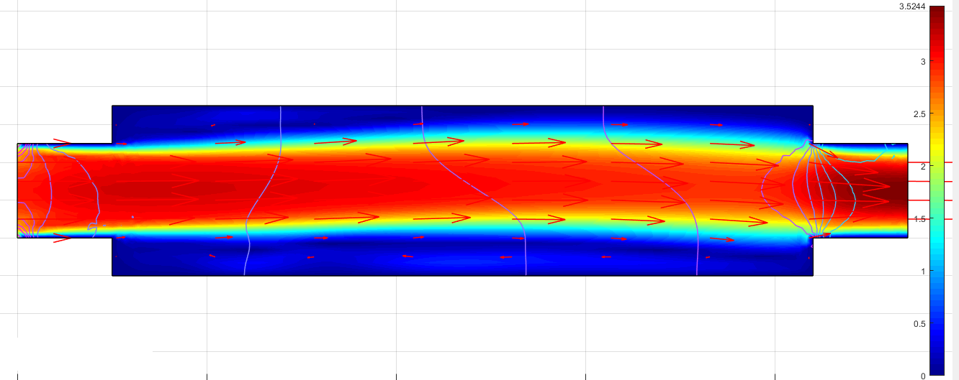
(c)
Figure 5: Air velocity distribution profile inside the drying chamber (in (a), (b), and (c) the inlet velocities are 1 m/s, 2 m/s, and 3 m/s, respectively).
By observing these results, we notice a concentration of airflow distribution in the middle of the drying chamber. This airflow distribution becomes more uniform as the inlet velocity increases. On the other hand, we observe a lack of airflow distribution at both ends, the top and bottom sides, of the drying chamber. This situation is due to the geometric structure of the dryer, which has right angles between the section designed to house the fan and the drying chamber. This issue can be corrected by modifying the geometry of the drying chamber.
3.2 Temperature Diffusion
Figures 6 (a), (b), and (c) present the heat transfer profile in the drying chamber. In (a), (b), and (c), we have the wall temperature receiving solar radiation set at 40°C, 50°C, and 60°C, respectively.

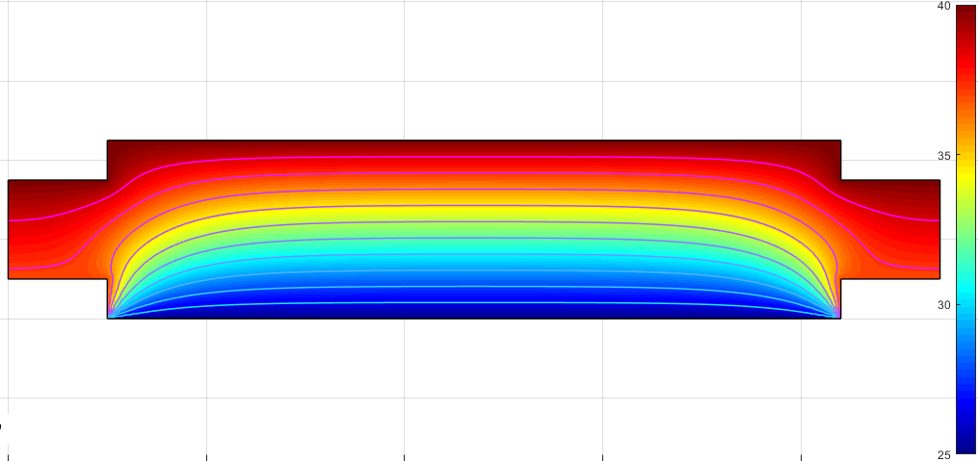
(a)

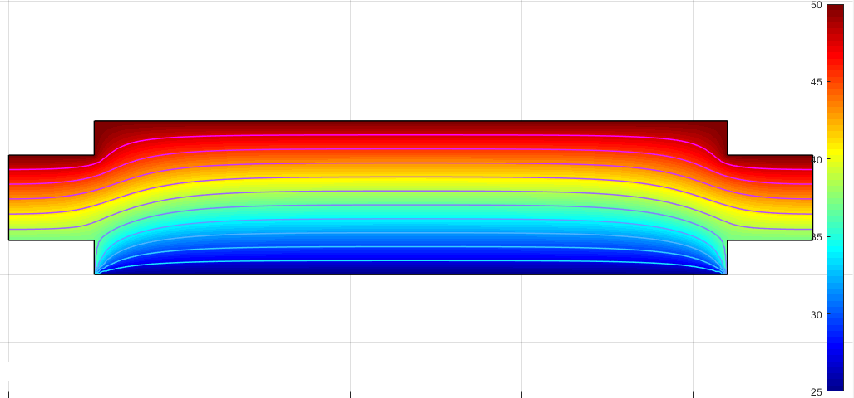
(b)
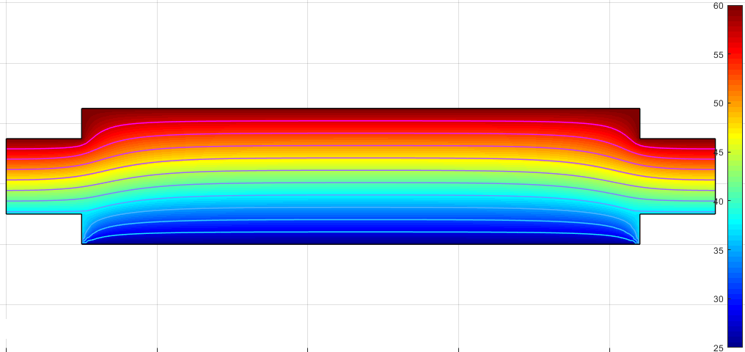
(c)
Figure 6: Temperature distribution profile inside the drying chamber (in (a), (b), and (c), the wall temperature is set at 40°C, 50°C, and 60°C, respectively).
By observing these results, we notice a heat distribution pattern from the upper wall of the dryer toward the interior of the drying chamber. This illustrates a temperature difference between the upper and lower parts of the dryer. This temperature gradient becomes more pronounced as the temperature of the upper wall increases. This phenomenon is also attributed to the geometric structure of the dryer. In addition to the right-angled corners on the sides, the dryer is designed to rest directly on the ground. As a result, the lower part of the drying chamber contributes little to the heat transfer unless it is placed in a high-temperature environment.
3.3 Comparison between Experimental Measurements and CFD Models
The air temperature and velocity measured experimentally within the drying chamber are compared with the data obtained from the CFD models. Figures 7 (a) and (b) present the comparison of the temperature and air velocity profiles, respectively.
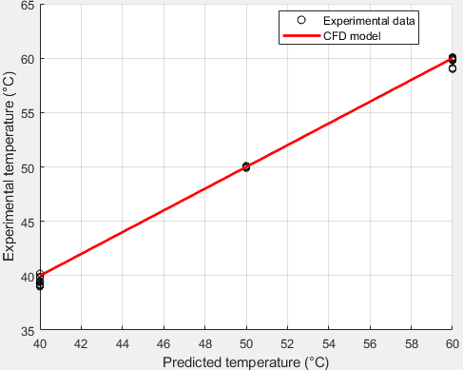 | 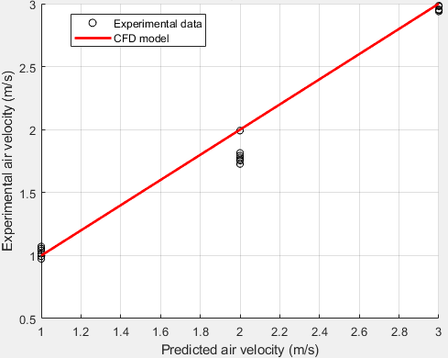
Figure 7 (a) : 3 Comparaison entre les mesures expérimentales des températures et les modèles CFD | Figure 7 (b): Comparison between experimental air velocity measurements and CFD model predictions
Figure 7: Comparison between CFD model predictions and experimental data points
By analyzing these figures, a good agreement can be observed between the CFD model predictions and a number of experimental data points. The table below presents the statistical parameters of the relative errors between the experimental and simulated results, calculated using the following formulas:
R-Square
$$R^{2}=1-\frac{\frac{1}{n}\sum_{i=1}^{n}{{\left({Yexp}_{i}-{Ymod}_{i}\right)}^{2}}}{\frac{1}{n}\sum_{i=1}^{n}{{\left({Yexp}_{i}-\overline{{Yexp}_{i}}\right)}^{2}}} (4)$$
Table 3: Statistical Parameters
Statistical Parameters | R²
Relative errors between the two sets of temperature results | 0.9951
Relative errors between the two sets of temperature results | 0.9217
The examination of these values shows an R² close to one. We can conclude that the model is satisfactory.
3.4 Optimizing the Dryer Performance through the CFD Model
Although this type of dryer has yielded good results for drying certain agri-food products, modifications to its geometry are necessary to achieve better distribution of air and temperature flows. Figures 8 and 9 present, respectively, the air velocity and temperature distribution profiles inside the drying chamber of the modified dryer.

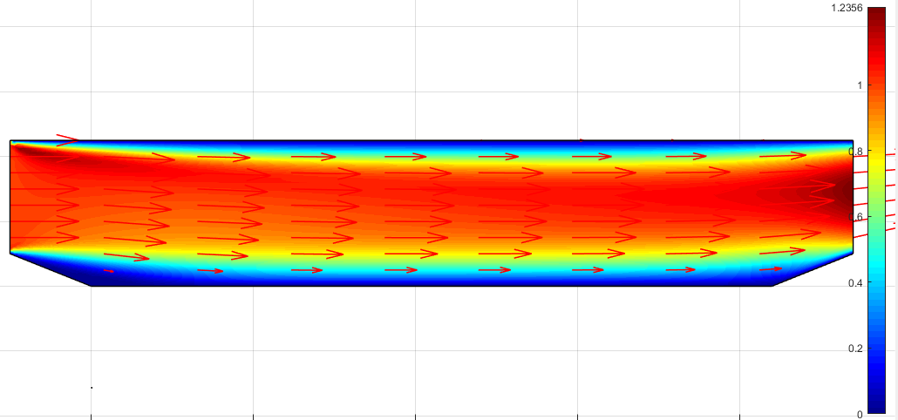
Figure 8: Air velocity distribution profile inside the drying chamber of the modified dryer
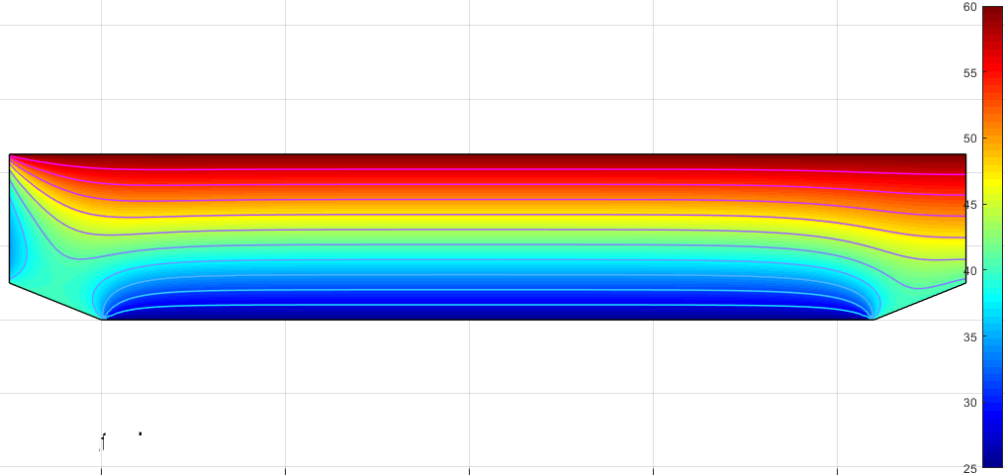
Figure 9: Temperature distribution profile inside the drying chamber of the modified dryer.
By removing the upper corner angles at both ends and modifying those at the bottom of the drying chamber, we observe in Figure 8 a better distribution of airflow within the drying chamber. Figure 9 also shows an improvement in temperature distribution inside the chamber, even though the original setup—with the dryer placed directly on the ground—was maintained.

IV. Conclusion
This work provided a better understanding of the distribution of airflow and temperature inside the studied dryer. We compared the CFD model's predicted values with experimental measurements. The two sets of results are in good agreement, with an R value close to 1. A modification of the dryer's geometry was carried out using the CFD numerical model, while maintaining its original dimensions and architecture. The results of the numerical model for the modified dryer show improved performance.

References
[1] Dissa, A. O. (2007). Convective drying of mango: Analysis of the influence of aerolic and intrinsic parameters, design and modeling of an indirect solar dryer. PhD Thesis, University of Ouagadougou, Burkina Faso.
[2] Nganhou, J., & Nganya, T. (2003). Numerical simulation of the dynamic behavior of a solar drying system for cocoa beans in Cameroon. Biological and Food Processing (PBA). Retrieved from http://spip.em.refer.org/tet/pba1/article40.html
[3] Amanlou, Y., & Zomorodian, A. (2010). Applying CFD for designing a new fruit cabinet dryer. Journal of Food Engineering. https://doi.org/10.1016/j.jfoodeng.2010.06.001
[4] Goudjinou, C. (2018). Theoretical and experimental study of solar drying of Moringa oleifera leaves: Thermophysical, physicochemical, and functional characterization of the derived powder. PhD Thesis, University of Abomey-Calavi, Benin.
[5] Mulet, A., Berna, A., Borras, M., & Pinaga, F. (1987). Effect of airflow rate on carrot drying. Drying Technology, 5(2), 245–258.
[6] Karathanos, V. T., & Belessiotis, V. G. (1997). Sun and artificial air-drying kinetics of some agricultural products. Journal of Food Engineering, 31(1), 35–46.
[7] Mirade, P. S. (2003). Prediction of the air velocity field in modern meat dryers using unsteady computational fluid dynamics (CFD) models. Journal of Food Engineering, 60, 41–48.
[8] Norton, T., & Sun, D. W. (2006). Computational fluid dynamics (CFD) – an effective and efficient design and analysis tool for the food industry: A review. Trends in Food Science & Technology, 17, 600–620.
[9] Wikipedia contributors. (2021, June 2). Computational fluid dynamics. Retrieved from https://fr.wikipedia.org/wiki/M%C3%A9canique_des_fluides_num%C3%A9rique
[10] John, V. (2004). Reference values for drag and lift of a two-dimensional time-dependent flow around a cylinder. International Journal for Numerical Methods in Fluids, 44, 777–788.
[11] Nabh, G. (1998). On higher order methods for the stationary incompressible Navier-Stokes equations (PhD Thesis). Universität Heidelberg, Preprint 42/98.
[12] John, V., & Matthies, G. (2001). Higher-order finite element discretizations in a benchmark problem for incompressible flows. International Journal for Numerical Methods in Fluids, 37(8), 885–903.
[13] John, V., & Rang, J. (2010). Adaptive time step control for the incompressible Navier–Stokes equations. Computational Methods in Applied Mechanics and Engineering, 199, 514–524

